Assessment of Groundwater characteristic studies using the Magneto telluric method in Kalugumalai, Tamil Nadu, India
Abinaya.R^{1, 2}, Antony Ravindran.A¹, Richard Abishek.S¹, Vinoth Kingston.J¹, Antony Alosanai Promilton A¹
¹ PG and Research Department of Geology, V.O.Chidambaram College, Thoothukudi – 628008
² (Reg.no: 2121223222013) Research scholar in affiliated by Manonmaniam Sundaranar University, Tirunelveli
*Corresponding author: Abinaya.R
E-mail: antonicogeo@gmail.com
Abstract
The aim of the study is to present the principles and procedures of the magneto telluric approach. The resistivity characteristics of the rocks in Tamil Nadu's Thoothukudi district's Kalugumalai hamlet were the basis for the aquifer investigation. The research region has granitic hard rock, worn gneiss, and black soil. The magneto telluric method will employ resistivity variations to assess the connection of permeable rock and groundwater in land and underground discharges. The natural electromagnetic field strength is determined by the rock structure of the underground earth and its resistivity variations. In order to increase spacing transmission and get more information, two copper electrodes are used for the M and N electrodes. For hydrogeological objectives, the approach has given information on the rocks and structural relationships up to a depth of 300 m. The study demonstrates that fractured and weathered zones in the region have a major role in controlling groundwater occurrence. At the saprock zone, it is very likely that you may run into groundwater. Between the overburden and the bedrock are fractured and weathered zones. The MT approach is efficient for investigating groundwater in a geological setting.
Keywords: Groundwater, Magneto telluric method, Kalugumalai, Rock structure

1. INTRODUCTION
A vital natural resource, groundwater also plays a big part in the economy. It serves as the primary water source for agriculture and the food sector. In general, groundwater is a dependable source of water for agriculture and may be used in a flexible way: more groundwater can be extracted when it's dry and there is a higher demand, and less groundwater will need to be extracted when the rain fall satisfies the needs. Globally, more than 70% of all water withdrawal is used for agriculture (both surface and groundwater). Approximately 43% of the total irrigation water used is thought to come from groundwater. In hydrology, an aquifer is a rock layer that stores water and periodically releases significant volumes of it. The rock has pore spaces that are filled with water, and when the spaces are linked together, the water can pass through the matrix of the rock. A zone, lens, or stratum that contains water is another name for an aquifer. One of the most significant sources of fresh water on Earth, wells can be drilled into a variety of aquifers. When the water table, the upper surface of a groundwater aquifer, is exposed to the atmosphere through permeable material, the aquifer is said to be unconfined. Unconfined aquifer systems lack the impervious rock barrier that separates the water table from the atmosphere in confined aquifer systems.
Geology is a branch of science that focuses on the study of the earth as it appears on its surface, within, and structurally, particularly as it pertains to the composition, arrangement, and structure of rock formations. In order to comprehend geology, the science of geophysics examines the physical characteristics of the earth. Geophysical methods make use of several physical factors, including density, magnetic and electrical properties, etc. Therefore, the investigation of mineral deposits by the right application of the physical characteristics of the earth's minerals is known as applied or exploration. 'Geophysical prospecting,' also known as geophysicsMeidav T (1960), Parasnis D. S (1997). Geophysical prospecting, also known as applied geophysics, has become crucial for the exploration of mineral deposits, the resolution of bed-rock foundation issues, civil and military engineering projects, the location of ground water, and offshore or oceanic research. Reynolds, J.M., 1995. Karanth K. R (1987)
The current study sought to use the Magnetotelluric (MT) approach in the search for acceptable locations for digging numerous boreholes for community water supply, despite the fact that Electrical Geophysical Methods are frequently used in groundwater investigations. The Magnetotelluric method was chosen because it can be used for great depths of investigation, good space sampling, and the ability to distinguish between salt-saturated water and freshwater layers, whereas Electrical Tomography and Electrical Vertical Sounding cannot ensure complete and dense space coverage. This approach is frequently used worldwide in groundwater investigations and other geoscience research since it is well-documented in the literature. (Tinlin et al. 1988; Brasse 1989; Bernard et al. 1990; Bartel 1991; Chouteau et al. 1994; Nichols et al. 1994; Bourgeois et al. 1994; Dennis et al. 2011; Chave and Jones 2012; Nittinger and Becken 2016; Amjadi et al. 2020; Muttaqien and Nurjaman 2021). When using MT for groundwater research, especially in regions where the presence of groundwater is dependent on cracks and weathering, Archie's law, which demonstrates the relationship between the porosity of rock materials and their electric conductivity, is very beneficial.Agyemang, V. O. (2022).
2. STUDY AREA
The study region is in Tamil Nadu's Thoothukudi District, and it is situated between 9°08'59.5" N latitude and 77°42'13.6" E longitude. The water-bearing formations include charnockite, Terri sands (sand dunes), Quaternary alluvium, Tertiary sediment sand, and weathered zones in gneisses. Marine deposits and river marine deposits make up the majority of the litho units in coastal locations. (Magesh et al. 2016; Narayanaswamy and Lakshmi 1967). The study is underlain by rocks of the Archean age, which is having gneisses, granites, and charnockite(Narayanaswamy and Lakshmi 1967. The main aquifer systems are composed of porous Tertiary and recent Sedimentary formations and worn and cracked hard rock formations of Archean age. In the research area, alluvium deposits cover the surface layer to a large extent. In order to determine the research area's acceptable soil and dune thickness as well as the infiltration of groundwater and saltwater, resistivity experiments were conducted. (Antony Ravindran 2012). Sandstone with Kankar/Caliches, weathered gneissic rock with basement rock, soil, clay-rich soil, alluvium deposits, and sandstone are all present in the studied region.
In the towns of Pudukkottai, Kovilpatti, Ottapidaram, and Vallanadu, quartzites are exposed as hillocks. The hills generally trend in a direction of NWW to SSE. Ottapidaram and Vallanadu's hills are respectively 28 m and 314 m in height at their highest point. The district of Thoothukudi's main soil types are listed below: river alluvium, shallow red soil, black cotton soil, and shallow red soil. Solid calcareous soil, salty soil, salty mangrove soil, and red-ferralitized soil

The following geological formations, namely Archaean, Tertiary, Recent to Sub-Recent age, are encountered in Tuticorin. (Table2.1)
Table.1 Below is a description of the district's geological structure.
Period | Age | Stage | Lithology
Quaternary | Holocene to Recent | Alluvium –Recent Deposits | Red soils, coastal sands, river alluvium, laterite one red teri, kankar, shell fragments and calcareous sand stone.
Tertiary | Miocene | Panampari  Sandstone | Hard and Compact Calcareous Sand stone, shell Limestone.
Achaeans | Precambrian | Crystalline | Quartzite, charnockite, calc-granulite, peninsular gneiss. Pink granite,

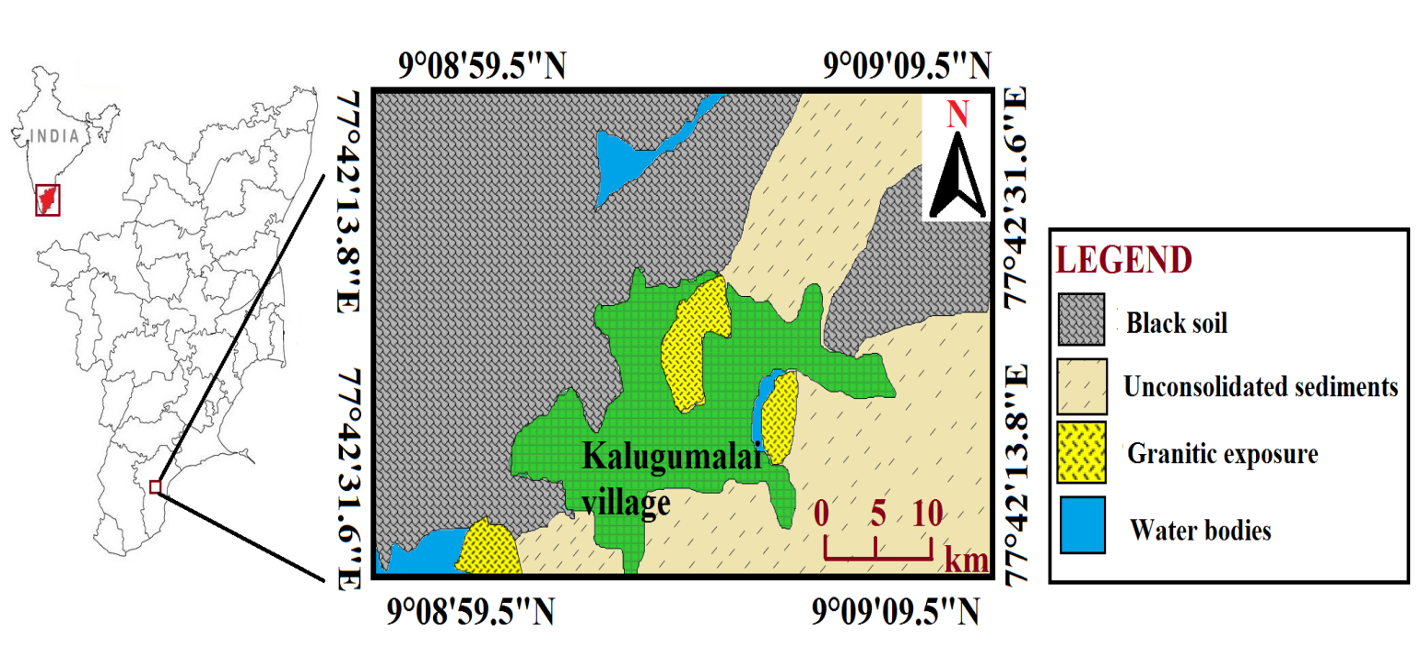
Figure 1. Location Map of the study area.

3. METHODOLOGY
Identification of the subsurface geology, formation, and freshwater discharge is done using the magnetotelluric approach. Li and Jie (2017), Vozoff and Keeva (1991), Abdelzaher et al. (2012), deGroot-Hedlin (1990), Jones and Alan (1988), Falgàs (2009), Demirci and İsmail (2017), Albouy et al. (2001). The magnetotelluric approach is beneficial for studying aquifers or the deep subsurface. Aquifer depth, freshwater flow, saline intrusion, and tectonically fractured and folded terrain.
The quartzite and gneissic, schist, and granitic rock below deeper structural formation is identified using the low frequency ADMT-300S Magneto Telluric apparatus and mapped in a 2D picture. The underground earth's rock formation and its fluctuations in resistivity are used to determine the natural electromagnetic field's strength. The two copper electrodes are utilised for the M and N electrodes in spacing transmission to improve it and gain more information depth up to 300m.
4.Result and DISCUSSION
This study uses the magneto telluric approach to explore the kalugumalai groundwater system. For subsurface deeper aquifer mapping, the magneto telluric approach is employed. Granitic and gneissic development is what the high resistivity portion of 0.0051-0.0057 ohm.m. indicates. The low resistivity is 0.0037-0.0043 ohms/m, which indicates an intrusion from a water-bearing zone at a depth of 60 m. The weathered zone shows gneissic rock with an impedance between 0.0045 and 0.0049 ohm.m.
Profile 1
Profile 1 covers a length of 280 metres and a depth of 300 metres. The unconsolidated soil package is to blame for the high resistivity portion, which ranges from 0.0076 to 0.0092 ohm.m. The low resistivity, which ranges from 0.0027 to 0.0048 ohms per metre, indicates a water-bearing zone. The weathered zone shows that there is gneissic and granitic rock present in this region, ranging from 0.0055 to 0.0069 ohm.m.
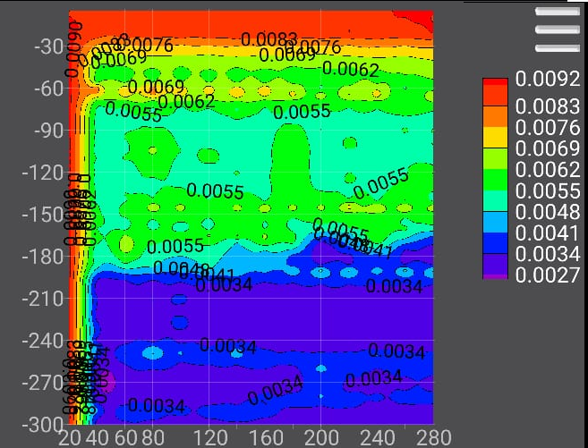
Fig 2.1 MT profile 1
Profile2
Profile 2 covers a length of 240 metres and a depth of 300 metres. The 0.0051–0.0057 ohm.m. high resistivity portion is indicative of granitic and gneissic development. The low resistivity of 0.0037-0.0043 ohms per metre indicates an intrusion from a water-bearing zone at a depth of 60 m. The weathered zone shows gneissic rock with a resistance of 0.0045–0.0049 ohm.m.
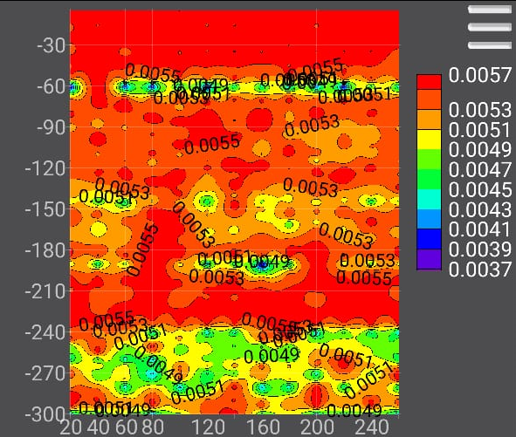
Fig 2.2 MT Profile 2

Profile3
A distance of 60 metres and a depth of 300 metres are covered in profile 3. Granitic and gneissic rock can be found to a depth of 1800 metres due to the high resistivity portion, which measures 0.0054–0.0059 ohm.m. The low resistivity, which indicates a water bearing zone at a distance of 30 metres and a depth of 200 metres, is 0.0040–0.0048 ohm.m. The formation rock's weathered indication ranges from 0.0048 to 0.0052 ohms.
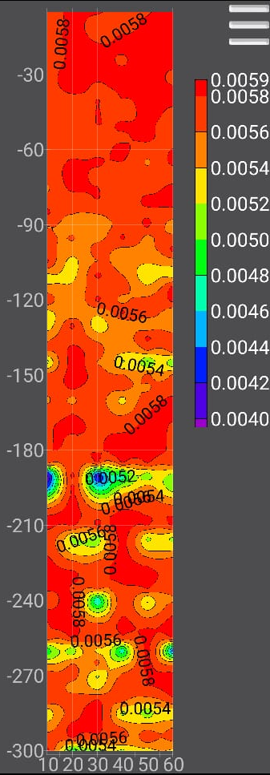

Fig 2.3 MT profile

Profile4
The length of profile 4 is covered by a distance of 60 metres and a depth of 300 metres. Granitic and gneissic rock are present at a depth of 1800 metres, as shown by the high resistivity portion of 0.0054-0.0060 ohm.m. The low resistivity of 0.0042-0.0046 ohm/m indicates a water carrying zone at a distance of 30 m and a depth of 200 m. The weathered formation rock is measuring between 0.0048 and 0.0052 ohms.
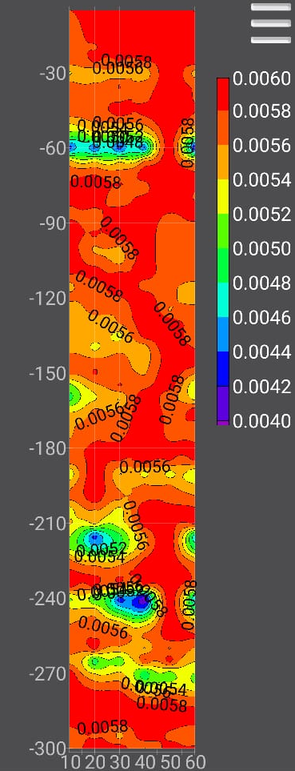
Fig 2.4 MT profile 4
5. CONCLUSION
This study uses the magnetotelluric approach to explore the kalugumalai groundwater system.For subsurface deeper aquifer mapping, the magneto telluric approach is employed. Granitic and gneissic development is what the high resistivity portion of 0.0051-0.0057 ohm.m. indicates. The low resistivity is 0.0037-0.0043 ohms/m, which indicates an intrusion from a water-bearing zone at a depth of 60 m. The weathered zone shows gneissic rock with an impedance between 0.0045 and 0.0049 ohm.m.
REFERENCE
Abdelzaher M, Nishijima J, Saibi H, El-Qady G, Massoud U, Soliman M, Younis A, Ehara S (2012) A coastal aquifer study using magnetotelluric and gravity methods in Abo Zenema, Egypt. Pure ApplGeophys 169(9):1679–1692. https://doi.org/10.1007/s00024-011-0407-y
Agyemang, V. O. (2022). Groundwater exploration by magnetotelluric method within the birimian rocks of mankessim, Ghana. Applied Water Science, 12(3), 1-6. https://doi.org/10.1007/s13201-022-01576-9
Albouy Y, Andrieux P, Rakotondrasoa G, Ritz M, Descloitres M, Join J-L, Rasolomanana E (2001) Mapping coastal aquifers by joint inversion of DC and TEM soundings-three case histories. Groundwater 39(1):87–97. https://doi.org/10.1111/j.1745-6584.2001.tb00354.x
Amjadi AA, Takalu M, Namvaran M, Kushki M (2020) An application of magnetotelluric data inversion in a stratovolcano region. Phys Astron Int J 4(6):2576–4543
Antony Ravindran A (2012) Azimuthal square array resistivity method and goundwater exploration in Sanganoor, Coimbatore District, Tamilnadu, India. Res J Recent Sci ISSN 2277:2502
Chave AD, Jones AG (2012) The Magnetotelluric Method Theory and Practice. Cambridge University Press
Chouteau M, Krivochieva S, Rodriguez R, Gonnlez T, Jouanne V (1994) Study of the Santa Catarina aquifer system (Mexico basin) using magnetotelluric soundings. J ApplGeophys 3(1–4):85–106
deGroot-Hedlin C, Constable S (1990) Occam’s inversion to generate smooth, two-dimensional models from magnetotelluric data. Geophysics 55(12):1613–1624. https://doi.org/10.1190/1.1442813
Demirci İ, EminCandansayar M, Vafidis A, Soupios P (2017) Two dimensional joint inversion of direct current resistivity, radio-magnetotelluric and seismic refraction data: an application from Bafra Plain, Turkey. J ApplGeophys 139:316–330. https://doi.org/10.1016/j.jappgeo.2017.03.002
Dennis ZR, Moore DH, Cull JP (2011) Magnetotelluric survey for undercover structural mapping: central Victoria. Aust J Earth Sci 58:33–47
Falgàs E, Ledo J, Marcuello A, Queralt P (2009) Monitoring freshwater-seawater interface dynamics with audiomagnetotelluric data. Near Surf Geophys. https://doi.org/10.3997/1873-0604.2009038
Jones AG (1988) Static shift of magneto telluric data and its removal in a sedimentary basin environment. Geophysics 53(7):967–978. https://doi.org/10.1190/1.1442533
Karanth, K. R. (1987). Ground water assessment: development and management. Tata McGraw-Hill Education.
Li J, Pang Z, Kong Y, Lin F, Wang Y, Wang G, Lv L (2017) An integrated magnetotelluric and gamma exploration of groundwater in fractured granite for small-scale freshwater supply: a case study from the Boshan region, Shandong Province, China. Environ Earth Sci 76(4):163. https://doi.org/10.1007/s12665-017-6486-z
Meidav, T., 1960. An electrical resistivity survey for ground water, Geophysics, 25(5): 1077-1093.
Muttaqien I, Nurjaman J (2021) Two-dimensional inversion modeling of magnetotelluric (MT) synthetic data of a graben structure using SimPEG. RisetGeologi Dan PertambanganIndones J Geol Mining 31(1):1–12. https://doi.org/10.14203/risetgeotam2021.v31.1121
Narayanaswamy, S., & Lakshmi, P. (1967). Charnockitic rocks of Tinnevelly district, Madras. J Geol Soc India, 8, 35-50.
Nichols EA, Morrison HF, Lee S (1994) Controlled- source magnetotelluric for groundwater. In: Proceedings of the SEG, 64th Annu. Int. Meeting, pp 553–554
Nittinger CG (2016) Becken M (2016) Inversion of magnetotelluric data in a sparse model domain. Geophys J Int 206:1398–1409. https://doi.org/10.1093/gji/ggw222
Parasnis, D.S., 1997. Principles of applied geophysics, Chapman and Hall, 2-6 Boundary Row, London SE1 8HN, UK.
Reynolds, J.M., 1995. An Introduction to Applied and Environmental Geophysics, John Wiley and Sons, pp: 796.
Selvam, S., Dar, F. A., Magesh, N. S., Venkatramanan, S., & Chung, S. Y. (2016). Application of remote sensing and GIS for delineating groundwater recharge potential zones of Kovilpatti Municipality, Tamil Nadu using IF technique. Earth Science Informatics, 9(2), 137-150.https://doi.org/10.1007/s12145-015-0242-2
Tinlin RM, Hughes LJ, Anzzolin AR (1988) The use of controlled source audio magnetotellurics (CSAhlT) to delineate zones of groundwater contamination: a case history. In: Collins, A.G., Johnson. A.I. (Eds.). Groundwater contamination field methods. vol. 963 of ASTM Spec. Tech. Publ. American Society for Testing and Materials, pp. I O I - I IS.
Vozoff K (1991) The magnetotelluric method. In: Electromagnetic methods in applied geophysics: Volume 2, Application, Parts A and B. Society of Exploration Geophysicists, pp. 641–712. https://doi.org/10.1190/1.9781560802686.ch8

