Quantitative Study of Biologically Important S-Nitrosothiol: Contribution of Sigma-Hole Interactions

Sumit Kumar and Ravindra Kumar
Department of Chemistry
Magadh University, Bodh Gaya, India
Email: sumitkrmgr@gmail.com

Keywords: S-Nitrosothiol, Sigma-Hole, Lewis acid, nitric oxide, coronary artery diseases.

Abstract:
Nitric oxide is an important compound for inter and intra cellular signal processing during various physiological conditions and it helps to increase the flow of blood inside human tissues. S-nitrosothiol is the major component during nitric oxide production under biological conditions. The interaction of -SNO group of S-nitrosothiol with amino acids is important in biological context. The interaction can occur through two σ-holes/ chalcogen bonding formed close to Sulphur along S-N and S-C bonding. Some relevant examples show here that ionic state of -SNO group plays a pivotal role during this interaction. Ionized and neutral Lewis bases with S-nitrosothiol through σ-hole/ chalcogen bonding along S-N bonding forms more stable complex than that along S-C bonding.

Introduction:
Nitric oxide is an important compound for our inter as well as intra cellular signal processing during various physiological conditions.^{1,2} The main function of nitric oxide is as a vasodilator which is helpful to reduce as well as improve the blood pressure in our body and their presence increases the oxygen contained in the blood.²⁻⁴ This is also helpful to increase the flow of blood inside tissues present in the body.^{3,4} Nitric oxide is produced by the linings present in the vessels containing blood, these lining are majority designated as endothelium.⁵ Nitric oxide is the responsible messenger molecule, which is commanding the vessels to dilate as well as widen and therefore guiding the vessels to contract as well as relax similar to an elastic band.³⁻⁵ A deficiency of nitric oxide occurs with aging which leads to the complications related to pathology and physiology in vivo.⁶ To overcome this deficiency, noble nitric oxides are used during the clinical conditions majorly coronary artery diseases. These diseases originate from the blockage or narrowing of arteries.^{1,7}
S-nitrosothiols are found to be a major component during the production of nitric oxide in various biological processes.⁸ It is also helpful in gasotransmission processes in the body.^{9,10} S-nitrosothiols has S-NO bonds having the bind dissociation energy less than 28 Kcal/mol whereas the bond length of ~1.8 Å and therefore it is defined as weak bond.¹¹ A few reports are only available in the literature discussing the bonding nature of S-nitrosothiols.¹¹⁻¹³ Keeping this in mind, the reported study discusses the nature of S-NO bond and discuss the attack of electron rich molecules i.e., Lewis bases to S-nitrosothiols, which is helpful to understand various biological interaction of electron rich centres of amino acids to S-nitrosothiols.

Computational details:
A quantitative study of the interaction between molecules in complexes has been performed using the TURBOMOLE quantum calculation package.¹⁴ The structural optimization and binding energy calculations along with electrostatic potential and potential energy scan have been carried out using TURBOMOLE quantum calculation package and graphical user interface TmoleX.^{14,15}

Result and discussion:
S-nitrosothiol has an interesting nature due to -SNO group, which is shown in Figure 1. Figure 1 shows the resonance structures of Methyl-SNO. Methyl-SNO (A) due to presence of -SNO group can forms two resonance states zwitter ion (B) and ionic state (C). The interaction of amino acids to S-nitrosothiol can be understood by monitoring the attack of Lewis bases to -SNO group. It is an interesting topic because Lewis bases can interact with -SNO through σ-hole formed close to Sulphur atom of -SNO. Moreover, there are two possibilities during the interaction of Lewis bases to -SNO, which are along (i) S-N bond and (ii) S-C bonds.
Figure 1: Representation of resonance structures of Methyl-SNO
The interaction of Lewis bases to S-nitrosothiol is guided through the formation of sigma holes close to sulphur atom.^{12,16} Sigma hole interaction is a non-covalent interaction between a molecule having electron deficiency due to half or partially field p-orbitals and an electron rich atom.^{12,17,18} A sigma hole is majority affected by two factors. First factor is the polarizability of an atom, which increases going down to the column and going from left to right along the raw in the periodic table. Second factor is the electron withdrawing group attached to the more polarizable heavy atom, which leads to the deficiency of the electron cloud or creation of electropositive region. Figure 2 shows one of prototype of sigma hole formed between HCHO and I-CF₃ molecules. Here there is a formation of sigma hole close to iodine opposite to -CF₃ as iodine is heavy polarizable atom attached to strong electron withdrawing group -CF₃. Further the interaction of electron rich centre to σ-hole results a non-covalent interaction.
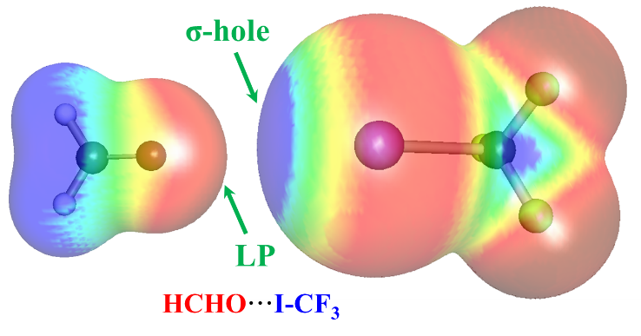
Figure 2: Graphical representation of electrostatic potential representing the prototype of σ-hole formed between HCHO···I-CF₃. Here the most electropositive region is represented by blue color whereas the most electronegative region is shown by red colour.

It is important to achieve the information related to possible conformers of CH₃SNO along with its binding energies. For this, potential energy associated to various conformers are obtained through scan along the dihedral angle (O2 N3 S1 C4), which is shown in Figure 3. The study shows that there are only two possible stable conformers of CH₃SNO. These are cis and trans conformers.
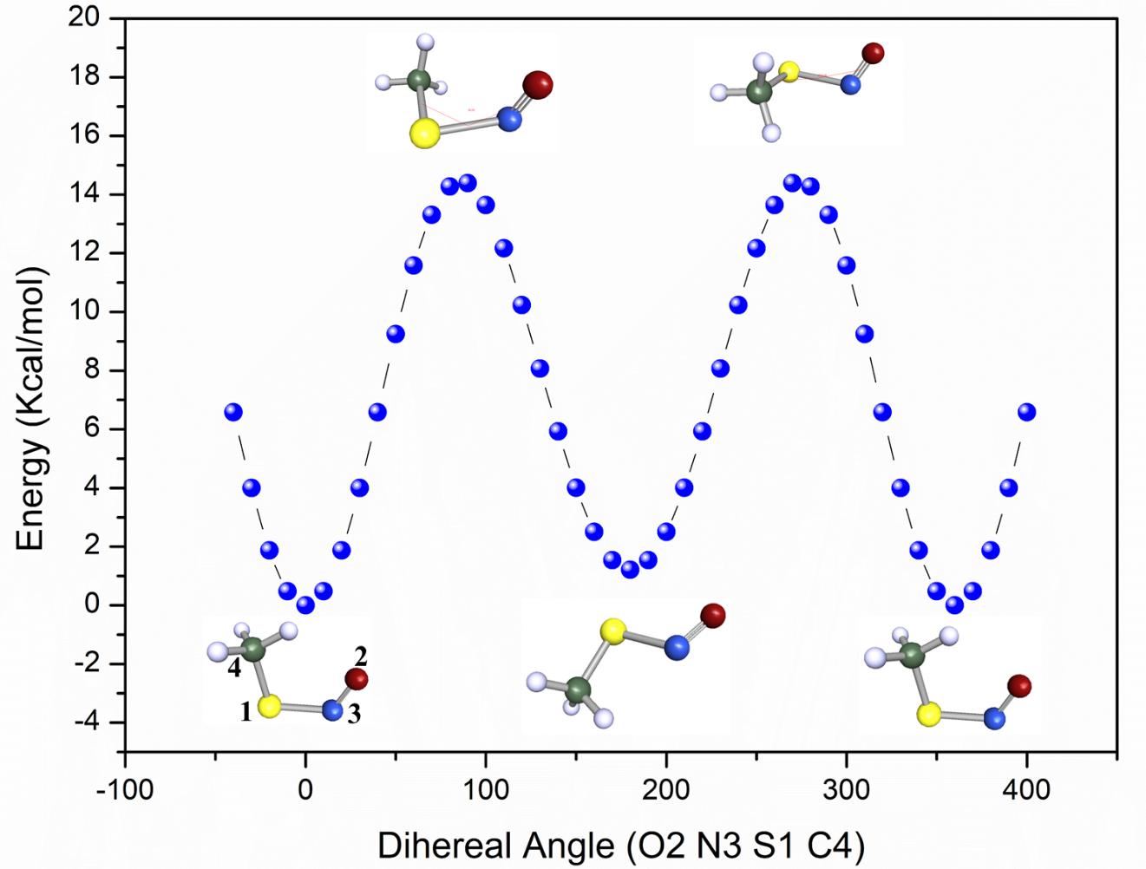
Figure 3: Potential energy scan along the dihedral angle (O2 N3 S1 C4) of CH₃SNO calculated using B3-LYP/def-TZVP level of theory.
Table 1: Geometrical parameters of Cis and trans conformers of CH₃SNO calculated using B3-LYP/def-TZVP level of theory
Geometrical parameters | cis - CH₃SNO | trans - CH₃SNO
d_{O2…N3} (Å) | 1.17632 | 1.17223
d_{N3…S1} (Å) | 1.87183 | 1.87704
d_{S1…C4} (Å) | 1.81717 | 1.82224
<O2-N3-S1 | 117.2° | 116.6°
<N3-S1-C4 | 101.8° | 94.2°
<O2-N3-S1-C4 | -0.1° | 179.7°
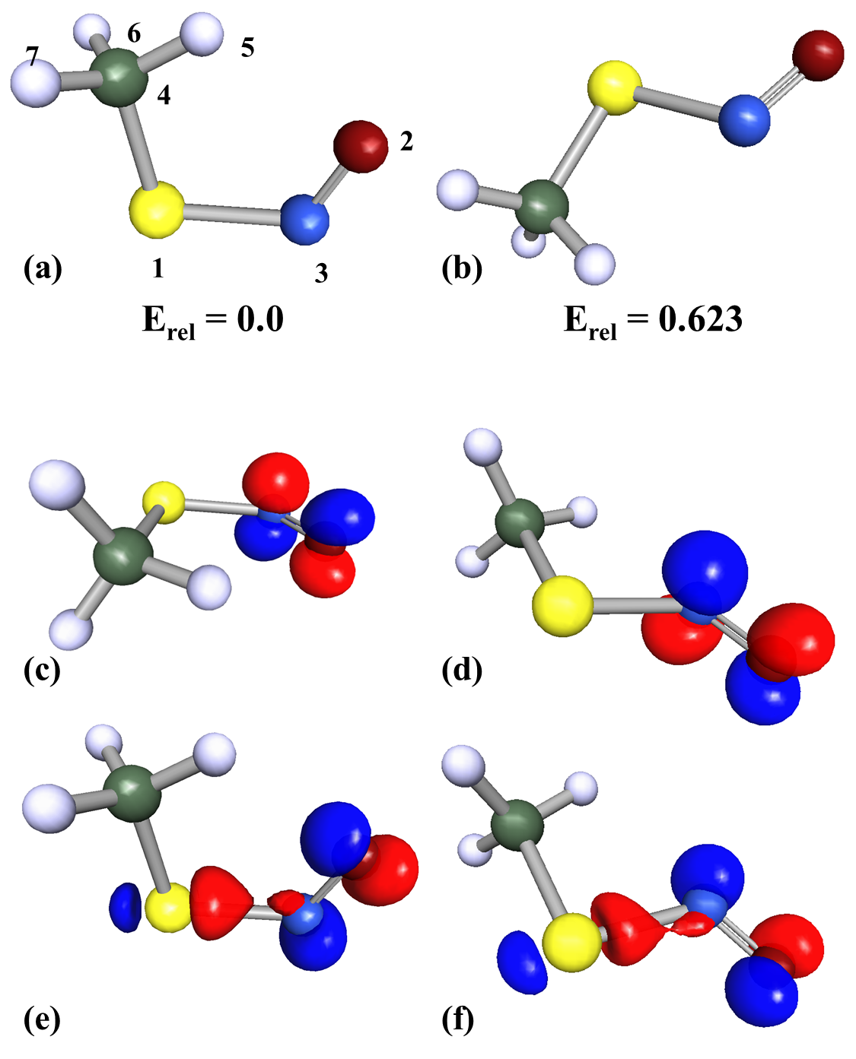
Figure 4: Optimized structure of (a) cis and (b) trans conformers of CH₃SNO along with relative binding energies (E_{rel}) calculated at B3-LYP/def-TZVP level of density functional theory. Atom numbering scheme is also shown. Lowest unoccupied molecular orbital (LUMO) and highest occupied molecular orbital (HOMO) diagram of cis conformer of CH₃SNO calculated at B3-LYP/def-TZVP level of density functional theory are shown in (c) and (e), respectively. LUMO and HOMO of trans-conformer of CH₃SNO at same level of theory are represented in (d) and (f), respectively.
The cis conformer lies in the global minima and found stable compared to trans conformer. Figure 4 (a, b) shows the optimized geometries of cis and trans conformers of CH₃SNO calculated using B3-LYP/def-TZVP level of theory. The cis conformer of CH₃SNO is found stable in comparison to trans conformer by a relative binding energy of 0.623 Kcal/mol. Geometrical parameters of cis and trans conformers of CH₃SNO calculated using B3-LYP/def-TZVP level of theory are arranged in Table 1.
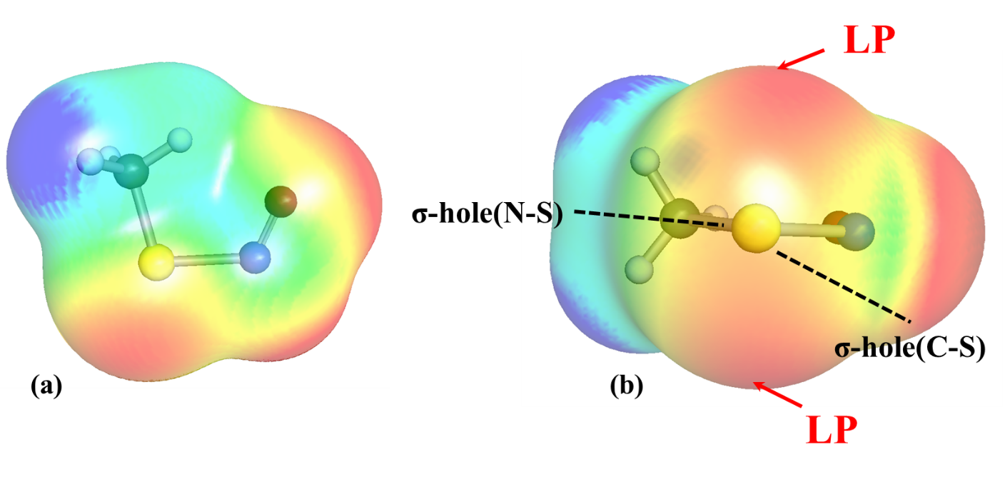
Figure 5: (a) Top and (b) side views of calculated electrostatic potential (ESP) map of cis-CH₃SNO showing two lone pair at Sulphur atom and σ-holes along N-S and C-S. Here the most electropositive region is represented by blue color whereas most electronegative region is shown by red colour.

Cis-CH₃SNO is found more stable compared to trans conformers therefore this conformer has been used for the further study. Figure 5 shows the electrostatic potential map of Cis-CH₃SNO, which shows the two lone pairs of Sulphur atom. The interest property of CH₃SNO due to formation of two sigma hole on Sulphur along N-S and C-S bonds. These sigma holes are mainly interacting with electron rich Lewis bases. The study has been performed for Chloride, Bromide, hydroxide ions and methyl iodide molecule.

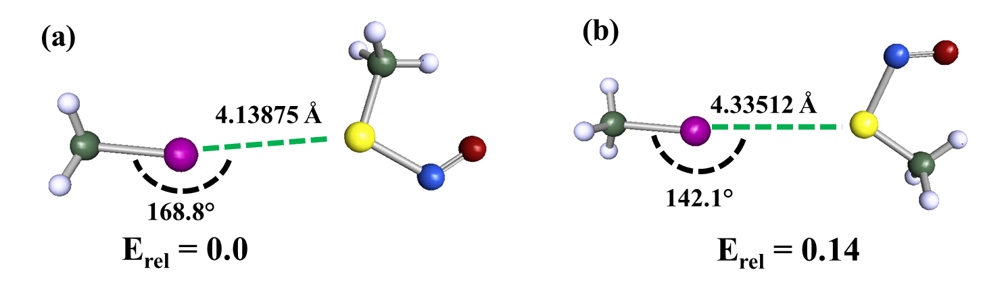
Figure 6: Complex of CH₃SNO with CH₃I with relevant geometrical parameters and relative binding energies (E_{rel}) calculated at B3-LYP/def-TZVP level of density functional theory.

Complex formation of CH₃SNO along with CH₃I has been studied first to understand the nature of bonding with two σ-holes along S-N and S-C bonds, which is reported in Figure 6. The interaction with Sulphur moiety of CH₃SNO with CH₃I along S-N and S-C are shown in Figure 6a and Figure 6b, respectively and these structures are found very close to each other using B3-LYP/def-TZVP level of density functional theory. C···S bond length and ∠C-I-S bond angle for CH₃SNO···CH₃I complex using σ-hole (S-N) are 4.13875 Å and 168.8° whereas these for the same complex using σ-hole (S-C) are 4.33512 Å and 142.1°, respectively. Both complexes are only having the binding energy difference of 0.14 Kcal/mol.

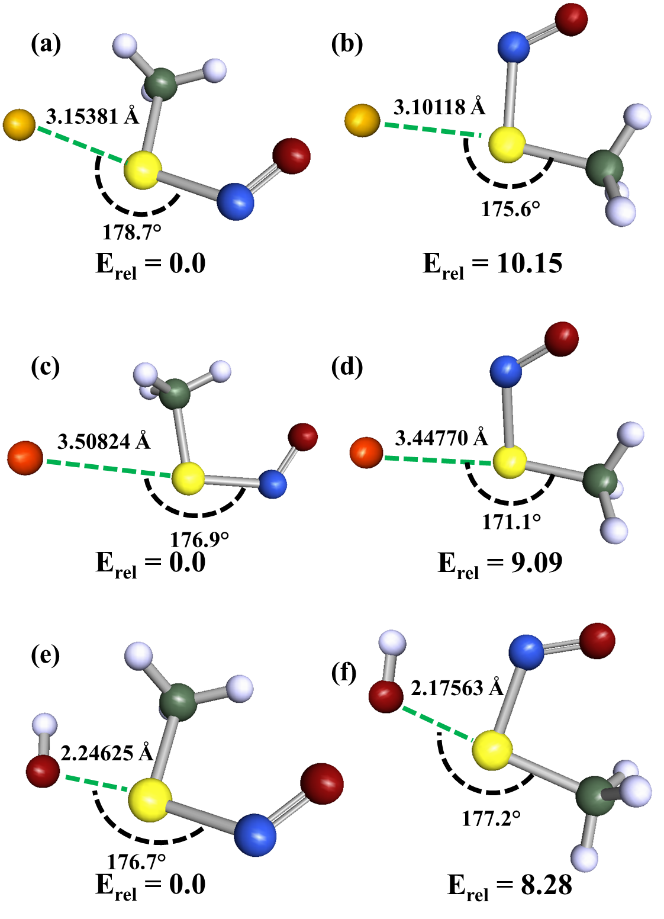
Figure 7: Complexes of CH₃SNO with (a, b) Chloride (c, d) Bromide and (e, f) hydroxide ions with relevant geometrical parameters and relative binding energies (E_{rel}) calculated at B3-LYP/def-TZVP level of density functional theory.
To get the better insight of the σ-hole interaction, complexation of cis- CH₃SNO has been studied with charged species such as anions. These anions are Chloride, Bromide and Hydroxide ions. Complex formation of cis- CH₃SNO with negatively charges Chloride ions are found stronger along σ-hole (S-N) than σ-hole (S-C) and the binding energy difference is 10.15 kcal/mol. The formation of complex of cis- CH₃SNO with chloride ion along σ-hole (S-N) decrease S-N bond length from 1.87183 Å to 1.78116 Å whereas complexation along σ-hole (S-C) decease C-S bond length from 1.81717 Å to 1.84589 Å. Interesting complex formation of cis- CH₃SNO with chloride ion along σ-hole (S-N) and σ-hole (S-C) through S···Cl bond having length of 3.15381 Å and 3.10118 Å, respectively and these bonds are colinear (only deviation by ~1-5°). Further the complexation of CH₃SNO with Bromide ion has been shown in Figure 7 (c, d). The study shows that Bromine ion also interacts more strongly along σ-hole (S-N) than σ-hole (S-C) and therefore binding energy of second one has relative binding energy of 9.09 Kcal/mol with respect to the most stable one. Both complexes are collinear (only ~3-9° deviation from 180°) and have bond length between ~3.44 - 3.50 Å. The interaction of hydroxide ion is also monitored through complexation with CH₃SNO. It forms two complexes, which are shown in Figure 7 (e, f), are using two σ-holes. The study shows that the interaction along σ-hole (N-S) is more stable in comparison to that along σ-hole (S-C) by a relative binding energy of 8.28 Kcal/mol. In Figure 7e, the complexation along σ-hole (N-S) shows a decease in the bond length of S-N by 0.07 Å whereas S···O bond length is found 2.24625 Å. The complexation along σ-hole (N-C) shows that S···O bond length is 2.17563 Å whereas both the complexes of CH₃SNO with hydroxide ion are collinear (only change of ~3-4°). Thus the complexation of CH₃SNO with ionic Lewis bases such as Chloride, Bromide and hydroxide ions shows a drastic increase in stability on using σ-hole along S-N bond in comparison to σ-hole along S-C bonds. But the similar change has not been observed for neutral Lewis bases such as CH₃I. Thus, the study shows that the Lewis bases having ionic electron rich centres are more preferable than neutral electron rich centres during the complexation with CH₃SNO.

Conclusion
In this work, it is demonstrated that the -SNO can be in two states zwitter ion and ionic state. The interaction of Lewis acid to -SNO group promotes the possibility of ionic state. The interaction of Lewis bases (electron rich) can occur along two facades of -SNO group. These are two σ-holes, which are along S-N and S-C bonding. It is also shown through multiple examples here that σ-hole along the S-N bonding site form more stable complexes in comparison to σ-hole along the S-C bonding site. Furthermore, neutral Lewis bases form weak interaction with -SNO group whereas ionic Lewis bases can form stronger interaction with -SNO group. This study is helpful for the discussion in the interaction of Lewis bases such as amino acids having neutral or ionized states with σ-holes of -SNO group of S-Nitrosothiol.

Acknowledgement:
SK thanks the Department of Science and Technology (DST), India (Grant No. SRG/2019/002284) for financial support. Authors thank Magadh University, Bodh Gaya, India for providing lab facility.

References
1. Giustarini, D., et al., Clin. Chim. Acta (2003) 330 (1-2), 85
2. Lundberg, J. O., et al., Nat. Rev. Drug Discovery (2015) 14 (9), 623
3. Farah, C., et al., Nature Reviews Cardiology (2018) 15 (5), 292
4. Naseem, K. M., Molecular aspects of medicine (2005) 26 (1-2), 33
5. Moncada, S., and Higgs, E., The vascular endothelium I (2006), 213
6. Baylis, C., and Vallance, P., Current opinion in nephrology and hypertension (1996) 5 (1), 80
7. Riccio, D. A., et al., Biomaterials (2009) 30 (27), 4494
8. Smith, B. C., and Marletta, M. A., Curr. Opin. Chem. Biol. (2012) 16 (5-6), 498
9. Nagpure, B., and Bian, J.-S., Oxidative medicine and cellular longevity (2016) 2016
10. Butler, A. R., et al., Chem. Commun. (Cambridge, U. K.) (2001) (18), 1732
11. Lü, J.-M., et al., J. Am. Chem. Soc. (2001) 123 (12), 2903
12. Hendinejad, N., and Timerghazin, Q. K., Phys. Chem. Chem. Phys. (2020) 22 (12), 6595
13. Hosseininasab, V., et al., Angew. Chem. (2020) 132 (27), 10946
14. Ahlrichs, R., et al., Chem. Phys. Lett. (1989) 162 (3), 165
15. Steffen, C., et al., J. Comput. Chem. (2010) 31 (16), 2967
16. Hein, R., and Beer, P. D., Chemical Science (2022)
17. Lim, J. Y., and Beer, P. D., Chem (2018) 4 (4), 731
18. Aakeröy, C. B., et al., Faraday Discuss. (2017) 203, 131

