BIOLOGICAL SYNTHESIS OF NANOPARTICLES

Prachi Jha
School of Sciences
MATS University
Raipur, C.G.
E mail id – Prachi.jha0@gmail.com

Ashish Saraf
School of Sciences
MATS University
Raipur, C.G.
E mail id- ashish.saraf22@gmail.com

ABSTRACT
Nanotechnology has emerged as a very promising branch of science. Nanoparticles with wide application in various industries have received global attention. Recently, synthesis of nanoparticles using green methods has gained importance as it has been considered cost effective, environment safe as well as efficient. This method uses microorganism and plants working as nano-factories to mediate synthesis of nanoparticles with different size, shape and characteristics. This chapter includes green methods of nanoparticle synthesis, advantages of biological methods and characterization techniques of nanoparticles.

Key Words- Nanoparticles, green method, cost effective, plant, microbe,

- INTRODUCTION

Nanotechnology as a field of research is growing day by day creating an impact in almost every aspect of human lives. It is considered as one of the most promising approach to many areas such as biomedicine, electronics, agriculture, antimicrobials and cosmetics, etc. (Shah et al. 2022; Salvioni et al. 2022; Jha et al. 2021). The physical, chemical and optical properties of Nanoparticles (NP) differ from their respective bulk matters. These Properties of NPs change with the change in size, surface properties and morphology of the particle. The novel idea of nanotechnology was given for the very first time in 1959 by Richard Feynman in his visionary talk “There’s Plenty of Room at the Bottom”. But the term Nanotechnology was coined in 1974 by Tokyo science university professor Norio Taniguchi. Since then Nanotechnology has set many milestones. Currently, the more commercially viable and environment friendly approach to synthesize the NPs are being worked upon by the scientist all over the world which may eliminate the adverse effects of already existing physical and chemical methods.

- METHODS OF NANOPARTICLE SYNTHESIS

Figure 1. Nanoparticles synthesis methods
s
Methods of Synthesis

Chemical
Biological
Physical

Chemical precipitation, micro emulsior, spray method etc.
Use of Plants, Algae, Bacteria, Fungi etc.
Laser ablation, ultrasonication, high energy ball milling etc.

Generally there are 3 ways to produce NPs i.e. chemical, physical, and biological methods. (Fig-1). The physical and chemical methods of the NP synthesis are traditional methods with many attractive advantages such as high yield in less time, precise control over structure of NPs, and extensive scalability. However, potential harm associated with these methods overshadows the advantages of these approaches. The excessive use of chemicals as capping agent and precursor leading to the production of toxic by-products, disposal of these by products, high pressure and high temperature working conditions are some disadvantages that raises grave concern. Therefore, there is an urgent need for environment friendly, non-toxic, and cost effective approach for NP synthesis. These disadvantages can be overcome by applying biological method or green technology which uses the biological entities as nano-factories (Fig. 2). In this approach, natural sources like plants, fungi, yeast, actinomycetes, and bacteria etc. are used to synthesize intracellular and extra cellular NPs having natural reducing and stabilizing properties (Bahrulolum et al., 2021).

Fig 2 Advantages of the biological method of Nanoparticle synthesis

Cost effective

Eco friendly

Advantage of Biological synthesis

No hazardous by-products
Single step process

Presence of natural reducing and capping agents

- BIOSYNTHESIS OF NANOPARTICLES

In the current scenario the green method of NPs synthesis using plants, bacteria, fungi etc. has gained attention as they are compatible to be used in biomedical and pharmaceutical sectors (Geethalakshmi and Sarada, 2010). Basically, in biosynthesis, the metal salt is reduced to ions by bioactive compounds. Various factors like temperature, concentrations of precursor metal, and p^{H} affects the process of synthesis. Thus, it becomes important to understand the interaction mechanism of biological systems and precursor metal to get the control the entire process.

- Synthesis of Nanoparticles by Microorganisms

The NPs are formed when metal salts are reduced to ions (Sadowski et.al, 2008). Prokaryotes are commonly used for the synthesis of metallic Nps (Gobinath et al., 2021). Bacteria mediated synthesis have gained attention as bacterial cultures are easy to grow and their genetic code can be easily manipulated. The first ever bacteria mediated NP synthesis was reported in 1984 when a strain of Pseudomonas stutzeri AG259, isolated from silver mine was found to be capable of synthesizing silver NPs (Venkataraman et al., 2011).
There are reports of fungal mediated synthesis as well (Wang et al., 2021). Higher tolerance to toxicity, easy culture methods and simple biomass handling characteristics has made fungus a very significant medium of NP synthesis. They also secrete a large amount of enzymes.
Algae are capable of merging heavy metals from the surroundings. They reduce these metals to NPs. Fucus vesiculosus, is one such algae which was reported to absorb Au [III] ions (Mata et al., 2009).

- Plant mediated synthesis of Nanoparticles

Plants contain many bioactive elements which are responsible for the formation of NPs. Plant extracts based synthesis has advantages as it’s single step process, cost-effective and nonpathogenic (Fig. 3) (Roy and Bharadvaja, 2017a, b; Nagore et al., 2021; Mittal and Roy, 2021). It also eliminates the tedious process of maintenance of cell cultures and release of hazardous by-products.

Fig 3 Synthesis of the Nanoparticles from Plants

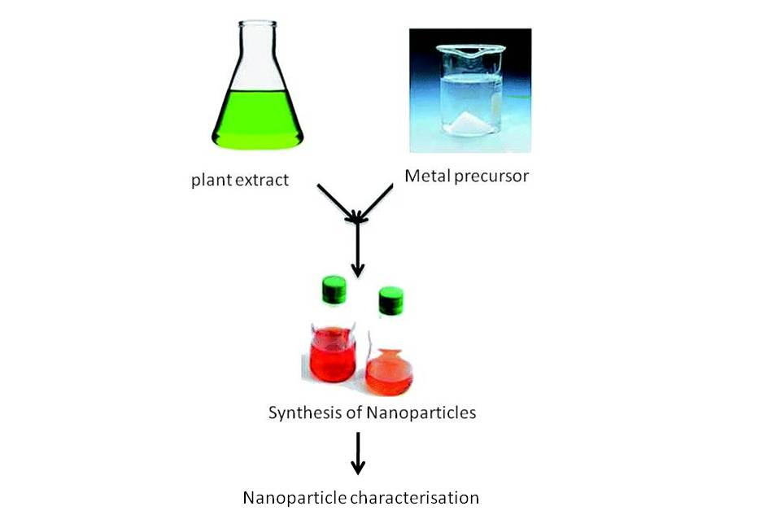

- CHARACTERIZATION OF NANOPARTICLES

- Scanning Electron Microscope (SEM)

SEM determines the surface properties of any sample. In SEM, electrons beam are used to strikes a sample surface to get the information about sample’s surface characteristics (Begum et al., 2022).

B. Transmission Electron Microscope (TEM)
TEM studies the size and structure of NPs. When electrons are passed through a sample, some of the electron beam interacts with the sample, remaining is diffracted. Thus an image is formed revealing the information about size and shape of NPs.

C. Dynamic Light Scattering (DLS)
DLS determines the size and size distribution of particles (Begum et al., 2022).When a sample is illuminated with the laser, some of the light is scattered. The change in the intensity is measured which corresponds to the size of the sample particle.

D. UV-Vis Spectroscopy
Nps are able to absorb and scatter optical light. The absorption spectrum is indicative of their size and shape.

E. Fourier Transform Infrared Spectroscopy (FTIR)
Functional groups present on the surface of NPs can be identified using FTIR. These groups can be responsible for synthesis and stability of NPs (Eid, 2022).

- CONCLUSION

Various studies are reported for the green synthesis of the NPs. The physical and chemical methods bring about many drawbacks including hazardous by-products, use of toxic chemicals, high energy consumption etc. Therefore it can be assumed that in future a clean, safe and green method of the NP synthesis will be largely accepted. Greater understanding of mechanism involved with biological nano-factories will help to regulate the process more efficiently.

- BIBLIOGRAPHY

Bahrulolum, H., Nooraei, S., Javanshir, N., Tarrahimofrad, H., Sadat, V., Mirbagheri, Easton, A.J., & Ahmadian, G. Green synthesis of metal Np using microorganisms and their application in the agrifood sector, journal of Nanobiotechnology, volume 19, Article number: 86 , 2021.

Begum, S.J.P.; Pratibha, S.; Rawat, J.M.; Venugopal, D.; Sahu, P.; Gowda, A.; Qureshi, K.A.; Jaremko, M. Recent Advances in Green Synthesis, Characterization, and Applications of Bioactive Metallic Nanoparticles. Pharmaceuticals,15, 455, 2022.
- Eid, M. Characterization of Nanoparticles by FTIR and FTIR-Microscopy. Handbook of Consumer Nanoproducts,June 2022. DOI:10.1007/978-981-15-6453-6_89-1
- Geethalakshmi R, Sarada DVL. Synthesis of plant-mediated silver nanoparticles using Trianthema decandra extract and evaluation of their antimicrobial activities. International Journal of Engineering Science and Technology, 2(5),970-975,2010.
- Gobinath, R., Bandeppa, Manasa, V., Rajendiran, S., Kumar, K., Paul, R., & Basavaraj, K. Nanoparticle-Mediated Adsorption of Pollutants: A Way Forward to Mitigation of Environmental Pollution. Microbial Rejuvenation of Polluted Environment,vol 2, pp 317–348.,2021.
- Jha, P., Saraf, A., Sohal, J. K. Antimicrobial Activity of Biologically Synthesized Gold Nanoparticles from Wild Mushroom Cantharellus Species. Journal of scientific Research, Vol 6(3), pp. 78-83, 2021.
- Mata YN, Blazquez ML, Ballester A, Gonzalez F, Munoz JA. Biosorption of cadmium, lead and copper with calcium alginate xerogels and immobilized Fucus vesiculosus. Journal of Hazardous Materials,163(2–3):555–562,2009.
- Mittal, S., Roy, A. Fungus and plant-mediated synthesis of metallic nanoparticles and their application in degradation of dyes. In: Photocatalytic Degradation of Dyes. Elsevier,pp. 287–308, 2021.
- Nagore, P., Ghotekar, S., Mane, K., Ghoti, A., Bilal, M., Roy, A. Structural properties and antimicrobial activities of polyalthia longifolia leaf extractmediated CuO nanoparticles. BioNanoScience 11 (2), 579–589, 2021.
- Roy, A., Bharadvaja, N. Qualitative analysis of phytocompounds and synthesis of silver nanoparticles from Centella asiatica, Innovat. Tech. Agric. 1 (2) ,88–95,2017a
- Roy, A., Bharadvaja, N. Silver nanoparticles synthesis from a pharmaceutically important medicinal plant Plumbago zeylanica. MOJ Bioequiv Availab 3 (5),00046,2017b..
- Sadowski Z, MaliszewskaIh, Grochowalska B, Polowczyk I, Koźlecki T. Synthesis of silver nanoparticles using microorganisms. Materials Science-Poland, 26(2), 419-424, 2008.
- Salvioni,L., Morelli, L., Ochoa, E., Labra, M., Fiandra, L., Palugan, L., Prosperi, D., Colombo,M. The emerging role of nanotechnology in skincare. Advances in Colloid and Interface Science, Volume 293, July, 2021.
- Shah , M.A., Pirzada, B.M., Price, G., Shibiru, A.L., Qurash, A. Applications of nanotechnology in smart textile industry: A critical review, Journal of Advanced Research,Volume 38, pp 55-75, 2022.
- Venkataraman D, Kalimuthu K, Sureshbabu RKP, Sangiliyandi G, Rai M, Duran N. Metal nanoparticles in Microbiology. Springer, Vol.-XI, , , 17-35, 2011.
- Wang, D., Xue, B., Wang, L., Zhang, Y., Liu, L., Zhou, Y. Fungus-mediated green synthesis of nano-silver using Aspergillus sydowii and its antifungal/antiproliferative activities. Sci Rep 11, 10356, 2021.

