Polyploidy: An evolutionary plant breeding approach
A. V. Shinde | R. A. Jadhav
Assistant Professor,  Department of Genetics and Plant Breeding | Junior Research Fellow,  AICRP on Linseed &mustard,
MGM Nanasaheb Kadam College of Agriculture | College of Agriculture, Nagpur,
Gandheli, Aurangabad. MS. India.431 001. | Dr. PDKV, Akola. MS. India. 444 001.
E-mail- akshatavshinde13@gmail.com | Email- ranijadhav74@gmail.com
A. S. Deshmukh | N. R. Thakur
Department of Agricultural Botany, | Sorghum Breeding,Accelerated Crop Improvement
College of Agriculture, Parbhani. | ICRISAT, Patancheru.
V.N.M.K.V., Parbhani. MS. India 431 402 | TS. India. 502 324.
E-mail- akshaydeshmukh1415@gmail.com | E-mail- niranjan.thakur95@gmail.com
ABSTRACT
Plants have a favourable impact on human life and supply food, medicine, and fuel. To address the issue of the need to diversify crop plants, modern breeding techniques are developed. These techniques significantly reduce the length of the breeding period and also have an impact on the breeding of some plants whose improvement is not possible using conventional techniques. The new sources of germplasm that can be exploited to create new cultivars or in breeding programmes are haploid, double haploid, and polyploid plants. Artificial polyploidy induction is one of the breeding techniques used to enhance the desirable traits of plants. Improvements in varieties, the creation of sterile lines, the recovery of hybrid fertility, growth and increased vigour, an increase in allelic diversity, and heterozygosity etc. All of these aspects must be taken into account in a genome-wide context to maximize marker-assisted selection and crop plant improvement. Plants that have all of their chromosomes duplicated (instead of only some of them) have more distinguishing characteristics, such as altered phytochemical properties, a higher concentration of therapeutic compounds, and unique plant shapes, colours, sizes, scents, and flowering times. The genotype of the plant and the type of sample must be taken into account in order to create an effective protocol for chromosomal duplication. Principal aspects that must be taken into account include the kind, quantity and length of mitotic inhibitors.
Keywords:Diversity, Germplasm, Heterozygosity and Polyploidy.
I. INTRODUCTION
"Polyploidy" means an organism possesses more than two basic sets of chromosomes (Acquaah 2007; Chen 2010; Comai 2005; Ramsey and Schemske 1998). Polyploidy breeding refers to the genetic enhancement of crop plants through chromosome number manipulation. Widespread in nature, polyploidy allows for adaptability and the emergence of new species. It has been reported that a large number of crop plants have undergone polyploidy as part of their evolutionary process, according to Chen et al. (2007). According to Comai (2005), angiosperms create polyploid plants much more frequently than other plant types, with one plant becoming polyploid for every 100,000 plants, as it is estimated.
The current chapter aims to shed light on polyploidy's use and consequences in plant breeding and other commercial endeavors, based on numerous studies. A few fundamental concepts must be defined in order to comprehend polyploidy. "x" stands for the entire basic set of chromosomes, while "2n" stands for the total number of chromosomes in a somatic cell. While gametes only have a haploid pair of chromosomes, somatic cells have twice as many (Acquaah 2007; Otto and Whitton 2000). Stebbins in 1947 has described three different types of polyploids in the plants viz. autopolyploidy, allopolyploidy, and segmented allopolyploidy. Every genome within a species is similar and develops through genome duplication (Stebbins 1947; Lewis 1980). Several genomes can exist in allopolyploids, some of which are different from one another (Stebbins 1947; Grant 1975). As a third type of allopolyploidy, segmental allopolyploidy consists of more than two incompletely different genomes that are capable of creating both bivalents and multivalents following chromosome pairing (Stebbins 1947; Levin 2002). Early in the 20th century, the occurrence of polyploidy became much more significant. One of the earliest examples of natural polyploidy was Hugo De Vries' initial work on mutation of Oenothera lamarckiana, where he described his work in ‘Theory of Mutation’ in 1990 later, Digby (1912) discovered that a fertile-type Primula kewensis could arise from a sterile interspecific hybrid through chromosome doubling, but the author was unaware of the significance of this in the context of polyploidy. Numerous agricultural crops, such as T. aestivum, z. mays, S. officinarum, C. arabica, G. hirsutum and N. tabacum, are polyploid either as a result of intentional hybridization and selective breeding (such as some blueberry varieties) or an ancient polyploidization event (such as maize) (Ramsey and Schemske 2002).
Long-lived perennials with a range of vegetative mechanisms of propagation (such Fragaria, Rubus, Artemisia and Potamogeton, etc.) and those with frequent occurrences of natural interspecific hybridizations seem to benefit greatly from polyploidy (Hilu 1993).
II. CHANGES IN CHROMOSOME NUMBER
Aneuploidy results from alterations in one or more chromosomes. These chromosome number variations are calculated in proportion to the somatic chromosome number (2n) of the species. Nullisomic aneuploid creatures are those that are missing one pair of chromosomes (2n-2). While monosomic aneuploids (2n-1) are those that have just one chromosome. Two chromosomes from two separate chromosome pairs (2n-1-1) are absent in double monosomic individuals. Trisomy (2n+1) refers to the presence of one additional chromosome in an aneuploid person and double trisomy (2n+1+1) refers to the presence of two extra chromosomes from two separate chromosomal pairs. A tetrasomic individual possesses an additional pair of chromosomes (2n+2). Euploidy, on the other hand, entails a change in the entire set of the genome, which is an exact multiple of the species’ basic chromosome number. It is commonly referred to as polyploidy. An autopolyploid is a polyploid with identical genomes across the board. On the other hand, allopolyploids have two or more unique genomes. Three, four, five, six, seven, eight or more somatic chromosomes-made up of several genomes-may be present in euploids.
Table 1. summarises the commonly used terminology related to heteroploidy.
Table 1: Type of variations in chromosome number
S.N. | Term | Type of change | Symbol
1 | Aneuploid | Chromosomes 1, 2, or a few may be absent in 2n | 2n±few
2 | Nullisomic | Lacking one set of chromosomes | 2n-2
3 | Monosomic | Lacking one chromosome | 2n-1
4 | Double monosomic | One missing chromosome from each of the two pairs of chromosomes | 2n-1-1
5 | Trisomic | An additional one chromosome | 2n+1
6 | Double trisomic | Each of the two chromosome pairs has one additional chromosome. | 2n+1+1
7 | Tetrasomic | One additional pair of chromosomes | 2n+2
 | Euploid | More than two copies of a same genome
8 | Monoploid | Only one genome's copy exists | x
9 | Haploid | Whole set of gametic chromosomes | n
 | Polyploid | One genome has more than two copies
 | Autopolyploid | Genomes that are similar to one another
10 | Autotriploid | One genome has three copies | 3x
11 | Autotetraploid | One genome has four copies | 4x
12 | Autopentaploid | One genome has five copies | 5x
13 | Autohexaploid | One genome has six copies | 6x
 | Allopolyploid | Two or more different genomes
14 | Allotetraploid | Two distinct genomes | 2x₁ + 2x₂
15 | Allohexaploid | Three distinct genomes | 2x₁ + 2x₂ ₊ 2x₃
16 | Allooctaploid | Four distinct genomes | 2x₁ + 2x₂ ₊ 2x₃ ₊ 2x₄
Source: Singh B.D. (2012). Plant breeding, Principles and Methods.
III. ORIGIN OF POPYPLOIDY
There are numerous reasons that might lead to polyploidy. Somatic doubling during mitosis, nonreduction in meiosis leading in the production of unreduced gametes, polyspermy (fertilization of the egg by two male nuclei), and endoreduplication are some of the essential processes that lead to polyploidy (DNA replication without cytokinesis). several authors have claimed that endoreduplication and somatic doubling are more similar than distinct mechanisms. Chromosome duplication can result in polyploidy chimaeras (a kind of cartilaginous fish) and full polyploids, depending on whether it happens in the zygote or certain apical meristems. Some non-meristematic plant tissues show somatic polyploidy, according to Ramsey and Schemske (1998) (eg., tetraploid and octoploid cells in the cortex and pith of Vicia faba). Grant (1981) claims that the primary cause of somatic doubling is mitotic non-disjunction. Early embryonic divisions, branches that could bear flowers and purely vegetative tissues can all experience somatic doubling (Grant 1981). The heat shock studies, in which immature embryos were temporarily exposed to high temperatures, provided the best explanation for how chromosome doubling in the zygotes occurred (Lewis 1980).
There are two types of polyploidies which are mentioned as follows;
- Autopolyploidy
- Allopolyploidy

- Autopolyploidy:
Autopolyploids are polyploids that develop through the multiplication of chromosome of a single species and this situation is referred to as autopolyploidy. Low frequency spontaneous occurrences of autopolyploids are possible in nature, and they can also be artificially created using a variety of techniques, including decapitation, heat and chemical treatments, and selection from twin seedlings. Autopolypoidy occurs when meiosis fails, resulting failure of splitting of the chromosomes. Due to the fact that gametes (2n) have twice as many chromosomes as regular gametes, unreduced 2n gametes produced as a result of gametic nonreduction or meiotic nuclear restoration during microsporogenesis and megasporogenesis can eventually grow into autopolyploids. Fig. 1. Shows the origin of autopolyploidy from two non reduced gametes. Autoploids include triploids (3x), tetraploids (4x), pentaploids (5x), hexaploids (6x), septaploids (7x), octaploids (8x), and more polyploids. It is also known as simple polyploids or single species polyploids. Let’s discuss this theory in more details,
- Autotriploids:
- They can be created experimentally by crossing autotetraploid and diploid species, or in some cases they can arise naturally.
- They have the three sets of chromosomes that are specific to the species.
- Triploids usually have faulty gamete production thus, makes them infertile. Only asexually reproducing plant species, such as banana, sugarcane, and apple benefits from triploids.

- Banana:Bananas are triploid and seedless cultivars. The fruits of such bananas are larger than those of diploids species
- Apples: Certain triploid apple types are propagated asexually through budding or grafting.
- Sugarbeet: Triploid sugarbeet species contain more sugar than diploids and are typically mold-resistant.
- Watermelon: Triploid watermelons are either seedless or have little, cucumber-like seeds. Tetraploid females and diploid males are crossed to create these seedless watermelons. However, a reciprocal cross does not work.

- Autotetraploids:
- They can be artificially created by doubling the number of chromosomes in a diploid organisms via colchicine therapy, or they can occur naturally.
- They have four copies of the DNA of the same species. Because pairing partners are accessible during meiosis, tetraploids are typically stable and fruitful.
- Diploid gametes (2n) are developed in such plants. Rye, grapes, alfalfa, groundnuts, potatoes, and coffee are a few well-known examples of autotetraploid plants. They are typically larger and are vigorous than diploid species.

- Rye: Germany and Sweden both grow autotetraploid rye. They have larger seeds and greater proteins than diploids.
- Grapes: These grapes have larger fruits and fewer seeds per fruit than diploids. In the USA and Japan, tetraploid grapes have been developed and are in use.
- Alfalfa: Tetraploid cultivars of alfalfa yield more and recover faster from grazing than diploid ones do.

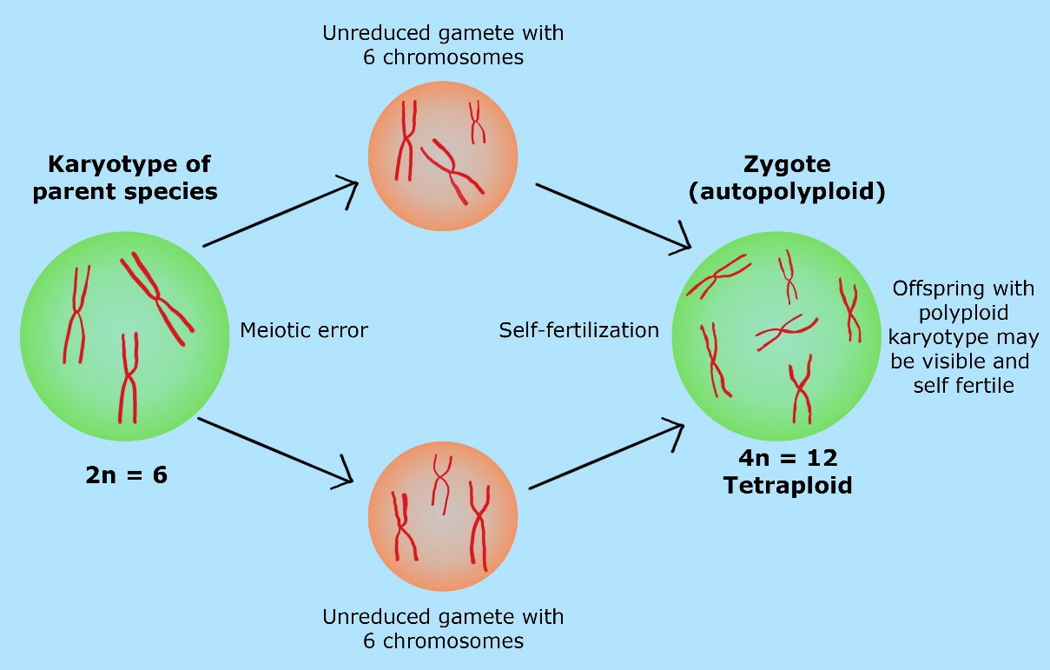
Fig 1: A diagram demonstrating how unreduced gametes can produce autopolyploidy
- Allopolyploidy:
Allopolyploidy is the term used to describe a polyploidy organism that results from the union of whole chromosomal sets from two or more species. A reduced "1n" gamete and a "3n" gamete, which are produced by the union of a reduced "1n" gamete and an unreduced "2n" gamete, are mated to produce a tetraploid individual in the following generation. Sometimes referred to as a triploid bridge, this two-step method allows to the formation of allopolyploid. In the other example it was discovered that the elongate gene on chromosome 3 in maize increased the proportion of diploid eggs, serving as an illustration of how genotype can influence the development of nonreduced gametes (Grant 1981; Lewis 1980). Quick screening methods like flow cytometry, chromosomal matching, and other genomic methodologies are useful for studies on unreduced gametes in both plants and animals (Mable 2003). Ramsey and Schemske (1998) assert that the contribution of polyspermy as a method of polyploidy generation is unusual, with the exception of some orchids. Endosperm as well as the cotyledons of growing seeds, leaves and stems of bolting plants have all been documented to experience endoreduplication (Larkins et al. 2001). Fig. 2 provided a diagrammatic representation of the development of allopolyploidy.
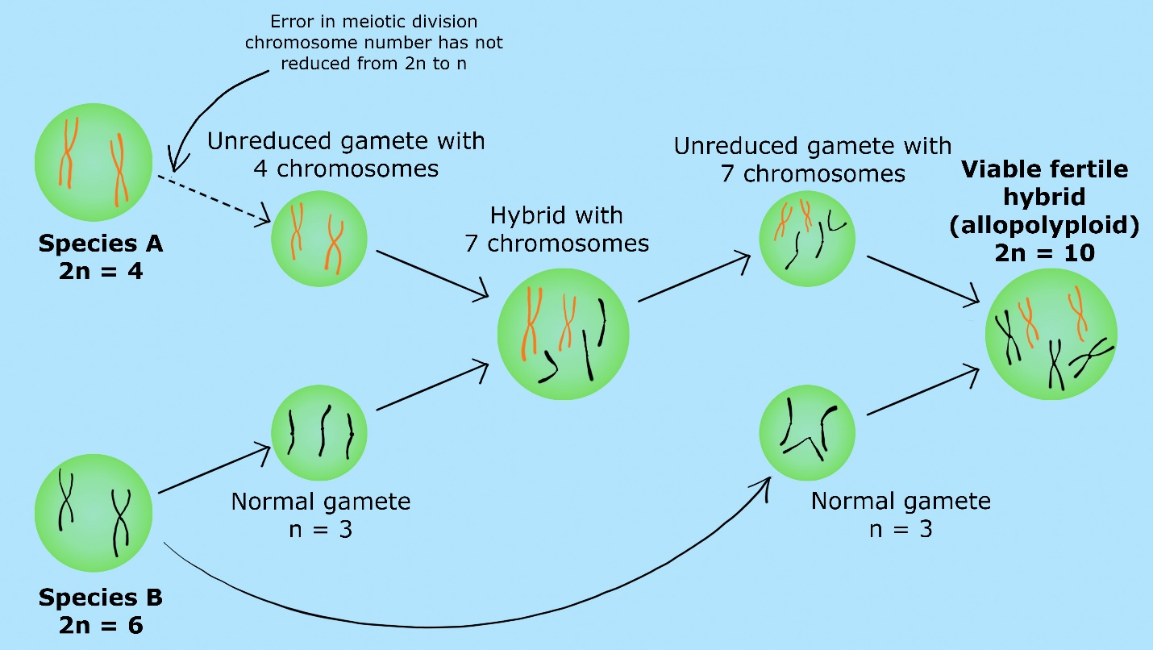
Fig. 2: Illustration demonstrating the genesis of allopolyploid from both unreduced and reduced gametes.
I. Natural Allopolyploids:
Let’s try to understand the concept of natural allopolyploids with the following examples,
- Wheat:
The bread wheat's evolutionary origin has received the greatest attention till date because it’s one of the major cereals in the world. Numerous researchers have looked into the identity of the diploid species that contributed to the three distinct genomes (A, B, and D) of T. aestivum, most notably pioneer work demonstrated by Kihara (1944), McFadden and Sears (1944, 1946) in the identification of Aegilops tauschii (syn Ae. squarrosa, T. tauschii) as the progenitor of the D genome of hexaploid wheat (T. aestivum) for more than 75 years now. The genome A found in diploid wheat is thought to be similar to that found in tetraploid and hexaploid wheat. Furthermore, the tetraploid emmer wheat genome B is similar to the hexaploid wheat genome B. This is demonstrated by chromosome pairing in crosses between wheat, which are diploid, tetraploid and hexaploid. While hybrids between tetraploid and hexaploid wheat display around 14II and 7I, those between diploid and tetraploid wheat display 7II and 7I. T. monococcum is thought to have provided the wheat genome A, T. tauschii the genome D and an unidentified source that most likely provided the genome B (2n = 14).
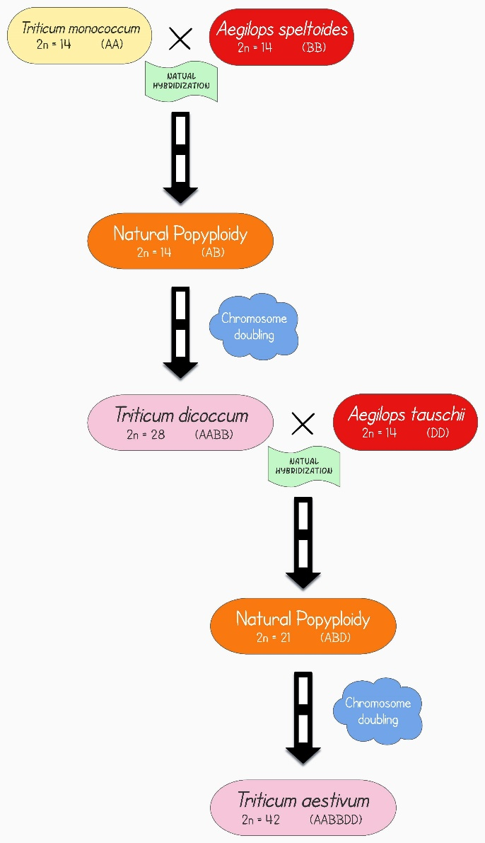
Fig 3. Evolution of allohexaploid wheat (T. aestivum) (Image is created in ‘Lucidchart’).
- Tobacco:
About 76 currently identified naturally occurring species are included in the genus Nicotiana, which is classified into 13 sections (Knapp et al. 2004). The typical allotetraploid species N. tabacum (2n=4x=48) resulted from interspecific hybridization between N. sylvestris (female donor) and N. tomentosiformis (male donor), both of which are diploid with 2n=24. This hybridization took around 200,000 years back (Leitch et al 2008). N. sylvestris has been identified as the section Tomentosae's maternal parent and the, another donor of the S genome (Bland et al. 1985; Olmstead and Palmer 1991; Aoki and Ito 2000; Yukawa et al. 2006), while N. tomentosiformis, N. otophora, or an introgressive hybrid between the two has been identified as the section Tomentosae's donor (Kenton et al. 1993; Riechers and Timko 1999; Lim et al. 2000; Kitamura et al. 2001; Ren and Timko 2001).
- Cotton:
All of the diploid species in the genus Gossypium have 13 haploid chromosomes and fall under one of seven different genome types that were created from A to G using chromosome pairing interactions (Beasley 1942; Endrizzi et al. 1984). Gossypium contains a total of five tetraploid species (n=2x=26). All tetraploid species have disomic chromosomal pairing, according to Kimber (1961). Chromosome pairing in interspecific crosses between diploid and tetraploid cotton suggests that tetraploid cotton may have two separate genomes that resemble the A genome of G. hirsutum (n = 13) and the D genome of G. raimondii (n = 13). About 6–11 million years ago, the A and D genome species separated from a common ancestor (Wendeil 1989). About 1.1–1.9 million years ago, the putative A x D polyploidization event took place in the New World, and the female parent was the old world-native A gene donor (Wendeil 1989; Wendeil and Albert 1992). It is thought that polyploidy-level diversification led to the emergence of the five allotetraploid species (G. hirsutum, G. barbadense, G. darwini, G. mustelinum, and G. tomentosum).
- Oat:
The allohexaploid, cultivated oat (n=21), is thought to have developed via a hybrid between the tetraploid A. barbata (n=14) and the diploid A. strigosa (n=7).
- Brassica spp.:
Nagaharu (1935) suggested a theory for the evolution and development of the six most common members of plants belonging to Brassica species. This theory is commonly known as Brassica triangle or the ‘Triangle of U’. The Brassica triangle provides an intriguing illustration of the part that allopolyploidy played in the evolution of several Brassica species. According to his theory, Indian mustard [Brassica juncea (n=18)] is an amphidiploid produced by an interspecific cross between Black mustard [Brassica nigra (n=8)] and Turnip/Field mustard [Brassica campestris (n=10)], whereas amphidiploid Rapeseed/Canola [Brassica napus (n=19)] was produced by an interspecific cross between Wild cabbage [Brassica oleracea (n=9)] and Turnip/Field mustard [Brassica campestris (n=10)] andWild cabbage [Brassica oleracea (n=9)] and Black mustard [Brassica nigra (n=8)] were interspecifically crossed to produce Ethipian mustard [Brassica carinata (n=17)].
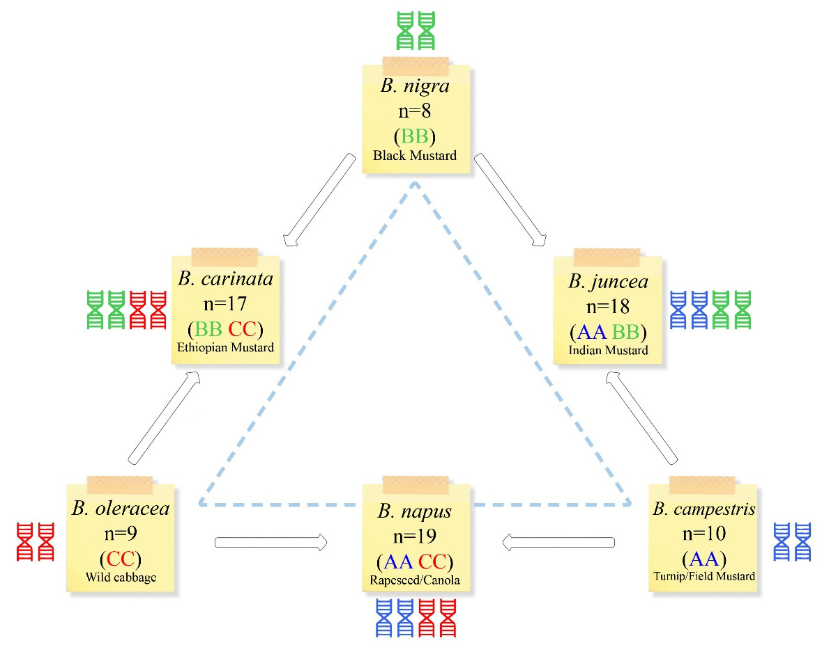
Fig4. Brassica triangle showing the relation between diploid and naturally occurring amphidiploidspecies of brassica. Three diploid species can be seen on the tips of the triangle, while amphidiploids are represented in the middle of two parents.
(Image is created in ‘Lucidchart and Vecteezy’).
II. Artificial Allopolyploids:
- Raphanobrassica:
This is a classic instance of an allopolyploid that was created artificially. In 1928, Russian geneticist Karpechenko created this cross between the radish (Raphanus sativus, 2n=9) and the cabbage (Brassica oleraceae, 2n=9). He sought to create a fruitful cross between these two species using cabbage leaves and radish roots. However, he was able to produce a fertile amphidiploid (4n=36) through spontaneous chromosomal doubling, which tragically had radish leaves and cabbage roots. It was therefore useless.
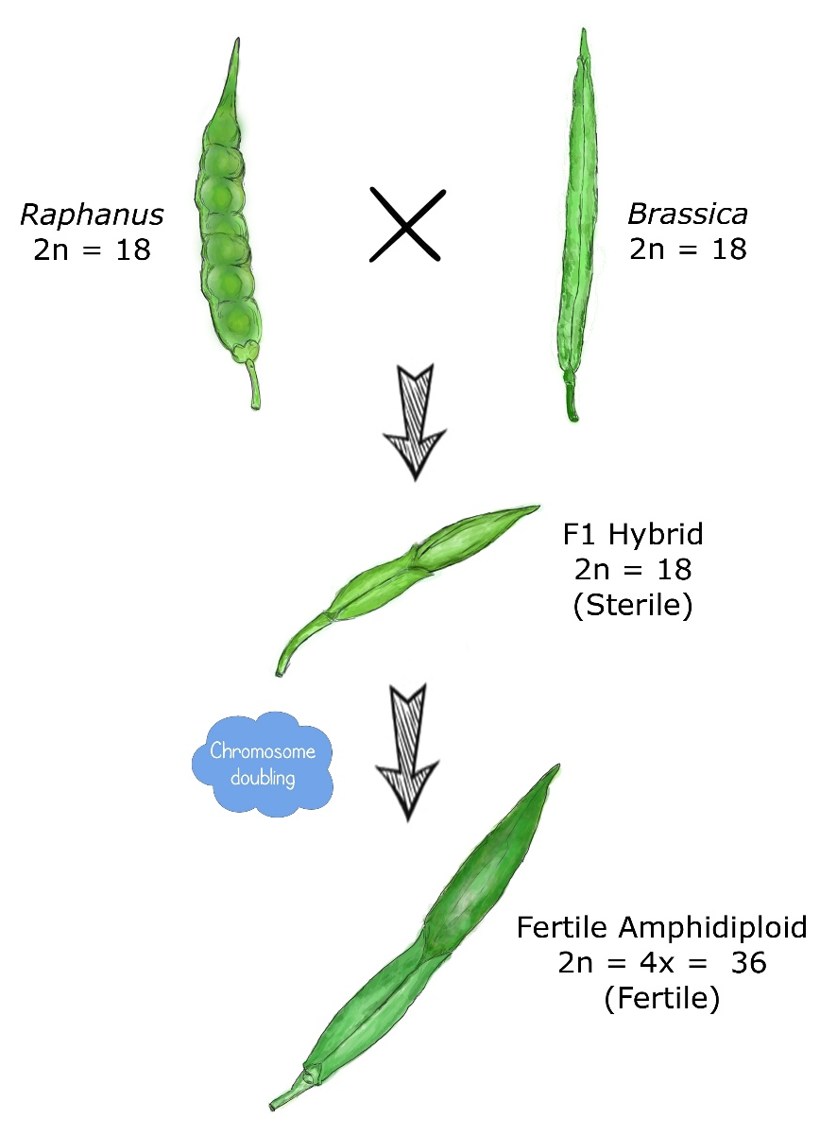
Fig 5: Evolution of Raphanabrassica (Artificial allopolyploid) from cross between Radish x cabbage (Image is created in ‘Lucidchart’).
- Triticale:
A new crop species called triticale was the first man-made artificially created cereal crop. Depending upon whether tetraploid (2n=4x=28) or hexaploid (2n=6x=42), derivations are different as shown in figure 5. Hexaploid triticale (2n=42) is created using Triticum durum (2n=28) and Secale cereale (2n=14). This crossing programme results in the formation of sterile F₁ hybrid (2n=21). After colchicine treatment, chromosomes get doubled in number and we get hexaploid triticale (2n=42). Similarly, octoploid triticale (2n=56) is obtained using Triticum aestivum (2n=42) and Secale cereale (2n=14). This crossing programme also sterile F₁ hybrid (2n=28) and after colchicine treatment, we get stable and fertile octoploid triticale (2n=56). Tetraploid (2n=4x=28) and hexaploid (2n=6x=42) wheat are used to produce hexaploid (2n=6x=42) and octoploid (2n=8x=56) triticale, respectively. Now a day, triticale is widely farmed in Canada, Mexico, Hungary and other nations.
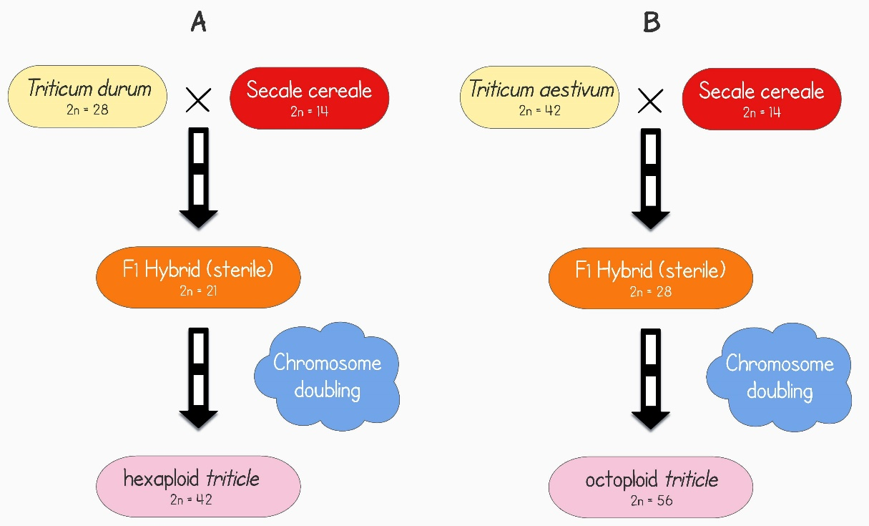
Fig. 5: Evolution of triticale. Left side (A) illustration of evolution of the hexaploid triticale and the right side (B) illustration of evolution of octoploid triticale
(Image is created in ‘Lucidchart and Vecteezy’).
- Wheat:
As an amphidiploid of wild or farmed emmer with, McFadden and Sears (1944) recreated hexaploid wheat, A. tauschii. The artificial wheat was hexaploid and resembled spelt (T. aestivum sp. spelta, genomes BBAADD). This led them to the conclusion that T. aestivum’s ancestor was spelta and that unrestricted T. Spelta gave rise to T. aestivum.
IV. INDUCTION TO POLYPLOIDY
Colchicine slows the development of spindle fibers and momentarily halts chromosomes at the anaphase stage, it was discovered in the 1930s (Blakeslee and Avery 1937). The chromosomes have duplicated at this point, but cell division has not yet occurred, leading to the formation of polyploidy cells. Mitotic inhibitors like as oryzalin, trifluralin, amiprophos-methyl, and N2O gas have also been found and used as doubling agents (Bouvier et al. 1994; Van Tuyl et al. 1992; Taylor et al. 1976). These doubling agents can be applied in a variety of ways, working with a lot of seedlings with small, active meristems is one of the simplest and most efficient approaches. Different concentrations, times or frequencies of a particular doubling agent can be applied to seedlings or the apical meristems. Although older plants shoots can be treated, doing so frequently has less success and produces more cytochimeras. Sometimes it is more successful to treat smaller axillary or sub-axillary meristems. By dipping branch tips into a solution for a stipulated period of time and using cotton, agar or lanolin can be used to apply chemical solutions to buds. To increase efficacy, surfactants, wetting agents and other carriers (dimethyl sulfoxide) are occasionally used. X-ray, gamma rays and heat or cold treatment can also cause polyploidy in low frequencies. In Datura, triploid branches have been created by applying cold treatment. During the initial zygotic division, when maize plants or ears are exposed to extreme heat (38–45 °C), 2-5% of the progeny are tetraploid (Randolph 1941). H. vulgare, T. aestivum, S. cereal and a few more crop species have all been successfully heat-treated to induce polyploidy.
V. APPLICATIONS OF POLYPLOIDY
- Mutation breeding:
In contemporary breeding methods like tilling, high frequencies of chromosomal mutations are desired as they offer new sources of variety. There are numerous benefits to polyploid loci's multiallelic nature that are helpful in breeding. The dominant alleles of any potentially dangerous alleles that may arise from forced mutation in polyploids provide protection against the lethal circumstances typically associated with inbred diploid crops (Gaul, 1958). This idea has played a crucial role in the evolution of polyploids during bottlenecks where forced inbreeding occurs (Comai, 2005). In polyploid crop improvement, mutation breeding uses the ideas of gene redundancy and mutation tolerance in two different ways. As a result of their enormous genomes, which are the result of their genes being duplicated, polyploids are able to survive harmful allele alterations after mutation and also have an enhanced mutation frequency (Gaul, 1958). When trying to cause mutations in diploid cultivars that don't yield enough genetic variety following a mutagenic treatment, the high mutation frequencies seen with polyploids may be taken advantage of. This method has been used to breed mutations in Achimenes spp. by first creating autotetraploids by the use of colchicine, then using fast neutrons and X-rays. Due to their huge genomes, it was discovered in this study that autotetraploids had mutation frequencies that were 20–40 times greater than those of the corresponding diploid cultivars (Broertjes, 1976).
- Seedless fruits:
Triploids seedlessness has been favored, particularly in fruits. Commercially useful triploid fruits like watermelon are created artificially by first creating tetraploids, which are then crossed with diploid species. The triploid watermelon is crossed with a desired diploid pollen donor in order to set fruits.
- Bridge crossing:
Bridge crossing is another breeding method that makes use of polyploids superiority in reproduction. When ploidy levels between two species cause incompatibilities in sexual reproduction, transitional crossings can be performed, followed by chromosomal doubling, to create fertile bridge hybrids. Using meadow grass (Fescue pratensis) as a bridge species, this technique has been utilized to breed for superior tall fescue grass (F. arundinacea) from Italian ryegrass (2n=2x=14) and tall fescue (2n=6x=42. (Acquaah, 2007). By increasing the number of chromosomes in the superior progeny of hybrids, the same theory has been used to fix heterozygosity in those hybrids (Comai, 2005).
- Ornamental and forage breeding:
One of the most noticeable and immediate effects of polyploidy in plants is a rise in cell size, which results in larger plant organs. This phenomenon is known as the gigas effect (Acquaah, 2007; Levin, 1983; Stebbins, 1971). Chromosome doubling may produce noticeably larger seeds and more seed protein in cereal crops, but this benefit is countered by reduced seed set (Dhawan and Lavania, 1996). The gigas effect, on the other hand, has been studied in the breeding of trees, ornamentals, feed crops, and fruits (Emsweller and Ruttle, 1941; Schepper et al., 2001). The quality and size of the blooms on ornamental plants like snapdragons and marigolds have been enhanced through chromosomal doubling breeding (Emsweller and Ruttle, 1941). Numerous authors have discovered a substantial inverse relationship between plant development rates and DNA concentration (Levin, 1983; Smith and Bennett, 1975). Less auxin, a lower surface-to-volume ratio, and a different nuclear surface-to-cell volume ratio have all been linked to it (Acquaah, 2007; Levin, 1983). Polyploids are able to flower later and for a longer length of time than their diploid ancestors due to their slower growth rate (Levin, 1983). This trait may be particularly valuable in breeding ornamental plants.
- Production of apomictic crops:
Another way to employ polyploids in breeding is through apomixis. Through parthenogenesis, apomixis offers a method for the asexual generation of seeds. Although most polyploid plants are not apomictic, the majority of apomictic plants are polyploid (Otto and Whitton, 2000). In plants that can reproduce asexually as well as sexually, polyploidy favors the latter (Dhawan and Lavania, 1996; Levin, 1983). The most coveted hybrids are termed apomicts, but little progress has been made in their advancement. However, it has been proposed that the growth of plants with extremely high ploidy levels may be used to create obligate apomicts (Levin, 1983). The octoploid of the grass Themedatriandra is a prime example of an obligatory apomict produced at a high ploidy level (Levin, 1983).
- Biotic resistance through aneuploidy:
By inserting an additional chromosome into the progeny genome, aneuploidy has been used in plant breeding to create disease-resistant plants. One illustration is the backcrossing of Tricum aestivum with Aegilops umbellulata to impart its resistance to leaf rust. Additionally, alternative breeding techniques involving aneuploidy, such as chromosome deletion, chromosome replacement and supernumerary chromosomes, have been investigated (Acquaah, 2007).
- Restoring fertility in wide hybrids:
Hybrids between different taxa do not always need to be sterile. Chromosome sterility, or the inability of the chromosomes to pair properly during meiosis, is a common cause of this. A broad hybrid's fertility can be recovered by doubling its chromosomal count. This strategy has been employed with effectiveness in × Chitalpatashkentensis and Rhododendron (Contreras 2006; Olsen 2006). However, in certain instances, such as with tetraploid hybrids of Alstroemeria aurea and A. caryophyllaceae, this strategy has been successful in restoring fertility (Lu and Bridgen 1997).
- Helps to increased allelic diversity and heterozygosity:
Increased allelic copy number and heterozygosity have contributed significantly to the emergence of new traits. When two (or more) distinct genomes coexist in the same nucleus, a process known as allopolyploidy, allelic diversity likewise rises. According to Osborn et al. (2003), intergenomic heterozygosity has a favourable impact on the development of oil seeds in B. napus. The QTL for seed yield and other variables are similarly impacted by intergenomic heterozygosity in several populations of B. napus (Udall et al. 2006; Quijada et al. 2006). Tetraploid cotton also leads the world textile market because it can create fabric that is longer, finer, and tougher than its diploid relatives. According to Jiang et al. (1998), several QTLs on the D genome showed that D genome loci have been used for fibre synthesis after polyploidy developed.
VI. LIMITATIONS OF POLYPLOIDY
- Limited applications: The single species polyploidy has few uses. It is typically helpful in crop species that reproduce asexually, such as grapes, potatoes, bananas, and sugarcane.
- Difficult to maintain: In the case of crop species that reproduce sexually, maintaining monoploids and triploids is impossible.
- Unwanted traits: In bispecific or multispecific polyploids, traits come from both parental species. In some cases, such as in the case of Raphanobrassica, these characters may be undesirable.
- Additional flaws: Numerous flaws, including low fertility, genetic instability, slow development, late maturation, etc., are present in induced polyploids.
- Opportunities:There are very few opportunities for allopolyploidy to create new species.
VII. CONCLUSION
It is currently unclear how polyploidy affects a species evolutionary path, despite the fact that it occurs frequently in nature and leaves its mark on all angiospermic genomes. With the help of modern genomic technologies, old concerns like how polyploidy responds to environmental stress or whether genome doubling is beneficial or detrimental to evolutionary survival are being explored. Studies at the molecular level have shown that polyploidization related genomic alteration occurs at many different regulatory levels. In many cases, the implications of polyploidy on fitness under various environmental settings are still unknown, and there is few evidence that the observed transcriptional and genomic modifications in natural populations actually speed up evolution or increase adaption. In terms of physical, ecological, physiological, and cytological traits, polyploids generally varies from their progenitors, which can both help them fill a new niche and cause reproductive isolation. Polyploidy is a key process for adaptability and speciation in plants, as a result. Polyploidy breeding can be used to track the interspecific gene transfer, evolution of new crops as well as the source of new crops. In order to show how agricultural plants have evolved and to take advantage of their variability in crop breeding, polyploidy is an intriguing area of study.
REFERENCES
Acquaah, G. 2007. Principles of Plant Genetics and Breeding. 2nd Edition. Willey-Blackwell.
Aoki S and Ito M.2000.Molecular phylogeny of Nicotiana (Solanaceae) based on the nucleotide sequence of the matK gene. Plant Biology. 2(3):316–324. https://doi.org/10.1055/s-2000-3710
Beasley YO. 1942. Meiotic chromosome behavior in species hybrids, haploids, and induced polyploidsof Gossypium. Genetics. 27(1): 27:25. https://doi.org/10.1093/genetics/27.1.25
Blakeslee AF and Avery AG. 1937.Method of inducing doubling of chromosomes in plants by treatment with colchicine. Journal of Heredity. 28(12): 393–411. https://doi.org/10.1093/oxfordjournals.jhered.a104294
Bland MM, Matzinger DF andLevings CS. 1985. Comparison of the mitochondrial genome of Nicotiana tabacum with its progenitor species. Theoretical and applied genetics. 69:535–541.https://doi.org/10.1007/BF00251100.
Bouvier L, Fillon F andLespinasse Y. 1994. Oryzalin as an efficient agent for chromosome doubling of haploid apple shoots in vitro. Plant Breeding. 113:343–346
Broertjes C. 1976. Mutation breeding of autotetraploid Achimenes cultivars. Euphytica. 25:297- 304.https://doi.org/10.1007/BF00041560.
Chen L., Lou Q., Zhuang Y., Chen J., Zhang X., Wolukau J.N. 2007. Cytological diploidization and rapid genome changes of the newly synthesized allotetraploids Cucumis× hytivus. Planta 225:603-614.https://doi.org/10.1007/s00425-006-0381-2.
Chen Z. 2010. Molecular mechanisms of polyploidy and hybrid vigor. Trends in plant science 15:57-71.https://doi.org/10.1016/tplants.2009.12.003.
Comai L. 2005. The advantages and disadvantages of being polyploid. Nature Reviews Genetics 6:836-846. https://doi.org/10.1038/nrg1711.
Contreras RN. 2006. Using polyploidy to restore fertility in azaleodendrons and investigating parentage of these wide hybrids. MS thesis, North Carolina State University, Raleigh
Dhawan O. and Lavania U. 1996. Enhancing the productivity of secondary metabolites via induced polyploidy: a review. Euphytica 87:81-89. https://doi.org/10.1007/BF00021879.
Digby L. 1912. The cytology of Primula kewensis and of other related Primula hybrids. Annals of Botany. 26:357–388. https://doi.org/10.1093/oxfordjournals.aob.a089395.
Emsweller S. and Ruttle M. 1941. Induced polyploidy in floriculture. American Naturalist:310-328.https://doi.org/10.2307/2457403.
Endrizzi JE, Turcotte ELand Kohel RJ. 1984. Qualitative genetics, cytology, and cytogenetics. In: Kohel RJ, Lewis CF (eds) Cotton. American Society of Agronomy, Madison, pp 81–129. https://doi.org/10.2134/agronmonogr24.c4.
Gaul H. 1958. Present aspects of induced mutations in plant breeding. Euphytica 7:275-289. https://doi.org/10.1007/BF00025269.
Grant V. 1975. Genetics of flowering plants. Columbia University Press, New York
Grant V. 1981. Plant speciation, 2nd edn. Columbia University Press, New York
Hilu KW. 1993. Polyploidy and the evolution of domesticated plants. American Journal of Botany. 80(12):1494–1499. https://doi.org/10.1002/j.1537-2197.1993.tb15395.x.
Jiang Y, Scarpa A, Zhang L, Stone S, Feliciano E and Ferro-Novick S. 1998. A high copy suppressor screen reveals genetic interactions between BET3 and a new gene. Evidence for a novel complex in ER-to-Golgi transport. Genetics 149(2):833–841. https://doi.org/10.1093/genetics/149.2.833.
Karpechenko GD. 1928. Polyploid hybrids ofRaphanus sativus L. X Brassica oleracea L. Bulletin of Applied Botany. 17: 305–408. https://doi.org/10.1007/BF01740955.
Kenton A, Parokonny AS, Gleba YY and Bennett MD. 1993. Characterization of the Nicotiana tabacum L. genome by nuclear cytogenetics. Molecular Genetics and Genemocis 240:159–169. https://doi.org/10.1007/BF00277053.
Kihara H. 1944. Discovery of the DD analyser, one of the ancestors of Triticum vulgare (in Japanese). Agriculture and Horticulture 19: 889-890.
Kimber G.1961. Basis of the diploid-like meiotic behavior of polyploid cotton. Nature 191:98–100.https://doi.org/10.1038/191098a0.
Kitamura S, Inoue M, Shikazono N. and Tanaka A. 2001. Relationships among Nicotiana species revealed by the 5S rDNA spacer sequence and fluorescence in situ hybridization. Theoretical and Applied Genetics.103:678–686. https://doi.org/10.1007/s001220100643.
Knapp S, Chase MW and Clarkson JJ. 2004. Nomenclatural changes and a new section classification in Nicotiana (Solanaceae). Taxon 53:73–82. https://doi.org/10.2307/4135490.
Larkins BA, Dilkes BP, Dante RA, Coelho CM, Woo YM and Liu Y. 2001. Investigating the hows and whys of DNA endoreduplication. Journal of Experimental Botany. 52:183–192. https://doi.org/10.1093/jexbot/52.355.183.
Leitch, I. J., Hanson, L., Lim, K. Y.,Kovarik, A., Chase, M. W.,Clarkson, J. J.,Leitch,A. R. 2008. The Ups and Downs of Genome Size Evolution in Polyploid Species of Nicotiana (Solanaceae). Annals of Botany. Volume 101, Issue 6. Pages 805–814.https://doi.org/10.1093/aob/mcm326
Levin D. 1983. Polyploidy and novelty in flowering plants. American Naturalist 122:1-25.https://www.jstor.org/stable2461003.
Levin D. 2002. The role of chromosomal change in plant evolution. Oxford University, Oxford.
Lewis W. 1980. Polyploidy in species populations. In: Lewis W (ed) Polyploidy: biological relevance. Plenum, New York, pp 103–144. https://doi.org/10.1007/978-1-4613-3069-1_6.
Lim CR, Kimata Y, Ohdate H, Kokubo T, Kikuchi N, Horigome T and Kohno K. 2000. The Saccharomyces cerevisiae RuvB-like protein, Tih2p, is required for cell cycle progression and RNA polymerase II-directed transcription. Journal of Biological Chemistry. 275(29):22409–22417. https://doi.org/10.1074/jbc.Moo1031200.
Lu C and Bridgen MP. 1997. Chromosome doubling and fertility study of Alstroemeria aurea A. caryophyllaceae. Euphytica. 94:75–81. https://doi.org/10.1023/A:1002911522748.
Lucidchart. www.lucidchart.com.
Mable BK.2003. Breaking down taxonomic barriers in polyploidy research. Trends in Plant Science. 8(12):582–590. https://doi.org/10.1016/j.tplants.2003.10.006.
McFadden ES and Sears ER. 1944. The artificial synthesis of Triticum spelta. Records of the Genetics Society of America. 13: 26-27.
McFadden ES and Sears ER. 1946. The origin of Triticum spelta and its free-threshing hexaploid relatives. Journal of Heredity. 37: 81-89. https://doi.org/10.1093/oxfordjournals.jhered.a105594.
Nagaharu, U. 1935. Genome Analysis in Brassica with Special Reference to the Experimental Formation of B. Napus and Peculiar Mode of Fertilization. Japanese Journal of Botany, 7, 389-452.
Olmstead RG and Palmer JD. 1991. Chloroplast DNA and systematics of the Solanaceae. In: Hawkes JG, Lester RN, Nee M, Estrada N (eds) Solanaceae III: taxonomy, chemistry, evolution. Royal Botanic Gardens, Kew, London, pp 161–168.
Olsen KB. 2006. Productivity impacts of offshoring and outsourcing: a review. OECD Directorate for Science, Technology and Industry (STI), Paris, pp 1–35. https://www.oecd.org/sti/working-papers.
Osborn TC, Pires JC, Birchler JA, Auger DL, Chen ZJ, Lee HS, Comai L, Madlung A, Doerge RW, Colot V and Martienssen RA. 2003. Understanding mechanisms of novel gene expression in polyploids. Trends Genet 19:141–147.
Otto S.P., Whitton J. 2000. Polyploid incidence and evolution. Annual Review of Genetics 34:401-437. https://doi.org/10.1146/annurev.genet.34.1.401.
Quijada PA, Joshua A, Udall JA, Lambert B, Osborn TC. 2006. Quantitative trait analysis of seed yield and other complex traits in hybrid spring rapeseed (Brassica napus L.): 1. Identification of genomic regions from winter germplasm. Theoretical Applied Genetics 113:549–561. https://doi.org/10.1007/s00122-006-0323-1.
Ramsey J and Schemske DW. 2002. Neopolyploidy in flowering plants. Annual Review of Ecology and systematic. 33:589–639. https://doi.org/10.1146annurev.ecolsys.33.010802.150437.
Ramsey J. and Schemske D.W. 1998. Pathways, mechanisms, and rates of polyploid formation in flowering plants. Annual Review of Ecology and Systematics 29:467-501. https://doi.org/10.1146/annurev.ecolsys.29.1.467.
Randolph L.F. 1941. An evaluation of induced polyploidy as a method of breeding crop plants. American naturalist. 75(759):347–363. https://www.jstor.org/stable/2457405.
Ren N and Timko MP. 2001. AFLP analysis of genetic polymorphism and evolutionary relationships among cultivated and wild Nicotiana species. Genome 44:559–571. PMID:11550889.
Riechers DE and Timko MP. 1999. Structure and expression of the gene family encoding putrescine N-methyltransferase in Nicotiana tabacum: new clues to the evolutionary origin of cultivated tobacco. Plant Molecular biology. 41:387–401. https://doi.org/10.1023/A:1006342018991.
Schepper S., Leus L., Mertens M., Debergh P., Bockstaele E., Loose M. 2001. Somatic polyploidy and its consequences for flower coloration and flower morphology in azalea. Plant cell reports 20:583-590. https://doi.org/10.1007/s002990100372.
Singh BD. 2012. Plant breeding principles and methods, 9th edn. Kalyani Publishers, New Delhi, pp 641–667
Stebbins GL. 1947. Types of polyploids: their classification and significance. Advances in Genetics. 1:403–429. https://doi.org.10.1016/s0065-2660(08)60490-3.
Stebbins GL.1971. Processes of organic evolution. Prentice- Hall, Englewood Cliffs.
Taylor NL, Anderson MK, Wuesenberry KH, Watson L. 1976. Doubling the chromosome number of Trifolium species using nitrous oxide. Crop Science. 16:516–518. https://doi.org/10.2135/cropsci1976.0011183X001600040019x.
Udall JA, Quijada PA, Lambert BA, Osborn TC. 2006. Quantitative trait analysis of seed yield and other complex traits in hybrid spring rapeseed (Brassica napus L.): 2. Identification of alleles from unadapted germplasm. Theoretical Applied Genetics. 113:597–609. https://doi.org/10.1007/s00122-006-0324-0.
Van Tuyl JM, Meijer B, Van Dien MP. 1992. The use of oryzalin as an alternative for colchicine in in-vitro chromosome doubling of Lilium and Nerine. Acta Horticulture. 325:625–629. https://doi.org/10.17660/ACTAHORTIC.1992.325.88.
Vecteezy.www.Vecteezy.com<ahref=https://www/vecteezy.com/free-vector/sticky-notes>Sticky Notes Vectors by Vecteezy</a>.
Wendeil F and Albert VA. 1992. Phylogenetics of the cotton genus (Gossypium): character-state weighted parsimony analysis of chloroplast-DNA restriction site data and its systematic and biogeographic implications. Systematic Botany. 17:115–143. https://doi.org//10.2307/2419069.
Wendeil F. 1989. New world cottons contain old world cytoplasm. Proceeding of the National Academy of Sciences. USA 86:4132–4136. https://doi.org/10.1073/pnas.86.11.4132.
Yukawa M, Tsudzuki T, Sugiura M. 2006. The chloroplast genome of Nicotiana sylvestris and Nicotiana tomentosiformis: complete sequencing confirms that the Nicotiana sylvestris progenitor is the maternal genome donor ofNicotiana tabacum. Molecular Genetics and Genomics. 275:367–373. https://doi.org/10.1007/s00438-005-0092-6.

