Incorporating ESG in IT

Shubhankar Malhan
Forensic CCS | IT Asset management
KPMG
Gurugram, India
line 4-e-mail address if desired

Anshul Koul
Forensic CCS | IT Asset management
KPMG
Gurugram, India
line 4-e-mail address if des

Kabir Dhankhar
OSS Delivery
Amdocs
Pune, India

ABSTRACT
This topic aims to highlight the potential impact that IT (Information Technology) sector can make towards the Environment, Social and Corporate Governance (ESG) and the practices that can be followed by organizations to accomplish this. Though the concept of ESG has been around for a while but its proper implementation in the IT sector is very well below the acceptable levels if at all implemented but slowly the trend is changing as IT firms are becoming more and more concerned about their potential impact towards environment and society and ways to remediate it. So, the idea of putting the topic as a “Future Trend in IT” has been thought.

INTRODUCTION

The problem of e-waste generation, large carbon footprint, high power consumption and unsustainable corporate practices, combined with lack of expertise in this arena is creating a mounting pressure on organizations around the world to take action and come up with measurable outcomes to reduce their impact specially in the wake of the drive to limit the temperatures from crossing 1.5 degree by the century end and avoid catastrophic impact on the planet.
Thus, the topic of ESG gains relevance in this scenario. While ESG is being implemented across sectors but it is seen that IT remains a hidden ghost here due to the fact that the sector is primarily concerned with scope 2 and 3 emissions (Indirect emissions). Industries concerned with scope 1 emissions (direct emission we can see, say smoke from the thermal plants) are more the focus area in ESG but this trend is changing now. Here we propose certain methods and best practices firms can follow to better their ESG standing.

HARDWARE ASSETS

Asset lifecycle
We can start by incorporating policies across the IT asset lifecycle stages from planning to retirement. To give an example, in the planning stage we can opt for standardization of IT asset models, say an organization can have 5 standardized models of a laptop from a specific manufacturer depending on the specification of the department. A standard case we come across is that an organization having 20-30 different models for an asset size of 1000. This is not recommended as the assets can be really difficult to manage as each have their separate accessories, different support contracts, different end of support dates etc. To solve this, we can have user segregation and role-based PC allocation where each group has defined configurations.
In the procurement stage, the firm can have a defined policy to access the suppliers on ESG parameters, say checking supplier registration under Global compact, ISO 26000 standards for corporate social responsibility. Of the approximate 4 trillion USD spent globally in 2020 on information and communication technology, more than half, 2.7 trillion (as per Global Electronic Council data) was from public and commercial institutional purchasers. With this vast purchasing power, public and private sector institutional players can play an important role in influencing companies to make key social improvements across their supply chains. To get a detailed list of parameters we can assess our IT suppliers on, please refer to the Global Electronics Council’s purchaser guide.
While deploying our assets we can make sure to keep the optimum PC power management settings configured and making sure that optimum energy management drivers and tools are correctly installed. This can significantly help lower the carbon emissions resulting from the consumption of electricity.
In the retirement stage, instead of letting the asset go to the landfill and add to the pile of e-waste, we can look to implement employee purchase options, donate usable assets to Non-Government Organizations (NGOs)/Schools/Colleges, and have contractual obligations in place to ask our manufacturers to buy back our assets after a certain period of time or offer asset recycling services to help in creation of circular economy. Though the approach is fairly simple, we hardly come across any organization implementing it and the norm is either to store such assets in a warehouse or dispose with other e-waste which is not the correct approach.

Checking certain standard certifications
When we procure the IT assets, say laptops in this case we should look for certain standard certifications such as Electronic Product Environment Assessment Tool (EPEAT), TCO and Energy Star. Majority of these are applicable to desktop, servers, laptops and other networking equipment. To give a brief overview on them, EPEAT and TCO are type 1 ecolabel recognized by ISO 14024: Environmental Labels and Declarations. While EPEAT focus more on environmental parameters such as percentage of plastic content, harmful elements used, separable packaging material for easy recycling and offer three ratings of gold, bronze and silver, TCO brings into picture holistic social and governance parameters which the manufacturers have to comply with such as ensuring that labor laws were followed, anti-bribery practices, health and safety of workers, responsible sourcing etc. Procuring energy star devices ensures they are energy efficient and consequently give out less emissions. So, we should go for devices that have these standard certifications in place.
As an example, we would like to show the potential impact we can make by procuring say 1000 laptops and 20 servers with EPEAT gold rating based on Asia-Oceania region using the EPEAT benefits calculator.

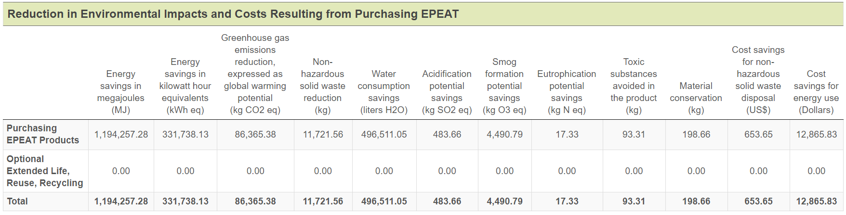
Fig 1: EPEAT Benefits calculator

This is the potential impact we can we can make by procuring sustainably and having prudent policy norms in place. The figures shown represent the savings done throughout the lifespan of an asset. You can use this website and account for your assets as well and make use of the optional criterial which are more holistic. This is the impact for a medium size organization, we can imagine the impact if a large organization say one having 20000 assets goes this route.
Also, there is the option to migrate our assets to those cloud service providers that power their datacenters with 100% clean energy and save on our carbon emissions.

CARBON FOOTPRINT

Before we try to find out the solution, we must first understand the impact we make on our environment and society by our choices. For this we will present a simple formula that has been derived from the Greenhouse Gas Protocol and Environment Protection Agency of USA. The practical application has been taken from the documents of Confederation of Indian Industries. This can be used to arrive at the approximate carbon emission released by a particular model of an IT asset say laptop, desktop and servers.
Here we will present an example of a server model to give an idea of the approximate emissions released by one device. Though there are many online calculators available, we feel that this approach caters to a particular country and gives a fair estimate. For example, if we use a third-party calculator and are not aware that it is using the emission factor for USA, then the firm using that calculator in India will have a wrong figure. So, it is best recommended to do some manual calculation ourself, at least in this area. But if a firm is already using some verified methodology, then we can proceed either ways.

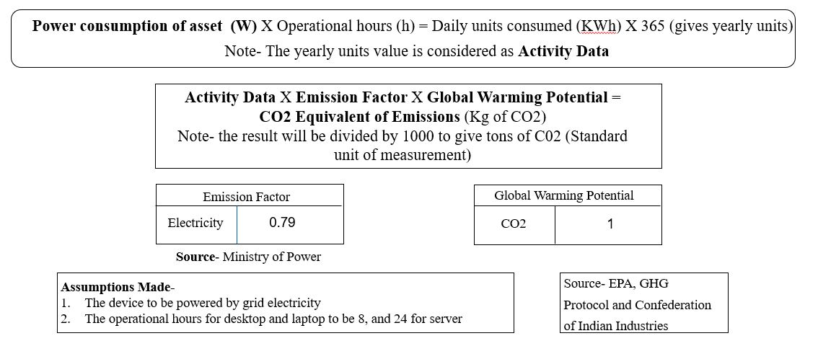
Fig 2: Carbon emission calculation formula

Calculation
Let us use an example of a HPE ProLiant DL360 Gen10 server which uses 1600 watt as input power and servers operate for 24 hours usually, so 1600 (W) X 24 (h) = 38400 Wh, now divide this by 1000 and we get 38.4 KWh X 365 days = 14016 KWh as the yearly units consumed by this server.
Put this 14016 into the second formula (one with the activity data) and we get 14016 X 0.79 X 1 = 11072.64 Kg of CO2 or 11.07 tons of CO2 per year. Multiply the number of assets you have of this model and we get their total emissions. Please note that the emission factor varies from country to country and we have considered this for India.
We can put the formula in an excel to automate the process. Although this is an approximate value but still gives us a pretty good idea of how much our assets are emitting. We can use this in our home scenario as well to calculate the emission of our laptop or desktop and thus be aware of our contribution towards the emission cycle.

Way ahead
This approach is particularly useful for organizations in a work from home scenario where the assets do not necessarily produce an electricity bill (an important input for carbon calculation) but still contribute towards the CO2 emissions.
Now how we can reduce the emissions depend a lot on our habits as well, like a common practice while going to lunch is we put our laptops to sleep instead of shutting it down, for one hour it is continuously running without use, utilizing power and consequently releasing emissions. If organizations conduct awareness sessions regarding this, then this surely will have a positive impact in the long run. We have mentioned one common example but we have to diligently identify other such areas for improvement.

SOFTWARE

Software is also an area where which can contribute towards ESG, particularly the social and governance aspects of it.

User privacy
When organizations procure a software from a publisher, they usually look at the utility angle while ignoring the more pertinent aspects such as how exactly do the publisher use the organization’s data. While closely analyzing the privacy policy of several publishers we found that many of the major publishers sell the user data to a third-party affiliate for commercial purposes, share with social media platforms, payment processing firms and in some cases lack policies to protect the user data in case of a merger or acquisition. Now all these areas are highly relevant to an organization that takes their user privacy seriously. The aim here to make the relevant stake holders aware so that they keep these areas in mind and ask the right questions to their publishers for areas that are relevant to them and keep contractual safeguards in place to ensure protection before making a purchase.
Cost of software is now days very well more than the hardware on which these run in some cases and thus firms should leverage this purchasing power and be secured in the area of user privacy.

User awareness
We are currently in a scenario where users in an organization are constantly faced with the risks of targeted phishing attacks, credential harvesting attacks etc. which are getting more and more complex to detect and avoid. Thus, user awareness in this area is paramount in such a situation and we believe that actual scenarios are more efficient to prevent such attacks.
To give an example, the M365 portal offers the administrators the option to conduct such attack drills throughout the organization, the attacks resemble real time scenarios and are updated regularly. Users that get trapped are made to go through mandatory training to avoid the situation in future and organizations also get real time statistics on their vulnerability status because even if one user is compromised, the entire network could be at risk. So, a culture of regular attack drills should be implemented to keep users aware and alert and prevent possible future attacks.
There are many such areas which can be identified and these vary from organization to organizations and thus the IT team should be aware on all latest developments and conduct awareness drives and trainings to keep users safe.

CONCLUSION

We hope with this topic we were able to provide some insights in how ESG can play a vital role in the
IT sector and can meaningfully contribute towards the environment and society for a better future. Organizations are becoming more and more aware in this area and this is a field that we feel can become a specialization in itself and thus be a new future trend in IT.

REFERENCES

- The Greenhouse Gas Protocol, “A Corporate Accounting and Reporting Standard”.
- Global Electronics Council, “Purchaser Guide for addressing labor and Human Rights Impacts in Technology Procurements”.
- Environment Protection Agency, “Indirect Emissions from Purchased Electricity”.
- Schneider Electric, “ Implementing Sustainable IT Asset Management Practices for Enterprise-wide Carbon Reduction”.

