Prospects of Artificial Intelligence in Agriculture

Samarth Godara¹, Shbana Begam²*, Ramanjit Kaur³, Jatin Bedi⁴, Ram Swaroop Bana³, Deepak Singh¹, Sudeep Marwaha¹, Rajender Prasad¹
¹ICAR-Indian Agricultural Statistics Research Institute, New Delhi, India
⁴ICAR-National Institute for Plant Biotechnology, New Delhi, India
³Division of Agronomy, ICAR-Indian Agricultural Research Institute, New Delhi, India
⁴Department of Computer Science and Engineering, Thapar Institute of Engineering and Technology, Patiala, Punjab, India

*Dr Shbana Begam: shaba.shb@gmail.com; shbana.begam@icar.gov.in

ABSTRACT

Agriculture and its allied sectors significantly contribute to the Indian economy's long-term growth and development and a livelihood for the majority of the population that can never be deprecated. Since it has made significant progress toward the agricultural development goals of food security, abundance, and accessibility, it started to pose a serious agricultural crisis to satisfy hunger in the coming period. Although farmers are very innovative and always ready to accept and adopt the latest technologies developed in the farming sector for increasing the farmers’ income but there are many more advanced technologies available and one outcoming technology is the use of robots in the field of agriculture in various farm operations like weed control fertilizer application, automated irrigation, etc. So here the goal of Artificial Intelligence (AI) comes. AI is a discipline that can empower machines to execute tasks in real-time situations and cognitive processing like the human mind. AI in agriculture not only helps the farmers to automate their farming operations like sowing, harvesting, crop monitoring, and sale purchase of their product but also shifts to precise cultivation for precision farming for higher crop yield and better quality by optimizing the inputs/resources. Using AI techniques in various fields of agriculture will provide more useful applications to the sector, which are directly or indirectly helping the world to deal with food production issues for the growing population. Some of the challenges faced by farmers using traditional agricultural methods are as follows: harsh weather conditions, the gap between demand and supplies, competition for growth factors by pests, etc. can be optimized using AI techniques.

Keywords: Artificial intelligence; machine learning; deep learning; crop monitoring; optimization

- INTRODUCTION

Artificial intelligence (AI) is a technique for teaching a computer, a robot, or a product to think intelligently like a human. AI is the study of how the human brain functions while attempting to solve issues. The study's eventual product is intelligent software systems. AI seeks to enhance computer abilities that are connected to human understanding, such as problem-solving, learning, and reasoning (Jackson, 2019).
Although Alan Turing first proposed an "imitation game" to measure machine intelligence in the 19th century, the idea of AI didn't become a reality until recently because of the growing accessibility of computer power and data to train AI systems.
- Different fields of AI
AI is the umbrella term for the ability to programme computers to perform tasks that would normally need intelligence from a human (Oke, 2008). AI can be divided into two main subfields: Neural Networks (NN) and machine learning (ML). Each of these AI subfields has its own techniques and algorithms for problem-solving (Figure 1).
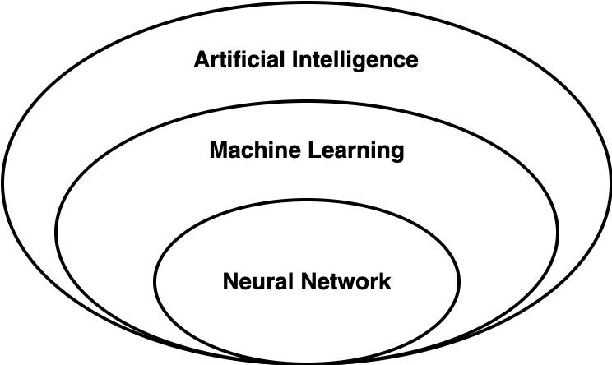
Figure 1: Important fields of AI

- Machine Learning
With the help of data and experience, computers can perform better on certain tasks or make better decisions using machine learning. For this, ML makes use of statistics and probability theory. Without explicit programming, machine learning employs algorithms to analyse the data, learn from it, and draw conclusions. Algorithms for machine learning are frequently divided into supervised and unsupervised categories. Unsupervised algorithms can deduce conclusions from datasets; supervised algorithms can apply what has been learned in the past to new data sets. In order to find both linear and non-linear associations in a given collection of data, machine learning algorithms are made to do just that. The statistical techniques used to train the algorithm to classify or predict from a dataset are responsible for accomplishing this accomplishment (Camara et al., 2022).
- Neural Network
Neural networks are made up of layers of connected nodes, or "neurons," that include mathematical functions to interpret incoming data and anticipate an output value. These networks are modelled after the biological neurons in the human brain. Similar to how individuals learn from their parents, teachers, and friends, artificial neural networks pick up new skills by watching others. An input layer, hidden layers, and an output layer are the minimum number of layers that they have. Each layer consists of nodes (sometimes referred to as neurons), which compute the output from weighted inputs.
- Deep learning
Deep learning is a kind of machine learning that use multiple layers of artificial neural networks to achieve cutting-edge accuracy in language translation, object detection, and speech recognition. A key component of autonomous automobiles is deep learning, which allows machines to analyses vast volumes of complex data, such as identifying faces in pictures and videos (LeCun et al., 2015).

- APPLICATION OF ARTIFICIAL INTELLIGENCE IN AGRICULTURE

      - Precision Agriculture
Precision Agriculture is a farming management strategy that collects, processes, and analyses the data for precise usage of the resources with precise sensing of the farm to improve sustainability (Dobermann et al., 2004).
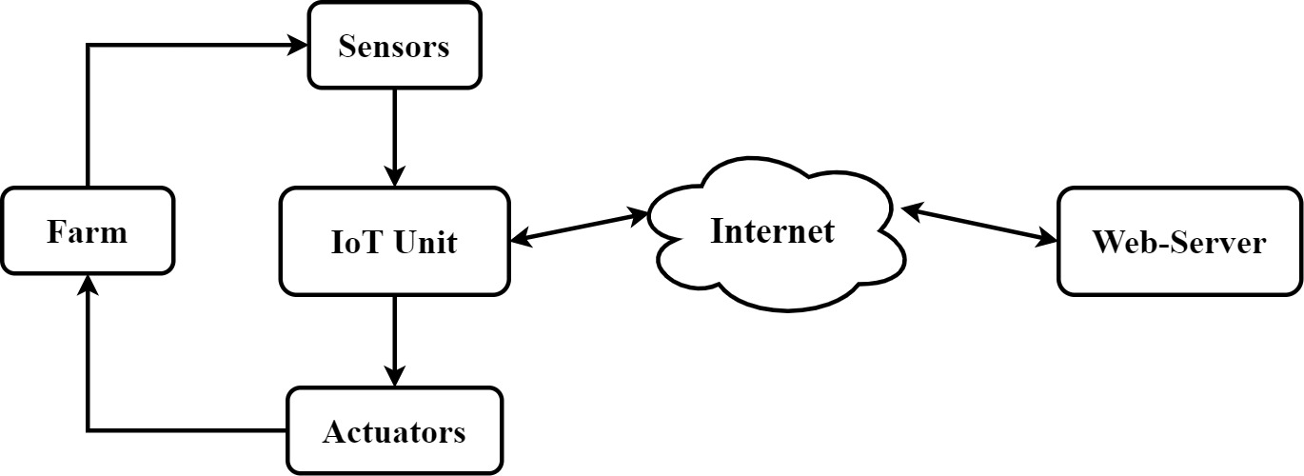
Figure 2: Precision Agriculture
Initially, installed sensors in the farm collect the data from different parts of the fields, then these collected data go to the computational unit for processing (figure 2). The computational unit transfers the data online to the server and after some analysis, the server makes decision which is again transferred to the computational unit. The computational unit receives the commands and transfers them to the actuators (Singh, 2010). It, later on, leads to actual work on farms such as opening and closing of irrigation valves, turning on/off the water pump, etc. Some examples of such systems are:
- Automated irrigation system: a system to irrigate the field with no or just a minimum of human intervention. With the help of computers, sensors, and other mechanical devices every irrigation system gets automated. It is helpful to overcome the problem of unnecessary water flow into agricultural lands.
- Automated fertilizer system: a system that supplies the required amount of fertilizer dose to the individual crop and as per the site-specific soil requirement.
- Automated pest-control: automatic identification and analysis of pest attack and spray the necessary pesticide in optimum amount.
For the development of such systems, one needs various types of sensors such as soil moisture, soil temperature, air moisture, air temperature sensor, etc. Data from these sensors get fed to computational units like Arduino or raspberry pi. These modules transfer the data to the server over the internet. To develop the whole system, from a software perspective one needs the knowledge of embedded c, HTML, PHP, SQL, etc.

      - Agricultural Robotics
Today, robots are being used in almost every sector. These machines reduce the dull repetitive manual labor allowing manpower to focus more on improving the overall production. Such systems use complex mathematical modeling in order to take action to reach the defined goal. Robots can be used to perform complex tasks including seeding, spraying, mowing, pruning, harvesting, packing, and many more.

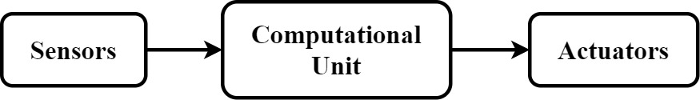
Figure 3: Workflow of Agricultural Robotics

In a robotic system, the sensor takes sensor data as input which can be in the form of Image, audio, color, etc (figure 3). In order to retrieve the environmental information, a number of sensors are used, namely sonar sensors, cameras, etc. The data from these sensors get transmitted to the computational unit which runs the AI model. These models evaluate the current situation that the robot is in and from that information the next series of steps are decided in order to achieve the desired goal (Shamshiri, 2018). After this decision-making, the corresponding commands are passed to the actuators like stepper motors, servo motors, etc. This procedure is followed in a loop until the desired goals are reached.

- Remote Sensing
Remote sensing refers to the data collected about a phenomenon without making physical contact with it. This includes collecting information about the farms using satellite data (figure 4). Such data can be used for:
- Forecasting of crop production
- Crop damage assessment
- Estimation of Crop acreage
- Pests and disease detection
- Estimation of Soil moisture
- Detection of crop nutrient deficiency
- Estimation of Air moisture, and many more

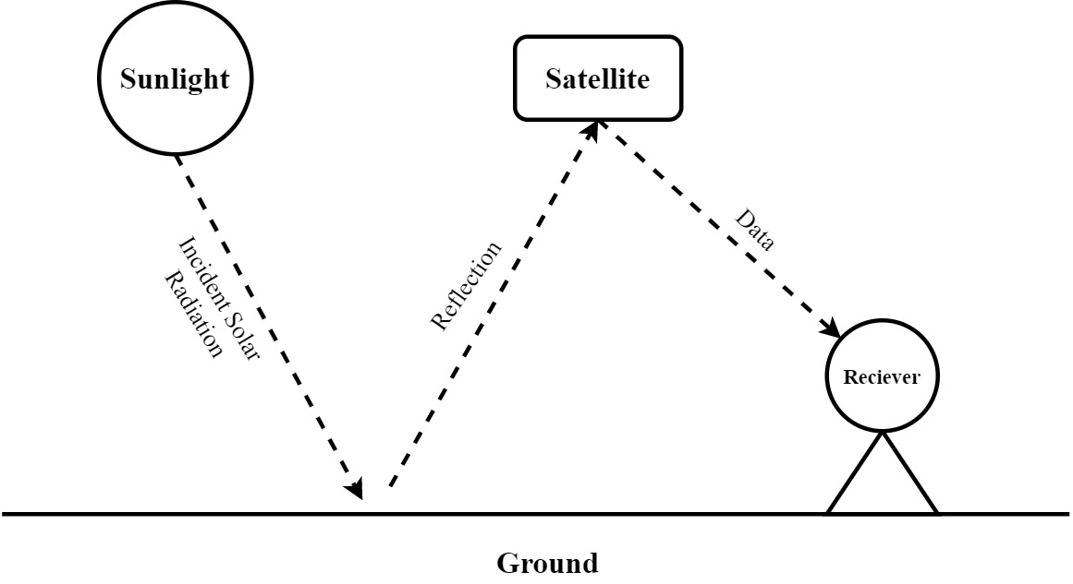
Figure 4: Remote sensing process
A typical remote sensing system works when the radiation from the sun hits the ground and gets reflected after getting scattered (Huang et al., 2018). The reflected radiation is then received by satellite which then transfers the data to a receiving point on the ground where all data gets collected. From there the data gets analyzed and results are formed regarding estimations.

- Hydroponic Farming
In hydroponic farming crops are grown on water mixed with liquid nutrients instead of soil. Through this technique, farmers can grow the crop anywhere in the world. Moreover, it uses 20 times less water than conventional farming. Another big advantage of using this technique is that there is no need for field preparation practices like mulching, tilling, and weeding. Since this type of farming can be done indoors, this makes harvesting an easy task. In such systems the roots of the plants are dipped in flowing water and water is constantly monitored for its nutrient quantity through the use of sensors. Then the data from the sensors is transmitted to a single computational unit which uses an AI model to identify the required amount of nutrients to be added to the flowing water.
After the system automatically makes decisions regarding the nutrient addition, the computational unit sends commands to the nutrient storage system in order to add particular amounts of nutrients into the water (Sardare & Admane, 2017). This system can also be used for maintaining a particular temperature of the water. In order to develop the overall hydroponics AI system, one needs various types of sensors including water nutrient and temperature sensors. The sensor data is later processed by computational units like the raspberry pi. The commands given by the unit to maintain the nutrients’ quantity are executed by actuators like solenoid values, motor pumps, etc. To develop all these various programming languages are needed, like embedded c or python to design the data monitoring and decision-making system.

- Remote Monitoring
Remote monitoring in agriculture deals with AI-based monitoring of the current on-goings of the field. This can include monitoring of disease, pests, irrigation, crop-stage, etc. in the field.

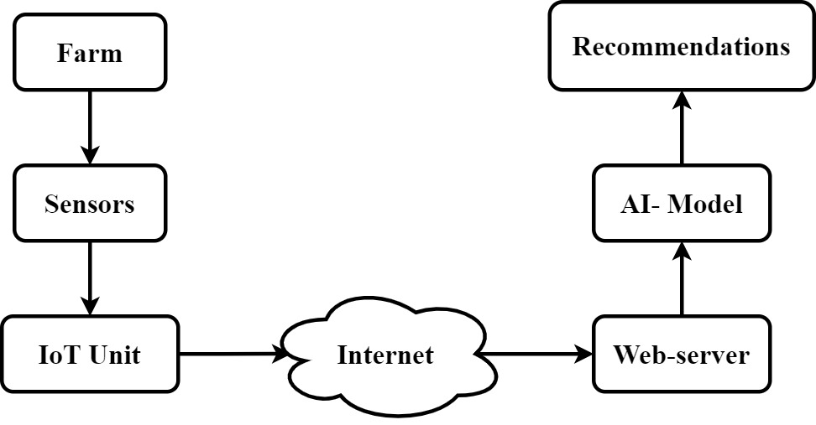
Figure 5: Remote monitoring process
In such systems, the data from the field gets collected in various sensors such as cameras, soil moisture sensors, etc (figure 5). This data is first collected and stored locally in a head node of the sensor unit which includes a computational unit. Later on, the data is transferred to a web server over the internet where the AI-based model keeps an eye on the sensor data in real-time. Whenever an expected event occurs in the farms, it may be pest disease, or low soil moisture, or anything. The model detects it and sends recommendations to the farm manager through various mediums like SMS, call, email, etc. These systems are very useful in getting alerts at the early state of pest management. Such systems can also be used to identify the various stages of the crop in the field. It can also identify the crop from which section is ready to harvest and which section needs more days. Through such systems the monitoring of the farm can be done from anywhere around the world, therefore the farm owner has flexibility in this case. The sensor-collected data from the field is stored in a database which can be used to develop models for forecasting or analysis of the previous year's performance. There are many options in the market which provide such solutions, these include remote monitoring systems from agriexpo, aggreko, farmerp, and many more (Talaviya et al., 2020; Jha et al., 2019).

- Forecasting
Predicting the futuristic trend is one of the most common uses of AI. Such models can be used for predicting rainfall, air temperature, wind velocity, evapotranspiration, agricultural yield, etc. AI models which are used for forecasting use complex mathematical models in the background in order to capture the previous pattern in the data. This captured pattern is later repeated while predicting future values.

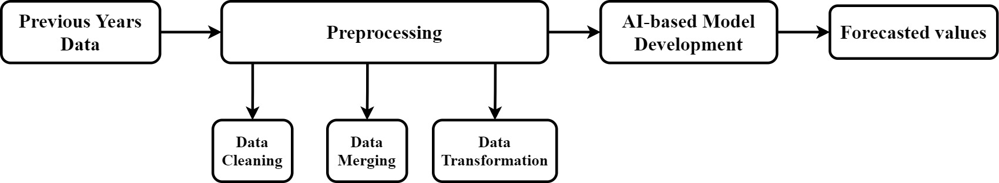
Figure 6: Agricultural forecasting using AI

In order to build an effective forecasting model, there is a need for the previous years’ dataset (figure 6). The bigger the dataset is, the better can be the captured pattern. But before feeding the data to the model, it is preprocessed. In this step, the data is cleaned, multiple data files are merged, and transformed in the form from which the model can easily read the pattern (Jha et al., 2019). In some cases, features are extracted from the dataset to gain better prediction accuracy. In the later step, the data is fed to the model for training. At this point, the model is ready for forecasting futuristic values (the next values of the series). Performing such tasks need heavy computational powered systems. In India, The Indian Meteorological Department (IMD) is one of the Governmental Departments responsible for weather forecasting. Moreover, the Division of Forecasting & Agricultural Systems Modeling of ICAR-Indian Agricultural Statistics Research Institute (IASRI) deals with research in the forecasting of agricultural and environmental phenomena (Godara et al., 2022).
ICAR-IASRI introduced, KCC-CHAKSHU, an Artificial-intelligence equipped online system for monitoring Indian farmers' demand for help (https://kcc-chakshu.icar.gov.in/). The presented system is composed of the three sub-systems:

  - A Real-Time Alert System using Kisan Call Center Data

The "Alerts" section of the website gives the information regarding the crops for which the farmers are currently asking the most questions. The platform also provides information on the crops corresponding to the highest inquiry rate at present. The system uses call-record data from the Kisan Call Centers that contains information regarding the telephonic calls made by the Indian farmers. The data from the helpline centers is then processed through an artificial intelligence-based system to extract critical information. The insights indicate the major crops regarding which farmers demand help most, corresponding to the selected state, in real-time. These insights are beneficial for planning short-term extension activities to provide assistance to the Indian farmers as soon as possible. The early alerts are also valuable for detecting pandemics and outbreaks of plant-protection-related problems.

ii. Kisan Call Center Data Repository

Along with the alerts, the website gives access to the pre-processed dataset containing records of more than 30 million telephonic calls made by Indian farmers since March 2013. The collated call records include the details regarding the location of the farmers, time of the phone calls, questions asked by the farmers, answers delivered to the farmer by the Kisan call center operator, and many more.

iii. Kisan Call Center Data Insights

Furthermore, KCC-CHAKSHU also provides helpful information regarding the historic query-call records. The "Insights" section of the website delivers details regarding the state-wise number of calls received since March 2013. Similar insights are made available for various categories, including crop-wise, year-wise, month-wise, sector-wise, hour-wise (and many more) query counts. These insights are helpful for decision-making in agricultural extension and other related domains.

- Online Market System
AI-based online platforms can be used for farmers to sell their products directly to the customers/dealers (figure 7). In this system, AI-based algorithms are responsible for maximizing the benefit for both parties. Such systems have online databases, in which users (farmers and buyers) can create their profiles. Through the farmers’ profiles, product profiles can be created by the farmers which will include the details of the products. On the other hand, the buyers’ profile contains the buyers’ details and the details of their recommendation. The AI module will then show the users a sorted list of the requested products according to the users’ priority. A graphical representation of such a system is given below.

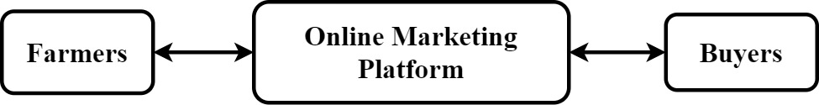
Figure 7: Online market system

In such an online platform, the farmers get to input their product details along with their geographical location. It helps the buyers’ to precisely target the farmers of selected regions. Moreover, buyers from all over the world can participate in the process and they can sort the list of requested products according to their available quality, quantity, and geographical location (Bisen & Kumar, 2018). Farmers on the other hand get to see the list of buyers who are interested in their products and can contact them through their profile for any negotiation or any other inquiries. Such platforms are beneficial for providing full transparency and customer satisfaction. Along with this, It maximizes the farmers’ profit. Some of such existing platforms are as follows: smartcrop, dhaan mandi, agribuzz-agriapp, digital india mandi, gramseva, mandi trades, and agri market. These platforms can be developed using any online web-development programming languages, including HTML, CSS, and javascript for designing the web pages. The database of such systems can be developed through any database management system, such as MySQL, SQL, etc.

SUMMARY
The farming sector faces a lot of issues, including a lack of effective irrigation systems, crop monitoring, and undesirable weather conditions. However, with the help of technology, efficiency can be improved, and therefore these issues can be resolved. It can be augmented with AI-driven techniques. AI is a discipline that can empower machines to execute tasks in real-time situations and cognitive processing like the human mind. AI in agriculture not only assists farmers in automating their farming practices from sowing to harvesting and selling their goods, but it also moves to precision farming for higher crop yield and quality while using fewer inputs/resources. The integration of effective AI components would provide more useful applications to the sectors, assisting the world in dealing with food.

REFERENCES

Bisen, J., & Kumar, R. (2018). Agricultural marketing reforms and e-national agricultural market (e-NAM) in India: a review. Agricultural Economics Research Review, 31(conf), 167-176.
Camara, J., Neto, A., Pires, I. M., Villasana, M. V., Zdravevski, E., & Cunha, A. (2022). Literature Review on Artificial Intelligence Methods for Glaucoma Screening, Segmentation, and Classification. Journal of Imaging, 8(2), 19.
Dobermann, A., Blackmore, S., Cook, S. E., & Adamchuk, V. I. (2004). Precision farming: challenges and future directions. In Proceedings of the 4th International Crop Science Congress (Vol. 26).
Godara, S., & Toshniwal, D. (2022). Deep Learning-based query-count forecasting using farmers’ helpline data. Computers and Electronics in Agriculture, 196, 106875.
Huang, Y., Chen, Z. X., Tao, Y. U., Huang, X. Z., & Gu, X. F. (2018). Agricultural remote sensing big data: Management and applications. Journal of Integrative Agriculture, 17(9), 1915-1931.
Jackson, P. C. (2019). Introduction to artificial intelligence. Courier Dover Publications.
Jha, K., Doshi, A., Patel, P., & Shah, M. (2019). A comprehensive review on automation in agriculture using artificial intelligence. Artificial Intelligence in Agriculture, 2, 1-12.
LeCun, Y., Bengio, Y., & Hinton, G. (2015). Deep learning. nature, 521(7553), 436-444.
Oke, S. A. (2008). A literature review on artificial intelligence. International journal of information and management sciences, 19(4), 535-570.
Sardare, M. D., & Admane, S. V. (2013). A review on plant without soil-hydroponics. International Journal of Research in Engineering and Technology, 2(3), 299-304.
Shamshiri, R., Weltzien, C., Hameed, I. A., J Yule, I., E Grift, T., Balasundram, S. K., ... & Chowdhary, G. (2018). Research and development in agricultural robotics: A perspective of digital farming.
Singh, A. K. (2010). Precision farming. Water Technology Centre, IARI, New Delhi.
Talaviya, T., Shah, D., Patel, N., Yagnik, H., & Shah, M. (2020). Implementation of artificial intelligence in agriculture for optimisation of irrigation and application of pesticides and herbicides. Artificial Intelligence in Agriculture, 4, 58-73.

