Compact 8-Port MIMO Antenna for C-Band and 5G Applications

Navneet Singh
Department of Electronics and Communication Engineering
MJP Rohilkhand University, Bareilly, Uttar Pradesh, India
navneetsingh.engg8@gmail.com

Yash Bhardwaj
Department of Electronics and Communication Engineering
MJP Rohilkhand University, Bareilly, Uttar Pradesh, India
yash.bhardwaj.engg@gmail.com

Dr. Hari Kumar Singh
Department of Electronics and Communication Engineering
MJP Rohilkhand University, Bareilly, Uttar Pradesh, India
harsdik@gmail.com

ABSTRACT

This chapter proposed a design of 8×8 MIMO antennas is placed on the top edge of the system ground of 80mm×80 mm×30mm. The size of the proposed antenna is 60mm×60mm×1.6mm. The antenna is printed on FR4 substrate of permittivity of 4.4 and thickness of 0.8 mm. The design extended to 8×8 MIMO antennas operating at WRC 5G (7.5– 9.5GHz). The simulated efficiency has a 47–59% over the operating band. This design with good radiation performances and keeping low profile is suitable for the application of laptop computers.

- INTRODUCTION

The era of fifth generation wireless systems (5G) is coming and is deployed in this year. At present, 5G mobile phones have appeared, and future laptop computers may use 5G C-band . For improving data transmission speed, MIMO technology should be adopted. For 5G MIMO antenna design, some methods of mobile phones antenna design [1]-[4] have been reported, and the most design of them are designed by using monopoles or slots.
Recently, demand for huge bandwidth, high data rates and low latency communication has been dramatically increased. The fifth generation (5G) communication systems are possible candidates to offer adequate bandwidth with low latency for many use cases which cannot be addressed by the conventional Long-Term Evolution (LTE) and LTE-advanced (LTE-A) communication systems. Different frequency bands (i.e. low frequency, mid-frequency, and high frequency bands) are considered for 5G new radio (NR) to be used for various use cases. The C-band or mid-frequency band at 3.6GHz (3.4GHz to 3.8GHz) has been specified as primary band for 5G by EU among its 5G pioneer bands [1] in order to provide a wider coverage compared to millimeter waves band, and a larger bandwidth compared to the low frequency band to support some 5G use cases e.g. mission critical applications and Enhanced Mobile Broadband (eMBB). Therefore, a 5G antenna operating at C-band should provide an impedance bandwidth of ≥400 MHz.
In wireless communication systems, multiple input multiple output (MIMO) or multiple antenna deployment technology significantly enhances the data rate, channel capacity, and link reliability by multi-path data transmission and reception [2]. A high isolation (low mutual coupling) is one of the key requirements of MIMO antennas for achieving a high throughput, spectral efficiency and overall better antenna performance. Antenna designers tend to obtain a high isolation between the antenna elements without utilizing extra materials (e.g. decoupling structures) or increasing the distance between the antenna elements which lead to a larger antenna size and high manufacturing cost.
Many studies have been carried out on MIMO antenna design for C-band communication systems [2-10]. However, the reported antennas provide either low antenna realized gain (Max 5dBi) or small bandwidth which do not satisfy 5G C-band communication systems requirements. In addition, in order to reduce the mutual coupling between the antenna elements, decoupling structures have been utilized which led to an increase in the manufacturing cost. A four-element MIMO antenna for 5G communication systems operating at sub-6GHz band is reported in [3]. It has been loaded with split-ring resonators (SRRs) to improve the antenna performance including the mutual coupling between the antenna elements. It achieves a bandwidth, gain and mutual coupling of 440MHz, 2.98dBi and -15dB, respectively. Although it satisfies the bandwidth requirement, it requires a higher gain to achieve better antenna performance. A four-port MIMO antenna using microstrip feed lines for 5G C-band communication systems is reported in [6]. It achieves a 10dB-bandwidth, gain, and mutual coupling of 350MHz, ⁓5dBi and -17dB, respectively. Although it offers a relatively good gain, it requires a bandwidth of 400MHz to cover the 3.4GHz – 3.8GHz band identified for EU countries.
The objective of this work is to propose a 5G C-band antenna providing a bandwidth of ≥400MHz, and a higher gain (>5dBi) compared to other studies reported [2-10]. In addition, it should provide an improved throughput and mutual coupling (<-15dB) without utilizing decoupling structures or increasing the distance between the antenna elements. Therefore, a slotted eight-element MIMO antenna with partial ground plane using a new design method is proposed. We applied, to appropriately design and optimize the partial ground plane and slots on the patch and ground plane for the purpose of bandwidth enhancement in order to meet 5G C-band communication systems requirements. In addition, it triggers the current flow to mainly concentrate around the feedline, slots and the partial ground plane of the excited antenna element, so the current flow to other elements is greatly prevented and a low mutual coupling is achieved without increasing the distance between the antenna elements or using a decoupling structure.

- ANTENNA DESIGN

Geometry for proposed 8-Port ‘MIMO antenna’ having two frequency rejection characteristics is shown in Fig.-1.

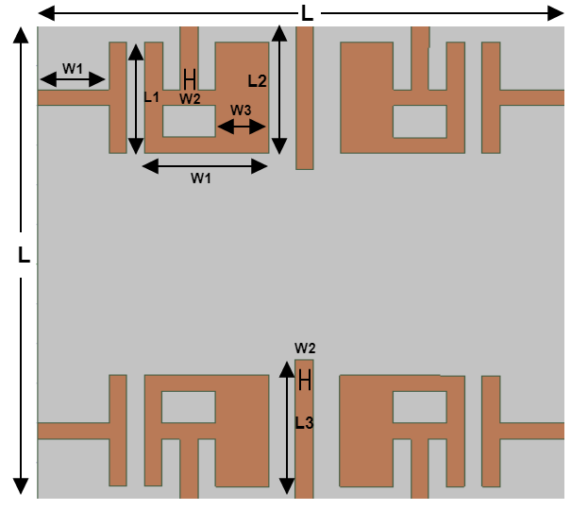
Fig. 1.(a): Front of the antenna
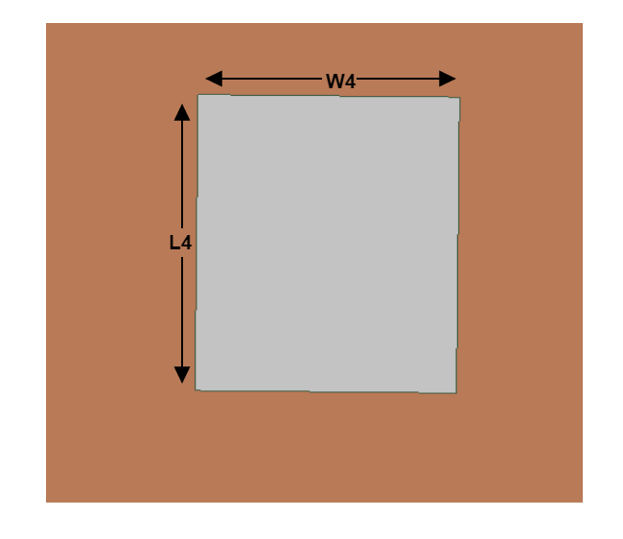
Fig. 1.(b): Back of the antenna

To provide a broad frequency response, design procedure begins with fabrication of eight-port ‘MIMO antenna’ having four symmetrical A shaped patch & four symmetrical T-shaped patch and modified plane with partial ground. A two-lines rectangle sheet inserted at plane with upper ground over the entire bandwidth to improve bandwidth, impedance matching, isolation in-between pair of elements of two antenna. To acquire our results within range of frequency of 7.5 – 9.5GHz, CSRR been imprinted upon patch elements, at the same time a SRR been loaded upon ground plane upon rear of every radiation element. The proposed structure was built on ‘FR4-epoxy substrate’ having thickness equal to 1.6-mm, with ε_{r} (dielectric constant) equal to 4.4, tangent loss (δ) equal to 0.0023. The physical dimensions of the proposed ‘8-Port MIMO antenna’, which having small size of 60×60 ${mm}^{2}$, are listed in Table 1.

Table 1. Physical dimensions of the antenna
Parameters | h | L | W | L1 | W1 | L2
Values (mm) | 1.6 | 60.0 | 60.0 | 14 | 6.0 | 16.0
Parameters | W2 | L3 | W3 | L4 | W4 | -
Values (mm) | 2.0 | 18 | 4.0 | 36.0 | 28.0 | -

- DISCUSSION AND RESULTS

A. Scattering Parameters for MIMO Antenna
In the following subsection, the Scattering Parameters of the proposed 8-Port ‘MIMO antenna’ construction includes the terms Reflection Coefficient, Z-Parameters, and Antenna to Antenna Isolation is discussed in depth.

- Reflection Coefficient
The simulated and the measured reflection coefficient plots of the proposed MIMO antenna is shown below. For isolation enhancement, some parameters are changed in MIMO antenna, thence the MIMO antennas have a little different 10 dB bandwidth than the proposed single-element antenna. It can be seen that the antenna has a good impedance matching in a wideband frequency range starting from 7.5 to 9.5 GHz, equivalent to a fractional bandwidth of 15.9% with respect to the central operating frequency. The antennas show almost the same reflection coefficient curves since all the antenna elements have symmetrical geometry and placement. A little difference in the measured reflection coefficients among the antenna elements is due to the measurement tolerances. The Reflection Coefficient (in dB) of the combined result of four ports is given in Fig2 and we are isolating the rest of the four remaining ports.
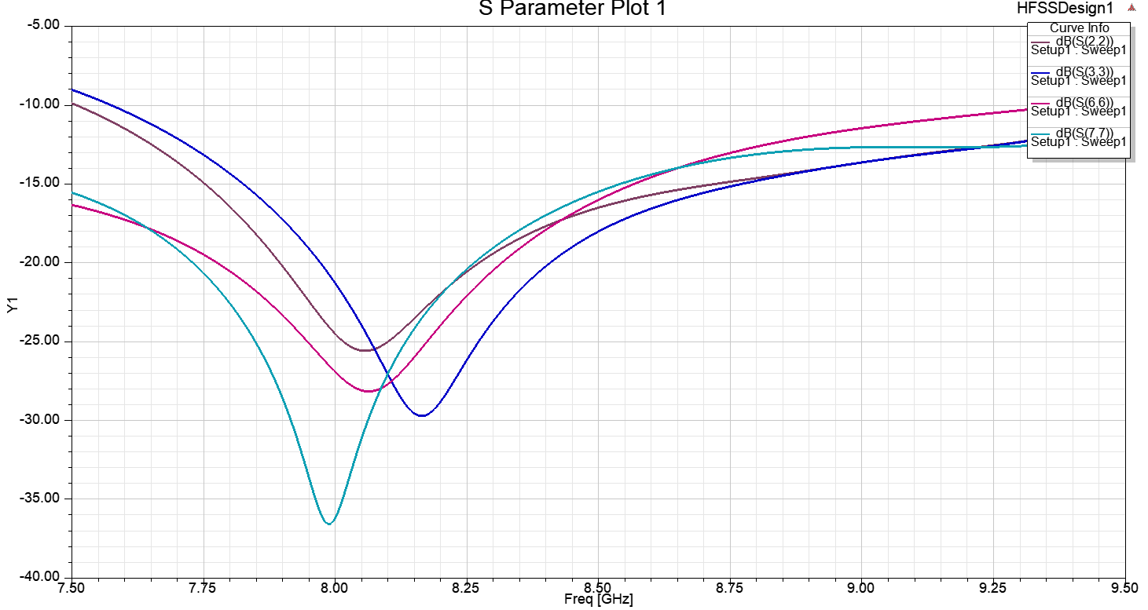
Fig. 2. Reflection coefficient curve of the antenna

- Z-Parameters
The Z parameter is used to determine the quality factor of an antenna which can give you an insight into the attainable bandwidth. Z(ant)=R+jX, where R=R(rad)+R(Loss), so you can predict somehow the losses and the efficiency. It could also be useful for determining an equivalent circuit model of the antenna. The simulated and the measured Z-parameter plot of the proposed MIMO antenna is shown in Fig.3.

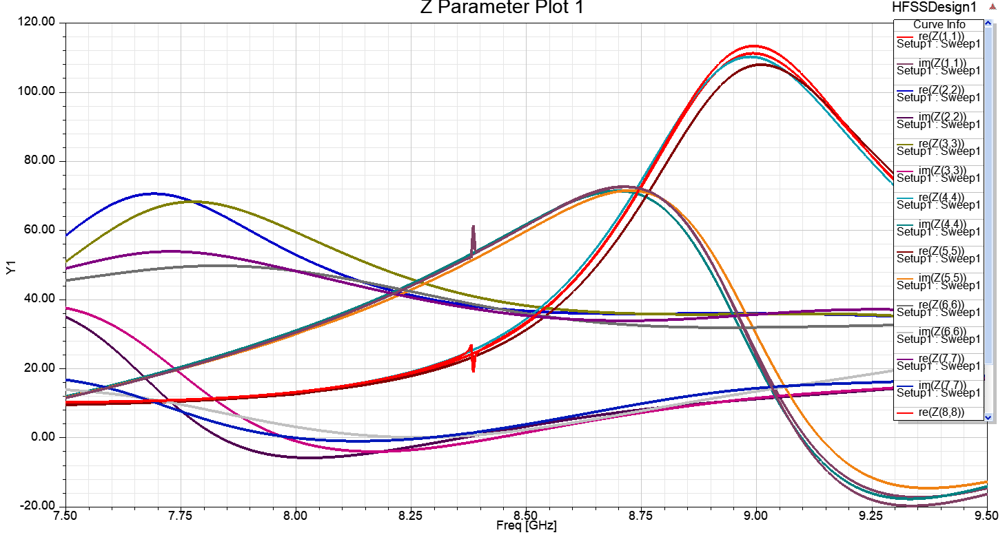
Fig. 3. Z-Parameter curve of the antenna

- Antenna to Antenna Isolation
Antenna to antenna isolation is a measure of how closely two antennas are coupled. Antenna isolation is typically evaluated for antennas within the same product, such as the separation between a smartphone's GPS and WiFi antenna. The isolation should be as large as possible when provided in this manner.

At the lowband, isolation can be as low as -10 dB or less for antennas that share a similar ground plane, such as the diversity and primary cellular antennas on a smartphone. Both antennas' efficiency will suffer as a result of isolation. The simulated and the measured Isolation plot of the proposed MIMO antenna is shown in Fig.4.
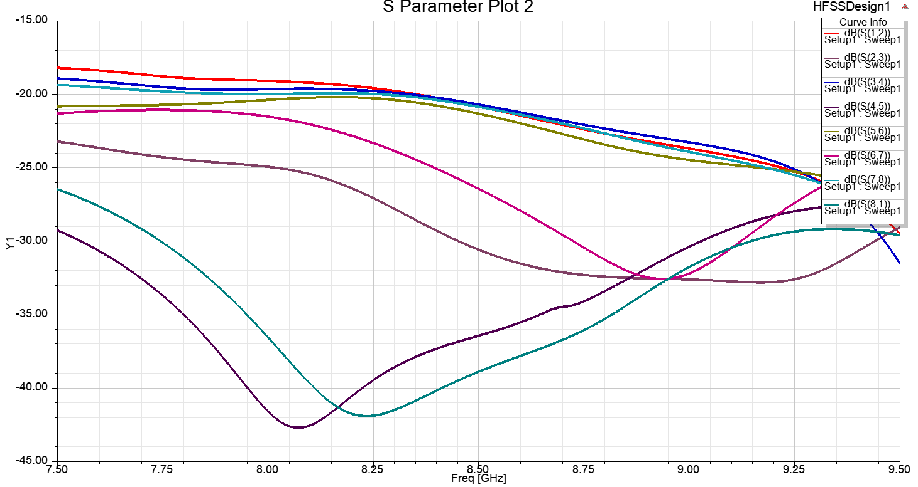
Fig. 4. Isolation of the antenna

- Far-Field Parameters for MIMO Antenna
In the following subsection, the Far-Field Parameters of the proposed Compact 4-Port ‘MIMO antenna’ construction include the terms 3-D Polar Plot and gain is discussed in depth.

- 3-D Polar Plot
The Polar Plot is a plot that depicts the transfer function of the system G(jω) on a complex plane in polar coordinates. The polar plot representation depicts a plot of magnitude vs. phase angle on polar coordinates with variation in ω from 0 to ∞. The simulated and the measured 3-D Polar plots of the proposed MIMO antenna is shown in Fig.5.
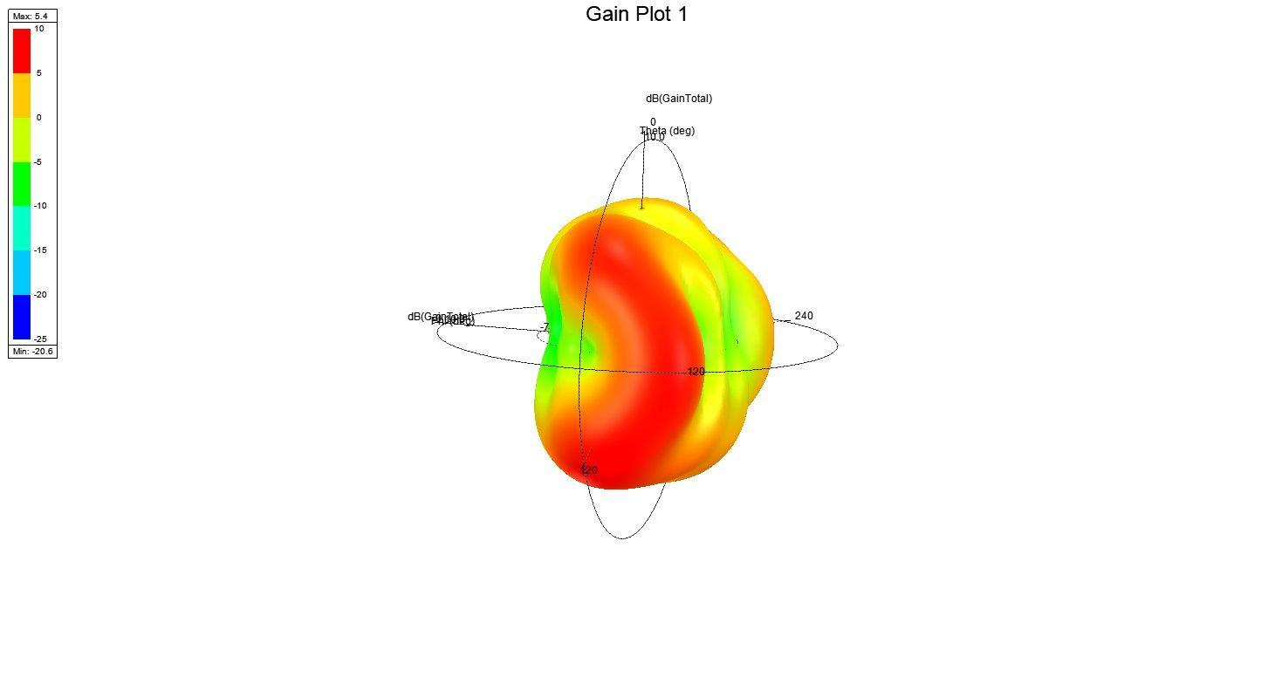
Fig.5. 3-D Polar plot of the antenna

- Gain
That portion of the radiation intensity in a given direction corresponding to a certain polarisation divided by the radiation intensity that would be obtained if the antenna's power was radiated in an isotropic manner. The sum of the partial gains for any two orthogonal polarizations is the (total) gain of an antenna in a given direction. Losses due to impedance and polarisation mismatches are not included in the gain. If an antenna has no dissipative loss, its gain is equal to its directivity in any given direction. The direction of the highest radiation intensity is assumed if the direction is not provided.
The simulated and the measured gain plot of the proposed MIMO antenna is still working.

- Performance Parameters of MIMO Antenna
In the following subsection, the performance of the proposed Compact 8-Port ‘MIMO antenna’ construction includes the terms DG, ECC, TARC, and efficiency is discussed in depth.

- Envelope Correlation Coefficient and Diversity Gain
‘ECC in-between next to radiation element 1st and 2nd port of N port MIMO antenna system using far-field patterns is given by Equation (1):

$$ECC = \frac{{\left|S_{11}^{*}S_{12}+S_{21}^{*}S_{22}\right|}^{2}}{(1-{\left|S_{11}\right|}^{2}-{\left|S_{21}\right|}^{2})(1-{\left|S_{22}\right|}^{2}-{\left|S_{12}\right|}^{2})}$$

It turns out that, for extremely efficient antennas (let's say, >90% or >-1dB), the ECC can be fully estimated from the antenna isolation. As a result, you can just measure $S_{12}$ and determine the ECC without analysing the antennas' radiation patterns. Without getting into the arithmetic, the explanation is that tight coupling will occur if antennas produce the same (or strongly correlated) radiation pattern (or low isolation). This is due to the reciprocity of antennas, which means that if antenna 1 transmits a radiation pattern, antenna 2 will "see" this pattern and receive energy corresponding to the degree of correlation between the antennas' radiation patterns. It's a straightforward argument, but it holds up.
The following expression specifies the DG of the planned MIMO antenna [19, 20]:
$$DG = 10\sqrt{1-{|ρ|}^{2}}$$
where ρ is the coefficient of complex cross-correlation, and $|ρ|$ ≈ECC. Figure 6 and Figure 7 shows the ECC and DG graphs that were simulated and measured. The radiation patterns are used to generate the simulated ECC and DG results, while the S-parameters are used to generate the measured results.
As we can understand from Figure 6, the ECC is less than 0.03 for the whole C band, except at the frequency band (7.5 to 9.5 GHz), where the ECC is greater than 1db. As indicated in Figure 7, the DG is larger than 9.95 dB.
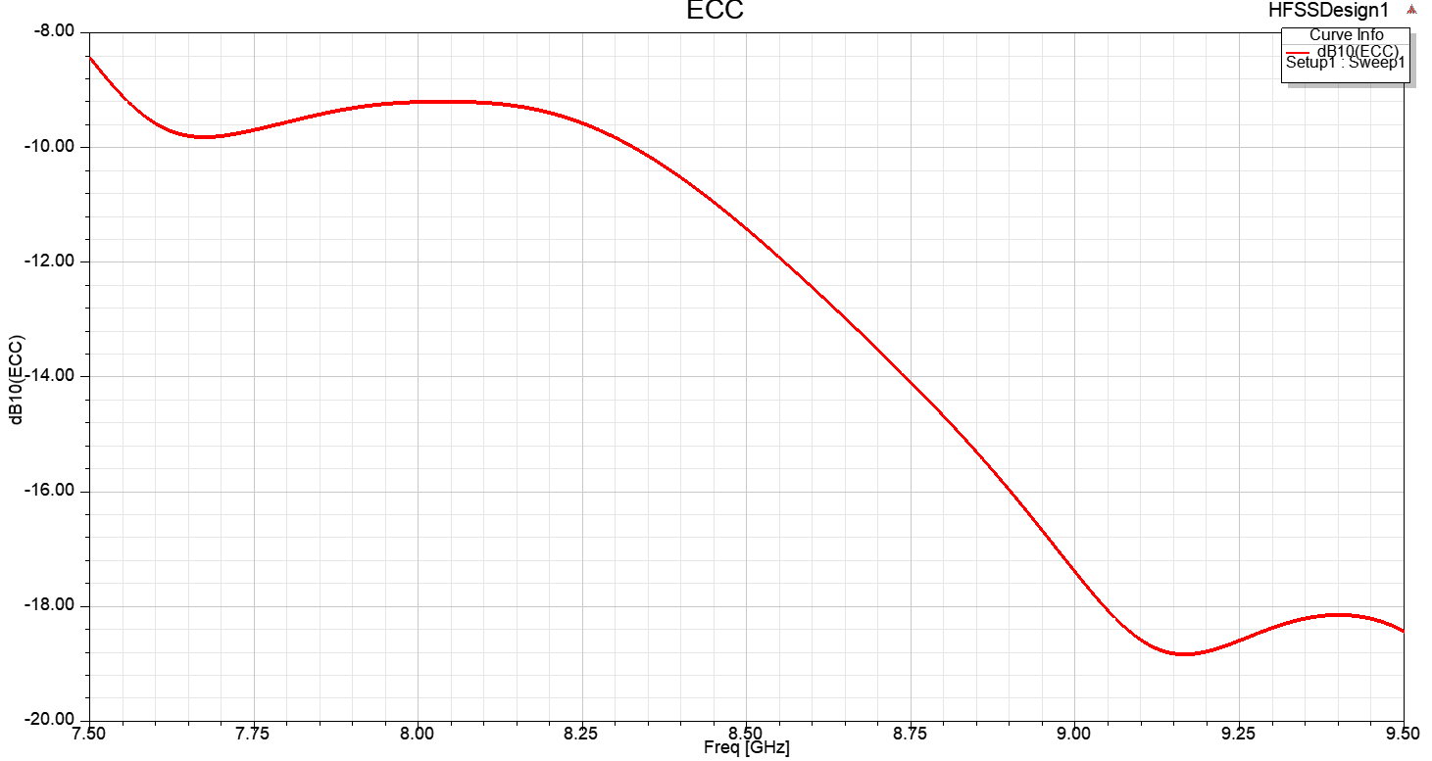
Fig. 6. ECC of the antenna

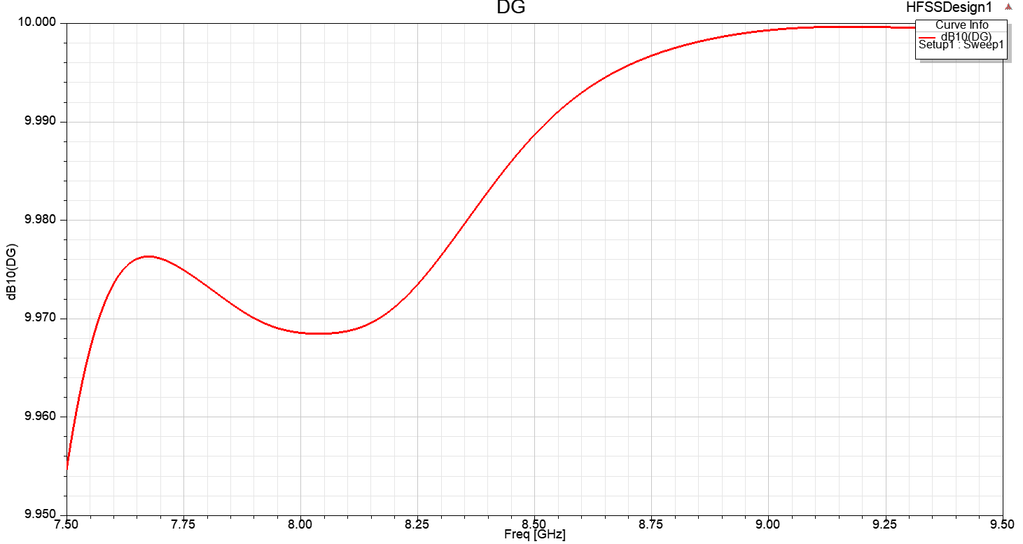
Fig. 7. Directive Gain of the antenna

- Efficiency
The high radiation efficiency of over 75 percent backs up the Compact 4-Port MIMO antenna's almost constant performance.

- Total Active Reflection Coefficient
‘For a eight-port MIMO system, i = 1,2,3,4,5,6,7,8 j = 2,3,4,5,6,7,8,1 in that order and N = 8, The following equation considers the TARC using the S-parameters [19]:
$$TARC =\sqrt{\frac{{\left|S_{ii}+S_{ij}\right|}^{2}+{\left|S_{jj}+S_{ji}\right|}^{2}}{2}}$$
As seen in Figure 8, this parameter is less than -10 dB over the whole frequency range. The slight disparity between the simulated and observed findings could be related to the effect of soldering the SMA connectors, as well as the tolerance levels for the antenna construction process period’.
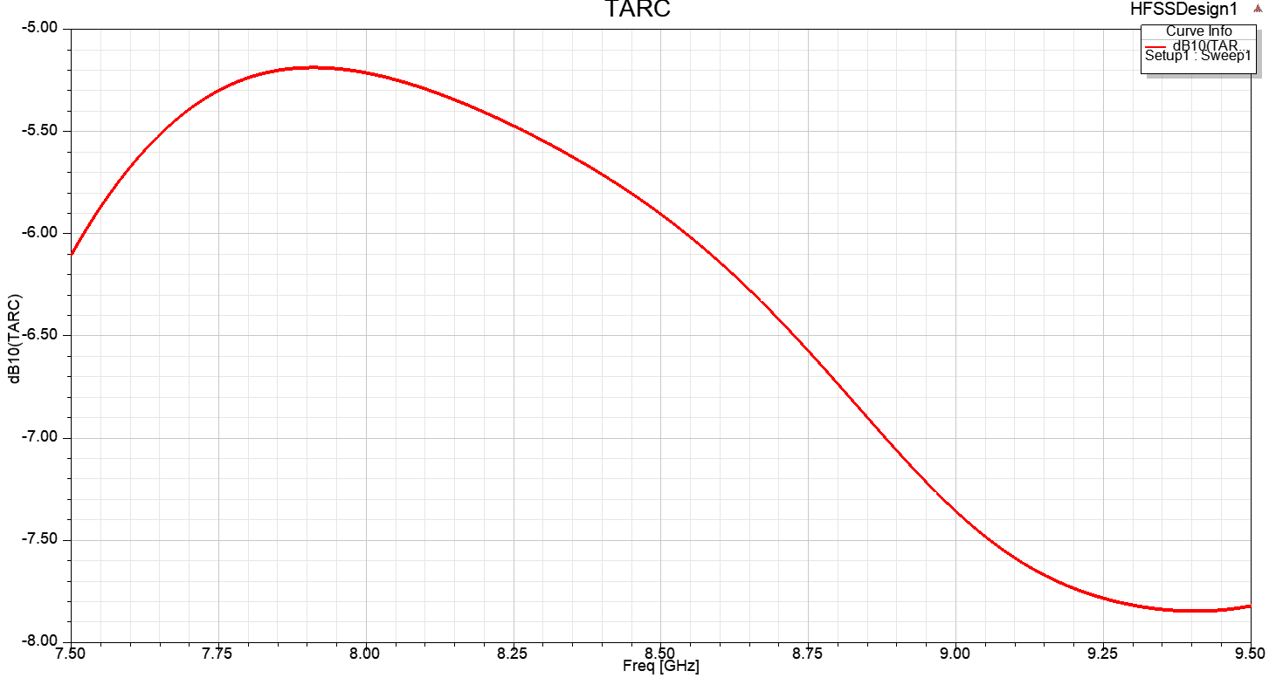
Fig. 8. TARC of the antenna

- Voltage Standing Wave Ratio (VSWR):
The voltage standing wave ratio, VSWR is defined as the ratio of the maximum to minimum voltage on a loss-less line.In practice there is a loss on any feeder or transmission line. To measure the VSWR, forward and reverse power is detected at that point on the system and this is converted to a figure for VSWR. In this way, the VSWR is measured at a particular point and the voltage maxima and minima do not need to be determined along the length of the line.The Figure 9 shows the VSWR of all the ports of the Antenna.

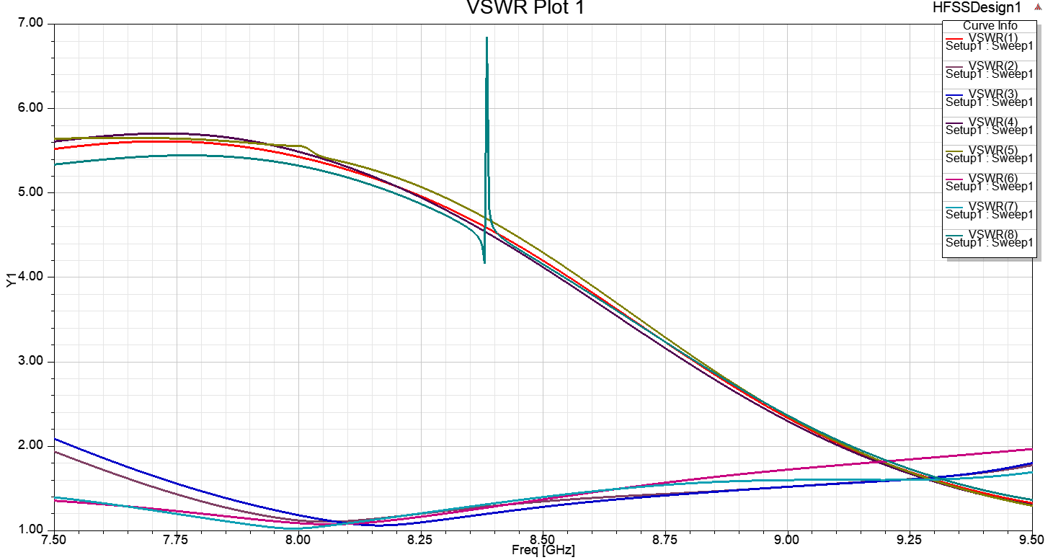
Fig. 9. VSWR curve of the antenna

- PERFORMANCE COMPARISON
Table 2 compares the intended Compact four-port MIMO antenna array to various existing MIMO systems in terms of size, isolation between antenna elements, ECC, operating bands, efficiency, and DG. As shown in the table, the recommended 4-port MIMO antenna has a wide impedance bandwidth, small dimensions, and excellent ECC and DG values.
P.S = proposed structure, DG =Directive Gain, ECC = Envelope correlation coefficient’

Ref. No. | Year | Number of  Ports | Size  (${mm}^{3}$) | Isolation  (dB) | ECC | Bandwidth  (GHz) | Efficiency  (%) | DG(dB)
[21] | 2018 | 2 | 30✕41 | < -20 | <0.1 | 2.2 GHz to 5GHz | 80 | -
[22] | 2018 | 3 | 58✕45 | < -15 | <0.6 | 3.1Ghz to 7GHz | 80 | -
[23] | 2021 | 2 | 50✕50 | < -21 | <0.04 | 2.36GHz to 12GHz | - | 9.99
[24] | 2020 | 2 | 32✕46 | <-20 | <0.5 | 3GHz to 11Ghz | - | -
[25] | 2018 | 1 | 46✕46 | <-17 | <0.02 | - | 75 | -
[26] | 2015 | 2 | 40✕40 | <-15 | - | 2.3 GHz to 8.8 GHz | - | -
[27] | 2015 | 1 | 38.5✕38.5 | <-15 | <0.1 | 2.5 GHz to 12GHz | >75 | 99
[28] | 2014 | 0 | 40✕40 | - | <0.005 | 2.2 GHz to 13.3GHz | - | 8-9.5
[29] | 2021 | 2 | 48✕48 | < -18 | <0.04 | 2.5 Hz to 5 GHZ | - | -
[30] | 2014 | 1 | 50✕82 | < -15 | <0.02 | 3 GHz to 9GHz | 60 | -
[31] | 2017 | 1 | 40✕30 | < -15 | - | 2.2GHz to 4.25GHz | 58 | 9.94
P.S | 2022 | 8 | 60✕60 | <-10 | <0.03 | 7.5 GHz to 9.5 Ghz | >75 | >9.95
Table 2. Performance Comparison of other antenna with proposed antenna

- CONCLUSION

Multiple input multiple output (MIMO) antennas with pattern diversity are a key technology for modern mobile communication system which enable high spectral efficiency. A key limiting factor in this technology is the size of the device which limits the number of radiating elements. This is due to the fact that preserving high isolation between plane. Using this technique ensures the high isolation between the ports and can lead to directive patterns from each element in the MIMO antenna. This makes the resulting design suitable for pattern diversity. The technique is applied on a IFA antenna and to test the validity of the proposed technique, 4 and 6 elements MIMO antenna are simulated and fabricated. A good agreement between the simulation and measurement is achieved which can validates the proposed technique. This technique can be a good candidate to design massive MIMO antenna for the IoT applications and 5G systems. where large number of antennas in a limited space is required.

REFERENCES

- J. Y. Deng, J. Yao, D. Q. Sun, and L. X. Guo, “Tenelement MIMO antenna for 5G terminals,” Microwave and Optical Technology Letters, vol. 60, Oct. 2018.
- H. Zou, Y. Li, C. Y. D. Sim, and G. Yang, “Design of 8 × 8 dualband MIMO antenna array for 5G smartphone applications,” International Journal of RF and Microwave ComputerAided Engineering, vol. 28, June 2018.
- W. Zhang, Z. Weng, and L. Wang, “Design of a dual-band MIMO antenna for 5G smartphone application,” 2018 International Workshop on Antenna Technology, pp. 1-3, Mar. 2018.
- Z. Qin, W. Geyi, M. Zhang, and J. Wang, “Printed eight-element MIMO system for compact and thin 5G mobile handset”, Electronics Letters, Vol. 52, pp. 416-418, Mar. 2016.
- W. S. Chen, Y. C. Wu, H. J. Lin, and J. C. Hsu, “Coupled-fed Meandered Loop Antenna for Mobile Phone Applications,” 2014 International Symposium on Antennas and Propagation Conference Proceedings, pp. 495-496, Dec. 2014.
- W. S. Chen, J. H. You, C. M. Wu, H. T. Chen, and Y. T. Liu, “Coupled-fed meandered loop antenna for USB Dongle Applications,” 2014 IEEE International Workshop on Electromagnetics, pp. 82-83, Aug. 2014.
- Ramachandran, A., S. Valiyaveettil Pushpakaran, M. Pezholil, and V. Kesavath, “A four-port MIMO antenna using concentric square-ring patches loaded with CSRR for high isolation,” IEEE Antennas and Wireless Propagation Letters, Vol. 15, 1196–1199, 2016.
- Wang, S. and Z. Du, “Decoupled dual-antenna system using crossed neutralization lines for LTE/WWAN smartphone applications,” IEEE Antennas and Wireless Propagation Letters, Vol. 14, 523–526, 2015.
- Tiwari, R. N., P. Singh, B. K. Kanaujia, and K. Srivastava, “Neutralization technique based two and four-port high isolation MIMO antennas for UWB communication,” AEU-International Journal of Electronics and Communications, Vol. 110, 152828, 2019. [Online]. Available: http://www.sciencedirect.com/science/article/pii/S1434841119311227.
- Srivastava, G. and A. Mohan, “Compact MIMO slot antenna for UWB applications,” IEEE Antennas and Wireless Propagation Letters, Vol. 15, 1057–1060, 2016.
- Lim, J., Z. Jin, C. Song, and T. Yun, “Simultaneous frequency and isolation reconfigurable MIMO PIFA using pin diodes,” IEEE Transactions on Antennas and Propagation, Vol. 60, No. 12, 5939– 5946, Dec. 2012.
- Lee, J., S. Kim, and J. Jang, “Reduction of mutual coupling in planar multiple antenna by using 1-D EBG and SRR structures,” IEEE Transactions on Antennas and Propagation, Vol. 63, No. 9, 4194–4198, Sep. 2015.
- Zhai, G., Z. N. Chen, and X. Qing, “Enhanced isolation of a closely spaced four-element MIMO antenna system using metamaterial mushroom,” IEEE Transactions on Antennas and Propagation, Vol. 63, No. 8, 3362–3370, Aug. 2015.
- Zhao, L. and K. Wu, “A dual-band coupled-resonator decoupling network for two coupled antennas,” IEEE Transactions on Antennas and Propagation, Vol. 63, No. 7, 2843–2850, Jul. 2015.
- Yuan, Y., K. Zhang, X. Ding, B. Ratni, S. N. Buroker, and Q. Wu, “Complementary transmissive ultra-thin meta-deflectors for broadband polarization-independent refractions in the microwave region,” Photon. Res., Vol. 7, No. 1, 80–88, Jan. 2019.
- Zhang, K., Y. Yuan, X. Ding, B. Ratni, S. N. Buroker, and Q. Wu, “High-efficiency metalenses with switchable functionalities in the microwave region,” ACS Applied Materials & Interfaces, Vol. 11, No. 31, 28423–28430, 2019.
- Kim, K. H. and J. E. Schutt-Aine, “Analysis and modeling of hybrid planar-type electromagnetic bandgap structures and feasibility study on power distribution network applications,” IEEE Transactions on Microwave Theory and Techniques, Vol. 56, No. 1, 178–186, Jan. 2008.
- Ryu, J. and H. Kim, “Compact MIMO antenna for application to smart glasses using T-shaped ground plane,” Microwave and Optical Technology Letters, Vol. 60, No. 8, 2010–2013, 2018.
- Lin, K., C. Wu, C. Lai, and T. Ma, “Novel dual-band decoupling network for two-element closely spaced array using synthesized microstrip lines,” IEEE Transactions on Antennas and Propagation, Vol. 60, No. 11, 5118–5128, Nov. 2012.
- Su, S., C. Lee, and F. Chang, “Printed MIMO-antenna system using the neutralization-line technique for wireless USB-dongle applications,” IEEE Transactions on Antennas and Propagation, Vol. 60, No. 2, 456–463, Feb. 2012.
- Gorai, A., A. Dasgupta, and R. Ghatak, “A compact quasi-self-complementary dual band-notched UWB MIMO antenna with enhanced isolation using Hilbert fractal slot,” AEU — Int. J. Electron. Commun., Vol. 94, No. June, 36–41, 2018.
- Jaglan, N., S. D. Gupta, B. K. Kanaujia, S. Srivastava, and E. Thakur, “Triple band-notched DG CEBG structure-based UWB MIMO/diversity antenna,” Progress In Electromagnetics Research C, Vol. 80, 21–37, 2018.
- Zhou, J. Y., Y. F. Wang, J. M. Xu, and C. Z. Du, “A CPW-fed UWB-MIMO antenna with high isolation and dual band-notched characteristic,” Progress In Electromagnetics Research M, Vol. 102, No. January, 27–37, 2021.
- Zhang, J., L. Wang, and W. Zhang, “A novel dual band-notched CPW-fed UWB MIMO antenna with mutual coupling reduction characteristics,” Progress In Electromagnetics Research Letters, Vol. 90, No. December, 21–28, 2020.
- Debnath, P., A. Karmakar, A. Saha, and S. Huda, “UMB MIMO Slot antenna with Minkowski fractal shaped isolators for isolation enhancement,” progress In Electromagnetics Research M, Vol. 75, No. September, 69–78, 2018.
- Zhu, J., B. Feng, B. Peng, S. Li, and L. Deng, “Compact CPW UWB diversity slot antenna with dual band-notched characteristics,” Microw. Opt. Technol. Lett., Vol. 55, No. 11, 2562–2568, 2015.
- Kang, L., H. Li, X. Wang, and X. Shi, “Compact offset microstrip-fed MIMO antenna for band-notched UWB applications,” IEEE Antennas Wirel. Propag. Lett., Vol. 14, 1754–1757, 2015, DOI: 10.1109/LAWP.2015.2422571.
- Mao, C. X., and Q. X. Chu, “Compact radiator UWB-MIMO antenna with dual polarization,” IEEE Trans. Antennas Propag., Vol. 62, No. 9, 4474–4480, 2014, DOI: 10.1109/TAP.2014.2333066.
- Mohan Reddy, S. S., B. Sanjay, K. Aruna Kumari, B. T. P. Madhav, and B. Prudhvi Nadh, “MIMO dual-sensing antenna with notch characteristics,” J. Phys. Conf. Ser., Vol. 1804, No. 1, 012194, 2021, DOI: 10.1088/1742-6596/1804/1/012194.
- Gao, P., S. He, X. Wei, Z. Xu, N. Wang, and Y. Zheng, “Compact printed uwb diversity slot antenna with 5.5-GHz band-notched characteristics,” IEEE Antennas Wirel. Propag. Lett., Vol. 13, 376–379, 2014.
- Toktas, A., “G-shaped band-notched ultra-wideband MIMO antenna system for mobile terminals,” IET Microwaves, Antennas Propag., Vol. 11, No. 5, 718–725, 2017, DOI: 10.1049/iet-map.2016.0820.

