RECENT TRENDS IN PLANT GENOME EDITING
R. R. Vaid
Ph.D. Scholar: Dept. of genetics and plant breeding,
C. P. College of Agriculture,
Sardarkrushinagar Dantiwada Agricultural University,
Sardarkrushinagar, 385505
rahulpatel5767@gmail.com

C. D. Prajapati
Ph.D. Scholar: Dept. of genetics and plant breeding,
C. P. College of Agriculture,
Sardarkrushinagar Dantiwada Agricultural University,
Sardarkrushinagar, 385505
chirag120397@gmail.com

R. S. Solanki
Ph.D. Scholar: Dept. of genetics and plant breeding,
C. P. College of Agriculture,
Sardarkrushinagar Dantiwada Agricultural University,
Sardarkrushinagar, 385505
srs75531@gmail.com

D. P. Joshi
Ph.D. Scholar: Dept. of genetics and plant breeding,
C. P. College of Agriculture,
Sardarkrushinagar Dantiwada Agricultural University,
Sardarkrushinagar, 385505
dhruvj4696@gmail.com

ABSTRACT
Genomic editing is a potent technology that enables researchers to change the DNA nucleotide sequence at almost any genome of species. Plant research and agriculture have been transformed by advances in genomics and the introduction of numerous genome-editing tools using designed site-specific nucleases (SSNs). Programmable nucleases, such as “meganuclease”, “zinc-finger nucleases”, “transcription activator-like effector nucleases (TALEN)”, and most recently “CRISPR-Cas9” systems, have been used in the development of a variety of technologies. The first programmable nucleases created to target and cleave specific locations were “zinc finger nucleases (ZFNs)”. The CRISPR-Cas9 system, a flexible tool for genome engineering, uses a guide RNA (gRNA) to direct Cas9 to a particular sequence. CRISPR stands for clustered regularly interspaced short palindromic repeats, while Cas9 stands for CRISPR-associated nuclease 9. This straightforward RNA-guided genome-editing technique has developed into a ground-breaking tool. In order to meet the increasing demands of the current global food hunger and to implement a workable and environmentally safe agriculture programme that is greater specifically, productive, economical, and eco friendly, genome editing technology is consistently used to increase average yield. These novel techniques, which are succinctly covered here, have shown to be effective and trustworthy tools for plant genetic modification.
Keywords: Meganuclease, Zinc finger nucleases, TALEN, CRISPR-cas 9
INTRODUCTION
Food security is the most urgent problem in the current circumstances of a fast growing global population.. Traditional plant breeding techniques for agricultural enhancement are more difficult and require extensive germplasm selection. However, contemporary genome editing (GE) techniques have the potential to precisely integrate a foreign gene into a specific location of the genome, enabling the correct replacement of an existing allele with an alternative one. Techniques that permit a targeted intervention in the genome with or without the insertion of a transgene are the most advanced breeding phase. Currently, highly adaptable genome-editing technologies allow for accurate and predictable editing of practically any locus in the plant genome, expanding the breadth of applications to include molecular crop breeding and functional genomics research. Compared to other organisms, plant cells face special difficulties when it comes to delivering the gene-editing agents. These difficulties include the presence of a rigid cell wall, the prevalence of species that are resistant to genetic transformation, the frequent occurrence of polyploidy, and the integration of Cas9 expression cassettes into the host genomes, to name a few. Over the past few decades, there have been numerous significant developments in molecular biology techniques. Programmable gene editing at the DNA level has made it possible to produce crops with desired traits and altered functions thanks to the development of the CRISPR/ Cas 9 system and the discovery of sequence-specific nucleases (SSNs). This article will concentrate on CRISPR/ Cas 9 reagents as well as recent advancements in the delivery of these reagents to plants, the current gaps, and potential future directions. The term "genome editing" refers to a group of procedures created recently to accurately alter organisms' genomes. Site-directed nuclease (SDN) technology and oligonucleotide-directed mutagenesis are two techniques used for genome editing (ODM). With the development of zinc-finger nucleases (ZFNs), meganulceases (MNs), transcription activator-like effector nucleases (TALENs), and CRISPR/ Cas 9, significant advancements in the field of genome engineering have recently been made.
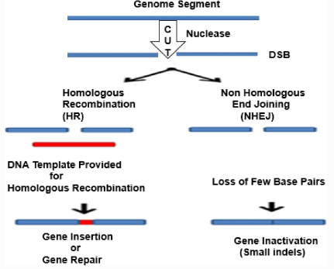

Fig 1. Results of genome editing, Double-strand breaks are produced by genome editing nucleases (DSBs). There are two methods for repairing breaks: homologous recombination (HR) in the presence of a donor template, or non-homologous end joining (NHEJ) in the absence of a donor template. Few base insertions or deletions, which result in an indel, or frameshifts, which disrupt genes, are produced by the NHEJ. A donor DNA can be integrated to the target site in the HR pathway to change the gene, introducing the nucleotides and inducing the insertion of cDNA or frameshifts.

APPLICATION OF GENOME EDITING
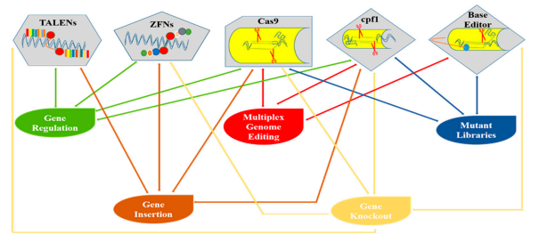

Fig 2. Diagrammatical representation of various genome editing tools and their applications in plants.

- Genome editing tools
- Site-directed nucleases (SDN)1/2/3
- Zinc Finger Nucleases
- TALE Nuclease
- CRISPR/CAS 9

- Site-directed nucleases (SDN)1/2/3
Genome editing using Site-Directed Nuclease (SDN) uses a variety of DNA-cutting enzymes (nucleases) that are guided to cut the DNA at a specific spot by a variety of various DNA binding mechanisms. One of two inherently occurring processes in cells is used by the cell's own DNA repair system to fix the damage after the cut is made:
Non-homologous end-joining (NHEJ): Non-homologous end-joining (NHEJ) involves rejoining the cut DNA, but during this process, a few basepairs may be eaten away or added, causing sporadic minor deletions (up to 20) or additions (a few basepairs) of nucleotides at the cut location.
Homology-directed repair (HDR): Using a donor DNA with the desired modification and homology to the target location, homology-directed repair (HDR) introduces this change.

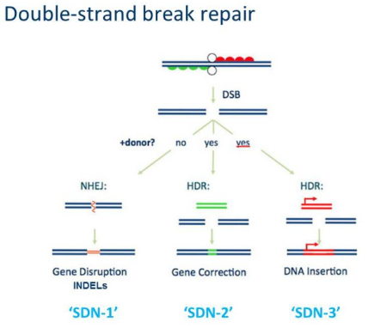

Fig 3. Site-directed nucleases (SDN)1/2/3

- Zinc Finger Nucleases
In the Zinc Finger Nuclease (ZFN) method, natural proteins are employed to attach to DNA in a sequence-specific manner, enabling the fused nuclease to cut as a "DNA scissor" at that particular site.
- This system includes a domain called "Zinc Finger" (recognising a sequence of specific base pairs triplets in the DNA sequence).
- A DNA nuclease that can break double-stranded strands.
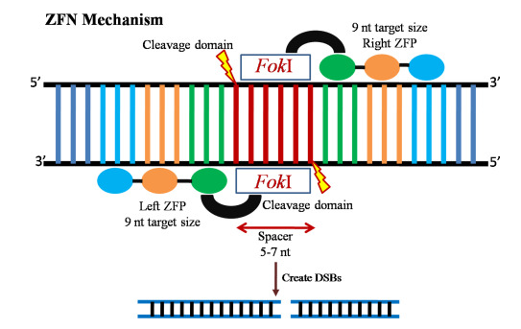
Fig 4. Zinc Finger Nucleases
- TALE Nuclease
Natural proteins are employed in the transcription activator-like Effector (TALE) method to attach to DNA in a sequence-specific manner, enabling the fused nuclease to cut as a "DNA scissor" at that particular spot.
This system consists of:
- This system includes a "TAL-effector" domain (which recognises a sequence of particular base pairs in the DNA sequence one by one)
- A nuclease that cleaves double-stranded DNA.
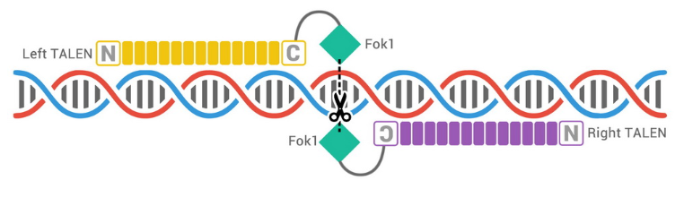
Fig 5. TALE Nuclease

- CRISPR/CAS 9
With CRISPR/Cas9, the process is made simpler since a guide RNA replaces a DNA binding protein. "Clustered Regularly Interspaced Short Palindromic Repeats (CRISPR)" is the name of this genetic technique.
The CRISPR/Cas9 system is modelled after a bacterial defence mechanism that uses an RNA guided nuclease to create highly focused genomic cuts in response to invading DNA (such as viruses).
The CRISPR-Cas9 complex consists of
- A Cas9 protein (Cas9 stands for “CRISPR associated)
- A single guide RNA (sgRNA)
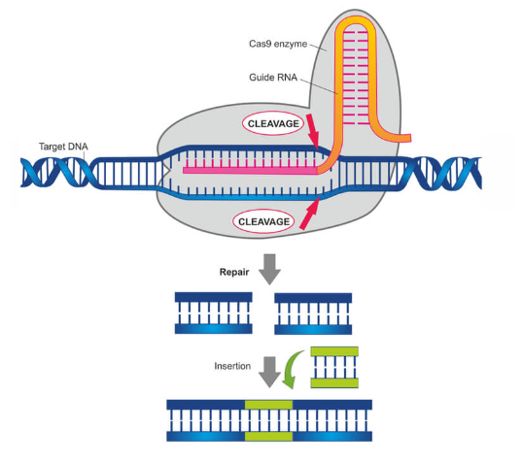

Fig 6. CRISPR/CAS 9
- Comparison of ZFN, TALENs and CRISPR-CAS9
Programmable nuclease | ZFNs | TALENs | CRISPR-CAS9
Derived from | Eukaryotic transcription factor | Eukaryotic transcription factor | Adaptive immune system of bacteria and archaea
Functional molecule | Protein | Protein | Ribonucleoprotein
DNA binding domain | Zinc fingers | TALE Protein | Guide RNA
Nuclease domain | FokI cleavage domain | FokI cleavage domain | Cas9 nuclease
SDN function provided by | one pair of ZFNs | one pair of TALENs | A single CRISPR-CAS9 SDN
Sequence recognition involves | Protein – DNA interaction | Protein – DNA interaction | RNA – DNA interaction
Recognition code | One ZF recognizes three bases; recognition context –dependent | One set of two amino acids recognizes one bases; recognition rules simple and independent of context | One base of sgRNA recognizes one base of the complementary strand of target DNA
Design and selection | Tedious and time consuming (protein engineering) | Easier than ZFNs (protein engineering) | Simple (RNA sequence design)
Commercial pricing | Very expensive | Expensive | Cheap
Target efficiency | Variable | Moderate | High
Off – target cleavage | Variable | Low | Moderate
Viral delivery | Easy | Moderate | Moderate
Length of binding site | 18-24 bases | 30-40 bases | 22 (20 target + 2 PAM) bases
Target site requirement | G rich; estimated to occur on an average, every 100 bp of genome sequence | Begins with T and ends with A; modified versions of TALENs do not have this requirement | Ends with NGG or NAG (to a lesser extent); mutant Cas9 have altered PAM requirements; other Cas9 orthologous require other PAM sequence
Length (in kb) of DNA encoding the SDN | 1 | 3 | 4.2
Suitability for target multiple loci | Low | low | Very high
Ease in targeting multiple targets | Difficult | Difficult | Easy
Success rate | Low | High | High
Cut ends at DSBs | Staggered with cohesive overhangs of variable lengths; useful for precise integration of donor DNA | Staggered with cohesive overhangs of variable lengths | Blunt; Staggered ends can be generated by using a pair of cas9 nickases for DSB induction

References
Ain, Q. U., Chung, J. Y., & Kim, Y. H. (2015). Current and future delivery systems for engineered nucleases: ZFN, TALEN and RGEN. Journal of Controlled Release, 205, 120-127.
Gaj, T., Gersbach, C. A., & Barbas III, C. F. (2013). ZFN, TALEN, and CRISPR/Cas-based methods for genome engineering. Trends in biotechnology, 31(7), 397-405.
Razzaq, A., Saleem, F., Kanwal, M., Mustafa, G., Yousaf, S., Imran Arshad, H. M., ... & Joyia, F. A. (2019). Modern trends in plant genome editing: an inclusive review of the CRISPR/Cas9 toolbox. International Journal of Molecular Sciences, 20(16), 4045.

