Review of Image Enhancement in Spatial vs, Frequency Domain
¹Anita Pati Mishra
²Monika Dixit Vajpayee
Abstract:
Image enhancement is a critical and difficult step in the processing of digital images.The fundamental aim of image enhancement is to uncover the hidden components in a picture. Picture enhancement improves the quality of the image for human presentation. Enhancement procedures include things like increasing contrast, eliminating noise and blur, and revealing details.Spatial domain and frequency domain picture enhancement are the two basic types.The two tactics discussed in this chapter are contrasted with ones that are comparable to them.The aim of image enhancement is to make images simpler for research to comprehend or perceive or to provide "better" input to other automated image processing techniques, like face recognition-based biometric techniques, among others.Face recognition, matching fingerprints, and early biology applications. Picture enhancement is one of the most important and difficult steps in digital image processing. The main aim of image enhancement is to reveal the hidden details in a picture.The quality of the image is improved for human presentation by picture enhancement.Increasing contrast, eliminating noise and blur, and illuminating features are a few examples of enhancement operations.Spatial domain and frequency domain are the two main types of image enhancement.This chapter contrasts these two approaches with ones that are comparable to them.The goal of image enhancement is to make images simpler for people to interpret or perceive or to provide "better" information to other automated image processing techniques, including biometric techniques that use face recognition, among others.Face recognition, fingerprint comparison, and preliminary biological terms biometric techniques that use face recognition, among others like matching fingerprints, recognising faces, and morphological applications.
Keywords: Digital Image processing, Image Enhancement, Automated Image Processing, Fingerprint Matching & Fourier Transform.
Introduction
Image processing is a technique used to perform specific operations on an image to create a better image or to extract some useful information from it.A picture is used as the input in this type of signal processing, and the output may be another image or properties or attributes that are connected to the input image.Image processing is one of the modern technologies that is growing swiftly.It also functions as a key research topic within the fields of engineering and computer science.
Improvement and coercion on Arithmetic and Logic operations:
Importing the image using image capture tools, analysing and editing the image, and producing the result—which could be an altered image or a report that incorporates image analysis—are the three steps that make up an image process.Analogue and digital technologies are the two main categories used for picture processing.
Analogue and digital technologies are the two main categories used for picture processing.
Analog image processing can be used for copies that require a lot of labour, including printouts and images. Image analysts apply a number of interpretational pillars while utilising these visual techniques. Computers can edit digital photos more easily thanks to digital image processing algorithms. Each form of knowledge should go through three general steps when employing digital technology: pre-processing, development, and show, data extraction. In this course, we'll utilise a lot of basic terms like "image," "digital image," and "digital image process."For each source of digital photos, an example will be shown, and numerous sources will be thoroughly analysed. the time it takes for a picture to appear in a laptop's screen. We will use several numerous techniques Basic terms like "image," "digital image," and "digital image process" are used throughout the course. For each source of digital photos, an example will be shown, and numerous sources will be thoroughly analysed. The journey from image processing to computer vision will be covered in this talk. We'll sum up by citing various image sensor types and image acquisition.
Division and Sampling
To be appropriate for digital processing, an image action f(x,y) needs to be digitalized both spatially and by amplitude.A frame unpleasant person, or digitizer, is often used to quantize and sample the analogue video output.Therefore, our goal is to digitise continuous knowledge in order to produce a digital image.

There are two steps to completing it:
Sampling Quantization
The division level defines the number of grey levels in the digitised image, whereas the rate controls the abstraction resolution of the digitised image. In image processing, the size of the sampled image is expressed as a digital worth. Division is the process of switching from the continuous values of an image to its digital equivalent.For humans to be able to distinguish the subtle shading characteristics in the image, there should be a sufficient number of division levels. The fundamental flaw in an image that has been measured at a low brightness level is the prevalence of spurious contours.We'll use two crucial steps of the digital picture processing in this course. Sampling and division will be adequately explained. The introduction of abstraction and grey-level resolutions.
Common interpolation algorithms may be classified into 2 categories:
Accommodative and Non-adaptive.
The division level defines the number of grey levels in the digitised image, whereas the rate controls the abstraction resolution of the digitised image.
In image processing, the size of the sampled image is expressed as a digital worth.
Division is the process of switching from the continuous values of an image to its digital equivalent For humans to be able to distinguish the subtle shading characteristics in the image, there should be a sufficient number of division levels. The fundamental flaw in an image that has been measured at a low brightness level is the prevalence of spurious contours. We'll use two crucial steps of the digital picture processing in this course. Sampling and division will be adequately explained. The introduction of abstraction and grey-level resolutions
Aliasing and image improvement
Image improvement: distinction enhancement, part I
Digital slice of any signal, whether sound, digital film land, or other signals, can produce apparent signals at frequentness that are significantly lower than those of the original. When a symbol is tried from a signal at double the optimal frequence, aliasing occurs. In order to help the product of signals at frequentness outside the original sound, signals advanced than0.5 Hz should be filtered. As a result, low- pass pollutants are used in digital audio recording outfit to remove any signals that are constantly lesser than0.5. Since a sample is a direct system, its affair will be an addition of tried sinusoids if its input is an addition of sinusoids.

Image enhancement ways are wide employed in several operations of image process
wherever the private quality of filmland is vital for mortal interpretation. Distinction is a pivotal think about any private analysis of image quality. Distinction is made by the distinction
in brilliance imaged from 2 conterminous shells. In indispensable words, distinction is that the distinction in visual parcels that produces Associate in Nursing object distinguishable from indispensable objects and thus the background..

Our sensitive system is fresh sensitive to distinction than absolute luminance; so, we will understand the earth inversely in malignancy of the respectable changes in illumination conditions. several algorithms for negotiating distinction enhancement are developed and applied to issues in image process.
In this lecture we'll quote distinction enhancement. Linear andnon-linear metamorphosis functions like image negatives, exponent metamorphoses, power- law metamorphoses, and piecewise direct metamorphoses are going to be mentioned. Bar graph system and bar graph of 4 introductory slate- position characteristics are going to be introduced. A fashion that aims to lessen the appearance of aliased slant edges isanti-aliasing. More resolution and the appearance of sandblasted edges are handed byanti-aliasing. It functions by counting for the degree to which a perfect edge overlaps neighbouring pixels. We ’ll use quotations from abstraction aliasing andanti-aliasing in this donation. In addition, we'll start talking about how to boost your image. There will be 2 main orders of image enhancement introduced. The purpose system and neighbour system will be described. Eventually, we'll offer an preface to associate in nursing distinction.
Image improvement: Distinction enhancement, part II
Still, e, If the distinction of a picture is extremely concentrated on a particularvaries.g. a picture is incredibly dark; the data could also be lost in those areas that are too and slightly targeted. The matter is to optimize the distinction of a picture so as to represent all the data within the input image.

Abstraction sphere filtering, part I

Removing noise can be a way of modifying or enhancing an image thereby not loosing the quality of pixels. Abstract sphere manipulation or filtering (current pixel reuse value current pixel reuse value depends on each pixel itself and its neighbors). Removing disturbances can thus be a surrounding pixels’ operation in which the value of any element in the incident image is fixed by applying a formula to the values ​​of the image primitives in the surroundingof the corresponding input pixel values. A pixel neighborhood is a set of pixels represented by their position with respect to the pixel.
This part cover concrete sphere calculations. Sketches and contaminants were outlined. Final complication system. explained introduction of employees involved in nursing care. We also take examples of smoothing direct contaminants such as box and weighted average contaminants.

Abstraction sphere filtering, part II
One type of finite impulse response (FIR) filtering is spatial filtering.Actually, the sludge is a mask of weights arranged in a truly blocklike pattern.The method works by sliding the mask across the image and performing a multiply and add operation on the pixels it lines up.Ordered applied calculation contaminants and median sludge will be discussed in this presentation.Gradient and Laplacian ordered discriminational pollutants, both original and alternative, will be introduced.
.Basics of Spatial Pollutants

Spatial Filtering and Its kinds
Direct application of spatial filtering types on image pixels.Most masks can be customised to fit a specific centre component.The centre of this mask, which impacts the specified image, goes through every pixel in the target image. Classification on the premise of linearity
There are 2 types of square measure.
1. Linear spatial Sludge
2. Non-linear spatial Filter
General Classification

Smoothing Spatial Sludge Smoothing sludge is employed for blurring and noise reduction within the image. Blurring ispre-processing way for junking of bitsy details and Noise Reduction is fulfilled byblurring images.
Forms of Smoothing spatial Filter

1. Linear Filter( Mean Filter)
2. Order Statistics(Non-linear) filterBMGHKHIGKHYOOMPKPPTPMPPH- HJ( H(()( F)() FHJHH) H() LH)) JGL( JG( LG( J() GLJ( GLH( G( JLF() O
DYRGIRIITRYROYORIDAYOPUTUJDGLTIO( OP( UIHUHJJJJI ’( O, JKKJJ

These square measures explained as following below.
Mean Filter

Linear space mud is only representative of the pixels contained in the neighborhood of the mud mask. The study is the value of each element in the painting through a neighborhood figure through a mud mask typical of the Argentinian situation.
Types of Mean sludge

•( i) Comprising sludge it's employed in reduction of the detail in image. All portions square measure equal.
•( ii) Weighted averaging sludge during this, pixels square measure increased by fully different portions. Center element is increased by a better worth than average sludge.

2. Order Statistics Filter
It's supported the ordering the pixels contained within the image space encompassed by the sludge. It replaces the worth of the middle element with the worth determined by the ranking result. Edges square measure advanced saved during this filtering.

Types of Order statistics sludge
Text To Speech
y the most important value within the window.
•( iii) Median sludge every element within the image is taken into account. 1st neighbouring ingredients square measure sorted and original values of the pixel square measure replaced by the standard of the list.

stropping special Filter

It's also called by- product sludge. The end of the stropping spatial sludge is simply the volition of the smoothing spatial sludge. It’s main focus in on the junking of blurring and highlights the sides. It's supported the primary and alternate order by- product.

First order outgrowth
Must be zero in flat parts.
• Must be non zero at the onset of a argentine position step.
• Must be non zero on ramps.

First order by- product in 1- D is given by
f' = f( x 1)- f( x)
Alternate order secondary

• Must be zero in flat areas.
• Must be zero at the onset and finish of a ramp.
• Must be zero on ramps.

Alternate order by- product in 1- D is given by
f'' = f( x 1) f(x-1)- 2f( x)
The special sphere enhancing relies on pixels in a veritably bitsy vary( neighbour). this implies the remodelled intensity is set by the slate values of these points inside the neighbourhood, and thus the special sphere sweetening is also appertained to as neighbourhood operation or neighbourhood process.

The x-y plane specifies a specific position word, sometimes known as the special sphere, because digital images are frequently regarded as two-dimensional objects f(x, y).Special sphere filtering is the name of the filtering procedure that is provided by the x-y area neighbourhood.To make the middle of the sludge correspond with the goal, the filtering system will move the sludge point-by-point within the image by performing f(x, y) ( x, y).The response of the sludge is determined at each point (x, y) using its exact composition and a predetermined relationship referred to as an example.However, if the element in the neighbourhood is calculated as a direct operation, it is also referred to as direct special sphere filtering; otherwise, it is referred to as nonlinear spatial sphere filtering.The portions of the sludge in direct spatial filtering give a weighting pattern. For illustration, for Figure2.3.1, the response R to the template is
R = w(- 1,-1) f(x-1, y- 1) w(- 1, 0)
f(x-1, y) w( 0, 0) f( x, y)
w( 1, 0) f( x 1, y) w( 1, 1) f( x 1, y 1)
For a sludge with a size of( 2a 1, 2b 1), the affair response can be calculated with the following function
Cleaning Up Pollutants
Image smoothing is a technique for suppressing and reducing noise in digital images.
Neighborhood averaging can typically be used to achieve the goal of smoothing in the spatial domain.Average Smoothing
Let's start by examining the smoothing sludge in its most basic manifestation—the average template and its perpetrator.
The (x, y) purpose element within the new image " g " is determined by the points within the three by three neighbourhood focussed on the purpose(x, y).
Since all sections are one, they all contribute an equal amount of weight to the g(x, y) value system.
The final constant, 1/9, is used to demonstrate that the total length of the template corridor adds up to one.
As a result, the new image maintains the original image's argentine scale range, such as (0, 255).
A median template is referred to as such a " w ".
How it works?
The intensity values of adjacent pixels are typically similar, and as a result, noise causes argentine scale leaps at noise spots.However, it is reasonable to presume that infrequent noises do not affect a picture's inherent longevity.For example, in various image below, the bright area contains two black dots..
For the borders, we can add a padding using the “ replicate ” approach. When smoothing the image with a 3 × 3 average template, the performing image is thefollowing.OHOBOONOH Squall( FGNJF( = MHNFHHMHPJRP )=P
The two noises are replaced with the normal of their girding points. The process of reducing the influence of noise is called smoothing or blurring.

In the image-processing step, spatial pollutants are stropped and smoothed.
However, in this particular instance, smoothing will be necessary to get a solid conclusion.
This prompted the investigation and creation of strategies equipped to handle any operation.

The original strategy is sometimes to think of it as a two-way process, with the original smoothing coming first and the latter stropping, or the other way around.
However, this strategy can occasionally result in a number of problems.
On the one hand, if we utilise smoothing techniques, we run the risk of losing data that cannot be retrieved in the following step of the stropping process.
The opposite is true, though, if we tend to employ a stropping methodology over . We're going to magnify the noise gift in a loud image.
The best way to deal with this issue is to think of a method that may sharpen image features and edges while reducing noise.
Given the different nature of those 2 procedures, this may not be an easy task.

There are several methods for both stropping and smoothing that are described in the literature, but if we choose to restrict oneself to methods that consider each of them simultaneously, the progressive is not as fierce.
In this work, we'll conduct a joint survey.
Smoothing
These techniques are additive, cumulative, and impulsive.
Impulsive noise can occasionally be identified by certain image pixels becoming corrupted while the others remain unaltered.
Once the values in the original image are altered by adding arbitrary values that follow a specific liability distribution, cumulative noise appears.
In the end, introducing noise makes it more difficult to escape filmland than cumulative noise since, in this instance, intensities fluctuate in conjunction with signal intensity (e.g., patch noise).

There are several and completely diverse sources of noise..
The thing of defensive image quality can be found in image smoothing methods.
In other words, to eliminate noise without sacrificing the image's best options.
However, there are many different types of noise.
three most
Another captivating example is Gaussian noise, in which each visual component will have its initial value altered by a touch that follows a distribution.
White cumulative Gaussian noise is used to model this form of noise.
Therefore, if the quality of the distribution characterises the noise intensity, its presence is routinely deceived by adding arbitrary values from a zero-mean distribution to the original picture element intensities in each individual image channel.

UIUCThe elimination of this kind of noise is understood as smoothing, and this may be the kind of noise elimination allowed - about during this work. There square measure numerous nonlinear ways for smoothing. within the remainder of the section, we're going to review a number of them.
Bilateral Sludge( BF)
A great number of them leverage the zero-mean quality of the Gaussian noise in nonlinear ways to their benefit.
The well-known Bilateral Sludge BF) and its variations are included in this order.
BF may be a non-linear method capable of smoothing a picture while appreciating solid edges.
This might be accomplished by processing each component of the image as a weighted average of its pixel values.

Spatial and Frequency Domain — Image Processing
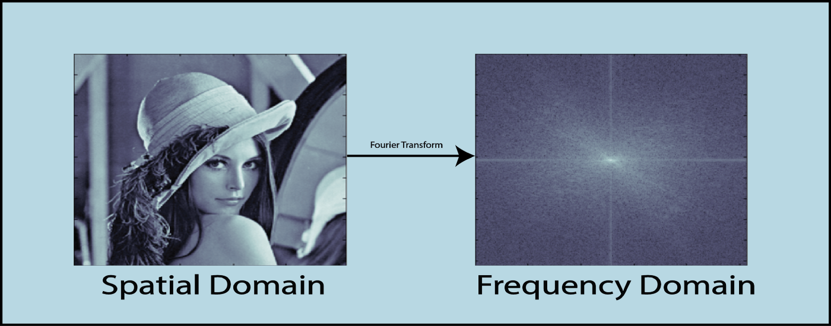

Spatial Domain-
Representing the intensity of a pixel can be used to represent an image.
The term "Spatial Domain" refers to the state of 2D matrices that show the intensity distribution of an image.
It can be visualised as follows: 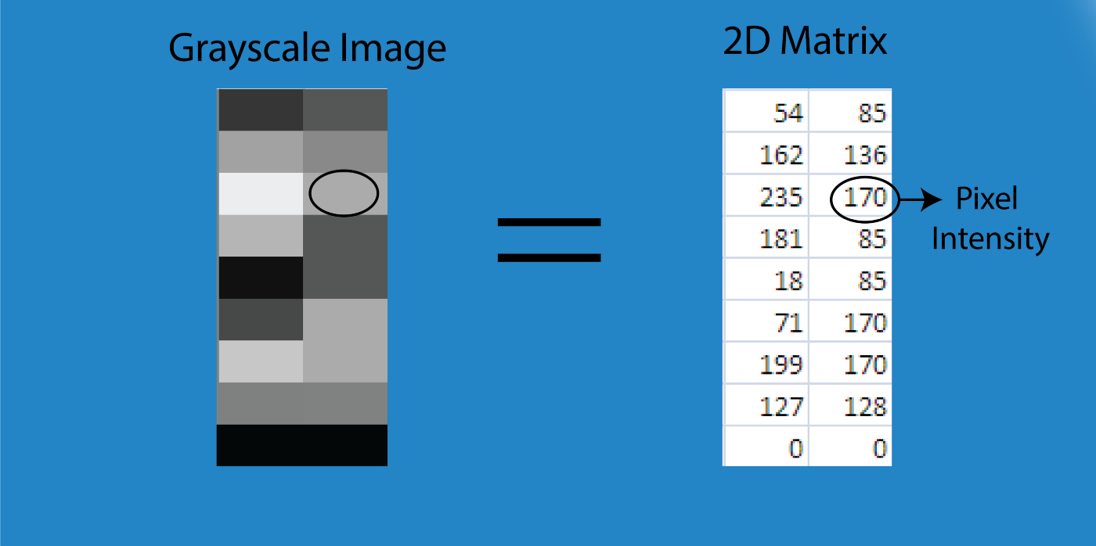
Illustration of Spatial Domain
For the RGB image, the spatial domain is represented as a 3D vector of 2D matrices. Each 2D matrix contains the intensities for a single color as shown below-
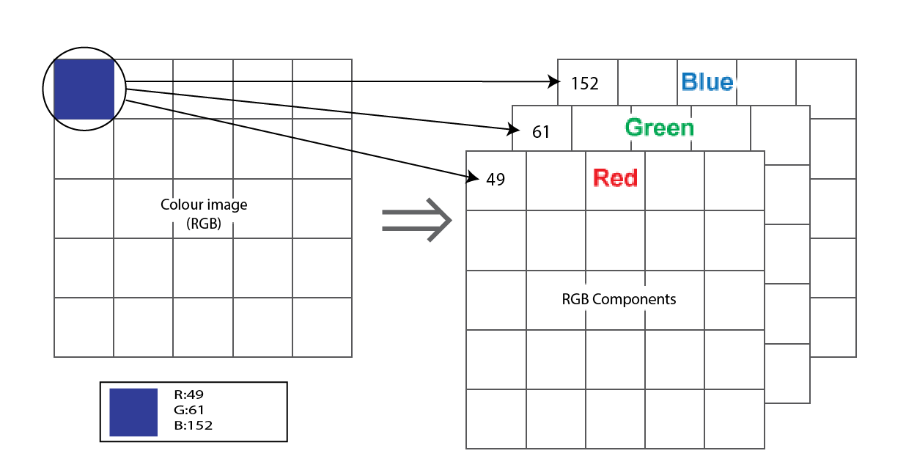
The coordinates of each pixel in the 2D matrix, x, and y, are used to represent each pixel's intensity as I(x,y).
This value performs a variety of operations.
For instance, operation T (let's say adding 5 to all the pixels) is carried out in I(x,y), increasing each pixel's value by 5.
You might write this as- I’(x,y) = T[I(x,y)]
where, I’(x,y) is the new intensity after adding 5 to I(x,y).

Frequency Domain-
The foundation of frequency-domain techniques.
The term "frequency" in an image generally refers to the rate at which pixel values vary.

The picture below shows how to use the Fourier Transform to convert an image from the spatial domain to the frequency domain.
Some pictures mentioned below of image enhancement techniques of frequency domain as well as spatial domain.

Image Transformation mainly follows three steps-
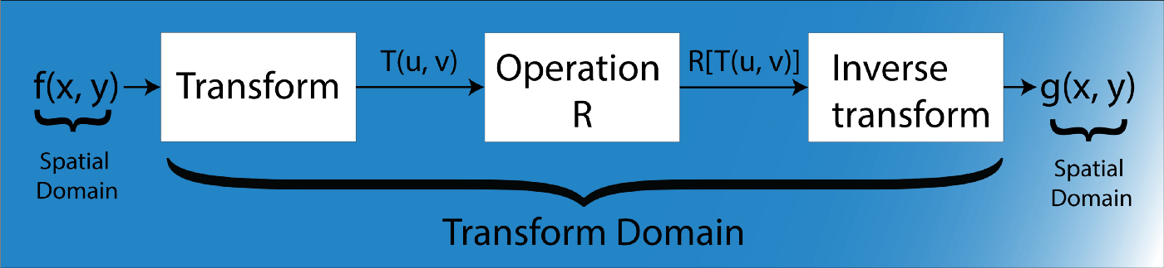
Step-1. Transform the image.
Step-2. Carry the task(s) in the transformed domain.

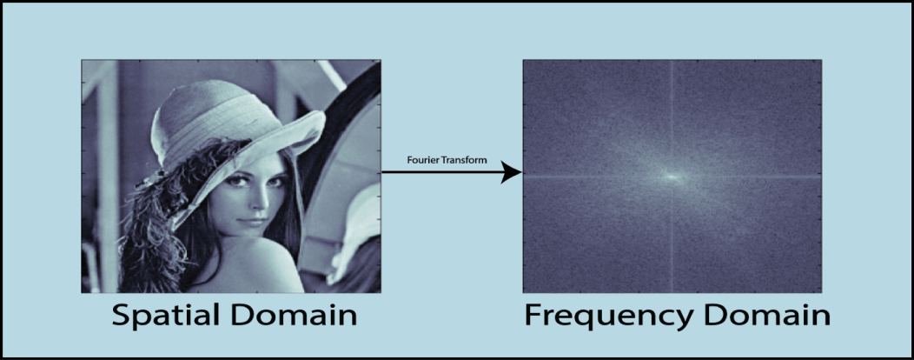
Conclusion:
Linear filtering is one of the most comfortable involved in 2 dimensional image processing. Before such processing methods can be implemented on a system, the images have to be digitalized, which implies spatial sampling and luminance quantization. Spatial sampling induces periodicities in the frequency representation of the processed images, which allows limiting their pixel categorization to a precise frequency domain. The spatial convolution operator is the mathematical representation associated with linear and spatially invariant filtering. Filtering computation can be implemented in the spatial or frequency domain depending on the nature and the complexity of the applied filters. In the most common cases, the operator is fully represented by a (2x2) order or a( 3x3) order matrix which is called moving window matrix which is used as an operator to check the whole matrix of the total image pixels. Examples of such filters and their results on real images are presented to give an idea of the application potential of the technique. The operations are carried out on Clown(320,320) and Lena images(120,120) for better performance observation. Further research can be continued for lesser degradation in various images restoration and better clarity in pixel values of 2 dimensional images.
References:
[1] A. Adler, D. Boublil, and M. Zibulevsky. Block-based com-pressed sensing of images via deep learning. In 2017 IEEE19th International Workshop on Multimedia Signal Process-ing (MMSP), pages 1–6, 2017.
[2] P. E. Batson, N. Dellby, and O. L. Krivanek. Sub- ̊angstromresolution using aberration corrected electron optics. Nature,pages 617–620, 2002. 1
[3] Benjamin Berkels, Peter Binev, Douglas A. Blom, Wolf-gang Dahmen, Robert C. Sharpley, and Thomas Vogt. Op-timized imaging usingnon-rigid registration. Ultrami-croscopy, 138:46 – 56, 2014. 1.
[4] E. J. Candes and T. Tao. Near-optimal signal recoveryfrom random projections: Universal encodinstrategies?IEEETransactionsonInformation Theory, 52(12):5406–5425, 2006. 1
[5] Emmanuel J. Cand`es, Justin K. Romberg, and Terence Tao.Stable signal recovery from incomplete and inaccurate measurements.Communications on Pure and Applied Mathe-matics, 59(8):1207–1223, 2006.
[6] I. Daubechies, M. Defrise, and C. De Mol. An iterativethresholding algorithm for linear inverse problems with asparsity constraint. Communications on Pure and AppliedMathematics, 57(11):1413–1457, 2004.
[7] W. Dong, G. Shi, X. Li, Y. Ma, and F. Huang. Compressivesensing via nonlocal low-rank regularization. IEEE Transac-tions on Image Processing, 23(8):3618–3632, 2014. .
[8] D. L. Donoho. Compressed sensing. IEEE Transactions onInformation Theory, 52(4):1289–1306, 2006. 1, 2
[9] Jeffrey M. Ede, Beanland, and Richard. Partial scanningtransmission electron microscopy with deep learning. Sci-entific Reports, page 8332, 2020. 2
[10] M. Haider, S. Uhlemann, E. Schwan, and et al. Electronmicroscopy image enhanced. Nature, pages 768–769, 1998

