A Rising Tendency in Humans’ Farming and Linking Farmers to Data Science & IOT Technology

¹Dr A Arun Kumar, Associate professor
Department of CSE
Marri Laxman Reddy Institute of Technology and Management
Dundigal, Hyderabad -500043.

²Dr. Madhavi Pingili, Professor & HoD
Department of Information Technology
CMR ENGINEERING COLLEGE (CMREC)
HYDERABAD
TELANGANA - 501401

ABSTRACT
A specially appointed system is a promising innovation which can be connected in a broad number of regions extending from natural observing to fiasco the executives. Moreover, specially appointed systems can be executed in use of sensors for procedure mechanization in a decent variety of modern applications. Occasions, for example, quakes can frequently serve to represent the shortcoming of midway overseen systems and the significance of innovative work in impromptu systems Technology in data science to make smarter decisions, reduce costs, and boost production of crops through GPS – based application development for web and mobile platforms to keep track of farm feeds and check soil moisture levels, wearable device integration to connect with the farmer's community and share information among them to updates day-to-day activities. Automation of farm equipment through online marketing, data warehousing, management, cloud-based services for weather, maps, visual aids to comprehend data for a faster decision-making system. Space technology helps to urge fast and unbiased information about the crop situation in India. It provides digital data, which is amenable to varied analyses, which require information on crop type, crop area estimates, crop condition, crop damages, crop growth, etc.
Keywords - E-agriculture, Data Science technology, Sciences, GPS.

INTRODUCTION

Data science is the management of large data sets from disparate sources to generate specific results which assist in informed decision making National Agriculture Market indiancommodities.com, agricoop.nic.in, Indian Society of Agribusiness Professionals, Department of Agriculture, Cooperation and Farmers Welfare, Agriculture Insurance, Farmer’s Portal, E-Couple, Big basket The healthcare industry has an enormous amount of data generated from various researches, patient’s diagnosis, hospital record systems, aged care, and many other related services and products.,
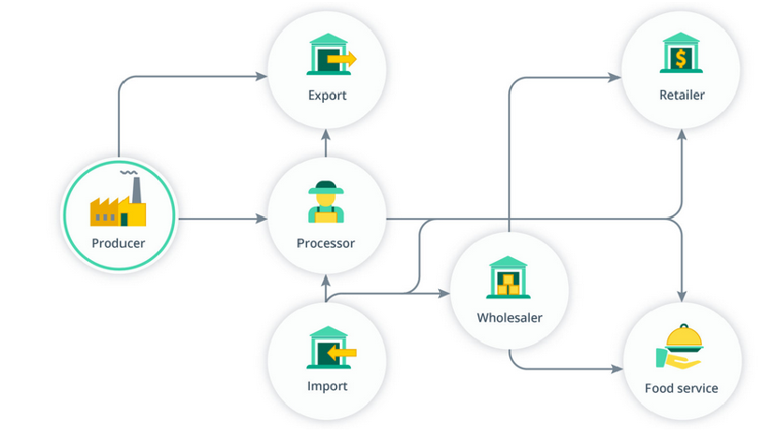
FIGURE 1 Role of Farming
Now a day's most countries adopt the “IoT” technology in agriculture to enhance food production and safety with smart logistics & warehousing. Collecting data and analyzing crop diseases, weather-forecasting, soil quality. Integrated pest management and control to observation, inspection, identification, record tracking and automatic spraying of pesticides at right time through remote crop A specially appointed system is a promising innovation which can be connected in a broad number of regions extending from natural observing to fiasco the executives. Moreover, specially appointed systems can be executed in use of sensors for procedure mechanization in a decent variety of modern applications. Occasions, for example, quakes can frequently serve to represent the shortcoming of midway overseen systems and the significance of innovative work in impromptu systems monitoring, climate monitoring, and forecasting as well the water management through due to adequate water system is important for agriculture, excess or shortage of water will kill the crops. “IoT” makes better water management with a couple of sensors, data, and other machinery is used for smart farming, so a farmer can get real-time data related to the agriculture process. The paper aims at making modern agriculture using advanced machinery like remote sensing, Geographical Information System (GIS), soil and seed development through.
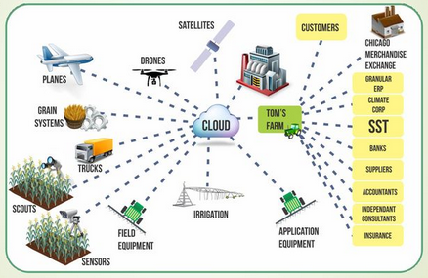
FIGURE 1.1 Sources and application of Data
PROEDURE OF E-AGRICULTURE IN NOIDA

E-agriculture is to establish communication through the virtual will be given to agricultural extension officer who acts as an interface, and plays a crucial role in executing agro advisory services to empower the farmer, and enable to provide the updated information about the government subsidies and initiatives. so the farmers are well aware of the eco-system and enable the process of getting information of weather, soil, humidity, climate change data by storing wireless sensor in the agricultural fields, get the direct market value and ask the queries through video calling directly by the scientist. The Government of India also creates an awareness campaign for the farmers on how best they can use modern technologies to conduct agribusiness.
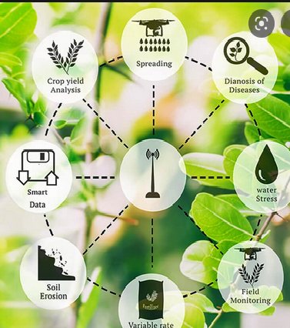
FIGURE 1.2 E-Agriculture Architecture

SMART AGRICULTURE MANAGEMENT SYSTEM
Advanced machinery for routine operations is used instead of using in traditional farming as manual labor work. get the direct market value and ask the queries through video calling directly by the scientist. The Government of India also creates an awareness campaign for the farmers on how best they can use modern technologies to conduct agribusiness Crop & water management, pest management, soil monitoring, and crop area estimation, food production storage, and safe processing get the direct market value and ask the queries through video calling directly by the scientist. The paper aims at making modern agriculture using advanced machinery like remote sensing, Geographical Information System (GIS), soil and seed development through.
The Government of India also creates an awareness campaign for the farmers on how best they can use modern technologies to conduct agribusiness water will kill the crops. “IoT” makes better water management with a couple of sensors, data, and other machinery is used for smart farming, so a farmer can get real-time data related to the agriculture process. The paper aims at making modern agriculture using advanced machinery like remote sensing agricultural productivity and avail the information of farm research, planning, extension, production, monitoring, marketing, and trade. E-agricultural market capable of handling all market operations auctions and price discovery

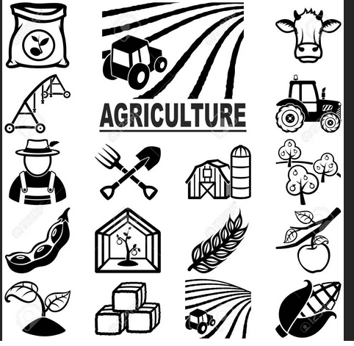

FIGUR1. 3 Smart Agriculture Methodology Framework
E-AGRICULTURE MARKET STRATEGY
E-Agriculture is a piece of modern information and communication tools and technologies that increase agricultural productivity and avail the information of farm research, planning, extension, production, monitoring, marketing, and trade. E-agricultural market capable of handling all market operations auctions and price discovery, trade fulfillment, fund processing, getting a better price on the sale of produces. The adoption of online trading of agricultural commodities, will eliminate delays in finalizing the transactions and bring in transparency In South Africa we have not seen this type of technology yet, although there are a number of companies who are in the process of developing data products and might even be in the final testing stages. In the US, there are a lot of data products and services available to the public, but it’s only in its first innings and iterations. We’ll need to wait for the real innovation to come, but once it does, it will be transformational.
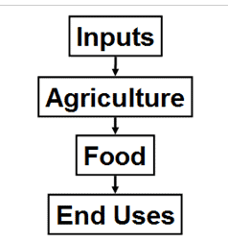
FIGURE1. 4 Online Commodities Marketing of Farming
The paper aims at making modern agriculture using advanced machinery like remote sensing, Geographical Information System (GIS), soil and seed development through.Transforming rural India with the E-Agriculture concepts farmers get better returns for their farm produce. Indian rural market of farming is going to transform with the better access of policies and programs of government schemes for farmers, on Soil recommendations, crop management, weather and marketing of Digital Temperature Sensor: The temperature sensor read the temperature with one digital pin of. Soil Moisture Sensor: soil moisture sensor FC-28 interface with gives us the moisture level as an output. Pressure Sensor agriculture produce, e-aid. According to the report of Department of Agriculture, Cooperation and Farmers Welfare give the estimation of production of food grains.

The paper aims at making modern agriculture using advanced machinery like remote sensing, Geographical Information With the movement of the world towards digital agriculture, a lot of investment has been poured into it. Numerous research and development are going on to maximize the efficiency of farms. Incorporating new technology will escalate the yields of both small- and large-scale farms System (GIS), soil and seed development through.as shown in below agricultural economics and statistics chart of mainly produced crops Wheat Rice and Maize, it grows exponentially with adopted strategies of Agriculture. But if we see the world open market of exports of crops, according to the survey report of a global agricultural commodities market for selected countries by 2050 With the movement of the world towards digital agriculture, a lot of investment has been poured into it. Numerous research and development are going on to maximize the efficiency of farms. Incorporating new technology will escalate the yields of both small- and large-scale farms outcomes of crop exports is decreased as shown The paper aims at making modern agriculture using advanced machinery like remote sensing, Geographical Information soil and seed development through.

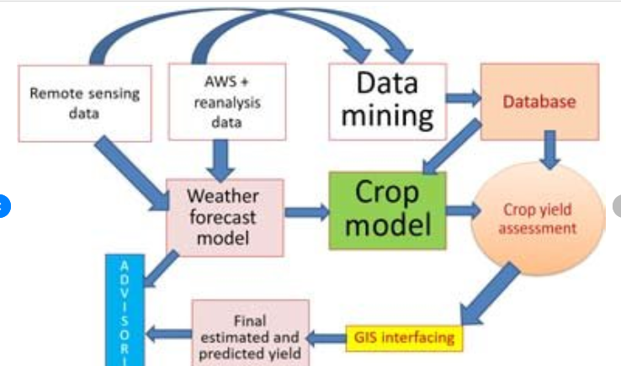
FIGURE 1.5 impact of open markets on net trade positions, and production in India
SOLUTION ARCHITECTURE AND IOT COMPONENTS
To make the complete “IoT” system architecture for agriculture the following components are required: Digital Temperature Sensor: The temperature sensor read the temperature with one digital pin of. Soil Moisture Sensor: soil moisture sensor FC-28 interface with gives us the moisture level as an output. Pressure Sensor A specially appointed system is a promising innovation which can be connected in a broad number of regions extending from natural observing to fiasco the executives. Moreover, specially appointed systems can be executed in use of sensors for procedure mechanization in a decent variety of modern applications.
Occasions, for example, quakes can frequently serve to represent the shortcoming of midway overseen systems and the significance of innovative work in impromptu systems Digital Temperature Sensor: The temperature sensor read the temperature with one digital pin of. Soil Moisture Sensor: soil moisture sensor FC-28 interface with gives us the moisture level as an output. Pressure Sensor or Air Quality Sensor: pressure sensor and. Digital Humidity Sensor: is used with. Light Intensity Sensor & Amplifier: Digital Light Sensor detects a wide range at high resolution.
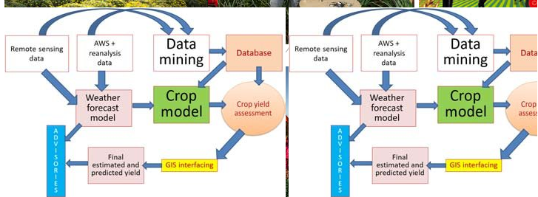
FIGURE1. 6 Based Agriculture Field Monitoring

NOVEL PROPOSED IOT WORKING MODEL
A specially appointed system is a promising innovation which can be connected in a broad number of regions extending from natural observing to fiasco the executives. Moreover, specially appointed systems can be executed in use of sensors for procedure mechanization in a decent variety of modern applications. Occasions, for example, quakes can frequently serve to represent the shortcoming of midway overseen systems and the significance of innovative work in impromptu systems Both the soil moisture sensor and humidity sensor are connected to perform an action, will send the data to the database through the internet cloud if any emergency then sends the message to the farmers using a device called GSM Module. In “IoT" based crop field monitoring system the motor will be automatically ON through a Soil moisture sensor, it will show you on your handheld devices (Mobile or Tablets) shown through a webpage or mobile application
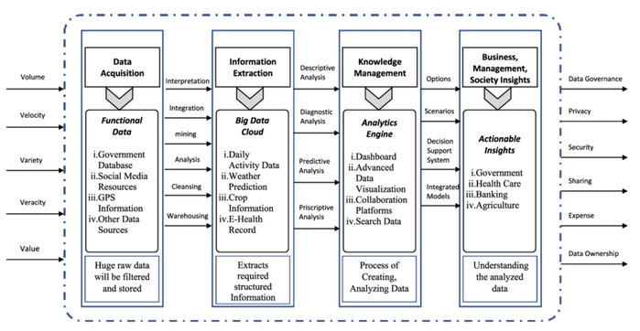
FIGURE 1.7 Working Model
Agriculture is the backbone of the Indian Economy. However, statistics show that the rural population and arable land per person is declining. This is an ominous development for a country with a population of more than one billion, with over sixty-six percent living in rural areas. This paper aims to review current studies and research in agriculture If the moisture is detected a bit low, in that case, the motor should be power supply is step-down by a transformer, and then supplied to will collect all the data from all sensors then send it to the server and perform data analytics action.
RESULTS
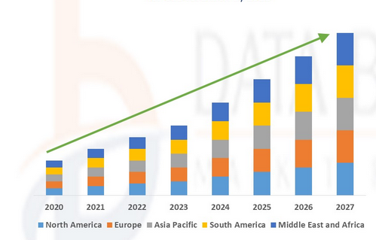
FIGURE1. 8 Analysis

CONCLUSION
The rapid growth in the agricultural sector E-Farming provides new avenues to share and access information to our farmers. Modern E-Agriculture technology (Machine Learning, Internet of Things, Cloud computing, Big Data, and data analytics) is enabling tremendous innovation potential of the agriculture sector, A specially appointed system is a promising innovation which can be connected in a broad number of regions extending from natural observing to fiasco the executives. Moreover, specially appointed systems can be executed in use of sensors for procedure mechanization in a decent variety of modern applications. Occasions, for example, quakes can frequently serve to represent the shortcoming of midway overseen systems and the significance of innovative work in impromptu systems to meet the identified goal and challenges that our farmers face in recent trends. The Government of India also creates an awareness campaign for the farmers on how best they can use modern technologies to conduct agribusiness.
References
- Chaitanya S, K., Ilayarajaa, K., Karthikeyan, & Reddy, K. M. (2017). ANDROID BASED IOT FOR AGRICULTURE AUTOMATION. International Journal of Pure and Applied Mathematics , XVII (21), 169-176.
- Chandra, G. N., Khayongek, S., Armedia, N., Soni, R., & Brahma, B. (2016). E-AGRICULTURE STRATEGY GUIDE. Bangkok: Food and Agriculture Organization of the United Nations and International Telecommunication Union .
- Chauhan, R., Jagtap, S., Ahire, S., Bhoyate, A., & Nalavade, K. (2017). E-trading of Agricultural Products from Farm to Customer Application. International Research Journal of Engineering and Technology , IV (3), 2756-2759.
- da Silva, J. G. (2018). The State of Agricultural Commodity Markets 2018. Agricultural trade, climate change and food. Rome: Food and Agriculture Organization of the United Nations.
- Ghogare, S. A., & Monga, P. M. (2015). E-Agriculture” Introduction and Figuration of its Application. International Journal of Advanced Research in Computer Science and Software Engineering , V (1), 44-49.
- Gondchawar, N., & Kawitkar, R. S. (2016). IoT based Smart Agriculture. International Journal of Advanced Research in Computer and Communication Engineering , V (6), 838-842.
- M R, S., Pabshettiwar, A., Ghumatkar, K., Budhehalkar, P., & Jaju, P. (2012). E-FARMING. International Journal of Computer Science and Information Technologies , III (2), 3479-3482.
- Madhusudhan, L. (2015). Agriculture Role on Indian Economy. Business and Economics .
- Malavade, V. N., & Akulwar, P. K. (2016). Role of IoT in Agriculture. IOSR Journal of Computer Engineering , 56-57.
- Patil, G. L., Gawande, P. S., & Bag, R. V. (2017). Smart Agriculture System based on IoT and its Social Impact Social Impact. International Journal of Computer Applications , XVI (1), 1-5.
- Raju, K., Naik, G., Ramseshan, R., Pandey, T., & Joshi, P. (2016). Transforming Agricultural Marketing in India: Linking Farmers to a National Gateway and E-Markets. Telangana, India: ICRISAT Development Center.
- Sangtrash, H. M., & Hiremath, A. S. (2017). Review on IoT for Indian Farmers. International Journal of Scientific Research in Computer Science, Engineering and Information Technology , II (3), 236-239.
- Sharma, D., Shukla, A., Bhondekar, A. P., Ghanshyam, C., & Ojha, A. (n.d.). A Technical Assessment of IOT for Indian Agriculture Sector. International Journal of Computer Applications , 1-5.
- Strzębicki, D. (2011). Selling of agricultural products via the Internet. 176-195.
- Sundar, I. (2016). AGRIBUSINESS SCOPE, OPPORTUNITIES AND CHALLENGES IN INDIA. EPRA International Journal of Economic and Business Review , IV (7), 171-178.
- Thankachan, S., & Kirubakaran, S. (2014). E-Agriculture Information Management System. International Journal of Computer Science and Mobile Computing , III (5), 599-607.
- Myung Jong Lee, Jianling Zheng, Xuhui Hu, Hsin-hui Juan, Chunhui Zhu, Yong Liu, June Seung Yoon, and Tarek N. Saadawi, “A New Taxonomy of Routing Algorithms for Wireless Mobile Ad Hoc Networks: The Component Approach”, IEEE Communications Magazine, vol. 44, no.11, pp. 116-123, November 2006
- K. Akkaya and M. Younis, “A Survey of Routing Protocols in Wireless Sensor Networks”, Elsevier Ad Hoc Network Journal, Vol 3/3,pp.325-349, 2005
- Veena Venugopa, Radim Barto, Michael J. Carter, and Sai S. Mupparapu, “Improvement of Robustness for Ad Hoc Networks Through Energy-Aware Routing”, University of New Hampshire, Durham, NH 03824, USA,2002.

- Charles E. Perkins, “Ad hoc On-Demand Distance Vector (AODV) Routing”, INTERNET DRAFT, Mobile Ad Hoc Networking Working Group, 17 February 2003.
- Rabaey, J. Ammer, J. L. da Silva Jr, D. Patel, “PicoRadio: Ad hoc Wireless Networking of Ubiquitous Low-Energy Sensor/Monitor Nodes”, Proceeding WVLSI '00 Proceedings of the IEEE Computer Society Annual Workshop on VLSI (WVLSI'00), 2001.

