Groundwater Management Studies Using Geological and 2D ERI Techniques in Ariyanayakipuram Village, Tirunelveli, Tamil Nadu, India.
Antony Ravindran. A¹, *Vinoth Kingston. J¹, Antony Alosanai Promilton. A¹, Moorthy. G¹, Richard Abishek. S¹, Aswin. S.K¹, Abinaya. R¹
¹ Department of Geology, V.O.Chidambaram College, Thoothukudi
*Corresponding Author- Vinoth Kingston. J
e-mail-vinothkingston17@gmail.com
Abstract
The research evaluates the aquifer and groundwater seepage all around the reservoir. Researchers employ imaging techniques based on the electrical resistivity of materials in two dimensions. Ten different profiles were obtained at the site of the study, each from a side perspective. The average length of the profiles is 90 meters, and their average depth is 25 meters. The RES2DINV tool was used to generate graphs of the resistance readings. Inside the reservoir, 2D electrical resistivity imaging (2D ERI) was acquired utilizing a Wenner array, and the data were analyzed utilizing a pseudo-section approach. The geology of the study area consists of red soil and weathered gneissic rock, both of which are appropriate for 2D electrical resistivity imaging due to their high contrast. As the resistivity data is interpreted along the profile, the model's resistivity pseudo section in the reservoir region becomes clear. The pseudo section indicates hard rock at a depth of 4.06 m to 5.96 m, where the resistivity ranges from 103 Ωm to 120 Ωm.
Keywords: Aquifer, RES2DINV, 2D ERI, Resistivity, Pseudo-section

1.1 Introduction
Besides drinking and farming, people use water for many other purposes. In the vast majority of areas where water scarcity is a problem. The ever-increasing need for groundwater is a direct result of the world's population expanding at an exponential rate. An overall lack of topographic variation characterizes the area. The water utilised for irrigation comes from a selective network of rivers. Tamiraparani, Nambiar, Hanumanthai, and Vaippar are some of these rivers. Over 62% of the district's net cultivated area is devoted to growing paddy, making it the most important crop there (Central Ground Water Board, 2009; Gupta, 2008; Venkatasalam, 2020). The majority of India's agricultural and household water comes from groundwater rather than surface water. This percentage falls somewhere between 70 and 80 percent. Because of increased urbanization and the subsequent overuse of groundwater and improper disposal of trash, groundwater quality has declined. Many studies on the safety of groundwater for human consumption and agricultural irrigation have been done in recent years (Patil et al., 1989). Research of this nature has been conducted in a wide range of settings. Wells and tube wells are regularly being dug deeper to tap into the ever-dwindling groundwater resources in areas where there is a severe water deficit and a high demand for agricultural output. This is carried out to fulfill consumer needs. Consequently, this investigation is being conducted to evaluate and map the distribution of groundwater in the inner blocks of the Tirunelveli district. Several studies examined the Tirunelveli region's groundwater potential by employing Remote Sensing and GIS (Muthuraj et al., 2010; Kirubakaran et al., 2018; Senthilkumar et al., 2015and Muniaraj et al., 2020).
1.2 Study Area
The villages of Thalarkulam, Ariyanayakipuram, and Sanganhiradu are included in the area of study, which is situated within the Tirunelveli district. The southwest and northeast monsoons have an effect on the amount of rain that falls in the study area. The northeast monsoon is largely responsible for the rainfall in the region. The total area of the district receives an average annual rainfall of 879 millimeters. Typical of the subtropics, this area has warm, humid summers and mild, dry winters. The months of May and June are notorious for their high temperatures and lack of precipitation. The months of December and January have mild temperatures and clear skies. The usual range for relative humidity is between 79% and 84%. The average high temperature is 33.5 degrees Celsius, with a low of 22.9 degrees Celsius.

1.3 Geology:
The top layer is predominantly composed of clay, red soil, and welded gneissic rock with a range of undulations. Micaceous schist is intruded in the charnockite rock, which is quickly worn due to water leaks and excess burden of weight. Water seeps through the rock because of erosion. Minor joints and faulted zones of several types can be seen in the field.
2.1 Material and Methods
Subsurface vertical and horizontal horizons can be examined quickly and inexpensively using the 2D electrical resistivity imaging investigation. To determine the resistivity model, the measured values of apparent resistivity are inverted into inversion resistivity pseudo sections using the RES2DINV program. Model resistivity values are evaluated smoothly with sharp contrast using iteration, which also lowers the disparity between the computed values. Results from this smooth inversion are more accurate when examining subsurface geology with distinct zones separated by sharp boundaries. The electrical resistivity method has been recognized as an innovative approach for assessing groundwater seepage. Surface electrical resistivity recorded for the same geological formation can be used to estimate recharge based on the characteristics of the groundwater aquifer. To better locate underground water sources, electrical resistivity profiling data was gathered in the field. The electrical resistivity imaging study was carried out by the researchers Ravindran and Ramanujam, 2014; Asry et al., 2012; Day Lewis et al., 2006; Vinoth Kingston et al., 2022; Kroeger et al., 2007; Hermans and Paepen, 2020; Henderson et al., 2010 and Farooq et al., 2022.
With the help of an Aquameter CRM 500 Resistivity meter, steel electrodes, and connecting cables, ten 2D ERI profiles were taken in the reservoirs near the villages of Thalarkulam, Ariyanayakipuram, and Sanganhiradu.(Fig.1).
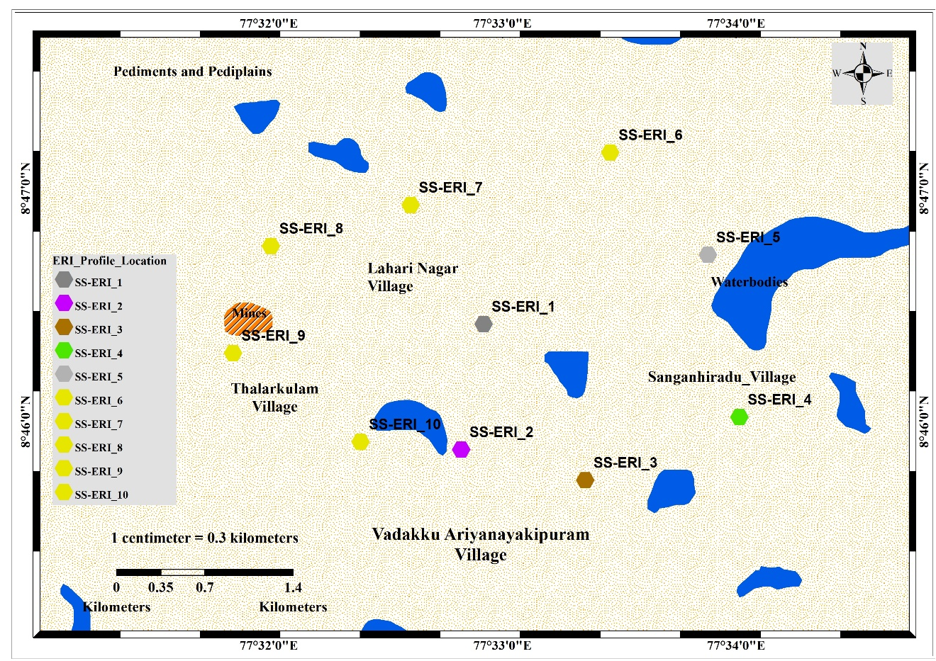
Figure 1 Location map of the Study Area
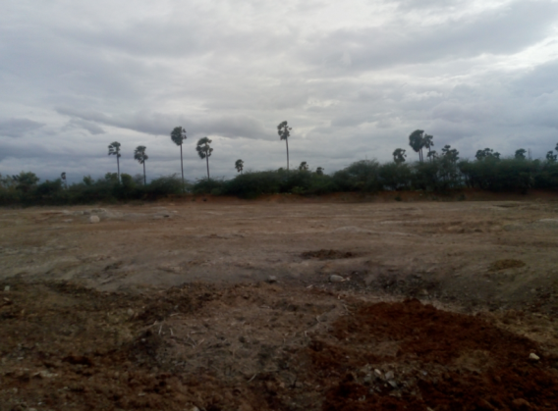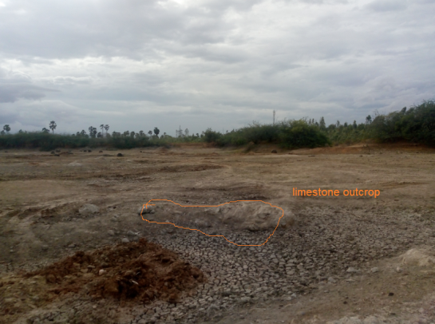
Figure 2 fautled zone in the reservior
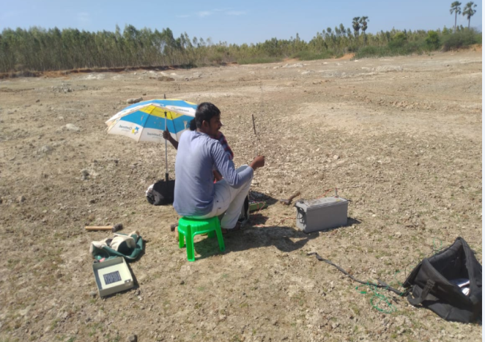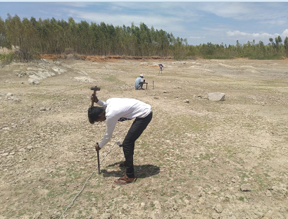
Figure 3 Field work data collection and electrode layout
3. Result and Discussion
The plotted resistivity pseudo section value is used to determine water level and geological formation of the study area. From the resistivity profiling data is used to identify the top layer covered with red soil with clay with fine sand and caliche deposits mixed with gneissic rocks. The highly hard rock of charnockite is occurred at hilly structure of the study area.The electrical resistivity method determines the presence of water at varying depths by measuring the range of resistivity from 100 to 120 Ohm.m.
3.1 Profile 1 – 4:
For a total of 80 meters in length, profiles 1-4 trend in a southeast-northwest direction. Up to a depth of 10 meters, the inversion shows resistivity values between 50–150-ohm m, indicating that weathered composite rock is present. The resistivity of the second, intermediate layer varies between 110-20-ohmm for water-bearing formations in worn gneissic rock and calcareous limestone deposits, respectively. A hard and compact granulitic rock can be identified by its high resistivity zone in the pseudo section, which has a resistivity range of 200 to 1500 ohm.m and occurs between 15 and 30 meters deep.
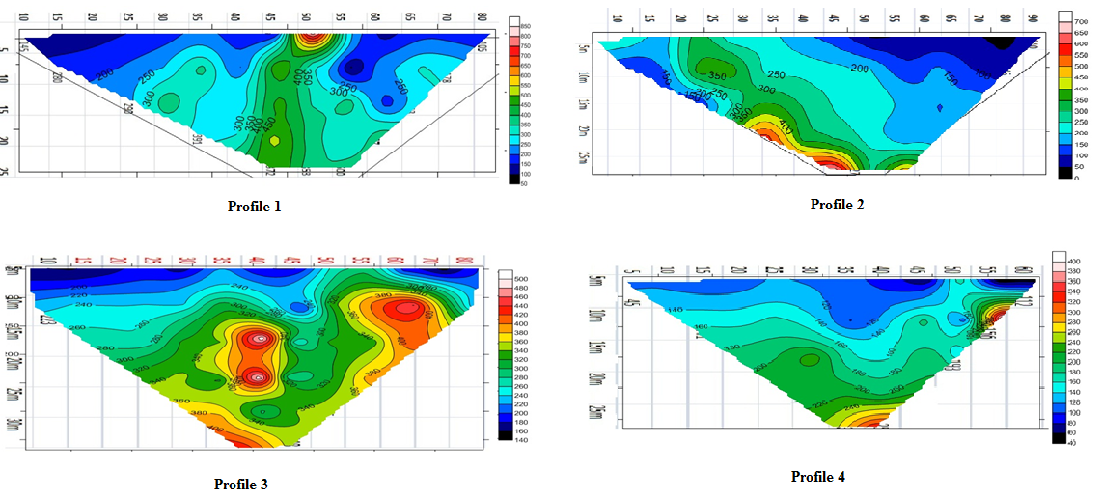
Figure 4 2D Electrical Resistivity Imaging Profile 1 to 4
3.2 2D ERI Profile 5 - 7:
This profile begins 80m from the northwestern portion of the research area in a northeast-to-southwest orientation. In the middle, the low resistivity zones of 20 to 60 ohm. m varies from dark blue to light blue, indicating a weathered rock with a water-saturated zone. Up to a depth of 10 meters, 120-ohm m. The water resistivity leaking zone is consistent with the weathered gneiss.
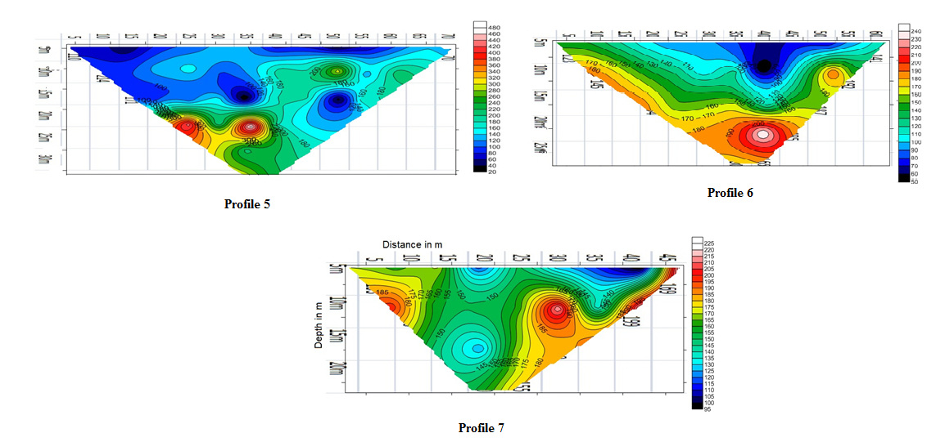
Figure 5 2D Electrical Resistivity imaging Profile 5 to 7

3.3 2D ERI Profile 8 - 10
The study area profiles 8–10 follow a pattern of 80m in length from the southern half of the reservoir to the eastern edge. The inversion resistivity pseudo section shows the water-saturated soil formation at 5 m depth, with the upper as deposits defined by resistivity in the 50-70 Ohm.m range. For the intermediate layer that contains the water-bearing zone, the resistivity of the weathered gneissic rock can be anywhere from 100 to 125 Ohm.m. The resistivity values in the composite gneiss zone segment range from 250 to 750 Ohm.m.
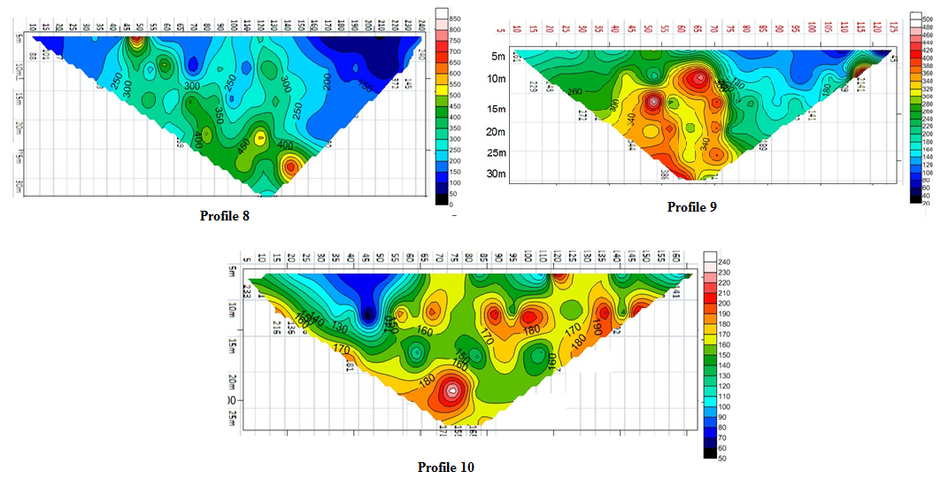
Figure 6 2D Electrical Resistivity Imaging Profile 8 to 10
4. Conclusion
Observations of the shallow and deep groundwater levels are taken in a depth range of 1-15 metres with a resistivity range of 100–120-ohm m for all profiles. The resistivity value is utilized to establish the suitable groundwater zone of the study area for groundwater management. The profiles 8 through 10 are employed for this determination. A resistivity reading of 250 ohms or more was recorded near a stony ridge, while a reading of 100 to 120 ohms was recorded in a freshwater zone. There are three distinct resistivity zones visible in the electrical pseudo section along the profiles in the current study: hard rock, weathered zone, and soil with water bearing zone. The 2D ERI analysis was utilised to ascertain the predominant groundwater trends in the reservoir, which were found to be to the southeast, northeast, and northwest.
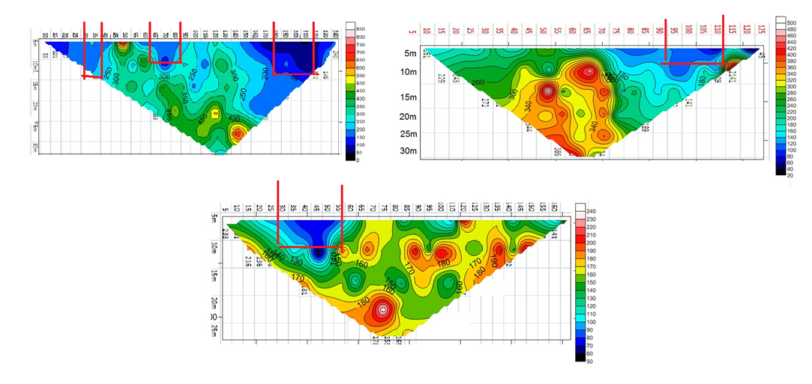
Figure 7 Shows the well recommended zone
Following the selection process, further construction of dug wells was carried out on the selected profiles, as seen in the image above with red lines drawn on them. The graphic showed that the shade of blue was beneficial for the aquifer qualities that were covered by the hard rocks in order to control the groundwater in the nearby locations. Following the selection process, further construction of dug wells was carried out on the selected profiles, as seen in the image The graphic showed that the shade of blue was beneficial for the aquifer qualities that were covered by the hard rocks in order to control the groundwater in the nearby locations.
References
- Venkatasalam, K., Balasubramaniam, P., & Ramesh, G. G. T. (2020). Assessment of groundwater quality in inland blocks of Tirunelveli District of Tamil Nadu. IJCS, 8(3), 2350-2356. https://doi.org/10.22271/chemi.2020.v8.i3ah.9563
- Balachandran A. District Groundwater Brochure Tirunelveli District, Tamil Nadu. Central Ground Water Board South Eastern Coastal Region Chennai, 2009, 1- 20. http://cgwb.gov.in/District_Profile/TamilNadu/Tirunelveli.pdf.
- Gupta, E. K. (Ed.). (2008). Water crisis in India. Atlantic Publishers & Dist. ISBN: 9788126909582, 8126909587.
- Kirubakaran, M., Colins Johnny, J., & Samson, S. (2018). MODFLOW based groundwater budgeting using GIS: a case study from Tirunelveli Taluk, Tirunelveli District, Tamil Nadu, India. Journal of the Indian Society of Remote Sensing, 46(5), 783-792. https://doi.org/10.1007/s12524-018-0761-7

- Muthuraj, D., Srinivas, Y., & Chandrasekar, N. (2010). Delineation of groundwater potential areas--a case study from Tirunelveli district, tamilnadu, India. International journal of applied environmental sciences, 5(1), 49-57.
- Senthilkumar, M., Arumugam, R., Gnanasundar, D., C Thambi, D. S., & Kumar, E. S. (2015). Effects of geological structures on groundwater flow and quality in hardrock regions of northern Tirunelveli district, southern India. Journal of Earth System Science, 124(2), 405-418. https://doi.org/10.1007/s12040-015-0538-0
- Muniraj, K., Jesudhas, C. J., & Chinnasamy, A. (2020). Delineating the groundwater potential zone in Tirunelveli Taluk, South Tamil Nadu, India, using remote sensing, geographical information system (GIS) and analytic hierarchy process (AHP) techniques. Proceedings of the National Academy of Sciences, India Section A: Physical Sciences, 90(4), 661-676. https://doi.org/10.1007/s40010-019-00608-5
- Ravindran, A. A., & Ramanujam, N. (2014). Detection of submarine groundwater discharge to coastal zone study using 2d electrical resistivity imaging study at Manapad, Tuticorin, India. http://nopr.niscpr.res.in/handle/123456789/27258
- Day-Lewis, F. D., White, E. A., Johnson, C. D., Lane Jr, J. W., & Belaval, M. (2006). Continuous resistivity profiling to delineate submarine groundwater discharge—Examples and limitations. The Leading Edge, 25(6), 724-728. https://doi.org/10.1190/1.2210056
- Vinoth Kingston, J., Antony Ravindran, A., Richard Abishek, S., Aswin, S. K., & Antony Alosanai Promilton, A. (2022). Integrated geophysical and geochemical assessment of submarine groundwater discharge in coastal terrace of Tiruchendur, Southern India. Applied Water Science, 12(1), 1-17. https://doi.org/10.1007/s13201-021-01553-8
- Kroeger, K. D., Swarzenski, P. W., Greenwood, W. J., & Reich, C. (2007). Submarine groundwater discharge to Tampa Bay: Nutrient fluxes and biogeochemistry of the coastal aquifer. Marine chemistry, 104(1-2), 85-97. https://doi.org/10.1016/j.marchem.2006.10.012
- Henderson, R. D., Day-Lewis, F. D., Abarca, E., Harvey, C. F., Karam, H. N., Liu, L., & Lane, J. W. (2010). Marine electrical resistivity imaging of submarine groundwater discharge: sensitivity analysis and application in Waquoit Bay, Massachusetts, USA. Hydrogeology Journal, 18(1), 173-185. https://doi.org/10.1007/s10040-009-0498-z
- Hermans, T., & Paepen, M. (2020). Combined inversion of land and marine electrical resistivity tomography for submarine groundwater discharge and saltwater intrusion characterization. Geophysical Research Letters, 47(3), e2019GL085877. https://doi.org/10.1029/2019GL085877
- Asry, Z., Samsudin, A. R., Yaacob, W. Z., & Yaakub, J. (2012). Groundwater investigation using electrical resistivity imaging technique at Sg. Udang, Melaka, Malaysia.
- Farooq, M., Nisar, U. B., Khan, S., Jalees, T., Mughal, M. R., Ali, L., & Ahmed, T. (2022). Electrical resistivity tomography for delineating groundwater potential zones in fractured meta sedimentary rocks, Lesser Himalayas, Pakistan. Journal of Earth System Science, 131(2), 1-14. https://doi.org/10.1007/s12040-022-01863-8

