BOOK Title: Futuristic Trends in Renewable & Sustainable Energy
Chapter 1. Solar energy advancements and their environmental impacts
Priyanka Sati, Ankita Kumari and Sudesh Kumar*
Department of Chemistry, Banasthali Vidyapith, Rajasthan 304022, India
Author’s Email: satipriyanka789@gmail.com
Author’s Email: ankitakumari01955@gmail.com
*Corresponding author’s Email: sudeshneyol@gmail.com
Contents
1.1. Introduction……………………………………………………………….1
1.2. History of Solar energy…………………………………………………....3
1.3. Types of Solar energy…………………………………………………......4
1.3.1. Passive Solar energy………………………………………………...4
1.3.2. Active Solar energy…………………………………………………5
1.3.3. Photovoltaic Solar energy………………………………………......6
1.3.4. Thermal Solar energy……………………………………………….6
1.4. Advantages of Solar energy……………………………………………… 7
1.5. Disadvantages of Solar energy……………………………………………8
1.6. Environmental impact assessment of solar energy…………………..........9
1.7. The innovations of solar energy technology…………………………........9
1.7.1. Self-cooling panels…………………………………………….......11
1.7.2. Innovation in materials…………………………………………....11
1.7.3. Solar straight from space………………………………………......12
1.7.4. Solar desalination………………………………………………......12
1.7.5. Solar panels………………………………………………………...12
1.7.6. Portable solar……………………………………………………....13
1.7.7. Grid batteries……………………………………………………....13
1.8. Ways to improve the efficiency of solar energy………………………….13
1.9. Advantages after introducing advanced technologies in solar energy .......14
1.10. Environmental Impact assessment…………………………………….16
1.10.1. Environmental impacts from photovoltaic power generation....17
1.10.2. Environmental impacts from solar thermal electricity………...18
1.11 Conclusion………………………………………………………………18
1.12 Acknowledgement………………………………………………………19
1.13 Conflict of interest……………………………………………………….19
1.14 Research funding’s………………………………………………………19
1.15 References……………………………………………………………….20-23

Abstract
Through the use of photovoltaic panels or indirectly through the use of concentrated solar power, the solar energy system transforms solar energy into electrical energy. Solar Energy is the most essential source of energy, and it has continued to gain popularity globally. Solar energy has recently experienced a massive growth as a result of both technological advancements that have reduced costs and government policies that support the development and use of renewable energy sources. This is because there is an increasing demand for clean, environmentally friendly energy sources. This chapter largely tackles solar energy and covers its innovations, advancements, and prospects for the future. Energy resources can be divided into non-renewable and renewable energy sources. Due to some adverse environmental effects including air pollution, climate change, and the loss of natural resources, people are concentrating on employing renewable energy resources to generate electricity. One of the most talked-about sources of sustainable energy is solar energy. The current chapter gives a general summary of the world's solar energy capacity, their classification, advantages, and contains crucial methods for enhancing their usability, dependability, and affordability. This chapter ends by discussing potential environmental incursions in order to mitigate them with new technology advancements and ethical behaviours in the future power systems. This will serve as motivation for additional research in this area.
Keywords: Solar energy; environmental impact; technologies; advancements

1.1. Introduction
The most plentiful source of energy on planet is likely solar energy. Solar energy is the term used to describe solar radiations that are used to produce heat and electricity.
Solar energy is a renewable resource; thus, it will never run out. Because of this, we are free to experiment and determine how to use it most effectively and efficiently. Sunlight and heat are captured and transformed into several types of energy. One of the renewable energies is solar energy, which is the transformation of solar energy. Most of the sunlight is converted to visible light and infrared radiation once it has passed through the atmosphere of the earth. These energies are transformed into electricity using solar cell panels. People need to focus on renewable energy sources because of the drawbacks and consequences of non-renewable energy sources. The increasing need for power in developing nations as a result of global warming, greenhouse gas emissions, shifting oil costs, and other factors requires innovative approaches. [1]. Therefore, the direction of energy development and the current energy structure have a significant impact on renewable energy. Due to restrictions on energy transmission, solar energy, a type of renewable energy resource, has undergone extensive-scale development and comprehensive applications [2]. Solar energy often offers several advantages over fossil fuels like coal and oil since it cleans the air, emits fewer greenhouse gases, and can be produced again during our lives [3]. The world's current situation has led to a rise in global electricity usage. As a result, research has focused on developing solar energy technologies that offer high levels of efficiency at cheap investment costs and minimal environmental impact [4].
In order to achieve high efficiency with little environmental contamination, researchers are making significant contributions to innovation in the solar energy area. Crystalline silicon can be expensive to use in the production of solar cells due to the cost of the extraction and manufacturing procedures. Consequently, new materials for solar cell construction will include organic components in the future [5]. Organic materials are more environmentally friendly and have lower production costs, thus they can be used to make solar photovoltaic cells. The typical solar cell maintains that sunlight is necessary for the production of electricity. However, in the near future, power will be produced at night without sunlight thanks to the anti-solar cell concept [6]. Therefore, briefly explore the advancement and future of solar energy technology in this review study. Many other potential applications for solar energy in both household and commercial settings have been studied. Through intense research and development programmes, the prospects for others who are not yet commercially viable are also improving.
Environmental effects are a result of all energy generation and transmission methods [7]. Traditional producing options can harm the air, climate, water, land, wildlife, and ecosystem as well as raise unsafe radiation levels, as is evident from their consequences. Renewable technologies offer a solution to a number of social and environmental problems and are substantially safer than fossil and nuclear energy [8]. Solar power technology outperforms the potential of other renewable energy sources like wind and biomass-derived energy by several orders of magnitude [9]. Additionally, solar energy has a number of benefits that appeal to people in different parts of the world, such as lowering greenhouse gas emissions, stabilising degraded land, increasing energy independence, creating jobs, accelerating rural electrification, and raising living standards in developing nations [10].
1.2. History of Solar energy
Since 1767, solar energy has included solar thermal energy in its history.
For life to exist on the Earth, the Sun is necessary. It is in charge of the water cycle, photosynthesis, and other processes. The first civilizations understood this and created methods for utilising their energy [11]. They began as methods for capturing passive solar energy. Later methods for utilising solar thermal energy from the sun's rays were created. To obtain electrical energy, photovoltaic solar energy was then added. Since the beginning of time, the Sun has been crucial to the growth of life. Without realising it, the most primitive tribes have been indirectly profiting [12].
The first people to intentionally use passive sun energy were the Greeks. The Greeks started building their homes with the sun's beams in mind some 400 years before Christ. The earliest examples of bioclimatic architecture were these. The first glass homes or greenhouses were created by the Romans [13]. It was designed to capture solar heat in dwellings and make use of light.
Archimedes was the first to devise a different method of using the sun. The method involved employing mirrors to focus solar radiation at a single location. This method was kept becoming better. Lavoisier built his solar furnace in 1792. It was made up of two strong lenses that focused sun light. In the history of solar energy, photovoltaic solar energy first appeared in 1838. Modern solar systems exist now, such as solar hybrid panels. These modern systems are less expensive and more effective.
The most popular material for solar cells in the past was silicon [14]. One factor contributing to the appeal of this material is that the energy of the majority of light particles is relatively near to the energy needed by silicon's electrons to cross the energy barrier. The size of the space between silicon's conduction and valence bands is another factor.
1.3. Types of Solar energy
Solar energy systems come in a variety of forms. They are divided in two:
- When the direct energy of the sun is converted into heat energy
- When solar energy is transformed into electrical electricity
Furthermore, there are two distinct solar energy types that can be produced by utilising the sun's heat:
1.3.1. Passive solar energy
It is a form of solar energy that uses no outside power. The goal is to benefit from direct sunshine. In terms of bioclimatic architecture, this idea is useful. For instance,
- Insulated, thick walls. They keep the house cool in the summer and prevent heat output in the winter.
- Sunlight is absorbed by dark surfaces.
1.3.2. Active solar energy
Active solar energy is the solar energy that humans actively collect and store for later use. Active solar energy is, in other words, solar energy that has been enhanced by the use of mechanical or electrical devices [15]. It sustainably uses sunlight. For instance,
- Hydraulic pump to maintain flow of fluid in internal circuits.
- A generator that transforms mechanical energy into electrical energy.
The two primary forms of solar energy are:
- Photovoltaic solar energy
- Thermal solar energy
1.3.3. Photovoltaic solar energy
Electricity is produced by photovoltaic solar systems using the active solar system technology. These systems can be configured for domestic use, huge industry, or urban planning projects. The appropriate structure is powered by photovoltaic panels, which produce electricity by heat conduction [16]. They may also be used with other renewable energy sources, such as wind energy.
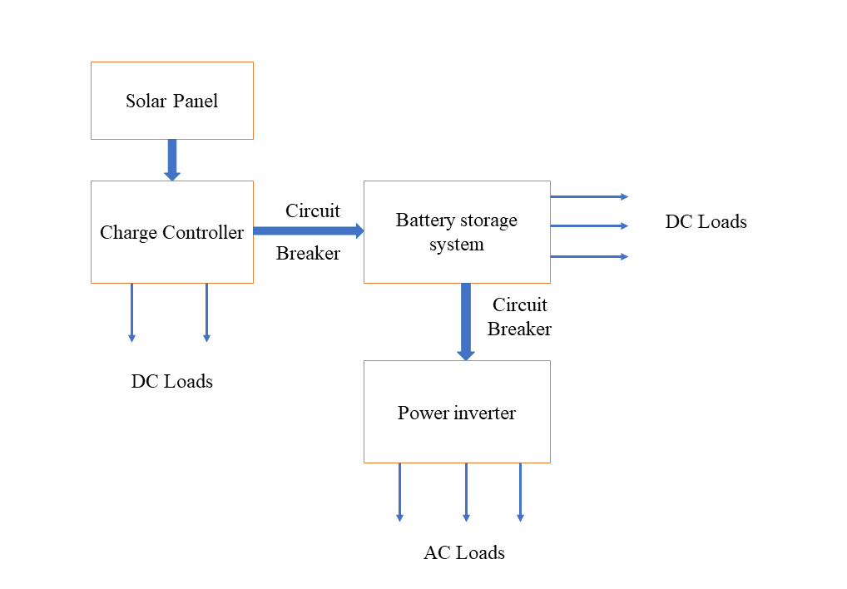
Fig.1 Typical photovoltaic system's block diagram
1.3.4. Thermal solar energy
The thermal solar energy system makes use of the sun's primary active solar system by using its energy to gather and store heat before transferring it to fluids and air to produce outcomes. To enhance heat absorption, solar panels for thermal energy can also be positioned at an angle.
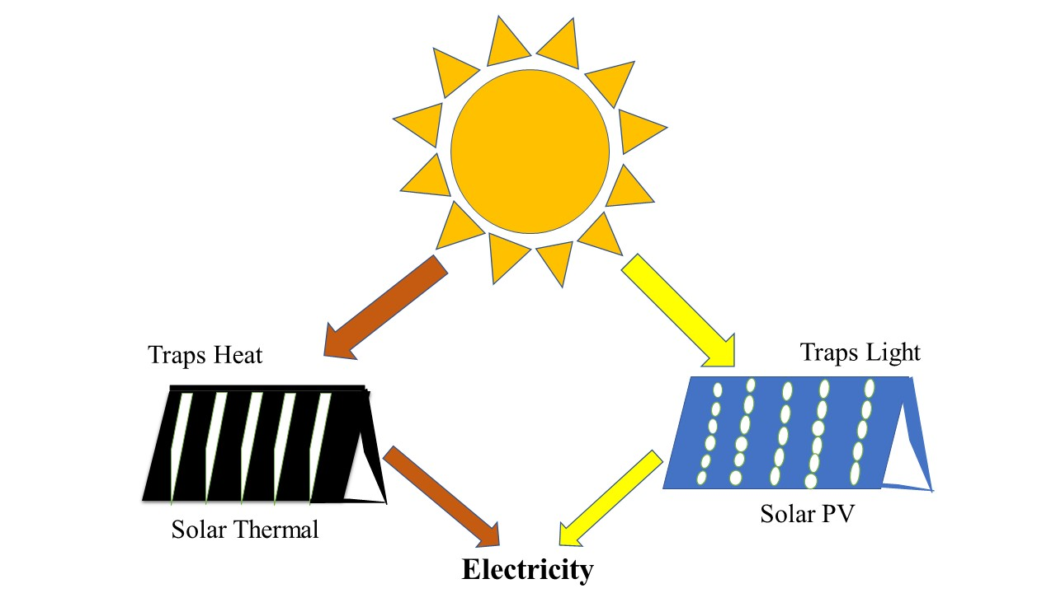
Fig.2 Difference between Solar Thermal and Solar PV
1.4. Advantages of solar energy
- One of the major benefits of solar energy over fossil fuels is that it has less of an adverse effect on the environment.
- Solar energy also contributes to water conservation [17]. While nuclear power facilities require a lot of water for maintenance, which results in water waste, solar panel maintenance uses very little water.
- Sunlight is used by solar panels. Solar energy is a regenerative energy source that won't run out anytime soon. You can therefore unwind in the knowledge that you'll probably never run out of fuel to satisfy your electricity needs.
- Another piece of good news is that maintaining solar panels requires little work and has cheap maintenance costs. There is no need for extensive maintenance or cleaning.
- The likelihood of blackouts is quite low when solar panels are widely spaced throughout an area. These systems serve as the grid's energy production hubs, enhancing grid security in the event of overload or other situations that result in blackouts.
- You can use batteries to store extra power generated by your solar panels so that you can use it at night, when there isn't enough sunshine for the panels to continue producing electricity.
- You can position your solar system anywhere there is sunlight. To give places without electricity the necessary power, you can utilise these technologies.
- The benefit of solar energy that has the greatest economic impact on society is the generation of jobs. A rise in solar system demand has produced a variety of work opportunities involving their installation, maintenance, cleaning, etc [18].
1.5. Disadvantages of solar energy
- Energy efficiency is low when measured against alternative energy sources. Low correlation exists between the quantity of energy received and the quantity of electrical energy produced. Especially when contrasted with alternative energy sources like nuclear.
- The weather has an impact on performance. For instance, performance is quite bad where the sky is typically foggy.
- Restrictions throughout the day. Some places have shorter daylight hours. The Sun's angle with respect to the solar panel's surface is another drawback. The inclination of the sun radiation is insufficient in some areas [19].
- Storage restrictions for produced energy. because you sometimes cannot have electricity at the hours that you need it. There are solar batteries and hot water tanks for this in a photovoltaic installation; however, the efficiency is still relatively poor.
- Some plants have the potential to have various environmental effects. Despite being regarded as clean energy, solar energy nevertheless contains elements that are bad for the environment. Impacts connected to the usage of land, water, materials, etc.

1.6. Environmental impact assessment of solar energy

- The possible environmental effects of solar energy might differ greatly depending on the technology [20]. These effects are connected to the use of land and the destruction of habitat, the use of water, and the creation of hazardous products.
- Larger utility-scale solar projects may cause issues about habitat loss and land degradation depending on their location. Water is needed for solar thermal concentration plants to cool down. These plants also need more water because it is necessary to maintain the reflectors.
- Several hazardous compounds are used in the production of solar cells. The majority of those substances are utilised to polish and clean the semiconductor surface. Compared to conventional silicon photovoltaic cells, thin-film photovoltaic cells use a variety of more harmful substances.
- Global warming emissions occur during operation. However, other phases of the solar life cycle are also connected with emissions [21]. It covers production, material transportation, installation, upkeep, decommissioning, and deconstruction.

1.7. The innovations of solar energy technology
Electricity cannot be produced after sunset, according to conventional solar cells. According to the anti-solar cell theory, solar cells might be used to produce electricity at night [20]. The earth is regarded as a heat source in the anti-solar cell theory, and principles from the advanced radiative cooling field as well as radiative photovoltaic are taken into account for the night sky [22]. Thermo-radiative cells operate on the same basic principles as traditional photovoltaics. When a p-n junction achieves thermal equilibrium with its surroundings in the dark and the Fermi level through the semiconductor stays constant, random photon absorption by the cell equals random emission from the cell. The device seeks to cool when the p-n junction becomes hotter than its surroundings by discharging more energy than it absorbs. When a thermal reservoir is attached to the cell, the temperature stays constant. When the enhanced emission drops the carrier concentration below its equilibrium level, separating the hole and electron Fermi levels in the opposite way, a reverse bias voltage is produced across the junction [23]. A further electron and hole are introduced via the contacts to make up for the missing pair when an electron and hole pair recombine but are not balanced by photon absorption. There is a current flow in this scenario when a cell is linked to a load [24]. A thermo-radiative PV cell and a traditional PV cell primarily vary by:
- The current moves against its natural direction
- The voltage created has a reversed sign as well.
As an alternative to traditional semi-conductor photovoltaic, the optical rectenna concept has been presented. A rectenna is a high-frequency rectifier system that consists of a diode that transforms electromagnetic radiation into DC power and an antenna that captures the radiation.
Concentrated photovoltaic (CPV) technology is a recent development in solar power technology [25]. This technique directs sunlight onto solar cells, which produce electricity, using mirrors and lenses. Compared to non-concentrated photovoltaic systems, CPV provides a benefit. One of them is the fact that fewer solar cells are needed to produce the same amount of power. Temperature and sunlight intensity have a considerable impact on the solar cell's efficiency. Higher temperatures cause the solar panel's output performance to decline in contrast to lower ones. Therefore, a good cooling system is essential for getting the best performance out of solar cells and safeguarding them from deterioration and harm. Either actively or passively cooling the photovoltaic solar panel is possible [26]. In active mode, an external power source is needed to power the cooling system; in passive mode, no external power source is needed [27].
A micro-heat-pipe arrays system is suggested when discussing the cooling system for solar panels in order to drain heat from the operating temperature of solar cells. With this suggested approach, the issues of low energy output efficiency and thermal failure brought on by high solar cell temperatures can be resolved [28].
Even if the adoption and use of solar power has significantly increased in recent years, there are always ways that solar-related technologies might be enhanced. To address the drawbacks of solar cells, some improvements have been made, some of which are given below:
1.7.1. Self-cooling panels
A crucial component of how solar panels work is continuous exposure to the sun's beams. However, severe temperatures cause the majority of panels to perform less effectively. Some researchers have developed a method to enable panels to cool themselves in order to overcome this overheating issue and ensure that they can continue to work at their best even in the hottest temperatures.
Basically, the bottom of a standard solar panel has a gel sheet attached to it. This gel absorbs the night time airborne water vapour [29]. The water is then evaporated during the day as a result of the solar panel producing too much heat. The solar panel will cool off as a result of water evaporation, just like when you splash water on your skin on a hot summer day.
1.7.2. Innovation in materials
The search for innovative components and photovoltaic cell arrangements that can improve the performance of current solar panel technology is never-ending. Perovskites, a class of semiconductors, is one example of such a substance [30]. They have the potential to be the key element in solar cells of the future. These new cells won't just be more affordable; they'll also likely be far more effective than current cells. The fact that the solar power sector is researching specific forms of synthetic perovskites is important in this regard. The type of resources extracted from the earth are not a factor in their supply because they are made in laboratories [31]. They will therefore be less expensive.
1.7.3. Solar straight from space
The effort to create a technology that transmits solar energy directly from space to earth is in full force. The first attempt in this direction was carried out by American researchers who launched a small photovoltaic module.
This experiment tries to examine how solar energy is transformed into microwaves [32]. The panel features a layer intended to collect the blue light spectrum of the sun's beams, which is conceivable in the atmosphere of space, according to a clever detail the researcher has made public.
Technology, production, and methods for solar electricity are constantly changing. The industry can only maintain its momentum and bring in the era of renewable energy in this way. The fact that there are always fascinating new innovations taking place in the solar energy sector is a wonderful thing.
1.7.4. Solar Desalination
Desalination is the process of removing undesirable minerals from tainted water for use in agriculture and human consumption [33]. Over time, inventors created a solar-powered device that can remove contaminants from water and transform salty water into potable water. The apparatus also disinfects and purifies water using UV light. Unfortunately, despite the fact that water covers 70% of the Earth's surface, many areas of the world still lack access to clean, pure water.
1.7.5. Solar Panels
Anyone wishing to save money and the environment at the same time can consider solar panels as a fantastic energy source. Solar panels can be purchased for a fair price and are an investment that will save the buyer money for at least two decades [34]. Solar panel investments are being made by more and more businesses in an effort to reduce expenses. Solar panels have been around for a while, but because to advancements in solar energy, they are now affordable for everyone, providing power to those who have never had access to it before.
1.7.6. Portable solar
For safety, affordability, and efficiency, developing nations and regions that are recovering from catastrophic occurrences like floods and earthquakes are turning to alternative energy sources like solar energy [35]. Millions of dollars have been spent by agencies like the Red Cross and the United Nations on transportable solar panels that can power and illuminate their disaster recovery teams. Kits are provided with mobile solar power systems so that aid personnel can gather and store energy. In the near future, entrepreneurs will use solar-powered 3D printers to provide vital medical supplies to disaster-affected areas.
1.7.7. Grid batteries
The other difficulty that sustainable solar energy has is energy storage technology, in addition to the high cost of solar equipment [36]. The development of solar energy technology depends on energy storage, which is also what gave rise to the current development of grid batteries. Compared to other cells, these batteries are more effective at storing solar energy. Combining grid batteries and solar technology is the best approach to ensure a consistent electricity supply that is less expensive than fossil fuels. Solar panels can be shared with neighbours at a price that is less expensive than purchasing other forms of energy by those whose roofs aren't suitable for PV panels.
1.8. Ways to improve the efficiency of solar energy
Because it has limitless reserves, is accessible everywhere, is clean, and has many other benefits, solar energy is presently utilised extensively in a variety of industries. The solar cell's efficiency is a crucial factor. Following are some crucial suggestions for increasing the effectiveness of solar electricity [37].
- Increasing the solar panel's conversion efficiency - Solar panels are the key element in turning solar energy into electricity. Researchers have been working on new solar panel inventions in recent years. As the most current advancement in solar panels in recent years, the Nano solar panel shows a new side to development. The solar light and solar panel are vertical and have an automatic tracking system. Due to the sunlight's shifting angle, the solar cell's generating capability will alter over time. By implementing an autonomous tracking system, the generating capacity can be increased [38].
- Create two independent devices by dividing the collecting and transformation portions. One of them is the collector, which is used to augment solar energy by collecting solar energy serially.
- A different converter transforms light energy into electrical energy. These mirrors were used to create this collector [39]. The converter transforms thermal energy into electrical energy, resulting in a thousand times greater generating capacity than a standard solar panel.
- The best invention in solar cell technology is the solar tree idea because there isn't enough room to place the solar panel due to the rapid increase in human population nowadays. To generate effectively, this solar tree needs very little room. The solar tree may therefore be the most appropriate for the modern world.
Solar energy is one of the finest solutions to meet the need for energy in the future. For the first time, researchers have been able to measure in great detail how solar energy is distributed among and among the many parts of a photosynthetic organism [40]. This outcome may lead to the development of solar energy technologies with higher efficiency than what is now feasible. Broad-spectrum solar energy can be captured by the device and converted to power using a heat-resistant gadget constructed of layers of tungsten and alumina, according to research. In order to create the dye-sensitized solar cells, a green polymer derived from biowaste was used [41].

1.9. Advantages after introducing advanced technologies in solar energy
The main problem with solar energy technology is that it is less effective than non-renewable technologies at producing electricity. A fossil fuel or nuclear power station can generate more electricity than a solar power plant. Therefore, to meet the future energy demand, solve this issue, and achieve maximum efficiency, innovation and research in the field of solar energy are required. This is not an easy process. In order to do research, scientists must study cutting-edge technologies and incur a significant upfront expenditure [42]. However, by developing solar energy and doing research in the field, we can lessen the environmental impact of non-renewable technology, improving the quality of life on Earth.
The second and third generations of solar power technology are currently being developed. For use in solar technology, further study has been done on nanomaterials. Only a small portion of the sun spectrum can be extracted with conventional silicon-based solar panels. The efficiency of the solar cell can be raised by using a multi-junction solar cell, which can absorb the complete spectrum of sunlight. By utilising hybrid solar power technologies, such as solar-wind systems and solar-biomass systems, electricity can be generated on cloudy days and at night [43-45]. Benefits from implementing advances in solar technology are possible. The solar spectrum can be extracted in many different ways to achieve optimal efficiency.
- Lower the start-up costs
- Get a flexible solar cell and have less of an influence on the environment.
- Capable of producing power during the day.
- In high-temperature zones, concentrated solar technology may produce power much more effectively than conventional solar technology.
According to the present findings, solar energy technologies are unable to supply enough energy to fulfil the world's steadily growing energy needs while minimising their negative effects on human health and the environment [46]. To overcome the aforementioned issues and achieve higher efficiency, similar to non-renewable technologies like nuclear and fossil-based energy, innovation and upgrades are required.
1.10. Environmental Impact Assessment
1.10.1. Environmental impacts from photovoltaic power generation
When in use, photovoltaic systems are often considered to have a minimally harmful impact on the environment because they don't create any noise or chemical pollutants. It is one of the most useful renewable energy technologies to use in urban settings as a replacement for the present building cladding materials [47].
- Land use
Specific elements determine how land usage affects natural ecosystems. Various elements, like the geography of the landscape, the area of land covered by the PV system, the type of land, the distance from sensitive ecosystems or regions of natural beauty, and the biodiversity, affect how land usage affects natural ecosystems. During the construction stage, construction operations like earth movements and transport movements are likely to cause impacts and landscape modification [48]. Furthermore, the deployment of a PV system in formerly arable land has the potential to destroy biodiversity, soil productivity, the amount of the land covered by the PV system, the nature of the land, and the distance from sensitive ecosystems and scenic regions. During the construction stage, construction operations like earth movements and transport movements are likely to cause impacts and landscape modification. Furthermore, it is feasible to destroy soil-productive areas by installing a PV system in once-cultivable land.
- Visual impacts
The kind of the scheme and the PV systems' surroundings have a significant impact on visual intrusion. It goes without saying that the aesthetic impact of installing a PV system close to a scenic place would be very high [49]. Comparing modern buildings to historic or culturally significant buildings, there may be a favourable visual influence in the case of modules integrated into building facades. Optimum architectural solutions to lessen potential effects on building aesthetics and visual aesthetic. design and proper location of big PV installations. PV modules are assembled in large-scale systems using colour.
To reduce the negative effects on the environment caused by the manufacture of PV cells, a number of factors need to be researched:
- prospects for thinner cell layers;
- The full potential of the concentrator PV technologies;
- Prospects for more efficient material utilization;
- Safer materials and alternatives; and
- Module recycling technology and its efficiency.
- Air pollution
According to life cycle assessments, the environmental performance of the system is greatly influenced by how energy-efficiently it is manufactured, particularly when it comes to the generation of power [50].
Modern PV systems may directly offer clean electricity that is perfectly matched to the building's demand when they are structurally integrated into buildings. In urban settings, they can also support day illumination, shadow management, and ventilation. Mirrors can be replaced with PV panels on a building's front. PV systems also help to foster a climate where additional energy-saving measures can be promoted by building promoters, owners, and users. Where relatively small amounts of power are required, like in rural electrification applications, and where consumers can directly gain from the extremely high reliability of owning their own PV generator, PV energy services are particularly clear. Installing a PV generator is typically less expensive in the first scenario than extending the main grid over significant distances.
- Noise intrusion
There won't be much noise, as with all construction-related activities. Additionally, there will be certain employment advantages throughout the construction period and, more so for big projects, during the operational phase. It is important to urge manufacturers to create systems that are simple to recycle. According to a life cycle analysis of batteries for standalone PV systems, the majority of environmental effects are caused by the batteries because of their heavy metal content and short life period. Furthermore, its creation requires a significant quantity of energy and raw resources. A module-recycling programme can make things better in this case.
1.11.1. Environmental impacts from solar thermal electricity
The possible environmental implications of such a concept have not been thoroughly examined due to the limited use of ST power. Even if some emissions do happen at other points in their life cycles, they are much smaller than the emissions when the system's activity stops. Materials’ processing and manufacture
- Construction
- Land use
- Ecosystem, flora and fauna
- Visual impact
- Water resources
- Health and safety
- Social impacts
A few examples of technologies or techniques that can be used to completely eliminate or minimise potential environmental impacts from SETs include the use of air emission or odour control equipment, design tools for the best design and sitting of the installations, best practise guidelines, improved pieces of equipment, or completely innovative design. To make the best decisions, the accountable parties must take environmental considerations seriously. An Environmental Impact Assessment (EIA) for central solar systems can significantly contribute to good project design and a project's eventual public acceptance by estimating the amount of potential environmental consequences and proposing appropriate mitigation strategies.
1.11 Conclusion
Due to capacity issues and poor power efficiency, conventional power generation based on solar energy is frequently thought to be unsustainable over the long run. As a result, more inventions are being published internationally. The most vital creative possibilities involve night time electricity generation. Based on current technology, solar energy technologies are better positioned to satisfy rising energy needs than non-renewable alternatives. Innovations are therefore crucial for the solar energy business to grow as efficiently as possible. The development, evaluation of the environmental impact, and outlook for solar energy technology are therefore presented in this chapter. Last but not least, innovation is the key to solar energy technology's success in meeting the world's expanding energy needs.

1.12 Acknowledgment
It is my proud privilege, and special appreciation towards my supervisor Dr. Sudesh Kumar, professor of chemistry, Banasthali vidyapith, Department of chemistry, Rajasthan under his guidance for his keen enthusiastic interest, ever willing cordial help, most valuable guidance, and suggestions, constant encouragement and constructive criticism which made it possible to complete this study.
1.13 Conflict of interest- We have no conflict of interest.
1.14 Research funding’s- No funding available.
1.15 References
[1] Peter, O., & Mbohwa, C. (2019). Renewable Energy Technologies in Brief. International Journal of Scientific & Technology Research, 8, 1283-1289.
[2] McKee, T. B., Doesken, N. J., & Kleist, J. (1993). Analysis of Standardized Precipitation Index (SPI) data for drought assessment. Water, 26, 1-72.
[3] Soonmin, H., Wagh, S., Kadier, A., Gondal, I. A., Azim, N. P. B. A., & Mishra, M. K. (2018). Renewable energy technologies. Sustainable Innovation and Impact, 237-250.
[4]. Weliwaththage, S. R., & Arachchige, U. S. (2020). Solar Energy Technology. Journal of Research Technology and Engineering, 1(3).
[5] Tran, T. T., & Smith, A. D. (2017). Evaluation of renewable energy technologies and their potential for technical integration and cost-effective use within the US energy sector. Renewable and Sustainable Energy Reviews, 80, 1372-1388.
[6]. Burney, J., Woltering, L., Burke, M., Naylor, R., & Pasternak, D. (2010). Solar-powered drip irrigation enhances food security in the Sudano–Sahel. Proceedings of the National Academy of Sciences, 107(5), 1848-1853.
[7]. Hestnes, A. G. (1999). Building Integration of Solar Energy Systems. Solar Energy, 67(4-6), 181–187.
[8]. Bazilian, M., Onyeji, I., Liebreich, M., MacGill, I., Chase, J., Shah, J., ... & Zhengrong, S. (2013). Re-considering the economics of photovoltaic power. Renewable Energy, 53, 329-338.
[9]. Tsoutsos, T., Frantzeskaki, N., & Gekas, V. (2005). Environmental impacts from the solar energy technologies. Energy policy, 33(3), 289-296.
[10]. Davigny, A., François, B., Henneton, A., & Sprooten, J. (Eds.). (2021). Electricity Production from Renewable Energies. John Wiley & Sons.
[11]. Perez, R., Zweibel, K., & Hoff, T. E. (2011). Solar power generation in the US: Too expensive, or a bargain? Energy Policy, 39(11), 7290-7297.
[12]. Laughton, C. (2010). Solar domestic water heating: The earth scan expert handbook for planning, design and installation. Routledge.
[13]. K. Hanjalić, R. van de Krol, A. Lekić, Eds., Sustainable energy Technologies: Options and Prospects. Dordrecht (Netherlands): Springer, 2007.
[14]. Armbrecht, S. (2014). The future of solar energy – opportunities and challenges of the solar photovoltaic industry. LG Solar.
[15]. Evans, R. L. (2007). Fueling our future: an introduction to sustainable energy. Cambridge University Press.
[16]. Hegedus, S. S., & Luque, A. (2003). Status, Trends, Challenges and the Bright Future of Solar Electricity from Photovoltaics. Handbook of Photovoltaic Science, 1-43.
[17]. Bartholy J. and Radics K. 2001. Selected characteristics of wind climate and the potential use of wind energy in Hungary. Part I. Idoj ́ar ́as vol. 105, 109–127.
[18]. T.E. Girish, Night time operation of photovoltaic systems in planetary bodies, (2006), Solar Energy Materials and Solar Cells, Vol.90, 825-831.
[19]. Arshad, R., Tariq, S., Niaz, M. U., & Jamil, M. (2014, April). Improvement in solar panel efficiency using solar concentration by simple mirrors and by cooling. In 2014 international conference on robotics and emerging allied technologies in engineering (iCREATE) (pp. 292-295). IEEE.
[20]. Sreewirote, B., Noppakant, A., & Pothisarn, C. (2017, May). Increasing efficiency of an electricity production system from solar energy with a method of reducing solar panel temperature. In 2017 International Conference on Applied System Innovation (ICASI) (pp. 1308-1311). IEEE.
[21]. Qinghui, D. A. I., & Jun, C. (2009). Improving the efficiency of solar photovoltaic power generation in several important ways.
[22]. Jawale, J. B., Karra, V. K., Patil, B. P., Singh, P., Singh, S., & Atre, S. (2016, March). Solar panel cleaning bot for enhancement of efficiency—an innovative approach. In 2016 3rd International Conference on Devices, Circuits and Systems (ICDCS) (pp. 103-108). IEEE.
[23]. Ehsanul Kabir, Pawan Kumar, Sandeep Kumar, Adedeji A. Adelodun, Ki-Hyun Kim, (2018), Solar energy: Potential and future prospects, Renewable and Sustainable Energy Reviews, Vol.82, 894-900.
[24]. In T. Ackerman (Ed.), Wind Power in Power Systems. The Atrium, West Sussex, England: John Wiley and Sons, Ltd. Ahiataku-Togobo, W. (2003).
[25]. End-of-life management and recycling of PV modules. Energy Policy 28, (2003), Fthenakis, V., Zweibel, K., 1051–1058.
[26]. Purohit, D., Singh, G., & Mamodiya, U. (2017). A review paper on solar energy system. International Journal of Engineering Research and General Science, 5(5).
[27]. Gupta, N., Alapatt, G. F., Podila, R., Singh, R., & Poole, K. F. (2009). Prospects of nanostructure-based solar cells for manufacturing future generations of photovoltaic modules. International Journal of Photoenergy, 2009.
[28]. Bagher, A. M., Vahid, M. M. A., & Mohsen, M. (2015). Types of solar cells and application. American Journal of optics and Photonics, 3(5), 94-113.
[29]. Santosh, R., Arunkumar, T., Velraj, R., & Kumaresan, G. (2019). Technological advancements in solar energy driven humidification-dehumidification desalination systems-A review. Journal of Cleaner Production, 207, 826-845.
[30]. Gorjian, S., Sharon, H., Ebadi, H., Kant, K., Scavo, F. B., & Tina, G. M. (2021). Recent technical advancements, economics and environmental impacts of floating photovoltaic solar energy conversion systems. Journal of Cleaner Production, 278, 124285.
[31]. Palomba, V., & Frazzica, A. (2019). Recent advancements in sorption technology for solar thermal energy storage applications. Solar Energy, 192, 69-105.
[32]. Ajarostaghi, S. S. M., & Mousavi, S. S. (2022). Solar energy conversion technologies: Principles and advancements. In Solar Energy Advancements in Agriculture and Food Production Systems (pp. 29-76). Academic Press.
[33]. Durganjali, C. S., Bethanabhotla, S., Kasina, S., & Radhika, S. (2020, March). Recent developments and future advancements in solar panels technology. In Journal of Physics: Conference Series (Vol. 1495, No. 1, p. 012018). IOP Publishing.
[34]. Thakur, A. K., Singh, R., Gehlot, A., Kaviti, A. K., Aseer, R., Suraparajud, S. K., ... & Sikarwar, V. S. (2022). Advancements in solar technologies for sustainable development of agricultural sector in India: a comprehensive review on challenges and opportunities. Environmental Science and Pollution Research, 1-28.
[35]. Nsengiyumva, W., Chen, S. G., Hu, L., & Chen, X. (2018). Recent advancements and challenges in Solar Tracking Systems (STS): A review. Renewable and Sustainable Energy Reviews, 81, 250-279.
[36]. Sharma, R., Sharma, A., Agarwal, S., & Dhaka, M. S. (2022). Stability and efficiency issues, solutions and advancements in perovskite solar cells: A review. Solar Energy.
[37]. Ganesh, B. N. V. S., Supriya, Y. V., & Vaddeswaram, G. (2013). Recent advancements and techniques in manufacture of solar cells: organic solar cells. International Journal of Electronics and Computer Science Engineering, 2(2), 565-573.
[38]. Awasthi, A., Kumari, K., Panchal, H., & Sathyamurthy, R. (2018). Passive solar still: recent advancements in design and related performance. Environmental Technology Reviews, 7(1), 235-261.
[39]. Chauhan, V. K., Shukla, S. K., Tirkey, J. V., & Rathore, P. K. S. (2021). A comprehensive review of direct solar desalination techniques and its advancements. Journal of Cleaner Production, 284, 124719.
[40]. Kannan, N., & Vakeesan, D. (2016). Solar energy for future world: -A review. Renewable and Sustainable Energy Reviews, 62, 1092-1105.
[41]. Kılkış, Ş., Krajačić, G., Duić, N., & Rosen, M. A. (2018). Advancements in sustainable development of energy, water and environment systems. Energy Conversion and Management, 176, 164-183.
[42]. Hayat, M. B., Ali, D., Monyake, K. C., Alagha, L., & Ahmed, N. (2019). Solar energy—A look into power generation, challenges, and a solar‐powered future. International Journal of Energy Research, 43(3), 1049-1067.
[43]. Lee, S. H. (2013). Advancements in n-type base crystalline silicon solar cells and their emergence in the photovoltaic industry. The Scientific World Journal, 2013.
[44]. McEneny, E., & Parker, L. Recent Advancements in Solar Energy.
[45]. Elumalai, N. K., Mahmud, M. A., Wang, D., & Uddin, A. (2016). Perovskite solar cells: progress and advancements. Energies, 9(11), 861.
[46]. Senthil, R. (2022). Recent innovations in solar energy education and research towards sustainable energy development. Acta Innovations, (42), 27-49.
[47]. Gorjian, S., Kamrani, F., Fakhraei, O., Samadi, H., & Emami, P. (2022). Emerging applications of solar energy in agriculture and aquaculture systems. Solar Energy Advancements in Agriculture and Food Production Systems, 425-469.
[48]. Heo, J. H., Lee, D. S., Shin, D. H., & Im, S. H. (2019). Recent advancements in and perspectives on flexible hybrid perovskite solar cells. Journal of materials chemistry A, 7(3), 888-900.
[49]. Price, H., & Kearney, D. (2003, January). Reducing the cost of energy from parabolic trough solar power plants. In International Solar Energy Conference (Vol. 36762, pp. 591-599).
[50]. Kumar, H. A., Venkateswaran, H., Kabeel, A. E., Chamkha, A., Athikesavan, M. M., Sathyamurthy, R., & Kasi, K. (2021). Recent advancements, technologies, and developments in inclined solar still—a comprehensive review. Environmental Science and Pollution Research, 28(27), 35346-35375.

