Current State of Graph Database Model

Raja Ram Dutta
Assistant Professor,
Dept. of Computer Science & Engg.
Birla Institute of Technoology,Ranchi
rajaramdutta@bitmesra.ac.in
Dr. Rahul Deo Sah
Assistant Professor
Dept. of Information Technology
Dr. Shyama Prasad Mukherjee University,Ranchi
rahuldeosah@gmail.com

ABSTRACT
Graph management problems are a new field covering a large number of applications, starting with various problems such as social networks, chemical data analysis, graph discovery, and communication networks. Various properties of graphs have been used in the form of graph isomorphism, mining, and subsequent analysis. Graphs have shapes and expressive data types, so we need a way to represent graphs in databases, manipulate queues, and search them. Representing data as a graph is well suited for structured data with dynamic schemas. This white paper describes the current state of the graph database model and its applications..

Keywords—graph database,graph model,database tools,priciple feature

INTRODUCTION

In recent years, many interesting variations and applications have been discovered for storing and managing chart data. It has also been studied that various database models have been proposed for large graph data such as Social Graph [1,5] and Web Graph [2]. Graph database models available since 1990 were typically GraphDB[3], O2[3], etc., but the emergence of graph databases has changed with the introduction of XML[4] and the Internet. Second, there are certain recent trends in the various movements in NOSQL [] database migration techniques. Moving NOSQL means that you can change a typical relational database and move from a relational database to a relational application. This is because the graph database model handles less data while still providing a higher level of data complexity. Data complexity can move from storing critical values ​​for information systems to storing databases of documents and finally creating databases of diagrams.

EASE OF USE

A database model known as a "data model" is a group of conceptual tools for simulating the representation of real-world objects and their connections. An example of a graph database model is one in which the schema and instance data structures are represented as graphs.
A graph database is a database that stores data in a structure of nodes, edges, and characteristics called a graph. It supports huge data and has a robust data model that is quicker than RDBMS.
Given the drawbacks of conventional databases, particularly the relational model NOSQL movement, a new trend is to switch from relational databases to databases that are better suited to certain applications. These databases fit into the following categories in this data model: broad-column stores (e.g. Cassandra) that follow Google's BigTable model, document stores (e.g. MongoDB) consisting of semi-structured data, and key-value stores (i.e. H. mapping indexing (e.g. Berkeley) and graph A graph database key for storing data like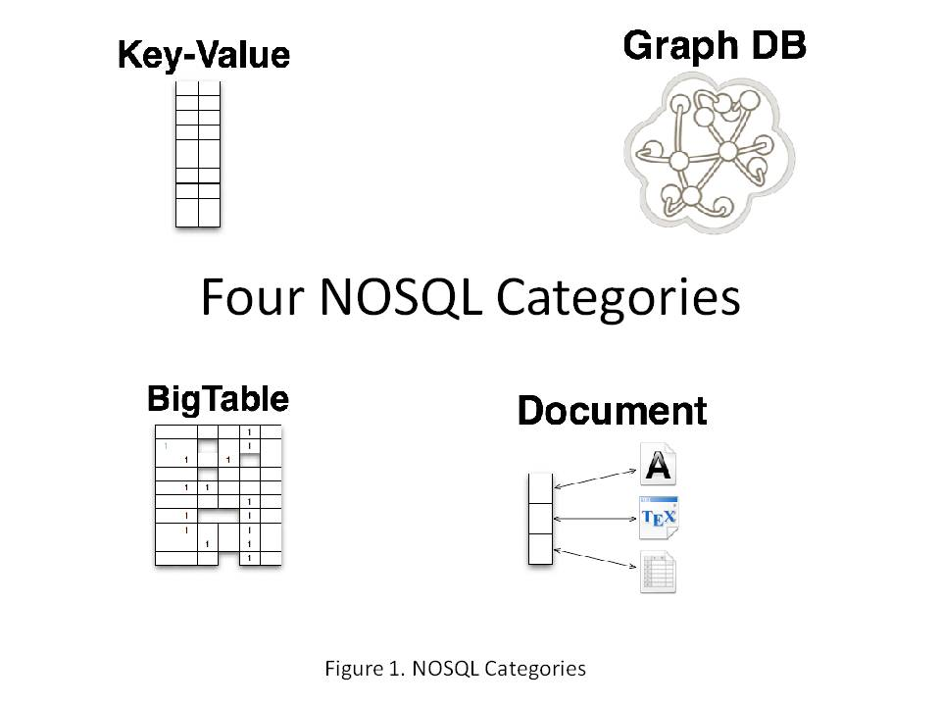

Figure 1. NOSQL categories
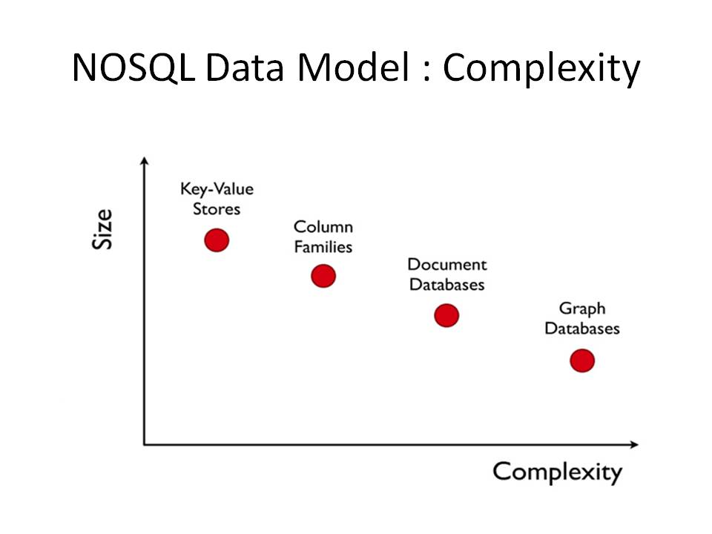
Figure 2. NOSQL Data Model[7]

RESEARCH WORK

Graphs are often used to model complex data. Graph Graph database research was popular in the early 1990s with database models such as LDM, GOOD, O2, and graphDB. Recently, this field has gained a lot of attention as trendy projects require databases (e.g. web mining and semantic web, chemical databases, protein interaction networks, bioinformatics, etc.). Databases were his area of ​​interest in the research community in 2000. Angles and Gutierrez [3] developed research on graph database models proposed before 2002. The authors integrated the concept of graph database models and the comparison of different models from the perspective of a theoretical rather than a practical approach. In 2011, Ronia Soussi et al. [8] Graph Databases for Collaborative Communities described a comparison of different models of graph databases developed in Hypernode, Groovy, GGL, GOOD, GMOD, GDM, and others. In 2012, Mike Buerli [9] reviewed his Current State of Graph Database query functions. 2012, P. Rajbhandari et al. [10] A graph database model for querying, searching, and updating. The purpose of this diagram database model review is to find the best one for modeling many complex data objects and their relationships. B. Social Networks, Market Analysis. Most of the work was reviewed as a comparison of graph database models. This is of more theoretical interest than practical development.

SCHEMATIC MODEL

A graph's topology can be described using the formula G= (V,E). where V is the collection of nodes (vertices) and E is the collection of edges (relationships). Two nodes are joined by an edge. Both have to be there. In other words, there can be no dangling relationships. The orientation of a graph's edges determines whether it is directed or undirected.

• Labeled Graph: Each edge's type is indicated on the graph.
• Multigraph: A multigraph is a labelled graph in which any two vertices may have many edges, provided that the edges have distinct labels.
• Attribute diagrams: To convey more information, attributes can be linked to diagram elements.
• Property Graph: A model that is implemented in and specified as a directed multigraph with attributes
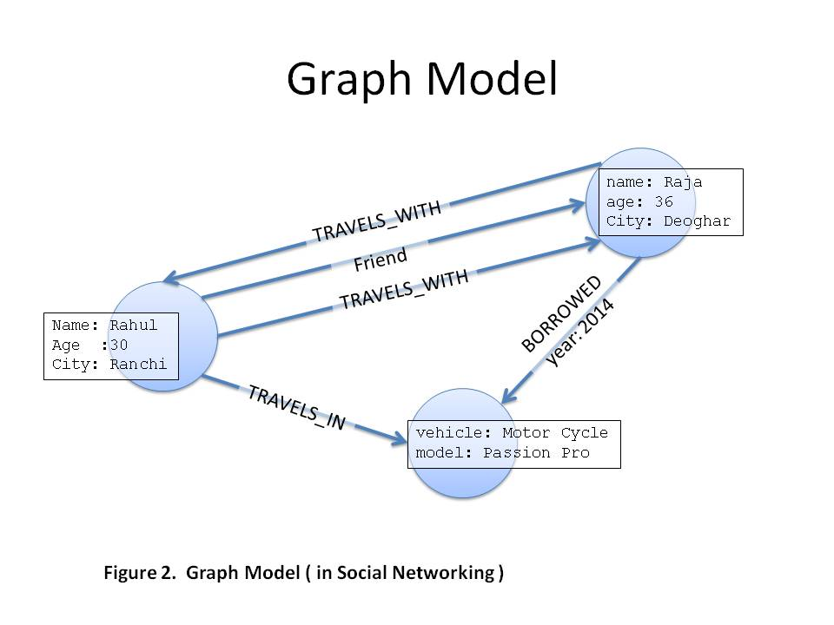
Figure 3. Graph Model

GRAPH APPLICATION

Applications for graphs: Graphs are used to represent data and to hold changing data schemas. An expanding field, the problem of graph management affects a wide range of applications, including social networking, the analysis of chemical data, graph discovery, and network communication.
Social Networks: Not only in society, but also in graph studies, social networks are a very hot topic. Social networks are dynamic online communities with a built-in sense of friendship and trust. These social networks replicate interactions in the actual world, allowing for the creation of this dynamic virtual structure. Users can communicate with one another, build connections, and exchange knowledge. In the social cloud, exchanging data, equipment, and services can be supported by this trust. biological and chemical: The graph representation of chemical data is achieved by designating atoms as nodes and defining edges between them. The similar method is used to display biological data, with the exception that the amino acids act as nodes and the interactions between them as edges. Drug discovery and analysis frequently make use of chemical databases. XML data: XML data is a natural type of chart data that may be displayed as charts with labels and is highly helpful for charts.
Web: In essence, the Web is a graph with connected data and information. Cudre Mauroux and others The Resource Description Framework (RDF), which offers a common format for linked data, and the rapid spread of large-scale structured data are both supported by the Linked Data movement.

GRAPH DATABASE MODEL

There is no common graph database model for creating graph algorithms, despite the fact that numerous graph database models have been created recently. A graph database is a database that stores and represents data using a graph structure made up of nodes, edges, and properties. Any storage system that offers an unindexed neighbourhood is a graph database. Most of the key elements of a database management system should be provided by a graph database. H. Database languages (DDL, DML), external interfaces (application programming interfaces), queries, query optimization, storage engines, etc.
I discovered other graph databases, including Neo4j, DEX[17], Infinite Graph, and HyperGraph.
DEX[17]: A commercial closed source graphics database with a Java and C++ core is called DEX. first available in 2007. It aspires to be an effective and scalable method for handling very big graphs.
Another commercial graph database with a Java and C++ core is called InfiniteGraph[16]. released in 2009 as a debut. Use a model with bidirectional edges called a Labeled Directed Multigraph.
Neo4j[7]: Neo4j includes a "property graph" graph model. It is totally implemented in Java and is an open source project. Different languages are offered with native APIs. PHP,.NET, Java, Python, Ruby, Javascript, etc. A native graph memory backend that employs an adjacency list design serves the Neo4j database.
One of his precursors of the current generation of graph databases is AllegroGraph [11]. Semantic Web standards like RDF/S, SPARQL, OWL, etc. are used in its development. Special capabilities from AllegroGraph are available for social network analysis and geotemporal reasoning. Hypergraph[12]: A database implementation called Hypergraph expands the idea of an edge by connecting two or more nodes. This approach is helpful for modelling data in areas like knowledge representation, artificial intelligence, and bioinformatics because it permits a natural depiction of higher-order interactions..

TECHNOLOGY USED IN GRAPH DATABASE MODEL

Any type of graph can be stored in graph databases. It is a customized database administration tool that implements using diagrammatic language. Utilized modelling techniques include document- and web-oriented databases.

• RDF data source

Use graph structures to model the data used in web-oriented applications in web-oriented databases. (For instance, Info Grid and Flock DB)

Utilize graph algorithms in document-oriented databases to navigate the relationships between documents. such as Orient DB[13] RDF[14] database: holds RDF graphs made up of subject-predicate-object assertions. Comparison of various graph databases There are numerous graph databases available today, both for sale and free.

Table 1: Comparision of different graph databse

Tool | Comparison of different graph database
Tool | Principle feature | Suited best for | Limitation
Horton [15] | provides an interactive query optimizer for a query execution engine.. | Social Networks - Online Query Execution Engine for Large Distributed Charts
Infinite Graph^{[16]} | Speeds up pathfinding between two known objects using a bidirectional pathfinding algorithm.. | Find data faster with powerful enhancements to navigation queries. | Visualization with JSON and GraphML  Supported languages ​​are Core C++, Java
Neo4j^{[7]} | Data is stored as graphs in a graph database. The most popular type of data structure, graphs may elegantly and conveniently represent any type of data. |  | only accessible through an online administrative interface.  The supported languages are Java, Python, JavaScript, and Core JRuby.

CONCLUSION

In this study, we looked at graph database models and contrasted them in terms of data modelling traits. We demonstrated the availability of many graph database models with attributes including graph structure, query functionality, and supported languages..

REFERENCES

[1] A. Broder et al., "Graph structure in the web," elsevier science B.V. - computer network 33, 2010, p. 309–320
[2] A Survey of Graph Database Models by R. Angles and C. Gutierrez, ACM Computing Research (CSUR), vol. 40, no. 1, pp. 1-39, 2008.
[3] "Keyword Proximity Search in XML Trees" by Vagelis Hristidis, Nick Koudas, Yannis Papakonstantinou, and Divesh Srivastava was published in the IEEE Transactions on Knowledge and Data Engineering, volume 4, on April 18, 2006.
[4] "Wikipedia the Free Encyclopedia" - Social Graph: http://en.wikipedia.org/wiki/Social graph
[5] www.nosql-database.org
[6] Neo4J, Inc.
[7] Ronia Soussi, Marie-Aude Aufaure, and Hajer Baazaoui, "Graph Databases for Collaborative Communities," Chapter 9 Springer-Verlag Berlin Heidelberg 2011, Community-Build Databases, pp. 205-234.
[8] increase."The Current State of Graph Database," by Mike Buerli, published in December 2012 at the University of Texas at Austin.
http://www.cs.utexas.edu/~cannata/dbms/Class%20Notes/08%20Graph Databases Survey. pdf"
[9] Graph Database Model for Query, Search, and Update by P. Rajbhandari (2012) IPCSIT vol. 41, IACSIT Press, Singapore, International Conference on Software and Computer Applications (ICSCA 2012)
[10] "Allegrograph" can be found online at www.franz.com/agraph/allegrograph.
[11] http://www.hypergraphdb.org, "HyperGraphDB"
[12] "Orientdb," accessed at orienttechnologies.com
[13] Bipartite Graphs as an Intermediate Model for RDF in Proceedings of the Third International Semantic Web Conference by J. Hayes and C. Gutierrez (ISWC). LNCS, Number 3298 47–61, November 2004, Springer-Verlag
[14] "Horton," available at research.microsoft.com/en-us/projects/ldg.
[15] "Infinite Graph," available at infinigraph.com
[16] N. Martinez-Bazan et al., High Performance Exploration on Large Graphs for Information Retrieval, 16th Conference on Information Management in the Web Age Proceedings (WAIM). S. 37–48, Springer Publishing, 2010.
[17] H. He, A.K. Singh. "Graph - at a time": Query Language and Access Methods for Graph Databases.. in ACM SIGMOD pp 405-418,2008
[18] P. Zhao, J. Han. "On graph optimization in large-scale networks". 3(1): pp. 340-351, 3010.
[19] JR Ullman. "Algorithms for Subgraph Isomorphism". In J.ACM, Vol. 23, pp. 31-42, January 1976.
[20] http://www.vldb.org/pvldb/vol4/p1510-cudre-mauroux-tutorial5.pdf - Philippe Cudré-Mauroux, Sameh Elnikety - A Graph Data Management System for New Application Domains - VLDB Foundation - Volume 4, No. Aug 12, 2011 pg 1510-1511

