TopicHub

Pankaj Kunekar  Department of Artificial Intelligence and Data Science,  VIT Pune  Pune 411037, Maharashtra, India  pankaj.kunekar@vit.edu | Mihir Deshpande  Department of Artificial Intelligence and Data Science,  VIT Pune  Pune 411037, Maharashtra, India  mihir.deshpande20@vit.edu | Adwait Gharpure  Department of Artificial Intelligence and Data Science,  VIT Pune  Pune 411037, Maharashtra, India  adwait.gharpure20@vit.edu
Vedant Gokhale  Department of Artificial Intelligence and Data Science,  VIT Pune  Pune 411037, Maharashtra, India  vedant.gokhale20@vit.edu | Aayush Gore  Department of Artificial Intelligence and Data Science,  VIT Pune  Pune 411037, Maharashtra, India  aayush.gore20@vit.edu | Harsh Yadav  Department of Artificial Intelligence and Data Science,  VIT Pune  Pune 411037, Maharashtra, India  harsh.yadav20@vit.edu

ABSTRACT

Managing different assessment schemes has been a tedious task for teachers as well for students. Creating different spreadsheets for every assessment makes the work clumsier and difficult to manage and also makes it hectic for students and teachers to maintain and assess them. To solve this problem, the presented work created a single platform to assess, manage all the respective subject’s assignments and all the work. This will boost up the academic process and help professors and students to easily and efficiently go through their academics. Students can also form groups with other students and can get approved by the respective faculty.
Keywords— react, web-development, express, mongo dB;

INTRODUCTION

The term "web technology" refers to all forms of technology used largely on the World Wide Web. It's an information system where Uniform Resource Locators may identify papers and other online resources. The usage of web technology is essential in order remotely managing and getting information [1].
The advantages of web technology in our day to day life and in education after the pandemic are known to all. This enables us to save time and unnecessary efforts. We aim to achieve this goal. In college, students have a multitude of assessments in addition to exams that are important, assessments like group discussions, viva Voce exams, seminars, course projects and more, keeping track of all these is a tiresome process. Students and teachers currently use informal means like excel spreadsheets and WhatsApp groups to bring some structure and communicate. These methods can bring trouble for students that are out of the loop. We aim to solve this problem using TopicHub.
TopicHub is a web-based application that helps students and faculties to comfortably select the assignment topics and easily grade them. This project is based mainly on MERN stack and is developed with the emerging technologies such as ReactJS which help in creating an optimized frontend of our app, Express JS as Backend for creating API’s, Mongo-DB as database, also used chakra for the UI of our web Application.

LITERATURE REVIEW

1.Protrack: A Student-Teacher Project Management Tool : Protrack is a web based tool to create teams among students in cooperation with the teachers.
2.A portal of educational resources: providing evidence for matching pedagogy with technology: This paper focuses on TPK, the intersection between technology knowledge and knowledge as a crucial field of investigation.
3..College ERP Using MERN Stack : This application was developed for an engineering college to maintain and facilitate ease of access to information using MERN.
4.Node.js: Using JavaScript to Build High-Performance Network Programs : This paper discusses the importance of NodeJs in the web development field.
5.Using NodeJS to Build High Speed and Scalable Backend Database Server: This paper discusses the use case of Node Js in building the backend for a project.
6.Full Stack Web Development Teaching: This paper promotes learning and skill enhancement in the field of Web development with the emerging technologies.
7. The New Era of Full Stack Development: This paper is a concise study of the evolution of full stack web development. The paper discusses different technologies of full stack development.
8.Database-Driven Web Development Fundamentals : This paper discusses the fundamentals of database management in the development of web technologies.
9.Modern web application development technologies : This paper discusses the evolution of modern web technologies and also discusses the uses of web development in various fields.
10.Django-Based Web Application to Empower Skilled People : This paper mainly focuses on how Django can be useful in web development and future uses of the same.
11.HTML Educational Node.js System (HENS): An Applied System for Web Development: The paper introduces the reader to the Node JS and HTML framework for web development.
12.Web development with node.js : Paper demonstrates step-by-step instructions to develop a web application and deploy it on Heroku.
13. REST API Development with Node.js: This paper discusses the development of REST API’s using Node Js in the web development domain.
14.Using Express.js to Create Node.js Web Apps: This paper demonstrates the integration of ExpressJS with Node js.
15.Programming Web Services on the Cloud with Node.js : This paper demonstrates working of web services in integration with cloud services such as MySQL,MongoDb,.

SYSTEM DESIGN

TopicHub is a web based application that is used to keep track of all your assessments in a class. The system consists of two modes - one for the students and one for the instructor. The app is designed in a way where students and teachers can collaborate for transparency and clarity.

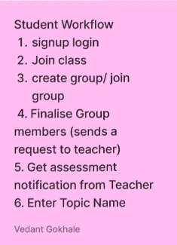
- Students view as shown in figure 1: When students access TopicHub, they can use the options to Join a class, Create/Join a group with different members of the class, access their subject and subject teachers. They can also view their previous assessments in a modal in their subjects page, and choose the topic name for a new assessment that their teacher starts.
Figure 1 : Student View

- Teacher View : When teachers use TopicHub, they can start a new class and share the class code with students, appoint different subject teachers for different subjects, start newassessments, approve/ reject the topic selected by the students, and allot marks on assignments after evaluation as shown in figure 2. This makes the whole process smooth and easier.

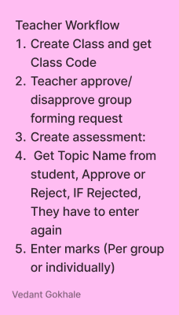

Figure 2: Teacher View

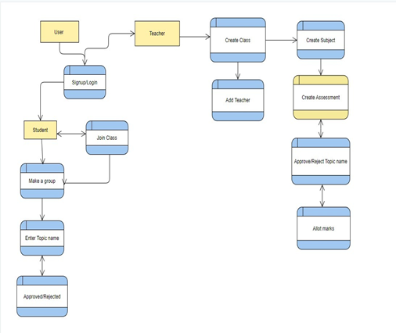
Flow Diagram :

Figure 3 : System Flow

RESULTS AND DISCUSSIONS

We have created the WebApp for the desired task which is where students can be able to add topics and the faculty can approve it.
Basically we have created two login options:

1. For Students
2. For Teachers
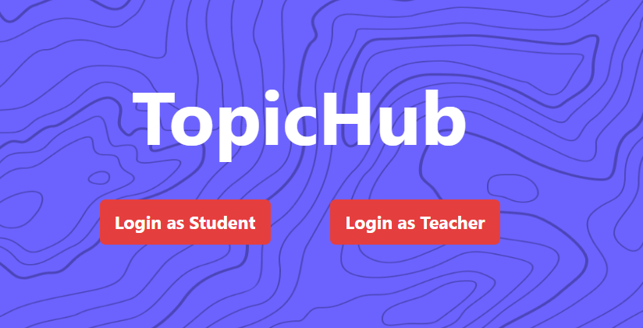
Figure 4 : Home Page

We also created two schemas in the database for achieving this as shown in figure 4.
- In student’s login we implemented options like join class using ID, create a group, join a group, share group link etc.

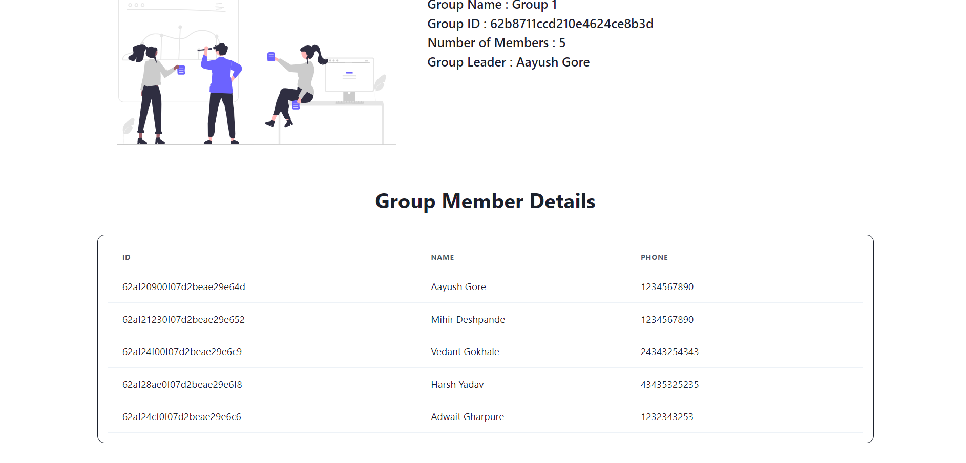
Figure 5 : Group members module details
- The figure 5 shows the list of group members who have joined the group.
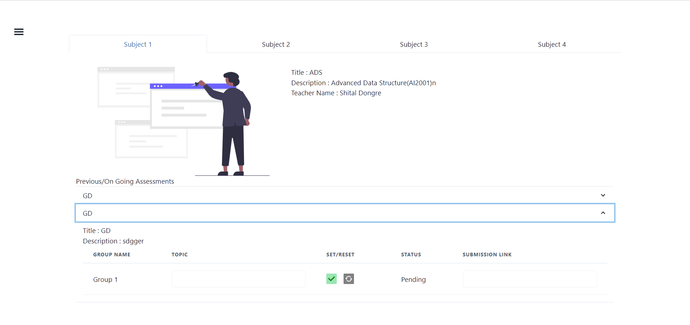
Figure 6: Process student submission
- The figure 6 shows how the students can submit their topics and get accepted by the respected tutor.
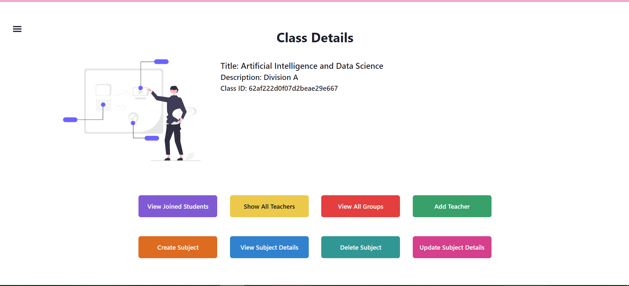
Figure 7: Class details
- The figure 7 shows the options the class teacher has to grade, view , assess students. The proposed system applied and analyzed in Department of Artificial Intelligence and Data Science, VIT Pune
The observations show many of the students and teachers liked the App. Around 122 students joined and out of that 90 students feel comfortable of using the same and among 30 teachers all 30 liked app and given some suggestions for improvement.

FUTURE SCOPE AND CONCLUSION

As our project is highly scalable, we can implement various modules for more interaction between students as well as students and teachers like chatbots, video conferencing, etc. Also, we can add various features like where we can share assignments, docs, or the link to them. This project could be used by different universities for their own internal assessments.
Nowadays web applications are used in various different sectors. Web applications based on modern technologies are easy to scale and easy to run, and can be operated remotely from any part of the world. Though different applications are available currently, there is not a single web application that has both teacher and student interaction. Topic Hub gives a one-stop solution to get rid of different spreadsheets and provides an easy to manage application that can be used by both teachers as well as students simultaneously.

REFERENCES

- Dr. V. Vijayakumar, R. Pradeepkumar, S. Siddharthan, C. Harish Mohan, V. Deepak Kumaran,"Protrack: A Student-Teacher Project Management Tool", Turkish journals of computer and mathematics education/ Volume :12 No. 10(2021)/page no 3173 to 3186
- Blas, Nicoletta Di et al. “A Portal of Educational Resources: Providing Evidence for Matching Pedagogy with Technology.” Research in Learning Technology 22 (2014): n. pag. 1-26
- Dr. Ritesh Patil, Vaishali Gentyal, Vaishnavi Mudaliar, Gauri Kanpurne, Devyani Ambi,"College ERP Using MERN Stack",International Journal of Scientific Research in Computer Science, Engineering and Information Technology, ISSN 2456-3307
- Tilkov, Stefan and Steve Vinoski. “Node.js: Using JavaScript to Build High-Performance Network Programs.” IEEE Internet Computing 14 (2010): 80-83.
- S. L. Bangare1 , S. Gupta2 , M. Dalal3, A. Inamdar,"Using Node.Js to Build High Speed and Scalable Backend Database Server ",International Journal of Research in Advent Technology (E-ISSN: 2321-9637) Special Issue National Conference “NCPCI-2016”, 19 March 2016
- Anna Petrikoglou, Theodore H. Kaskalis,"Full Stack Web Development Teaching: Current Status and a New Proposal",WEBIST 2019: Proceedings of the 15th International Conference on Web Information Systems and TechnologiesSeptember 2019 Pages 218–225
- Akshat Dalmia , Abhishek Raj Chowdary, 2020, “The New Era of Full Stack Development”, international journal of engineering research & technology (IJERT) Volume 09, Issue 04 (April 2020).
- Valentine, T. (2021). “Database-Driven Web Development Fundamentals. In: Database-Driven Web Development.” A press, Berkeley, CA.
- Afroj Satwilkar , Tushar Sawant , Vaibhav Shirke , Santosh V. Jadhav "Django Based Web Application to Empower Skilled People" Iconic Research And Engineering Journals Volume 4 Issue 11 2021 Page 119-120
- B. Carter, "HTML Educational Node.js System (HENS): An Applied System for Web Development," 2014 Annual Global Online Conference on Information and Computer Technology, 2014, pp. 27-31.
- Jung, S. (2018). Web Development with Node.js. Journal of Computing Sciences in Colleges 33(6), 154-156.
- Doglio, F. (2018). “API Design Best Practices. In: REST API Development with Node.js” . A press, Berkeley, CA.
- Mardan, A. (2018).” Using Express.js to Create Node.js Web Apps. In: Practical Node.js. “A press, Berkeley, CA.
- Aruna Pavate Pranav Nerurkar,"Study of angular js: a client side javascript framework for single page applications" International journal of contemporary research in computer science and technology,2015, vol 4, issue 4 pp 92-96
- Ortiz, A.: Programming web services on the cloud with Node.js. In: SIGCSE 2016, Memphis, TN, 2–5 March 2016
- A. Pavate, A. Chaudhary, P. Nerurkar, P. Mishra and M. Shah, "Cuisine Recommendation, Classification and Review Analysis using Supervised Learning," 2020 International Conference on Convergence to Digital World - Quo Vadis (ICCDW), 2020, pp. 1-6,.
- Aruna Pavate. (2021), " Innovative trends that influence on teaching and learning process towards the revolution education 4.0", European Journal of Volunteering and Community-based Projects, 1(4), 1–19.

