Overview of Medical Device Regulation

Dr. P. Charulata Sree
Dental Intern
Rungta College of Dental Sciences and Research
Bhilai, India
charulata014@gmail.com

ABSTRACT
Medical devices are designed and manufactured for overall healthcare, not concentrating specifically on nutritional or medical requirements. Government and Authorized Entities supervise the introduction and maintenance of the device. A new regulatory framework, MDR (EU) 2017/745 Medical Devices Regulation was officially published on May 5, 2017 and implemented on May 26, 2017. It is executed using a conformity assessment depending on risk based classification of the device. The regulation has introduced a UDI system (Unique Device Implementation) to support device traceability with the help of a numeric code or an alphanumeric code. Custom made devices (CMD) in a dental setting have to undergo certain legislative requirements in EU and UK to get their regulatory approval.

Keywords—Medical devices, Regulatory affairs, Medical device regulation, Custom made devices.

INTRODUCTION

‘Medical device’ refers to any instrument, apparatus, appliance, software, implant, reagent, material or other article intended by the manufacturer to be used, alone or in combination, for human beings. It is designed and manufactured for overall healthcare, not concentrating specifically on nutritional or medical requirements. They have an elementary role in rescuing lives by stipulating healthcare solutions for the diagnosis, prevention, monitoring, prediction, prognosis, treatment or alleviation of disease. Government and Authorized Entities supervise the introduction, maintenance of the device. Although they pose potential risk, especially those which have to be implanted, national regulatory agencies try their level best to protect society from unreliable products. In a general context, the new implantable biomaterials have to undergo necessary tests involving in vivo and in vitro tests, physical and chemical characterizations as well as clinical investigations. Stakeholders can expedite the innovation process in the field by gaining knowledge on concepts relating to market approval and maintenance process of the device.
Stanford Biodesign framework concised innovation process into ‘three I phases’- identifying clinical needs, inventing solutions and implementing systems to address them. Different phases require assistance from clinicians, inventors and developers but regulation is a universal theme influencing the whole cycle of a device.

THE NEW EUROPEAN UNION REGULATION:

A new framework governing access to the market in the European Union was designed and taken into consideration to provide uniform technological evolution throughout the EU. MDR (EU) 2017/745 Medical Devices Regulation was officially published on May 5, 2017 and implemented on May 26, 2017. To fulfill the conditions stated in MRD, the aspiring manufacturers are given a three year transition time. It is executed using a conformity assessment depending on risk based classification of the device. The regulation has introduced a UDI system (Unique Device Implementation) to support device traceability with the help of a numeric code or an alphanumeric code. Additionally MDR has developed ‘Eudamed’, an application to gather all the salient features concerning the device market from all EU countries in a binary database. This approach aims to reinforce traceability and transparency in the medical device market.

CLASSIFICATION OF MEDICAL DEVICES:

Table 1 Classification of medical devices

CLASSIFICATION | EXAMPLES
CLASS Ⅰ | Otoscope, Scalpel
CLASS ⅡA | Syringe, Teeth Implant, X ray device
CLASS ⅡB | Blood bag, Lung ventilators, Implantable fixation plate
CLASS Ⅲ | Drug coated Stent, Spinal Disc cage, Breast implants

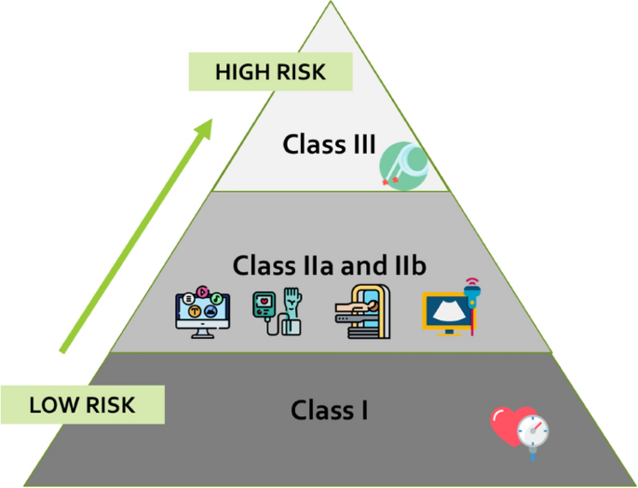

Figure 1 Risk based classification of medical devices.

For most Class Ⅰ medical devices, the basic requirement is to be registered in reference to the FDA. Although some of them do not have to undergo a premarket review, but it is necessary for them to fulfil general controls like manufacturer registration and notification to the FDA prior marketing of the device, adequate manufacturing procedures, appropriate branding and labelling as well as basic post market reporting course of action. For devices falling in Medium risk category, which is class ⅡA and ⅡB, are allowed to present their devices in the market if there is enough evidence that there already are devices similar to their given device which have cleared all the tests concerning the safety of the patient; This procedure is called Substantial Equivalence. Another way to clear the device for the market may be via a “De Novo” review for devices for which there is no predicate. For high-risk devices, which includes devices falling under class Ⅲ, thorough clinical trials are a must to execute their safety and effectiveness, in accordance with Good Clinical Practices (GCP).
In certain circumstances which are concerned with public health or patient safety, a competent authority may authorize placing a device on the market which has not undertaken a conformity assessment. Humanitarian Device Exemption Program deals with devices related to rare diseases. It is based on the fact that randomized clinical trials are impractical in the rare disease population. In spite of that the devices accepted under this exclusion are put through curtailments such as getting consent from the relevant institutional review board before use.

REGULATORY UNCERTAINTY IN DEVICE MARKET:

According to a study by Stern A.D, although early movers have a regulatory advantage in drugs, the case is opposite in medical devices where new manufacturers spend 34% (around 7.2 months longer) to get their regulatory approval. Hence the process delays small firm’s entry into the market making them unlikely to be a pioneer in the new device market. Device approval time can be expedited by publishing objective regulatory guidelines.

REGULATION OF CUSTOM MADE DEVICES IN A DENTAL SITTING:

Custom made device (CMD) refers to a device having specific characteristics which is custom made according to the patient. It is made specifically in obedience to a medical practioner’s guidance and prescription. This includes removable (dentures, obturators) or fixed (inlay, onlay, crowns) prosthodontic appliances, speech prosthesis, bruxism splints, devices for trauma prevention (buccinators flap appliances, mouthguards), orthognathic surgery (arch bars) and obstructive sleep apnoea management.

Table 2 Classification of custom made devices in dental settings.

CLASSIFICATION | EXAMPLES
CLASS Ⅰ | Arch bars, Buccinator muscle flap appliances, special trays
CLASS ⅡA | Removable and fixed prosthodontic devices, orthodontic appliances, removable sleep apnoea devices
CLASS ⅡB | Dental implants
CLASS Ⅲ | -

Legislative requirements in pertaining CMD’s in EU and UK can be summarised as:
- Inform competent authority.
- Select a representative for regulatory compliance
- For placing the device in the market select an appropriate agent.
- Double check the management system to enhance quality.
- Follow Annex 1 requirements which are applicable to CMD’s.
- Prepare documentation and statements concerning the design, manufacturer and performance of the device produced.
- For at least five years, hold fast to the hard copy of the statement.
- Document happenings in post production phase.
- Reveal any serious incidents or actions concerning field safety.

CONCLUSION:

The keystone of most regulatory systems in the world is by classifying medical products into drugs, biologics and medical devices. But new and innovative products do pose a great challenge to this existing product classification. Advancing inventive products such as 3D bioprinting and materials used for tissue engineering need a more streamlined regulatory evaluation to encourage innovation and expedite delivery of harmless and potent medical devices to patients.

REFERNCES

- Guerra-Bretaña RM, Flórez-Rendón AL. Impact of regulations on innovation in the field of medical devices. Res Biomed Eng. 2018. DOI: 10.1590/2446-4740.180054
- Bianchini, E., Mayer, C.C. Medical Device Regulation: Should We Care About It?. Artery Res 28, 55–60 (2022). https://doi.org/10.1007/s44200-022-00014-0
- https://assets.publishing.service.gov.uk/government/uploads/system/uploads/attachment_data/file/640404/MDR_IVDR_guidance_Print_13.pdf
- Innovation under regulatory uncertainty: Evidence from medical technology – Ariel Dora Stein - https://www.sciencedirect.com/science/article/abs/pii/S0047272716301669?via%3Dihub
- Green JIJ. Medical Device Regulation: Requirements for Dental Professionals Who Prescribe and Manufacture Custom-Made Devices. Primary Dental Journal. 2021;10(1):64-88. doi:10.1177/2050168420980980

