3D PRINTING: A NEW ERA FOR DRUG DELIVERY
Dr.N. Tamilselvan, Radhika Sivaraj and Aishwarya K N
Department of Pharmaceutics
Nehru College of Pharmacy, Pampady , Kerala

Ⅰ. INTRODUCTION
Three-dimensional (3D) printing is layer-by-layer production of 3D objects from digital designs using Computer aided software. It is the process of making 3-dimensional solid object from a digital file ^{[1,2]}. This technique is widely used in drug development process. 3D printing is also known as additive manufacturing or additive layer manufacturing or freedom fabrication manufacturing. It is using even during preclinical studies. Charles Hull an American engineer invented 3D printing technology ^{[3]}.3D printing results in high production rate due to its rapid operation, capable to accomplish high drug loading efficiency, diminution of material wastage saves the production cost.3D printing technology has got multifaceted features. It is possible to produce any dosage form predetermined release profile. For the production of active pharmaceutical ingredient 3D printed miniaturized reaction vessels are available.3D printing is useful for the synthesis of variety of molecules on a small scale. 3D printing is mainly useful for drugs with high cost and poor stability. 3D printing can produce different dosage form with complex internal geometries, multiple drugs and excipients. For the purpose of manufacturing personalized medicine 3D printers can be provided in hospital pharmacy which results in economic benefits. 3D printed personalized dosages contribute to cost effective medications. Main benefits of 3D printers is that, they are easy to handle, accurate deposition of materials with changes in active ingredient and excipients can be easily achieved. Often drugs used in the treatment of rare diseases which are more costly can be acquired by 3D printing technology.
3D printing can be used in personalised medicine. Spritam is the first 3D printed tablet, it is an orodispersible tablet ^{[4]}. In the course of covid 19 pandemic 3D printer has adopted for the manufacture copper 3D NanoHack mask, HEPA masks, PPE kits. The intent of this review is to emphasise the 3D printing approach being established for the invention of drug delivery system and formulation and processing.
Ⅱ. HISTORY
In the mid-1980s Charles Hull examined the development of 3D printing, as patented, developed and commercialized the leading apparatus and also developed STL file format that merge with current CAD software ^{[5,6,7]}. The theory of 3D printing has been coined in the 1970s, but the experiments were started from 1981.First 3D printing experiments were conducted by Dr Kodama for his rapid prototyping technique. In 1984 French engineers developed a stereolithography and later neglected. In the mid of 1986 Charles hull showed interest in 3D printing and submitted first patent in stereolithography. In 1988 Carl Deckard filed a patent for SLS technology. In the meanwhile, Scott Crump filed a patent for the fused deposition modelling of 3D printing ^{[8]}. In 1990 there was evolution of 3D printers’ manufacturers. The first EOS “stereos” system was also developed in 1990. In 1993 solidscape a 3D printer was founded. In 1999 engineered organs has brought new approaches to medicine. In 2000s 3D printing has obtained media visibility. First commercially available SLS printer was released in 2006.In 2020s was marked by the advent of more sophisticated additive manufacturing materials (high performance materials).
Ⅲ. ADVANTAGES OF 3D PRINTING
- In contrast to conventional dosage form, high drug loading can be achieved via 3D printing.
- Production cost can be reduced as there is minimum wastage of materials.
- 3D printing can print the object very fastly.
- 3D printing is cost effective.
- 3D requires minimum space.
- 3D printing technology is environment friendly.
- Manufacturing of small batch is profitable and the process can be completed in a single run.
- 3D printing is used to print organs such as heart, liver and kidney.
- It is suitable for the delivery of less water soluble and low therapeutic index drugs.
- Batch-to-batch variations can be reduced ^{[9]}.
- Accurate and precise dosing is possible in the case of potent drugs.

Ⅳ. DISADVANTAGES
- Limited materials are available for 3D printing technique.
- Clogging of powder printing is a hindrance.
- In the case of powder-based 3D printing confined or special area is required to perform the printing as powder spillage is critical and can pose as an occupational hazard ^{[10]}.
- 3D printing technology reduce human labour due to automation.
- 3D Printer related specifications effects its quality and cost.
- 3D printing technology consumes high energy.
- Final structure may be modified owing to mechanical stress and ink formulation effects.

Ⅴ. 3D PRINTING TECHNIQUES

Zip dose printing
Inkjet printing system

Stereolithography
3D PRINTING TECHNOLOGIES

Extrusion based printing

Nozzle based deposition system
Powder based printing

There are various techniques of which fused deposition modelling is widely used. Basic principle of manufacturing remains the same.

- INKJET PRINTING SYSTEM

In this method ink is deposited on a substrate by any one of the 2 methods.
Main advantage of this method is that it is capable of high-resolution printing. This method offers low cost and minimum wastage. It provides a detailed information of CAD in a ‘direct write’ way.

Consists of 2 types
- Continuous inkjet printing
- Drop on demand printing

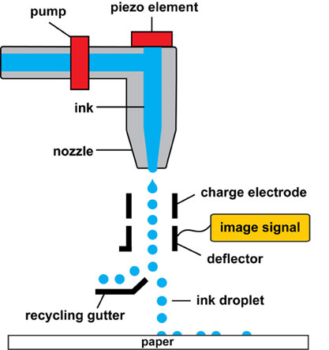
1. Inkjet printing system ^{[11]}
Continuous inkjet printing
Continuous inkjet printing initiate with a high-pressure pump device that direct liquid from a reservoir to a bank of micrometre-sized nozzles, thus generating a continuous stream of droplets at frequencies decided by the oscillations of vibrating piezoelectric crystals ^{[12]}. It is possible to carry out two-dimensional and three-dimensional printing of pharmaceutical substances. Continuous jet printing has embedded printer head which can be thermal or piezoelectric and has the control over viscosity of the liquid. In order to clarify the factors that influence print distortion continuous inkjet printing was developed.

Drop on demand printing
DOD printing has a more accurate execution. It consists of 1000 nozzles. Print heads are activated by thermal and piezoelectric trigger mechanisms.
There are 2 types of drops on demand inkjet printing technology
1.Thermal-inkjet printing
2.Piezo-inkjet printing
It is possible to mark the products with very high printing quality of up to 600 dpi. This technology is also beneficial for large scale font printing. It permits prints up to 800mm high. In thermal inkjet printing pressure is generated by heat. Steam bubbles are produced in printhead by means of heating element ^{[13,14]}. These bubbles elicit a pressure pulse allowing ink drops to escape through the nozzles and printing takes place. Contrary to the thermal inkjet printers, piezo inkjet printers do not require heat. Piezo electric printers make use of electric voltage to create pressure pulses. Piezoelectrical materials changes its shape when voltage is applied. This is known as Piezoelectrical effect.

- EXTRUSION BASED PRINTING
It involves two techniques,
- Hot melt extrusion
- Fused deposition method

Hot melt extrusion:
In the case of Hot melt extrusion techniques, a homogenous, solid dispersion of pharmaceutical excipients such as polymeric materials and plasticizers are prepared in a molten form of polymer and a drug substance is introduced in the polymeric composition ^{[15]}. Next, the formulation ink can be extruded directly through a dye under high pressure and elevated temperature, then fused and solidified after printing, thereby generating a 3-D product of uniform shape with high quality and drug content. Main advantages of this method is that it is a solvent free method which eliminates the need for a rigorous solvent selection step, making it an environment friendly method of production.

Fused deposition method:
This method requires elevated temperature for its operation (220°C) which may degrade large number of pharmaceutical excipients and active drugs. In fused deposition modelling, beads of heated plastic are extruded from the print head. This technique makes use of thermoplastic polymers like polylactic acid, polyvinyl alcohol. Active pharmaceutical ingredients and polymer mixtures are made to pass through the nozzles and deposited on a platform in the form of filaments ^{[16]}. These filaments are then hardened. It is known as fused filament fabrications. Nozzle diameter feed rate, pressure drop determine the extent of deposition of materials. This method provides high mechanical strength. This method is not suitable for thermolabile active pharmaceutical ingredient and thermoplastic.

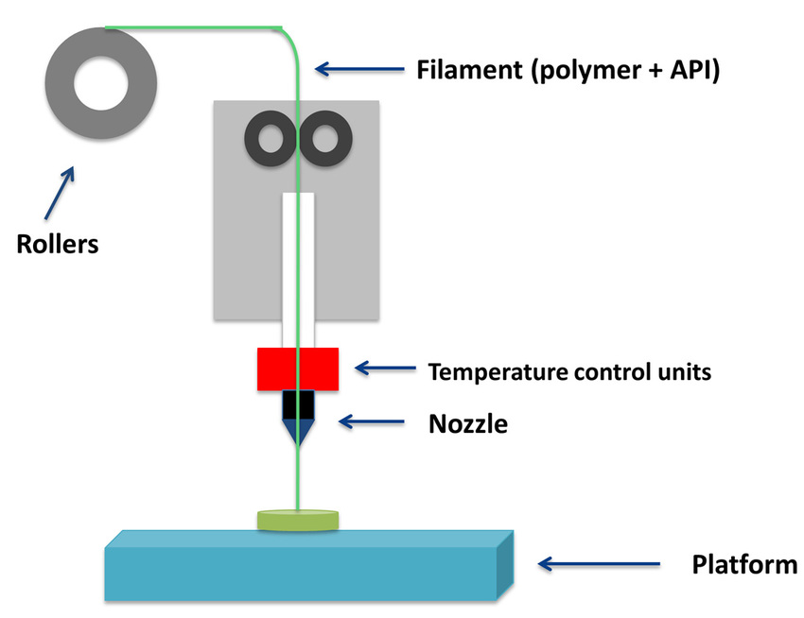
2.Fused deposition method ^{[17]}
- POWDER BASED PRINTING OR SELECTIVE LASER SINTERING
Powder bed printing technology have the ability to achieve drug loading up to 1000mg. Spritam (levetiracetam) was developed by this technology and used for the treatment of epilepsy in paediatric and geriatric patients ^{[18]}.
Powder 3D printing technique uses powder substrates for the sprayed ink and then it solidifies into a solid dosage form. This method mainly uses metals and polymers. Uses high power laser carbon-dioxide. Laser fuses powdered material by scanning cross section generated from CAD file on the surface of building platform. After scanning, the powdered bed is lowered by one layer thickness. New layer of material is applied on the top, and the process is repeated until the part is completed ^{[19,20]}.
D. NOZZLE BASED DEPOSITION SYSTEM
There are 2 types of printings according to the type of material used: Fused deposition modelling, which uses melted components, and pressure-assisted micro syringes which does not require the use of melted material.
PRESSURE ASSISTED MICROSYRINGE TECHNOLOGY
This technology uses syringe extruder which deposit a viscous material using pressurized air piston. It deposits in layer-by-layer fashion in the predetermined geometry.

- STEREOLITHOGRAPHY(SLA)
Stereolithography is the method based on the photopolymerization of liquid resin by ultraviolet light. This technique has been utilized in the manufacture of tablets of paracetamol.
By means of this technique, it was possible to print tablets containing varying amount of polyethylene glycol 300. When compared to fused deposition modelling has resulted in high drug loading with rapid drug release devoid of drug degradation.
The process of printing involves a uniquely designed 3D printing machine called a stereo lithograph apparatus which converts liquid plastic into solid 3D objects.
UV lasers are used to draw a pre-programmed design, normally resins are used.
The first step involves designing a 3D object by the help of CAD file, then these are sliced into horizontal layers. Hence, a digital code is generated which is given to printer after giving an input, it will move step by step down and will stay below the liquid level. Liquid will be spread over the platform, then UV rays are focused on liquid based on desired shape. It will move upward for the removal of liquid, and further taken away from the platform ^{[21]}.

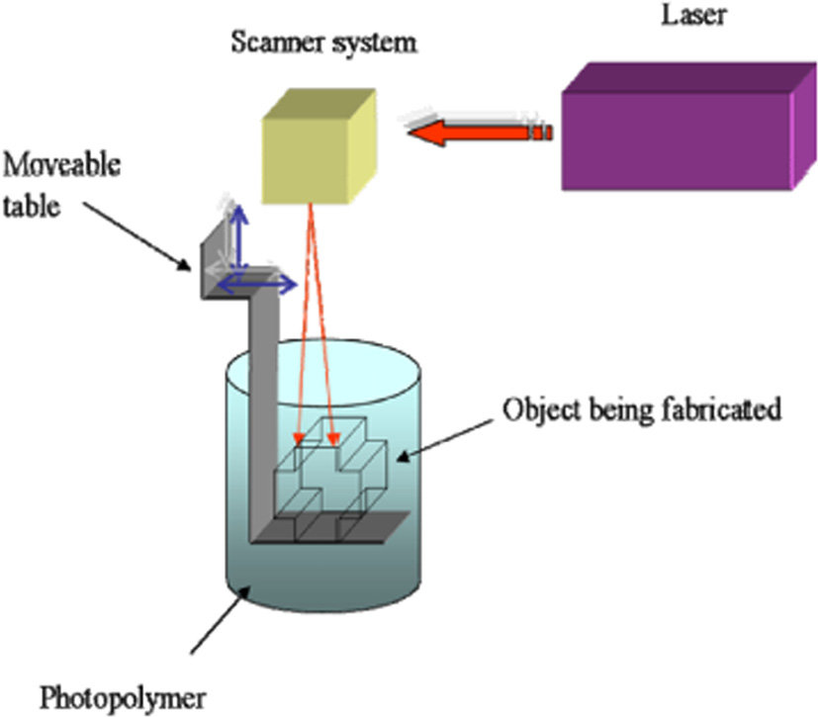

3.Stereolithography ^{[22]}
- ZIP DOSE PRINTING
Provide a personalized dose in addition to delivery of high drug loaded with high disintegration and dissolution levels by manufacturing highly porous material. In this method powdered medicine spread into a thin layer. Liquid is dropped into a powder in order to bind the particles together in a thin porous layer and the process is repeated.
Zip dose technology can hold a high dosage load and still maintain rapid disintegration with just a sip of water. This technology is also beneficial for patients with following difficulty.
This technology reduces the complexity of ink formulation and resulting in the production of high dose medication.
Zip dose® is relatively easy to scale by assemblage of multiple inkjet heads to print tablets in parallel ^{[23]}.

Ⅵ. APPLICATION IN PHARMACEUTICAL INDUSTRY

Dosage form | API | 3D technique | Excipients | Reference
Tablet | Acetaminophen | Powder bed inkjet | MethocelTM E50, Polyvinyl pyrrolidone, ethyl cellulose, fluorescein, colloidal silicon dioxide, Eudragit RS 100 | [24]
Tablet, ER | Theophylline | Fused deposition modelling, hot melt extrusion | Eudragit RL 100, RS 100, Hydroxy propyl cellulose, tri ethyl citrate | [25]
Tablet, ER | Prednisolone | Fused deposition modelling | Polyvinyl alcohol | [26]
Polypill, SR | Captopril, Nifedipine, Glipizide | Extrusion | HPMC, PEG 6000, Tromethamine, lactose, sodium chloride, D-mannitol, sodium starch glycolate, hydroxy propyl methyl cellulose, croscarmellose sodium, microcrystalline cellulose | [27]
DuoCaplet, delayed | Paracetamol, caffeine | Fused deposition modelling, hot melt extrusion | Polyvinyl alcohol | [28]
Shell-core tablets | Theophylline, Budesonide, Diclofenac sodium | Dual fused deposition modelling and hot melt extrusion | Core: polyvinyl pyrrolidone, triethyl citrate, talc, and API  Shell: Eudragit L 100, triethyl citrate, talc | [29]
Two compartmental capsular device, pulsatile | Acetaminophen | Fused deposition modelling, hot melt extrusion | Polylactic acid, poly vinyl alcohol, PEG 400, PEG 8000, Glycerol, Blue and yellow dye containing formulation (Kollicoat® IR brilliant blue and Kollicoat® IR yellow) | [30]

Ⅶ. CONCLUSION
3D printing has emerged as a new horizon for drug delivery. Conventional method of production which are outdated in terms of flexibility and efficiency can be improved by incorporation of 3D printing into manufacturing of drug product.
In the near future 3D printing will be utilized to fabricate different novel dosage forms. By the usage of 3D printing technology personalized medications, optimized drug release from dosage form, avoiding drug-drug incompatibilities protection of biomolecules during manufacturing process are possible which will take the drug delivery to a new era.

Ⅷ. REFERENCE
1.Gross BC, Erkal JL, Lockwood SY, Chen C, Spence DM. Evaluation of 3D printing and its potential impact on biotechnology- the chemical sciences. Anal. Chem 2014; 86(7): 3240-53.
2. Belhabib S, Guessasma S. Compression performance of hollow structures: From topology optimisation to design 3D printing. Int. J. Mech. Sci. 2017; 133: 728-39.
3.Hull CW. Apparatus for production of three-dimensional objects by stereolithography. USA: UVP, Inc. 1986.
4.FDA SPRITAM (Levetiracetam) Tablets. Available online: https://www.accessdata.fda.gov/drugsatfdadocs/nda/2015/207958Orig1s000TOC.cfm.
5. Hull CW. Apparatus for production of three-dimensional objects by stereolithography. US4575330; 1986.
6. Hull CW. Method for production of three-dimensional objects by stereolithography. US4929402; 1990.
7. Hull CW, Spence ST, Albert DJ, et al. Method and apparatus for production of high-resolution three-dimensional objects by stereolithography. US5184307; 1993.
8.Crump SS. Apparatus and method for creating three-dimensional objects. US5121329;1992.
9.Aprecia Zipdose® technology. 12/3/2015. Available from: https://aprecia.com/zipdose-platform/zipdose technology.php.
10. Huang SH, Liu P, Mokasdar A, Hou L. Additive manufacturing and its societal impact: a literature review. International Journal of Advanced Manufacturing Technology. 2013; 67(5–8):1191–203.
11. Jain K, Jain A, Mehra NK, Jain NK. Lipoproteins tethered dendrimeric nanoconstructs for effective targeting to cancer cells. Journal of Nanoparticle Research 2013; 15:2003.
12. Ihalainen P, Maattanen A, Sandler N. Printing technologies for biomolecules and cell-based applications. Int. J. Pharm 2015; 494: 585-92.
13.Acosta-Vélez GF, Wu BM. 3Dpharming: Direct printing of personalized pharmaceutical tablets. Polym. Sci. 2016; 1:2.
14. Alomari M, Mohamed FH, Basit AW, Gaisford S. Personalised dosing: Printing a dose of one’s own medicine. Int J Pharm 2015; 494: 568-77.
15.Nayan GS, Tahsin Md, Ankita VS, Abu TM. Formulation of 3D Printed Tablet for Rapid Drug Release by Fused Deposition Modeling: Screening Polymers for Drug Release, Drug-Polymer Miscibility and Printability J Pharm Sci 2018; 107(1): 390-40.
16. Hoy MB. 3D printing: making things at the library. Med Ref Serv Q 2013; 32(1): 94-99.
17. Gross BC, Erkal JL, Lockwood SY, et al. Evaluation of 3D printing and its potential impact on biotechnology and the chemical sciences. Anal Chem 2014;86:3240–53.
18. Rowe CW, Katstra WE, Palazzolo RD, et al. Multimechanism oral dosage forms fabricated by three dimensional printing. J Control Release 2000;66:11–7.
19. Katstra WE, Palazzolo RD, Rowe CW, et al. Oral dosage forms fabricated by three dimensional printing. J Control Release 2000;66:1–9.
20. Palazzolo RD. Formulation of oral dosage forms by three dimensional printing. Massachusetts: MIT; 1998.
21. Pere CPP, Economidou SN, Lall G, Ziraud C, Boateng JS, Alexander BD, et al. 3D printed microneedles for insulin skin delivery. Int J Pharm. 2018;544:425–32.
22. Minna, Peltola A, Sanna M, Grijpma, Dirk W, Melchels, et al. A review of rapid prototyping techniques for tissue engineering purposes. Ann Med 2008;40(4):268–80.
23. Prasad L K and Smyth H 2016 3D Printing technologies for drug delivery: a review Drug Dev. Indust. Pharm. 42 1019–31.
24. Yu DG, Yang XL, Huang WD, et al. Tablets with material gradients fabricated by three-dimensional printing. J Pharm Sci 2007;96:2446–56.
25. Pietrzak K, Isreb A, Alhnan MA. A flexible-dose dispenser for immediate and extended release 3D printed tablets. European Journal of Pharmaceutics and Biopharmaceutics. 2015;96:380-387. DOI: 10.1016/j.ejpb.2015.07.027.
26. Skowyra J, Pietrzak K, Alhnan MA. Fabrication of extended release patient-tailored prednisolone tablets via fused deposition modelling (FDM) 3D printing. Eur J Pharm Sci 2015;68: 11–7.
27. Khaled SA, Burley JC, Alexander MR, et al. 3D printing of tablets containing multiple drugs with defined release profiles. Int J Pharm 2015;494:643–50.
28. Goyanes A, Wang J, Buanz A, Martínez-Pacheco R, Telford R, Gaisford S, et al. 3D printing of medicines: Engineering novel oral devices with unique design and drug release characteristics. Molecular Pharmaceutics.2015;12(11):40774084.DOI:10.1021/acs.molpharmaceut.5b00510
29. Okwuosa TC, Pereira BC, Arafat B, Cieszynska M, Isre A, Alhnan MA. Fabricating a shell-core delayed release tablet using dual FDM3D printing for patient-centred therapy. Pharmaceutical Research. 2017;34:427. DOI: 10.1007/s11095-016-2073-3
30. Maroni A, Melocchi A, Parietti F, Foppoli A, Zema L, Gazzaniga A. 3D printed multi-compartment capsular devices for two-pulse oral drug delivery. Journal of Controlled Release. 2017;268:10-18. DOI: 10.1016/j.jconrel.2017.10.008

