The nutrient cycling in soil
Jagriti Patel
PhD research scholar, Department of Soil Science and agricultural chemistry,
College of Agriculture, Indira Gandhi Krishi Vishwavidyalaya,
Raipur, India
pateljagriti06@gmail.com
- Introduction
Nutrient cycling in ecosystems is the process through which various chemical components and nutrients are transformed between soil, plants, and the atmosphere. It is a mechanism where matter and energy are transmitted between living things and the environment's non-living components. This happens as a result of soil nutrients being used by plants and animals, which are subsequently released back into the environment as a result of decomposition and death. The recycling of nutrients is greatly aided by soil microorganisms. They break down organic material in order to release nutrients in the soil. They are also crucial for capturing and transforming nutrients into the soil so that plant roots may absorb them. The nutrient cycles can be assessed at different levels viz. global level, country level, farm level and at field level.
Nutrient cycling is an important mechanism by which plants influence the soil in which they grow, changing the rate of soil growth and the appropriateness of the soil environment for subsequent vegetation generations. The frequent and efficient replacement or recycling of plant nutrients helps maintain the fertility in soil since they are the major component required for growth, development and yield of the crop.
- Different nutrient transformation processes
- Natural ecosystems – natural conditions
Under natural conditions, soil organic matter or humus plays the key role in nutrient cycling. The organic compounds from plant residues and manure from animal wastes are in general complex sources of nutrients which are converted into simpler substances through the process of mineralization and decomposition by soil bacteria and fungi. The distinct processes involved in the release of plant nutrients in available forms are weathering, decomposition, desorption from the clay-humus complex, etc. The nutrients which are absorbed by the plants are liable to re-enter the process of cycling of nutrients.
- Agro-ecosystems – farm conditions
The features of nutrient transformations under farming conditions are substantially different from those of natural condition. Various farming systems possess different patterns of nutrient cycling pertaining to different farm types viz. crop farms, livestock farms and mixed crop and livestock farms. The outputs or yield produced in the agro-ecosystems are significantly higher than the natural ecosystems. Here, the nutrient flow can be both internal or external in nature. The internal nutrient flow are the ones taking place within the farm while the external nutrient flows to and from the farm.
Figure 1 – Basic nutrient cycling
- Different nutrient cycles in nature
The nutrient cycle comprises of transformation of nutrients through different spheres viz. biosphere and geological strata. It also stimulates the movement of nutrients between different components of ecosystem viz. biotic and abiotic elements. These cycles are ultimately driven by solar energy and are regulated and guided by the energy used by living things. The hydrologic cycle, which is driven by solar energy, functions much like an infinite conveyor belt that transports elements necessary for life throughout ecosystems. The nutrient cycling of important elements also involves its presence in atmosphere in gaseous forms, mineral forms and its utility in plant ecosystems. The nutrient cycles of various nutrients are functional in our surrounding some of which are discussed later in this chapter.
- The Nitrogen cycle
It is the most complex nutrient cycle present in nature. Different sources providing nitrogen to this endless cycle of environment are plant residues in the soil, organic matter or humus present in the soil, FYM, fertilizers and the nitrogen present in the atmosphere. Since elemental nitrogen, or N₂, makes up 78% of the atmosphere's volume, it serves as an endless source of this vital element. The N₂ molecule is extremely stable, therefore the nitrogen cycle's limiting phase is breaking it into atoms that can be added to inorganic and organic chemical forms of nitrogen. Therefore, this process is performed by extremely energetic phenomena i.e., lightning so that nitrogen gets chemically associated with oxygen or hydrogen as nitrogen oxides and ammonia. The major transformations taking place under this cycle are
- Physical transformations – These processes include the transport of various forms of nitrogen freely between soil and the atmosphere. For instance, release of nitrogen in gaseous form under the process of ammonia volatilization.
- Chemical transformation – It includes mainly two processes firstly fixation of ammonia by clay minerals and secondly denitrification due to anaerobic conditions.
- Biological transformation - The microorganism present in soil plays a major role in this kind of transformations. Biological nitrogen fixation is a significant process performed by free living and symbiotic (Rhizobium sp.) microorganisms. The other mechanism is mineralization which is the process of conversion of complex form of nitrogen present in organic materials as amino acids, proteins, nucleic acid, etc into a form available to the plants for the efficient uptake of the element.
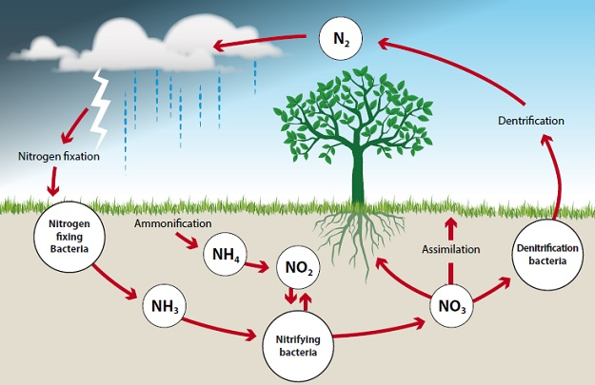
Figure 2 – The Nitrogen Cycle (Adapted from studyacs.com)
Phases of nitrogen cycle
- Nitrification
It is a microbial process through which ammonia gets converted to nitrite and then nitrate. The bacteria which help in this process of nitrification are Nitrosomonas and Nitrobacter. The conversion of ammonia to nitrite is performed by Nitrosomonas while the conversion of nitrite to nitrate is done by Nitrobacter. This is a main process taking place in the soil ecosystem and has a great importance since nitrate is the form of nitrogen which is required by most of the plants for absorption.
- Ammonification
The dead and decaying plants present in the soil possess nitrogen in organic forms of nucleic acid, proteins, etc which is unavailable to the plants. The microorganisms act upon these organic materials and convert it into inorganic form of ammonia by the process of ammonification. Several microorganisms are involved in this process viz. different fungi and bacteria, they breakdown the organic matter using their metabolic energy and carbon thereby, releasing nitrogen in to the soil atmosphere.
- Immobilization
Immobilization is the process of conversion of inorganic form to organic form of the element. It is the opposite of mineralization. In this process, the inorganic forms of nutrients get incorporated into the living cell resulting in the loss of nutrients from the soil atmosphere. The process is important because it makes mineral nutrients available to plants and minimise their loss via leaching, it also moves them to soil pools with a rather quick turnover period.
- Biological nitrogen fixation
The leguminous plants are an important group of plants having importance not only in the human diet but also possessing a significant place in the crop ecosysytem. The plants have a special character of fixing nitrogen with the help of nodules present in their roots. These nodules are home to some specialized bacteria of Rhizobium sp. which helps in fixing nitrogen into the roots from the atmosphere, ultimately helping in increasing nitrogen concentration in soil and subsequently in plants. Some other species of free living bacteria (azotobacter, acetobacter, etc.) also aids in this process of nitrogen fixation.
- The phosphorus cycle
Phosphorus is a major nutrient required by the plants but is usually a limiting nutrient in the gro-ecosystems. The phosphorus cycle is a sedimentary cycle since there are no typical stable gaseous forms of phosphorus. Phosphorus is mostly stored in the geosphere as insoluble minerals like the calcium salt hydroxyapatite. Plants absorb soluble phosphorus from these minerals and other sources, such fertilisers, and integrate it into the nucleic acids of crop biomass. Phosphorus is then returned to the salt solution through mineralization of biomass by microbial decomposition, where it may precipitate as mineral materials. Inorganic phosphorus in soil solution can also be adsorbed to mineral surfaces or precipitation (often referred to as P fixation). The residual P availability can persist for several years. Only 0.01% of the phosphorus is found as soluble, while the remaining 1-2% is in microbial tissue. There are no significant losses of phosphorus either by leaching or in gaseous forms. The fertilizer P provided to plants viz. Single super phosphate, di ammonium phosphate, rock phosphate, etc are an important source of phosphorus and plays an important in this biogeochemical cycle.
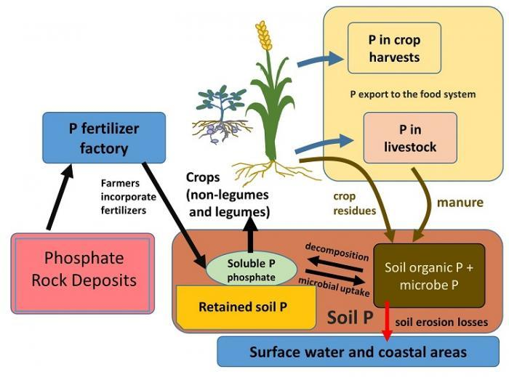
Figure 3 – The Phosphorus cycle (Adapted from the website serc.carleton.edu)
- The Sulphur Cycle
This biogeochemical cycle is also a complex cycle prevailing in the nature. This involves various gaseous species in solution and insoluble minerals. Sulfur interacts with oxygen to generate soluble sulphate ions and gaseous sulphur di oxide (SO₂), both of which are pollutants in the atmosphere. The gaseous species involved in the sulfur cycle are gaseous hydrogen disulphide (H₂S), mineral sulphides such as Lead sulphide (PbS), sulphuric acid (H₂SO₄) and some biologically bound sulfur in sulfur containing plant proteins. A variety of soil organisms break down sulfur-containing proteins into their individual amino acids. Another group of soil bacteria converts the sulphur in the amino acids to hydrogen sulphide (H₂S). Greater volumes of hydrogen sulphide gas are also released into the atmosphere when vast amounts of fossil fuels are burned, notably coal. Sulfur bacteria transform H₂S into sulphur and then sulphate in the presence of oxygen. The sulphate eventually turns into H₂S. Rapid oxidation of hydrogen sulphide produces gases that combine with water to make sulphurous and sulfuric acids responsible for the acid rain.
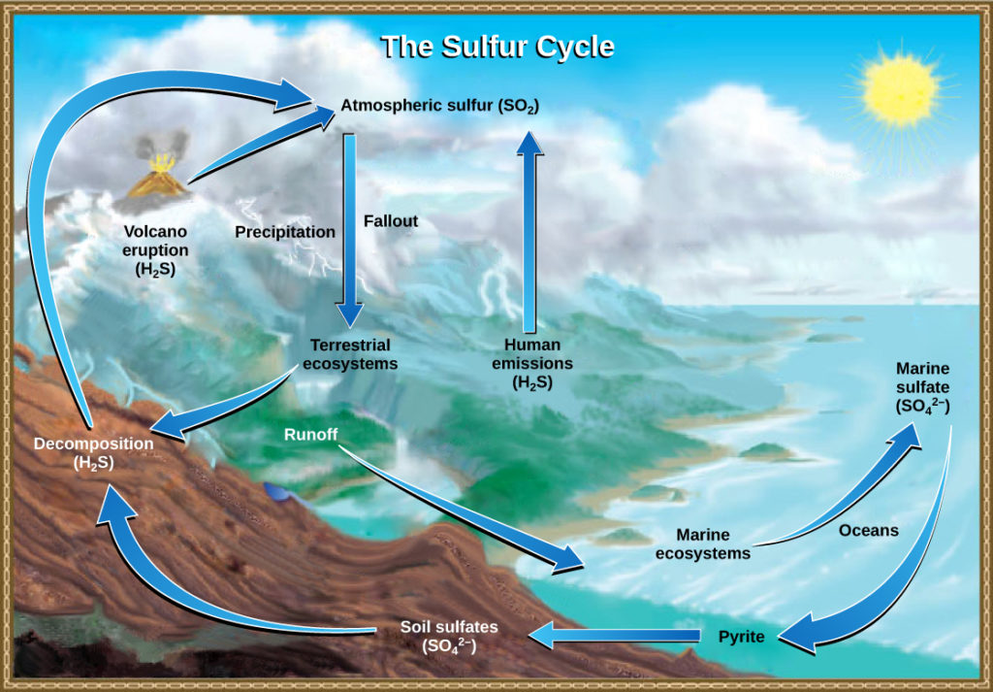
Figure 4 – The Sulphur cycle (Adapted from lumenlearning.com)
- Nutrient losses from the soil
The nutrient losses are a major concern in global agro-ecosystems leading to losses of nutrients globally. The losses of nutrients result in depletion of the amounts of plant available soil nutrients. It can occur majorly by
- Release from the soil which results in the loss of nutrients beyond soil plant systems.
- Transformation of soil nutrients into non available forms viz. precipitation, etc. which are known as internal losses.
- Release from the soil
This loss mainly includes the losses of nutrients through crop removal in the form of yields. Other losses include erosion losses, runoff, leaching, etc. The erosion of nutrients present in the soil particles through water is becoming a major concern nowadays. Runoff loss includes loss of dissolved nutrients in soil solution by moving across the soil profile whereas, the leaching includes the downward movement of nutrients soluble in water to the ground water. Other losses include gaseous losses through volatilization and denitrification.
- Internal losses
This refers to the transformation of soil nutrients into non-available forms and they do not leave the soil systems (i.e., precipitation and chemical reactions leading to insoluble forms, etc.) In case of phosphorus, its transformation into insoluble forms is the result of strong fixation of P in interlayer sites of clay minerals.
REFERENCES
- https://www.studyacs.com/blog-nitrogen-cycle-37.aspx
- https://courses.lumenlearning.com/wm-biology2/chapter/the-sulfur-cycle/
- britanica.com
- Shankar IAS Academy, Environment, 9th edition.
- http://serc.carleton.edu

