GEOPHYSICAL INVESTIGATION OF GROUNDWATER EXPLORATION USING SELF-POTENTIAL AND RESISTIVITY METHOD IN VEPPILAIPATTI VILLAGE, SALEM DISTRICT, TAMILNADU

Gopal V*., Chandravijay M., Ranjith Kumar R., Krishnamurthy R.R.
Department of Applied Geology, University of Madras, Guindy Campus, Chennai-600 025.

*Corresponding Author

Dr. Gopal V
veegopaal@gmail.com

INTRODUCTION
Geophysics is a subject of natural science concerned with the physical processes and physical properties of the Earth and its surrounding space environment, and the use of quantitative methods for their analysis. The term geophysics sometimes refers only to the geological applications. Earth's shape, its gravitational and magnetic fields structure and composition, its dynamics and their surface expression in plate tectonics, the its internal generation of magmas, volcanism and rock formation. Over the past several decades, geophysical surveying has become increasingly effective and useful for understanding the subsurface groundwater conditions (Murthy et al; 1968 and Raman et al: 2000).
GEOPHYSICAL EXPLORATION OF GROUNDWATER
Geophysical exploration is the scientific measurement of physical properties of the earth crust for investigation of mineral deposits or geologic structure. With the discovery of oil by geophysical methods in 1926, economic pressure for locating petroleum and mineral deposits stimulated the development and improvement of many geophysical methods and equipments. Geophysical methods detect differences or anomalies of physical properties within the earth’s crust. Density, magnetism, elasticity, and electrical resistivity are properties most commonly measured. In the application of geophysical methods for groundwater exploration, it is often misunderstood by many that they are used to directly detect groundwater.
Scientific methods of groundwater exploration can generally be classified based on the are of tools employed. The important exploratory techniques normally adopted are
1. Geological methods
2. Geomorphological methods
3. Remote sensing methods
4. Geophysical methods
Geophysical methods
Geophysical methods depends on certain physical properties of earth materials. The properties are measured and variations in their values in lateral or vertical directions are made use of for gathering subsurface information
The most important rock properties that are made use of are
1. Gravity prospecting
2. Magnetic prospecting
3. Seismic prospecting
4. Electrical prospecting
5. Radiometric prospecting
Electrical prospecting
Electrical resistivity techniques are based on the response of the earth to flow of electric current. The resistivity of a rock unit depends on its mineral composition and is influenced to a very large extend by the interstitial water content present there in. Electrical resistivity method involves the measurement of surface potential caused by the passage of an electric current. In actual field measurements, a variety of electrode arrangements are used.
1.3 ELECTRICAL RESISTIVITY METHOD
This method involves the measurement of the resistance, offered by the rock formations in an area to the flow of an electric current of known intensity. The resistivity of a rock unit depends on its mineral composition and is influenced to a very large extent by the interstitial water content present there in. Electrical resistivity methods involve the measurement of surface potential caused by the passage of an electric current, impressed on the ground from an artificial source. is based on the validity of Ohm's law for linear conductors R-Av/1, where Ris the resistance in Ohms, offered to the flow of current I and Av is the potential difference, in volts, across two end faces of the conducting material. The resistance of the medium is directly proportional to its length L and inversely proportional to its cross-sectional area so that R α L/A
The electrical resistivity or the specific resistance, P of the conducting medium, then is
Ρ= (A/L) R = (∆v / I) A/L
Thus, the resistivity can be defined as the resistance offered by a material of unit dimensions and in the mks system its unit is ohm-meter (Ω m). The pioneering efforts of Conrad Schlumberger (1912 - 1914) are mainly responsible for the development of electrical resistivity method as an effective tool in geophysical exploration. In field measurement, current is introduced to the ground through two electrodes and the potential difference between another pair of electrodes is measured. The strength of the current impressed and the potential difference that is measured is then used to calculate the resistivity of the ground, taking into account the geometry of the electrode spread.
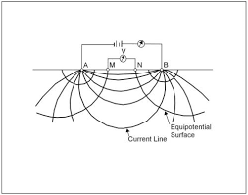
Figure 1.1 RESISTIVITY METHOD
The above figure shows the arrangement and the current and potential lines in a homogeneous and isotropic medium. The potential difference between the two potential electrodes, M and N due to the current introduced by the two current electrodes, A and B.

1.4 ELECTRODE CONFIGURATION
In actual field measurements, a variety of electrode arrangements or configurations are used, the difference being in the inter electrode distance and or geometry. The most commonly employed configurations are the Wenner, Schlumberger and dipole- dipole arrangements.
In the Wenner electrode array, the four electrodes, equidistant with respect to each other, are kept alone a straight line, the outer two being the current electrodes. The inter electrode distance is commonly denoted by the letter 'a'. The relation for apparent resistivity ga for Wenner configuration is
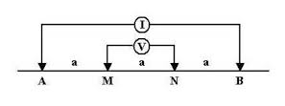
Fig 1.2 Wenner electrode configuration
The Schlumberger electrode configuration is also a symmetrical array like wenner, but in this case the potential electrodes are kept close to each other and away from the current electrodes, with the distance between the potential electrodes (MN) being generally kept less than 0.2 AB.
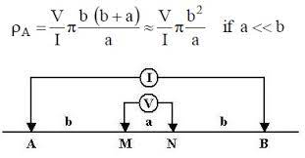
Fig 1.3 Schlumberger electrode configuration
1.5 HORIZONTAL PROFILING
Horizontal profiling is done to examine lateral variations in the subsurface in the area of interests. Apparent resistivity measurements are made along the chosen azimuth covering the entire area using a pre - determined electrode separation, the value of the separation dependant of the depth of interests. In practice, the whole electrode array is moved from one point of measurement to the next as a single unit. The distance between two locations were measurements are done depends on the nature and type of information sought type of terrain, time available etc.
VERTICAL ELECTRICAL SOUNDING
While profiling gives an indication of any changes in the lateral direction, to obtain information of the subsurface in the vertical direction, a technique known as vertical electronic sounding (VES) is employed. This involves in making a series of measurements at a given point with several electrode separation. The electrode separations are expanded, around the point of measurement, from an initial small value to several hundred meters, depending on the depth of interests. This is because, in in general, larger the electrode separation, greater will be the depth of investigation is quite a complex one, and among other things is controlled by the relative thickness of individual layer, and the resistivity contrast present between them.
The VES data is plotted as an apparent resistivity versus electrode separation curve, normally on a log - log scale. The general practice is to plot a as a function of a' in case of Wenner and AB/2 in the case of Schlumberger.
SELF-POTENTIAL
The self-potential (SP) technique is a passive electrical geophysical method based upon the measurement of spontaneous or natural electrical potential developed in the earth due to: electrochemical interactions between minerals and subsurface fluids,electrokinetic processes resulting from the flow of ionic fluids or thermoelectric mechanisms from temperature gradients in the subsurface.
STUDY AREA
The study area is from Veppilaipatti village, Salem district, Tamil Nadu. This area lies between north latitude and longitude 11⁰35’03″ and 78⁰21’35″,11⁰35’03’’ and 78⁰21’39’’ and south latitude and longitude 11⁰34’51’’ and 78⁰21’33’’ , 11⁰34’56’’ and 78⁰21’38’’. Salem district is bounded north Tamil Nadu. It is located between on 11.669437°N Latitude, 78.140865°E Longitude at an average elevation of 278 m (912 ft) above the mean sea level except Yercaud hills. It has an area of about 7905.38 Kms with 38, 96,388 inhabitants. The city is surrounded by hills: Nagaramalai on the north, Jarugumalai on the south, Kanjamalai on the west, Godumalai on the east and the Shevaroy Hills on the northeast. Entire district comprises of a hard rock terrain of Archaean age with the principal rock type of granite and a semi-arid weather.
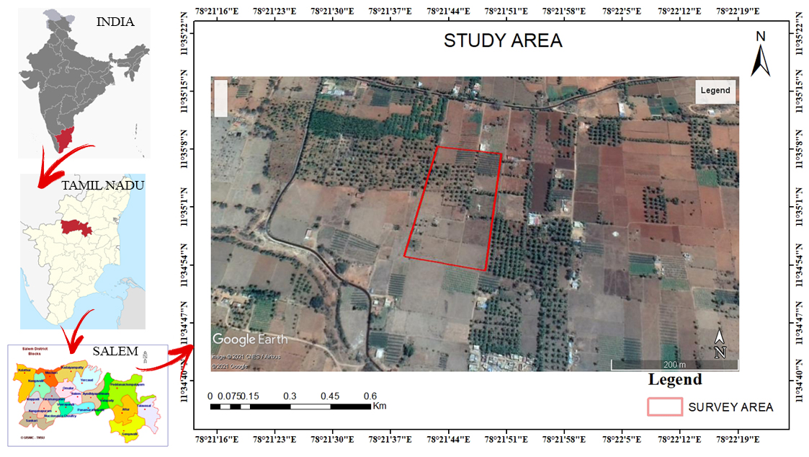
Fig 1.4 STUDY AREA

Geology of study Area
The district is rich in mineral deposits like Magnesite, Bauxite, Granite, Limestone, Quartz and Iron ore for which units have been established in the region. Geologically, the entire district can be classified into hard rock formation. More than 90 percent of the district is underlain by hard rock of Archaean age. Quartz, Feldspar, and limestone which are resistant to weathering are also seen as patches in Charnockite and gneissic varieties and the above rock types found Sedimentary Formation: - Recent alluvial deposits such as sand, silt, clay, gravel etc. The granulite terrain of Salem area has witnessed two major periods of granitic activity – one during Late-Archaean to Early Palaeo-Proterozoic and the other during Neo-Proterozoic times. The granites of older event are restricted to the southern part of Salem district ie. North of Moyar – Bhavani – Attur Lineament (MBAL), while the younger Pan-African event is widespread in the terrain south of MBAL. The rocks of the Khondalite and Charnockite groups have been subjected to regional migmatisation and retrogression with influx of quartzofeldspathic material resulting in the formation of different types of gneiss such as biotite gneiss, hornblende gneiss, augen gneiss, garnetiferous biotite gneiss, garnetiferous quartzofelspathic gneiss depending upon the parent rock.
Geomorphology and soil types
The entire area of the district is a pediplain. The Shevaroy Hills on the northeast and Jarugumalai on the south side of the district constitutes the remnants of the much denuded Eastern Ghats and rise to heights of over 1031 m above mean sea level. From these hills the district slopes gently towards north east and forms a vast stretch of plain country till the eastern boarder of the district. There are numerous small residual hills represented by Nagaramalai, Kanjamalai and Kodhumalai hills. The general elevation of the area is ranging between 120 m and 200m above mean sea Level The prominent geomorphic units identified in the district through interpretation of Satellite imagery are 1) Structural hill, 2) Pediments, 3) Shallow Pediments, 4) Buried Pediments and 5) Alluvial plain.
The soils can be broadly classified into 6 major soils types viz., Red insitu, Red Colluvial Soil, Black Soil, Brown Soil, Alluvial and Mixed Soil. Major part of the district is covered by Red insitu and Red Colluvial soils. Block soils are mostly seen in Salem, Attur, Omallur and sankari taluks. Brown Soil occupies major portion of Yercaud and parts of Salem and Omallur taluks and the Alluvial Soil is seen along the river courses in Omallur and Sankari taluks. Mixed soil is occurring only in Attur taluk.
1.8.3 Rainfalls and climate
The district receives the rain under the influence of both southwest and northeast monsoons. The northeast monsoon chiefly contributes to the rainfall in the district.
Rainfall data from six stations over the period 1901-2003 were utilized and a perusal of the analysis shows that the normal annual rainfall over the district varies from about 800 mm to 1600 mm. It is the minimum around Sankari (800 mm) in the southwestern part of the district. It gradually increases towards north, northeast and east and attains a maximum around Yercaud (1594.3 mm) in the northern part.
The district enjoys a tropical climate. The weather is pleasant during the period from November to January. Mornings in general are more humid than the afternoons, with the humidity exceeding 75% on an average. In the period June to November the afternoon humidity exceeds 60% on an average. In the rest of the year the afternoons are drier, the summer afternoons being the driest.
The hot weather begins early in March, the highest temperature being reached in April and May. Weather cools down progressively from about the middle of June and by December, the mean daily maximum temperature drops to 30.2°C, while the mean daily minimum drops to 19.2°C and 19.6°C in January in Salem and Mettur Dam respectively.
1.8.4 Hydrogeology
Salem district is underlain entirely by Archaean Crystalline formations with recent alluvial deposits occurring along the river and streams courses like Cauvery, Thirumanimutharu, Sarapangandhi are the important rivers in the district. Except Cauvery, other rivers flow only during rainy seasons. Weathered, fissured and fractured crystalline rocks and the recent alluvial deposits constitute the important aquifer systems in the district. The porous formations in the district are represented by river alluvium. These alluvial deposits are confined to the Major River and stream courses only. Ground water occurs under phreatic conditions. The maximum saturated thickness of these aquifers is up to 10 m depending upon the topographic conditions. The hard consolidated crystalline rocks of Archaean age represent weathered, fissured and fractured formations of gneisses, granites, Charnockite and other associated rocks.
OBJECTIVES OF THE STUDY
The major objective of present study is to explore the ground water.
- To describe the outcrop geology of the study area.
- To explore sub surface fractures, weathered zone and water filled pores spaces at a selected depth (Using 2D profiling)
- To select suitable location to vertical electrical sounding using profile data 3D plot generated from surfer.
- To explore ground water potential of the selected point and to select a point to drill for high yielding bore well. (Using Vertical electrical sounding, Schlumberger electrode configuration).
REVIEW OF LITERATURE
INTRODUCTION
Conducting a literature review is a means of demonstrating an authors knowledge about aparticular field of study, including scientific innovations, theories key variables, phenomena, methodology and historical developmens. Conducting a literature review provide sample information to the researcher and research groups in the field.
NATIONAL LITERATURE
Sakthivel Govindaraj et al., 2020, studied the Coastal shallow aquifer characterization in Tiruchendur coastal district of Tuticorin, Tamil Nadu, India utilizing geophysical and geochemical approaches. The effects of the ERT method show that even for a depth of 3 m, salinisation of the aquifer reaches the study area in the Tiruchendur, Kulasekarapattinam and DCW (Sahupuram) industries. The tests of the electrical resistivity are verified with EC.
R. Kavidha and K. Elangovan. (2013) the ground water potential in the study area is identified by weighted overlay of three maps such as weathered layer, depth to basement and lineament density. The study has shown that the modern tools of GIS and remote sensing can provide an efficient method for delineating groundwater prospects zones in an area and there was a good inter relationship found among the geography units, geological characteristics and yield data in the study area.
Selvam and Sivasubramanian. (2012) studied Groundwater potential zone identification using geoelectrical survey. Present work has shown that in a hard rock environment, Vertical Electrical Sounding (VES) excellently be used for shallow and deep underground water geophysical resistivity investigation. The most part of the Study area consists of good quality of groundwater because the study area is dominated by the H type curve. The top layer is the black cotton soil and it is followed by a weathered zone which is underlain by basement rock.
Yadav and Shashi Kant Singh. (2007) studied Integrated resistivity surveys for ion of fractures for ground water exploration in hard rock areas. The efficacy of bined gradient profiling (GP) and Geoclectrical sounding (GS) using Schlumberger iguration is presented here to map the weathered and fractured zones in hard rock areas. The ent study clearly indicates that exploration of ground water resources can be done with a er planning especially in the hard rock areas.
Narasimha Prasad. (2011) studied Geophysical investigation for groundwater exploration akshadweep Islands - A case study. Proper understanding of the groundwater condition, in s of availability, distribution and quality, is very important to meet the increasing demand also to formulate future planning and development of water resources.
Venkateswaran: et al, (2014) explained that vertical electrical sounding (Schlumberger unding) is effectively used for groundwater studies due to the simplicity of the technique, easy erpretation and rugged nature of the associated instrumentation. The suitable potential zones groundwater were delineated from first layers combinations of low resistivity with more ckness in areas occupied by hornblende-biotite-gneisses and Charnockite. The depth for the nstruction of tube-wells and dug-wells were suggested.
Jeyavel (2011) conducted Geophysical Resistivity survey and tested aquifer performance delineate groundwater potential zones. The present study has proved the use of resistivity ethod and aquifer test as excellent tools to delineate groundwater potential zones and absurface lithology. The present attempt helped to identify groundwater potential zones using erface resistivity technique and aquifer performance test.
Srinivas, et al. (2008) et al studied Geophysical survey using electrical resistivity method as carried out near Abhishekapatti, Tirunelveli district, Tamilnadu in order to delineate the ossible structural features of the subsurface. The resistivity variation due to gneissic formations erlain by thin soil and limestone formation overlain by black cotton soil is observed in the mudy area. The spatial contact between gneiss and limestone was identified based on the ariation of resisitivity values. The resistivity cross section also confirms the high and low resistivity zones at depths.
INTERNATIONAL LITERATURE
Olisaemeka K. Ezema et al., (2020) conducted the Geophysical investigation of aquifer repositories in Ibagwa Aka, Enugu State, Nigeria, using electrical resistivity method. The results show a general low groundwater potential delineated from the values of the hydraulic conductivity and transmissivity and also the aquifer layer is vulnerable to contamination over time. The hydrogeological information gathered from the results of this study will be helpful in groundwater exploration and management in Ibagwa Aka and will also serve as a guide for future research.
M.A.Yusuf et al, (2019) researched the Risks of groundwater pollution in the coastal areas of Lagos, southwestern Nigeria. The longitudinal conductance generally shows that the areas along the coastal belt are prone (variably) to pollution. he 2D- ERT revealed that the second aquifer was highly impacted by saline intrusion relative to the surficial aquifer (essentially fresh aquifer) deducible from low resistivity and that saline water incursion progresses further inland with increased pressure on groundwater.
Raimi (2011) studied Application of Schlumberger Vertical Electrical Sounding for Determination of Suitable Sites for Construction of Boreholes for Irrigation Scheme within a Basement Complex. The field Curves of the study generally suggest four geoelectric layers. In this study area the weathered and the fractured were considered as the aquiferous components because of their role as water bearing geologic units in basement complex. The aquiferous unit with a thickness range of 8- 35m, is overlain by top soil that is characterized by resistivity and depth range of 126 - 1292 m and 5.5 - 10.7 m respectively. The resistivity value range suggests composition of sand, silt, clay and laterite.
Oyedele; et al, (2009) a geophysical technique has been employed to investigate seawater intrusion into freshwater aquifers in the coastal environment. The study revealed that the subsurface in contact with the lagoon was invaded by saline oceanic seawater. The subsurface lithology comprised of fine through medium grained sand to coarse sand intercalated in most cases with sandy clay and clayey sand. The study area shows evidence of subsurface formations by saline water intrusion. The salinity problem may exist due to upward movement of water and salts from groundwater.
METHODOLOGY
There are several variants in electrical methods. In fact, largest variety of methods is possible in electrical prospecting and it will be no surprise if new methods are developed in future. In electrical methods either the natural electrical field in an area is investigated or the ground is charged by an artificial electrical field and the distribution of the electric field at the surface of the earth is investigated.

Fig 2.1 METHODOLOGY FLOW CHART

ELECTRICAL RESISTIVITY PROSPECTING
Electrical resistivity techniques are based on the response of the earth to the flow of electric current. Among the geophysical techniques, electrical resistivity methods enjoys the greatest popularity and are widely used for both regional and detailed groundwater surveys because of its better resolving power, less expenses as well as range of applicability.
The electrical resistivity methods has been used in this study in order to,
1. Delineate potential zones of ground water.
2. Find out the thickness of saturated zones, depth to the basement topography,
APPARENT RESISTIVITY
The ability to conduct current is an important physical property of rock forming minerals and this property is made use of in electrical prospecting Electrical resistivity surveying is based on measuring of the resistivity 'p' of subsurface by passing a known electric current into the ground and measuring the potential difference between two points. The technique is based on the validity of Ohm's law for linear conduction which is represented as, $R=\frac{∆V}{I}$
R- Resistivity in Ohm's to the flow of current. I- Current in Amperes, V- Potential difference in volts across the two end faces of a conductor.
The resistance of the medium is directly proportional to its length L and is inversely proportional to its sectional are ‘A’, so that R proportional to L/A
i.e., R.=ρL/A (or) ρ=R. AL
While carrying out the survey in the field. either direct current or low frequency alternating current introduced into the ground, through two current electrodes(A, B) and the potential difference is measured between another pair of (potential) electrodes (M. N). By considering the values of current, potential difference and the geometry of electrode configuration it is possible to compute the resistivity of the material as
ρ= 2$π$ x $∆$V/ (1/AM-1/BM-1/AN+1/BN) x 1
Where AM, BM, AN, and BN are the inter electrode distances.
The factor $\frac{2π x AV}{2a(1/AM-1/BM-17AN+1/BN)}$ is referred to as the geometric constant K, of the configuration used.
Hence, $ρ$= K. $∆V/I$
The resistivity measured by the above method is said to be the true resistivity of the medium only when the measurements are made over a homogeneous and isotropic medium. As the earth's subsurface generally is not so, the measured resistivity is not the true resistivity and is said to be the apparent resistivity (pa).

ELECTRODE CONFIGURATION
In actual field measurement, a variety of electrode arrangements or configurations are used, the difference being in the inter-electrode distance and geometry. The most commonly employed configuration are the Wenner and Schlumberger arrangements.
Wenner Configuration
In the Wenner electrode array, all the four electrodes, equidistant with respect to each other, are kept along a straight line, the outer two being the current electrodes The inter electrode distance is commonly denoted by the letter 'a'. The relationship for apparent resistivity pa, for Wenner configuration is given by, $ρ$a = 2$πaR$ , Where ‘a’ = distance between successive electrodes.
Schlumberger Configuration
The Schlumberger electrode configuration is also a symmetrical array like Wenner, but differs in placing the two current electrodes with a much larger interval than that between the potential (inner) electrodes. Only one set of electrodes either potential or current are moved to expanded intervals at a time while conducting depth soundings unlike in Wenner array where there are four electrodes are moved simultaneously. The current electrodes are denoted by A and B, while the potential electrodes are denoted by M and N. The interval between M and N is denoted by 'b' while the interval AB is denoted by a'. The apparent resistivity is given by,
$ρ$a = KR
$K=π\frac{AM. AN}{MN}$ , K- Configuration constant, R= Obtained resistance
There are several other electrode configurations which are modifications of Wenner and Shlumberger arrangements, such as Lee partitioning. Carpenter tri-electrode arrangement, Single angement and Dipole system of electrode arrangement.
FIELD PROCEDURES
Resistivity methods are employed for both lateral and vertical exploration
1. Resistivity profiling for lateral exploration,
2. Resistivity sounding for vertical exploration
Resistivity profiling
Horizontal profiling is done to examine lateral variations in the subsurface in the area of interest. A series of measurements of resistivity are carried out with constant electrode spacing. moving the whole of the electrode arrangements consecutively to a number of points along a given line. The apparent resistivities so obtained are plotted on the central points of the array along a profile. This method is also termed Constant depth traversing or Electrical trenching Structures like dyke, faults, shear zones (apart from changes in rock types) etc, which is Generally associated with lateral variations, can be investigated by the profiling method.

Vertical electrode soundings (V.E.S)
In resistivity sounding, the measurements are made at one location (keeping the centre of the electrode system fixed) for various values of current electrode separations starting from analy, small value to several hundred meters, depending on the depth of interest. This is because, in general, larger the electrode separation, greater will be the depth of investigation. The Variation of the apparent resistivity with current electrode separation this obtained would give the variation in the electrical characteristics of the formation with depth. This method (V.E.S) is most commonly applied for groundwater investigations and will be discussed in detail in this project work. For carrying out resistivity sounding, the following equipments are necessary.
1. One resistivity meter.
2. One DC current source or an AC generator with low frequency.
3. Insulated electrical cables.
4. One pair of current electrodes in the form of iron stakes.
5. One pair of potential electrodes.
6 Hammer to fix the electrodes in the ground.
Resistivity survey should be made paying due attention to possible disturbing elements such as pipe lines, wire fences, rail tracks, etc. These methods cannot be used in the vicinity of power plants, substations, high tension power lines and similar sources of extraneous earth currents which would adversely affect the accuracy of the field measurements.
INTERPRETATION OF RESISTIVITY DATA
Interpretation of the electrical resistivity data in terms of the subsurface geology and hydrology forms two most important phase in the exploration of groundwater. The aim of interpretation of resistivity is to determine the thickness and resistivity of different horizons present. Interpretation of V.E.S data is both quantitative and qualitative. The type of V.E.S curve obtained indicates the qualitative nature of subsurface that may be expected in an area. For example, a H type curve in a hard rock terrain may be interpreted as comprising of (1) a dry top soll cover followed by (2) moist weathered rock/regolith, underlain by (3) the bed rock There are many ways to interpret the resistivity data starting from empirical method to Sophisticated techniques using fast computers. In this project work all the resistivity data are interpreted with the help of Auxiliary Point Chart (APC) Method.
SELF-POTENTIAL
The self-potential (SP) technique is a passive electrical geophysical method based upon the measurement of spontaneous or natural electrical potential developed in the earth due to: electrochemical interactions between minerals and subsurface fluids,electrokinetic processes resulting from the flow of ionic fluids or thermoelectric mechanisms from temperature gradients in the subsurface. Some physical processes caused sources of SP are still unclear. Groundwater is thought to be common factor responsible for SP.Potentials are generated by the flow of water, by water reacting as an electrolyte and as a solvent of different minerals.Electrical conductivity to produce potentials of porous rocks depends on porosity and on mobility of water to pass through the pore spaces depend on ionic mobilities, solution concentrations, viscosity, temperature & pressure.
There are a few types of SP:
1. Electro kinetic potential
2. Thermoelectric potential
3. Electrochemical potential
4. Mineral/mineralization potential
Simple and inexpensive,2 non-polarizable porous-pot electrodes connected to a precision voltmeters capable of measuring to at least 1.Each electrode is made up of a copper electrode dipped in a saturated solution of copper sulphate which can percolate through the porous base to the pot. An alternate zinc electrode in saturated zinc sulphate solution or silver in silver chloride can be used. Maximum depth of sensitivity of SP method = -60-100m depending on ore body and nature of overburden.
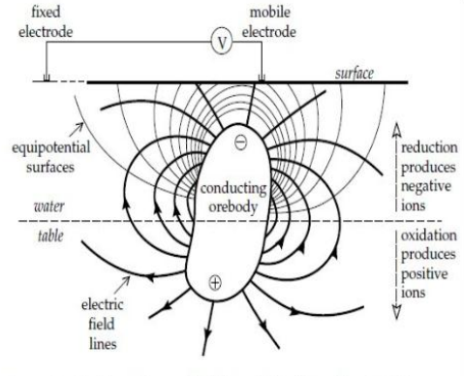
Fig 2.2 SELF-POTENTIAL
RESULT AND DISCUSSION
Vertical electrical soundings were carried out in the field by using shlumberger configuration and also self potential itself. In all 3 soundings were carried out and analyzed. The minimum and maximum values of AB/2 (current electrode separation) chosen for the surveys is 2 meters to 60 meters, The apparent resistivity data of VES locations have been plotted on log-log graph and matched with the master curves for obtaining the layer parameters (resistivity and thickness). The depth sounding curves are classified based on layer resistivity combinations.
GEO-SURVEY EQUIPMENT
The geo-physical instrument was used for field work is DDR-2, which is the indigenous IGIS make from Hyderabad. The 3 Vertical Electrical depth Soundings (VES) were taken for critical analysis of the qualitative and quantitative interpretations. The readings are tabulated and shown in the Table 4.1. The 3 numbers of sounding were initially matched manually with the master curves prepared for vertical electrical sounding by the Ernesto Orellana and Harold. Mooney, Intercien Costanilla De Los Angeles, Madrid 1966. Then the interpreted data has been verified using the software and details are as follows:
ANALYSIS WITH "IPI2 WIN"
The interpreted resistivities and thicknesses of different layers. Solid line represents the interpreted data and solid line with circles represents the observed data.
The curve types obtained in the study area where 28 VES sounding was carried out include 11 H type curves (p1 > p2 <p3), 5 K type (p1 < p2 > p3), 4 A type (p1 <p2 < p3), 1 AA type (p1 < p2 < p3 < p4), 1 HK type (p1 > p2 < p3 > p4), 4 HA type (p1 > p2 < p3 < p4) and 1 KH type (p1 <p2> p3 <p4) respectively (Table.1).
TABLE 4.1 VES READING 1 :
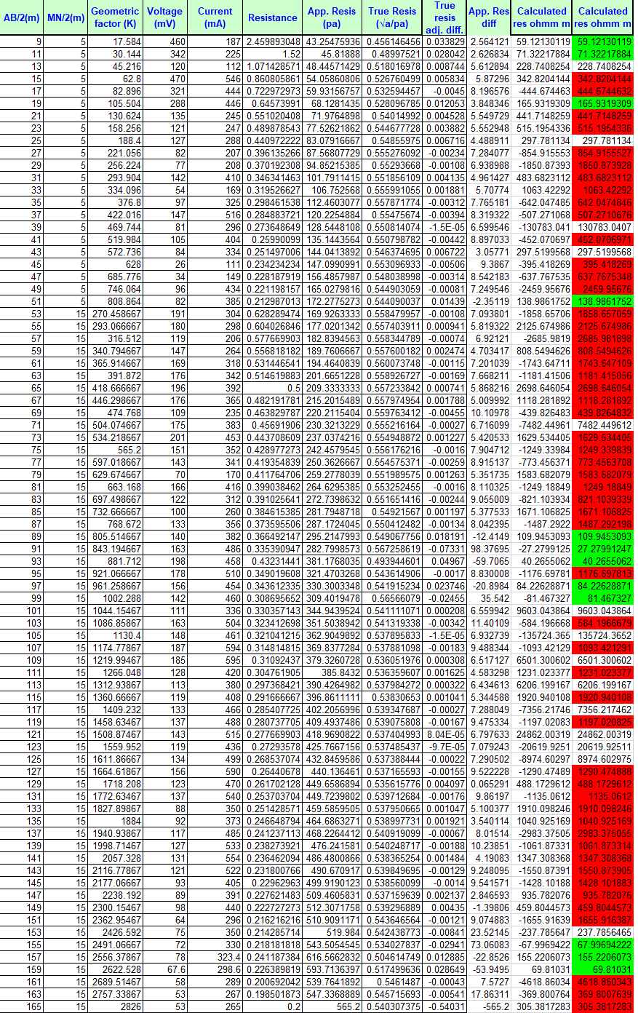

TABLE 4.2 VES READING 2:
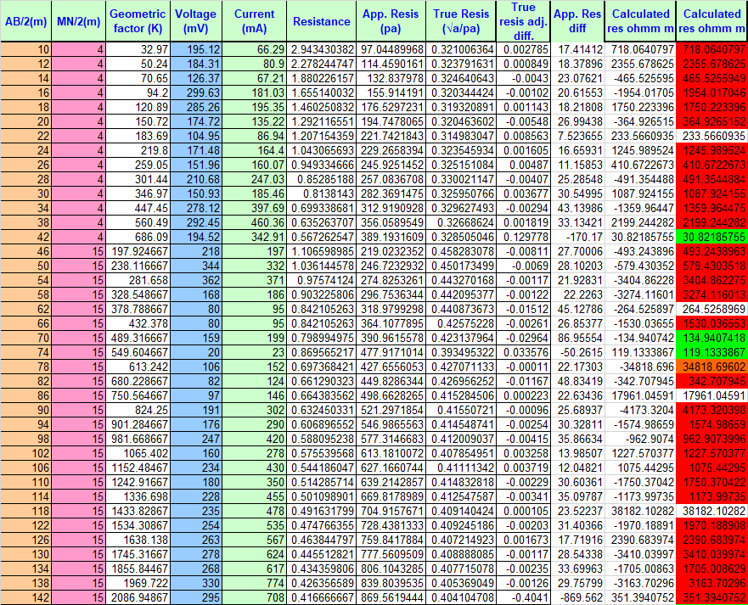

TABLE 4.3 VES READING 3:
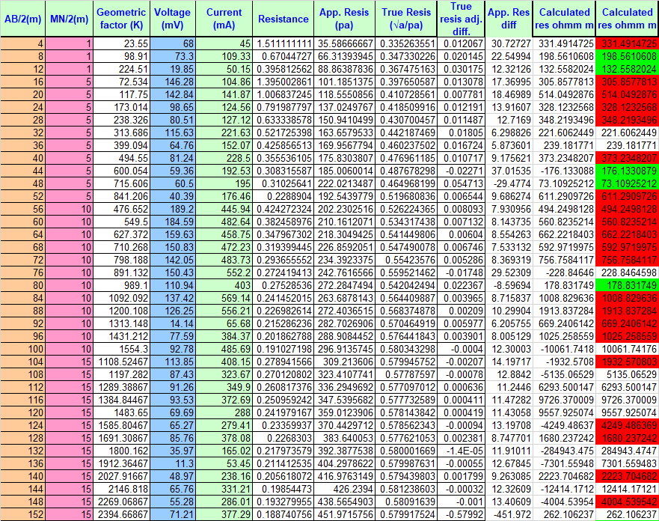

TABLE 4.4 SELF-POTENTIAL DATA
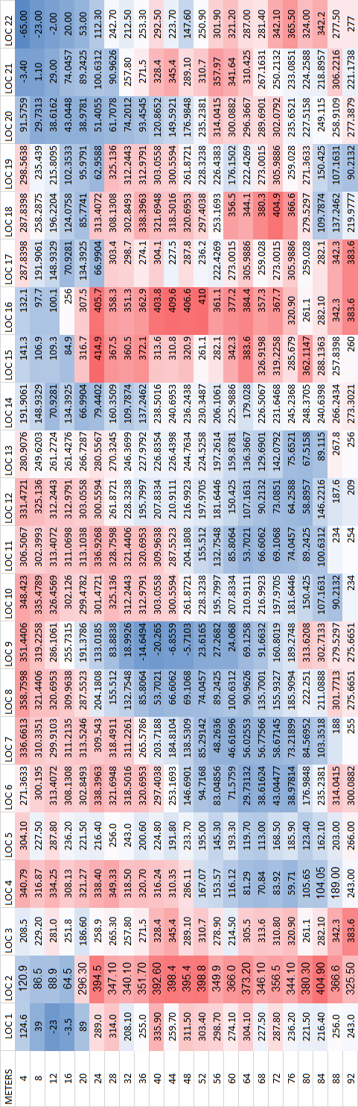
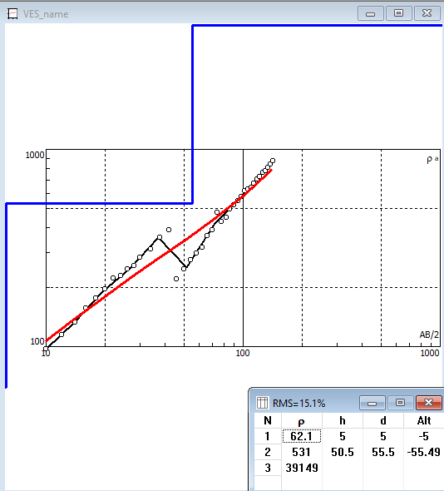
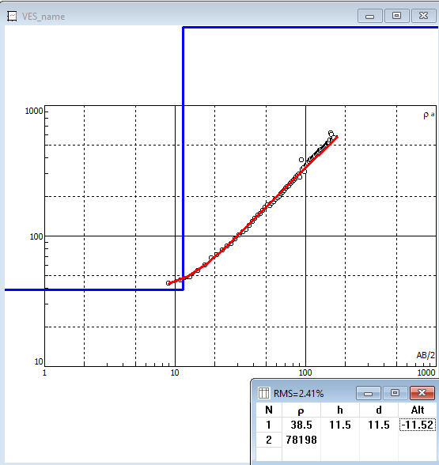
Fig 4.1 VES CURVE AT LOCATION 1 Fig 4.2 VES CURVE AT LOCATION-2
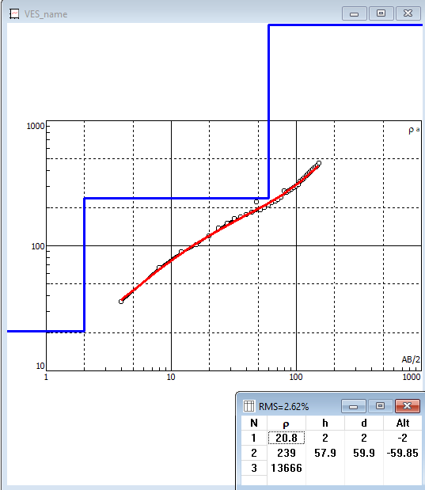

Fig 4.3 VES CURVE AT LOCATION 3

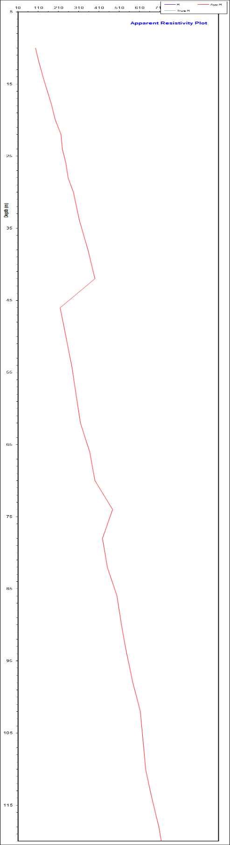
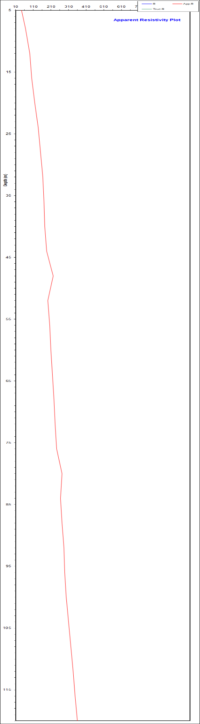
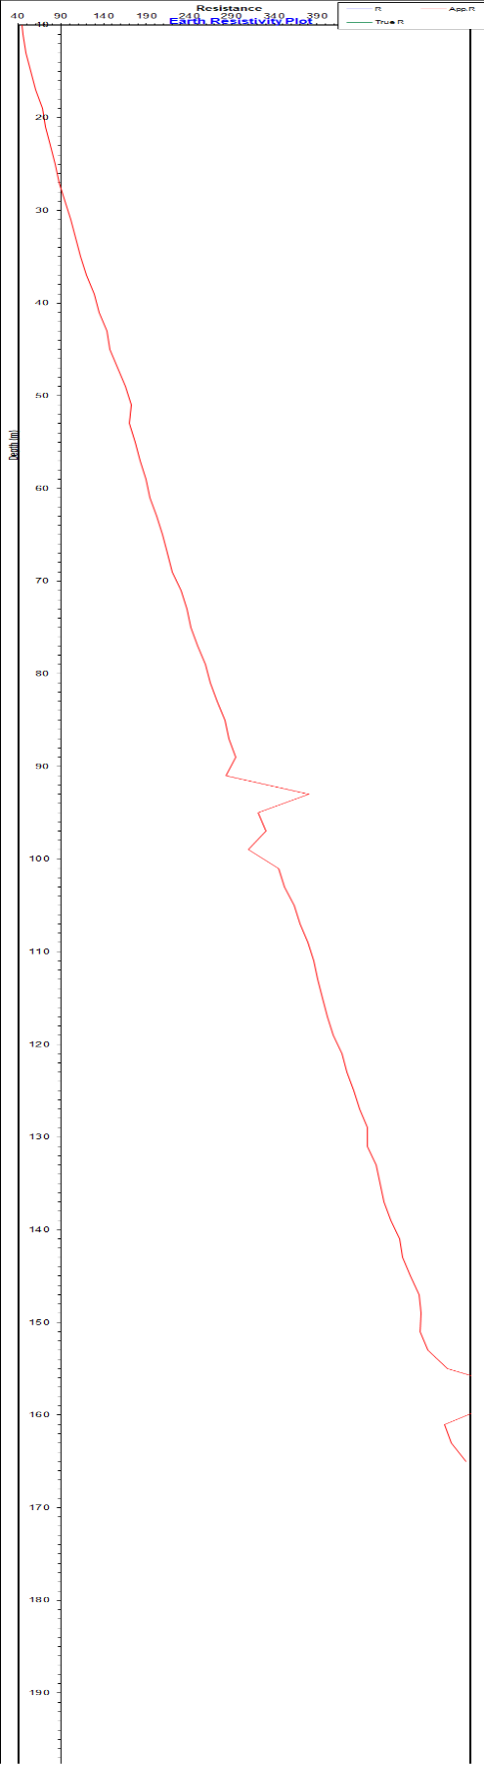
Fig4.4 LOC 1.APPARENT RES PLOT VS DEPTH
Fig 4.5 LOC 2.APPARENT RES PLOT VS DEPTH
Fig 4.6 LOC 3.APPARENT RES PLOT VS DEPTH

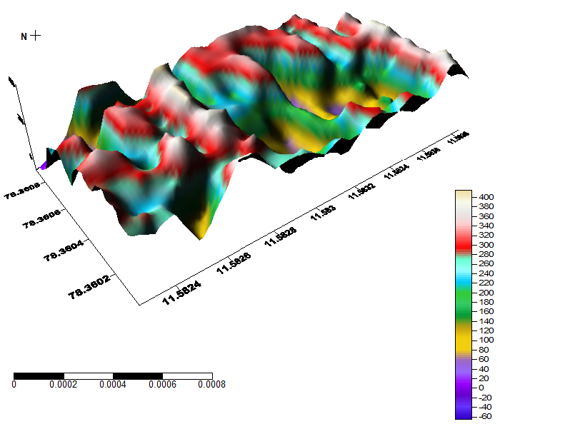

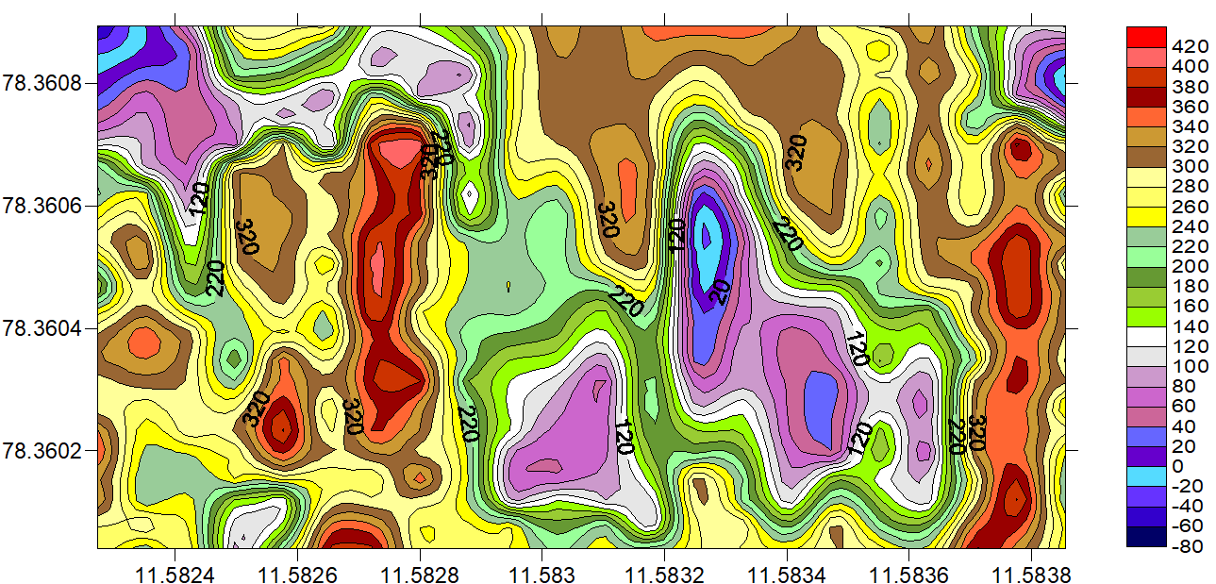

Fig 4.7 3D APPARENT RESISTIVITY PLOT

Fig. 4.8 APPARENT RESISTIVITY CONTOUR MAP
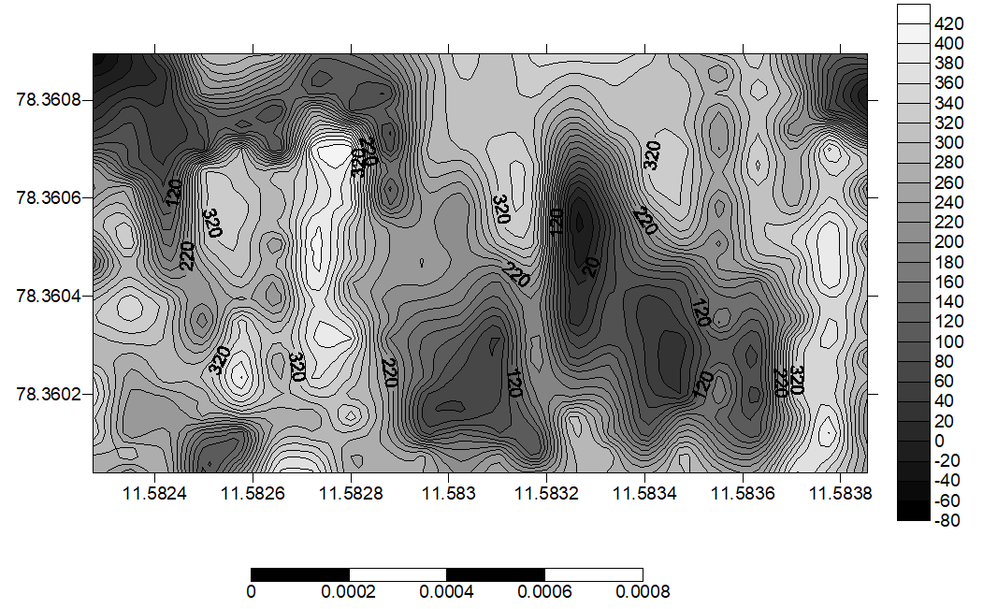

Fig 4.9 APPARENT RESISTIVITY CONTOUR MAP AND THEIR DEPTH
CONCLUSION
Ground water exploration has been carried out in part of the Veppilaipatti Village, Vazhappady Taluk, Salem District in Tamil nadu using 2D profiling and VES using Schlumberger electrode configuration and self potential method. Vertical electrical sounding technique of the electrical resistivity method and self-potential method has proven to be successful and highly effective in the identification and delineation of subsurface structures that are favourable for groundwater accumulation in a crystalline basement complex area. The interpretation of the VES data indicates the presence of two, three, four layers in the study area.
In this study, an attempt has been made to assess the resistivity values for various layers. The most part of the study area is dominated by the A and H type curve which reveals the number of subsurface layers, their thickness and their water bearing capacity within the study. Based on self potential data it indicates the three negative values point in the area considered as the streaming potential point in the area (the weathered water saturated point). At the same point took the VES based on Schlumberger method, Identified three water bearing zone 67m,30m and 73m depth.The investigated VES (VES POINT 2,Depth at 73m) point suggested as high yielding well bore point among the study area. In conclusion it can be said that the electrical resistivity studies have helped in understanding the subsurface hydrology and the occurrence of saline and brackish water in the centre part of the study area and the surfer diagram reveals that 3D subsurface of the study area.
REFERENCE
Adeotil, L., Alile. O. M., Uchegbulam, O, and Adegbola, R. B. Geoelectrical Investigation of the Groundwater Potential in Mowe, Ogun State, Nigeria, British Journal of Applied Science & Technology 2(1): pp. 58-71.
Adepelumi, A. A., Akinmade, O. B., Fayemi, O (2013). Evaluation of Ground Water Potential of Baikin Ondo State Nigeria Using Resistivity and Magnetic Techniques: A Case Study. Universal Journal of Geoscience, Vol 1(2), pp. 37-45.
Emmanuel C. Okolie (2010). Geophysical investigation of effects of topographic complexities on groundwater potential in Ibusa, Delta State Nigeria, Archives of Physics Research, 1 (3): pp. 62-71. Jeyavel, T., Raja Kumar., Balasubramanian, A., Kumar, R.S., Dushiyanthan, C., Karthikeyan,
K., Thiruneelakandan, B., Davidraju, D., and Manoharan, K (2011). Delineation and evaluation of groundwater potential zones using electrical resistivity survey and aquifer performance test in Uppodai of Chittar - Uppodai water shed, Tambaraparani River Basin, Tirunelveli-Thoothukudi Districts, Tamilnadu, J. Ind. Geophys. Union Vol.15, No.2, pp.85-94.
Joseph Olakunle Coker, (2012). Vertical electrical sounding (VES) methods to delineate potential groundwater aquifers in Akobo area, Ibadan, South-western, Nigeria. Journal of Geology and Mining Research Vol. 4(2), pp. 35-42.
Kavidha, R., and Elangovan, K (2013). Delineation of Groundwater Prospective Zones by Electrical Resistivity Method in Erode District, Tamilnadu, India, Journal of Environment. Vol. 02, Issue 01, pp. 14-18.
Lateef, T.A. (2012). Geophysical Investigation For Groundwater Using Electrical Resistivity Method - A Case Study Of Annunciation Grammar School, Ikere Lga. Ekiti State, South Western Nigeria. IOSR Journal of Applied Physics (IOSRJAP) ISSN - 2278-4861 Volume 2, PP 01-06.
Murthy, B. V. S., Varaprasada Rao, S. M and Bhimasankara, M. V. L. S (1982). Structure and geology of the Munneru valley as inferred from gravity and magnetic surveys, J. Indian Acad.
Narasimha Prasad, N.B (2011). Geophysical investigation for groundwater exploration in Lakshadweep Islands - A case study, J. Ind. Geophys. Union Vol.15, No.4, pp.221-227.
Oseji. Julius Otutu and Ajnabi, O (2009). Hydrogeophysical investigation of groundwater potential in Emu kingdom, Ndokwa land of Delta State, Nigeria. International Journal of Physical Sciences Vol. 4 (5), pp. 275-284
Owen, R., Gvavav O.,and Gwaze, P(2005). Multi-electrode Resistivity Survey for Groundwater Exploration in the Harare Greenstone Belt, Zimbabwe. Hyrdogeology Joumal. Vol14, pp.244-252.
Raman, K. Kumar, K V., Tata S. N and Chary, M N (2000). Report on geophysical investigations for groundwater in the upland areas of Krishna district, A.P, Central Groundwater Board
Sabet Mohamed, a.,( 1975) Vertical Electrical Resistivity Soundings to Locate Ground water Resources: A Feasibility Study A publication of Virginia Water Resources Research Center Virginia Polytechnic Institute and State University Blacksburg, Virginia 24061Selvam, S. and Sivasubramanian, P. (2012) Groundwater potential zone identification using Geoelectrical survey:A case study from Medak district, Andhra Pradesh, India. International journal of geomatics and geosciences Volume 3. pp.55-62.
Senthil kumar, M. Gnanasundar, D., Elango, L (2001). Geophysical studies to determine hydraulic characteristics of an alluvial aquifer. Journal of environmental hydrology, Vol.9. Sreedevi. P.D., Srinivasulu, S., Kesava Rju, K (2001). Delineation of Ground Water Potential Zones and Electrical Resistivity Studies for Groundwater Exploration Springer, Vol.40, pp. 1252-1264.

