Recombinant DNA technology: Moving toward Gene Revolution
Sri Hima Gampala¹, Nidhi Singh², Brijesh Kumar Singh³, Sonu⁴, Nandakumar S⁴ and Vikram Jeet Singh⁴
¹Centurion University of Technology and Management, Odisha- 761211
²Medicaps university, Indore- 453331
³ICAR-Indian Institute of Maize Research, New Delhi- 110012
⁴ICAR-Indian Agricultural Research Institute, New Delhi- 110012

Abstract
Recombinant DNA (rDNA) is an arrangement of DNA manufactured in the laboratory. It is produced by moving opted DNA piece from one organism to another. The appearance of rDNA technology turned up with the significant utility of known approach and tools in novel ways that resulted in wide applications in multidisciplinary including medical science, agriculture, industrial world etc. A revolution has been achieved with application of biotechnology tools in the field of genomics. Beyond our imagination we have achieved so much desirable modification in the living organism, that were impossible to achieve via traditional methods. The vast application of rDNA technology is in agriculture, medical science, industry world. Production of pharmaceuticals or new vaccines has been achieved with the application of recombinant DNA technology. The possible role of rDNA technology has been explored and presented in the current book chapter.

Keywords- Recombinant DNA, Genomics, Gene, Biotechnology

Introduction

The expanding human population is presenting so much challenges in the world resulting so much negative impacts including food insecurity, onset of various disease, resources exhaustion etc. Meeting food requirement is one of the greatest challenges we are facing today. Modern and updated techniques are required to meet food demands. Modern techniques like genetic engineering and genome modification involving molecular techniques like molecular cloning and transformation has productive use in agriculture to enhance the production to meet our demand. Desired targeted gene modification can be achieved using rDNA technology. Methods like Agrobacterium mediated transformation and biolistic can be used for genetic transformation. Genome editing techniques are also employed to bring genetic changes (Zhang et al., 2018). Site specific genome modification can be achieved using oligonucleotide-directed mutagenesis and recombinase methods. First rDNA was produced by Paul Berg in 1970, who was honored with Nobel Prize for the same in 1980 (Kolata, 1980). With the advent of molecular biological tools rDNA technology has been improved and reached to the heights of achievements. Genetically identical individuals have been cloned by using this technology. The most important role of genetic engineering is the production of genetically modified organisms, which has been applied to different fields like agriculture, medicine, industries, bioremediation etc (Arfin and Sonawane, 2019). Not only this, rDNA technology has been also applied to biomining and production of biofuels and bioethanol. Due to plenty number of benefits associated with this technology it has beneficial effect on every aspect. In the current book chapter, we discussed the revolutionary effects of rDNA technology in various fields.

- What is recombinant DNA (rDNA) technology
rDNA technology is the application of enzymes and some laboratory techniques to exploit and separate DNA piece desired. DNA from different species can be combine to create genes with novel functions. Recombinant DNA is chimeric DNA produce from combination of DNA from different species (Slatko et al., 2018). This technology involves evaluating or combining DNA segments from different organism including introduction of the rDNA molecule into a cell for its amplification in to the target cell. Progress in molecular biology inclusive of the advancement in generating and transferring DNA molecules into cells, revolutionized both science and industry. Major milestones in the augmentation and operation of rDNA technology are presented in Table1.

Table1: Major milestones in the development of rDNA technology
S. No. | Year | Event
 | 1950 | Term 'genetic engineering' first coined
 | 1950 | Lambda phage was discovered
 | 1957 | DNA synthesis in a test tube
 | 1970 | Discovery of Reverse transcriptase
 | 1971 | Use of restriction enzymes
 | 1972 | First recombinant DNA molecule was generated
 | 1980 | Production of monoclonal antibodies via recombinant DNA technology
 | 1981 | First transgenic mice produced with rabbit beta-globin gene
 | 1982 | USFDA approved sale of genetically engineered human insulin (first recombinant product to be marketed in US)
 | 1983 | First transgenic plant (a tobacco plant resistant to an antibiotic) was developed.
 | 1984 | Alec Jeffreys’ introduced technique for DNA fingerprinting to identify individuals.
 | 1990 | Creation of genetically engineered cotton plants developed by Calgene Inc., Davis, California.
 | 1994 | Flavr Savr tomato was given approval by FDA for human consumption.
 | 1995 | First full gene sequence of a living organism was completed for Hemophilus influenzae
 | 1997 | Dolly was cloned from the cell of an adult ewe
 | 1998 | First genome Caenorhabditis elegans sequenced
 | 2001 | Genome sequence of rice decoded- first food crop to be sequenced
 | 2005 | Golden Rice 2 which produced up to 23 times more beta-carotene than the original variety of golden rice produced
- Tools of Recombinant DNA technology
- Enzymes
They are very important factors in the recombinant DNA technology field. Restriction enzymes also known as molecular scissors are required for cutting the DNA. These are of two types endonucleases and exonucleases. Endonuclease enzymes cut the DNA strand within the strand, whereas outside cutting is achieved with the help of exonuclease. Restriction endonucleases are present in the restriction enzymes that assist in cutting the DNA at desired sites. Again restriction endonuclease enzymes are divided in mainly three types Type-I Restriction endonuclease, Type-II Restriction Endonucleases and Type-III Restriction Endonuclease. These enzymes create cuts at palindromic sequences in restriction site. Out of these three enzymes type-II restriction enzyme is very important and useful for gene cloning. The desired gene of interest is introduced in to the vector genome with the help of restriction endonuclease enzyme. Both the desired gene and vector is cut by same restriction enzymes so that sticky ends created can be utilized for ligation. DNA synthesis is helped by polymerase enzymes. Binding of different DNA segments facilitated by DNA ligase enzymes which are also known as molecular glue.
- Vectors
Vectors are cloning vehicles use as carrier of gene of interest. Vectors are use integrating gene of interest in to the host. These are vehicles used for transferring desired gene in to the host organism. Plasmids are the most frequently used vectors because of several advantages associated with them.
- Host
Host is the target organism in which the rDNA is desired to introduced. Vector plus gene of interest that is chimeric DNA is targeted to introduced in to host organism. Host is the organism where we want our gene of interest to get expressed.
- Procedure of rDNA system
First step of rDNA technology is the isolation of genetic material from various sources including plant, human beings etc. Appropriate plasmids are selected where isolated gene of interest will be integrated using sticky ends. Now, the chimeric DNA made up of plasmid and gene of interest will be transferred in to the host for its multiplication or expression. Complete procedure of rDNA technology is given in the Figure1.

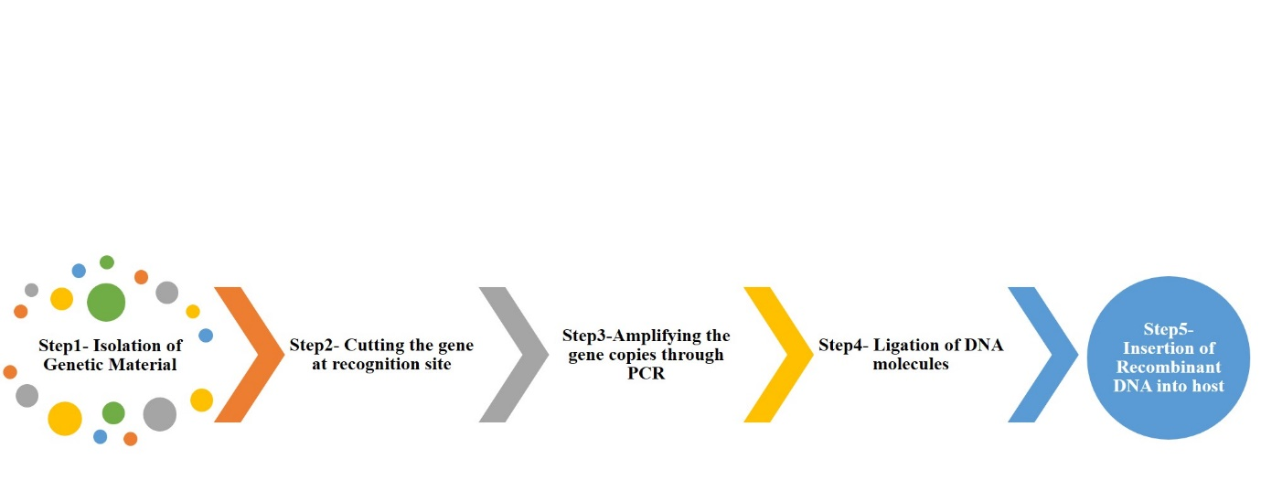
Figure1: Steps involved in recombinant DNA technology

- Application of recombinant DNA technology
rDNA technology is a multidisciplinary approach with application in various fields and area. Different application of rDNA technology has been presented in Figure2.

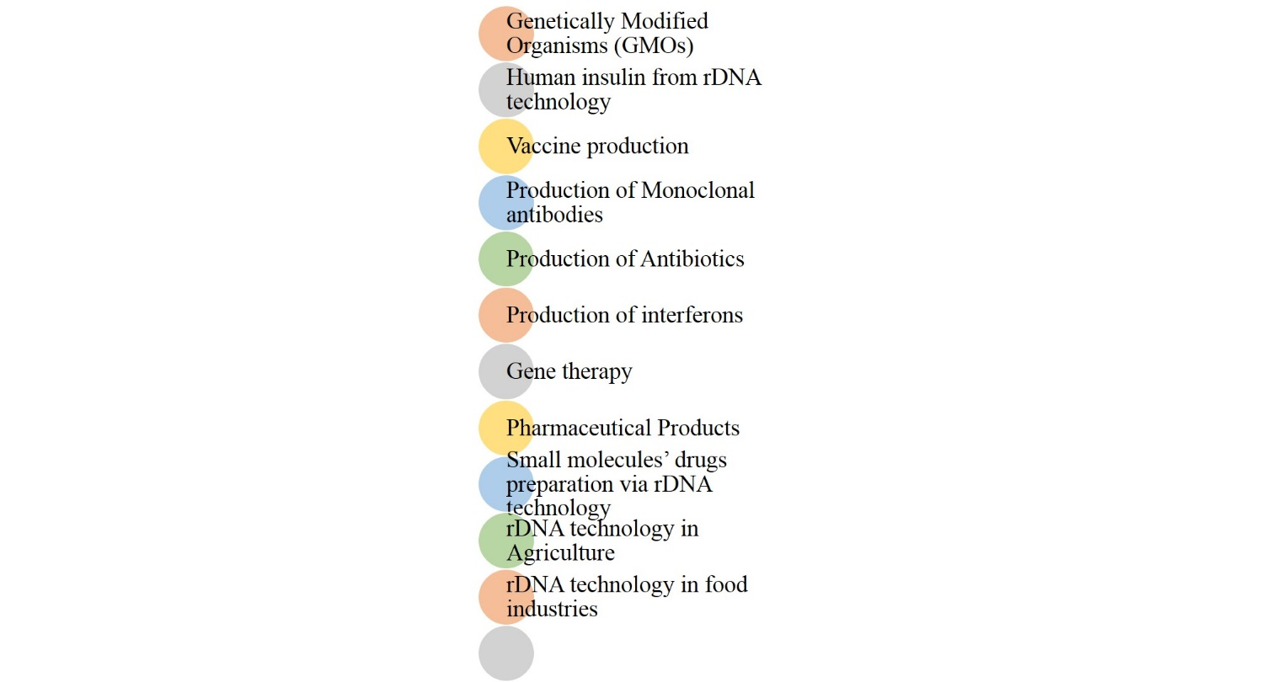
Figure2: Application of rDNA technology
Table 2: Genetically modified plants.
Crops | Traits | References
Canola | Glyphosate tolerance | Hadi et al., 2012
Corn | Glufosinate ammonium tolerance | Pornprom et al., 2003
Soybean | High oleic acid soybean oil | Kinney and Knowlton 1998
Cotton | Resistance to lepidopteran insects | Jenkins et al.,1997
Papaya | Tolerance against papaya ring spot virus | Davis and Ying 2004
Egg plant | Resistance to Colorado potato beetle | Arpaia et al 1997
Sugar beet | Phosphinothricin (PPT) herbicide tolerance | D'Halluin et al 1992
Tomato | Delayed ripening | Reed et al., 1995

- DNA Cloning
DNA cloning is the procedure of multiplying number of copies of DNA segments. Selected DNA segments is inserted into a cloning vehicle with the help of enzymes viz. restriction enzymes and DNA ligase. Restriction enzymes are used for cutting and DNA ligase is used for joining DNA segments. Recombinant DNA thus produced is transferred in to host organism for its amplification and expression. Clones of vectors containing gene of interest is produced and thus exact number of recombinant DNA is produced. These exact copies are known as clones.
- Genetic engineering
Genetic engineering is the modification in gene or DNA at molecular level using laboratory-based techniques. Recombinant DNA is one of the techniques used to produce genetically modified DNA (Paoletti and Pimentel, 1996). Recently researchers are using genetic engineering for the production of transgenic organism in the fields of biotechnology, medicine, bio-remediation and even in the field of agriculture. With the direct alteration in DNA changes in phenotype is observed in the living organism. Thus, desired changes in the phenotype are achieved using genetic engineering. Researchers have reported several stress tolerant crops developed using genetic engineering techniques.
- How is Recombinant DNA technology transforming the world
Recombinant DNA technology is expected to have intense outcome on the public, inclusive of improved health by virtue of enhanced disease analysis, much better interpretation of human gene variation, upgraded drug and pharmaceutical production, extremely more delicate and precise crime scene forensics (Rexroad et al 2018). In addition to all these rDNA technologies has also resulted vital production of vaccines like human insulin, interferon and human growth hormone. This technology has multifaceted utilization and possibility to handle with eminent facet of life like health improvement, increment in food production and development of stress tolerant cultivars. Various benefits of rDNA technology transforming the world has been depicted in Figure3.
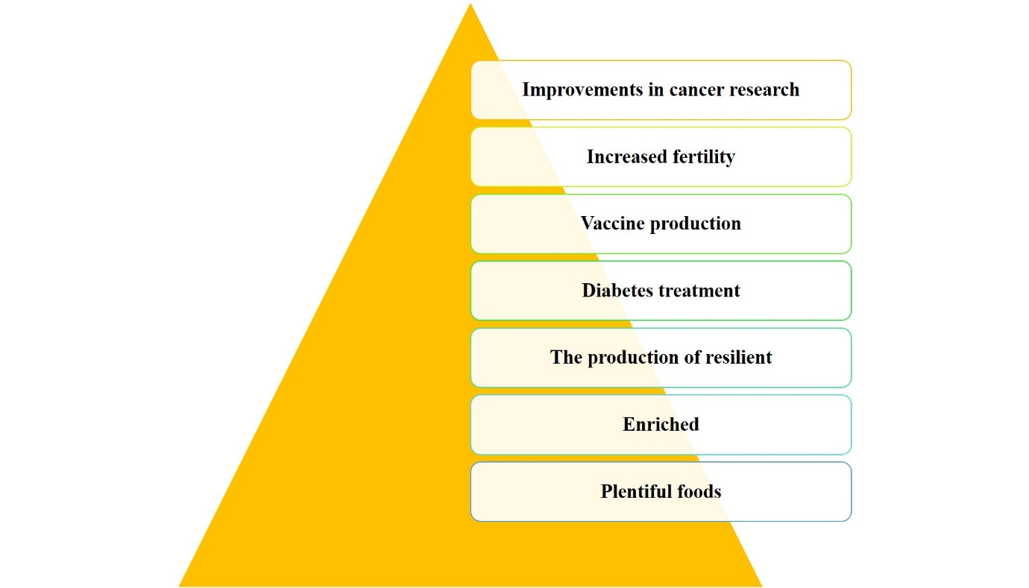
Figure3: Benefits of rDNA technology transforming the world

References
Arfin, T. and Sonawane, K., 2019. Biotechnology: Past‐to‐Future. Integrating Green Chemistry and Sustainable Engineering, pp.617-645.
Arpaia, S., Mennella, G., Onofaro, V., Perri, E., Sunseri, F. and Rotino, G.L., 1997. Production of transgenic eggplant (Solanum melongena L.) resistant to Colorado potato beetle (Leptinotarsa decemlineata Say). Theoretical and Applied Genetics, 95(3), pp.329-334.
Davis, M.J. and Ying, Z., 2004. Development of papaya breeding lines with transgenic resistance to Papaya ringspot virus. Plant Disease, 88(4), pp.352-358.
D'Halluin, K., Bossut, M., Bonne, E., Mazur, B., Leemans, J. and Botterman, J., 1992. Transformation of sugarbeet (Beta vulgaris L.) and evaluation of herbicide resistance in transgenic plants. Bio/technology, 10(3), pp.309-314.
Hadi, F., Mousavi, A., Salmanian, A.H. and Akbari Noghabi, K., 2012. Glyphosate tolerance in transgenic canola by a modified glyphosate oxidoreductase (gox) gene. Progress in Biological Sciences, 2(1), pp.50-58.
Jenkins, J.N., McCarty Jr, J.C., Buehler, R.E., Kiser, J., Williams, C. and Wofford, T., 1997. Resistance of Cotton with δ‐Endotoxin Genes from Bacillus thuringiensis var. kurstaki on Selected Lepidopteran Insects. Agronomy Journal, 89(5), pp.768-780.
Kinney, A.J. and Knowlton, S., 1998. Designer oils: the high oleic acid soybean. In Genetic modification in the food industry (pp. 193-213). Springer, Boston, MA.
Kolata, G.B., 1980. The 1980 Nobel Prize in Chemistry: Three molecular biologists win the prize for discoveries that can be used to study gene structure and control. Science, 210(4472), pp.887-889.
Paoletti, M.G. and Pimentel, D., 1996. Genetic engineering in agriculture and the environment. BioScience, 46(9), pp.665-673.
Pornprom, T., Chompoo, J. and Grace, B., 2003. Glufosinate tolerance in hybrid corn varieties based on decreasing ammonia accumulation. Weed biology and Management, 3(1), pp.41-45.
Reed, A.J., Magin, K.M., Anderson, J.S., Austin, G.D., Rangwala, T., Linde, D.C., Love, J.N., Rogers, S.G. and Fuchs, R.L., 1995. Delayed ripening tomato plants expressing the enzyme 1-aminocyclopropane-1-carboxylic acid deaminase. 1. Molecular characterization, enzyme expression, and fruit ripening traits. Journal of Agricultural and Food Chemistry, 43(7), pp.1954-1962.
Rexroad, C., Vallet, J., Matukumalli, L.K., Reecy, J., Bickhart, D., Blackburn, H., Boggess, M., Cheng, H., Clutter, A., Cockett, N. and Ernst, C., 2019. Genome to phenome: improving animal health, production, and well-being–a new USDA blueprint for animal genome research 2018–2027. Frontiers in genetics, 10, p.327.
Slatko, B.E., Gardner, A.F. and Ausubel, F.M., 2018. Overview of next‐generation sequencing technologies. Current protocols in molecular biology, 122(1), p.e59.
Zhang, Y., Massel, K., Godwin, I.D. and Gao, C., 2018. Applications and potential of genome editing in crop improvement. Genome biology, 19(1), pp.1-11.

