Potential and prospects of grow lights in crop production
Golmei Langangmeilu¹ and Kamei Gaisinmeilu²
¹Research Scholar, Department of Agronomy, College of Agriculture, IGKV, Raipur, Chhattisgarh
²Research Scholar, Department of Vegetable Science, Dr Yashwant Singh Parmar University of Horticulture and Forestry, Nauni, Himachal Pradesh
(langangmeilu2@gmail.com)
Abstract
Plants can be manipulated to meet different needs by changing how they respond to different colors of light. Plants primarily used blue and red color spectrum and some ultraviolet for their photosynthetic reaction. The plants will grow taller and their leaves will be lighter in color if they aren't getting enough regular sunshine. Growing bulbs that provide the precise illumination needed for plants at different growth stages have been made possible by technology. Artificial light can be used for photosynthesis. Utilizing wavelengths to activate specific organic functions is a new area that can be investigated in the world of agricultural applications. One of the most promising directions for future agriculture is the scientific use of light. A fine-tuned management of all vegetation characteristics is now possible thanks to increasingly accurate numerical data on sunshine. Utilizing wavelengths enables cutting-edge crop protection options. In addition to their intensity, spectrum, and energy, LEDs (light emitting diode) are an innovative artificial lighting source for plants, whether used as additional or sole-source lighting. This is because they allow for the precise modulation of metabolic reactions to increase plant quality and production. LEDs are increasingly widely used in agriculture, mostly for leafy vegetables, herbs, and potted plants. Recent improvements in LED technology have made it feasible to accurately modify a crop's lighting schedule. As a result, there are now opportunities to use plants' ability to adapt during development to raise agricultural yield and quality.
Keywords- grow lights; color spectrum; light emitting diode; photosynthesis; Controlled-environment agriculture
- INTRODUCTION
The ability of light is crucial for plant existence. A plant's dry matter is composed of 45 percent air-derived carbon used in the photosynthetic process. Only light can participate in this process; numerous other elements have an impact on the intensity of photosynthesis. Photosynthesis is the primary process used in the synthesis of organic matter, which is directly reliant on agriculture. Utilizing solar energy, airborne carbon dioxide absorption, and oxygen release, plants create organic matter. There are two faces to the sun in agriculture. On the plus side, it promotes plant growth by enabling photosynthesis and giving plants a healthy atmosphere. Overexposure to sunlight exposes plants to water and heat stress that hinders their growth and may be dangerous increasing water use and their ability to survive.
The law of limiting factors is important because it affects plant quality. Light is the main component influencing how plants develop. Plants cannot develop to their full capacity or at their fastest rate if enough light is not received, regardless of how much water, growth medium, or fertilizer they receive. By altering how they react to different light colors, plants can be made to serve a variety of purposes. Plants primarily use the red and blue regions and some ultraviolet for their photosynthetic reaction. The plants grow taller and their leaves will be faded in color if they aren't getting enough regular sunshine. When that occurs, it's time seek out more lights. Precise growing bulbs are available for different growth stages and these are possible because of latest technology.
Light is the one of the sources influencing the production of specialized metabolites. It influences the cascade response set off by photoreceptors, which in turn influences the expression of genes and the biosynthetic pathways. Thanks to recent improvements in LED technology, improvements have been made. A number of crops have shown altered metabolite content when given the option to choose particular spectrum light compositions, intensities, and photoperiods. Reaction of plants to light is determine by the photoreceptors which detect the light intensity, direction, photoperiods,etc and thereby produce signals that controls the physiological and metabolic reaction when artificial light are applied in agriculture. Plants respond to a wide range of light, from ultraviolet B (UV-B) to far red light through the identification of five kinds of photoreceptors. The primary receptors for red and far red light spectrum developments are phytochromes, also known to assistance in germination of seed and de-etiolation of seedling.

- LIGHT AND ITS EFFECTS ON PLANT GROWTH
To produce food, plants collect minerals and nutrients from the earth; water and carbon dioxide through their stomata and roots. Without light, which is the primary source of energy, the three cannot exist. The sun serves as the primary energy source for the majority of plants because they are grown outside.

- Essential for direct growth
The fact that plants always grow toward the light is not a coincidence. The plant hormone auxin is released on the stems when they are exposed to light, encouraging them to grow in that direction. A plant's stems will bend in nearly any direction in quest of light if you deny it direct light. For direct growth, plants require light; otherwise, their stems would deteriorate. Food is stored in several ways by diverse plants. Some plants store their nourishment in the stems, some in the roots, and yet others on the leaves. Light is essential for the storage process to be successful, especially where the storage is in the stems. Sugarcane and cacti are two examples of plants that store food in their stems.
- Seasonal effects
Some plants have a seasonal nature. They depend on the seasons to blossom, set seeds, or fertilize. Flower bloom in the majority of four-season countries in the spring and summer that is the time when the plants bloom and produce their fruits. The majority of plants are dormant and only exist to store energy in other seasons when there is insufficient sunlight. Some plants occasionally lose their leaves, look dry, and then come back to life in the spring.

- Light Exposure
Photosynthesis cannot occur when plants are not exposed to light, which means they cannot produce sufficient food and energy for healthy plants. Checking whether the plants are classified as low-light, medium-light, or high-light is necessary because the needs of plants in terms of light differ. They simply require a minimum of 4 hours of light exposure for low-light plants. High light plants require light exposure between 12 and 16 hours, whereas medium light plants require minimum 8 hours. It is also essential to arrange a schedule for light exposure so that plants can adapt to photosynthesis and its opposite, respiration, without difficulty. Below is a list of various lighting elements that have an impact on plant growth:
- Intensity
More photosynthesis will occur if the light is stronger. Moreover, plants will grow larger as photosynthesis increases. By shortening or lengthening the distance between the plants and the light source, a grow light intensity can be changed. This is a challenge because certain grow lights create heat that may be detrimental to plants. But not all; some brands have efficient cooling systems that guarantee little to no heat is released [1].
- Duration
Some plants flower when exposed to brief periods of light, others can do so when exposed to long durations of light. Photoperiodism is the name for this occurrence. Chrysanthemum and strawberries are among the first group of plants, also referred to as short day plants. Radishes and spinach are examples of long day plants. Photoperiodism has slight impact on day neutral plants like tomatoes and cucumbers. Short-day plants can avoid bolting and flowering when briefly exposed to light at night and visa vice in long day plant.
The rate of growth is higher when plants are exposed to light for longer periods of time. The key factor that contributes to indoor gardening's higher yields is that grow lights can be adjusted to enhance sunlight hours, whereas the sun cannot.
- Light spectrum
Light is more of an energy type that propagates as electromagnetic waves. An entire light spectrum consists of 12 bands with various types of light. All of these light spectrums are necessary for plant growth, but red, blue, and violet light are particularly important. The longest of all the light spectrums, red light lacks energy. It made its way through thick canopies and even slightly warmed the earth. This is the light that encourages plants to grow and flower. Plants with insufficient red light experience delayed flowering. The vegetative phase of growth requires blue spectrum light. Plants that receive insufficiently or no blue light are prone to turn yellow. This is due to the fact that blue light aids in the production of chlorophyll when magnesium is present.

Plants reacts to various light spectrum and can be can be employ for different uses such as
- UV radiation for shortening the internodes
- Blue light for stimulation of vegetative growth and deflowering in short day plant
- Red light for inducing flowering, elongation of internodes and bigger flower.
- Far red to control photoperiodism in plants.

According to NASA researchers, NASA researcher also reported that different colors has different effect on plants such as:
- Better taste, odor and color can be obtained from violet light
- Faster growth through blue light
- Chlorophyll production from green light
- Produce more leaves from red light
- Red and blue light together produce larger crops

It is important to measure light and can ensure sufficient plant light through
- Daily light integral (DLI): It is a measure of the total daily light input that plants receive, which is measured in millimeters per day. The length and intensity of light exposure are other factors that affect DLI (number of sunlight hours). The DLI modification could shorten the time needed for cuttings and seedlings for root initiation and improve crop quality while using less energy.
- Photomorphogenesis: It measures plants development from seed to flowering. This depends on different photopigments to detect and react to light colors, which include all the colors of the rainbow.

- Increasing light increases yield
According to a general rule of thumb, 1% additional light will result in a corresponding proportion increase in plant growth and 1% more yield.
- Winter growing

- SYMPTOMS OF LACK OF LIGHT IN PLANTS
- Abnormal growth: plant seeks to move to an area with lighter when it realizes it is too dark. To outgrow shade-givers, the orientation is typically then as high up as possible. The term "abnormal growth" describes this phenomenon.
- Loss of buds and leaves: plant may experience irregular growth in addition to just losing its buds or leaves. Initially plants turn yellow before just dropping off. Some even understand the basics of photosynthesis.
- When plants aren't exposed to adequate light for a long time, they start to exhibit symptoms including coloured changes in the leaves and a stem that is "leggy."
- Yellow Spots: when enough light is not there to produce chlorophyll
- Plant’s Growth: Plants aren't growing as tall as they ought to be.
- Extended Internodes: This determines the distance between leaves, and your plants' leaf gaps will be wider.
- Smaller Leaf size: The leaves won't develop as they should because they aren't producing energy and food.
- Leaning: Since plants struggle to acquire enough light, they have a tendency to search for what they need, the plant will expand and lean in the direction of the light. But it won't appear to be developing healthily.
- GROW LIGHT
Grow light is a source of artificial light which successfully promotes plants development. To support the plant's capacity for photosynthesis, the grow light must create an adequate light balance of blue and red wavelengths. Grow lights either aim to offer a spectrum of light that is comparable to that of the sun or one that is more suited to the requirements of the plants being grown. With adjusting colour, temperature, and spectrum outputs from the grow light as well as varying the intensity of the lights, outdoor circumstances are imitated. The type of plants grown, the particular growth stages, the photoperiods needed by the plants, the specific spectrum ranges and the luminous efficacy vary with the specific plants, time and temperature of colors
Indoor gardening, plant propagation, food production, horticulture, indoor hydroponics and aquatic plants uses grow light these days. Horticulture, indoor gardening, plant propagation, and food production, including indoor hydroponics and aquatic plants, all make use of grow lights. Grow lights can be utilised in homes even though they are often only used in commercial settings. Grow lights can be used, for instance, to provide more light for plant development during the winter. Fruits and vegetables can also be grown indoors with its assistance. Direct sunshine can be entirely be replaced by grow lights in large scale indoor farming However, grow lights don't necessarily need to precisely replicate sunshine but can perform better than sunlight in many applications.
Types of Grow Lights
Three basics types viz. fluorescent grow lights, HPS or HID grow lights, and LED grow lights are available for indoor urban farming: [2].
  - Fluorescent Grow Lights.
Indoor herb and vegetable growth uses fluorescent grow lights. Fluorescent tubes and compact fluorescent lights are two examples of them (CFLs). There are numerous different intensities of fluorescent tubes. In comparison to incandescent bulbs, the standard bulbs which are used to light homes, they are more durable and energy efficient. Due to their extreme thinness, fluorescent lights are perfect for confined locations. On the other hand, CFLs are becoming more frequently used in homes rather than solely for indoor urban farming. CFLs last six to eight times longer than conventional incandescent bulbs while using just 20 to 30 percent of the energy. They are unquestionably the least expensive of the three main categories of grow lights. CFL bulbs have the benefit of not producing excessive heat, which enables farmers to keep light closer to plants. It is also incredibly energy-efficient thanks to this low heat function.
  - HPS Grow Lights:
The popularity of high-pressure sodium (HPS) lights has increased to the point that they are replacing fluorescent tubes and bulbs. Commercial and seasoned indoor growers use these lights more frequently, and the technology behind them is well-established and has been around for more than 75 years. HPS has a heat production issue since it generates a lot of heat. As a result, you need to keep the lights well away from the plants. It costs a lot of money to set them up and keep them running. HPS is therefore not advised for small growers.
  - LED Grow Lights:
Small, effective lights called LED are used to alter the light spectrum. To emit more than one wavelength at once, they are often utilized in a panel. LEDs are therefore beneficial for all growth phases. LEDs are one-color light sources. However, they are the only lighting sources created to deliver the proper spectrum for your plants' growth. They can emit a lot of light while consuming relatively little electricity, which helps them conserve energy. As a result, you ultimately save money.
Too much heat could be dangerous since it could burn the leaves. Generally, LED lights don't produce a lot of heat. Even some models have a self-cooling mechanism. Additionally, LED lights are a low-heat artificial light source. Because the LED technology is adaptable, each bulb is unique. You may obtain the various colour wavelengths that plants prefer to use here. In some instances, LED lighting can help plants grow quicker and healthier than they would under sunshine.
- BEST FITS BASED ON FARMING OR FARMER TYPE:
Artificial illumination should provide plants the energy and knowledge they need to grow. To accomplish the continuous photosynthetic photon fluence are required for high productivity. fluorescent lamps, particularly those with enhanced blue and red spectra (i.e., cool fluorescent white lamps), are extensively utilized in growth chambers. Fluorescent light's spectrum and intensity, however, are not long-term constants. Typically employed in greenhouses and plant growth chambers, high intensity discharge (HID) lamps like metal halide and high-pressure sodium have comparatively high fluence (max. 200 lumens per watt) and high photosynthetically active radiations (PARs) efficiency (max. 40%).

LED lighting systems have the highest PAR efficiency (80–100%) of all artificial lighting systems. Because of narrow bandwidth light spectrum, LEDs generating blue, green, yellow, orange, red, and far-red light are widely available and can be paired to produce either high fluence (over full sunlight, if needed), or specific light wavelength characteristics. LEDs can be utilized in pulsed lighting and positioned close to the leaves in inter-lighting and intra-canopy irradiation thanks to their small size, high efficiency and low operating temperature. They are perfect for year-round use greenhouses due to their extended life expectancy and simplicity of control. It's expected that LED technology would revolutionize controlled growing conditions and replace fluorescent and HID lighting in horticultural systems.

- Indoor farming: The best fit is CFL. CFL is ideal for usage in all the phases of plant development and is widely accessible in a variety of wavelengths. The fact that CFLs produce less heat is also beneficial for small farmers.
- Grow foods in large scale: Given that these are the most energy efficient, LEDs can be a good longstanding investment. Utilizing LEDs can result in energy savings of up to 70%. LED grow lights are far superior to natural light for plants in many ways.
Here are a few types of plants that grow well under lights:
- Vegetables: Radishes, lettuce, peppers, kale, carrots, onions, tomatoes, and bush beans.
- Herbs: Chive, cilantro, basil, parsley, lavender, and rosemary.
- Flowers: Geraniums, petunia, roses and daisies.
- Fruit: Citrus, blueberries, strawberries, and apples.
- Houseplants: Croton, aluminum plant, asparagus ferns, orchids, and spider plant.
- Succulents: Jade, aloe vera, panda plant, zebra plant, flaming Katy, and burros’ tail.

Table 1: Comparison of Regular LED bulb and Specific LED Grow light

 | Advantages | Disadvantages
Specifically Designed LED Grow Lights | - Specific light spectrum.  - Influence all stages of growth, especially photosynthesis.  - Produce great power with less energy | - Higher cost  - Irritates human eye.
Regular LED Light Bulbs | - Inexpensive  - Lifelong, like actual LED grow lights.  - Sparingly efficient | - Contains narrow spectral wavelengths.  - Produce large amount of heat

- IMPORTANCE AND BENEFITS OF LIGHT EMITTING DIODE GROW LIGHTS
- Photosynthesis
The main component for stem elongation inhibition and photosynthesis is red light. The blue wavelength helps on the expansion of leaves, budding and flowering. Thus, it controls the inhibition of stem elongation and stomatal opening. Additionally, it also is responsible for curvature of leaves towards the light, leaf expansion, and photoperiodic flowering. Blue and red are two main lights recommended for cultivating. Red and blue lights together encourage the vegetative growth and so red and blue LED chips are good for photosynthesis. LED lights can easily be obtained at low price.

According to studies on the use of LED in incubators and plant growth chambers for urban agriculture, plant growth was found to be restricted by the availability of light. LEDs might deliver a certain kind and amount of light above ground. LEDs have the potential to offer a precise quality and amount of light, surpassing current restrictions on typical plant growth. The study's devices were made with 100% red, 100% blue, 70% red with 30% blue, or 100% white LED lighting. To test the impact, they grew Mentha spicata, Mentha piperita, Mentha longifolia, lentil, basil, and four ornamentals to compare the productivity of plants under various LED lights to field and greenhouse environments. The findings demonstrate that, compared to field conditions, 70/30% red-blue LED light boosted Mentha essential oil yield up to four times while also increasing plant photosynthesis and fresh weight. Additionally, compared to greenhouse settings, the red-blue LED incubator resulted in bigger flower buds and shorter days to flowering for potted flowers, as well as superior growth of lentil and basil. Thus, their findings show how LED could enhance the economic properties of different plant species by, most likely, increasing plant metabolism and overcoming obstacles to typical plant growth. [3].

In contrast to white or red light, blue light illumination of chloroplasts under cucumber cultivated in low radiation produced more stacked thylakoid membranes and grana lamellae [4]. Quality of light can influence light interception and, as a result, indirectly alter photosynthetic capability at the level of the entire plant through effects on leaf area, leaf orientation, and branching.
- Better and faster growth
LED grow light is better for plant growth. All the factors required for plant growth in a synthetic environment, including light wavelength and time. Thus, enables indoor plants to produce more photosynthesis and, as a result, grow more quickly and effectively. It is preferable than sunlight for the growth of plants. Full spectrum LED grow lights for utmost plant growth are given below.
- Red Wavelengths: complete their life cycles.
- Blue Wavelengths: healthy plants.

When compared to standard greenhouse conditions, the effects of different LED light qualities, on the growth and photosynthesis, phytochemical contents, and mineral element concentrations in lettuce (Lactuca sativa L. cv. "Grizzly"), were studied. It was observed that a photon flux of 300 mol m⁻² s⁻¹ provided for 14 hours by 120 LEDs set on a 60 cm. When grown under 100% blue and 70% red + 30% blue LEDs, fresh mass per plant was higher than greenhouse [5].
Different colors of LEDs were used in combination with different light irradiances (50, 100, and 200 mol m⁻² s⁻¹), quality (red, green, and blue light-emitting LEDs), and photoperiods (10 h/14 h, 12 h/12 h, and 14 h/10 h light/dark cycles) to study the impact of different LED-based light regimes on growth and performance of passion fruit. The greatest results were seen for plant height, number of leaves, internode distance, stem diameter and fresh/dry weights at 100 mol m⁻² s⁻¹ of a 30% red/70% blue LED light combination and 12 h/12 h light/dark cycles and the same LED light will be on for 14 h/10 h. Combination increased the activity of antioxidant enzymes and phenol and flavonoid synthesis. Lower light irradiance (50 mol m² s¹), on the other hand, exhibited detrimental effects on the majority of the parameters. They come to the conclusion that lengthy, high light irradiances with a significant blue light component are necessary for the best performance and biomass generation of passion fruit seedlings [6].
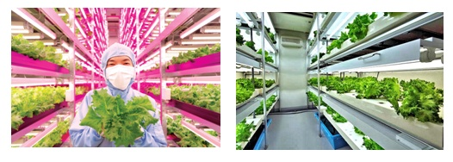
Figure1: Lettuce production using grow light
According to Hikosaka et al. [7], tomato plants with one and two leaves exposed to supplemental LED lighting had photosynthetic rates that were 12 per cent and 28 per cent greater than the control (only top lighting)
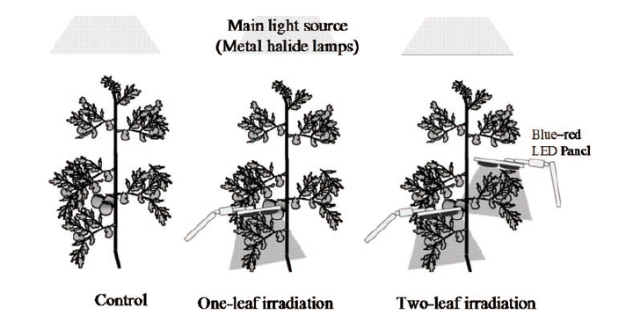
Figure 2: LEDs lighting in tomato
- Faster Harvest Cycles
Utilizing LED grow lights for indoor farming has a number of benefits, one of which is the acceleration of plant development. The lights can be utilized continuously, enabling the maximum amount of plant development per season. With this lighting, agricultural yields can be increased annually, increasing profitability. Without using chemicals, it is possible to optimise plant morphology thanks to LEDs' control over the light spectrum. In many species, blue color is identified to prevent stem elongation; for example, stem elongation of Chrysanthemum and Stevia rebaudiana diminishes as the fraction of blue light increases [8, 9].
LEDs irradiation at 75 μmol m-2 s⁻¹ of blue light and a B/R ratio of <1.0 would suppress spindly growth and promote flowering during tomato seedling growth [10].
- Higher yield
Multiple light spectra can be provided for horticulture production using LED systems. Mixture of red/blue light helps in accumulation of biomass in the cultivation of leafy vegetables [11]. The most typical crop grown in a vertical farming facility is lettuce. LED grow lights are utilized for multilayer applications to create enormous, bright green heads of lettuce or smaller, deep red heads of lettuce.

Samuoliene et al. [12] opined that additional blue light resulted in larger fruits with higher sugar content in strawberries, blue light was also found to increase the oil content in basil leaves compared to white light treatments [13], and red light alone inhibited flowering [14]. Light intensity influences secondary metabolite biosynthesis, with increasing light intensity resulting in increased polyphenol production in herbs [15].
Strawberry plants grown in the plastic green house with additional LED lights produced far more strawberries than those grown in the growth chamber with LED lights as the sole light source. When the effects of various LED lights were investigated, when ambient light was supplemented with either blue LED light or a combination of blue and red LED light, a significantly higher production of fruits was achieved in the plastic green house. Furthermore, when ambient light was supplemented with either red LED light or a combination of blue and red LED lights, there was a more accumulation of organic acids and phytochemicals such as phenolic compounds in the fruits grown in the plastic greenhouse [16].
- Better taste and nutrition
The light had a significant impact on the phytochemical concentrations and nutritional value of lettuce. Plants grown under 70% red + 30% blue LEDs had higher chlorophyll and carotenoid concentrations than those grown in the greenhouse [5]. Plants grown under 100% blue LEDs had 2.25 times the vitamin C content of those grown in the greenhouse. Plants treated with LED lights also had higher photosynthesis and maximum quantum yield of PSII photochemistry. The use of LED light resulted in higher concentrations of macro- and micronutrients in lettuce, which could be attributed to the direct effect of LED light and lower stress conditions under growth chambers compared to the green house.
The postharvest maturation of tomatoes under various light was investigated and found that raw tomatoes turned red under all light conditions, but the redness (lycopene content) was highest under LEDs, which also had a far red spectrum. The highest red to far red ratio in the spectrum (Valoya's AP673L spectrum) produced the best coloration. The firmness was increased under the previously mentioned spectrum, as measured with a fruit pressure tester. This same light spectrum was previously shown to boost antioxidants in basil. This increase in antioxidant also protects the plant from fungal pathogens such as downy mildew. The specific smell enhancement of increased rosmarinic acid content, anti-inflammatory health benefits to the consumer, and pathogen resistance are all quality enhancements caused by proper spectral selection. The higher dry matter content of the leafy greens extends the shelf life. Because drying takes longer when the plant has a higher fibre content and less water, the produce looks fresher for extended periods of time. Favour and smell of the vegetable is linked to the total phenolic amount, and it is also increased by the finely balanced light spectrum.
- Durability and Performance
With a lifespan of 102,000 hours, LEDs lights are made to last forever. These contemporary lights endure significantly longer than conventional lights, which generate more heat, in large part due to their low working temperature. The system lasts longer because of the reduced wear and tear caused by the lower temperature. Since LEDs lighting is based on solid-state technology, it has a longer lifespan because there are no moving parts. All the necessary light requirement for growing healthy plants is provided by LED lighting. Using LED lighting instead of conventional lighting systems, which emit damaging light wavelengths, would result in far healthier plants. With the ability to alter the light's wavelength provided by LED lights, growers can facilitate a better photosynthesis process. Since they don't emit heat, these lights also do away with the requirement for installing indoor cooling systems

- Energy Efficiency and Environmental Safety
Cost and energy are significant considerations for any company aiming for sustainability. Compared to conventional lights, LEDs are about 60% more energy efficient. Not only do they produce less heat, but they also deliver more useful light at a lesser price since burning is not required to produce light with LED lighting, there is a significant reduction in energy consumption and heat output. A software-based energy usage tracking system can help you improve energy efficiency even more. Since LED lights are recyclable and do not contain any harmful materials, they are also more environmentally friendly than traditional lights.

- FUTURE ADVANCES

Photosynthesis is essential for food production. Providing enough food in adequate quantity and quality for nine billion people by 2050 is especially difficult given global climate change constraints. Controlled-environment agriculture (CEA) technologies, such as greenhouses, aquacultures, hydroponics and aeroponic systems, as well as vertical farming options, provide substitute and balancing sources of crop production, particularly in areas with limited daylight (in northern latitudes) or adverse environmental conditions, or in areas with limited space, such as cities and space stations.
The benefits of CEA technologies, include increased crop yield annually due to quicker culture period under ideal environmental conditions and year round cultivation, greater growing area per m² through multi-tier cultivation shelves and more plant density, efficient nutrient and water use, lessened crop losses, and absence of pesticide application, make them effective for crop production. Additionally, these technologies might result in the production of typical, high quality horticultural goods. Closed and interior plant cultivation, in contrast to outside agriculture, rely on cutting-edge light sources like LEDs that can stimulate plant growth while significantly lowering energy use.

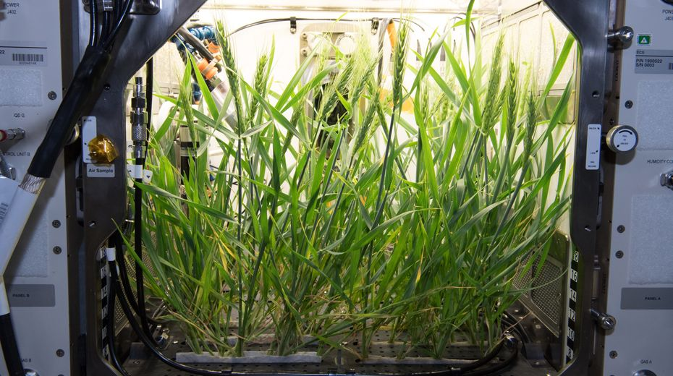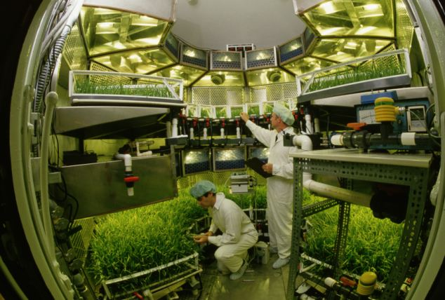
Figure 3: Controlled-environment agriculture (CEA) technologies

The use of LEDs also holds great promise for processes that produce oxygen and clean water, for the production of food, drugs, fuels, or colours in algal culture, and for the micropropagation of plants such as strawberry or blooming plants in plant tissue cultures. The efficient use of LED lighting technologies in plant cultivation in enclosed environments may be influenced by research on the effects of LEDs on primary and secondary metabolism of plants, as well as advancements in the dynamic modification in different growth stages with light quantity and quality.

Horticultural output in controlled environments and the horticulture industry are both predicted to expand in the near future. Future developments in technology will make it possible to grow crops both on Earth and in space while consuming light energy in a financially advantageous manner. This could contribute to the preservation of outdoor (mainly forest) ecosystems and the feeding of the planet's growing population of people.

CONCLUSION
Artificial light gives plant the energy required to grow and it ensures proper photosynthesis. LED Grow lights, HPS and CFL lamps are the most popular artificial light sources. A standard full-spectrum light is a good all-around choice for most plants. Red and blue are the most important colours. Plant grow lights can help us extend the growing season in the winter. Plant also grow better under these lights because the lighting, humidity, temperature, create the ideal environment for robust growth.
Advancements of LED technology have made it conceivable to create the ideal environment for growing vegetables on a large scale, within a short period with higher yields. Actually, LED is quickly becoming the genuine lighting source for creating the most beneficial controlled environment for indoor farming. LED technology advancements have made indoor vegetable cultivation more efficient in energy. However, as LED prices continue to fall, farmers should be able to convert to LED, which offers significant energy cost savings. LED lighting is a solid and dependable option for long-lasting and low-maintenance lighting. Grow lights for agricultural operations must be as influential as possible while remaining cost effective.

REFERENCE:

[1] Ma Z, Sh L, Zhang M, Jiang S, Xiao Y. 2010 Light intensity affects growth, photosynthetic capacity, and total flavonoid accumulation of Anoectohilus plants. Hort. Science 45, 863–867.

[2] Bula RJ, Morrow RC, Tibbitts TW, Barta DJ, Ignatius RW, Martin TS. 1991 Light emitting diodes as a radiation source for plants. Hort. Science 26, 203–205.
[3] Sabzalian, M.R., Heydarizadeh, P., Zahedi, M. (2014). High performance of vegetables, flowers, and medicinal plants in a red-blue LED incubator for indoor plant production. Agron. Sustain. Dev. 34: 879–886
[4] Wang, X.Y., X.M. Xu, and J. Cui. 2015. The importance of blue light for leaf area expansion, development of photosynthetic apparatus, and chloroplast ultrastructure of Cucumis sativus grown under weak light. Photosynthetica 53:213–222.

[5] Amoozgar, A., Mohammadi, A. and Sabzalian, M.R., 2017. Impact of light-emitting diode irradiation on photosynthesis, phytochemical composition and mineral element content of lettuce cv. Grizzly. Photosynthetica, 55(1), pp.85-95.
[6] Liang, D., Yousef, A.F., Wei, X., Ali, M.M., Yu, W., Yang, L., Oelmüller, R. and Chen, F. (2021) . Increasing the performance of Passion fruit (Passiflora edulis) seedlings by LED light regimes. Scientific Report 11: 20967.

[7] Hikosaka. S., Iyoki, S., Hayakumo, M. and Goto, E., 2013. Effects of light intensity and amount of supplemental LED lighting on photosynthesis and fruit growth of tomato plants under artificial conditions. Journal of Agricultural Meteorology, 69(2), pp.93-100.
[8] Kim SJ, Hahn EJ, Heo JW, Paek KY. 2004. Effects of LEDs on net photosynthetic rate, growth and leaf stomata of Chrysanthemum plantlets in vitro. Sci. Horticult. 101, 143–151. (doi:10.1016/j.scienta.2003.10.003)
[9] Yoneda, Y., H. Nakashima, J. Miyasaka, K. Ohdoi, and H. Shimizu. 2017. Impact of blue, red, and far-red light treatments on gene expression and steviol glycoside accumulation in Stevia rebaudiana. Phytochemistry 137:57–65.
[10] Nanya, K., Ishigami, Y., Hikosaka, S. and Goto, E. (2012). Effects of blue and red light on stem elongation and flowering of tomato seedlings. Acta Hortic. 956, 261-266
[11] Yorio, N.C., G.D. Goins, H.R. Kagie, R.M. Wheeler, and J.C. Sager. 2001. Improving spinach, radish, and lettuce growth under red light-emitting diodes (LEDs) with blue light supplementation. HortScience 36:380–383.
[12] Samuoliene, G., Brazaityte, A. and Urbonaviciute, A. 2010. The effect of red and blue light components on the growth and development of Frigo strawberries. Zemdirbyste-Agriculture 97:99–104.

[13] Amaki, W., N. Yamazaki, M. Ichimura, and H. Watanabe. 2011. Effects of light quality on the growth and essential oil content in Sweet basil. Acta Hort. 907:91–94
[14] Yoshida, H., S. Hikosaka, E. Goto, H. Takasuna, and T. Kudou. 2012. Effects of light quality and light period on flowering of everbearing strawberry in a closed plant production system. Acta Hort. 956:107–112

[15] Manukyan, A. 2013. Effects of PAR and UV-B radiation on herbal yield, bioactive compounds and their antioxidant capacity of some medicinal plants under controlled environmental conditions. Photochem Photobiol. 89:406–414.
[16] Choi HG, Moon BY, Kang NJ. (2015). Effects of LED light on the production of strawberries during cultivation in a plastic greenhouse and a growth chamber. Scientia Horticulturae 189:22-31
http://www.actahort.org/books/956.
https://en.wikipedia.org/wiki/Compensation_point
https://en.wikipedia.org/wiki/Grow_light
https://kimmerer.com/street-lights-tree-growth/
https://thepracticalplanter.com/plants-that-thrive-in-artificial-light/
https://www.urbanorganicyield.com/artificial-light-for-plants/
https://www.urbanorganicyield.com/regular-led-light-bulbs-as-plant-grow-lights/
https://www.thebalancesmb.com/grow-light-options-for-indoor-and-vertical-farming-4147429
https://www.lighting.philips.com/main/products/horticulture/vertical-farming-led-lights
https://www.valoya.com/can-leds-affect-the-taste-and-smell-of-vegetables/
https://www.farmersweekly.co.za/agri-technology/farming-for-tomorrow/light-effects-plant-growth/
https://www.valoya.com/artificial-lighting-in-agriculture/
http://dx.doi.org/10.1098/rstb.2013.0243
https://www.titanledus.com/2019/03/advantages-of-led-grow-lights-for-agricultural-greenhouses

