On some theoretic aspects of fuzzy subsets

Sisir Kumar Rajbongshi*a**,** Prasanta Gogoi*b

*aDepartment of Computer Science, Pandit Deendayal Upadhyaya Adarsha Mahavidyalaya, Amjonga, Goalpara , Assam, India, Pin: 783124, email: sisirrajbongshi@gmail.com*

*bDepartment of Chemistry, Pandit Deendayal UpadhyayaAdarsha Mahavidyalaya, Amjonga, Goalpara , Assam, India, Pin: 783124, email: prasantagogoi799@gmail.com*

**Abstract**

This article proposes some important theoretic aspects of fuzzy subsets. Here, we take a non-empty finite set and an ordered subset of the closed interval, then the set of mappings from to denoted by is defined as special fuzzy Boolean algebra. This article defines the subalgebra of a special fuzzy Boolean algebra. Some characteristics of the subalgebra are discussed.

**Keywords: fuzzy subsets, Special Fuzzy Boolean algebra, Subalgebra,**

**1. Introduction**

The idea of fuzzy sets was first presented by Zadeh1 and is used in many different areas of mathematics.

Goguen2 and Sarchez3 modified this idea to define and research fuzzy relations. Joseph Goguen originally considered fuzzy sets, a generalization of them, in 1967. Numerous academics have since conducted studies on fuzzy sets. Fuzzification of algebraic structures and the idea of fuzzy subgroups were both developed by Rosenfeld4.

Algebraic structures are crucial to mathematics and have numerous applications in various fields, including coding theory, computer science, and information technology. Numerous studies have placed a strong emphasis on the fuzzy sets' algebraic structures. 5,6,7,8

The set of all fuzzy subsets of is called the fuzzy power set of and denoted by . Since there is infinite numbers of values in , the fuzzy power set also have infinite numbers of fuzzy subsets or elements.That is why, in this article we take a non-empty finite set and an ordered subset  of such that , where is any positive integer greater than 1. Then the set of all fuzzy subsets obtained from the mappings from to is defined as special fuzzy Boolean algebra 8. It is denoted by. The total numbers of elements or fuzzy subsets in =.For better identification we denote the fuzzy subsets of as 0,1,2…. as follows:

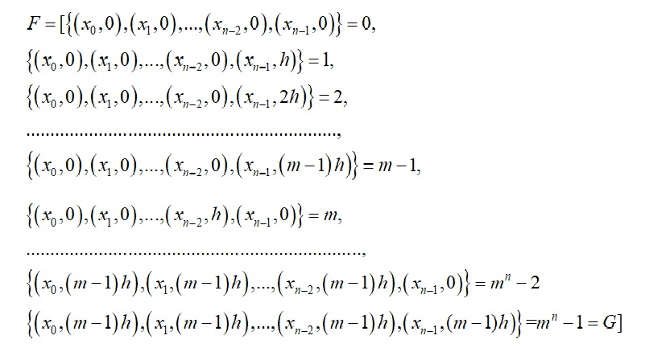

Subalgebra is a subset of an algebra in mathematics that is closed under all of its operations and carries the included operations. It is almost a necessity to study its subalgebra, just as it is to learn the various facets of special fuzzy Boolean algebra. The subalgebra of a unique fuzzy Boolean algebra is defined in this chapter. There is discussion of a few subalgebraic features.

**2 Special fuzzy Boolean Subalgebra**

Let,  is a special fuzzy Boolean algebra with andrepresents two binary operations fuzzy intersection and fuzzy union respectively, ‘/’ represents a unary operation complementation and two distinct elements empty fuzzy subset ‘’ and the universal fuzzy subset ‘’.

Now, if is a non-empty subset of containing and; and is closed under the same operations, then is a **special fuzzy Boolean subalgebra** of. Therefore a special fuzzy Boolean subalgebra of a special fuzzy Boolean algebra  is a subset of and itself a special fuzzy Boolean algebra.

**Improper subalgebra,** that is defined for every special fuzzy Boolean algebra has a special fuzzy Boolean subalgebra namely ; the other special fuzzy Boolean subalgebras can be said as as **proper**.

Similary every special fuzzy Boolean algebra has a **trivial subalgebra** containing the empty fuzzy subset  and the universal fuzzy subset  only; all other subalgebras of are defined as **non-trivial**.

**Example 2.1** Let, be a finite set. Then, for the mappings  into and  into ; where  we can obtain special fuzzy Boolean algebras denoted by  ,where





The fuzzy union the elements of are listed in the following table 2.1:

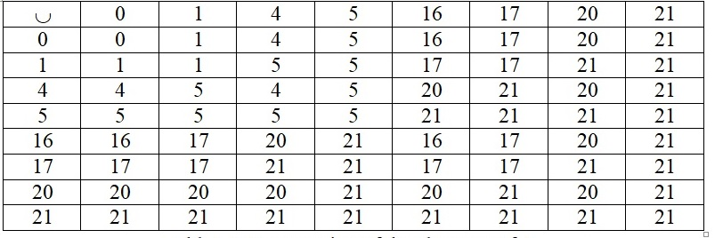

Table 2.1: Fuzzy Union of the elements of 

The fuzzy intersection of the elements of are listed in the following table 2.2:

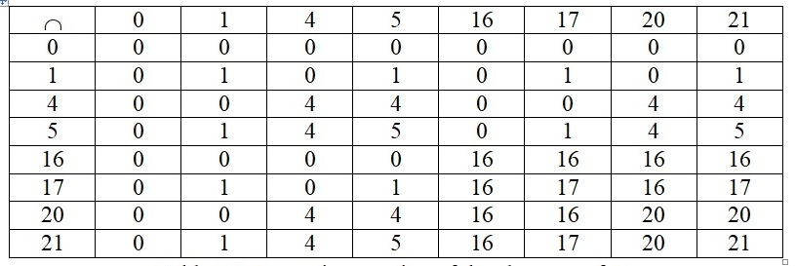

Table 2.2: Fuzzy Intersection of the elements of 

And the fuzzy complements the elements of are listed in the following table 2.3:

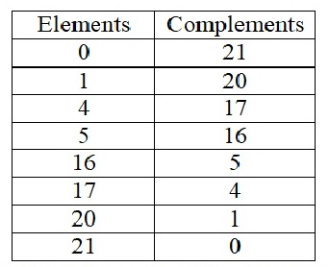

Fig: Fuzzy Complement of the elements of 

Observing the three tables some special fuzzy Boolean subalgebras of are:

improperspecial fuzzy Boolean subalgebra,

trivial special fuzzy Booleansubalgebra,

,



****etc. are special fuzzy Boolean subalgebras of .

**3.Some Characteristics of special fuzzy Boolean subalgebra**

**Theorem 3.1**

To be a special fuzzy Boolean subalgebraof a special fuzzy Boolean algebra ; must contain the empty fuzzy subset and the universal fuzzy subset of .

*Proof* Since, the complementation is an essential part of the structure of a special fuzzy Boolean algebra; the presence of the empty fuzzy subset ’ and the universal fuzzy subset in every special fuzzy Boolean subalgebra is necessary since and .

Since, a special fuzzy Boolean subalgebra contains an element with its complement . The fuzzy union or join is always the universal fuzzy subset and the fuzzy intersection is always . Hence, the special fuzzy Boolean subalgebra must have and.

**Remark 3.1**

Every special fuzzy Boolean subalgebra of a special fuzzy Boolean algebra contains elements but the reverse is not always true. If a subset of a special fuzzy Boolean algebra does not contain elements then it is never become a special fuzzy Boolean subalgebra, for some 

For example, observing the tables as shown in above, the subset of the special fuzzy Boolean algebra  of example 7.1 is not a special fuzzy Boolean subalgebra, because.

**Remark 3.2**

Every special fuzzy Boolean algebra can be expressed by the special fuzzy power set of its universal fuzzy subset  which is discussed in the section 3.9, but a proper special fuzzy Boolean subalgebra cannot be expressed as the special power set of  .

**Theorem 3.2**

If  ; where  are some special fuzzy Boolean subalgebras of a special fuzzy Boolean algebra , then is also a special fuzzy Boolean subalgebra of .*Proof*Let, and be two fuzzy subsets of . This implies that:

 (is a special fuzzy Boolean subalgebra) (1)

 (is a special fuzzy Boolean subalgebra) (2)

………………………….

 (is a special fuzzy Boolean subalgebra) (3)

From (1), (2) and (3) it implies that :



is closed with respect to fuzzy intersection .

Similarly, we can show that:



is closed with respect to fuzzy union .

Again, let 

(asaresubalgebras)

Also, 

,

So, is closed with respect to fuzzy complementation.

Again, and .

Hence,  is a special fuzzy Boolean subalgebra.

**Theorem3.3**

The relationof one special fuzzy Boolean algebra being a special fuzzy Boolean subalgebra of another is a partial order on the set of all special fuzzy Boolean subalgebras of a special fuzzy Boolean algebra.

*Proof* Let be the set of all special fuzzy Boolean subalgebras of a special fuzzy Boolean algebra 

**Reflexivity**: Here, , so the relation  is reflexive on .

**Ant symmetry**: If . Hence, the relation  is antisymmetric on .

two special fuzzy Boolean algebras are special fuzzy Boolean subalgebra of one another, then they are equal.

**Transitivity**: For any three special fuzzy Boolean algebras  and if is a special fuzzy Boolean subalgebra ofandis a special fuzzy Boolean subalgebra ofthenis a special fuzzy Boolean subalgebra ofwhich follows that the relation  is transitive.

Therefore, the relation  is a partial order relation on  as it is reflexive, antisymmetric and transitive. Therefore  is a poset.

**References and Notes**

1. A. Goguen, L-fuzzy sets, *J. Math. Anal. Appl.*, **1967**, *18*, pp. 145-174.
2. A. Rosenfeld, Fuzzy Groups, *J Math Anal Appl*., **1971**, *35*, pp. 512-517.
3. A. Tepavacevic; G. Trajkovski, L-fuzzy lattices: an introduction, *Fuzzy Sets Syst*., **2001**, 1*23*,

pp. 209-216.

1. E. Sanchez, Resolution of Composite fuzzy relation equation, *Infor. And Control*, **1976**, *30*,

*International Conference on Frontiers in Mathematics, Gauhati University, Guwahati,*

*Assam, India*, **2015**, *1*, pp. 26-28.

1. K. R. Bhutani, Fuzzy Sets, Fuzzy Relations and Fuzzy Groups: some interrelations, *Inform.*

*Sci.,* **1993***, 73*, pp. 107-115*.*

1. L. Zadeh, Fuzzy sets*, Infor. And Control*, **1965**, *8*, pp. 338-353.
2. M. Atif; A. Mishref, On the free product, *Fuzzy Sets and Systems*, **1996**, *81*, pp. 287-289.
3. S. K. Rajbongshi; D. Talukdar, An Introduction to a family of fuzzy subsets forming Boolean algebra, *International Journal of Computer Applications,***2013**, *68(24),* pp. 0975-8887.
4. S. K. Rajbongshi; D. Talukdar, Some aspects of Special fuzzy Boolean algebra, *Proceeding of*

*Sci*., **1993**, *73*, pp. 107-115.