Importance Of Cloud Computing
S M Firdaus Zaki Rizviª , Dr. Amar Nath Chatterjee^{b,*}

ªDepartment of Mathematics and IT, Magadh University, Bodh-Gaya, Bihar–824234(India)
^{b}Department of Mathematics, K.L.S. College, Nawada, Magadh University, Bodh-Gaya, Bihar – 805110 (India)
Abstract
Cloud Computing has totally changes the world of computing, now a days it is very hot and popular topic of discussion. Cloud computing is a channel through which the deliverance of services and resources using the internet medium is possible easily. the Cloud computing is useful for small as well as big business and organization. Cloud provides different services, using clod computing we can get many benefits than traditional computing system , it provides many facilities such as large mobile storage, cost saving on large scale, well-built and superior protection, access from everywhere, power saving and environment friendly, these are basic benefits of cloud computing. And facilities make the cloud computing important for an organization and individuals. Now it is very important for an organization or individual to reallocate from customary computing to cloud computing because they benefiting from it. Recently there are many different types of cloud computing services are available on very flexible cost models, such as, subscription and lease based cost models services for illustration, Remote Desktop Session Host (RDSH) used for cloud Terminal, Software as a Service (SaaS) provide facility to utilize software services on rent and Platform as a Service (PaaS) Provide facility to taket computing infrastructure on rent on minimum monthly or yearly cost. The Storage as a Service (STaaS) provide facility to use huge memory space on rent at a minimum cost and Security as a Service (SeaaS) provides a strong cloud based security applications. likewise, the Infrastructure as a Service (IaaS) provide facility to take computing infrastructure on lease that reduces the establishment cost for any individual or organization. By means of services, cloud computing offers more benefits than conventional computing.
Introduction
Cloud Computing is a group of technologies for storing and accessing of data and computing services over the internet. In cloud computing data doesn't store on your personal computer. The availability of cloud computer services is on demanded such as data servers, data storage, networking, databases, etc. The main goal of cloud computing is to give access permission to data centers (centralized virtual server) to many users. And the users can also access data from a remote server which connected to a centralized. It is a structure of application-based software which stores data on remote servers and it can be accessed by the internet. The cloud computing works , can be divided into two parts front-end and backend. The user access data stored in the cloud through front-end using an internet browser or a cloud computing software. The responsible of primary component of cloud computing is to securely storing data and information at the backend. It includes data storage servers, computers, databases, and central servers. And it is possible by cloud computing that a user can use many different gadgets such as laptop, personal computers, smart phones and other computing machines which connect virtually to the cloud. And the user also called client is able to use and make changes to the data stored on cloud by himself with a minimum rent cost charges by cloud owner. Client need not buy or pay extra for hardware because it’s a shared resource facility over the internet,
Now a day’s cloud computing demand of every sectors such as business world and other firms are changing the of traditional way of record keeping to cloud based infrastructure format, because its very beneficial and easy to retrieve data in case of disaster on local server or machine. Data can be access and updated from anywhere at any time. The middle (cloud) server makes possible operations by following a set of laws known as protocols. It occupy a software, middleware, to ensure faultless connectivity between the devices/computers linked via cloud computing. Cloud computing service providers generally sustain multiple replica of the data to mitigate example of security threats, data loss, data breach, etc.
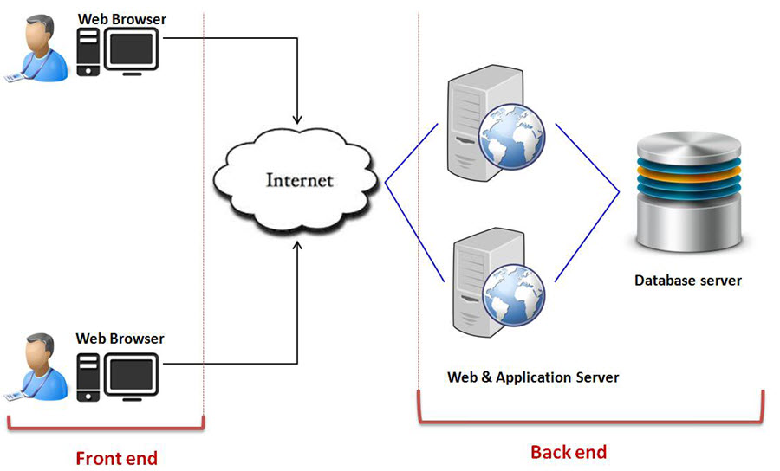

Cloud computing provides shared resources software and information to the various computers and devices on demand because cloud computing is an internet based.
Service Models of the Cloud Computing.
Manly there are three service models for cloud computing are:
1. Software as a service (SaaS).
In this model vendor or provider’s hosted applications which running on a cloud infrastructure(internet) and available to different customer devices through a thin customer interface such as a Web browser. Benefit of this model is that instead of purchasing the software subscribe it for monthly rental on internet, even a particular piece of software can be subscribe.

2. Platform as a service (PaaS).
In this cloud infrastructure can customized applications with the help of programming languages and tools supported by the provider ( java, python, .Net)
3. Infrastructure as a service (IaaS)
It allow access to the infrastructure and computing resources such as storage, networks, and other fundamental computing resources in a virtualized manner where the customer is able to establish and run any software, which can consist of operating system and applications. It is a cost reduces internet based IT infrastructure
The aim of cloud computing is to realize the network is a high performance computer which is to permit users to keep all the services, and data information into cloud and get all types of services from cloud only through their remote terminal tools connect to internet. When the user used cloud services, they observe that it’s a virtual view and the data and services are actually distributed at different locations in cloud. The propensity that data and services will be transformed to web is to be expected and more and more services and information will be in cloud network. We already know that Cloud service is based on Web Services and Web Services are based on Internet. On the Internet there are many its own inherent security weakness because of its openness and it has many other attacks and threats also. So the cloud computing services will have to face a big range of security problems. Recently there are already many more security software technologies for Web Services so this is big implication for us to solve security issues of cloud service using the existing security information. The Cloud computing model is for facilitate suitable, on-demand network access to a common pool of configurable computing resources such as nets, grids, applications software, servers, storage, and the services that can be fast provisioned and get released with least management effort or service provider’s communication. These cloud models improves availability and is composed of four deployment models, five significant characteristics along with three service models.
Important features of Cloud Computing
Here I am discussing some important features of the cloud computing that generated by cloud characteristics.

1. Resources Pooling
Resources pooling is most important features of the cloud computing because through this characteristics the cloud computing service provider can share resources between many clients and providing each client with a different set of services as per the requirements. In cloud computing resource pooling is multi-client strategy system which is applied for data storage, data processing and bandwidth-provided services. And in this whole process the real time administration that allocating resources does not clash with the client services.

2. On-Demand Self-Service
This is also one of the important and necessary features of Cloud Computing. It enables the client to all the time supervise the server uptime, abilities, and selected network storage. This is a basic characteristic of Cloud Computing, and a client be able to similarly manage the computing abilities as per his needs..

3. Easy Maintenance
It is the best features of cloud that the servers can be easily maintained and the downtime is very low and even in some situations, there is no downtime. Cloud Computing comes up with bring up to date every time by steadily building it better.
The updates are well-matched with the devices and execute faster than previous along with the bugs which are predetermined.
4. Scalability and Rapid Elasticity
It is a key feature and advantage of cloud computing and it is its rapid scalability. This cloud feature enables the cost-effective operation of workloads that need a vast number of servers but only for a short period. Many clients have such workloads, which can be run on very less cost because of the fast scalability of Cloud Computing.

5. Large Network Access
The consumer can also use the data of the cloud or upload the data to the cloud from any place in the world just with the help of a computing device and an internet link. These capabilities are accessible all over the net and access with the help of internet connection.

6. Availability
The working capabilites of the Cloud can be modified as per the use and can be extended a lot. It analyzes the storage usage and allows the user to buy extra Cloud storage if needed for a very small amount.

7. Automatic System
This a special features of Cloud computing that it can automatically analyzes the data required and supports a metering capacity at a few level of services. We can easily monitor, control, and report the usage of data and the clients activity over the cloud network . It will provide clearness for the host as well as the customer.
∗ Corresponding author.
E-mail address: anchaterji@gmail.com (A.N. Chatterjee).

8. Economical
This cloud computing features help us to reduce the IT infrastructure expenditure of individual or organization level. It is a one-time investment over the IT assets as the Organization or individual (host) has to buy the storage over the cloud and a small part of it can be provided to the many Organizations or individuals which save the host from monthly or yearly costs. Only they have to pay that amount which is spent is on the basic maintenance and a few more expenses which are very less.

9. Security
Data security over the cloud is one of the most important features of Cloud computing.. It creates a copy or snapshot of the data stored to prevent the stored from lost even if one of the servers gets damaged.
The data is stored within the huge storage capacity devices that is highly secure and which cannot be hacked and unauthorized utilized by any other person. The storage service is very quick and reliable.

10. Pay as you go
Payment in cloud computing is depend upon user requirements and the, the user has to pay only for the service or the space they have used. There is no any hidden or extra charges that is to be paid. The service is low-cost and most of the time few space is allotted for free.

11. Measured Service
This is a major Cloud computing features that are utilized to monitor and control the entire system and the company uses it for recording. This resource consumption is measured by supporting charge-per-use capabilities.
It means that the resource utilizes which can be either virtual server instances that are consecutively in the cloud are getting monitored measured and reported by the service provider. This model pay as you go is variable based on actual utilization of the manufacturing organization.

Summary
These are the Companies who control and maintain the servers, maintain the boisterous of the server and take care over all security and tasks of it. The association also buys the software and the licenses for the action of their business. All these things protect by the monthly fee that they are expecting from the organizations they are serving.
They are listening cautiously on providing ranked service as if they not succeed to do so they will be at the back in the contest. This web-based system can only access through the internet.
Cloud Computing has different amounts of advantages which are serving both hosts as well as the individual customer or organization. A host construct of a range of profit too which benefit the customers.
There are a countless of safety element which is a hopeful point along with it the execution time is very low and one can easily upload and download data quickly. The organization nowadays is in huge need of the data storage capability and the Big Data companies provide them very easily.

Declaration of Competing Interest
The authors declare that they have no known competing financial interests or personal relationships that could have appeared to influence the work reported in this paper.

References
[1] Isha Upadhay(Content Writer), Jigsaw Academy Blog, June-2022
[2] Sagar Choudhary1, Garima Pundir2, Yashveer Singh3. International Research Journal of
Engineering and Technology (IRJET) e-ISSN: 2395-0056 Volume: 07 Issue: 01 | Jan 2020.
[3] Manish Kumar- Bhagwant Institute of Technology, Muzaffarnagar, UP. Shivani Chauhan
Assistant Professor Bhagwant Institute of Technology, Muzaffarnagar, UP. Ajay Singh
Assistant Professor Bhagwant Institute of Technology, Muzaffarnagar, UP, International
Journal of Computer Science and Mobile Computing, Vol.8 Issue.1, January- 2019.
[4] Sunil Kumar and Maninder Singh, Department of Computer Science, Punjabi University,
Patiala. Article Published : 12 Apr 2017
[5] T. Karnwal, S. Thandapanii, A. Gnanasekaran, “A filter tree approach to protect Cloud
Computing against Xml DDoS and http DDoS Attack”. In: Intelligent Informatics, pp. 459–
469. Springer, 2013.

