ENHANCEMENT OF PERFORMANCE AND EFFICENCY OF CONVENTIONALVERTICAL AXIS WIND TURNBINE SYSTEM BY MODIFYING THE TUBINE TO INCOPERATING THE PERMANENT MAGNET PROPELLING PEONOMENON

Sandesh Hegde

Department-of-Mechanical-Engineering.

Srinivas-Institute-of-Technology.

Mangalore, India.

sandeshh.hegde92@gmail.com

Dr. Nagesh S N

Department-of-Mechanical-Engineering

Ramaiah -Institute-of-Technology

Bangalore,-India

snnagesh80@gmail.com

Dr. Ramachandra C G

Department-of-Mechanical-Engineering.

Presidency-University

Bangalore, -India

[ramachandra.cg@gmail.com](mailto:ramachandra.cg@gmail.com)

Dr. Prashanth Pai M

Department-of-Mechanical-Engineering

PA-College-of-Engineering

Mangalore, -India

shanth.pai@gmail.com@gmail.com

ABSTRACT

Presently the two primary causes of the energy issue are the world's fast growing population and rapid improvement in people's living standard. As a result, there is an energy crisis that affects everyone in the world, and the cost of energy is increasing. Fossil fuels were mostly discovered in the earth's crust, which is the outermost layer of the planet's surface. Decomposed plants and animals naturally produced these fuels. These disintegrated components will be high in carbon and hydrogen content, and they will be burned to provide energy. Presently electricity is mostly produced by coal, nuclear energy, and hydropower together with small portion contribution from renewable sector. For heating, a lot of people utilize natural gas. For cooking and heating, biomass—which is typically wood or decomposed animal waste—is used. Oil is very flexible since it fuels practically advantage for all the devices that move. If oil production continues at its current rate until it runs out. Most people are aware that oil and gas will become costly and in short supply within their lifetimes. It is generally acknowledged that the energy as we now use, will not be adequate to meet the needs of all people on the planet in future, hence cleaner and more plentiful alternative energy sources are required which may be in the form of hybrid energy also. Renewable energy sources will certainly become more prominent. Then we have an option of a planned or arbitrary transition. Modern civilizations needs cheap, plentiful energy to survive,therefore, it is crucial for human civilization to create a sustainable, affordable, and environmentally benign alternative sources of energy. The global energy dilemma may have an efficient solution in the form of wind power. It is a source of clean and green energy that is completely safe, affordable, and an environmentally friendly. In current state of affairs, the air could seems like insignificant to any or all. However we tend to all grasp that, the planet has shaped up with associate uneven surface, which suggest that the sunrays could strike these surface with variable intensities at numerous spot on its uneven surface. This creates associated degree of unequal degree of heating of the earth surface, that which causes variation in part of atmospheric pressure thereon. Then it leads to wind. The Kinetic energy of these air molecules is nothing but wind energy. A mechanical mechanism known as a wind turbine which transforms, kinetic energy which is there in the air around it into the required form of mechanical energy. Here in this research we focused on the repellent qualities of permanently magnetized objects with similar poles. These innate qualities of magnetic propulsion are used here as an energy sources. Due to the inclusion of this components like magnetic repulsion, our VAWT system will operate more effectively even at lower wind speeds circumstance also. This magnets will produce a repulsive force that will add various sorts of kinetic energies to the wind turbines as they convert wind energy's kinetic energy of into the necessary mechanical power when it’s employed as an extra source of energy in a VAWT.

Keywords- Wind Energy, Renewable Renergy Sources, Hybrid Energy, Vertical Axis Wind Turbine, Magnets.

# INTRODUCTION

People have used the wind to help propel mills and sailboats for thousands of years and from equally ancient times, architects have utilized wind-driven natural ventilation in structures. But in the beginning of 1980s, the energy industries witnessed an incredible expansion that was particularly apparent in the wind energy industry. Therefore, within the current property energy sector, additional to the hydro power, alternative energy, and wind energy, they’re going to additionally play a crucial role, within a property energy bank in a name of hybrid energy source. The mechanical framework that produces up the turbine system converts the mechanical energy from the wind into the mandatory type of energy. Now, this mechanical power may be applied to operating/moving another system or rotating the generator shaft to come up with electricity. The blades of a windmill devices will get momentum due to change is air pressure applied to it. The shaft to which the rotating blades are fastened will start rotating in cylindrical motion. From the shaft typically these mechanical energy were directly used to power other machine were outdated technology, now presently these mechanical energy were converted in to electrical energy with help of generator coupled to shaft.

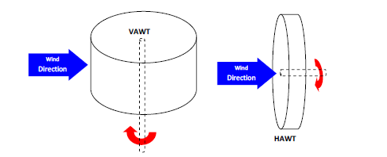

Figure 1: Alternative Shaft and Rotor Orientation Configuration

There are two major family in wind turbine, the majority of wind turbines feature a horizontal shaft with blades attached to it. And an electric generator coupled to shaft. We refer to these as horizontal axis wind turbines. They most frequently feature three blades and work "upwind," turning at top of a tower, so these can blades face the wind. The most typical turbine arrangement is the HAWT. The turbine mechanisms and propellers are elevated above the ground on a sizable pedestal. Whether they improve the landscape is a matter of subjective opinion. However, there is no disputing that when service is necessary, the location of their systems at a height is a disadvantage. In order to be positioned such that their horizontal axis is parallel to and facing the wind, they also need a mechanical yaw mechanism. More power is needed for a bigger diameter because the swept area (or rotor's diameter) and potential power output are correlated. The size is constrained by blade strength since the blades are subject to significant thrust and torque forces.

Another type of machine is the vertical axis machine, which as a set of long curvy blades on a vertical shaft and is shaped like an-eggbeaters. These turbines don't require particular positioning so that they face the wind to perform because of their omnidirectional nature. In initial period of invention consideration was given to vertical axis designs because of the anticipated benefits of omni-directionality. This is how wind turbines may be broadly categorized, as seen in Figure 2.

Since the plane of rotation for vertical-axis wind turbines (VAWTs) is vertical, the primary rotor shaft is positioned vertically. An older but less well-known class of wind turbines includes vertical-axis turbines. These straight blades vertical-axis turbine is a particular variety of vertical-axis wind turbine which has a number of potential benefits over a conventional horizontal-axis turbines that are now used widely across the world. The advantage of VAWTs is that they may be oriented toward wind direction without a yaw control system. These are therefore helpful in locations where the direction of the wind is unpredictable or there are big obstructions like homes, trees, or other structures. Additionally, VAWTs don't need a tower construction and may be installed close to the ground, making it possible to reach electrical components, generator may be placed closer to the ground, which makes it simpler to maintain the moving parts. And starts rotating at lower wind speed condition when compared to HAWT.



Figure 2: Configuring of a VAWT System.

Currently, in our article, it's been set to target the development of a permanent magnet-driven VAWT. This system with hybrid energy technology of permanent magnets is capable of functioning in a variety of wind-speed environment conditions. In this study, we compare the performance of vertical axis wind turbines in the PM style to the conventional VAWT system they are meant to be replaced in future.

# TURBINE DESIGN

The wind turbines during this instance area a unit mechanical structures that embody a blade, shaft, and supporting elements. Once the give system is placed and exposed to region of air movement, the air can contact the rotary blades and alter the pressure. Then as the result, the rotor turns within the direction of the carry. Here then wind mechanical energy is born-again into the mandatory style of energy and transmitted through the shaft to generator or alternative system once the given system's rotor sections begin to rotate.

There are mainly to sub-system in wind turbine family, which is commonly known as Horizontal Axis and Vertical Axis. In our research we opted Vertical axis wind turbine system to incorporate the magnetic propelling technology. The rotating shaft in a VAWT construction is vertical, and the rotating plane is vertical. Then the rotating shaft itself has a cylinder-like form. The VAWT Systems are the ancient & least well-liked turbine in the family. And this design offers a number of benefits over a more often used horizontal-axis turbine arrangement. Basically there is 2 sub types in the VAWT’s Structure, which are as follows-

* Darrieus Model.
* Savonius Model.

The Savonius-based turbine system within the VAWT system family uses a drag-type VAWT construction that operates similar to a pedal boat in water. S.J. Savonius is that the discoverer of this technique. Over the time, the drag-based Savonius Structure was developed by employing a bucket, plate, or cup as a propulsion device. The S-model rotary blades, area unit employed in this text as Savonius kind rotor devices. Compared to the lift-based systems, these pull kind VAWT systems have a really high starting torque and self-starting features. We have ultimately opted to base our foundation on the Savonius configuration with minor changes when researching the two primary sub sorts of VAWT system rotor components.

The key alteration to the fundamental Savonius sub system principle is to incorporation of magnetic repulsion qualities between the moving and stationary sections of turbines. Because of these repulsion, turbine will undergo scoops on the upper half of blades plane, and it is required to eliminate these scoop from turbine & to provide a smoother torque while rotor turns [4]. We somewhat adjusted our design in comparison to our ordinary Savonius turbine model [2] by changing the bending contour of a rotor blade's top to its base. This is accomplished by spiraling a collection of triangular faces cut from an aluminium sheet element from top to the bottom of the rotor blade according to our design parameters. Figure 3&4 displays the finalized modified Savonius design.

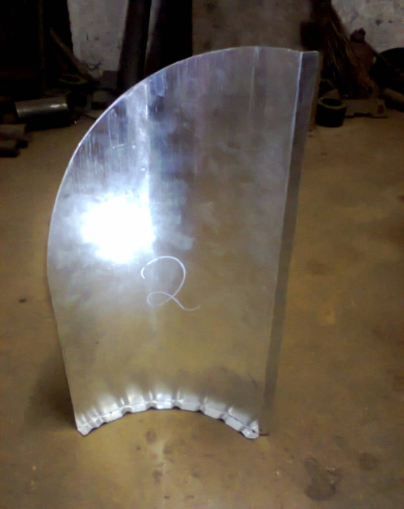

Figure 3a: Finalized Modified Turbine Model

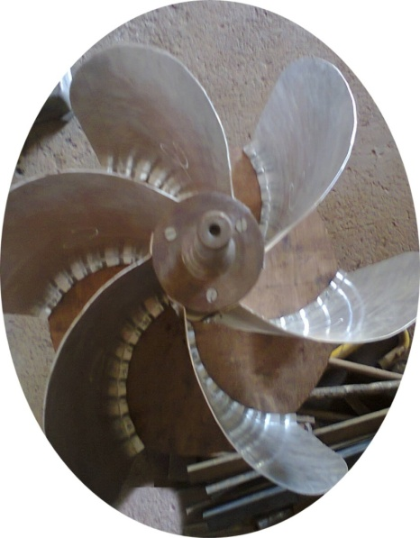

Figure 3b: Finalized Modified Turbine Model

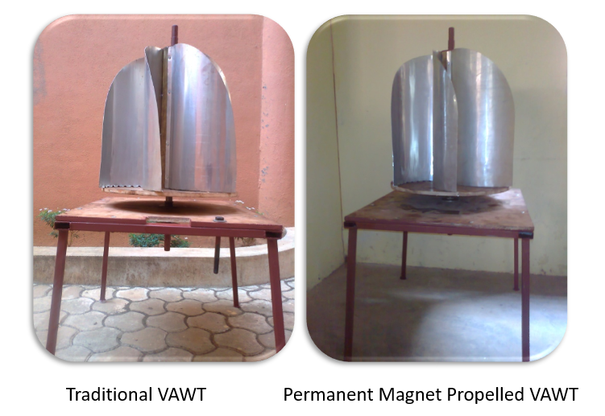

Figure 4: Conventional VAWT Model vs PM-VAWT Model

# REPULSION CHARACTERISTICS OF PERMANENT MAGNETS – ENERGY BANK

An objects which produce a magnetic-field, or force field, which either attracts or repels particular materials like nickel or iron; are called as magnets. Naturally, not all magnets are made up of the same elements, and as a result, they may be divided into groups according to their make-up and source of magnetism. When magnetized, permanent magnets continue to be magnetically attractive. When a magnetic field is present, materials known as temporary magnets function like permanent magnets, but when the magnetic field is absent, they lose their magnetic properties. Ceramic/ferrite magnets, Alnico, Samarium cobalt (Sm-Co), & Neodymium Iron Boron (Nd-Fe-B) are the four main types of permanent magnets. Permanent Magnet are source of energy banks and it will never lose its magnetic characteristics like attraction and repulsion unless it’s physically damaged by means of heating or hammering as showing Figure 5.

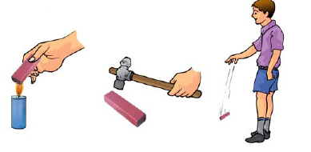

Figure 5: Magnetic Property Loss

Ceramic/ferrite permanent magnet may be simply & cheaply manufactured by sinteri pressing sintered iron oxide with barium or strontium carbonate. However, these magnets must be ground using a diamond wheel since they are frequently fragile. They are among the magnets that are most frequently utilized; they are powerful and difficult to demagnetize.

The first 2 letters of each of the 3 primary components—aluminum, nickel, and cobalt—give alnico magnets their name. Despite having high temperature resistance, they are quickly demagnetized and are occasionally replaced in some applications by ceramic & rare earth magnets. They may be made either by sintering or casting, and each method produces magnets with unique properties. Sintering results in improved mechanical characteristics. Casting produces goods with more energy and permits the development of more intricate design aspects for the magnets.

Sm-Co magnets are extremely powerful and challenging to demagnetize. They can endure temperatures of up to 300 °C and are also very temperature and oxidation resistant.

Rare earth magnetic material makes up Neodymium Iron Boron (Nd-Fe-B), which has a strong coercive force. They may often be produced in tiny, compact sizes because to the high product energy level. However, if left uncoated, Nd-Fe-B magnets which have low mechanical strength, are frequently brittle, and have little corrosion resistance. They may be utilized in several applications if they are given a gold, iron, or nickel plating treatment. They are extremely powerful magnets that are challenging to demagnetize. The time, temperatures, reluctance-changes, unfavorable stress, fields, shock, radiation, and vibration are some factors that might impact a magnet's stability.

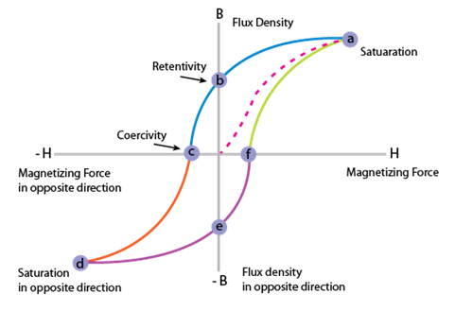

Figure 6: BH Curve Model

Each magnet material's B-H curve, also known as the hysteresis loop, serves as the foundation for magnet design. This graph depicts the cycling of a magnet in closed circuit as it subjected to an external magnetic field and brought to saturation, demagnetized, saturated in the other direction, and then demagnetized once again. The "Demagnetization Curve," or second quadrant of the B-H curve, depicts the circumstances in which permanent magnets are actually employed. If the size of the air-gap is maintained and all surrounding fields are kept constant, a permanent magnet will have a singular, static operating point. Otherwise, the working point will veer off the demagnetization curve; this behavior must be taken into consideration while designing the device.

The B-H curve's intersection with the B and H axes (at Br for residual induction and Hc for coercive force, respectively) and the point where the product of B and H is at its maximum are its three most significant features (BHmax - the maximum energy product). Br is a symbol for the maximum flux that a magnet may create in a closed circuit. Permanent magnets can only get close to this in practical application. Hc is a symbol for the point at which a magnet starts to lose its magnetic properties when it is exposed to an external magnetic field. The term "BHmax" designates the value of the product of B and H as well as the magnetic field's energy density into the air gap around the magnet.

The necessity for the magnet's volume decreases as the price of the product rises. The B-H curve's sensitivity to temperature should also be taken into account in designs. In the section headed "Permanent Magnet Stability," this effect is looked at in greater detail. When drawing a B-H curve, the flux density (B=/A) is calculated by taking the total flux in the magnet () and dividing it by the magnet pole area (A). The magnet's internal flux created by the magnetizing field (H) plus the inherent capacity of the magnet material to produce additional flux as a result of the domains' orientation make up the total flux. Therefore, the magnet's flux density has two parts: one equal to the applied H, and the other produced by the inherent flux-producing properties of ferromagnetic materials. When total flux B = H + Bi, or when Bi = B - H, the intrinsic flux density is denoted by the symbol Bi.

The magnet functions normally in the second quadrant, where H has a negative value, when there is no external magnetising field. Bi = B + H is the standard formula because, despite being strictly negative, H is frequently used to refer to a positive integer. Both a normal B-H curve and an intrinsic B-H curve can be plotted. The intrinsic coercive force (abbreviated Hci) is the force that exists when the intrinsic curve crosses the H axis. High Hci values indicate that the magnet material is naturally stable. Both the intrinsic curve and the normal curve may be derived from one another.The normal curve is adequate for design purposes when a magnet is operated statically without any external fields. The normal and intrinsic curves are used to assess how the material's intrinsic qualities vary in the presence of external fields.

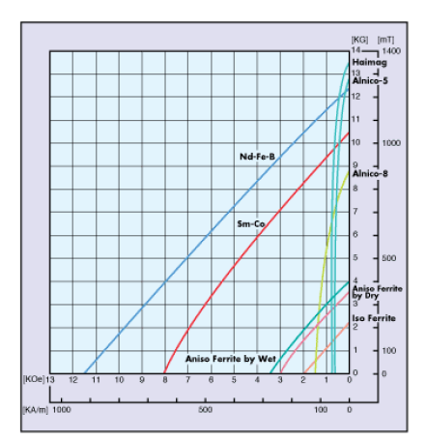

Figure 7: BH Curve of Commercial Permanent Magnet

Table 1: Magnetic Flux Density Comparison

|  |  |  |  |  |  |  |
| --- | --- | --- | --- | --- | --- | --- |
| **.Material** | **.Br** | **.Hc** | **.BHmax** | **.Tcoef of Br** | **. Tmax** | **. Tcurie** |
| **Nd-Fe-B** | **.**12800 | **.** 12300 | **.**40 | **.**-0.12 | **.** 150 | **.**310 |
| **Sm-Co** | **.** 10500 | **.** 9200 | **.**26 | **.**-0.04 | **.** 300 | **.**750 |
| **.Alnico** | **.**12500 | **.**640 | **.**5.5 | **.**-0.02 | **.**540 | **.**860 |
| **Ceramic** | **.**3900 | **.**3200 | **.**3.5 | **.**-0.20 | **.**300 | **.**460 |

From the BH Curve of Magnet materials it’s concluded that the Nd-Fe-B has a very attractive magnetic characteristic which offers better features like, it offers a high magnetic field flux density, provides high magnetic field strength in given condition and has the ability to resist demagnetization in extreme condition also. Hence decided to use the Neodymium Iron Boron (Nd-Fe-B), magnet

The magnetic characteristics such as repulsion of of like polarities of magnets can be used as an additional energy source and permanent magnets can be deployed to obtain these kinetic energy from the magnetic propelling phenomenon [5].

Depending on the manufacturing process, Nd-Fe-B magnet can be categorized as an sintered or bonded [8]. They have replaced other types of magnets in many applications in contemporary products that call for powerful permanent magnets, including hard disc drives, magnetic fasteners, and electric motors in cordless tools.

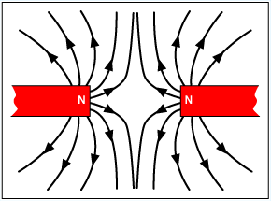

Figure 8a: Magnetic Repulsion Characteristic of same pole

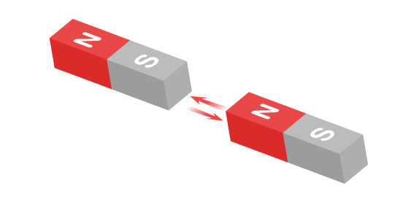

Figure 8b: Magnetic Attraction of Opposite Pole

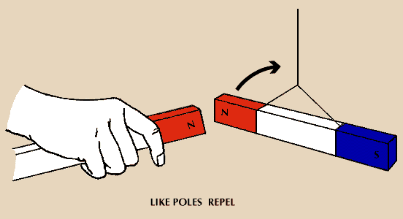

Figure 9: Linear Movement due to Kinetic Energy of Magnetic Repulsion to circular motion

Here, magnetic repulsion was created by exploitation of permanent magnets made from metal Neodymium-Iron-Born (Nd-Fe-B), that were organized with their similar polarities facing one another. Utilizing the mechanical energy created by the repulsion of magnets, while converting a wind mechanical energy to required form of an mechanical power.

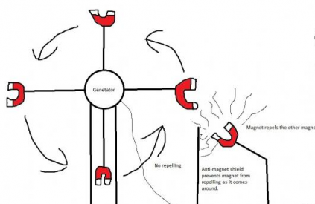

Figure 10: Linear motion of Magnetic Repulsion can be converted in to circular motion while converting wind energy in to mechanical energy.

The repulsive characteristics of magnets were enclosed during this study effort to feature some further kinetic power to achieve improved potency of rotary structure [8]. By sandwiching this repulsive feature between the structures mounted and rotary planes, magnetic repulsion could also be simply felt. Therefore, whereas, the force, which was created by the permanent magnet can add some sort of a reasonable kinetic power while, VAWT transforms the mechanical energy from wind into the required reasonably mechanical power.

# Validation Part of PM-VAWT

A multi-paradigm proprietary programming language and numerical computing environment were created by MathWorks under the name MATLAB (short for "MATrix LABoratory"). It is possible to manipulate matrices, visualise functions and data, apply algorithms, build user interfaces, and communicate with other programming languages using MATLAB.The MuPAD symbolic engine is used by an optional toolbox to provide access to symbolic computing capabilities, even though MATLAB is primarily designed for numeric computation. Simulink, a separate programme, enhances model-based design for dynamic and embedded systems and multi-domain graphical simulation. A programme named MATLAB, alongside with add-on options like Simulation and Linking, was created by the Mathwork Team. This programme allows users to model a system, simulate it, and then analyse it in an exceedingly dynamic setting with a graphical computer program. By choosing a choice from the choice box, the user could build a multi-domain dynamic system that is then planned and analyzed on graphs employing a changed library block's array and matrix operations. This is often why we tend to selected the MATLAB App models [5].

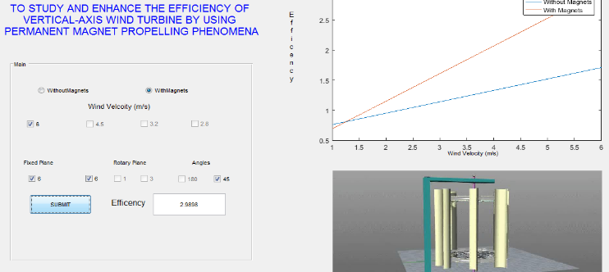

Figure 11: Validation work using MATLAB

# Experimental Analysis

In this state of affairs, the sweptwing front cross section area of turbine structures which is perpendicular to air density, air flow and wind speed can all be a proportional to general power of wind flow [8]. Additionally attainable to write down as follows:

PW = ρAV3

PW= Total Power in Wind (W/m2)

A = Rotary Turbine sweptwing area perpendicular to the air flow (m2) =0.173m2.

ρ= Density of air for given condition (kg/ m3)

V= Wind Speed Condition (m/sec)

Table2: Theoretical Calculation of Power available in Wind at Various Wind Speed Conditions.

|  |  |  |
| --- | --- | --- |
| **Sl. N** | **V= Avg. Wind Speed in m/sec** | **PW = ρAV3 W/m2** |
|  | .6.0 | i.22.54 |
|  | .4.50 | .9. 52 |
|  | .3.20 | .3. 4 |
|  | .2.80 | . .2. 28 |

## Mechanical Power (PT) is obtained from the rotary turbine system, is nothing but the operate of the tangentials forces ( F ) & rotary turbine movement speeds in rotation per minute (RPM) provide by Nr of the rotary shaft.

PTNrF

## Force (F) = Angular Acceleration X rotary Turbine Mass.

## Nr = Revolution/minutes of The Rotary Turbine

## Angular Acceleration = (acceleration / radius of the turbine) revolution /m2

## Total mass of the Turbine = 3.12 kg

Mechanical output powers PT is divided by the highest volume of total kinetic energy felt by the area of a particular wind turbine can be represented as power coefficient CP,

CP=

It’s observed a small obstruction to the turbine rotation, when magnets were placed in an orientation of 180 degree or parallel to each other on both rotary and fixed plane as shown in Figure 11. When like polarities magnets facing parallel to each other, magnetic field created by the permanent magnet will repel and will result in obstruction to the turbine rotation.

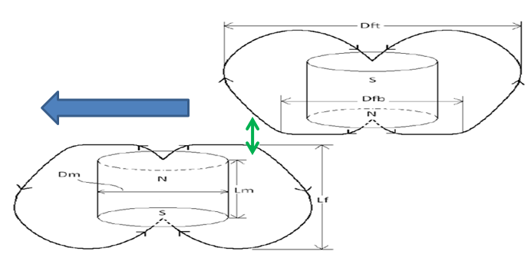

Figure 11: Magnets were placed parallel to each other.

Various orientation were checked for magnet placement to achieve magnetic repulsion of permanent magnets to add some sort of kinetic energy to the turbine while transforming the kinetic energies available in wind into the mechanical energy, challenge was to reduce the magnetic repulsion which adds some sort of resistance when rotary plane magnets coincides with fixed plane magnets while rotating.

These resistive repulsive force reduced by changing the magnets placement orientation to 45 Degree as shown in Figure 12. So that while coinciding the resistive force created by the repulsive force of magnets were less compared to repulsive force provided while departing the magnetic field. Resulting which add these repulsive force will some sort of kinetic energy while transforming wind K.E in to required form of mechanical energy.

The experiments were conducted to identify optimum orientation and position of magnet sets for various wind speeds condition.

Table 3: Experimental results for the best Orientation and position for placement of magnets in a PM-Propelled VAWT under various win speed conditions to achieve higher kinetic energy and smother operation.

|  |  |  |  |  |  |
| --- | --- | --- | --- | --- | --- |
| **S. No** | **Magnets Placement Orientation**. | .**Wind Speed in m/s** | .**Turbine RPM** | PTNrF | .**CP= PT/PW** |
| **Conventional - VAWT** | | | | | |
| 1.0 | Without Magnets | .6 | .88.00 | .385. 24 | .**17.08** |
| 2.0 | .4. 5 | .76.00 | .137. 00 | .**14.40** |
| 3.0 | .3. 2 | .72.00 | .37. 08 | .**10.84** |
| 4.0 | .2. 8 | .68.00 | .17. 51 | .**7.64** |
| **Permanent Magnet Propelled VAWT** | | | | | |
| 5.0 | Six magnets were arranged in a 180-degree angle, or parallel to one another. | .6 | .87.00 | .425. 67 | .**18.88** |
| 6.0 | .4. 5 | .79.00 | .162. 75 | .**17.11** |
| 7.0 | .3. 2 | .70.00 | .36. 05 | .**10.54** |
| 8.0 | .2. 8 | .61.00 | .15. 71 | .**6.85** |
| 9.0 | A stationary portion has 6 no permanent magnets placed into it, and a rotating part has 1 magnet positioned in a 180° orientation. | .6 | .89.00 | .389. 62 | .**17.28** |
| 10.0 | .4. 5 | .78.00 | . .140. 60 | .**14.78** |
| 11.0 | .3. 2 | .71.00 | 36. 57 | .**10.69** |
| 12.0 | .2. 8 | .66.00 | .17. 00 | .**7.42** |
| 13.0 | Three permanent magnets were positioned in the rotating component with a 180° orientation, & 6 PM were installed on the fixed part. | .6 | .92.00 | .426. 44 | .**18.91** |
| 14.0 | .4. 5 | .76.00 | .137. 00 | .**14.40** |
| 15.0 | .3. 2 | .70.00 | .18. 03 | .**5.27** |
| 16.0 | .2. 8 | .43.00 | .11. 07 | .**4.83** |
| 17.0 | One permanent magnet was placed in the rotating section at a 45° angle and six were installed on the fixed part in a 180° orientation. | .6 | .90.00 | .394. 00 | .**17.47** |
| 18.0 | .4. 5 | .82.00 | .147. 81 | .**15.54** |
| 19.0 | .3. 2 | .71.00 | .36. 57 | .**10.69** |
| 20.0 | .2. 8 | .65.00 | .16. 74 | .**7.30** |
| 21.0 | Three permanent magnets on the rotating component and six on the fixed part were each installed at a 45° angle. | .6 | .91.00 | .398. 37 | .**17.67** |
| 22.0 | .4. 5 | .78.00 | .160. 69 | .**16.89** |
| 23.0 | .3. 2 | .73.00 | .37. 60 | .**10.99** |
| 24.0 | .2. 8 | .70.00 | .18. 03 | .**7.87** |
| 25.0 | Three permanent magnets and six permanent magnets were placed in the rotating component at a 45-degree angle. | .6 | .94.00 | .435. 71 | .**19.32** |
| 26.0 | .4. 5 | .85.00 | .175. 11 | .**18.41** |
| 27.0 | .3. 2 | .73.00 | .56. 40 | .**16.49** |
| 28.0 | .2. 8 | .64.00 | .32. 96 | .**14.38** |
| 29.0 | The six magnet sets were positioned at a 45° angle. | .6 | .102.00 | .551. 59 | .**24.46** |
| 30.0 | .4. 5 | .82.00 | .211. 16 | .**22.20** |
| 31.0 | .3. 2 | .78.00 | .60. 26 | .**17.61** |
| 32.0 | .2. 8 | .71.00 | .36. 57 | .**15.96** |

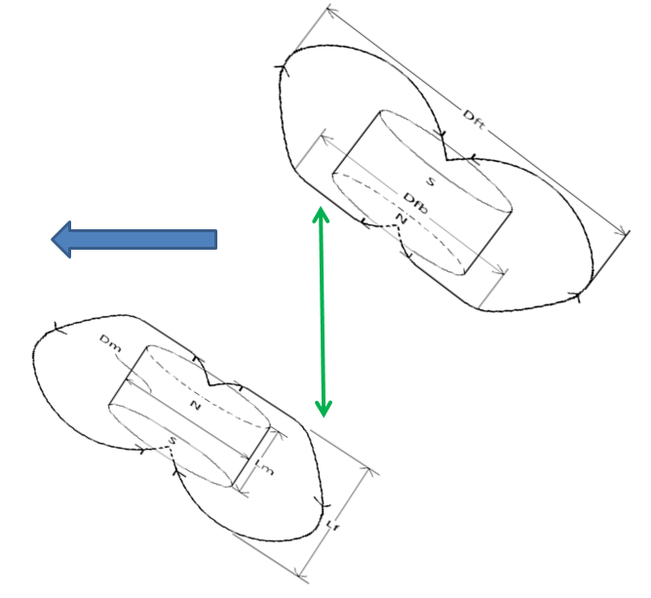

Figure 12: Else Resistive force created by magnetic repulsion for the turbine

Figure 12 demonstrates. The restive force produced by magnetic repulsive force will be smaller because of the 45 degree angle orientation, which increased the distance between the magnetic flux density produced by magnets of the same polarity when they were coincident.

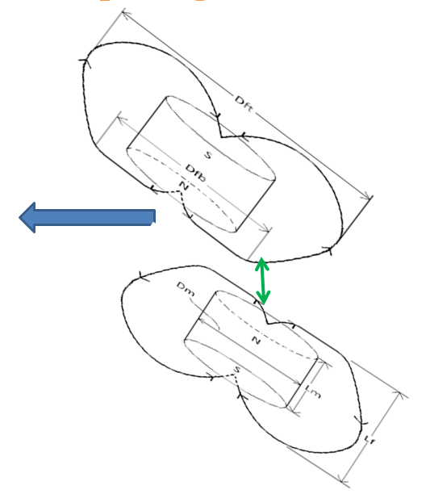

Figure 13: Else Resistive force created by magnetic repulsion for the turbine

According to figure 13, Due to the magnetic flux density produced by the same polarity magnets leaving the field being less separated due to the 45 degree orientation, there will be a greater restive force produced by the magnetic repulsive force. Thus, this will convert kinetic energies present in the wind into a mechanical energy while also adding some type of kinetic energy to the wind turbine.

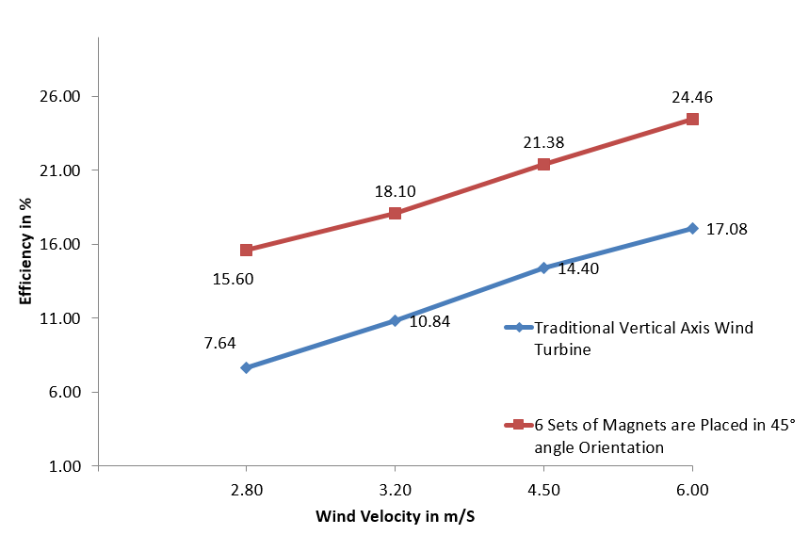

Graph 1: Conventional VAWT v/s PM - Propelled VAWT efficiency comparison graph

In this study, it was discovered that the rotating speed of the PM propelled- VAWT was higher than that of our Conventional VAWT. And although the Permanent magnet driven VAWT achieved an efficiency of 24.4 percent for the identical wind speed situation, compared to the conventional –VAWT which achieved only 17.08 percent efficiency.

# Findings and Discussion

Despite the fact that average wind speeds vary greatly from place to place, most locations of the world have the potential for considerable wind energy deployment. In fact the technological potential for wind energy is more than the worldwide power output. Strong winds may be found in many locations across the world, but often distant areas are the greatest for producing wind energy. Our energy needs may likely be met by wind energy. It is simple to run and has a lot of potential. Everything else will be provided for free as long as you build the turbine.

# Considering the information, we have determined that, magnetic characteristics specifically their capacity to repel & attract, were used as power banks. In this case, the force which was created by the magnets with opposite polarity was deployed to further energize the turbine while converting the kinetic energy stored in the form of wind into the required type of mechanical power. The kinetic energy that these winds created is known as wind energy. Other than the synchronization of solar and wind power, not much study was conducted utilizing hybrid power technology. Therefore, research and development were carried out to create a permanent magnet propelled vertical axis wind turbine by taking into account the magnetic propelling phenomena as a source of energy bank.

In this case, the force generated by the permanent magnets can contribute some form of dynamics power to the rotary blade construction while converting alternative energy to the required type of mechanical power [8].

In this performance study, it was discovered that the static magnet propelled-turbine VAWT's shaft rotational speed increased when compared to our conventional VAWT. The efficiency of conventional VAWT's is about 17.081 percent, but the static magnet propelled VAWT achieved a 24.466 percent efficiency for the same wind speed scenario. Additionally, for scenarios with lower wind speeds, potency was reported to have increased. Because of this, when static magnet dynamical properties are employed, it will function more powerfully under low wind conditions also. We believe that PM Propelled Wind Turbine is far more efficient than Hybrid concept of solar energy and wind energy for the aforementioned reasons.

# Conclusions.

# Renewable energy is derived from natural resources that regenerate more quickly than they are depleted. The sun and the wind are two examples of such continually replenishing sources. We may choose from a wide range of renewable energy sources. The creation of non-renewable fossil fuels like coal, oil, and gas, on the other hand, takes hundreds of millions of years. Carbon dioxide and other harmful greenhouse gases are released when fossil fuels are burned to produce energy. There is little doubt that the global power supply will need to expand substantially in the near future to keep up with the present growth in human living standards. At the same time, we are aware of the fundamental truth that wind is created as a result of the earth's surface being unevenly heated and its rotation, resulting in day and night with temperature differences. According to the temperature of the molecule, heated atmospheric air will so ascend at the equator and gradually expand toward the poles of the globe, resulting in wind.

It seems clear that using wind power as a long-term fix for the present energy problems facing the world may be viable. However, sustainability requirements have been assessed. As a result, even if the resource is valuable enough to sustain various commercial activities in its current technical condition, the realization of massive technological prospects may ultimately result in the resource being limitless.

# The kinetic energy that these winds created is known as wind energy. Other than the synchronization of solar and wind power, not much study was conducted utilizing hybrid power technology. Therefore, research and development were carried out to create a permanent magnet propelled vertical axis wind turbine by taking into account the magnetic propelling phenomena as a source of energy bank.

# Wind energy won't be in limited supply in the future due to climate change and global warming which helps in producing more kinetic energy in the form of wind. And by adding the fundamental characteristics of magnets, such as their attraction and repulsive forces, already appear improbable. The magnetic repulsion property increased our turbine's efficiency even in low wind speed constrains also. Hence there is a chance to contribute the world energy requirement with this hybrid energy concept of wind energy and magnetic characteristics.

##### REFERENCES

1. Gary L. Johnson “Wind Energy Systems”, Electronic Edition Manhattan, October 10, 2006, pp. 61-70-157
2. J. P. Hennessey, Jr., “Some aspects of wind power statistics, and performance analysis of a 6MWwind turbine-generator”. J. Appl. Meteorol., vol. 16, no. 2, pp. 119–28, Feb. 1997.
3. Er. Girt, K. M. Krishnan, G. Thomas, E. Girt, Z. Altounian, Coercivity limits and mechanism in nan composite Nd-Fe-B alloys, Journal of Magnetism and Magnetic Materials, 231 (2001) 219 – 230
4. A.D. Wright and L.J. Fingersh, Advanced Control Design for Wind Turbines: Part I, Design, Implementation, and Initial Tests. NREL /TP-500-42437, Golden, CO, National Renewable Energy Laboratory (2008).
5. Pallabazzer R. “Parametric analysis of wind siting efficiency”, J. Wind Eng Ind Aerodyn 2003; 91:1329-135
6. World Wind Energy Association (WWEA), "World wind energy report 2010", (April 2011).
7. N.Vaughn, “Renewable Energy & the Environment “, CRC Press, Ed. 2009 pp 63 -101
8. Robert W Whittlesey1, Sebastian Liska1 and John O Dabiri “Fish schooling as a basis for vertical axis wind turbine farm design”California Institute of Technology, Pasadena CA 91125, USA February 11, 2010 Page 1-10
9. Pradeep Bhatta, Michael A. Paluszek and Joseph B. Mueller “Individual Blade Pitch and Camber Control for Vertical Axis Wind Turbines” Princeton Satellite Systems, Inc., 33 Witherspoon Street, Princeton, NJ 08542, USA
10. Sevvel P, Santhosh P “Innovative Multi Directional Wind Turbine”International Journal of Innovative Research in Science, Engineering and Technology Volume 3, Special Issue 3, March 2014 page no 1237 to 1240
11. Castillo, Javier “Small-Scale Vertical Axis Wind Turbine Design” Bachelor’s Thesis Tampere University of Applied Sciences December 2011
12. N.Vaughn, “Renewable Energy & the Environment “, CRC Press, Ed. 2009 pp 63 -101
13. Gary L. Johnson “Wind Energy Systems”, Electronic Edition Manhattan, October 10, 2006, pp. 61-70-15
14. Er. Girt, K. M. Krishnan, G. Thomas, E. Girt, Z. Altounian, Coercivity limits and mechanism in nanocomposite Nd-Fe-B alloys, Journal of Magnetism and Magnetic Materials, 231 (2001) 219 – 230
15. J. P. Hennessey, Jr., “Some aspects of wind power statistics, and performance analysis of a 6MWwind turbine-generator”. J. Appl. Meteorol., vol. 16, no. 2, pp. 119–28, Feb. 1997.