A review on Pomegranate biology and Ethno medicinal application

Sutapa Mandal¹, Dipan Adhikari², Tuhin Ghosh^{1*}
¹Department of Chemistry (UG & PG), Durgapur Government College, Durgapur, Dist: Paschim Bardhaman, West Bengal-713214, India
²Department of Botany (UG & PG), Hooghly Mohsin College, Chinsurah, Hooghly, West Bengal-713427, India
*Corresponding author: tuhinghoshbuchem@gmail.com

ABSTRACT
The Pomegranate (Punica granatum) is a fruit that has been consumed to good effect since ancient time. The first report of this fruit was from Egypt just after the discovery of agriculture around 10,000 years back. The fruit pomegranate also has a Sanskrit name, which was reported from Indus Valley. Now, pomegranate is cultivated in subtropical and tropical areas in much-changing weather throughout the world. The pomegranate has charming biochemistry, and different classes of compounds found in it have been discussed in this study. Its importance lies mostly in its use as food, medicine and other important properties with its high consumption in food industry. In addition to the basic biology of the plant, the phytochemicals extracted from the different parts of it and their bioactivity has been briefly described in this study.

Keywords- Punica granatum L., Phytochemicals, Biotechnology, Antibacterial Effect, Ethnomedicinal use

INTRODUCTION
Pomegranate (Punica granatum L.) is rich in a number of bioactive compounds. There are so many phytochemical compounds with different biological properties present therefore it has been used as ethnomedicine. Pomegranate has a great food (as fruit juice) value. Excluding the seed, the fruit is eaten fresh and the juice is consumed by people all over everywhere. The fruit quantity of ~100 g provides 72 kcal energy, 1 g protein, 16.6 g carbohydrate, 1 mg Na, 379 mg K,13 mg Ca, 12 mg Mg, 0.7 mg Fe, 0.17 mg Cu,0.3 mg niacin, and 7 mg vitamin C (Grove and Grove, 2008). For its great nutritional value, it has achieved the title of “super-food”. Nowadays, studies on the antibacterial properties of different parts of plant extracts are of great interest. The scope of new findings from pomegranate fruit is promising mainly for its high nutritional benefits and ethno-medicinal purposes. There have been quite a number of reports related to extracts from pomegranate which are found to possess significant potential effects like antiviral, antifungal, antibacterial and other effects. The different parts of pomegranate fruits also possesses pharmacological, pharmaceutical and medicinal properties and the lead bio-active compound responsible for such specific anti-neoplastic, anti-diabetic, hypolipidemic, anti-diarrheal, vascular and digestive protection, anticancer, helminthic activity are flavonoids, triterpenenes, tannins, flavonoids, etc. The coloured skin of Pomegranate fruit are used as cosmetics due to its hardness. In Aslam et al. 2006, for instance, have described various pomegranate extract components that facilitate polar skin healing.

BIOLOGICAL GROWTH
The plants are small trees ~ 5–10m high, while some are small (1–2 m) with smooth stems and dark gray bark, the branches are sometimes spiny. The leaves are opposite to each other, simple, 2–8 cm long, glossy, and bright green, and flowers are terminal. The flower comes into this tree on the new branches of that year after one month of the bud breaking, on spurs or short branches in general. Flowers can come single, or in a cluster form. Three types of flowers can appear in a single tree at the same time. It is a very common one, long-styled perfect flower having larger ovaries set more fruit than short style types, short styles may be intermediate or male in nature. The ratio of the two types of flower changes from cultivar to cultivar. Fruits are generally globose in shape or to some extent simple flat, ~5–12 cm in diameter, the pericarp is smooth and the seeds have juicy arils around it, which may be consumed (Fig.-2).
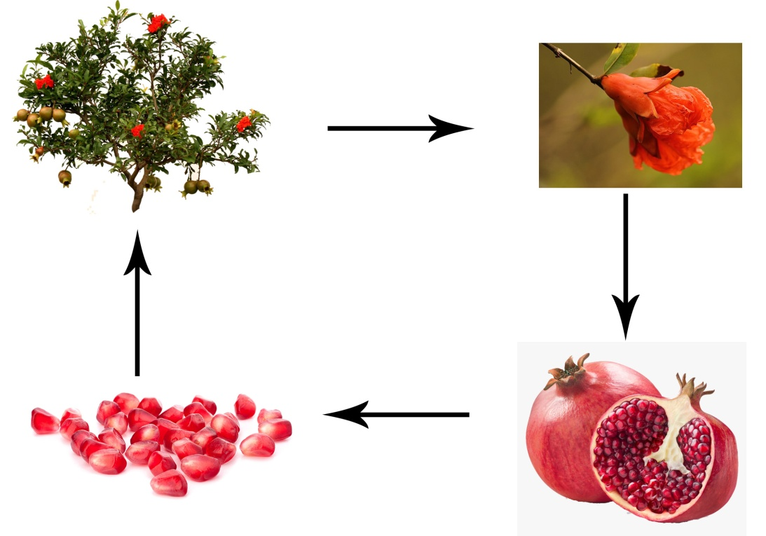

Fig.-2: Pictorial representation of the Pomegranate fruit cultivation.

PHYTOCHEMICALS
It contains chemical components such as phenols, ellagitannins, punicic acid, , tannins, flavonoids, anthocyanins, flavonoids, according to a variety of research findings (Table-1). Some of these have antimicrobial properties. Alkaloids are found in the leaves and bark, sterols, lignins and terpenoids are found in the seeds, leaves, bark, fatty acids and triglycerides are found in seed oil (Newman et al., 2007). The juice obtained from these arils contains ellagic acid glycosides, anthocyanins, gallotannins and ellagitannins. Ellagitannins are water-soluble (punicalagin), and small amounts of procyanidins (prodelphinidins and gallocatechin) and anthocyanins are found in the husk and fruit membrane. Delphinidin compounds are rarely seen, while pelargonidin and cyanidin derivatives can be found in juice and membranes. Pomegranates and pomegranate juice show different biological activity for the presence of antioxidant phenolic compounds. The investigation of biology, bioactivity, and metabolism of the pomegranate polyphenols is going on for better understanding of their significance in health betterment and medicinal use.

Table-1: Some phytochemicals extracted from pomegranate:

Sl. No. | Name | Chemical Formula | Plant Part
1 | (-)-Catechin | C15H14O6 | Fruit Juice
2 | Ellagic acid | C14H6O8 | Fruit, pericarp, bark
3 | Linolenic acid | C18H30O2 | Seed oil
4 | Punicic acid | C18H30O2 | Seed oil
5 | Testosterone | C19H28O2 | Seed oil
6 | Sedridine | C8H17NO | Bark
7 | Chlorogenic acid | C16H18O9 | Fruit Juice

APPLICATION
ANTIBACTERIAL ACTIVITY
From different research reports, this fruit consists of several chemical components that show antioxidant capacity. The antibacterial activity is usually depicted by the tannin-rich phenolic acids and ellagitannins components of pomegranate fruit. It has been reported that among all the chemical compounds present in pomegranate phenolics, the gallic acid component was the most common and active towards bacteria. The fruit showed rich content of tannins (25%) and secondary metabolites are the reason behind the antibacterial activity. It contains another chemical constituent Carvacrol methyl ether, thymol that has an antimicrobial effect. This effect could be explained by secondary metabolites. It has also been reported that the antibiotic activity of some substances (oxacillin, chloramphenicol, ampicillin, gentamicin and tetracycline) is increased in presence of pomegranate extract. The extract from Pomegranate peels showed a promising antibacterial effect in comparison to the extract from seeds.

ANTI-CARCINOGENIC EFFECT
It has been reported that the oil from Pomegranate seed (PGO) are reported for their inhibition of colon cancer when tested in rats. The majority of colon cancer cases are in western nations, although conjugated linolenic acid consumption may have a protective influence on colon carcinogenesis. There is a considerable amount of punicic acid, c9,t11, and c13-conjugated linolenic acid (CLN) in pomegranate seed oil. In a report, Kohno et al. explained that oral administration of PGO rich in c9,t11, and c13-CLN, even at very low dosage of 0.1% CLN, restricts the azoxymethane-induced colonic denocarcinoma development in rats significantly but does not cause any adverse effects.
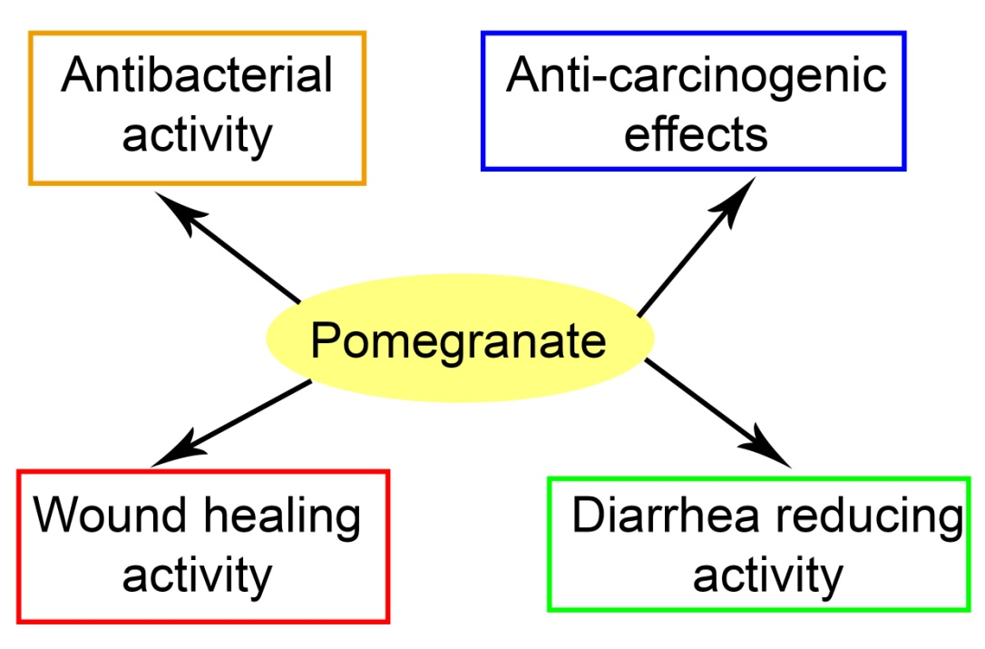

Fig.-1: Some applications of Pomegranate fruit.
POMEGRANATE SEED EXTRACT TO REDUCE DIARRHEA
Gastrointestinal motility could be inhibited by a methanolic extract from pomegranate seeds. It has been reported that the tannins present in the extract are that phytochemicals which are responsible for this activity. Tannins react with the proteins present and form tannates, which cause denaturation of the original protein. In this way, the secretions from the intestinal mucosa is being reduced.

WOUND HEALING ACTIVITY
Pomegranate peel extract exhibited good healing activity, with a very faster rate. It has been described that the healing power is due to the presence of polyphenol in the methanolic extract. The polyphenols can interact with the proteins and are able to precipitate them, and thus the wound healing process occurs through pomegranate peel extract.

CONCLUSION
This study includes biological growth, and a brief discussion on the phytochemicals present in different parts of pomegranate (peels, seeds, barks, etc). It contains a number of chemical constituents that have been used as medicine from ancient history. This report also aims to discuss the activities of different extracts of pomegranate.

REFERENCES
1. Vaya, J. and Aviram, M., Nutritional antioxidants: mechanisms of action, analyses of activities and medical applications, Curr. Med. Chem. Imm. Endoc. Metab. Agents, 1, 99, 2001.
2. Pomegranate Ancient root to modern medicine Edited by Navindra P.Seeram, Risa N Schulman and David Haber
3. Yaser Nozohour, Reza Golmohammadi, Reza Mirnejad, Majid Fartashvand Antibacterial Activity of Pomegranate (Punica granatum L.) Seed and Peel Alcoholic Extracts on Staphylococcus aureus and Pseudomonas aeruginosa Isolated From Health Centers J Appl Biotechnol Rep. 2018, 5(1): 32-36
4. H., Rezaei, K., Rashidi, L., 2008. Extraction of essential oils from the seeds of pomegranate using organic solvents and supercritical CO₂. J. Am. Oil Chem. Soc.85, 83–89.
5. Abd-Rabou, S., Simmons, A.M., 2010. Augmentation and evaluation of a parasitoid, Encarsiainaron, and a predator, Clitostethus arcuatus, for biological control of the pomegranate whitefly, Siphoninus phillyreae. Arch. Phytopathol. Plant Prot. 43, 1318–1334.
6. Jaime A., Teixeira da Silva, Tikam Singh Rana, Diganta Narzary, Nidhi Verma, Deodas Tarachand Meshram, Shirish A. Ranade, Pomegranate biology, and biotechnology: A review, 2013 Elsevier
7. Halvorsen, B.L. et al., A systematic screening of total antioxidants in dietary plants, J. Nutr., 132, 461, 2002.
8. Kelawala, N.S. and Ananthanrayan, L., 2004 Antioxidant activity of selected foodstuffs, Inter. J. Food and Nut., 55, 511.
9. Chu, Y.F., and Liu, R.H., 2004 Novel low-density lipoprotein (LDL) oxidation model: antioxidant capacity for the inhibition of LDL oxidation, J. Agric. Food. Chem., 52, 6818.
10. Burton, G.W., Joyce, A., and Ingold, K.U., 1983 Is vitamin E the only lipid-soluble, chain breaking antioxidant in human blood plasma and erythrocyte membranes?, Arch. Biochem. Biophys., 221, 281.
11. Klouche, K. et al., 2004 Mechanism of in-vitro heme-induced LDL oxidation: effects of antioxidants, Eur. J. Clin. Invest., 34, 619.
12. Maor, I. et al., 1997 Plasma LDL oxidation leads to its aggregation in atherosclerotic apolipoprotein E-deficient mice, Arterioscler. Thromb. Vasc. Biol., 17, 2995.

