THE SEED BORN MICROFLORA OF LEGUMINOUS PLANTS SEEDS OF
Arachis hypogea, Vigna mungo, Vigna radiate AND Pisum sativum

EUGIN AMALA.V., KEERTHANA.V¹. VINOTHINI.C¹. PRIYADHARSHINI.R¹.
DHIVYA.M.¹
Assistant professor and Head, PG &Research Department of Microbiology,

IdhayaCollege for Women ,Kumbakonam.

KEERTHANA.V¹. VINOTHINI.C¹. PRIYADHARSHINI.R¹.
DHIVYA.M.¹ B,SC, Students, PG &Research Department of Microbiology,

IdhayaCollege for Women, Kumbakonam.

*Corresponding Author. amalaeugin@gmail.com

ABSTRACT
The present work carried out on The seed born microflora of leguminous plants seeds of Arachis hypogea, Vigna mungo, Vigna radiate andb Pisum sativum. The percentage of fungal population on different leguminous seeds by deep freezing blotter method showed variation in number of fungal species and the most dominant species was Aspergillus.In Rolled paper towel method, The growth of seed borne fungi in different leguminous crops were treated with fungicides. Among the three fungicide contaf is very effective and completely checked the colonization of fungal population on the above-mentioned seeds.Different concentration of leaf extracts of three important medicinal plants such as Adarhoda vasica, Azadirachta indica and Vitex negundo were amended with PDA medium. The growth of fungal population was very much reduced in amendment method than dipped seed method.

INTRODUCTION

Seed is a basic input in modem agriculture. It has been an important agricultural commodity since the first crop-plant being domesticated. A farmer’s entire crop depends on the quality of the seed. Therefore, it is necessary to plant good quality seed (Agarwal, 2002). Whereas saprophytic fungi are not specific to any particular host and are found on seeds of different plants the pathogenic fungi are normally confined to a limited host range. Both types may occur on the seed surface, in cracks or inside the seed coat, but pathogenic fungi can also occur within the seed tissue. Seeds infected with pathogenic fungi may not germinate normally and may provide inoculum for further spread of disease, causing a reduction in yield and quality.Fungi cause the largest number of plant diseases and occur more commonly in or on the seeds than bacteria or viruses. More than 8000 species of fungi have been identified as plant pathogens. Whereas saprophytic fungi are not specific to any particular host and are found on seeds of different plants the pathogenic fungi are normally confined to a limited host range. Both types may occur on the seed surface, in cracks or inside the seed coat, but pathogenic fungi can also occur within the seed tissue. Seeds infected with pathogenic fungi may not germinate normally and may provide inoculum for further spread of disease, causing a reduction in yield and quality.seed treatment is not desirable from health view point and use of certain part harvest fungicides have also led to the development of fungicide resistant strains of the fungal pathogen. Therefore, the use of natural plant products (extracts) towards the control of growth and activity of seed borne pathogens and in the management of disease has often been emphasized. Among the various plants, which have such property neem is considered as the most important which has been used in the traditional agricultural practices. Keeping the above mention points in mind, the present investigation has been justifiably planned to study seed borne fungi which cause serious diseases during a particular season in legume crops (A. hypogea, p. sativum, V. mungo, V. radiata). Detection of seed borne fungi through various methods, such as Blotter method, Agar Plate Method, Deep Freezing Blotter Method, Rolled Paper Towel Method, effect of different fungicides on seeds to check the growth of fungi and Effect of plant extracts on the growth of seed borne fungi of legumes towards the control of diseases.

MATERIALS AND METHODS
Site of Collection:

The plant seeds were directly collected from various Formers and various Places. Arachis hypogea seeds collected from Jayamkondam. Pisum sativum, vigna mungo and vigna radiata collected from agricultural field

Detection of seed borne fungi by incubation method Blotter method
Petri plates of 9 cm diameter are used in the test. Petri plate are dipped in sterilized water and placed in the petri plate after dipping off extra water. Untreated seeds are plated at equal distance in each petri plate and upper lid of the plates were closed. The sample number, data and dish number were properly mentioned on the cover with the help of ball pen. Then the plates were kept in the incubation chamber at 28 ± 1°C ‘this cycle of 12 hours light and 12 hours darkness. After 8 days of incubation, the seeds were examined under the binocular microscope. Outer ring of the seeds was examined first, then the seeds of the second ring and finally the seeds in the center of the plate. Cultural characteristic features of fungi were noted. Slides were prepared for each and individual species of fungi and examined under the microscope. Percentage of infection of the individual fungal species-was recorded by using formula.

Number of seeds infection = Percentage of infection = x 100

Total number of seeds

3.2.3. Deep freezing blotter method (Jha, 1987)

Seeds were taken at random and were plated on moist blotters as foliws the method in the previous reaction 3.2.2. The plates were incubated in incubation chamber at 28 ± 1°C for 24 hours. After 24 hours the plates were transferred in deep freezer at -20°C for another 24 hours. After incubation, the plates were exposed to light and darkness for 12 hours at 28°C for 5 days. Then the seeds were examined on 8th day. Growth charlatanistic features of fungi as well as the percentage of inhibitions were recorded.

3.244. Rolled Paper Towel Method (Jha, 1987)

Damp chambers were prepared in enamel trays. The trays were thoroughly washed with distilled water and sterilized with alcohol. The size of 25 x 18 cm three layers of sterilized filter paper sheets was taken. Sample number, and date was mentioned with the help of marker pen on each tray. The filter sheets were dipped in sterilized distilled waters with the help of forceps. To remove the excess amount of water, the sheets were kept in vertical position. The seeds were selected at randomly and placed in an appropriate manner with equal distance. Then the frays were covered with polythene sheets and made pin hole for aeration. Trays were kept in a vertical or horizontal position and allowed to incubation. After 8 days of incubation sheets were folded along one edge and then carefully rolled without any movement (or) disturbances to the seeds. The rolled paper was kept horizontally or vertically and the results were recorded.
The organisms that grew from the seeds were observed under the microscope after staining with lactophenol and cotton blue. The fungi were identified by using standard manuals, such as manual of soil fungi (Oilman, 1957), Dematiaceous Hypomycetes-1 (Ellis, 1960), Deniatiaceous hypomycetes..v (Ellis, 1963), Dematiaceous hypomycetes VI (Ellis, 1965), Dematiaceous hypomycetes-VII (Elllis, 1966), Dematiaceous hyponlycetes CMI (Ellis, 1971), More Dematiaceous oxnyceteS CMI (Ellis, 1976) and Hypomycetes (Subramanian, 1971).

3.2.5 Effect of some fungicides on seed borne fungi (Jha, 1987)

Different concentration of fungicides (15, 25 and 50 ppm) were separately for their flingicidal activity against seed borne fungi. The seeds were separately dipped in different concentration of fungicides and placed in Petri plates containing potato dextrose agar medium in equal distance. The plates were incubated at 28 ± 1°C for 5 days. Growth of fungal organism was obsetted and the results were recorded. Control was, tit & n without dipping seeds in fungicide.

3.2.6. Effect of plant extracts on seed borne fungi

2.3.6.1. Astendmeiit of extracts on P.D.A. medium

Crude extracts of some important plants were tested separately for their fungi toxicity against seed borne fungi by food poisoning technique of Grover and Moore (1962). The crude extracts of Adathoda vasica, Azardirachta rndica and Vitex negundo was added separately to the cooled potato dextrose agar medium. The amended medium was dispersed in petri plates and allowed to solidify. After solidification the seeds were randomly selected and placed in PDA at equal distance. The plate was incubated at 28 ± 1°C for 5 days. After incubation the seeds wereexamined under the microscope. Presence or absence of fungal species were noted and recorded. Slides were prepared by using LCB and micro photographs were taken.

3.2.6.2. Seeds dipped in plant extracts

FDA medium was prepared as described in the previous paragraph

      - The seeds were randomly selected and dipped in 100 per cent crude extracts of Adathoda vasica, Azardirachta indica and Vitex negundo. They were placed in equal distance in petri plates containing PDA medium. The plates were incubated at 28 ± 1°C for 5 days. After incubation, the seeds were examined and the results were recorded and microphotographs were taken

RESULTS

  - Detection of seed borne fungi by incubation method
    - Blotter method

It is clear that irrespective of detection of seed borne fungi, the incidence of the presence of fungal. infestation was nearly present in 49 seeds out of 75 seeds in Arachis hypogea and percentage of infection was 69.3 per cent. Amongst the pathogens Aspergillus spp. caused significantly more incidence than other fungal organisms. In Pisum sativum among 75 seeds, 12 seeds alone infected and Aspergillus spp. and the percentage of infection was only 18 per cent. In Vigna mungo 29 seeds were infected out 100 seeds and the percentage of infection was 31 per cent similarly in V,radiata only 18 seeds were infected by fungal organism out of 100 seeds and the percentage infection was 19% Aspergillus spp was more dominant
in all the four leguminous seeds followed by Fusarium sp., Sterile mycelium, C pallescens and R. nigricans (Fig C, Table I and Fig.l).

    - Agar Plate method

In this method, it was clearly noted that irrespective of total number of seeds, the infection percentage of seeds by fugal pathogens were significant. Amongst the pathogens Aspergillus spp was in predominant all the four leguminous seeds (A. hypogea, P. sativum, V.mungo, V. radiata). Percentage of infection in treated seeds viz. A. hypogea (30%), P. sativum (15%), V. mungo (12%) and V radiata (28%) percentage of infection in untreated seeds viz. A. hypogea (45%), P. sativum (25%), V. mungo (32%) and V. radiata (27%). Percentage of infection was more in treated than untreated seeds (Fig D, Table 2 and fig.2).

    - Deep freezing blotter method

The results revealed that the percentage of infection was more in seeds Arachis hypogea i.e. 48.3 per cent followed by Vigna mungo (36%), V. radiata 32% and very poor inhibition in P. sativum (6.3%). Totally 75 seeds were taken for both
A. hypogea and P. sativum whereas 100 seeds for V. mungo and V. radiata because the seeds were selected based on their size. The most dominant species was Aspergillus spp. followed by Penicillium decumbens, Fusarium chamydosporum and sterile mycelium (Fig E, Table 3 and fig.3)

    - Roller paper towel method

The results revealed that 98 per cent of infection was noticed in A. hypogea and totally no seedling formation was observed. The fungal found in these
seeds were A. niger, Penicillium sp. and F. signitiforme, whereas 46 per cent of infection in P. sativum, 41 per cent in mungo and poor percentage of infection was observed in V. radiata (25%). Aspergillus was the dominant species followed by sterile mycelium (Fig F, Table 4 and Fig.4).

    - Effect of some fungicides on seed borne fungi

The growth of seed borne fungal organisms was completely 100 appressed in 100 per cent control in all the four plant seeds tested viz. V. radiata A. hypogea, V mungo and P. sativum. Different concentration of fungicides (15, 25 and 50%) were tested against above mentioned four plant seeds. Bavistin (65.5, 32.3 and 25.6%) and Trust (14, 22 and 6.8%), for A.Hypogea Bavistin (100, 34.3 and 21%),
Trust (14.2, 23 and 6.2%) for P.sativum Bavistin (66.6, 33.3 and 20.0%), and Trust

(66%), for V.mungo Bavistin (68,34 and 32.3%) and Trust (13,6.8 and 6.4%) for V. radiata (Fig G, Table 5 and Fig.5).

4.1.6 Effect of plant extracts on seed borne fungi

The percentage of inhibition of fungal species was comparatively more in extracts dipped seeds than seeds placed in extracts amended medium. Infection percentage of Arachis hypogea seeds amended in Adathoda vasica (33.3%), Azardirachta indica (33.3%) and Vitex negundo (33.3). In P. sativum seeds dipped in extract of Adathoda vasica is (33.3%), Azardirachta indica (20.1%) and Vitex negundo (26.6%). V mungo seeds dipped in Adathoda vasica was 60.0 per cent, Azardiracha indica (45.0%) and Vitex negundo (50.0%), V. radiata seeds in Adczthoda vasica is 60.0 per cent, Azardirachta indica (45.0%) and vitex negundo (50.0%) (Fig H, Table 6, 7 and Fig.6).
The percentage of associated fungi were recorded and shown in table 8. Fungal isolates gave higher frequency on contaminated seed samples of Arachis hypogea followed by V. mungo, V. radiata and P. sativum (Table 8).

Fig - A
SITE OF COLLECTION

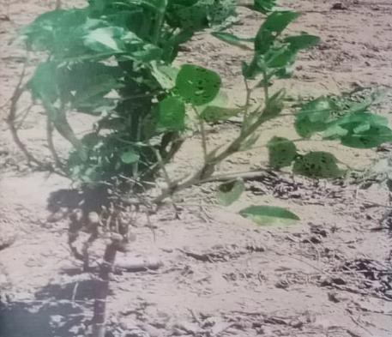
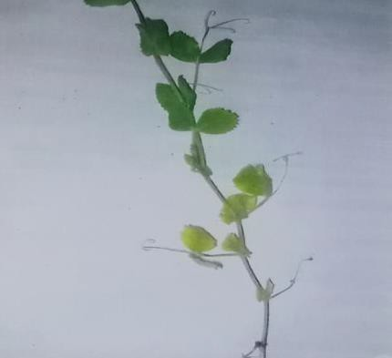

a) Arachis hypogea b) Pisum sativum

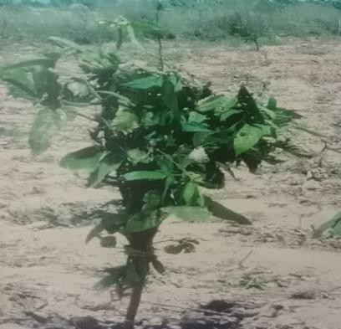
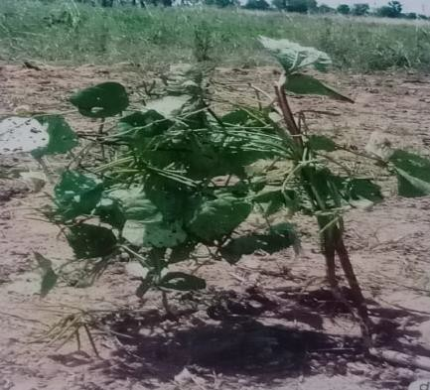

c) Vigna mungo d) Vigna radiata

Fig – B
COLLECTED SAMPLE

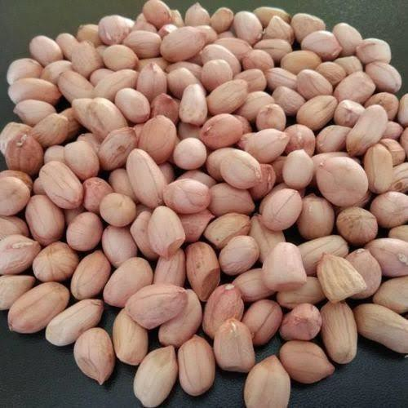
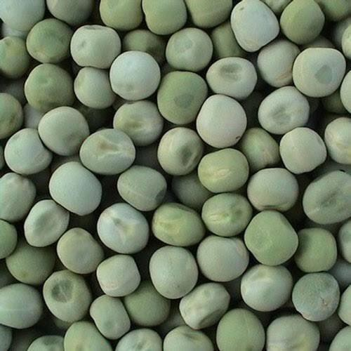

a) Arachis hypogea b) Pisum sativum

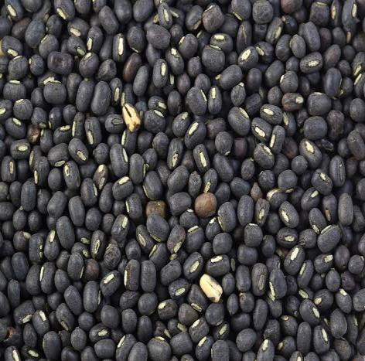
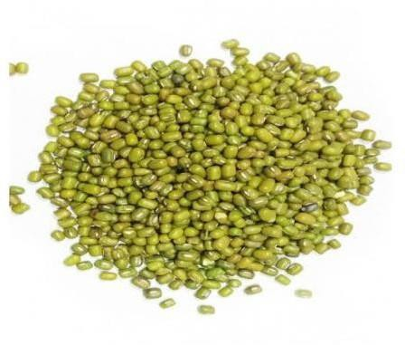

c) Vigna mungo d) Vigna radiata
Fig – C

Detection of Seed Borne Fungi from Different Leguminous Plant Seeds by BLOTTER METHOD
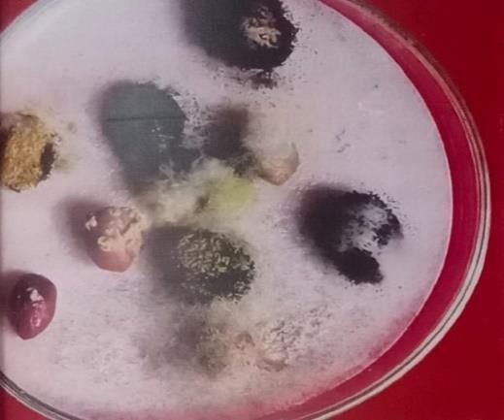
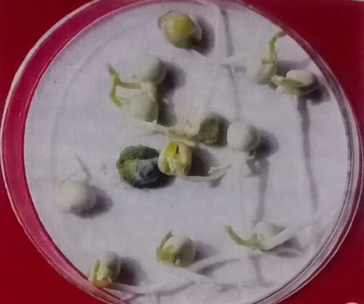

a) Arachis hypogea b) Pisum sativum

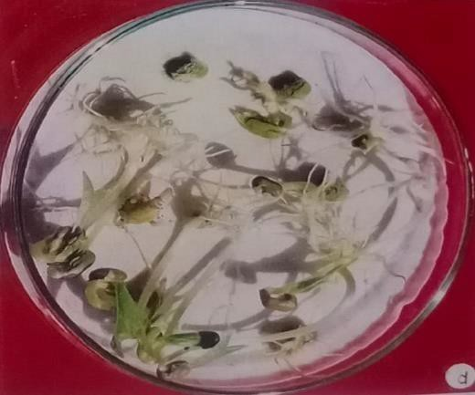
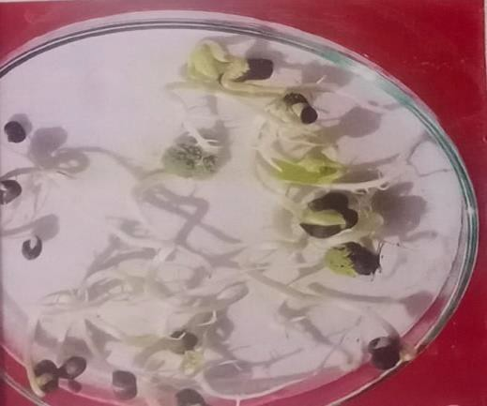

c) Vigna mungo d) Vigna radiata

Fig – D.1.

Detection of Seed Borne Fungi from Different Leguminous Plant Seeds by AGAR PLATE METHOD
(Treated with 0.1% mercuric Chloride)

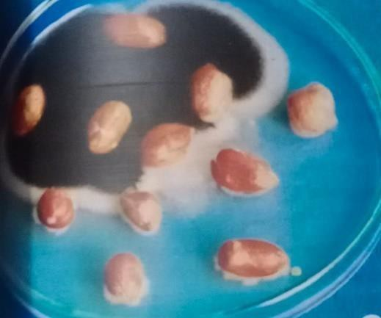
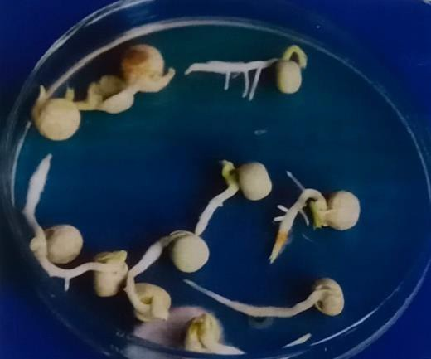

a) Arachis hypogea b) Pisum sativum

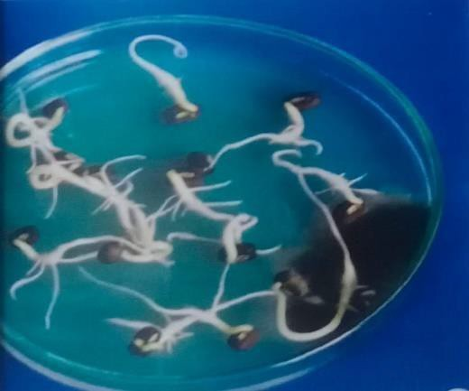
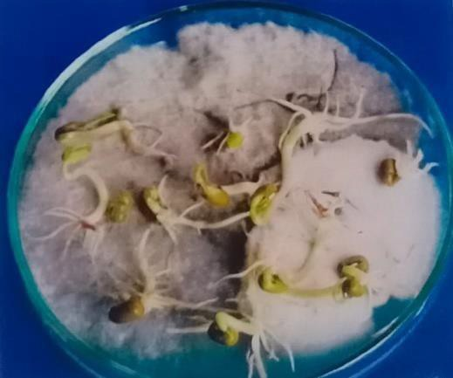

c) Vigna mungo d) Vigna radiata

Fig - D.2.

Detection of Seed Borne Fungi from Different Leguminous Plant Seeds by AGAR PLATE METHOD
(Untreated)

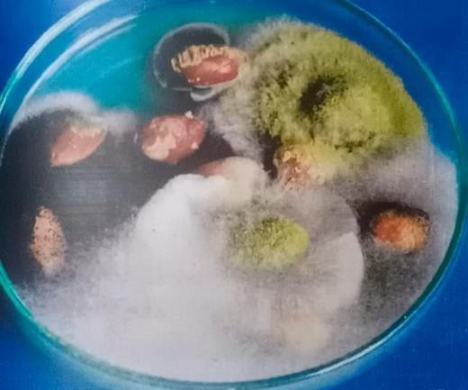
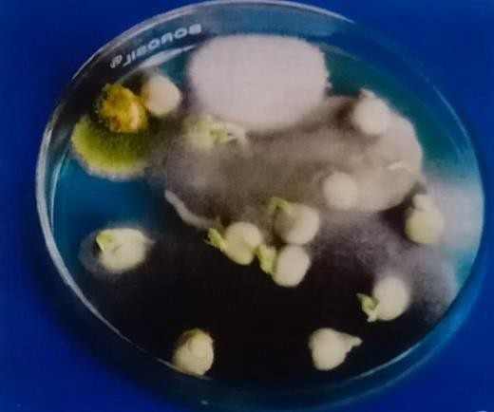

a) Arachis hypogea b) Pisum sativum

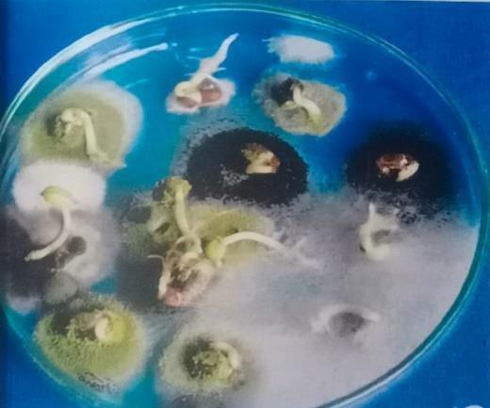
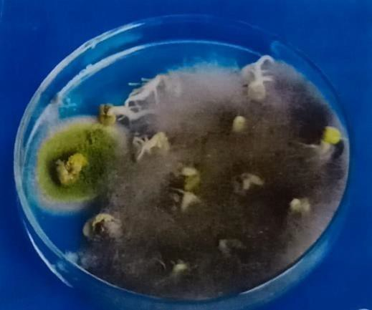

c) Vigna mungo d) Vigna radiata
Fig – E

Detection of Seed Borne Fungi from Different Leguminous Plant Seeds by DEEP FREEZING BLOTTER METHOD

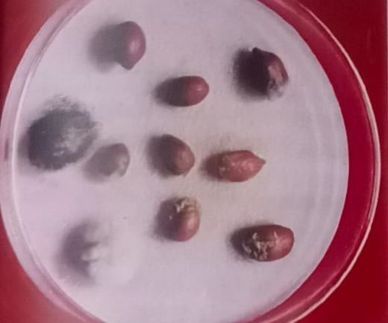
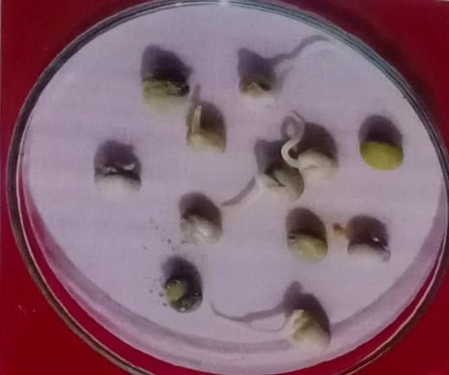

a) Arachis hypogea b) Pisum sativum

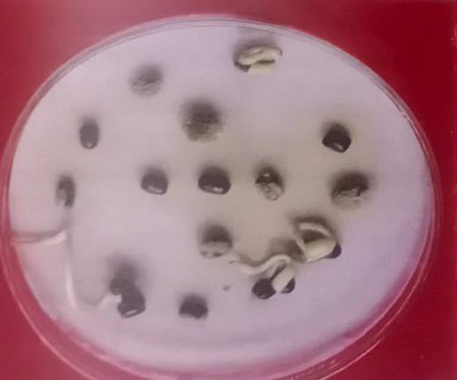
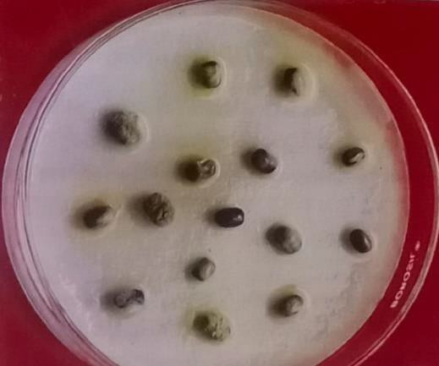

- Vigna mungo d) Vigna radiata

Fig – F.1.

Detection of Seed Borne Fungi from Different Leguminous Plant Seeds by ROLLED PAPER TOWEL METHOD

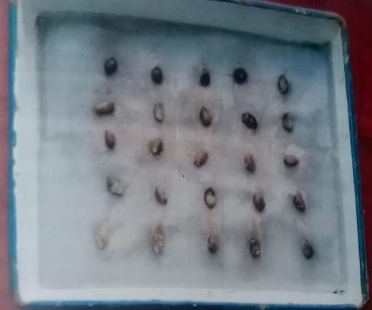

  - Arachis hypogea
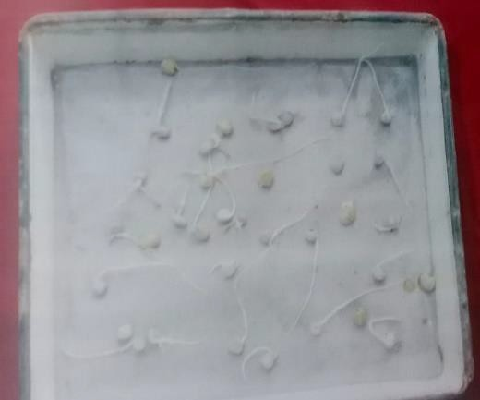

  - Pisum sativum

Fig – F.2.

Detection of Seed Borne Fungi from Different Leguminous Plant Seeds by ROLLED PAPER TOWEL METHOD
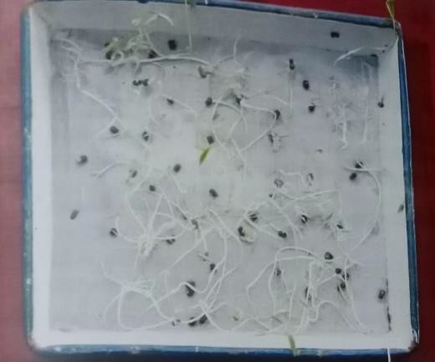

  - Vigna mungo

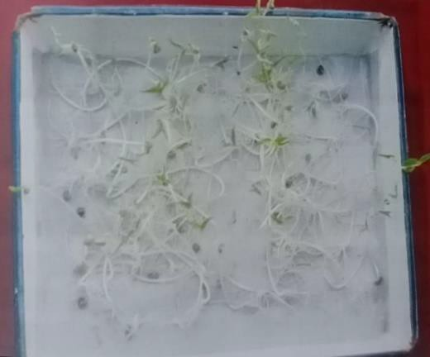

  - Vigna radiata
Fig – G.1.

Effect of Some Fungicides on The Growth of Seed Borne Fungi
- Bavistin Treated seeds (15%)
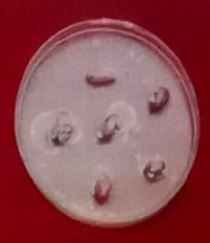
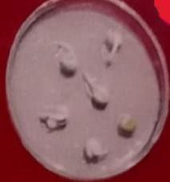

a) Arachis hypogea b) Pisum sativum
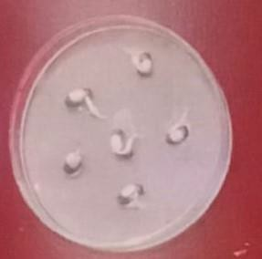

c) Vigna mungo d) Vigna radiata

- Bavistin Treated seeds (25%)
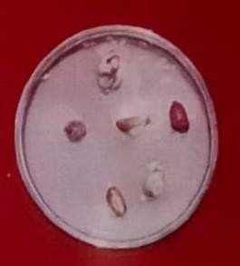
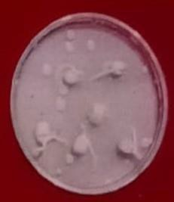

a) Arachis hypogea b) Pisum sativum
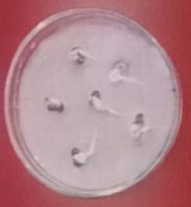
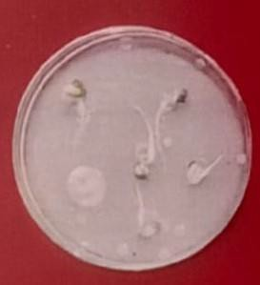

c) Vigna mungo d) Vigna radiata
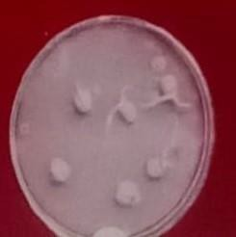
- Bavistin Treated seeds (50%)

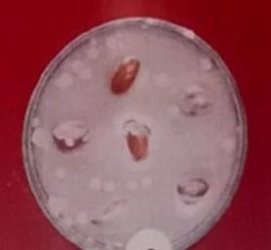

a) Arachis hypogea b) Pisum sativum

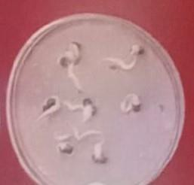
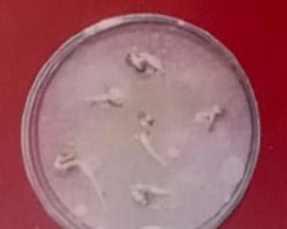

- Vigna mungo d) Vigna radiata
Fig – G.2.
Effect of Some Fungicides on The Growth of Seed Borne Fungi
  - Confaf Treated Seeds (15%)
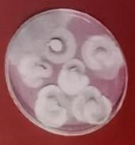

a) Arachis hypogea b) Pisum sativum

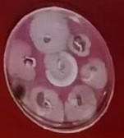
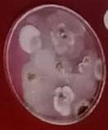

c) Vigna mungo d) Vigna radiata

  - Confaf Treated Seeds (25%)
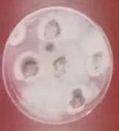
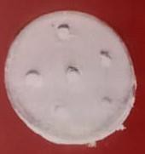

a) Arachis hypogea b) Pisum sativum

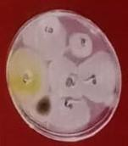
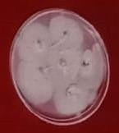

c) Vigna mungo d) Vigna radiata
  - Confaf Treated Seeds (50%)

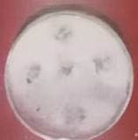
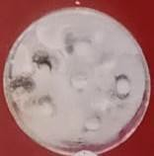

a) Arachis hypogea b) Pisum sativum

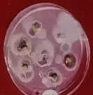
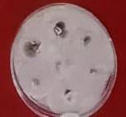

- Vigna mungo d) Vigna radiata

Fig G.3.
Effect of Some Fungicides on The Growth of Seed Borne Fungi
  - rust Treated Seeds (15%)
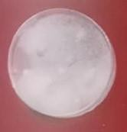
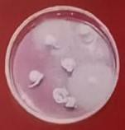

a) Arachis hypogea b) Pisum sativum

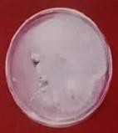
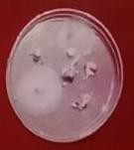

c) Vigna mungo d) Vigna radiata

  - Trust Treated Seeds (25%)
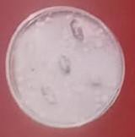
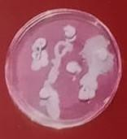

a) Arachis hypogea b) Pisum sativum

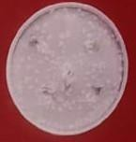
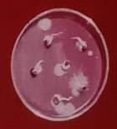

c) Vigna mungo d) Vigna radiata

  - Trust Treated Seeds (50%)

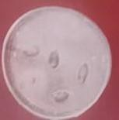
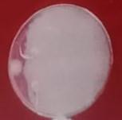

a) Arachis hypogea b) Pisum sativum

Fig H.1.

Effect of Plant Extracts on The Growth of Seed Borne Fungi Amendment Method
  - Adathoda vasica

a) Arachis hypogea b) Pisum sativum

c) Vigna mungo d) Vigna radiata

  - Azadirachta indica

a) Arachis hypogea b) Pisum sativum

c) Vigna mungo d) Vigna radiata

  - Vitex negundo

a) Arachis hypogea b) Pisum sativum

- Vigna mungo d) Vigna radiata

Fig H.2.

Effect of Plant Extracts on The Growth of Seed Borne Fungi Dipped Method
  - Adathoda vasica

a) Arachis hypogea b) Pisum sativum

c) Vigna mungo d) Vigna radiata

a) Arachis hypogea b) Pisum sativum

c) Vigna mungo d) Vigna radiata

  - Vitex negundo

a) Arachis hypogea b) Pisum sativum

c) Vigna mungo d) Vigna radiata

SUMMARY
The percentage of fungal population on different leguminous seeds by deep freezing blotter method showed variation in number of fungal species and the most dominant species was Aspergillus.In Rolled paper towel method, 100 per cent of infection was observed in A. hypogea seed. Aspergillus, Penicillium and Fusarium were found more in number than other legumes seeds and also showed poor percentage of infection.The growth of seed borne fungi in different leguminous crops were treated with fungicides. Among the three fungicide contaf is very effective and completely checked the colonization of fungal population on the above-mentioned seeds.Different concentration of leaf extracts of three important medicinal plants such as Adarhoda vasica, Azadirachta indica and Vitex negundo were amended with PDA medium.

REFERENCES

- Agarwal, P.K., 2002. Principles of Seed Technology. ICAR, Pusa, New Delhi, pp.16-19.Induced in amendment method than dipped seed method.

- Jha, K.D., 1987. Laboratory Manual on Seed Pathology, Vikas Publishing House Private Limited, Ranchi (Bihar), pp.1-101.
- Ellis, M.B., 1960. Dematiaceous hyphomycetes. I. MycoL Pap., 76: 1-36.
- Ellis, M.B., 1963. Dematiaceous hyphomycetes. V. MycoL Pap., 93: 1-33.
- Ellis, M.B., 1965. Dematiaceous hyphomycetes. VI. Mycol. Pap., 103: 4-46.
- E1lis M.B., 1966. Dematiaceous hyphomycetes. VII. Curvularia brachysperiurn Mycol. Pap., 106: 1-57.
- Ellis, MB, 1971. Dematiaceous Hyphomycetes. CMI.
- Ellis, M.B., 1976. Dematiaceous Hyphomycetes. CMI, pp.507.

