Analysis of Atmospheric Parameters using Remote sensing and ArcGIS

Yogesh Pratap, Yogesh Kumar Goswami, Kumar Shanu, Sanjeev Sharma*, Inderpreet Kaur, Hari Kumar Singh
Department of Electronics and Communication Engineering,
F.E.T, MJP Rohilkhand University, Bareilly
*R. D. Engineering College, Ghaziabad
harsdik@gmail.com
valiant.yogesh@gmail.com
yk460723@gmail.com
kumarshanu.ec@gmail.com

ABSTRACT
In the present day, majority of the world's population lives in cities. In developing countries, people are leaving rural areas and the much known fact is that population is increasing quickly. In some years from now, the above mentioned two factors will combine to impel over 1.5 billion people into urban areas, which in some cases are already congested. The circumstances that many fresh urban dwellers find on arrival simply mix the circumstances. For the most part urban growth falls outside proper planning controls, thus rising economic and social pressures and causing health and hygiene tribulations. The main rewards of Remote Sensing with GIS are to solve the problems caused due to overcrowding and make proper, land efficient and sustainable urban models for cities. ArcGIS is a tool used for analysis and mapping of regions and cities.
Keywords-Remote sensing, GIS, ArcGIS.

REMOTE SENSING
Remote Sensing is:”the measurement and analysis of electromagneticradiation reflected from, transmitted through, or absorbed and scattered by the atmosphere, the hydrosphere and by material at or near the landsurface, for the purpose of understanding and managing the Earth’s
resource and environment” (Larry Morley, Teledetection International).
As to GIS :”is an integrated system of computer hardware, software, andtrained personnel linking topographic, utility, facility, image and otherresource data that is geographically referenced” (NASA, 2000)
Remote sensing is the process of obtaining the physical and geographic properties of an area without being presentin that area. It enables users to fetch, envisage, and explore things and features on the Earth’s surface. By means of collecting images, one can sort it into land cover and various spatial analyses.
Remote sensing has been known worldwide as an effective technology for the monitoring and mapping the urban growth and environmental change. The main advantage of satellite remote sensing is its recurring and synoptic coverage that is very much useful for the study of urban area. It helps to create information base on land use, land cover distribution, urban change detection, monitoring urban growth and urban environmental impact estimation. Satellite images enable us to better understand some of the intrinsic components of urban ecosystems and the interactions within whole urban environment. Remote Sensing technology can be put to best use if it is incorporated with GIS [Longley, 1999].
Remote sensing is of two types:
- Active remote sensing
- Passive remote sensing
Active remote sensing
In active remote sensingactive sensors are used for the data accumulation. Active sensors emit some energy (electromagnetic) towards Earth’s surface and then it sense the reflection by the emitted energy (electromagnetic).
Passive remote sensing
In passive remote sensing passive sensors are used for data accumulation. Passive sensors do not emit any energy towards the Earth’s surface these sense by reflected light emitted by the sun.
GIS (Geographic Information System)

Geographic information system is a computer system that manages, analyzes and makes all types of geographical data.A geographic information system (GIS) is a type of record containing geographic data,united with software tools for managing, analyzing, and visualizing data. In a broader sense, one may consider such a system to also include human users and support staff, procedures and workflows, body of knowledge of relevant concepts and methods, and institutional organizations.
GIS is basically an information system that deals with spatial data. As almost all municipal data has spatial relevance GIS assumes a central role in such a system. Geographic Information System is a computer based system to capture store, edit, display, and plot geographically referenced data. Geographic Information System provides for input, co-ordinate registration/transformation, management, query, analysis, modeling, map composition and production of cartographic & maps. GIS does not hold maps or pictures – it holds a database. The database concept is central to GIS and is the main difference between a GIS and a computer mapping system, which can only produce good graphic output.
ArcGIS
ArcGIS is a package of client software, server software, and online geographic information system (GIS) services created and maintained by Esri. ArcGIS first releasewas in 1999. ArcGIS works in 2D and 3D for cartography and apparition, and includes Artificial Intelligence (AI).Esri also provides server side ArcGIS software for web maps, known as ArcGIS Server.
Esri stands for Environmental Systems Research Institute and it is an international provider of geographic information system (GIS) software, web GIS and geodatabase supervision applications. The company has headquarters in Redlands, California.

METHODOLOGY

Firstly download India’s map Shape file from the GADM website it is of the administration category and save it into the folder which is connected to the arc catalog.
- Now open the shape file in Arc Map and work on it. And make a separate layer for the Uttar Pradesh shape file from India’s map shape file.The figure below shows India’s shape file.
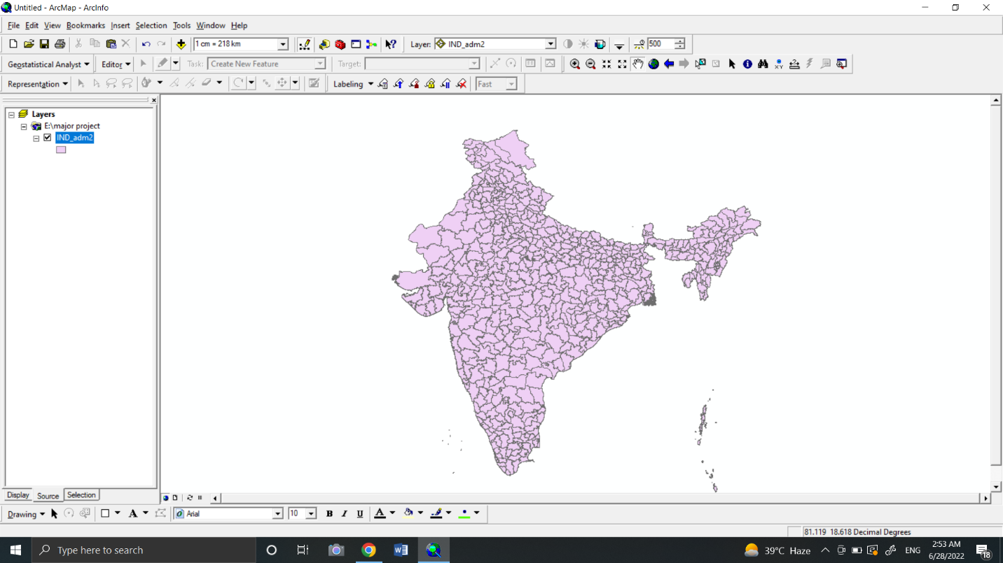
For that, open an attribute table( a table in which all kinds of descriptive information is stored about India.
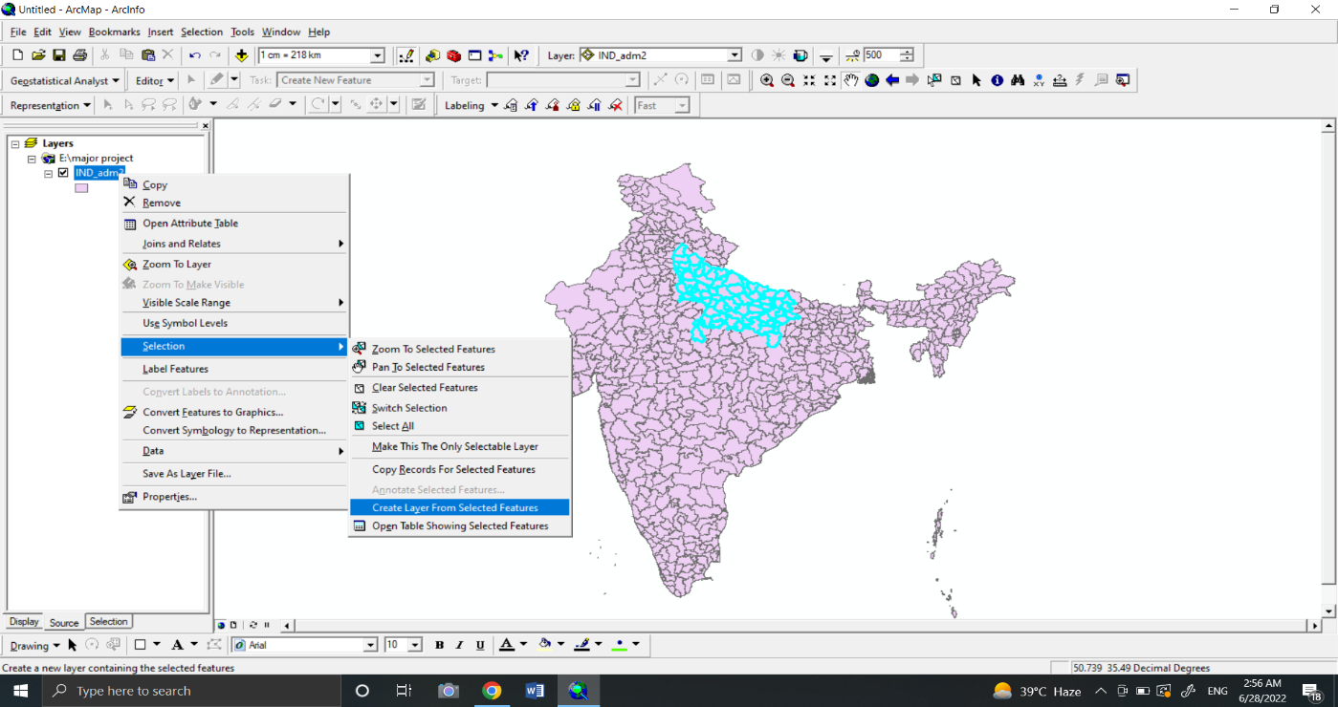
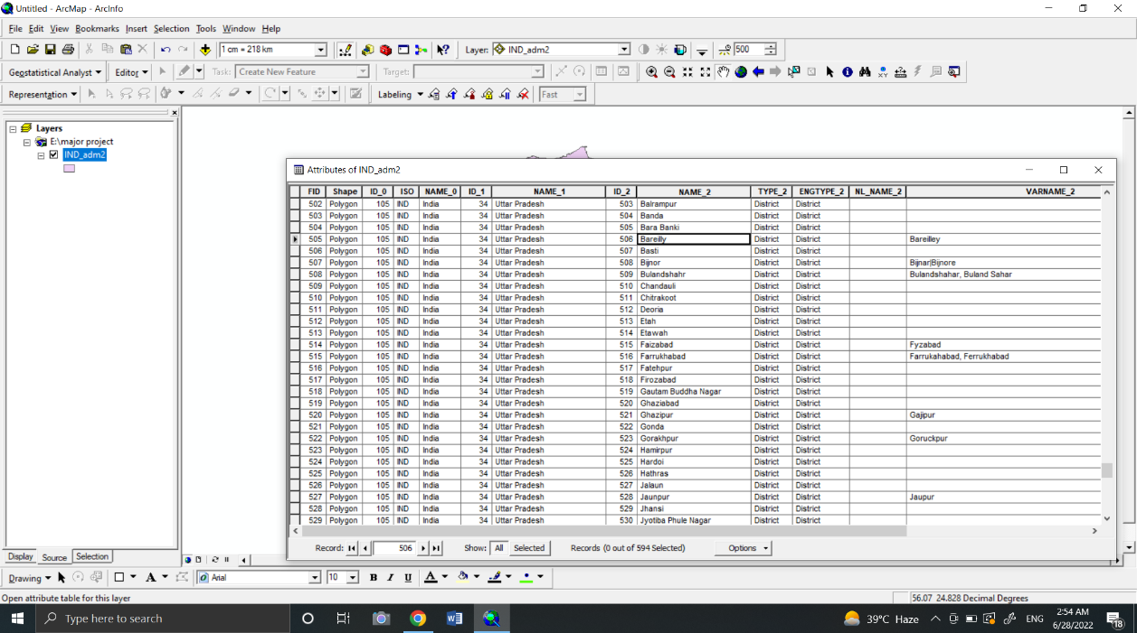
Now we will select the Uttar Pradesh state selecting by attributes from India’s shapefile which is under the ‘NAME_1’ category, then Uttar Pradesh map gets highlighted in India’s shapefile then we’ll create a separate layer for Uttar Pradesh. Now we will do the same for the Bareilly map.

As we get Uttar Pradesh as a separate layer then we will open the attribute table of the Uttar Pradesh map layer.
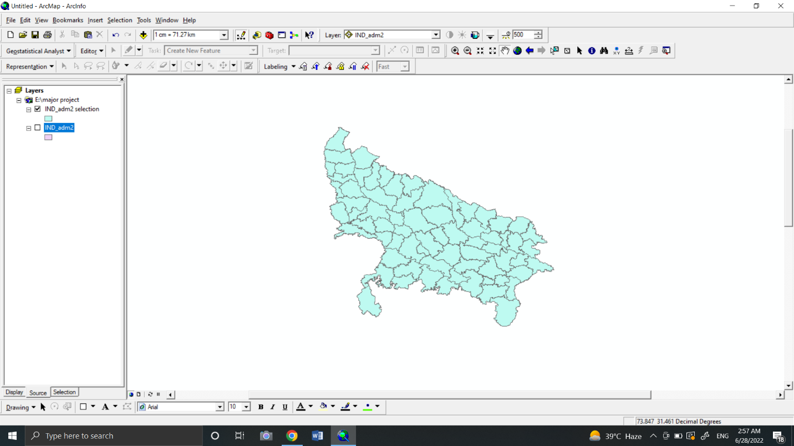
Uttar Pradesh shape file
Now we will open an attribute table of Uttar Pradesh then we will select Bareilly city. It is shown below figure.
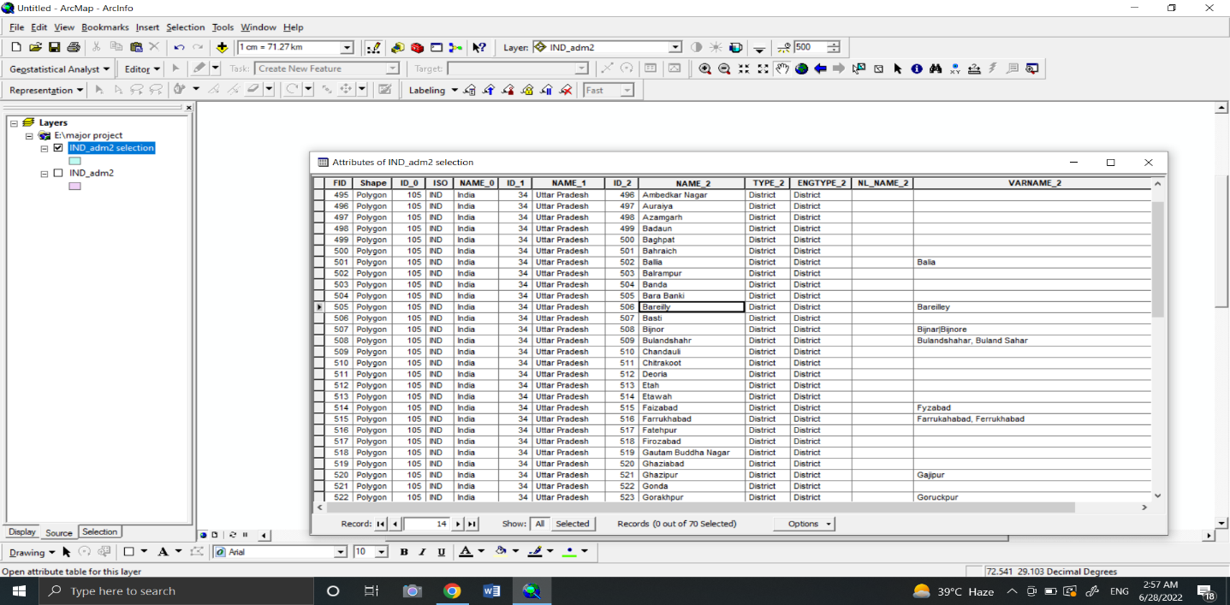
Then we will create a separate layer of Bareilly map shape file which looks like the below figure.
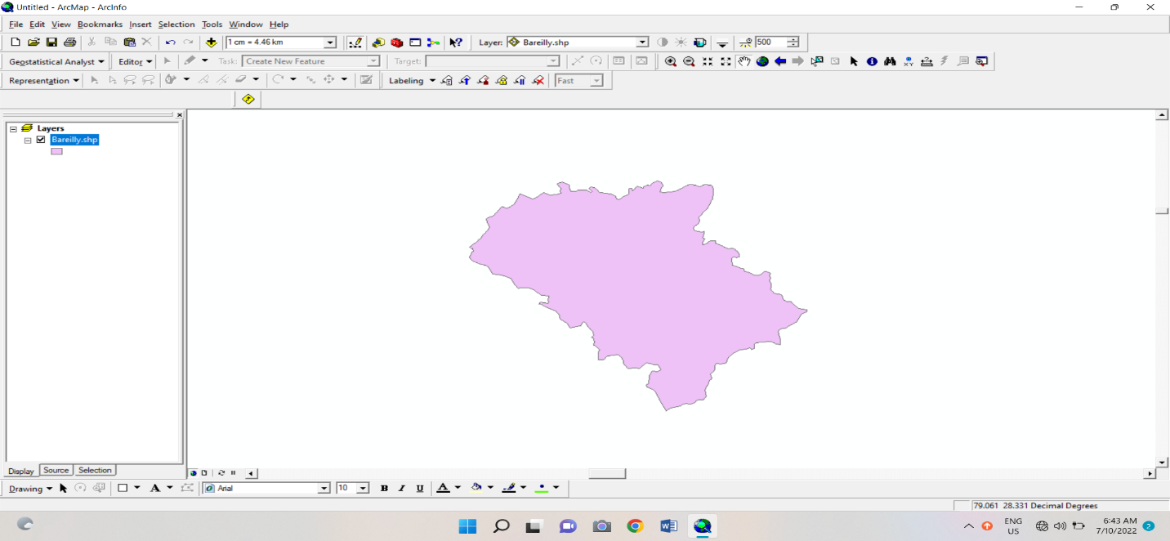

Now we have got Bareilly map shape file and we need to focus on our second step
This is to get data on our atmospheric parameters like annual radiation, annual rainfall, and annual humidity for 20 years and we will get this data from the websites like power data access viewer. And we download the data from the website.
Randomly we selected 23 to 25 locations of Bareilly along with their coordinates, now we will make an excel sheet of the parameters for 20 years, which contains FID, Coordinates, Rainfall/Radiation/Humidity, and Years.
Then we insert excel sheets in Arc map with the toolbar into x and y format, and we select the coordinate system as WGS1984 (world geographic coordinate system). Now we are all set to run a spatial analyst tool (Spatial Analysis refers to the discovery of trends or patterns in data about spatial or geographical aspects of the data. Spatial analysis is often based on techniques of annotation of data, such as Geo-referencing or Named Entity Recognition, and may lead to visualization or modeling in the form of maps).
There are three operations we run are given below
- IDW(Inverse Distance weighting)
- Spline
- Kriging
Now we will see what the above operation does to the inputs we have given in the software or other what they mean.
- Inverse distance weighting (IDW) is a type of deterministic method for multivariate interpolation with a known scattered set of points. The assigned values to unknown points are calculated with a weighted average of the values available at the known points.
- The Spline tool uses an interpolation method that estimates values using a mathematical function that minimizes overall surface curvature, resulting in a smooth surface that passes exactly through the input points.
- Kriging can be understood as a two-step process: first, the spatial covariance structure of the sampled points is determined by fitting a variogram; and second, weights derived from this covariance structure are used to interpolate values for unsampled points or blocks across the spatial field.
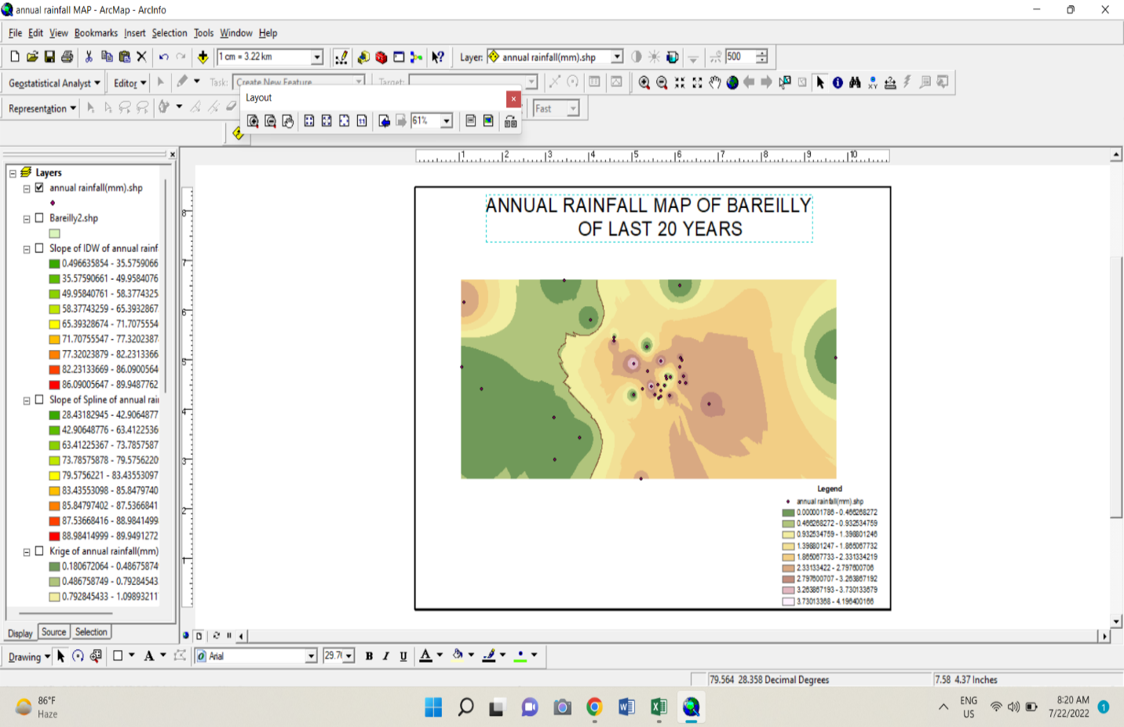
The results we obtained from the process are given below

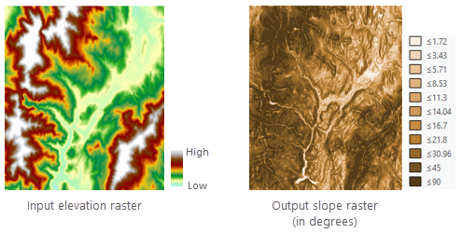
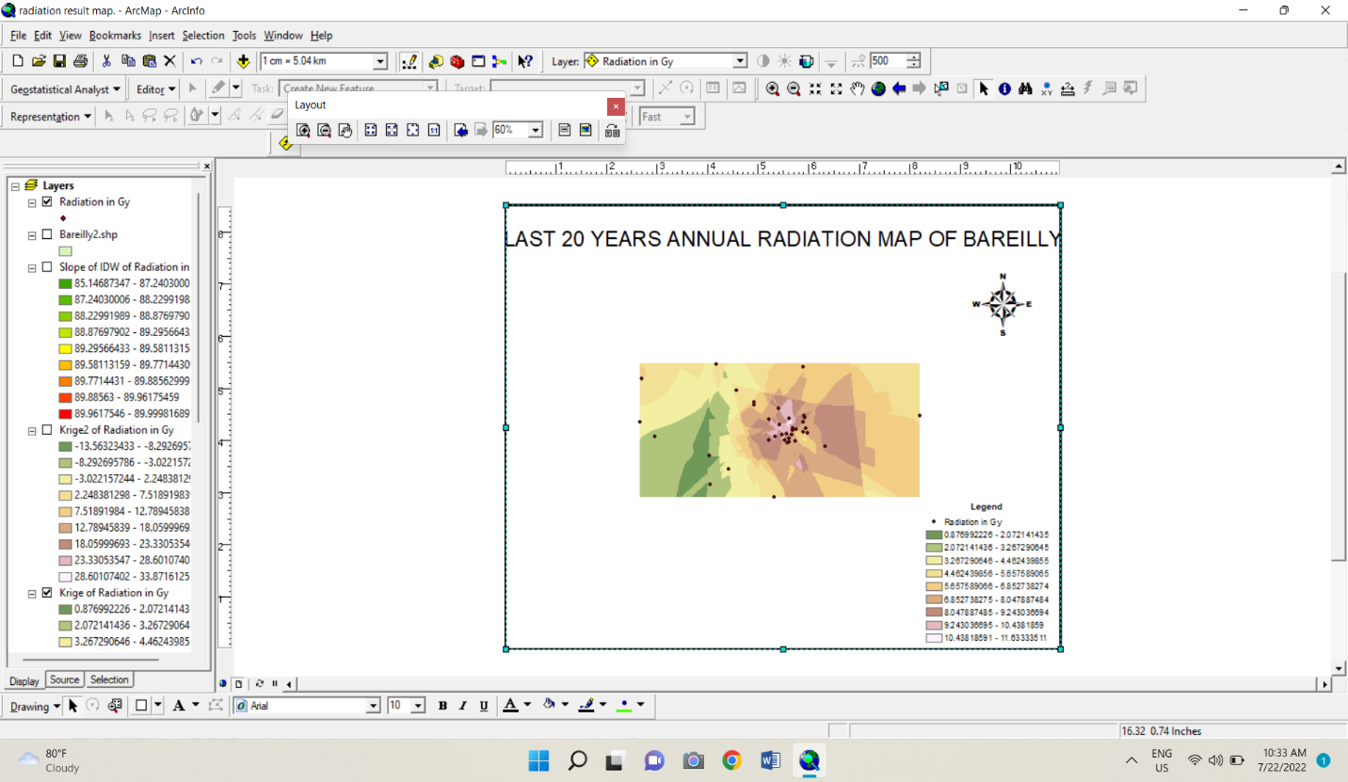
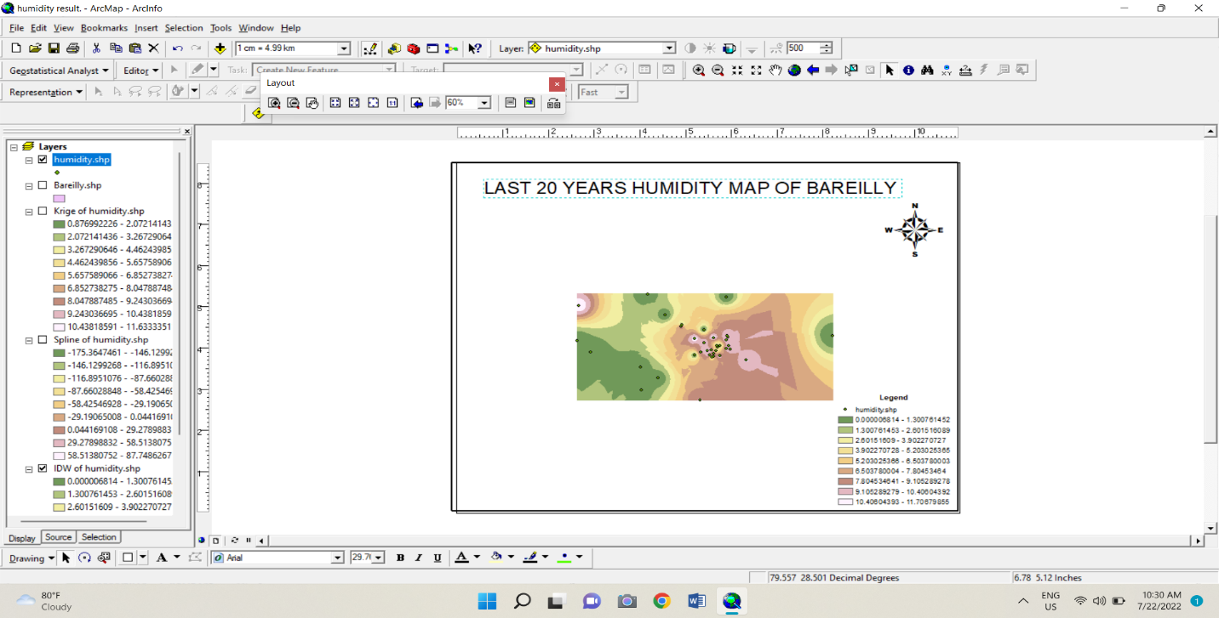
Annual Rainfall map of Bareilly

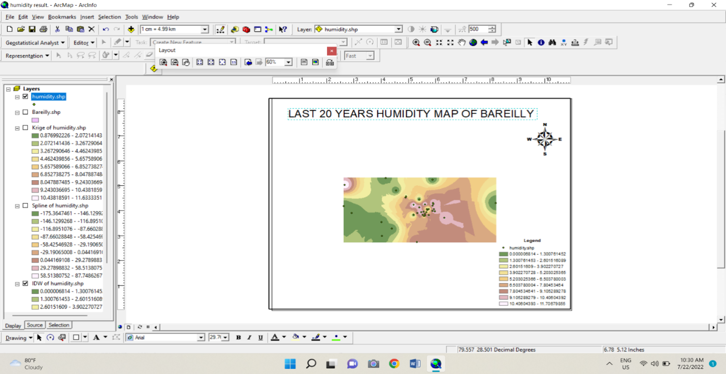
Annual humidity map of Bareilly

After these results we obtained from the process, we will run a few more operations for properties of our parameters like slope, contour, mean, median, and standard deviation.
Like before we will define each one by one and after we will see the result of each operation.
- The Slope tool identifies the steepness at each cell of a raster surface. The lower the slope value, the flatter the terrain; the higher the slope value, the steeper the terrain.
- The Slope tool is most frequently run on an elevation dataset as the following images show. Steeper slopes are shaded darker brown on the output slope raster.

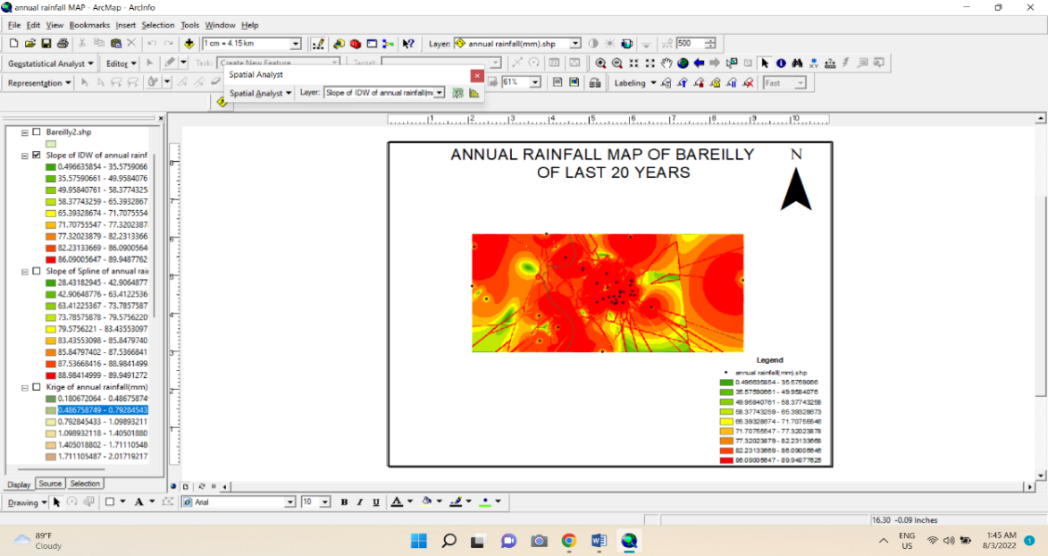

- A contour is an imaginary line that connects points of equal value. A contour map typically shows multiple contours such as elevation or temperature contours. This contour map shows elevation contours. Hills are steeper where the contours are closer together.

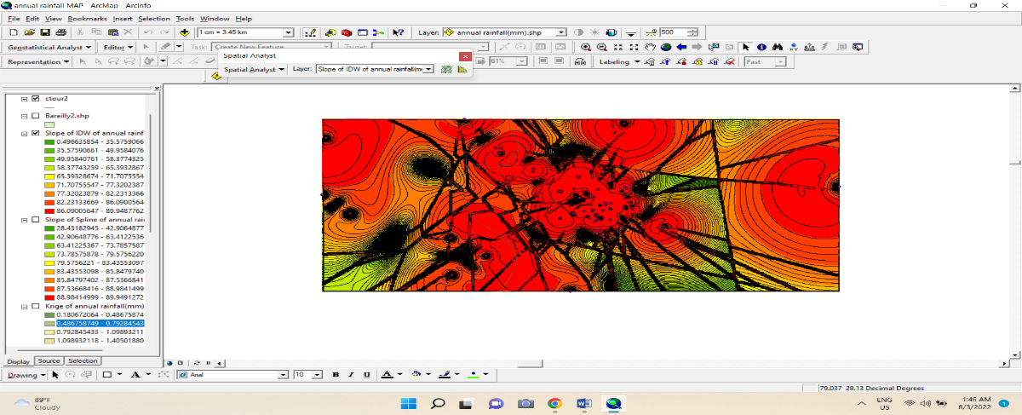

- The mean center is a point constructed from the average x and y values for the input feature centroids. This tool requires projected data to accurately measure distances. The x and y values for the mean center point features are attributes in the Output Feature Class.

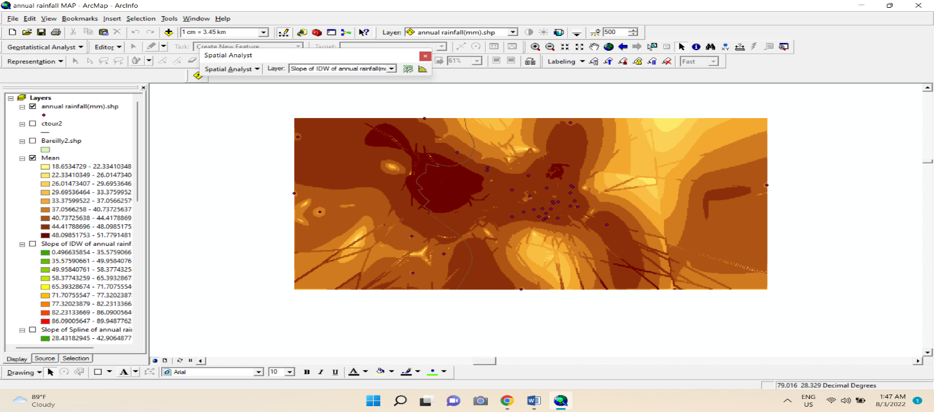

- The Median Center tool allows you to specify a Weight Field. You can think of weights as the number of trips associated with each feature (for example, if the weight for a feature is 3.2, the number of trips would be 3.2). The weighted median center is the location that minimizes distance for all trips.

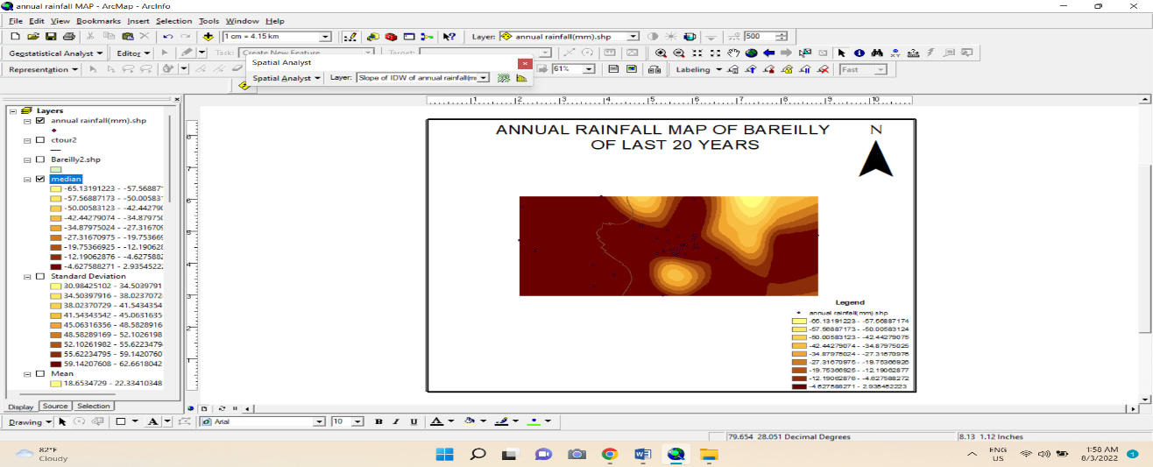
- ArcMap calculates the mean and standard deviation. Class breaks are created with equal value ranges that are a proportion of the standard deviation—usually at intervals of 1, ½, ⅓, or ¼ standard deviations using mean values and the standard deviations from the mean.
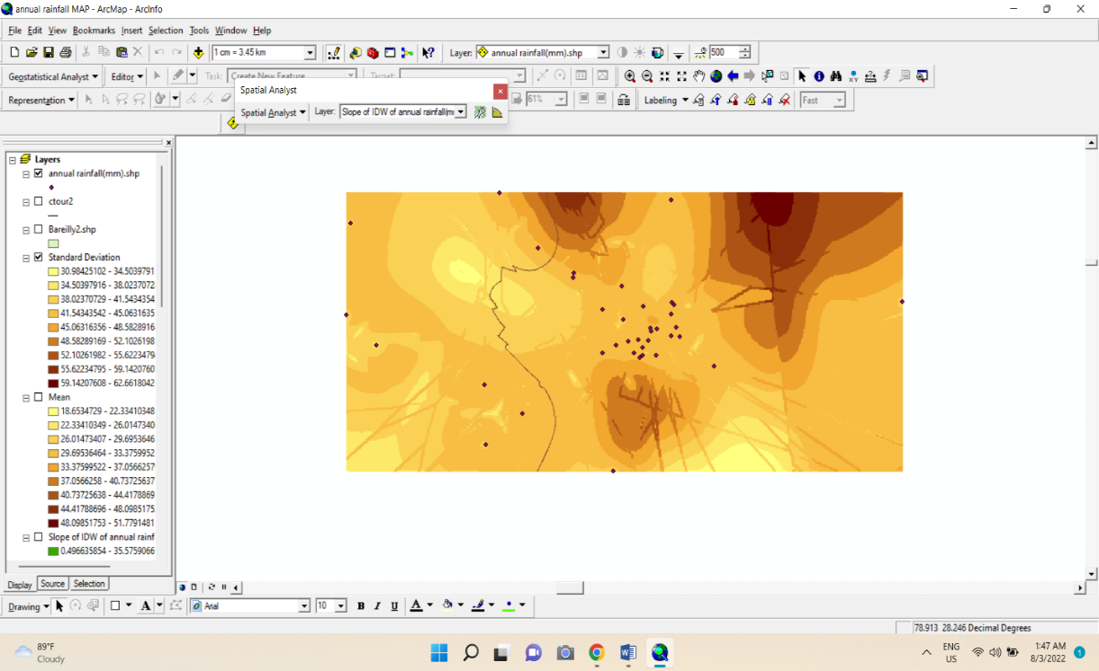

- The Majority Filter tool must satisfy two criteria before a replacement can occur. The number of neighboring cells of a similar value must be large enough (either by being the majority of, or half of, all the cells), and those cells must be contiguous about the center of the filter kernel.

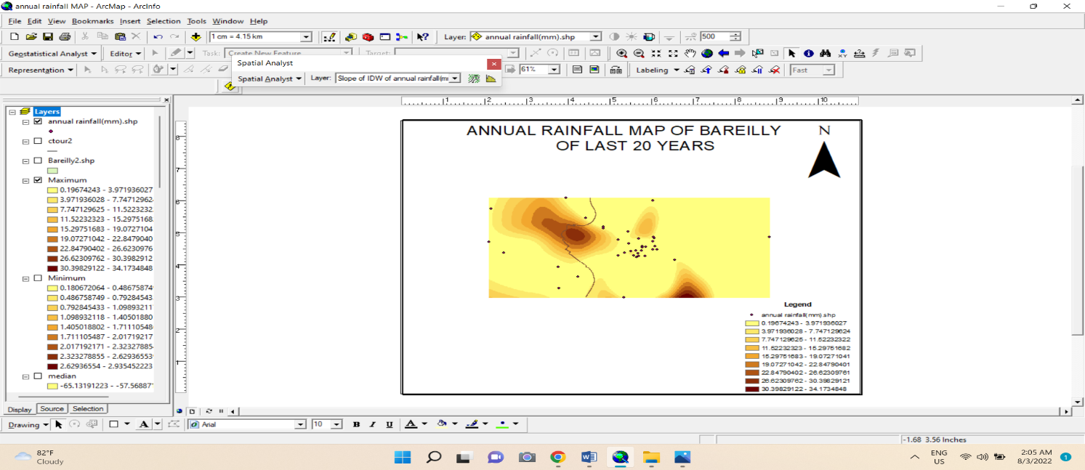
- Use Majority/Minority Analysis to apply majority or minority analysis to a classification image. Use majority analysis to change spurious pixels within a large single class to that class. You enter a kernel size and the center pixel in the kernel will be replaced with the class value that the majority of the pixels in the kernel have.
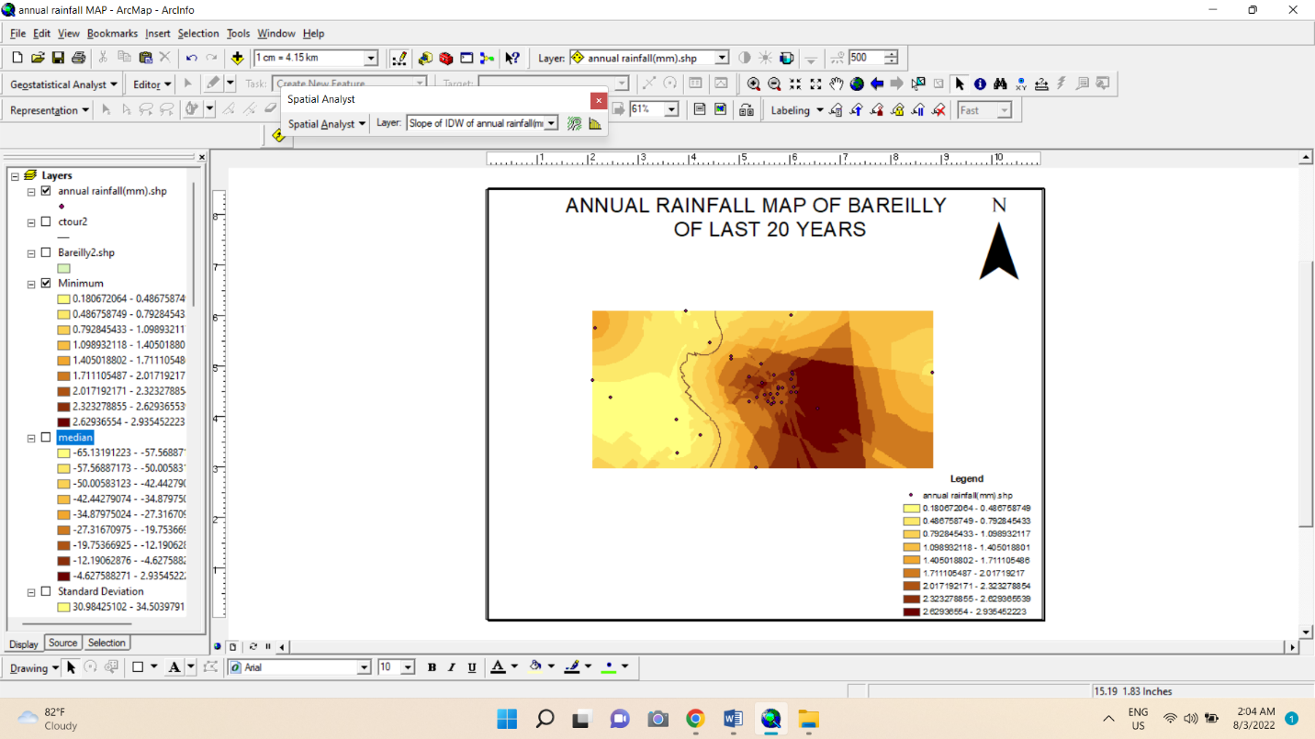

Uses of spatial analysis
Statistical analysis is often used to explore your data—for example, to examine the distribution of values for a particular attribute or to spot outliers (extremely high or low values). Having this information is useful when defining classes and ranges on a map, when reclassifying data, or when looking for data errors.
In the example below, statistics have been calculated for the distribution of senior citizens by census tract in this region (percentage of those aged 65 and over in each tract), including the mean and standard deviation, as well as a histogram showing the distribution of values. Most tracts have a lower percentage of seniors than the mean, but a few tracts have a very high percentage.
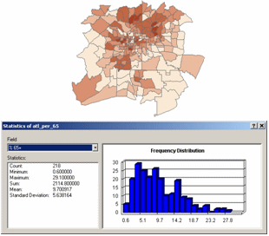
Another use of statistical analysis is to summarize data. Often, this is done for categories, such as calculating the total area in each land-use category. You can also create spatial summaries, such as calculating the average elevation for each watershed. Summary data is useful for gaining a better understanding of conditions in a study area.
In the example below, summary statistics have been calculated for each land-use class showing the number of parcels in that class, the size of the smallest and largest parcel, the average parcel size, and the total area in the class.
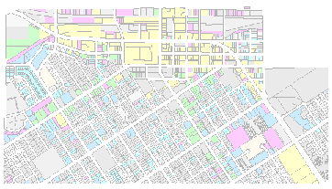
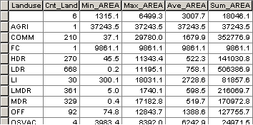

Statistical analysis is also used to identify and confirm spatial patterns, such as the center of a group of features, the directional trend, or whether features form clusters. While patterns may be apparent on a map, trying to conclude from a map can be difficult—how you classify and symbolize the data can obscure or overemphasize patterns. Statistical functions analyze the underlying data and give you a measure that can be used to confirm the existence and strength of the pattern.
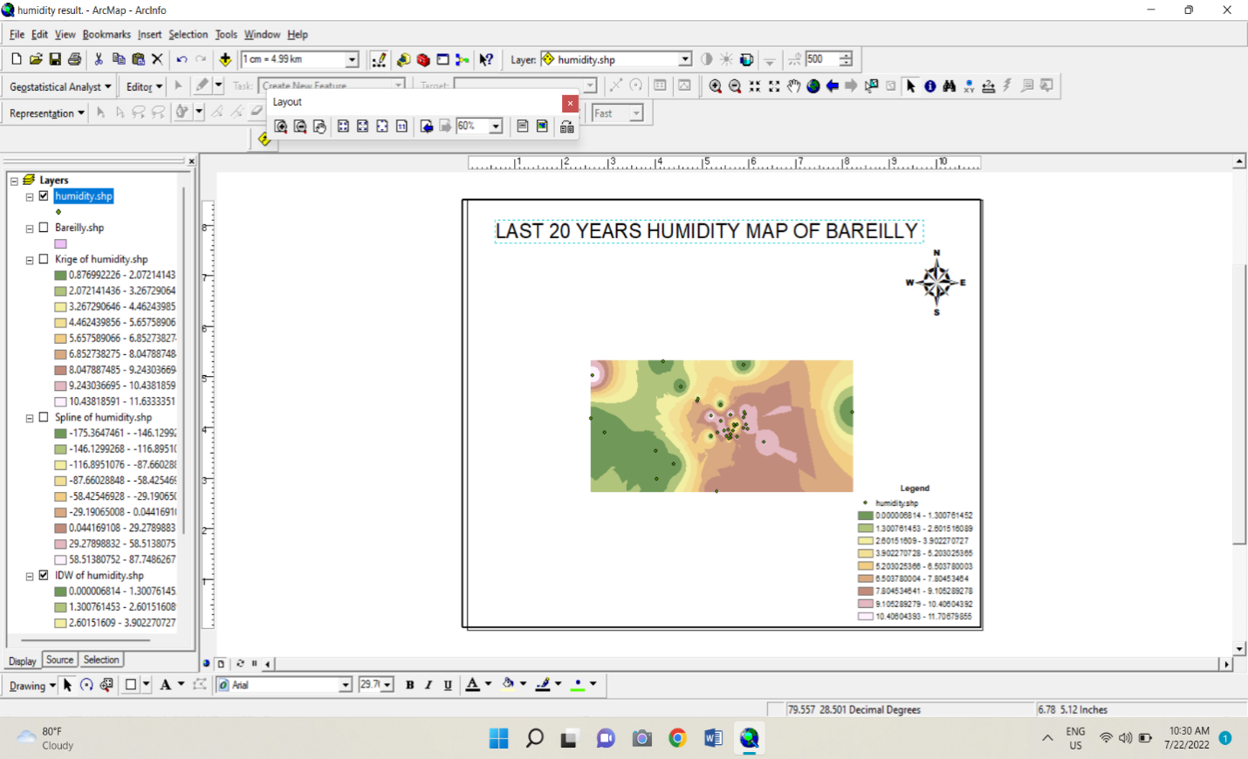
Annual Rainfall map of Bareilly
Annual radiation map of Bareilly
CONCLUSION
This tells the importance of computer aided tools for day-to-day activities. With this introduction for Remote Sensing and GIS should never be standalone operation. The Remote Sensing and GIS are being developed to support the urban planning process and will be part of a larger system. The new technology is a component based that makes possible to deliver scalable, continuously available, timely, and useful information from limitless variety of sources for analysis and update.
The present study indicates the uses of Remote Sensing and Geographic Information System for spatial planning. The study also demonstrates the potential of very high spatial resolution and multi-spectral data from Quick Bird satellite for effectively mapping the land use/land cover details rapidly. GIStechnology has provided a wide range of very easy to use analysis and visualization tools. The case study addresses a typical problem faced by the local government urban planning authorities, namely identification of lands suitable for the urban development at cadastral level using the remote sensing and GISas powerful tools of data generation, analysis and map generation. The area of this study was Bareilly; Uttar Pradesh. The present study area is a cosmopolitan and complex heterogeneous city with varied types of human races from different parts of India. The urban land suitability analysis does not demand micro level classification and
Therefore, a broader classification of land use and land cover has been adopted. It was possible to create a cadastral layer or parcel boundary layer because ofvery high spatial resolution satellite image.

REFERENCES
1.AnjiReddy.M, 2001 textbook of RS and GIS, second edition, B.S publications,Hyderabad.
2.International Conference on Environmental Management, B.S. Publications.
3.Batty M, 1992, Urban modeling computer graphic and geographic information systems environment, Environment and Planning Board.
4.D.P.Tiwari, Challenges in Urban Planning for local bodies in India, I.A.S.,Commissioner& Director, Town and Country planning, Bhopal.
5.Dr.S.P.Sekar 2000, GIS Application for Urban Planning ± A Case study of Tinidivanam Town, Tamil Nadu, GIS Development.
6.Encylopaedia of Environmental Sciences 1992, revised volume 15.
7.Govt. of India, 1988, Report of National Commission on Urbanization, Volume ± VI, Published by Govt. of India.
8.G.K.Tripathy, Urban Planning and information system for Municipal corporations, Tata Infotech Ltd, Mumbai.
9.Municipal Geographic Information Systems 2001, A note to the Empowered Committee (EC), APUSP/Governance & Reform component/Municipal GIS/Note to EC/10 Nov 21 .
10.1989, National Remote Sensing Centre, Department of Space, Govt. of India.
11.National urban Information System 2008 (NUIS), Manual for thematic mapping using high resolution satellite data and geospatial techniques by National Remote sensing Agency, Urban studies &Geoinformatics Group, dept. of space, Govt of india, Hyderabad.
12.NRSA, 1994, Mapping and Monitoring Urban sprawl Hyderabad city.
13.Anderson, J.R., E.E. hardy, J.T. Roach, and R.E. Witmer, 1976. Reston, va.Professional Paper 964, 28pp.
14.AnneVernezMoudon and Michael Hubner (2004) Monitoring Land Supply with GeographicData Systems, John Wiley and Sons Publication, New York.

15.AnneVernezMoudon and Michael Hubner (2004) Monitoring Land Supply with Geographic Information Systems, John Wiley and Sons Publication, New York.

16.Annemarie Schneider et.al., 2005, Urban Growth in Chengdu, Western China: Application of Remote Sensing to Assess Planning and Policy Outcomes, Environment and Planning B Planning and Design June 2005 vol. 32 no. 3 Pages. 323-345.

17.Ansari, J.H. (2009). Revisiting urban planning in South Asia. Regional Study Prepared for Revisiting Urban Planning: Global Report on Human Settlements.

18.Anthony Gar-on Yeh et. al., 1997, An integrated remote sensing and GIS approach in the monitoring and evaluation of rapid urban growth for sustainable enhancement in the Pearl River Delta, China, International Planning Studies Volume 2, Issue 2, 1997.

19.Arvind C. Pandy and M. S. Nathawat 2006. Land Use Land Cover Mapping Through Digital Image Processing of Satellite Data A case study from Panchkula, Ambala and Yamunanagar Regions, Haryana State, India.

20.Atkinson-Palombo, C., and Kuby, M. (2011). The geography of advance transit-oriented development in metropolitan Phoenix, Arizona, 2000–2007. Journal of Transport Geography, 19, 189–199.

21.Audirac, Ivonne (ed.) 1997. Rural Sustainable Development in America. John Wiley and Sons.

