Indian Textile Industry an Overview.
Dr.Rose Kavitha
Professor, Dept. of management studies
Manish Kumar.R
Manjesh.s.k
Students at New Horizon College of Engineering.

ABSTRACT:
The potential of Indian textile industry and apparel industry in India is valued at around 127 billion dollars in its size this means that the size of Indian textile and apparel industry is very huge then the sector is very important because it brings in a large foreign exchange .The reason is that the textile and apparel industry accounts for a significant percentage of exports from the country and then the experts from the country increases this will earn Forex or what we call as foreign exchange .So for an foreign exchange of a county is very important in determining the current account deficit all the current account stability or surplus. Forex is also an important determinant of rupees the depreciation or the appreciation of rupee will highly depend on the forex earning of the country so textile industry with its huge potential for exporting garments to other countries is a significant foreign exchange earner for the country and it is also significant in the way that it is a second largest employer in the country after Agriculture sector.
Indian textile industry exhibits rich cultural heritage of India with wide variety of fabrics, techniques and hues that reflect the diverse set of people and traditions across the country. One of the oldest industries in India, it covers an extensive spectrum of segments, from hand woven/hand-spun, unorganized segment on one end to capital and technology intensive organized segment on the other. India is the largest producer of Jute in the world and is the second largest producer of silk and cotton globally.
KEYWORDS:
Indian Textile industry, pandemic impact on textile industry, Government initiatives.
1. INTRODUCTION:
The traditional textile industry of India was virtually decayed during the colonial regime. However, the modern textile industry took birth in India in the early nineteenth century when the first textile mill in the country was established at fort gloster near Calcutta in 1818.
India’s textiles sector is one of the oldest industries in Indian economy dating back several centuries. Even today, textiles sector is one of the largest contributors to India’s exports with approximately 15 per cent of total exports. The textiles industry is also labour intensive and is one of the largest employers. The Indian textiles industry is extremely varied, with the handspun and hand-woven textiles sectors at one end of the spectrum, while the capital intensives mills sector at the other end of the spectrum. The decentralized power looms/hosiery and knitting sector form the largest component of the textiles sector. The close linkage of the textile industry to agriculture (for raw materials such as cotton) and the ancient culture and traditions of the country in terms of textiles make the Indian textiles sector unique in comparison to the industries of other countries. The Indian textile industry has the capacity to produce a wide variety of products suitable to different market segments, both within India and across the world.

In case of India textile industry is not just important because of its labour absorption or as a source of its foreign exchange earner but also it is a symbol if India’s rich heritage especially the handloom industry it is a signature of India’s rich heritage so it also helps in promoting the rich heritage of the country in the global level so for all these factors the textile industry is very significant and the potential is also very huge and enormous.

2. REVIEW OF LITERATURE:
The idea of writing survey includes different examinations made relating to the examination subject and specialization by various scientists during various times. In this part, studies embraced by different analysts are considered and a concise report of the perceptions, examination also, ends, in light of the goals of their individual review, are introduced as survey of before writing accessible in the connected subject. This exploration study is in regards to fabric exchanging business, all the more explicitly to discount exchanging material. In this part the analyst has considered the writing survey of material industry and fabric exchanging. All in all there are 8 surveys, out of which 7 are reads up submitted for Ph.D. Theory and one book explicitly composed on the solicitation made by Mill Proprietors Association, Bombay. These audits go under the subjects Part II - Theoretical foundation and Review of Literature 52 of, financial aspects, business and the executives. These books depend on perceptions on the real place of material industry during that period. A portion of the examination postulation was distributed as books with the goal that they can be utilized for reference by the group of people yet to come. Some were even taken under the educational plan of the colleges. Out of the seven examination concentrates on five are connected with material fabricating and related regions and two investigations are connected with material exchanging. In this part, these investigations are introduced by their year of exploration and distribution.

2.1 Futures trading and Futures Market in Cotton with special reference to India in 1942 – by Dr. H.L. Dholakia:
Dr. H. L. Dholakia, from Sir Prate Sinha School of Business and Financial aspects, Baroda, attempted a deliberate investigation of live subject for advance examination in financial matters and trade in 1942, under the Baroda College. His review was connected with cotton. That's what he saw, during that period the showcasing of rural produce was confronting issues. Prior promoting rehearses for cotton items depended being investigated and blunder premise. Dr. Dholakia saw that progressively the promoting rehearses created from being confused to coordinated area. He Section II - Hypothetical foundation and Audit of Writing 53 made sense of various significant elements of prospects market. These fates markets helped in the trading of cotton towards systematic dissemination of staple from the field to the industrial facility. He likewise saw that the fates market had a past filled with 75 years. He made sense of the impacts of universal conflict (1914 - 1939) on the cotton trade in India and far off nations. He additionally stressed the job of cotton trade in India, cotton costs, badla business, teji mandi exchange, hypothesis and control of future exchanging and market. To diminish the issues looked by the cotton exchange he suggested that there ought to be solidarity in charge under the help of single body for a given city or spot formally acknowledged by the rule.
2.2 The Indian Cotton Textile Industry during twentieth Century (with special reference to war periods) in 1947 - by Dr. N. H. Thakkar:
Postulation of Dr. N. H. Thakkar, Prof. of Current Monetary Turn of events and
Cotton Financial matters at Sir Kikabhai Premchand School of Business, Surat, distributed by Vora and Co. Distributers Ltd., Bombay, on 24th November 1947. The review was attempted during the freedom enough said. A short history of the business is given from 1854 to 1945 (during which the first universal conflict began in 1914 - 1919 and WWII in 1939 - 1945). The impacts of battle on the monetary construction of the Part II - Hypothetical foundation and Survey of Writing 54 industry, study of work conditions, shortage of fabric and ensuing controls, and the fate of the business during the two conflicts are
Examined in the review. Cotton Material Industry in India is maybe the main business with which individuals of this nation are firmly associated from the marks of speculation, business and as customers. Prof. Thakkar has made a
Exhaustive investigation of this significant subject particularly of war times impacts on it. Beginning with the hypothetical way to deal with the issue and following the development of cotton material industry in India to the full advantages and disadvantages of war economy and the spot of India in war time industrialization are examined in this review. This study is worried about the association of the material business, tasks in the material factory industry, issues
Of the material plant industry (particularly with handloom and power loom)
Also, rivalry of new strands and diminishing creation of cotton.
Dr. Thakkar saw that the material business had confronted certain issues like stock of colors, synthetic compounds, apparatus, coal, transport, work issues, excessive costs, and tax assessment and so on. He additionally saw that India experienced intense deficiency of fabric. Creation of fabric couldn't be adequately expanded. The public authority attempted to shield customers from abuse by a progression of measures which pointed toward controlling the costs and taking out illicit businesses.

2.3 The Indian Cotton Textile Industry in 1953 - by Dr. S.D. Mehta:
This study was finished by Dr. S. D. Mehta for his Ph. D degree in
Financial matters, submitted to the College of Bombay, in Walk 1953. He
Concentrated on an aggregate of 30 material factories in India from Bombay, Ahmedabad, Delhi, Coimbatore and Madurai. It is a monetary examination of cotton material industry. The outcomes might be subjectively summarized in three stages i.e., broadening of hardware inclinations, toward capital development and the reappearance of even patterns in the association in
An industry where vertical combination had gained amazing headway. He saw that after a significant stretch of security wage rates raised upwards. Work agitation showed itself in strike. Work issues have changed both in their inclination and in their accentuation during the course of advancement of cotton factory industry. The hand loom industry was researched by reality tracking down advisory group in 1942. The finishes of this council were inspected and dissected by Dr. S. D. Mehta in his review. He likewise saw that the design of cotton material business sectors was complex and had become more mind boggling during the conflict time frame, the accentuation moved from creation to deals during the conflict time frame and the material plant industry was arranged to wholesalers overwhelming the industry. Numerous perplexing variables made inconveniences in the monetary.

2.4 Shinivasulu K.
He called attention to in “Handloom weavers battle for endurance [1994]” that, with the modest and wide assortment of material delivered on the power loom flooding the wide open particularly from the 60s and with costs of cotton yarn and synthetic colors rising, the Free weavers, even those owing a few weavers, being compelled to join the positions of pay workers due to their Powerlessness to endure the opposition from powelooms and ace weavers and keep the costs of the coarse assortment of dhotis and sarees which they produce inside the compass of rustic poor. For sheer Endurance an immense number of these weavers have moved material Focuses in Western India like Bhiwandi and Sholapur in Maharashtra and Surat in Gujarat to work in the powerloom industry and in factories and other have settled of compensation workers to the expert weavers and as horticultural workers.

2.5 As per Vijay G.
“Government backed retirement of Labor in New Modern Towns” (1999) States that material laborers working conditions enrollment and working hours. In his paper he reasoned that, the specialists are first selected through the agreement premise and are paid an everyday compensation of Rs. 55 for 10 hours of work. The talented casual laborers have more noteworthy employer stability than the untalented specialists. The talented specialists have opportunity to be missing for a little while in month. The untalented laborers need to work 12 Hours in a day mandatory with no occasion including Sunday. None of the laborers is given E.S.I. or on the other hand P.F. benefits.

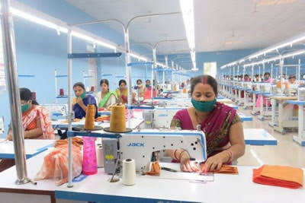
3. RESEARCH METHODOLOGY:

3.1 IMPACT OF COVID-19 PANDEMIC ON TEXTILE INDUSTRY:
Textile sector is highly unorganized sector. The government has initiated special measures to help ameliorate the conditions in textile sector due to Covid pandemic and to boost production, marketing and job opportunities in the sector. The government has conducted a study viz. ‘Impact of Covid-19 pandemic on Indian silk industry’ to ascertain the crisis caused to the sector. The industry has faced various problems of production, cocoon and raw silk prices, transportation problem, non-availability of skilled workers, sale of raw silk and silk products, working capital and cash flow, reduced export/import orders, besides restrictions. The last three month orders and supply as given below shows declining trend in jute production during the peak Covid-19 period which is substantially improving now.
3.2 STATISTICS OF INDIAN TEXTILES:
Government has conducted a Symposium with textile Export Promotion Councils and other industry stakeholders for finalizing a list of potential export products against which exports of textile and apparel can be enhanced. The list of potential export products were shared with the Indian Mission abroad for identification of potential buyers in the respective countries. In order to make the textile sector competitive by rebating all taxes/levies in international market, the Government has decided to continue the RoSCTL (Rebate of State and Central Taxes and Levies) scheme until such time the RoSCTL scheme is merged with Remission of Duties and Taxes on Exported Products (RoDTEP) scheme. For this purpose, the Government has approved adhoc allocation of funds of Rs. 7398 crore for FY 2020-21 for issuance of duty credit scrips under RoSCTL scheme. Further, in order to boost exports in MMF sector, Government has removed anti-dumping duty on PTA (Purified Terephtallic Acid), a key raw material for the manufacture of MMF fibre and yarn. To mitigate the effect of the COVID-19 pandemic on trade, this Ministry has taken up the various trade facilitation related issues raised by the industry stakeholders from time to time with the concerned Ministries for early redressal.
A special measure to alleviate the difficulties of beneficiaries under Amended Technology Upgradation Funds (ATUFS) was initiated in the Ministry of Textiles during the COVID pandemic. Under this measure, an option has been extended to the applicants, where the physical examination of the machineries by Joint Inspection Team (JIT) has been completed, to avail their subsidies released on submission of Bank Guarantee. The advance release of subsidy against bank guarantee is met from the regular budget allocation under ATUFS.
The Government of India has also announced a special economic package viz. Aatma Nirbhar Bharat Abhiyaan for boosting economy of the country and making India self-reliant. Relief and credit support measures have been announced for various sectors. The weavers & artisans can avail benefits of these relief and credit support measures to revive their businesses which have suffered due to lock down necessitated by Covid-19 pandemic.
Apart from the above special economic package, the Ministry of Textiles has taken following initiatives for the benefits of handloom weavers and artisans across the country: -
- To support the handloom and handicraft sectors and to enable wider market for handloom weavers/artisans/producers, steps have been taken to on-board weavers/artisans on Government e-Market place (GeM) to enable them to sell their products directly to various Government Departments and organizations.
- To promote e-marketing of handloom products, a policy frame work was designed and under which any willing e-commerce platform with good track record can participate in online marketing of handloom products. Accordingly, 23 e-commerce entities have been engaged for on-line marketing of handloom products.
4. CAMPAIGN:
A social media campaign #Vocal4handmade was launched on the 6th National Handloom Day by the Government, in partnership with all stakeholders, to promote the handloom legacy of India and to ensure people’s support for the weaving community. It has been reported that the social media campaign has resulted in renewed interest of the Indian public in handlooms and several e-commerce players have reported increase in sale of Indian handloom products.
The Ministry of Textiles has requested the Chief Ministers of all States and UTs to instruct their State Handloom Corporations/Co-operatives/Agencies to make purchases of the finished inventory available with the handloom weavers/artisans so as to put some ready cash in the hands of the weavers to enable them meet their household needs.
In the face of the unprecedented Covid-19 pandemic, it is not feasible to hold conventional marketing events such as exhibitions, melas, etc. To deal with this crisis, the Government endeavors to provide online marketing opportunities to our weavers and handloom producers.
Taking a step towards realizing “Aatma Nirbhar Bharat”, the vision of our Hon’ble Prime Minister, Handloom Export Promotion Council has endeavored to virtually connect the Handloom Weavers and exporters from different corners of the country with the International Market.
With more than 200 participants from different regions of the country showcasing their products with unique designs and skills, THE INDIAN TEXTILE SOURCING FAIR was organized on 7, 10 and 11th August 2020. The show has attracted considerable attention of the International Buyers.
To support the handloom and handicraft sectors and to enable wider market for handloom weavers/artisans/producers, steps have been taken to on-board weavers/artisans on Government-Market place (GeM) to enable them to sell their products directly to various Government Departments and organizations. To promote e-marketing of handloom products, a policy frame work was designed and under which any willing e-commerce platform with good track record can participate in online marketing of handloom products. Accordingly, 23 e-commerce entities have been engaged for on-line marketing of handloom products. A social media campaign #Vocal4handmade was launched on the 6 th National Handloom Day by the Government, in partnership with all stakeholders, to promote the handloom legacy of India and to ensure people’s support for the weaving community. It has been reported that the social media campaign has resulted in renewed interest of the Indian public in handlooms and several e-commerce players have reported increase in sale of Indian handloom products. The Ministry of Textiles has requested the Chief Ministers of all States and UTs to instruct their State Handloom Corporations/Co-operatives/Agencies to make purchases of the finished inventory available with the handloom weavers/artisans so as to put some ready cash in the hands of the weavers to enable them meet their household needs. In the face of the unprecedented Covid-19 pandemic, it is not feasible to hold conventional marketing events such as exhibitions, melas, etc. To deal with this crisis, the Government endeavors to provide online marketing opportunities to our weavers and handloom producers’ .Taking a step towards realizing “Aatma Nirbhar Bharat”, the vision of our Hon’ble Prime Minister, Handloom Export Promotion Council has endeavored to virtually connect the Handloom Weavers and exporters from different corners of the country with the International Market. With more than 200 participants from different regions of the country showcasing their products with unique designs and skills, THE INDIAN TEXTILE SOURCING FAIR was organized on 7, 10 and 11 th August 2020. The show has attracted considerable attention of the International Buyers. Design Resource are being set up in Weavers Service Centres (WSCs) through NIFT with the objective to build and create design-oriented excellence in the Handloom Sector and to facilitate weavers, exporters, manufacturers and designers for creating new designs. Apart from the above initiatives, Ministry of Textiles is implementing various schemes through the Offices of Development Commissioner (Handlooms) for overall development of handlooms and welfare of handloom weavers across the country.
4.1. THE SCHEME DETAILS ARE AS UNDER:
National Handloom Development Programme (NHDP)
Comprehensive Handloom Cluster Development Scheme (CHCDS)
Handloom Weavers’ Comprehensive Welfare Scheme (HWCWS)
Yarn Supply Scheme (YSS)
Under the above schemes, financial assistance is provided for raw materials, purchase of looms and accessories, design innovation, product diversification, infrastructure development, skill up gradation, lighting units, marketing of handloom products and loan at concessional rates. Textile sector allocation to increase 8.1% for FY23 Allocation for the textile sector will see an 8.1% increase in FY23 compared with the revised budget allocation for FY22. According to the Union Budget presented on Tuesday, of the total allocation of ₹12,382 crore for the textile sector for next financial year, ₹133.83 crore is for Textile Cluster Development Scheme, ₹100 crore for National Technical Textiles Mission, and ₹15 crore each for PM Mega Integrated Textile Region and Apparel parks scheme and the Production Linked Incentive Scheme. The Centre has also allocated ₹105 crore for FY23 towards the Raw Material.
5. DATA ANALYSIS:
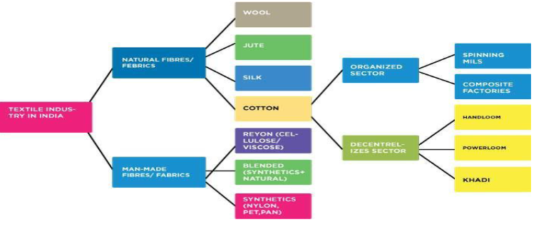
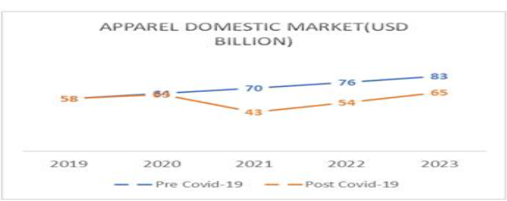
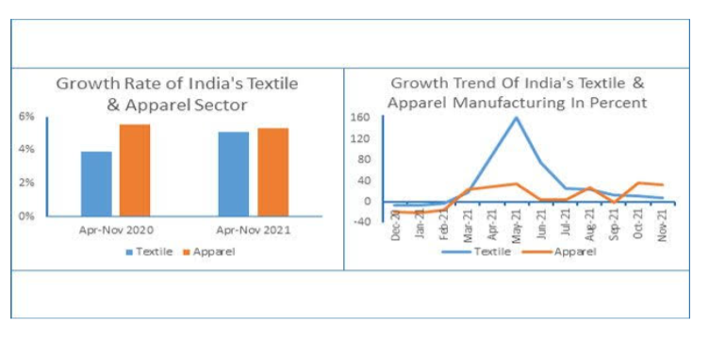
6. GOVERNMENT INITIATIVES:
Indian government has come up with several export promotion policies for the textiles sector. It has also allowed 100% FDI in the sector under the automatic route. The Rs. 10,683 crore (US$ 1.44 billion) PLI scheme is expected to be a major booster for the textile manufacturers. The scheme proposes to incentivize MMF (man-made fiber) Apparel, MMF Fabrics and 10 segments of Technical Textiles products.
Other Initiatives taken by Government of India are. The Indian government has notified uniform goods and services tax rate at, 12% on man-made fabrics (MMF), MMF yarns, MMF fabrics and apparel, which will come into effect from January 1, 2022.Union textile minister Mr. Piyush Goyal announced a mega handloom cluster in Manipur and a handloom and handicraft village at Moirang in Bishnupur. The mega cluster will be set up at an estimated cost of Rs.30 crore (US$ 4.03million) under the National Handloom Development Programme (NHDP).In October 2021, Union Minister for Commerce and Industry, Textiles, Consumer Affairs, Food &amp; Public Distribution, Mr. Piyush Goyal, announced the creation of 100 textile machinery champions in the country and to promote it in the global market. Through this, the government aims to make India a global player in textiles machinery.

CONCLUSION:

The Indian textiles sector has been one of the worst hit sectors due to COVID-19. Even prior to the pandemic, the industry suffered from some challenges on both demand and supply sides. In addition, it is due to its socio-economic primacy for the Indian economy, which is second only to agriculture, that the industry must be given a comprehensive financial package to ameliorate its distress. Failure to do so could imperil millions of already precarious jobs and livelihood.But on the other hand Indian textile industry was able to face the covid pandemic and bring a big change in Indian economy.

REFERENCES:
- Futures trading and Futures Market in Cotton with special reference to India in 1942 – by Dr. H.L. Dholakia
- The Indian Cotton Textile Industry during twentieth Century (with special reference to war periods) in 1947 - by Dr. N. H. Thakkar
- A structure of cotton mill industry in India in 1949 - by Dr. M. M. Mehta
- The Indian Cotton Textile Industry in 1953 - by Dr. S.D. Mehta
WEBSITES:
Ministry of Textiles, Indian Textile Journal, Department of Industrial Policy and Promotion, Press Information Bureau, Union Budget 2021-2022.
http://texmin.nic.in/
https://m.economictimes.com
http://ministryoftextiles.gov.in/press-release

