LIFE THREATENING SKIN RASHES
G. Shanthi Priya*, Sneha Chukkala
Department of Pharmacology
Gokaraju Rangaraju College of Pharmacy
Bachupally, Hyderabad, 500090.
gshanthipriya00@gmail.com

- INTRODUCTION:
Dermatology is the field of medicine that deals with skin conditions. It is a medical and surgical specialty. A dermatologist is a type of health care profession who treats skin, hair, nail, and aesthetic concerns. The skin, the body's largest organ, serves as a barrier to protect the inside organs from injury and pathogens. Furthermore, it is a good indicator of the body's general health, making dermatology important for the detection and therapy of a wide range of medical diseases.
Some of the most common dermatologic conditions include:
- Acne : skin pimples caused by irritation of the sebaceous glands.
- Dermatitis : skin irritation causes red, puffy and sore skin.
- Eczema : rough and inflamed skin
- Psoriasis : itchy, red, scaly patches on skin
- Fungal infections : fungus infection of the skin or nails
- Warts : small hard growth on the skin caused by virus
- Cold sore : inflamed blister near mouth caused by herpes simplex virus
Dermatological emergencies rare, but if they are not identified and treated right away, they might result in fatal complications.

- SKIN DISEASES:
An intensive care unit is necessary for the treatment of several skin disorders. The most dangerous skin problems are listed here.
- Necrotising fasciitis:

Necrotizing fasciitis is a subtype of aggressive skin and soft tissue infections (SSTIs) that induce necrosis of the muscular fascia and subcutaneous tissues. The fascial plane, where this illness often spreads, has a weak blood supply. As a result, the underlying tissues are initially untouched, which may delay detection and surgical treatment. The infectious process can progress quickly, infecting the fascia and peri-fascial planes as well as the skin, soft tissue, and muscle directly above and below [1,2,3].

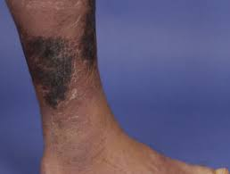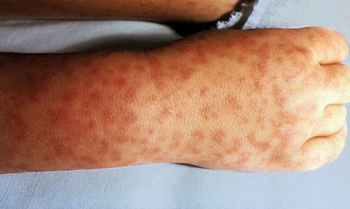

Figure 1: Necrotising fasciitis

Aetiology:

Necrotizing fasciitis is typically an acute disease that spreads rapidly over several days. It is a clear indication of bacterial infection introduced through a rupture in the skin's integrity in around 80% of all cases. Gram-positive cocci, notably strains of Staphylococcus aureus and Streptococci, cause the majority of these single-site source infections. Furthermore, gram-negative and anaerobic participation leads to polymicrobial infections [4,5].

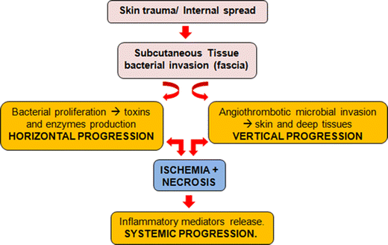

Figure 2: Pathophysiology of Necrotizing fasciitis

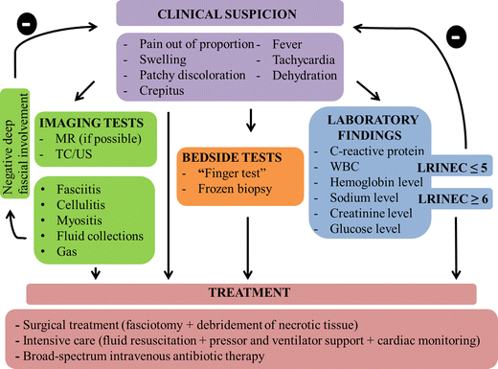

Figure 3: Diagnosis of Necrotizing fasciitis

Outcomes:

Necrotizing fasciitis is a dangerous condition with a death rate ranging from 30 to 90%. Patients infected with specific streptococcal strains have the worst prognosis. Other factors that affect prognosis include renal failure, respiratory distress, ARDs, and loss of consciousness. Patients who undergo rigorous debridement, hydration, and broad-spectrum antibiotics as soon as possible have the best chance of survival. Even after treatment, people with the illness often have shorter lifetimes than age-matched controls [6].

- Staphylococcal Scalded skin syndrome:

The bacteria staphylococcus aureus causes the skin infection like staphylococcal scalded skin syndrome (SSSS). As a result of the bacterium's exfoliative toxin, the skin's outer layers blister and peel.

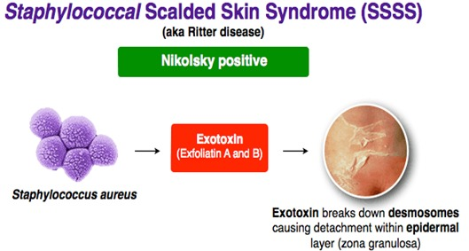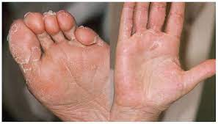

Figure 4: Scalded skin syndrome

Bacteria enter the body through a skin break. The toxin produced by the bacterium inhibits the skin's ability to stay together. The separation of the upper layer of skin from deeper layers causes the characteristic peeling of SSSS. When the poison enters the bloodstream, it may cause a response all over the skin. Young children, particularly newborns, are more vulnerable because they lack immune systems and kidneys that can clear toxins from the body.
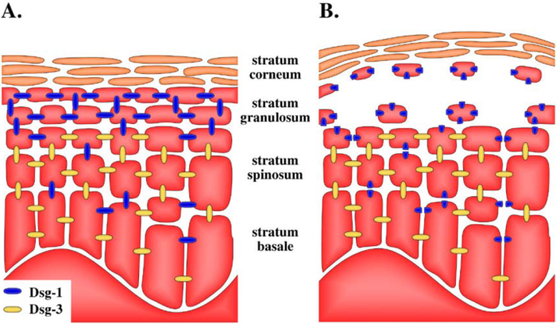

Figure 4: Scalded skin syndrome pathophysiology

The exfoliative toxin-induced splitting at the stratum granulosum is explained by the differential distribution of desmoglein isoforms in the epidermis [8]. Desmoglein distribution in (A) healthy skin and (B) skin that has been subjected to an exfoliative toxin is shown schematically. Desmoglein 3 compensates for the exfoliative toxin-mediated hydrolysis of desmoglein 1 (Dsg-1) in all layers other than the stratum granulosum (Dsg-3). The absence of Dsg-3 in the stratum granulosum explains why cells detached and the epidermal layers separated when Dsg-1 is hydrolyzed.
- Management of SSSS: As a dermatological emergency, SSSS calls for immediate hospitalisation and care. This typically entails:
- First-line: a penicillinase-resistant, anti-staphylococcal antibiotic such as flucloxacillin.
- Other options include: ceftriaxone, clarithromycin (for penicillin-allergy), cefazolin, nafcillin, or oxacillin.
- Methicillin resistance (MRSA) infection: vancomycin [7].

- DRESS Syndrome:

The "drug rash with eosinophilia and systemic symptoms" (DRESS) syndrome refers to a unique, severe, idiosyncratic reaction to a medication. It is characterized by a lengthy latency phase. It is followed by a variety of mild-to-severe systemic manifestations and clinical symptoms, including fever, rash, lymphadenopathy, eosinophilia, and lymphadenopathy. It is a term for a painful reaction that is currently used to describe an allergic reaction with a 10% fatality.

Patients typically experience fever in early phase of disease, which is followed by rashes. More prevalent than a moderate exanthem or considerable blistering and skin loss is a pruritic, macular erythema with papules, pustules or vesicles. Lymphadenopathy, hepatitis, pericarditis, interstitial nephritis or pneumonitis are common manifestations of systemic involvement. Auto-immunity could arise as a result of DRESS. Genetic factors play a role as well. Individuals for those who have first-degree relatives with a history of DRESS are at a 25% increased risk. [8].
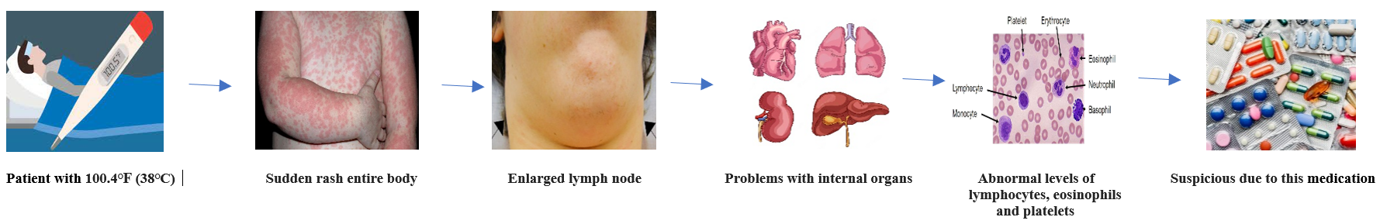

Figure 5: Pathophysiology of DRESS

Drugs that lead to DRESS syndrome are Anti-seizure drugs, such as lamotrigine, carbamazepine, and phenobarbital, Allopurinol, Antibiotics, are minocycline, vancomycin, and those that are sulfa-based, Sulfasalazine, drugs used to treat autoimmune diseases like rheumatoid arthritis and ulcerative colitis, NSAID drugs like ibuprofen and celecoxib and HIV medications, such as nevirapine [9].
Management of DRESS: In order to treat DRESS, systemic corticosteroids have been used.

- Rockey mountain spotted fever:

Rocky Mountain Spotted Fever is caused by the obligatory intracellular coccobacillus Rickettsia. Ticks, either Dermacentor andersoni like the Rocky Mountain wood tick in the west or Dermacentor variabilis like the American dog tick in the east spreads the disease. Although the disease was found in Idaho and Montana, the bulk of cases are concentrated in the United States' south central and southern areas, making the term "Rocky Mountain spotted fever" inaccurate from an epidemiologic standpoint. The sickness has been reported in almost every state [10].

Since RMSF is a seasonal illness, the majority of cases take place in the spring and summer, when tick activity is at its peak and human-tick contact is most common. The most commonly impacted groups include farmers, kids, and outdoor recreationists. A 5 to 25% mortality rate is possible. The prognosis is influenced by diagnosis of the illness and beginning of the proper antibiotic therapy.
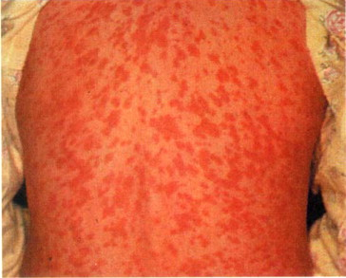

Figure 6: Symptoms of RMSF

Laboratory tests won't help with the diagnosis of RMSF during the acute stage. Recognition is solely dependent on comprehension of the clinical and epidemiologic symptoms, including fever, headache and rash in people who is in contact with ticks. It is best to look for signs of recent outdoor activity, travel to an endemic region, or a history of tick bites. Unfortunately, only 60 to 70% of patients initially examined the characteristic of fever, rash and history of tick bite.
Management of RMSF:

The cornerstone treatment for RMSF is doxycycline (administrated intravenously or orally). A pregnant woman or a small child may use chloramphenicol. For the seriously ill patient, supportive care may be required. Importantly, RMSF cannot be treated with normal broad-spectrum antibiotics [11].
- Toxic epidermal necrolysis:

Extensive exfoliating the epidermis and mucous membrane is a feature of toxic epidermal necrolysis (TEN), a potentially fatal illness that can cause sepsis and death [12]. The disease process that defines Steven-Johnson Syndrome (SJS) is the same that is seen in drug-induced epidermolysis. The degree of skin separation has the greatest difference [13].
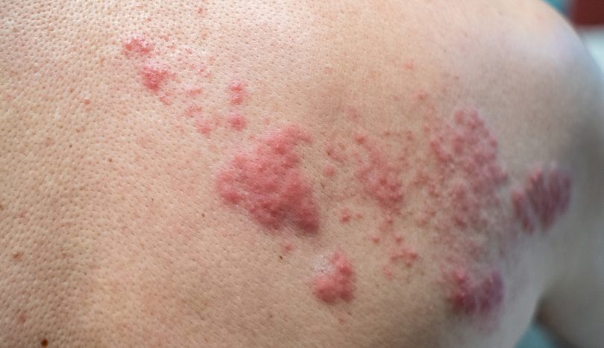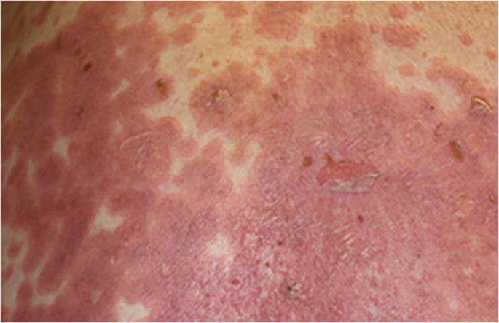
Figure 7: Toxic epidermal necrolysis
Etiology:

Lamotrigine, phenytoin, nevirapine, phenobarbital, sulfasalazine and NSAIDs are medication with a high risk of TEN (14,15,16).
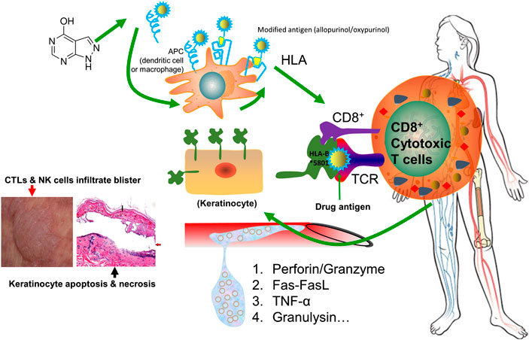
Figure 8: Toxic epidermal necrolysis Pathophysiology
Diagnosis:
Serum granulysin measurements made in the early days drug eruption may be predicted the development of this disease.
- Skin biopsy is necessary to verify the clinical diagnosis and exclude out other generalised rashes with blisters, such as staphylococcal scalded skin syndrome, as well as other rashes.
- Histopathology reveals keratinocyte necrosis, epidermal/epithelial necrosis and mild inflammation. Because the direct immunofluorescence test on the skin sample is negative, it is clear that condition is not caused by a buildup of antibodies on the skin.
- Blood tests are required to detect abnormalities, assess prognostic factors, and ensure enough hydration and nutrition, but they do not aid in diagnosis. Abnormalities may include:
  - Anaemia most often occurs (reduced haemoglobin).
  - Leucopenia (low white blood cell counts), particularly lymphopenia (low lymphocyte counts), is extremely common (90%)
  - Neutropenia, or decreased neutrophils, is a symptom that the outcome is poor.
  - There is no eosinophilia (increased eosinophil count) or atypical lymphocytosis (lymphocytes with unusual appearances).
  - 30% of people have mildly elevated liver enzymes, and 10% have observable hepatitis.
  - About 50% of people have protein leakage in urine. The majority of people experience some changes in renal function.
Investigations are being done on in-vitro diagnostic techniques for allergies medication, including SJS/TEN. Patch testing is not recommended because it rarely identifies the cause of SJS/TEN.

References:
- Kim YH, Ha JH, Kim JT, Kim SW. Managing necrotising fasciitis to reduce mortality and increase limb salvage. J Wound
Care. 2018 Sep 01;27(Sup9a): S20-S27.
- Lange JH, Cegolon L. Comment on: Early clinical manifestations of vibrio necrotising fasciitis. Singapore Med J. 2018 Aug;59(8):449.
- Heijkoop B, Parker N, Spernat D. Fournier's gangrene: not as lethal as previously thought? A case series. ANZ J Surg. 2019 Apr;89(4):350-352
- Erichsen Andersson A, Egerod I, Knudsen VE, Fagerdahl AM. Signs, symptoms and diagnosis of necrotizing fasciitis experienced by survivors and family: a qualitative Nordic multi-center study. BMC Infect Dis. 2018 Aug 28;18(1):429.
- Khalid M, Junejo S, Mir F. Invasive Community Acquired Methicillin-Resistant Staphylococcal Aureus (CA-MRSA) Infections in Children. J Coll Physicians Surg Pak. 2018 Sep;28(9):S174-S177
- Gawaziuk JP, Strazar R, Cristall N, Logsetty S. Factors predicting health-related quality of life following necrotizing fasciitis. J Plast Reconstr Aesthet Surg. 2018 Jun;71(6):857-862.
- Arnemann, J.; Sullivan, K.H.; Magee, A.I.; King, I.A.; Buxton, R.S. Stratification-related expression of isoforms of the desmosomal cadherins in human epidermis. J. Cell Sci. 1993, 104(Pt 3), 741–750.
- Seth D et al (2008) DRESS syndrome: A practical approach for primary care practitioners. Clinical Paediatrics. 47(9):947-52.
- American Academy of Allergy, Asthma & Immunology. (2020). Medications and drug allergic reactions.
- Klrkland KB, Wilkinson WE, Sexton DJ. Therapeutic delay and mortality in cases of Rocky Mountain spotted fever.Clin Infect Dis. 1995; 20: 1118-1121
- Spach DH, Liles WC, Campbell GL, Quick RE, Anderson Jr, DE, FriUche TR. Tick-borne diseases in the United States.N Engt J Med. 1993; 329: 936-947
- LYELL A. Toxic epidermal necrolysis: an eruption resembling scalding of the skin. Br J Dermatol. 1956 Nov;68(11):355-61.
- Bastuji-Garin S, Rzany B, Stern RS, Shear NH, Naldi L, Roujeau JC. Clinical classification of cases of toxic epidermal necrolysis, Stevens-Johnson syndrome, and erythema multiforme. Arch Dermatol. 1993 Jan;129(1):92-6.
- Pejčić AV. Stevens-Johnson syndrome and toxic epidermal necrolysis associated with the use of macrolide antibiotics: a review of published cases. Int J Dermatol. 2021 Jan;60(1):12-24.
- Moshfeghi M, Mandler HD. Ciprofloxacin-induced toxic epidermal necrolysis. Ann Pharmacother. 1993 Dec;27(12):1467-9.
- Mockenhaupt M, Viboud C, Dunant A, Naldi L, Halevy S, Bouwes Bavinck JN, Sidoroff A, Schneck J, Roujeau JC, Flahault A. Stevens-Johnson syndrome and toxic epidermal necrolysis: assessment of medication risks with emphasis on recently marketed drugs. The EuroSCAR-study. J Invest Dermatol. 2008 Jan;128(1):35-44.

