Synthesis and Applications of Functionalized Crown Ethers
Partha Pratim Das, Atul Kumar Stivastava
P.G. Dept. of Chemistry, Magadh University, Bodh-Gaya, Bihar
Email: parthapratimdasmu@gmail.com
Abstract: Chemistry of the crown ether has established itself as a new discipline since Pedersen's surprising discovery of dibenzo-18-crown-6 in 1967. The primary research goals of the scientific community across the globe were the synthesis of novel crown compounds and the characterization of their metal complexes. However over the years researchers have found several important applications of these crown ethers in numerous fields. Their extensive use in a variety of fundamental and applied chemistry fields heavily depends on methods for functionalizing them in order to produce compounds with the potential to perform a variety of tasks and be included into complex systems. Direct addition of functional groups on already synthesized macrocyclic backbone is very practical but understudied pathway to the traditional templated macrocyclisation method used to create functionalized crown ethers. Aromatic electrophilic substitution reactions are often employed for derivatizing aromatic crown ethers. Whereas, photochemical or thermal/chemical activation initiated and radical-mediated cross dehydrogenative coupling are the general methods used for aliphatic crown ethers. Direct functionalization methods simplify the synthetic process, allowing future altercations in the structural backbone and reveal novel applications for these multifaceted macrocycles in modern supramolecular research and industry. Following an overview of current functionalized crown ether syntheses, their uses in analytical chemistry are discussed in this chapter.
Keywords: Crown Ether, Macrocyclic, Supramolecular, fuctionlization

- History of Crown Ether
Crown ethers are macrocyclic compounds with several ethereal oxygen atoms joined together by organic spacers like "-CH₂CH₂-" groups. These macrocyclic compounds are some of the simplest. These substances came to light for the first time after C. J. Pedersen accidentally found the substance later known as dibenzo-18-crown-6 in the early 1960s¹. Due to the presence of free catechol as an impurity in the reaction mixture, he synthesised the predicted diol along with a little quantity of the crown ether while attempting to construct a linear diol starting from the catechol derivative. With a yield of 0.4%, he successfully isolated the crown ether, demonstrating his scientific ingenuity.

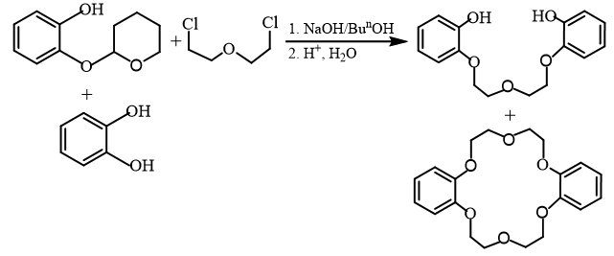
Scheme 1
It was discovered that dibenzo-18-crown-6 was only weakly soluble in methanol, but its solubility was significantly increased when alkali metal ions were added. He discovered that it was remarkably effective at complexing K⁺ ions². Worldwide excitement in Pederson's finding among chemists inspired rapid production of series of crown ethers for the complexation of Group I and Group II metal ions. This ground breaking work was awarded the Noble prize in Chemistry in 1987²⁻⁴. Currently, a vast variety of crown ethers with various ethereal O counts and diverse backbone topologies are known.
Crown ethers are categorized in two classes mainly, aliphatic and aromatic. Interlinked repeating units of ethylene oxide (-CH₂CH₂O-) in cyclic fashion are the most versatile aliphatic crown ethers. Cyclohexyl units are also abundant in aliphatic crown ether frame work. One or more endocyclic aromatic rings such as benzene ring, gives rise to aromatic crown ethers. Some of the examples of these two categories are displayed below:
Aliphtic Crown Ethers
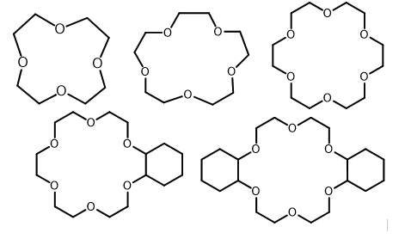
Aromatic Crown Ethers
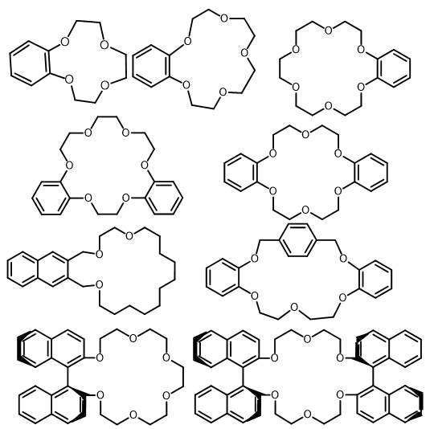

Figure 1
Flexible –CH₂CH₂- units and nucleophilic oxygen atoms produce an electron-rich cavity that can host the right guests. Researchers are focused on the mode of interaction of metal ions with crown ethers after complexation or formation of adducts. It was shown that a number of variables, such as the relative sizes of the crown ether (host) and the metal ions/other cationic guests, guest's charge, availability and position of oxygen atoms, bulkiness of the ring, and competitive participation from the mediated solvent, all play a role in the process²⁻⁵.
- Traditional Synthesis method via Template
These are initial synthetic methodologies for crown ethers using metal template. Templated techniques depend on the compatibility of the sizes between a metal cation that has been introduced and the cavity of the target macrocycle. Metal cation serves as a template by arranging precursor polyether framework towards the desired orientation before cyclization, minimising the production of polymeric side products. Li⁺, Na⁺, K⁺, and Cs⁺ favour serving as synthesis templates for cycles with 12, 15, 18, and 24 members, respectively. One such example is the synthesis of 18-crown-6 using K⁺ ion as template. Only 1.8 percent of 18-crown-6 is produced when hexaethylene glycol monochloride is intramolecularly alkylated with KOBu^{t} as the base. The yield of 18-crown-6 increased when tosylate was used as a leaving group in place of chloride. The yield in this case can reach up to ninety percent depending on the solvent utilised. Templated cyclization results in this atypically high yield of the cyclized product at a moderate concentration of reactants⁶. Here, the pottasium ion serves as a template to arrange the reactants so that the desired product gets produced with the higher efficiency. This cyclization reaction involves the deprotonation of the initial phenols or diols, and the base is crucial to the process. The yield of the macrocycle is significantly decreased if Bu^{n}₄NOH is used as the base instead of KOBu^{t}.
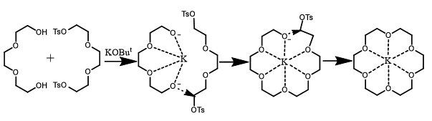
Scheme 2
General synthetic methodologies for one-step strategy involve nucleophilic addition reaction between n-ethyleneglycol-ditosylate and the functionalised diol. Whereas, first step of two-step strategy is formation of open functionalized (n+1)-ethylene glycol chain through the reaction of derivatized epoxide and n-ethylene glycol. Second step is one-pot tosylation-macrocyclization procedure, shown below [Scheme 3]⁶. Reaction between functionalized catechol with n-ethyleneglycol-ditosylate (or di-halogen) chain produces benzo-crown ether. Similarly, upon use of benzo-di-n-ethyleneglycol-ditosylate, dibenzo-crown ether is formed [Scheme 4]⁶.
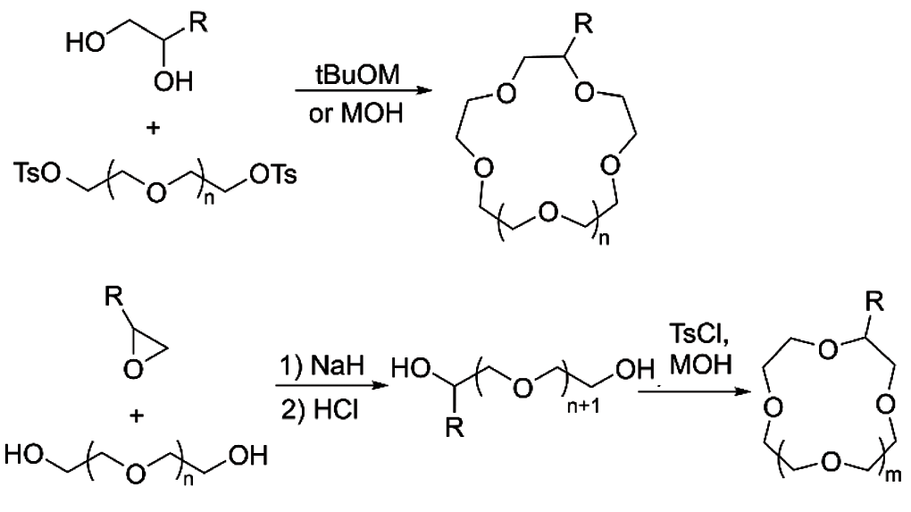
Scheme 3
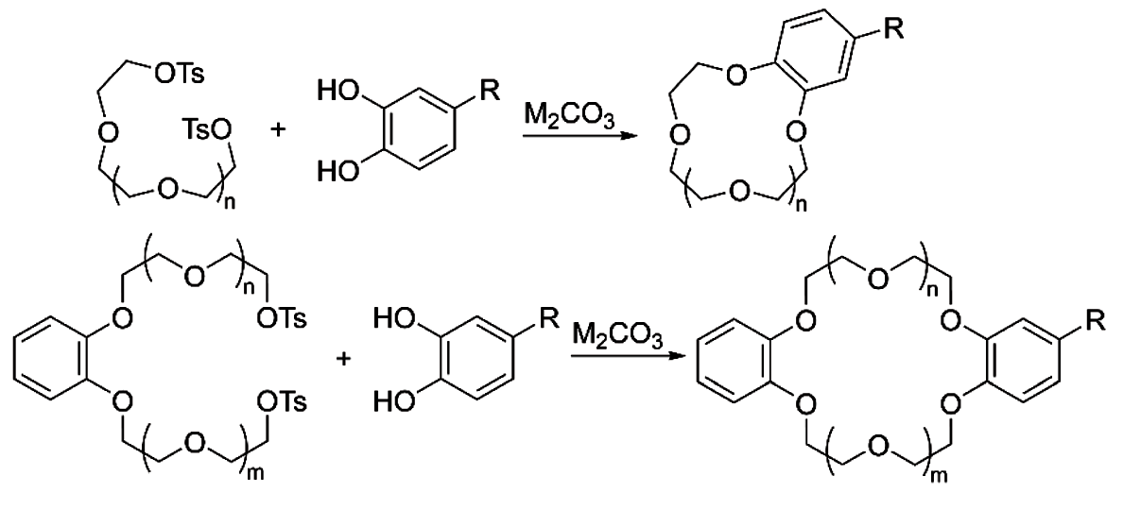
Scheme 4
- Host-Guest Chemistry of Crown Ethers
Crown Ether binds (Group I) alkali and (Group II) alkaline earth ions with specificity, creating adducts that gets solubilized in non-polar medium due to their lipophilic nature and serve as carriers for the charged species, thus, they been widely employed in ion extraction⁷ and phase transfer catalysis⁸. These also found usefulness as translocators of ions and synthetic channel building blocks, capable of passing through the lipidic membranes more recently⁹. Also, in aprotic solvents, they create supramolecular complexes of higher stability with a range of organic guests, proving that, their complexing power is not just restricted to metal cations. Arenediazonium salts¹⁰, which easily complex and stabilise with 18-crown-6 and 21-crown-7 are the earliest representatives of guests other than metal ions.
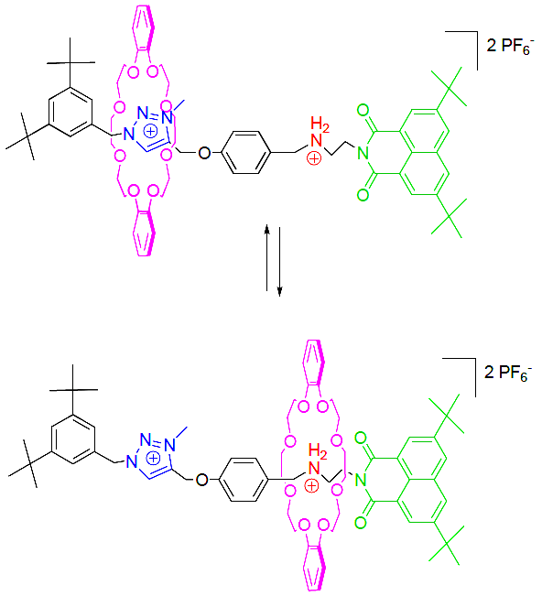
Scheme 5
Because of their abundance in π-electrons enriched aromatic groups, aromatic Crown ethers serve as hosts for variety of π-electron-poor visitors, including bipyridinium¹¹, diazapyrenium¹², bis-(pyridinium)ethane¹³, imidazolium¹⁴, and triazolium¹⁵ [Scheme 5]. Strong hydrogen bonds and donor-acceptor interactions in addition to electrostatic factors play a role in the synthesis and stability of these complexes.
Dibenzo-18-crown-6 primary alkylammonium ion complexes with primary ammonium cations¹⁶, have been the subject of in-depth research. Three alternating H-bonds are found between the oxygen atoms of the macrocycle and ammonium group, as a result of the face-to-face interaction between the host and guest, creating extremely stable supramolecular structures. Complexes generated with secondary as well as tertiary ammonium ions have significantly reduced stability as a result of this type of binding. Larger cavity crown ethers, such dibenzo-24-crown-8, combine with secondary alkylammonium ions to produce complexes where the cation enters the macrocycle's cavity¹⁷. Due to their ability to thread the right-sized crown ethers, secondary ammonium guests with axle-like designs¹⁸ can produce pseudorotaxanes¹⁹, which are practical supramolecular progenitors to mechanically interlocked molecules. By the virtue of being such multifaceted host molecule, of late, crown ethers have become major resource for mechanically interlocked systems in numerous rotaxane and catenane frameworks²⁰ and also found application in several moleculear machines²⁰⁻²², such as; molecular switches²³ (pH, redox or light sensitive) and molecular pumps²⁴.
- Functionalized Crown Ethers
Recently functionalization of crown ethers has gained immense interest in order to be inserted into dendrimers²⁵, polymers²⁶, metal organic frameworks²⁷. If one considers the functions of natural ionophores, for instance, one can see that they are created in a way that satisfies nature's functional requirements and functions effectively in a biological system. As a result, scientists started looking towards functionalizing supramolecules, which would eventually act as a link between the synthesis and the functional facet.
There are two basic methods for producing functionalized crown ethers: direct functionalization of already-formed crown ethers or templated macrocyclisation utilising starting materials that have already been functionalized. It's crucial to identify methods for performing selective reactions. In comparison to synthesis using the template approach, adding substituents to premade macrocycles is a better option, mainly for aliphatic ones, as the preparation of derivatized precursor typically necessitates a sizable number of steps, leading to loss of resources as well as time, in comparison to direct functionalization in single-step. The functionalized groups must be stable towards basic environment and heating under the macrocyclic ring enclosure reaction too. The lack of effective protocols and procedures that are meticulously specified and tested is the main drawback of direct techniques. Another downside of direct functionalization techniques is that high yields of the final product are typically only possible with an excess of the initial crown ether.
  - Direct functionalization of aliphatic crown ethers
Aliphatic Crown ethers are typically functionalized by selective oxidation of α-C(sp³)-H bond to α-C(sp³)-X (X = C, N, or F) bond, primarily through radical mediated cross coupling reactions of dehydrogenative nature²⁸⁻³⁰. This methodology involve three steps; (a) electrophilic radical generation, (b) hydron abstraction generating radical at electronically rich α-position, and (c) reaction between radical and coupling partner [Scheme 6]. Photochemical or thermal/chemical activation results in the production of an electrophilic radical. Under inert atmosphere, these reactions are often carried out and either fractional distillation or chromatography is used to easily purify the derivatives. Compared to thermal/chemical processes, approaches that rely on photochemical radical production have been shown to produce greater yields.
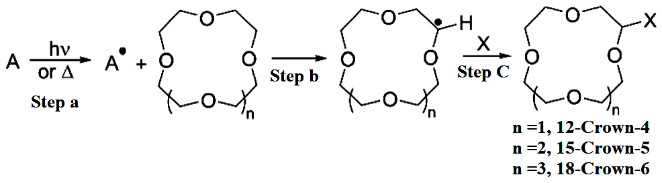
Scheme 6
4.1.1 Direct functionalization of aliphatic crown ethers by photochemical activation
Depending upon the nature of the R group at the keto species, irradiating a 1:1 mixture of 18-crown-6 and a ketone with a Hg lamp for quite a few hours yielded the expected mono-functionalized species with low to moderate yields³¹ [Scheme 7].
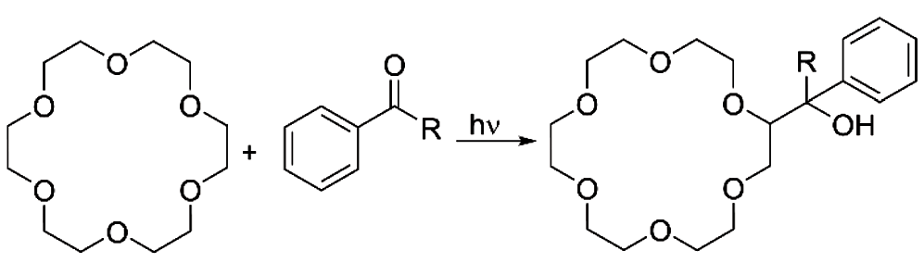
Scheme 7
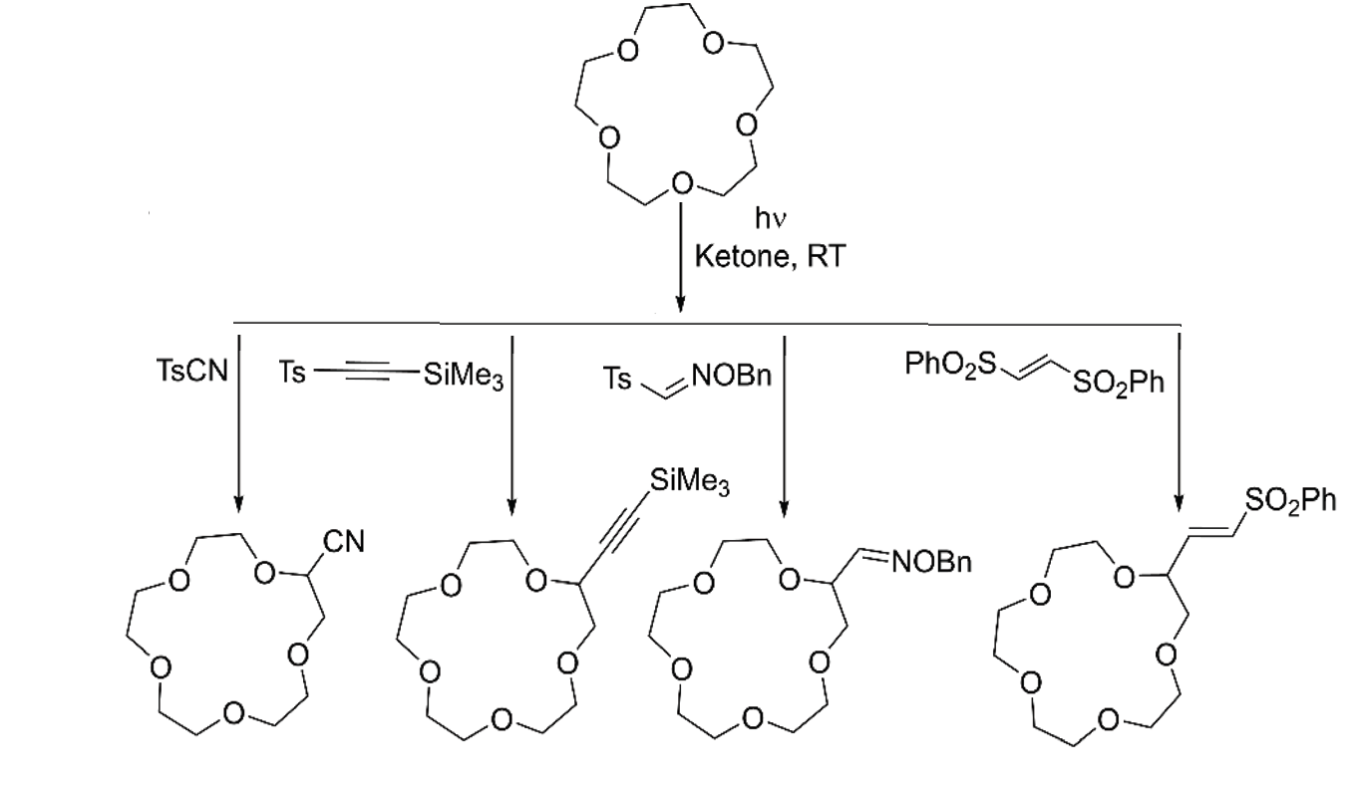
In order to create a generic approach for generation of C(sp³)-C bonds from electron-rich C(sp³)-H bonds, scientists took advantage of the capability of oxyl radicals (photochemically produced) for capturing one hydrogen atom through C-H bond cleavage in homolytic fashion.
Scheme 8
Here, the coupling partner gets introduced as a tosyl derivative, introducing cyano³², alkynyl³³, alkenyl³⁴, and aldoxime³⁵ functional groups. The ketone solely serves as a photosensitizer in the process. A combination that has an excess of 15-crown-5 and one equivalent of both the kenone and coupling partner at room temperature undergoes high yield mono-functionalization when exposed to Hg lamp [Scheme 8]. The time frames of reaction are dependent on the coupling partner.
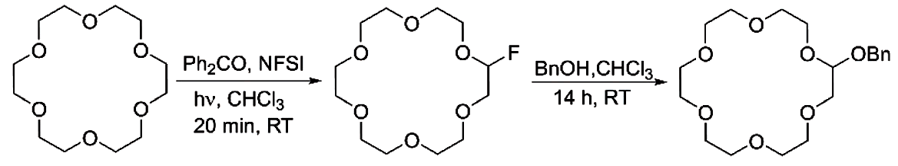
The scientific community employed a similar method for mono-fluorinating crown ethers to produce precursors suited for further nucleophilic substitutions. Into one equivalent of 18-crown-6 in CHCl₃, catalytic quantity of benzophenone, and N-fluorobis(phenyl)-sulfonimide as source of fluorine, are added, followed by irradiation of 320–390 nm radiation for twenty minutes at room temperature. Monofluorinated crown ether is produced with high yield by this procedure, and when benzyl alcohol is added in the next step of the process, it produced benzyl alcohol adduct in moderate yield via nucleophilic substitution [Scheme 9]³⁶. Additionally, mono-florination was carried out utilising copper(III) fluoride complex, which served as both a radical capture and hydrogen atom abstraction catalyst³⁷.

Scheme 9
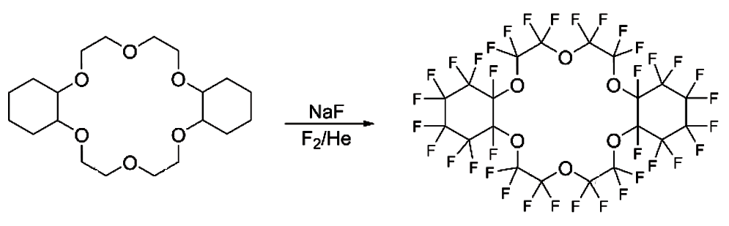
Only per-fluorination of aliphatic crown ethers and its cyclohexano derivatives have been studied before the recent investigations on direct mono-fluorination. The general process involved coating NaF with the selected precursor crown ether and then subjecting the solid combination to a stream of F₂ gas inside cryogenic fluorination reactor under Helium gas atmosphere³⁸. The method is presented in Scheme 10.

Scheme 10
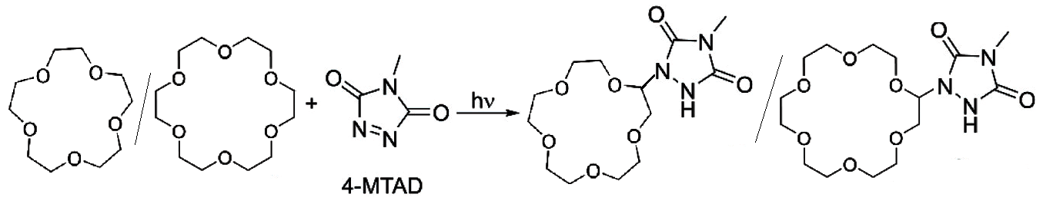
Product yield was low to moderate because it depends on a number of factors. Triazolinedione chemicals are widely used in the domains of click chemistry and polymer science. The formation of these occurs by a photochemically induced coupling reaction involving crown ethers with 4-MTAD [4-methyl-1,2,4-triazoline-3,5-dione]³⁹. To overabundance of 15-crown-5/18-crown-6, slowly 4-MTAD was added through many days, under constant radiation of laser light having wavelength of 514.5 nm. This produced the appropriate mono-functionalized α-urazolyl derivatives. [Scheme 11].
Scheme 11
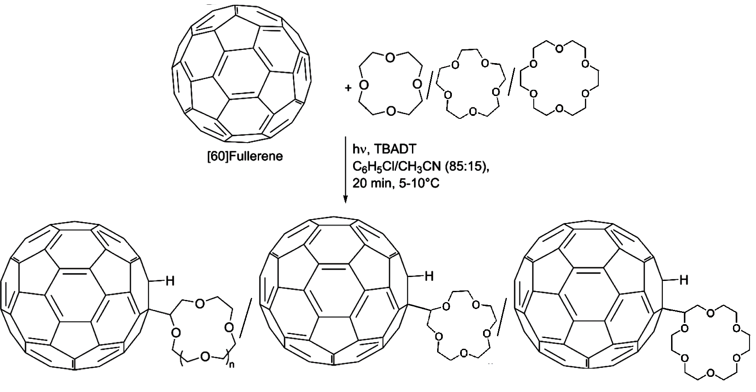
Covalent insertion of crown ether to [60]-fullerene garnered interest, because the resultant moieties have fascinating photophysical and electrochemical characteristics and their possible applications in sensing of ions and fluorescence switching devices. Direct coupling of cyclic ether to [60]-fullerene⁴⁰ was accomplished photochemically [Scheme 12] with the help of the photosensitizer tetrabutylammonium decatungstate, TBADT [(nBu₄N)₄W₁₀O₃₂]. The process involved exposing 100 equivalent of 12-cron-4/15-crown-5/18-crown-6 to a combination of one equivalent of C-60, and 0.5 equivalents of TBADT in chlorobenzene/acetonitrile (85:15) solution for 20 minutes at 5-10°C using a Xenon light.

Scheme 12

4.1.2 Direct functionalization of aliphatic crown ethers by thermal/chemical activation
Addition of crown ether to olefins has been done at 145ºC upon treatment of di-t-butylperoxide (DTBP) producing a radical, which attacks substrate’s double bond, resulting in alkylated end product. The methodology of slowly adding peroxide and olefin to 18-Crown-6 present in huge excess (crown ether: olefin: DTBP = 20: 2: 1)⁴¹, is shown in Scheme 13. The process has been used to functionalize 12-Crown-4, 15-Crown-5, and 18-Crown-6 with allyl chloride in order to introduce 8-hydroxyquinoline [Scheme 14]⁴².
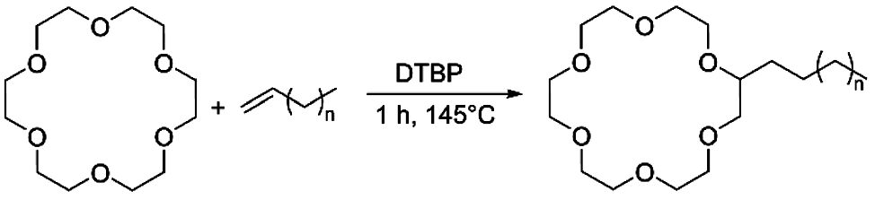
Scheme 13
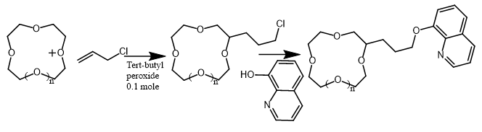
Scheme 14
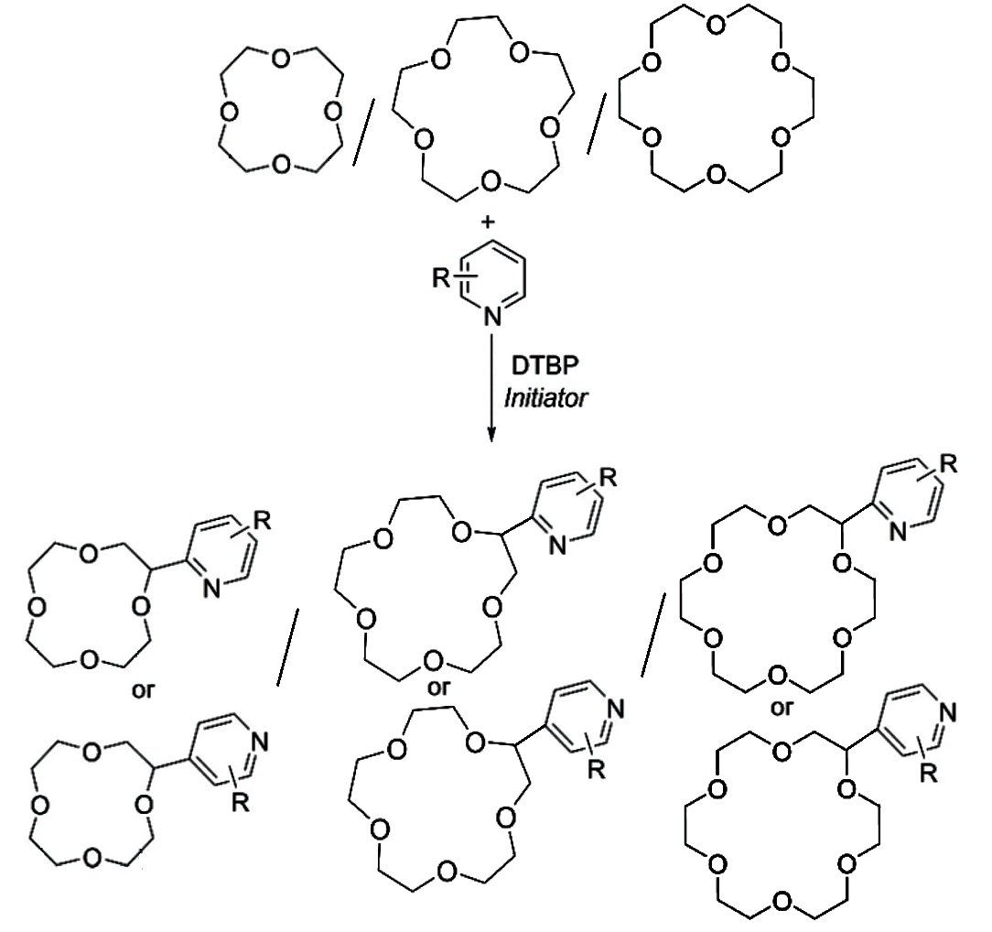
Scheme 15
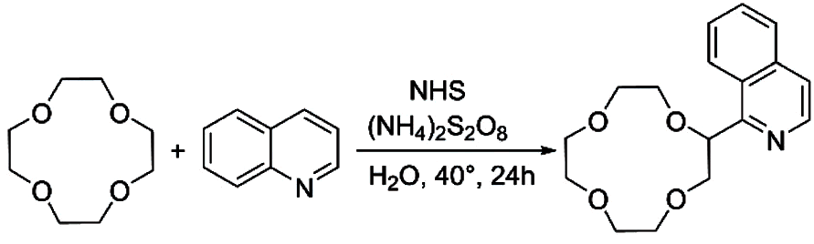
Scheme 16
High regioselectivity and good yield were achieved when di-t-butylperoxide was employed as a hydrogen abstractor (activated by photoirradiation) in the presence of radical initiators to functionalize crown ethers with N-aromatic bases⁴³ [Scheme 15]. Similar type of C_{α}-heteroarylation was performed mediated by N-hydroxysuccinimide (NHS). The process involves oxidizing NHS to produce a reactive N-radical form using ammonium persulfate [(NH₄)₂S₂O₈]⁴⁴. Abstraction of hydrogen at the ether is done by the produced radical, before moving on to regioselectively attack the heteroaromatic base [Scheme 16] with high yield.
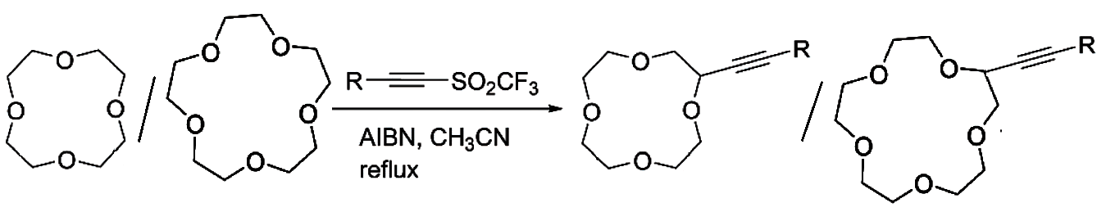
The direct alkynylation of 12-crown-4 and 15-crown-5 was accomplished using a novel method that uses trifluoromethyl radical's reactivity against abstraction of C_{α}-H for inserting alkyne group to numerous series of molecules. Moderate to high yield was observed during transformation to this appropriate mono-alkynylated end product. An excess of these ethers and one equivalent of acetylenic triflone in addition to catalytic quantity of radical initiator, azobisisobutyronitrile (AIBN), were heated in CH₃CN [Scheme 17]⁴⁵.

Scheme 17
4.2 Direct functionalization of aromatic crown ethers
Aromatic Crown ethers are generally functionalized by substitution reactions of electrophilic nature at the aromatic ring. These preparations were made possible by the availability of synthetic methodologies to form functionalized catechols. Lesser control over the number of functionalities inserted into the cyclic ether architecture is one of this strategy's weaknesses. The section is organised in accordance to the functional groups, which are introduced.
4.2.1 Direct functionalization with halides
In his review⁴⁶, Pluzhnik-Gladyr primarily concentrated on three direct halogenation methods; (A) in this case, molecular halogens are utilised. With this method, it is possible to produce di-halogenated benzo-crown ether and tetra-halogenated dibenzo-crown ether in satisfactory yields. As elemental halogen moieties are very reactive, it was impossible to make monofunctionalized derivatives [Scheme 18]. (B) N-halosuccinimides are used in this one. Though dibenzo-crown ether only reacts in organic solvents (CHCl₃ or CCl₄) or in mixes of ethanol and water, but benzo-crown ether was halogenated with ease by this method in water catalysed by addition of acid [Scheme 19]. (C) Hypohalites in water can be used to directly halogenate substances. Multiple halogen atoms are added under acidic conditions, whereas the process can be controlled under basic conditions to produce monohalogenated products [Scheme 20].
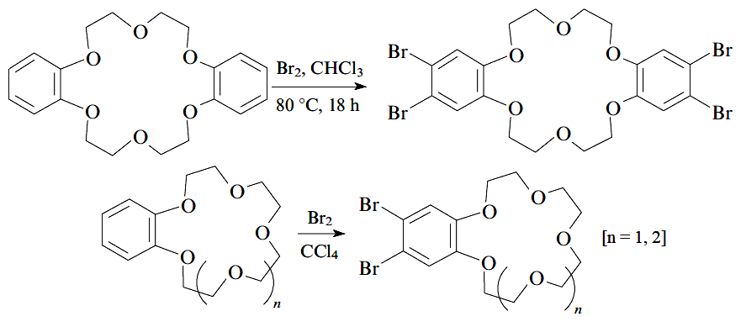
Scheme 18
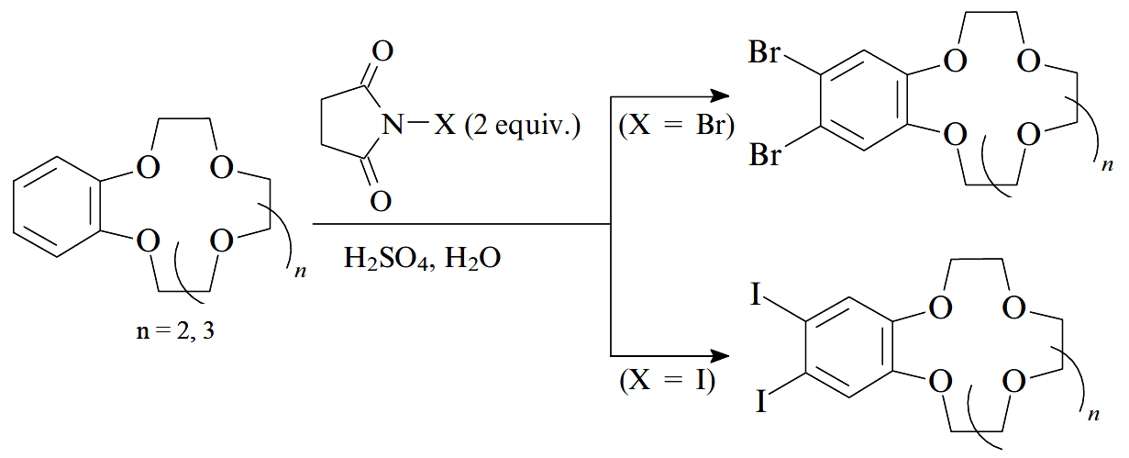
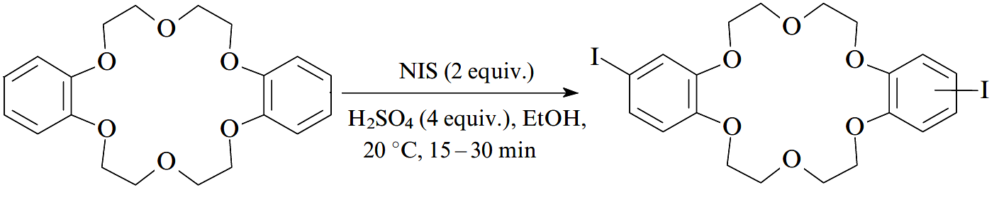
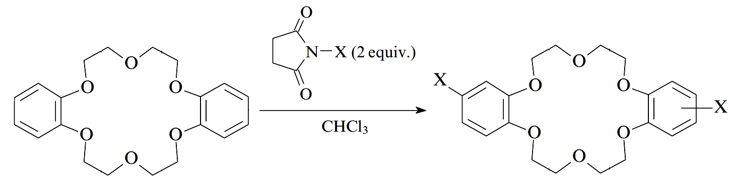
Scheme 19
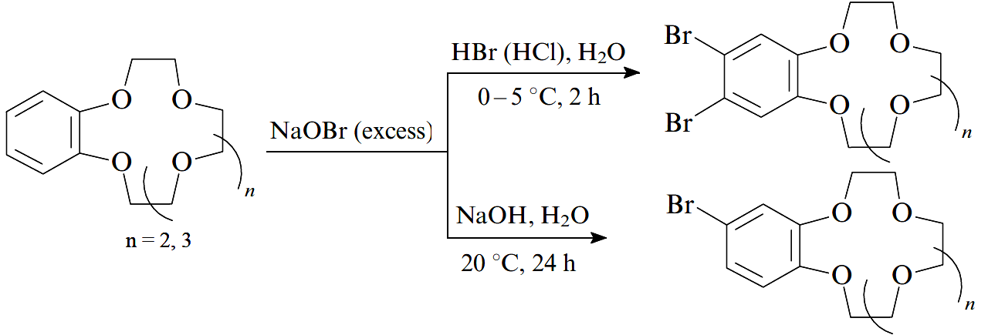
Scheme 20
Selectivity is the direct halogenation's most difficult challenge. Mono-functionalized product are generally formed with less yields as mixture of mono-functionalized and di-functionalized species (anti- and syn- isomers) both are formed. Recently, ceric ammonium nitrate [(NH₄)₂Ce(NO₃)₆] and NaBr mediated bromination of dibenzo-24-crown-8 in acetonitrile was reported [Scheme 21]. At room temperature, the reaction moves quickly with a yield of 39% for the monobrominated derivative⁴⁷.
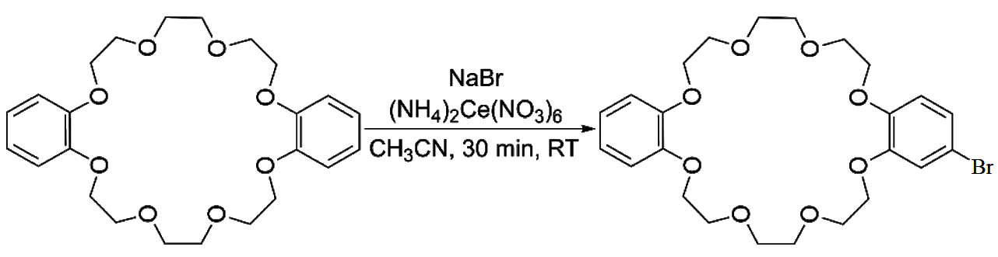
Scheme 21
4.2.2 Direct halomethylation
Direct halomethylation of crown ethers are done by several routes. For example; (A) bromomethylation using paraformaldehyde and hydrogen bromide in acetic acid⁴⁸ (B) bromomethylation by the combination of paraformaldehyde, sodium bromide and sulphuric acid⁴⁹, (C) chloromethylation by formaldehyde and gaseous hydrochloric acid⁵⁰, etc. All these pathways provide higher yields in general [Scheme 22].
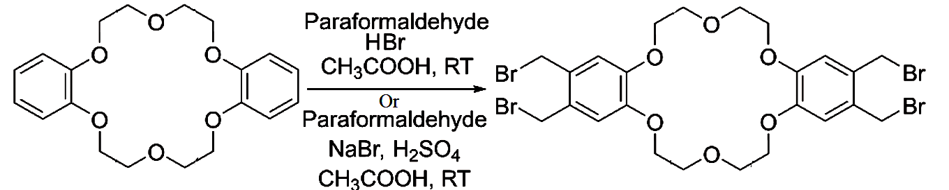
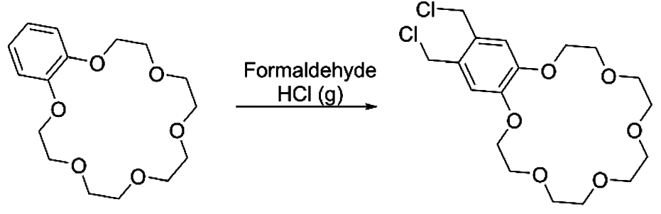
Scheme 22
4.2.3 Direct functionalization with nitro- and amine- groups
Following the widely established standard procedures for insertion of nitro- group into aromatic rings, direct nitration of aromatic crown ethers is performed. For instance, the syn- and anti- isomers are produced in a good yield when dibenzo-24-crown-8 reacts with HNO₃ in presence of acetic acid⁵¹, which aids in the generation of the electrophilic species [Scheme 23]. Few other methodologies include, formation of tetra-nitro derivatives of different dibezo-crown ethers, synthesised in high yields by substituting H₂SO₄ in place of CH₃COOH in the nitrating solution⁵², nitration by using potassium nitrate and excess polyphosphoric acid (PPA)⁵³ for both benzo-crown ether and dibenzo-crown ether. Since nitro-compounds can be quickly reduced to amino species in good yield and amino compounds too can be transformed into various functionalities for usage in polymers or further derivatization with chromophores^{51,54,55}, nitration is a very valuable procedure. Di- and tetra-modified amino functionalized crown ethers cannot be kept for a long time since they oxidise quickly and need to be handled in a controlled environment^{52,55}. A method utilising sodium azide in polyphosphoric acid had been published⁵⁶ for the direct amination of dibenzo-crown ether. An equimolar combination of the substrate ether and NaN₃ is heated in neat PPA at 100 °C to initiate the reaction [Scheme 24], which produces the mono-amino-functionalized derivative in high yield.
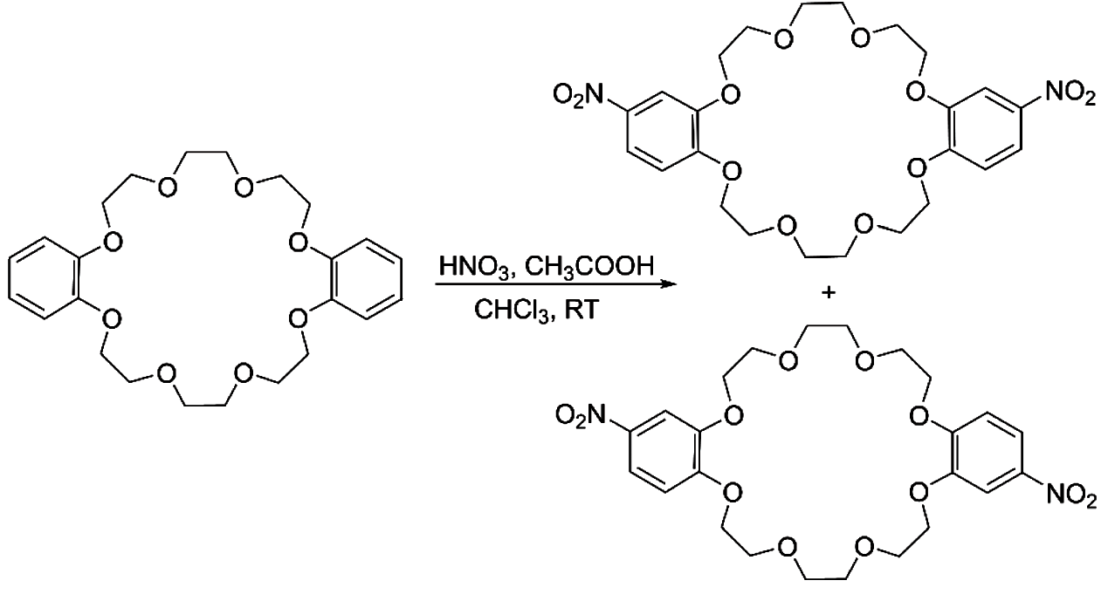
Scheme 23
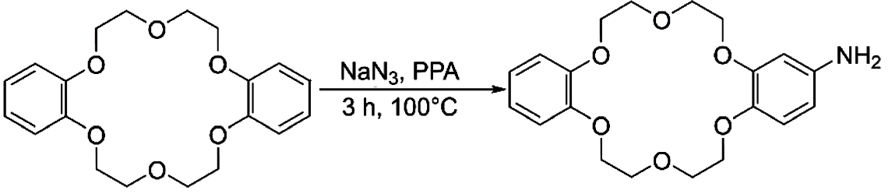
Scheme 24

4.2.4 Direct functionalization with formyl- group
Since formyl-benzo crowns are readily convertible to a variety of functional groups, they constitute important intermediates. The Vilsmeier-Heck reaction, which involves treating the substrate with N-methylformanilide and phosphoryl chloride for four hours at ~ 90 °C to produce a mono-functionalized derivative with a moderate yield⁵⁷, was used to first achieve direct formylation of Benzo-15-crown-5 [Scheme 25].
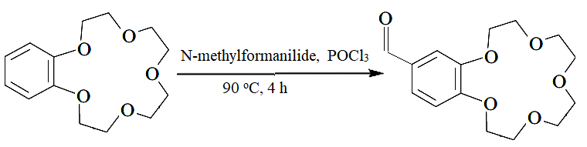
Scheme 25
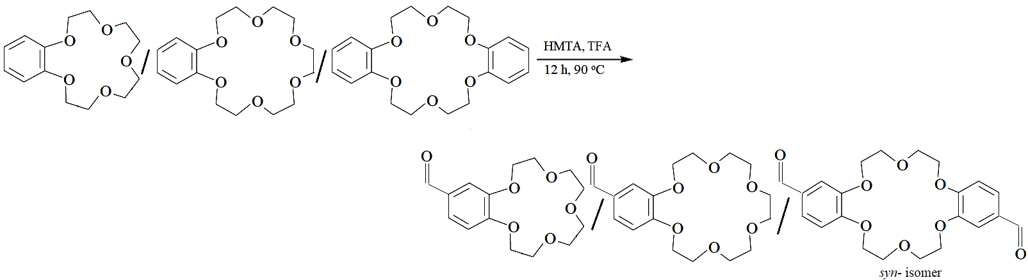
Similarly, the traditional Duff reaction was used to formylate benzo-15-crown-5/ benzo-18-crow-6/ dibenzo-18-crow-6 by combining the substrate, hexamethylenetetramine (HMTA) and trifluoroacetic acid (TFA), stirring for twelve hours at ~ 90 °C, and resulting both mono- and di-functionalized benzo and dibenzo crown ethers⁵⁸ [Scheme 26]. Here, only syn-isomers of dibenzo crown ether were formed.
Scheme 26
4.2.5 Direct functionalization with acyl- groups
Similar to formyl derivatives, acyl derivatives are acceptable precursors for a series of functional groups. Carboxylic acids/anhydride along with polyphosphoric acid had been used to directly acylate benzo crown ether and dibenzo crown ether⁵⁹ [Scheme 27]. Carboxylic acid along with Eaton's reagent (phosphorus pentoxide and methane sulfonic acid) can make the reaction happen too⁶⁰ [Scheme 28]. While modified dibenzo crown ethers were produced as a mixture of syn- and anti- isomers, benzo crown ether was mono-functionalized. Both routes produce comparable yields.
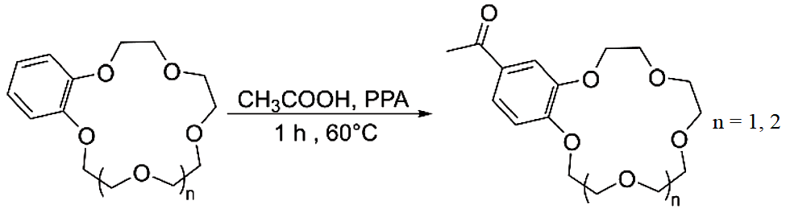
Scheme 27
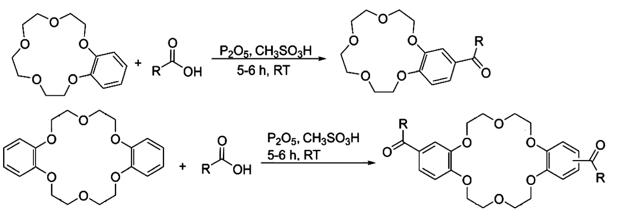
Scheme 28
When derivatizing dibenzo crown ethers, acetates have also been employed as a source of acetyl group⁶¹. In this method, the counter cation of the acetate ion undergoes complexation. It was proven that the rate and regioselectivity of the reaction are correlated with the size of the acetate's counter cation.
4.2.6 Direct functionalization with alkyl- groups
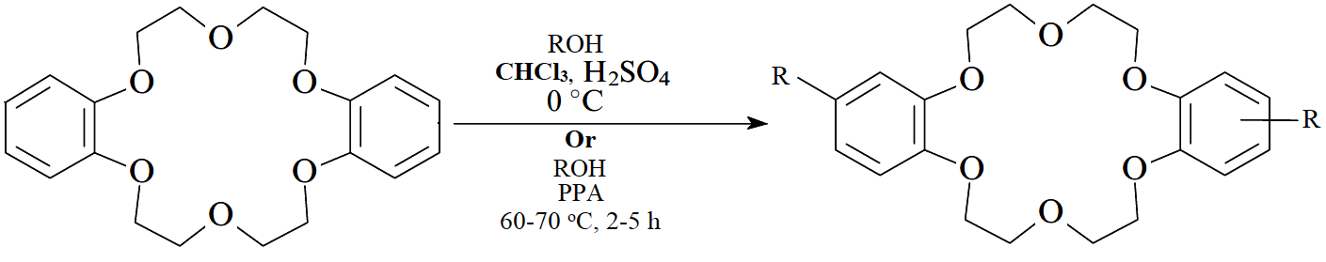
Crown ethers that have already been acylated, can be reduced to produce alkyl derivatives. There are more synthetic techniques as well, such as using combination of alcohols with sulfuric⁶² or polyphosphoric acids⁶³ [Scheme 29]. These approaches not only produced regioisomers but also had poor control over how many alkyl groups were inserted to the aromatic ring of the substrate.
Scheme 29
4.2.7 Direct Functionalization with sulfonate/ sulfonyl chloride group
Utilizing sulfuric acid in acetonitrile, benzo crown ether and dibenzo crown ether were sulfonated⁶⁴. Mono-sulfonated benzo crown ether as well as, di-sulfonated of dibenzo crown ether had been documented to have high yields. However, recent reports have pinpointed di-sulfonated products are typically mixtures of isomers, with properties different from one another. Sulfonated crown ethers are isolated as tetrabutylammonium salts, due to their greater solubility in polar protic solvents. The methodology is shown in Scheme 30. The use of potassium sulphate in polyphosphoric acid is a substitute method for sulfonation⁶⁵ [Scheme 31]. Treatment with sulfonyl chloride can easily transform sulfonated crown ethers into its chlorosulfonate derivatives. Chlorosulfonic acid in chloroform is used for direct chloro-sulfonation of aromatic crown ethers⁶⁶.
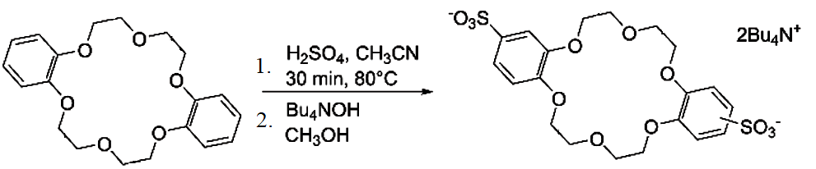

Scheme 30
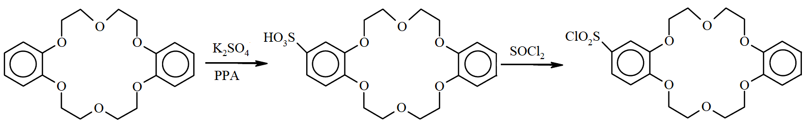
Scheme 31
There are numerous direct functionalization methodologies for incorporating several groups of importance, are reported in literature. Here our sincere effort has been to enlighten those which are versatile and most frequently used by scientific community all over the globe.
- Applications of Functionalized crown ethers
  - Application in chromatography
Functionalized crown ethers are broadly used for analytical purpose. Crown ethers can be used in ion chromatography due to their capacity to interact with Group I or Group II metal ions in a specific way.
Chromatography can be approached in one of two ways from an operational standpoint [Scheme 32]. (A) used in mobile phase; cations (M⁺) present in solution synthesizes complexes having the proper counteranions (A⁻) inside mobile phase having cyclic ethers (CE), producing lipophilic ion pairs (M⁺-CE:A⁻). These are then dispersed in a stationary lipophilic phase⁶⁷. (B) Crown ethers, inside the mobile phase form complexes with cations (M⁺) and gets dynamically (physically adsorbed) or covalently loaded into a stationary phase. Thus, cations (M⁺) get distributed among the stationary and mobile phase.
(A)
(B)
Scheme 32
    - Ion Chromatography on Physically Adsorbed Crown Ethers
Using the crown ethers listed below [Figure 2] coated on octadecyl-silanized silica (known as ODS), researchers reported separation of alkali metals by chromatography. When alkali metal ions got analysed using a 1:1 methanol-water eluent, it was discovered that the retention times decreased in the following order: K⁺ > Rb⁺ > Cs⁺ > Na⁺ > Li⁺, indicating relative stability of the complexes formed with cyclic ethers⁶⁸.

Figure 2

    - Ion Chromatography Upon Covalently-bonded Crown Ethers
The following crown ether polymers [Figure 3] were created upon poly-condensing benzo-crown ethers using HCHO along with toluene, xylene or phenol, as well as by condensing dibenzo-crown ethers with formaldehyde^{69,70}. The polymer particles placed inside the column of chromatographic set-up, were utilised for the purpose of chromatographic separation of ions, such as of several transition, Group I and Group II metal salts⁷⁰.

Figure 3
As per expectation, the retention behaviour, reflects the relative stability of metal complexes of concern. Nature of counter anions has a significant impact on the separation because these chromatographies are reliant on the generation of ionic pairs at the stationary phase.
  - Application in ion-selective electrode
Because they are neutral carriers, crown ethers can be used as the components with ion selectivity property, i.e. carriers of specific ions, at liquid membrane electrodes. The researchers have examined many macrocyclic carriers. Few are described below;
    - Lithium-Selective Electrode
Crown ether-based lithium-selective electrodes were described below;

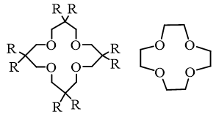
The membrane included the 16-crown-4 derivative mentioned below and linear response having nearly Nernstian slope was obtained. Activity spans from 10⁻⁴ to 1 M Li⁺ solution⁷¹. Same kind of 12-crown-4 derivatized electrode system was also reported⁷² [Figure 4]. However, in these cases, Lithium ion had lower selectivity than the proton, necessitating an increment of in the pH above five, for the sample solution Addition of an organophosphorus chemical⁷³ to the membrane in dibenzo-14-crown-4 derivatized PVC membrane electrode improves selectivity for Li⁺.

Figure 4
    - Sodium-Selective Electrode
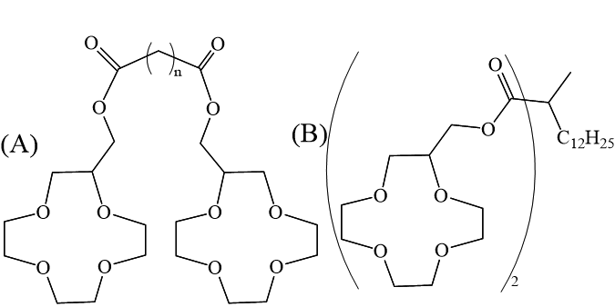
Bis-(12-crown-4) based derivatives [A and B in Figure 5] of neutral carriers are suitable for Poly Vinyl Chloride membrane electrode, which are selective Na⁺⁷⁴. The measurement of Na⁺ in urine and serum of human by the crown ether B-based coated wire electrode was successful⁷⁵. The electrode had a very long lifespan. Even after 300 measurements, there was no sign of deterioration. During this time, neither the selectivity factor nor the response slope changed.

Figure 5
    - Potassium-Selective Electrode
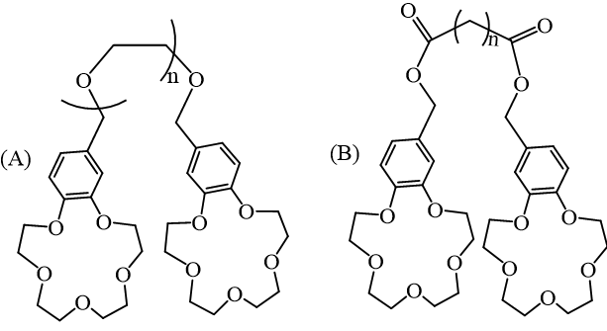
Bis-(15-crown-5) ether based membrane electrodes are helpful for being selective towards K⁺. Compound A, [Figure 6] which has been bis-(benzo-15-crown-5) functionalized, had been used onto PVC membrane electrode⁷⁶. The connecting polyoxyethylene chain's length affected the selectivity and responsiveness to K⁺. In the range of 10⁻⁵ to 0.1 M K⁺, the electrode using Compound A (n=0) displayed an almost Nernstian response, with immense selectivity of 4000 times over sodium ion had been shown. Plastisizer in the PVC membrane affects the electrode performance of diester functionalized bis-(benzo-15-crown-5) ether, compound B [Figure 6], and o-nitrophenyl octyl ether (NPOE) provided far better response with almost Nernstian slope and fast response time, than diphenyl phthalate⁷⁷.

Figure 6
  - Application in Colorimetry
For the majority of the metal ions, chromogenic species (colorimetric, photometric) which are selective towards ions, are known for a while. They have been proven useful too. However, efforts to create alkali metal selective reagents have long been ineffective. The discovery of crown ethers made it possible to create chromogenic reagents that are specific towards both Group I metals and Group II metals. In theory, the design process for Group I or Group II metal specific colorimetric chemicals is similar to other conventional chromogenic chelating agents. Metal complexes of crown ethers are least stable in water in general. This hampers the designing of crown ethers for colorimetric purpose in water. As an alternative, extraction based photometry or photometry in solution other than water, were chosen. Crown ether based dyes containing one and two protons which are dissociable, were generated to extract Group I and Group II metal ions, respectively. Crown ether performs metal binding and chromophores do the metal detection. Both perform independently. However, these two roles cannot be separated in actual reagents since the anionic chromophore can support crown ether's capacity to bind metals more or less.
5.3.1 Monoprotonic Crown Ethers
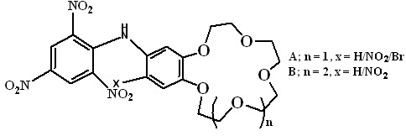
The distribution of the derivatized 4’-picrylamino-15-crown-5 dyes [A, Figure 7], between water and chloroform is greatly preferred by the latter. Potassium ions and rubidium ions were drawn into the chloroform solution when it came in touch with basic solutions of Group I metal salts⁷⁸. Following the production of Metal complex (ML) moiety inside organic solvents, chloroform solution showed colour change from orange (HL moiety) to blood red (L⁻ moiety). Lithium ion was not extracted, and sodium ion extraction was subpar. The resulting reactions are demonstrated below [Scheme 33]. Similar substances⁷⁹ [B, Figure 7] were also created from benzo-18-crown-6, which was shown to extract potassium ion the most successfully and to have a 1:1 composition in the extracted complex. The picryl-amino proton's acidity rises when a nitro group is added to the benzo crown ether's 5'-position. Since the reagent’s proton dissociation is implicitly involved into extraction constants, as dissociation constant of proton increases, the extraction constant too also increases. This indicates extraction of metal may occur at basic region of pH.

Figure 7

Scheme 33
5.3.2 Diprotonic Crown Ether Dyes
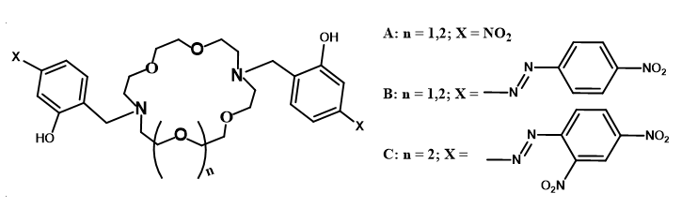
Adding a chromophore with two dissociable protons to crown ethers, results in dyes that are predicted to extract divalent metals, especially alkaline earth metals, with great precision. Diaza-crown ethers were easily converted into p-nitrophenol type reagents [A, Figure 8] and p-(p-nitropheny1azo)phenol type reagents [B and C, Figure 8]^{80,81}. These displayed remarkable alkaline earth metal ion extraction capabilities. These chemicals do not disperse into an aqueous solution and are soluble in organic solvents. Scheme 34 details how these reagents extract alkaline earth metal ions.

Figure 8

Scheme 34
Divalent metal extraction is not at all hampered by alkali metal ions. Selectivity for metal extraction is Ca²⁺ > Sr²⁺ > Ba²⁺ > Mg⁺. They are used to measure Ca²⁺ in blood serum because they are very efficient in extracting calcium ions. The reagents that is particularly sensitive to Ca²⁺ is the 4-(2.4 Dinitrophenylazo)phenol based chemical [C]. Since other M²⁺ ions such as, Cu²⁺, Pt²⁺, Cd²⁺, and Zn²⁺, generates similar type complexes in terms of stability with the cyclic ether molecules, they tend to interfere with the performance of these crown ether reagents. Since Pb²⁺ complex of [A] is so stable, it has actually been utilised as a photometric reagent for Pb²⁺-selective extraction. By utilising masking chemicals like sarcosine dithiocarbamate and nitrilotriacetic acid (NTA), these interferences can be eliminated.
5.3.3 Crown Ether Dyes Without Charge
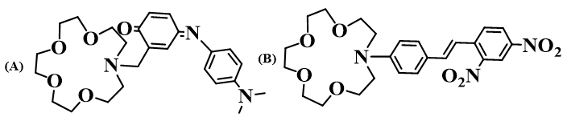
The fascinating non-charged cyclic ether family shown in Figure 9 changes colour as it interacts with Group I and Group II metal ions⁸²⁻⁸⁵. There’s donor and acceptor sites of electrons in these dye’s structural framework. Upon absorption of light of visible region, electronic charge transfer occurs towards the acceptor site from donor site. Incorporation of cyclic ether moieties allows metal ion to concurrently interact with either donor or acceptor part of the dye. It affects electron’s energy levels, responsible for absorption of light. On the complex formation, the spectral change can occasionally be exceedingly sharp.

Figure 9
  - Application in Lithium Ion Batteries
Performance of the battery of lithium manganite/carbon cell was governed by the activity of the lithium manganite. Positive electrode's [Lithium manganite] Manganese ions in solution moved towards negative electrode and accumulated there, impairing the operation of the cell in lithium-ion batteries. Levi et. al. developed polymers which are crown ether-based, poly-(vinylbenzo-18-crown-6) [A, Figure 10], which reduces Manganese ions in solution into getting deposited at the negative electrode, by trapping. Likewise, a capacity improvement of 26% was achieved upon completion of hundred cycles of the lithium manganite/carbon cell. Benzene ring served as a hard link connecting the macrocycle and the polymer backbone, and this link determined how well Mn ions could be trapped⁸⁶. The polymer serves as a Li-ion battery additive.
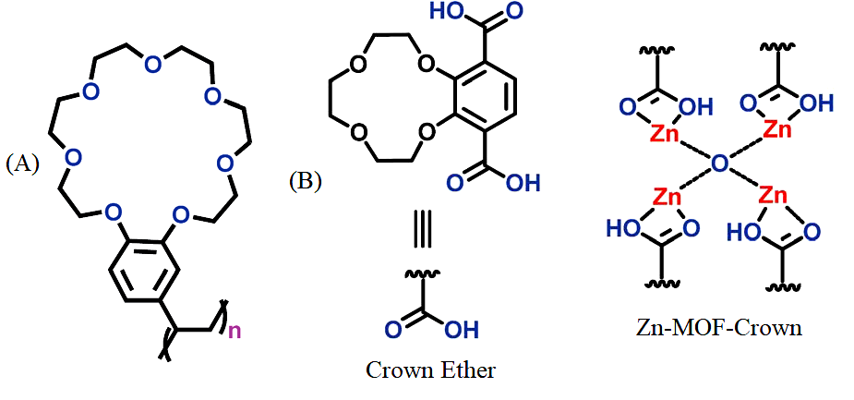
Microporous 12-crown-4 unit Zinc-based MOF-crown ether was reported. It could serve being the anode for a Li-ion battery having charging capacity of 273 mA h g⁻¹. More significantly, upon completion of five hundred cycles, it still held 88 percent of its capacity. Due to the interactions of the Lithium ions with crown ethers, at the time of charging and discharging, integrity of the rigid framework was not compromised at all [B, Figure 10]. Interestingly, the electrochemical performance of Zn-MOF-Crown improved having charging capacity of 348 mA h g⁻¹ and gained cycling capacity for increased time frame, when it complexed with Li⁺ ions and an adduct was produced. This indicates that the addition of crown ether might enhance the efficiency of green energy systems.

Figure 10
5.5 Morphological tuning of Cupric Oxide nanosheets
Dibenzothiazolyl dibenzo-18-crown-6 ether (DDCE) aided hydrothermal production of Cupric oxide nanosheets was reported as a new and simple process. This type of cyclic ether got additional cavity with coordinating sites for heteroatoms like, N and S. Additionally, these are suitable with water mediated hydrothermal process since it decomposes over eighty five degree centigrade and is soluble in water. These functionalized cyclic ethers got specific job of directing the growth of Cupric oxide crystals to take on various morphologies by acting as a structure-directing group. It has been noted that DDCE just serves as a structure-directing agent and does not participate in the response. CuO nanosheets, synthesised by the assistance of crown ether shows improved and encouraging electrochemical characteristics. The size, porosity, and shape of the material are affected by the DDCE concentration.⁸⁷
5.6 Polybenzoxazine Derivatized Crown Ethers for the Adsorption of Metal Ion
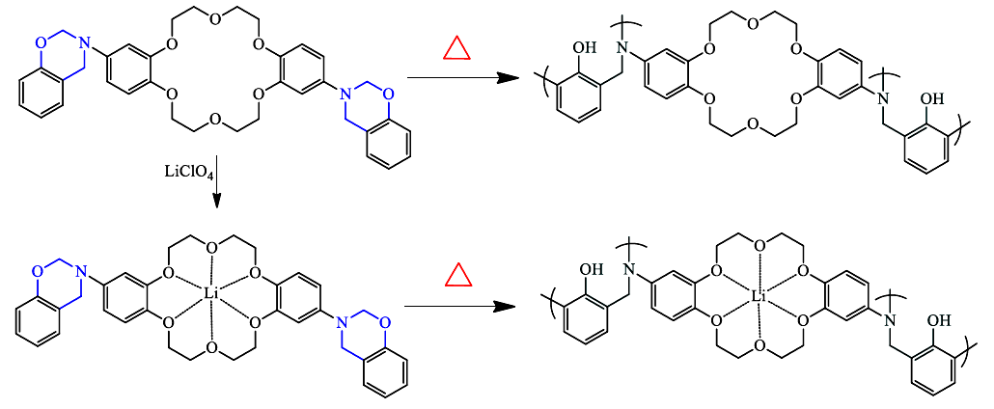
Crown-ether BZ is a benzoxazine monomer that has been functionalized with crown ether. The thermal stability and ring opening polymerization of the monomer under several forms of heating treatment were examined. Differential Scanning Calorimetry research showed that benzoxazine monomer exhibited lower curing temperature (210 °C). Polymerization by opening of the ring was stimulated by the flexible nature of the crown ether’s primary framework. DSC also looked upon the particular type of interactions between metal ions and crown ethers of the crown-ether BZ/Lithium perchlorate complexes. Lithium ions drastically lowered curing temperature by 34 °C, indicating that crown-ether BZ monomer's polymerization was accelerated by the metal ions, which served as an effective catalyst and promoter. [Scheme 35]⁸⁸.
Scheme 35
5.7 Miscellaneous Applications
Functionalized crown ethers have several uses in a variety of scientific fields of interest, including the development of dynamic crystalline polymers⁸⁹, molecular transporters⁹⁰, mechanically planar chiral rotaxanes⁹¹, interlocking polymers⁹², and higher order structures⁹³. These are also employed for catalysis⁹⁴, sensing⁹⁵, self-assembly⁹⁶, electrochemical ion transport⁹⁷, molecular recognition⁹⁸, metal ions sequestration⁹⁹, stimuli-responsive gel–sol transition¹⁰⁰ etc.
References:
- C. J. Pedersen, J. Am. Chem. Soc., 1967, 89, 7017–7036.
- C. J. Pedersen, Angew. Chem., Int. Ed. Engl., 1988, 27, 1021–1027.
- J.-M. Lehn, Angew. Chem., Int. Ed. Engl., 1988, 27, 89–112.
- D. J. Cram, Angew. Chem., Int. Ed. Engl., 1988, 27, 1009–1020.
- J. W. Steed and J. L. Atwood, Supramolecular Chemistry, Wiley, Chichester, 2nd edn, 2009.
- (a) B. R. Bowsher and A. J. Rest, J. Chem. Soc. Dalton Trans., 1984, 1421–1425. (b) I. Ikeda, S. Yamamura, Y. Nakatsuji and M. Okahara, J. Org. Chem., 1980, 45, 5355–5358. (c) G. W. Buchanan, A. Moghimi and C. I. Ratcliffe, Can. J. Chem., 1996, 74, 1437– 1446.
- R. Schettini, M. Sicignano, F. De Riccardis, I. Izzo and G. Della Sala, Synthesis, 2018, 4777–4795.
- J. Wang and S. Zhuang, Nucl. Eng. Technol., 2020, 52, 328–336.
- S.-P. Zheng, L.-B. Huang, Z. Sun and M. Barboiu, Angew. Chem., Int. Ed., 2021, 60, 566–597.
- J. Krane and T. Skjetne, Tetrahedron Lett., 1980, 21, 1775–1778.
- L. Pospisil and R. Fuoco, J. Electroanal. Chem., 1988, 240, 105–116.
- P. R. Ashton, S. E. Boyd, A. Brindel, S. J. Langford, S. Menzer, L. Perez-Garcia, J. A. Preece, F. M. Raymo, N. Spencer, J. F. Stoddart, A. J. P. White and D. J. Williams, New J. Chem., 1999, 23, 587–602.
- S. J. Loeb and J. A. Wisner, Angew. Chem., Int. Ed., 1998, 37, 2838–2840.
- N. Noujeim, K. Zhu, N. Vukotich and S. J. Loeb, Org. Lett., 2012, 14, 2484–2487.
- G. Ragazzon, A. Credi and B. Colasson, Chem. Eur. J., 2017, 23, 2149–2156.
- R. M. Izatt, J. D. Lamb, N. E. Izatt, B. E. Rossiter, Jr., J. J. Christensen and B. L. Haymore, J. Am. Chem. Soc., 1979, 101, 6273–6276.
- P. R. Ashton, E. J. T. Chrystal, P. T. Glink, S. Menzer, C. Schiavo, N. Spencer, J. F. Stoddart, P. A. Tasker, A. J. P. White and D. J. Williams, Chem. Eur. J., 1996, 2, 709–728.
- J. Groppi, L. Casimiro, M. Canton, S. Corra, M. Jafari-Nasab, G. Tabacchi, L. Cavallo, M. Baroncini, E. Fois and A. Credi, Angew. Chem., Int. Ed., 2020, 59, 14825–14834.
- E. Ishow, A. Credi, V. Balzani, F. Spadola and L. Mandolini, Chem. Eur. J., 1999, 5, 984–989.
- C. J. Bruns and J. F. Stoddart, The Nature of the Mechanical Bond: From Molecules to Machines, Wiley, Hoboken, 2016.
- V. Balzani, A. Credi and M. Venturi, Molecular Devices and Machines – Concepts and Perspectives for the Nanoworld, Wiley-VCH, Weinheim, 2008.
- S. Erbas-Cakmak, D. A. Leigh, C. T. McTernan and A. L. Nussbaumer, Chem. Rev., 2015, 115, 10081–10206.
- G. Ragazzon, C. Schäfer, P. Franchi, S. Silvi, B. Colasson, M. Lucarini and A. Credi, Proc. Natl. Acad. Sci. U. S. A., 2018, 115, 9385–9390.
- G. Ragazzon, M. Baroncini, S. Silvi, M. Venturi and A. Credi, Nat. Nanotechnol., 2015, 10, 70–75.
- D. Alivertis, V. Theodorou, G. Paraskevopoulos and K. Skobridis, Tetrahedron Lett., 2007, 48, 4091–4095.
- D. Xia, P. Wang, X. Ji, N. M. Khashab, J. L. Sessler and F. Huang, Chem. Rev., 2020, 120, 6070–6123.
- W. Gong, W. Zhang, F. A. Son, K. Yang, Z. Chen, X. Chen, J. Jiang, Y. Liu, O. K. Farha and Y. Cui, Chem, 2021, 7, 190–201.
- T. Newhouse and P. S. Baran, Angew. Chem., Int. Ed., 2011, 50, 3362–3374.
- S. A. Girard, T. Knauber and C.-J. Li, Angew. Chem., Int. Ed., 2014, 53, 74–100.
- A. K. Bagdi, M. Rahman, D. Bhattacherjee, G. V. Zyryanov, S. Ghosh, O. N. Chupakhin and A. Hajra, Green Chem., 2020, 22, 6632–6681.
- M. Tada and H. Hirano, Photochemistry of host-guest complex I, Tetrahedron Lett., 1978, 51, 5111–5114.
- S. Kamijo, T. Hoshikawa and M. Inoue, Org. Lett., 2011, 13, 5928–5931.
- T. Hoshikawa, S. Kamijo and M. Inoue, Org. Biomol. Chem., 2013, 11, 164–167.
- Y. Amaoka, M. Nagatomo, M. Watanabe, K. Tao, S. Kamijo and M. Inoue, Chem. Sci., 2014, 5, 4339–4345.
- S. Kamijo, G. Takao, K. Kamijo, M. Hirota, K. Tao and T. Murafuji, Angew. Chem., Int. Ed., 2016, 55, 9695–9699.
- R. Beniazza, B. Abadie, L. Remisse, D. Jardel, D. Lastécouères and J.-M. Vincent, Chem. Commun., 2017, 53, 12708–12711.
- J. K. Bower, A. D. Cypcar, B. Henriquez, S. C. E. Stieber and C. Zhang, J. Am. Chem. Soc., 2010, 142, 8514–8521.
- T.-Z.- Lin, W.-H. Lin, W. D. Clark, R. J. Lagow, S. B. Larson, S. H. Simonsen, V. M. Lynch, J. S. Brodbelt, Si. D. Maleknia and C.-C. Liou, J. Am. Chem. Soc., 1994, 116, 5172–5179.
- F. Risi, A.-M. Alstanei, E. Volanschi, M. Carles, L. Piazzala and J.-P. Aycard, Eur. J. Org. Chem., 2000, 617–626.
- M. D. Tzirakis and M. Orfanopoulos, Angew. Chem., Int. Ed., 2010, 49, 5891–5893.
- J. B. Zeleconok, V. V. Orlovskij, S. S. Zlotskij and D. L. Rachmankulov, J. Prakt. Chem., 1990, 5, 719–722.
- Y. B. Zelechonok, V. V. Orlocskii, S. F. Zelechonok, S. S. Zlotskii and D. L. Rakhmankulov, Chem. Heterocycl. Compd., 1990, 26, 121.
- N. Okugawa, K. Moriyama and H. Togo, Eur. J. Org. Chem., 2015, 4973–4981.
- S. Liu, A. Liu, Y. Zhang and W. Wang, Chem. Sci., 2017, 8, 4044–4050.
- J. Xiang, W. Jiang and P. L. Fuchs, Tetrahedron Lett., 1997, 38, 6635–6638.
- S. M. Pluzhnik-Gladyr, Russ. Chem. Rev., 2016, 86, 172–203.
- P. Mobian, N. Banerji, G. Bernardinelli and J. Lacour, Org. Biomol. Chem., 2006, 4, 224–231.
- A. Cygan, J. F. Biernat and H. Chadzynski, Pol. J. Chem., 1979, 53, 929–933.
- Y. Nakamura, A. Asami, T. Ogawa, S. Inokuma and J. Nishimura, J. Am. Chem. Soc., 2002, 124, 4329–4335.
- J. Otsuki, K. C. Russell and J.-M. Lehn, Bull. Chem. Soc. Jpn., 1997, 70, 671–679.
- W. M. Feigenbaum and R. H. Michel, J. Polym. Sci., Part A-1: Polym. Chem., 1971, 9, 817–820.
- S. A. Duggan, G. Fallon, S. J. Langford, V.-L. Lau, J. F. Satchell and M. N. Paddon-Row, J. Org. Chem., 2001, 66, 4419–4426.
- A. D. Grebenyuk, A. A. Andreev, I. A. Stempnevskaya, M. G. Levkovich and A. K. Tashmukhamedova, Chem. Heterocycl. Compd., 2000, 36, 1449–1456.
- (a) D. R. Patil, D. R. Chendam, A. G. Mulik, S. D. Jagdale, P. P. Patil and M. B. Deshmukh, Synth. Commun., 2015, 45, 1902–1911. (b) T. Liu, C. Bao, H. Wang, Y. Lin, H. Jia and L. Zhu, Chem. Commun., 2013, 49, 10311–10313.
- (a) J. D. Pike, D. T. Rosa and D. Coucouvanis, Eur. J. Inorg. Chem., 2001, 761–777, (b) G. J. Kirkovits, R. S. Zimmerman, M. T. Huggins, V. M. Lynch and J. L. Sessler, Eur. J. Org. Chem., 2002, 3768–3778.
- A. S. Lyakhovenko, A. V. Aksenov and M. M. Kugutov, Chem. Heterocycl. Compd., 2010, 46, 1138–1139.
- E. M. Hyde, B. L. Shaw and I. Shepherd, J. Chem. Soc. Dalton Trans., 1978, 1696–1705.
- F. Wada, H. Hirayama, H. Namiki, k. Kikukawa and T. Matsuda, Bull. Chem. Soc. Jpn., 1980, 53, 1473–1474.
- D. Vazquez-Garcia, A. Fernandez, M. Lopez-Torres, A. Rodriguez, A. Varela, M. T. Pereira, J. M. Vila and J. J. Fernandez, Organometallics, 2011, 30, 396–404.
- W. W. Parish, P. E. Stott and C. W. McCausland, J. Org. Chem., 1978, 43, 4577–4581.
- N. Z. Saifullina and A. K. Tashmukhamedova, Chem. Heterocycl. Compd., 2001, 41, 973–976.
- S. A. Kotlyar and E. I. Klimova, Chem. Heterocycl. Compd., 1990, 26, 1313–1314.
- A. K. Tashmukhamedova, I. A. Stempnevskaya, N. Z. Saifullina and M. G. Levkovich, Chem. Heterocycl. Compd., 1986, 22, 1461.
- T. Sasaki, S. Umentani, M. Masui, S. Tsurubou, T. Kimura and Z. Yoshida, Bull. Chem. Soc. Jpn., 1998, 71, 371–377.
- A. D. Grebenyuk, L. V. Zotova and A. K. Tashmukhamedova, Chem. Heterocycl. Compd., 2001, 37, 822–826.
- L. N. Markovskii, D. M. Rudkevich and V. I. Kal’chenko, Russ. J. Org. Chem., 1989, 25, 1995–2000.
- L. R Sousa D. H. Hoffman L. Kaplan and D. J. Cram, J. Am. Chem. Soc., 1974, 96, 7100-7101.
- K Kimura E. Hayara and T. Shono, J. Chem. Soc., Chem. Commun., 1984, 271-272.
- E. Blasius. K-P. Janzen W. Adrian, G. Klautke, R Lorscheider, P.-G. Maurer. V.B. Nauyen, T. Nguyen-Tien. G. Scholten and J. Stockemer, Fresenius Z. Anal. Chem., 1977, 284, 337-360.
- E. Blasius, K-P. Janzen, W. Adrian, W. Klein, H. Klotz, H. Luxenburger, E., Mernke, V.B. Nguyen T. Nguyen-Tien, R Rausch, J. Stockemer and A Toussaint, Talanta 1980, 27, 127-141.
- KM. Aalmo and J. Krane, Acta Chem. Scand., 1982, A36, 227-234.
- V.P.Y. Gadzekpo and G.D. Christian, Anal Left., 1983, 16, 1371-1380.
- T. Imato, M. Katahira and N. Ishibashi, Anal Chim Acta, 1984, 165, 285-289.
- T. Shono, M. Okahara, I. Ikeda, K. Kimura and H. Tamura, J. Electroanal. Chem., 1982, 132, 99-105.
- H. Tamura, K. Kumami, K. Kimura and T. Shono, Mikrochim Acta., 1983, II, 287-296.
- K. W. Fung and K. H. Wong, J. Electroanal. Chem., 1980, 111, 359-368.
- K. Kimura, T. Maeda, H. Tamura and T. Shono, J. Electroanal. Chem., 1979, 95, 91-101.
- (a) M. Takagi, H. Nakamura and K. Ueno, Anal. Lett. 1977, 10, 1115-1122 (b) H. Nakamura M. Takagi and K. Ueno, Talanta, 1979, 26. 921-927.
- H. Nakamura, M. Takagi and K Ueno, Anal. Chem., 1980, 52, 1668-1671.
- H. Nishida, M. Tazaki, M. Takagi and K Ueno, Mikrochim Acta., 1981, I, 281-287.
- M. Shiga, H. Nishida, H. Nakamura, M. Takagi and K. Ueno, Bunseki Kagaku, 1983, 32, E293-E300.
- J.P. Dix and F. Vogtle, Angew. Chem., 1978, 90, 893-894.
- J.P. Dix and F. Vogtle, Chem Ber.. 1980, 113, 457-470.
- J.P. Dix and F. Vogtle, Chem Ber. 1981, 114, 638-651.
- G. Hollmann and F. Vogtle, Chem Ber., 1984, 117, 1355-1363.
- F. Hu and T. Song, RSC Adv., 2017, 7, 54203-54212.
- S. D. Jagadale, A. M. Teli, S. V. Kalake, A. D. Sawant, A. A. Yadav and P. S. Patil, J. Electroanal. Chem., 2008, 816, 99-106.
- M. G. Mohamed and S. -W. Kuo, Macromolecules 2020, 53, 2420–2429.
- B. H. Wilson and S. J. Loeb, Chem, 2020, 6, 1604–1612.
- C. Schäfer, G. Ragazzon, B. Colasson, M. La Rosa, S. Silvi and A. Credi, ChemistryOpen, 2016, 5, 120–124.
- E. M. G. Jamieson, F. Modicom and S. M. Goldup, Chem. Soc. Rev., 2018, 47, 5266–5311.
- M. Zhang, D. Xu, X. Yan, J. Chen, S. Dong, B. Zheng and F. Huang, Angew. Chem. Int. Ed., 2012, 51, 7011–7015.
- C.-S. Kwan and K. C.-F. Leung, Mater. Chem. Front., 2020, 4, 2825–2844.
- C. Yoo, H. M. Dodge and A. J. M. Miller, Chem. Commun., 2019, 55, 5047–5059.
- A. V. Tsukanov, A. D. Dubonosov, V. A. Bren and V. I. Minkin, Chem. Heterocycl. Compd., 2008, 44, 899–923.
- K. Ghosh, H.-B. Yang, B. H. Northrop, M. M. Lyndon, Y.-R. Zheng, D. C. Muddiman and P. J. Stang, J. Am. Chem. Soc., 2008, 130, 5320–5334.
- Tetsuo Saji and lwao Kinoshita, J. Chem. Soc. Chem. Commun., 1986, 716-717.
- P. Bauerle and S. Scheib, Adv. Mater., 1993, 5, 848-853.
- S. Petrescu, S. Avramescu, A. M. Musuc, F. Neatu, M. Florea and P. Ionita, Mater. Res. Bull., 2020, 122, 110643.
- Z. Qi, P. M. de Molina, W. Jiang, Q. Wang, K. Nowosinski, A. Schulz, M. Gradzielski and C. A. Schalley, Chem. Sci., 2012, 3, 2073-2082.

