SYNTHESIS TECHNIQUES OF CADMIUM TELLURIDE THIN FILMS FOR SOLAR CELL APPLICATIONS
G.Kavitha¹, M.Karunakaran^{1*}, S.Usha¹ and K.Kasirajan²
¹ Thin Film and Nano Science Research Lab, PG and Research Department of Physics, Alagappa Government Arts College, Karaikudi, India – 630 003.
² Division of Advanced Materials Engineering, Kongju National University, Budaedong 275, Seobuk-gu, Cheonan-si, Chungnam 31080, Republic of Korea
Corresponding Author e-mail: tvdkaruna@gmail.com
Abstract
As a photoelectric and intense radiation detection compound, the II-IV semiconductor compound CdTe possesses suitable electrical and optical characteristics. By acting as an absorber material in thin-film solar cells created with inexpensive technology, CdTe has the potential to be used in the creation of high-efficiency solar cells. The methods for depositing thin films of CdTe are thoroughly examined in this chapter.
1. Introduction:
Sunlight is a renewable energy source. Solar energy is free, and solar modules have been used without any dangerous compounds being released. In general, the photoelectric effect was used to power many different types of solar cells [1]. Because it is non-toxic, plentiful, and has greater power conversion efficiency, silicon is now the leading photovoltaic material. The most significant disadvantage was that it was unreasonably costly. Later, the creation of a thin-film solar cell was revealed [2]. Thin film technology, according to experts, can reduce the quantity of active material in a cell while also being less expensive than crystalline silicon. Thin-film solar panels, which are a second-generation invention, are made by stacking one or more thin layers of PV components over a glass, plastic, or metal substrate [3]. The film's thickness may range from a few nanometers to tens of micrometers, making it significantly thinner than its rival, a normal first-generation c-Si solar cell with wafers 200 micrometers thick. As a result, thin-film solar cells are more flexible, lighter, and have lower abrasion resistance [4]. CdTe solar cells, the pioneer photovoltaic thin film technology, was created in the early 1970s and are currently the only ones to rank among the top ten global producers. This is because CdTe is exceedingly tough and chemically stable, and it can be deposited in a variety of ways, making it ideal for large-scale manufacture. CdTe is a potential absorber material for thin-film solar cells, with an energy band gap of roughly 1.5eV and an absorption coefficient greater than 10⁴ cm-1 [5]. It may be made as either a substrate or a superstrate. It is 90% absorbent at one mm thickness. CdTe thin film can therefore be used as the solar cell's effective absorber layer. Since the component is extremely stable in thin-film form and is less expensive to make than Si PV cells, the thin film is also considered to be important by the market [6]. Alternatively, using an injected carrier the CdTe multi-layer structure of the solar cell may provide excellent efficiency in both interface scattering and recombination. Keeping the p and n doping under control might lower the rating system. However, careful analysis of the p and n-type doped junction of CdTe and this area is essential [7].
Generally, the first component of thin-film deposition is the split of deposition techniques into physical and chemical processes. The initial step in the process starts with a solid substance that is sublimated before being placed on the substrate to transfer this gas. For this technique, a high vacuum—possibly even an ultrahigh vacuum—is required [8]. The second approach starts the deposition by utilizing reagents that, through chemical reactions, generate the material to deposit. The primary difference between these methods is how the vacuum is used during film deposition. Because of this, it is assumed that the first operation is more expensive than the second [9]. Another difference is that the physical technique enables more precise control of the deposition speed. The CdTe polycrystalline films may be created using a variety of processes, including chemical vapor deposition, closed space sublimation (CSS), pulsed laser deposition (PLD), Sputtering, thermal evaporation, screen printing, and molecular beam epitaxial approach [10].
2. Closed Space Sublimation:
CSS (close-spaced sublimation) is a simple method of physical vapor deposition. Under both vacuum and atmospheric pressure, materials that evaporate below 800°C, notable semiconductors, can be coated on substrates such as glass. The target materials must be solid, in the form of chunks or powder [11]. For example, cadmium telluride (CdTe) may be deposited in 10 minutes at 600°C with a thickness of 1-10 m, making it one of the shortest deposition durations among various physical vapor deposition (PVD) techniques. CSS and the binary compound material cadmium telluride (CdTe) are intimately related since CSS is used extensively in manufacturing CdTe thin films. When producing thin films on flexible glass substrates, one extreme must be considered: the glass transition temperature (Tg = 560°C). Controlling deposition pressure during the sublimation process can help improve thin-film characteristics [12].
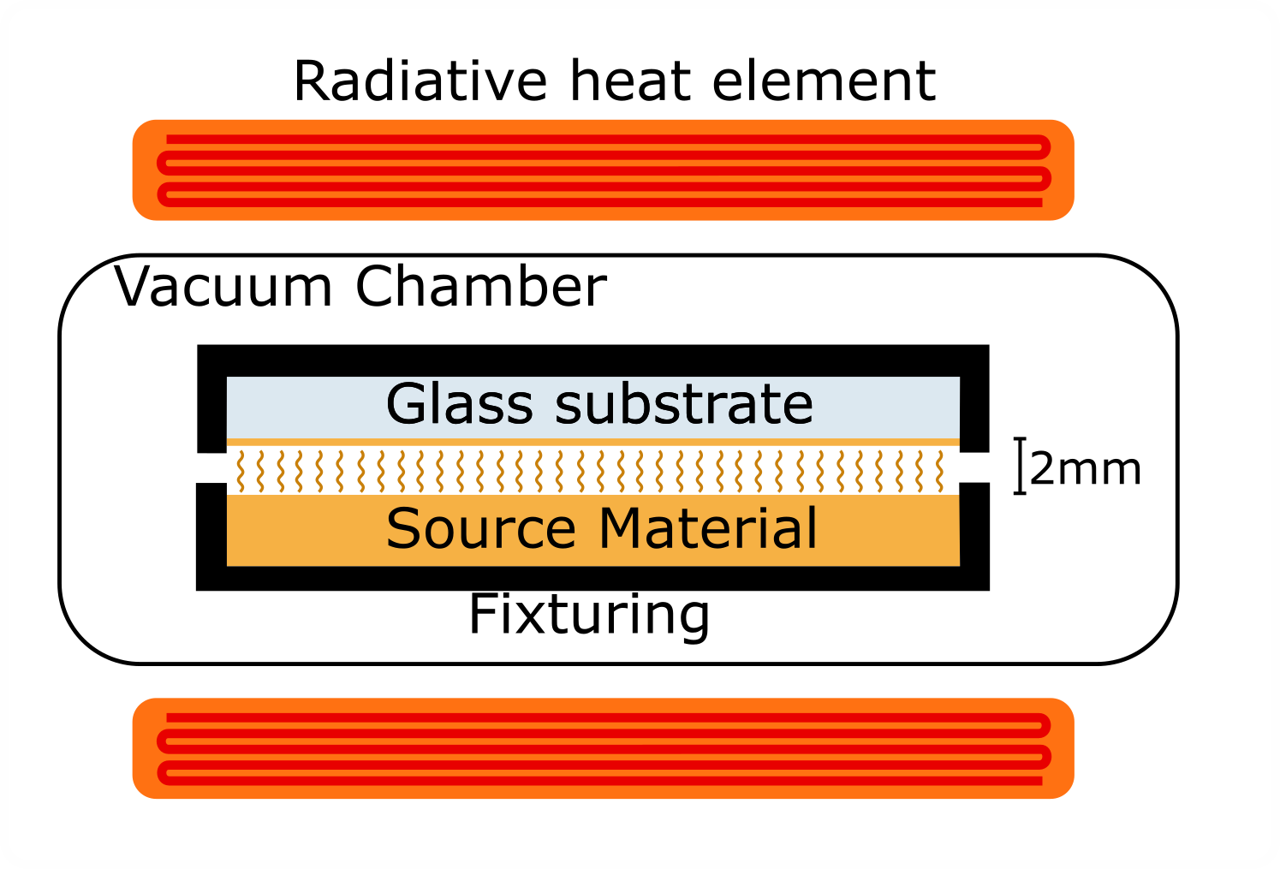
Fig.1. Working Model of Closed Space Sublimation
3. Chemical Vapour Deposition:
Chemical vapor deposition (CVD) is a common material processing technology that forms thin layers on a heated substrate by the chemical interaction with gas-phase precursors. CVD has a significant advantage over physical vapor deposition processes such as evaporation and sputtering because it is based on chemical reactions, which allow for variable deposition rates and high-quality products with great conformality [13]. The increasing need for semiconductor thin films during WWII provided the first impetus for the fast development of CVD technology. Carbon nanotubes, graphene, and 2D transition metal dichalcogenides (TMDs) have recently given fresh life to the electronics sector by developing more strict conditions for effective CVD of these materials with high purity and fine structure [14]. The architectures and properties of the resulting products may be modified using contemporary CVD systems and their modifications, such as plasma-enhanced CVD and metal-organic CVD (MOCVD). CVD is a common technology for applications in electronics, optoelectronics, surface modification, and biomedicine since it frequently does not need high vacuum working conditions [15].
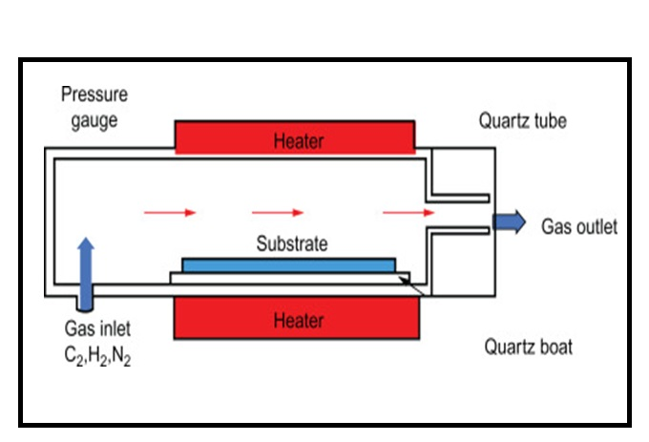
Fig.2. Systematic Diagram of Chemical Vapour Deposition
4. Spray Pyrolysis:
A simple chemical procedure called spray pyrolysis is mostly employed to deposit the TCO layer. In this procedure, the pressure of a gas crushes the substance in the solution (argon, air, nitrogen, etc.). For this procedure, it's essential to regulate the flow of the solution and the pressure of the gas. The pulverized solution is sprayed over the heated substrate to form the film. The kind of pulverization separates the two different spray pyrolysis methods that are now available [16].
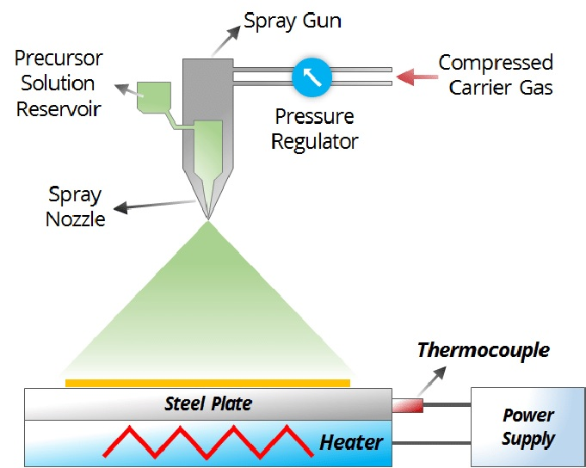
Fig.3. Working Principle of Spray Pyrolysis.
5. Sputtering technique:
Physically, the target is sublimated using the sputtering process, which involves bombarding the target with powerful ions. The plasma formed inside the apparatus, which contains a vacuum chamber, is where the ions are obtained. When the ions interact with the target, they shift momentum along with the target's atoms. Sputtering is the process of ejecting the target atoms when the energy of the ions striking is higher than the binding energy. Ion energy, incidence angle, ion mass, and atom mass in the target are the factors to take into account in this procedure. These ions are often produced from ionized gas, such as argon. [17].

6. Electro Chemical Deposition Technique:

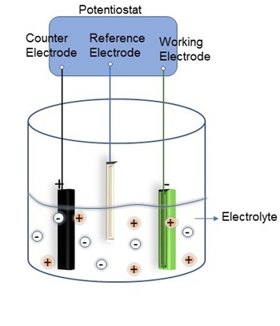
Fig.4. Electro chemical deposition set-up
Electro deposition would be a preferred method for producing CdTe due to its low cost, convenience, adaptability, and processability, as well as its ability to make p-, i-, or n-type materials by altering the cathodic voltage during electrodeposition [18]. Mathers and Turner published the first paper on the cathodic electrodeposition of CdTe using an aqueous solution of CdSO₄ and TeO₂ in 1928. Before the 1978 publication of Panicker et alpapers on the subject, there had been no fresh study on this electrodeposition method for 50 years. Electrodeposition is a popular approach for producing non-aqueous and anodic [19] deposition. A Cadmium source of CdTe employed in electrodeposition was the CdSO₄ precursor. The deposited CdTe layer should next be CdCl₂ treated to activate the CdTe characteristics for enhanced quality in CdS/CdTe solar cells. CdCl₂ treatment has been used as an activation step for CdTe solar cells since 1979 [20], and the efficiency of solar cells has always risen by an order of magnitude with this so-called "magic step". The CdCl₂ treatment is thought to accelerate grain development, improve charge carrier recrystallization and lifespan, modify the doping concentration, and eliminate defects and Te precipitations in CdTe thin films [21]. In light of these benefits, this work conducted comprehensive research on CdTe electrochemical anodization with an aqueous suspension chloride precursor utilizing Cadmium chloride as the Cadmium source rather than Cadmium sulfate [22].
7. Conclusion:
This chapter's goal is to provide a summary of the various methods for depositing CdTe thin films. All of the methods stated above are novel because they allow for the creation of thin films with various qualities. For instance, traditional solar cells are made using physical methods, whereas transparent technology is made using chemical methods due to their quick deposition times. Differ in various respects, the method used is determined by the uses for the thin films.
Reference:
- Anon, 2022. A review of metal oxide thin films in solar cell applications. International Journal of Thin Film Science and Technology, 11(1), pp.37–45.
- Joël Tchognia Nkuissi, H. et al., 2020. Toxic materials used in thin film photovoltaics and their impacts on environment. Reliability and Ecological Aspects of Photovoltaic Modules.
- Efaz, E.T. et al., 2021. A review of primary technologies of thin-film solar cells. Engineering Research Express, 3(3), p.032001.
- Breeze, P., 2016. Types of solar cells. Solar Power Generation, pp.57–70.
- Romeo, A. & Artegiani, E., 2021. CdTe-based thin film solar cells: Past, present and future. Energies, 14(6), p.1684.
- Hall, R.S., Lamb, D. & Irvine, S.J., 2021. Back contacts materials used in thin film CdTe solar cells—a review. Energy Science & Engineering, 9(5), pp.606–632.
- Hakeem, A.M.A. et al., 2021. Study the effect of type of substrates on the microstructure and optical properties of CdTe thin films. Optik, 225, p.165390.
- Jilani, A., Abdel-wahab, M.S. & Hammad, A.H., 2017. Advance deposition techniques for thin film and coating. Modern Technologies for Creating the Thin-film Systems and Coatings.
- Hamedani, Y. et al., 2016. Plasma-enhanced chemical vapor deposition: Where we are and the outlook for the future. Chemical Vapor Deposition - Recent Advances and Applications in Optical, Solar Cells and Solid State Devices.
- Ray, S., Bangera, K.V. & Tarafder, K., 2021. Synthesis and characterization of Cu doped CdTe thin films for solar cell application. Materials Today: Proceedings, 39, pp.2000–2004.
- Amin, N. & Rahman, K.S., 2017. Close‐spaced sublimation (CSS): A low‐cost, high‐yield deposition system for cadmium telluride (CdTe) thin film solar cells. Modern Technologies for Creating the Thin-film Systems and Coatings.
- Amin, N., Karim, M.R. & ALOthman, Z.A., 2022. An in-depth analysis of CdTe thin-film deposition on ultra-thin glass substrates via close-spaced sublimation (CSS). Coatings, 12(5), p.589.
- Sun, L. et al., 2021. Chemical vapour deposition. Nature Reviews Methods Primers, 1(1).
- Choy, K., 2003. Chemical vapour deposition of coatings. Progress in Materials Science, 48(2), pp.57–170.
- Kuzminykh, Y. et al., 2013. High vacuum chemical vapour deposition of oxides: Surface and Coatings Technology, 230, pp.13–21.
- Arce-Plazaa, A. et al., 2017. Study and application of colloidal systems for obtaining cdte+te thin films by spray pyrolysis. Journal of Analytical and Applied Pyrolysis, 124, pp.285–289.
- Amorim, M. et al., 2011. Recent developments on silicon carbide thin films for piezoresistive sensors applications. Silicon Carbide - Materials, Processing and Applications in Electronic Devices.
- Pandey, R.K., Maffi, S. & Bicelli, L.P., 1993. Study of CdTe electrodeposition from a nonaqueous bath. Materials Chemistry and Physics, 35(1), pp.15–20.
- Abdul-Manaf, N. et al., 2015. Electro-plating and characterisation of CdTe thin films using CDCL2 as the cadmium source. Energies, 8(10), pp.10883–10903.
- HAM, D. et al., 1990. Cheminform abstract: Anodic electrosynthesis of CdTe thin films. ChemInform, 21(11).
- Arce-Plaza, A. et al., 2019. CdTe thin films: Deposition techniques and applications. Coatings and Thin-Film Technologies.
- Dharmadasa, I. et al., 2017. Electroplating of CdTe thin films from cadmium sulphate precursor and comparison of layers grown by 3-electrode and 2-Electrode Systems. Coatings, 7(2), p.17.

