ANEKA FOR CLOUD APPLICATION PLATFORM

Mr.Dhruva M.S,  Assistant professor, Dept of CSE,  BGS Institute of technology, ACU  BG nagara, Mandya District,  dhruvams@bgsit.ac.in. | Mrs.Vani N,  Assistant professor,Dept of CSE,  BGS Institute of technology,ACU  BG nagara, Mandya District,  vanin@bgsit.ac.in.

ABSTARCT
Aneka is an Application Platform-as-a-Service (Aneka PaaS) for Cloud Computing. It goes about as a structure for building modified applications and sending them on one or the other public or confidential Clouds. One of the critical elements of Aneka is its help for provisioning assets on various public Cloud suppliers, for example, Amazon EC2, Windows Azure and GoGrid. In this part, we will give Aneka stage and its reconciliation one of the public Cloud foundations, Windows Azure, which empowers the utilization of Windows Azure Compute Service as an asset supplier of Aneka PaaS. The coordination of the two stages will permit clients to use the force of Windows Azure Platform for Aneka Cloud Computing, utilizing countless figure occurrences to run their applications in equal. Besides, clients of the Windows Azure stage can profit from the coordination with Aneka PaaS by embracing the high level elements of Aneka as far as various programming models, planning and the board administrations, application execution administrations, bookkeeping and valuing administrations and dynamic provisioning administrations. At last, notwithstanding the Windows Azure Platform we will delineate in this section the combination of Aneka PaaS with other public Cloud stages like Amazon EC2 and GoGrid, and virtual machine the board stages like Xen Server. The new help of provisioning assets on Windows Azure by and by demonstrates the versatility, extensibility and adaptability of Aneka.
Keyword
Cloud Computing, Platform–as-a-Service (PaaS), Aneka, Windows Azure, Dynamic Provisioning, and Cloud Application Development.

ANEKA: Cloud Application Platform
Aneka is a stage and a structure for creating disseminated applications on the Cloud. It saddles the extra CPU patterns of a heterogeneous organization of work area PCs and servers or datacenters on request. Aneka gives designers a rich arrangement of APIs for straightforwardly taking advantage of such assets and communicating the business rationale of utilizations by utilizing the favored programming reflections. Framework chairmen can use on an assortment of instruments to screen and control the conveyed foundation. This can be a public cloud accessible to anybody through the Internet, or a confidential cloud comprised by a bunch of hubs with confined admittance.
Aneka incorporates an extensible arrangement of APIs related with programming models like MapReduce.
These APIs support different cloud models like a private, public, crossover Cloud.
Manjra soft centers around making inventive programming innovations to work on the turn of events and arrangement of private or public cloud applications. Our item assumes the part of an application stage as a help for numerous distributed computing.
Numerous Structures:
Aneka is a product stage for creating distributed computing applications.
In Aneka, cloud applications are executed.
Aneka is an unadulterated PaaS answer for distributed computing.
Aneka is a cloud middleware item.
Manya can be conveyed over a network of computers, a multicore server, a data center, a virtual cloud infrastructure, or a combination thereof.

Multiple containers can be classified into three major categories:
- Textile services
- Foundation Services
- Application Services
- Textile Services: Texture Services characterizes the least level of the product stack that addresses various holders. They give admittance to asset provisioning subsystems and checking highlights executed in quite a large number.
- Foundation Services: Texture Services are the center administrations of Manya Cloud and characterize the framework the executives highlights of the framework. Establishment administrations are worried about the coherent administration of a circulated framework based on top of the foundation and offer subordinate types of assistance for conveying applications.
- Application Services: Application services manage the execution of applications and constitute a layer that varies according to the specific programming model used to develop distributed applications on top of Aneka.
Aneka in Cloud Computing
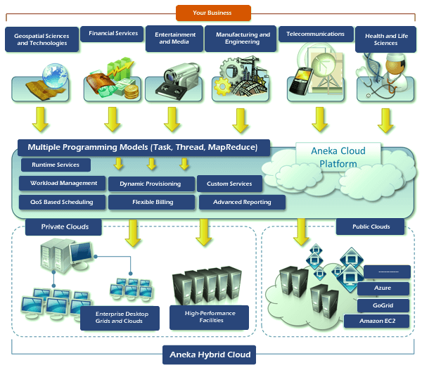
Fig 1: Aneka in Cloud Computing

In programming, structures are apparatuses that assist experts with building applications, sites and computerized frameworks. Since they capability as outlines for these various activities, systems can assist software engineers, designers and coders with conducting undertakings all the more actually. On the off chance that you're keen on a vocation in programming improvement, you might profit from having a superior comprehension of systems and how they contrast with other programming advancement devices, like libraries and programming dialects. In this article, we make sense of what a structure is, what their advantages are and the various sorts, and we address how they contrast from other programming improvement devices.
A system gives an establishment to creating programming applications. Programmers and engineers utilize a system as a layout to make sites and applications. Experts do this by adding code to a system, then, at that point, customizing it for their particular reason. A structure can join different assets, for example, a picture or record document, to make a bundle one of a kind to an undertaking. Indeed, even after an application is finished, coders can overhaul the system of an application to add new elements or alter existing parts.
Benefits Of Framework
Frameworks are helpful tools for programmers and developers to use during the creation of websites and other applications. Here are some of the benefits a framework can offer:
Saving software professionals time and energy
Providing a basic outline for coders to follow
Allowing coders to focus on tasks more specific to their project
Creating clean and adaptable code
Reducing costs by shortening the amount of time a professional spends programming the application.
Types of framework
There are several types of frameworks. Professionals define each by either the framework's function or the main coding language they add to it. Here are some of the most popular types of frameworks:
1. Web app framework: Professionals use web app frameworks when designing a website. A web app framework allows a software engineer's creations to function well on the internet, and they usually have a higher rate of usability, making them inclusive to users. Because websites require frequent updates and changes, developers and coders benefit from using web app frameworks, as they're easy to adjust.
2. Mobile app framework: A mobile app framework provides a general structure for developers to add onto in order to create an application for mobile devices such as smartphones. These frameworks are often open-source, and professionals can use a variety of coding languages to create them. While the mobile app framework is often similar to a web app framework, this framework allows software developers to format the application specifically for easy use on a smartphone or tablet.
3. Technology Framework: Software engineering professionals generally use technology frameworks for business purposes. This framework allows professionals to establish information technology (IT) systems within a company's database. Uses for a technology framework can include security measures for discrete data, management tools and common applications.
4. Enterprise Architecture framework: An enterprise architecture framework provides a blueprint for complex IT systems within a company. There are four major types of enterprise architecture framework, which professionals choose based on the framework's fit for their specific project. These framework subtypes include the Zachman, Federal, Gartman and the Open Group enterprise framework (TOGAF). Professionals most commonly use the latter.
5. Database framework: Professionals use database frameworks to manage a variety of database engines. They also help professionals perform database management tasks quickly and without spending time and effort on additional programming. Professionals use the database framework to help analyze, sort and find data within a certain collection. Database frameworks can also act as a starting structure for software professionals to create functions and commands that other professionals can use to perform the same database management tasks without coding knowledge.
6. Testing Framework: Software development professionals use testing frameworks as guidelines for creating test cases. This helps supply professionals with tools and practices that allow them to complete quality assurance tasks. Testing frameworks remind professionals what to test for and how to complete tests, and they ensure accuracy and efficiency in the quality assurance practices.
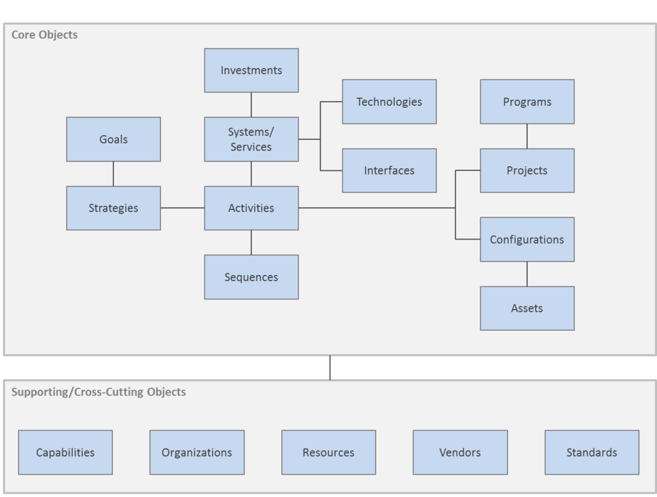
Fig 2:Structure of framework
Anatomy Of the Aneka Container:
The Aneka based registering cloud is an assortment of physical and virtualized assets associated through an organization, which are either the Internet or a confidential intranet. Every one of these assets has an occasion of the Aneka Container addressing the runtime climate where the dispersed applications are executed.
Aneka is a stage and system for creating disseminated applications on the Cloud. It utilizes work area PCs on-request and CPU cycles notwithstanding a heterogeneous organization of servers or datacenters. Aneka gives a rich arrangement of APIs for engineers to straightforwardly take advantage of such assets and express the business rationale of utilizations utilizing favored programming reflections.
Framework chairmen can use an assortment of devices to screen and control the sent foundation. It tends to be a public cloud accessible to anybody by means of the Internet or a confidential cloud shaped by hubs with limited admittance.
A multiplex-based figuring cloud is an assortment of physical and virtualized assets associated by means of an organization, either the Internet or a confidential intranet. Every asset has an example of various holders that address the runtime climate where appropriated applications are executed. The compartment gives the fundamental administration highlights of a solitary hub and exploits the wide range of various elements of its facilitating administrations.
Administrations are isolated into clothing, establishment, and execution administrations. Establishment administrations distinguish the center arrangement of Anka middleware, which gives a bunch of framework highlights to empower Anka holders to perform explicit and explicit errands. Texture administrations associate straightforwardly with hubs through the Platform Abstraction Layer (PAL) and perform equipment profiling and dynamic asset provisioning. Execution administrations manage booking and executing applications in the Cloud.
One of the vital elements of Aneka is its capacity to give various ways of communicating conveyed applications by offering different programming models; Execution administrations are generally worried about giving middleware the execution of these models. Extra administrations, for example, perseverance and security are opposite to the entire pile of administrations facilitated by the compartment.
At the application level, a bunch of various parts and instruments are given to
- Simplify the development of applications (SDKs),
- Port existing applications to the Cloud, and
- Monitor and manage multiple clouds.
An Aneka-based cloud is framed by interconnected assets that are powerfully altered by client needs utilizing asset virtualization or extra CPU cycles for work area machines. A typical sending of Aneka is introduced as an afterthought. In the event that the organization distinguishes a confidential cloud, all assets are in-house, for instance, inside the venture.

This arrangement is improved by interfacing freely accessible on-request assets or by cooperating with a few other public mists that give figuring assets associated over the Internet.
from the ground up: PLATFORM ABSTRACTION LAYER:
The center foundation of the framework depends on the .NET innovation and permits the Aneka holder to be convenient over various stages and working frameworks. Any stage highlighting an ECMA-334 [52] and ECMA-335 [53] viable climate can host and run an occurrence of the Aneka holder.
The Common Language Infrastructure (CLI), which is the detail presented in the ECMA-334 norm, characterizes a typical runtime climate and application model for executing programs however gives no connection point to get to the equipment or to gather execution information from the facilitating working framework. Besides, each working framework has an alternate document framework association and stores that data in an unexpected way. The Platform Abstraction Layer (PAL) addresses this heterogeneity and gives the compartment a uniform point of interaction for getting to the significant equipment and working framework data, subsequently permitting the remainder of the holder to run unmodified on any upheld stage.
The PAL is answerable for distinguishing the upheld facilitating climate and furnishing the relating execution to associate with it to help the movement of the holder. The PAL gives the accompanying elements:
- Uniform and stage free execution interface for getting to the facilitating stage
- Uniform admittance to broadened and extra properties of the facilitating stage
- Uniform and stage autonomous admittance to distant hubs
- Uniform and stage free administration interfaces
The PAL is a little layer of programming that involves a discovery motor, which consequently designs the holder at boot time, with the stage explicit part to get to the above data and an execution of the deliberation layer for the Windows, Linux, and Mac OS X working frameworks.
The collectible information that are uncovered by the PAL are the accompanying:
- Number of centers, recurrence, and CPU utilization.
- Memory size and utilization
- Total accessible plate space
- Network locations and gadgets connected to the hub
Also, extra custom data can be recovered by questioning the properties of the equipment. The PAL interface gives means to custom executions to pull extra data by utilizing name-esteem coordinates that can have any sort of data about the facilitating stage. For instance, these properties can contain extra data about the processor, like the model and family, or extra information about the cycle running the holder.
Consider the following diagram shows abstraction layer
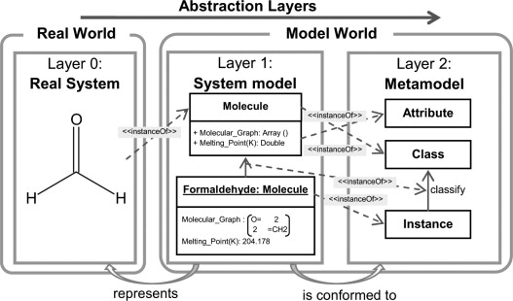
Fig 3: Abstraction Layer
Fabric Services:
Texture Services is a worldwide hotspot for a broad contribution of Fabrics, Leather, and Vinyl or Polyurethane covered textures for some applications and markets. As well as obtaining the essential material, Fabric Services offers fire overlay of polyurethane froths to the materials, glue cover, sheeting, slice to estimate capacities, and synthetically gets textures in-house empower the materials to pass combustibility necessities.
Texture Services, with its broad item improvement mastery, has made various extremely fruitful brands that are perceived all through the business. Among these are Halo polyurethane covered materials, Aura Vinyl and Auranautic Marine Vinyl, Lynx Semi PU, and Genua extravagant velvets. With stockroom dispersion serving North America, Fabric Services attempts to comprehend and execute the operations necessities for a large group of clients across numerous business sectors.
Customers choose Fabric Services when looking for a value-driven purchase that combines the best mix of:
- Price
- Innovative, application-driven product design and development
- High-quality product and process
- A customer-focused approach that makes doing business easy and mutually rewarding.

Overview of Azure Service Fabric

Sky blue Service Fabric is a disseminated frameworks stage that makes it simple to bundle, convey, and oversee versatile and solid microservices and holders. Administration Fabric additionally addresses the huge difficulties in creating and overseeing cloud local applications.

A critical differentiator of Service Fabric is areas of strength for its on building stateful administrations. You can utilize the Service Fabric programming model or run containerized stateful administrations written in any language or code. You can make Service Fabric bunches anyplace, remembering Windows Server and Linux for premises and other public mists, notwithstanding Azure.

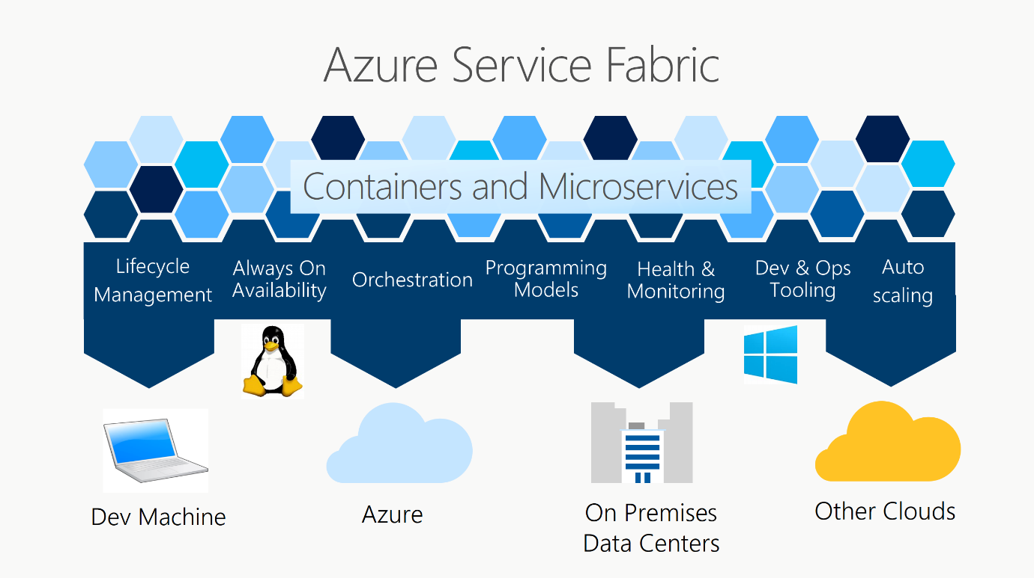
Fig 4: Azure Service Fabric
Service Fabric powers many Microsoft services today, including Azure SQL Database, Azure Cosmos DB, Cortana, Microsoft Power BI, Microsoft Intune, Azure Event Hubs, Azure IoT Hub, Dynamics 365, Skype for Business, and many core Azure services.

Foundation Services
The Netra HA Suite Foundation Services are a set-up of profoundly accessible and circulated programming administrations that run either on the Solaris™ Operating System (Solaris OS) or Carrier Grade Linux conveyances. Allude to the Netra High Availability Suite 3.0 1/08 Release Notes for data about which Solaris OS deliveries and which Linux circulations are upheld for use with the Netra HA Suite software. The Foundation Services empower you to send applications in a nonstop accessibility climate. You can utilize the Netra HA Suite Foundation Services to make a profoundly accessible, progressively versatile bunch of circulated hubs, and to expand existing exceptionally accessible structures.
The following figure illustrates a basic Foundation Services cluster.
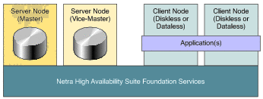
Fig 5: Foundation Services cluster
The ideas of bunches, server hubs (expert and bad habit ace hubs), and client hubs (diskless and dataless hubs) are depicted in Cluster Model.

The Foundation Services are intended to do the accompanying:

Take into consideration equipment substitution, update, and diagnostics without causing framework blackout

Offer exceptionally accessible types of assistance (running on server hubs) to applications (as a general rule, running on client hubs).

Give HA-uninformed applications a basic method for becoming HA mindful.
High-Level View of the Foundation Services
The following figure shows a high-level view of the services and application programming interfaces (APIs) provided by the Netra HA Suite Foundation Services product.

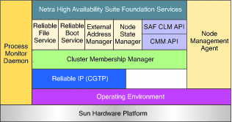
Fig 6: Application programming interface
The Foundation Services offer the following services:
- A reliable network communication service provided by the Carrier Grade Transport Protocol (CGTP). CGTP limits the consequences of single network failure by duplicating the communication on a minimum of two links. For more information.
- A Cluster Membership Manager (CMM) to provide a global view of the cluster. The Cluster Membership Manager determines which nodes are members of the cluster. It assigns the roles and attributes of nodes, detects the failure of nodes, and notifies clients of changes to the cluster. A heartbeat mechanism detects node failure. For more information.)A Reliable File Service (RFS) to ensure that data is accessible to applications, even in the event of hardware or software failure. Reliable File Service uses mounted file systems, IP replication of disk-based data or dual-hosted disks, and IP address failover of the master role. For more information.
- A Reliable Boot Service (RBS) to ensure the boot of diskless nodes regardless of software or hardware failures. For more information.

Application Services
Application Services (often used instead of application management services or application services management) are a pool of services such as load balancing, application performance monitoring, application acceleration, autoscaling, micro-segmentation, service proxy and service discovery needed to optimally deploy, run and improve applications.
The process of configuring, monitoring, optimizing and orchestrating different app services is known as application services management.
Today, organizations with their own data centers or which use the public cloud, handle applications services management. In the early days of online adoption, application service providers (or ASPs) were companies which would deliver applications to end users for a fixed cost. This single tenant, hosted model was largely replaced by the advent of the Software-as-a-Service (SaaS) delivery model which was multi-tenant and on-demand.
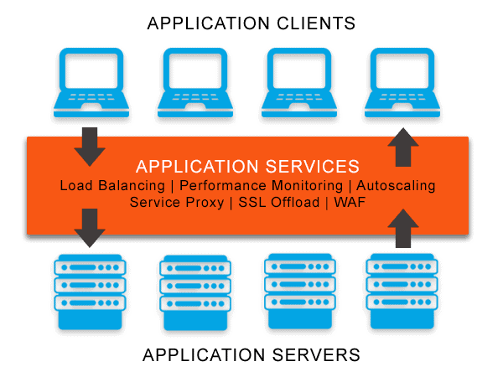
Fig 7: Application services
Cloud App Services are an extensive variety of explicit application administrations for applications conveyed in cloud-based assets. Administrations, for example, load adjusting, application firewalling and support disclosure can be accomplished for applications running in private, public, half breed or multi-cloud conditions.
Customary applications were worked as solid blocks of programming. These solid applications have long life cycles in light of the fact that any progressions or updates to one capability, as a rule requires reconfiguring the whole application. This exorbitant and tedious cycle defers progressions and updates in application improvement.
Application Modernization Services empower the relocation of solid, heritage application designs to new application structures that all the more intently match the business needs of present day endeavors' application portfolio. Application modernization is many times part of an association's advanced change.
An illustration of this is the utilization of a microservices engineering where all application administrations are made independently and sent independently from each other. This considers scaling administrations in light of explicit business needs. Administrations can likewise be quickly different without influencing different pieces of the application. Application-driven endeavors are picking microservices designs to exploit adaptable holder based foundation models.
Avi Networks upsets the business' meaning of Application Delivery Controllers (ADCs) with a 100 percent programming way to deal with application administrations. Dissimilar to inheritance, machine based ADCs, Avi conveys application administrations past burden adjusting, including, administration intermediary, application examination, autoscaling, application map and miniature division in any event, for current application designs.

BUILDING ANEKA CLOUDS
Aneka is a stage and a structure for creating conveyed applications on the Cloud. It saddles the extra CPU patterns of a heterogeneous organization of work area PCs and servers or datacenters on request. Aneka furnishes engineers with a rich arrangement of APIs for straightforwardly taking advantage of such assets and communicating the business rationale of utilizations by utilizing the favored programming reflections. Framework chairmen can use on an assortment of instruments to screen and control the conveyed foundation. This can be a public cloud accessible to anybody through the Internet, or a confidential cloud comprised by a bunch of hubs with limited admittance.
The Aneka based registering cloud is an assortment of physical and virtualized assets associated through an organization, which are either the Internet or a confidential intranet. Every one of these assets has a case of the Aneka Container addressing the runtime climate where the circulated applications are executed. The holder gives the fundamental administration elements of the single hub and use the wide range of various procedure on the administrations that it is facilitating. The administrations are separated into texture, establishment, and execution administrations. Texture benefits straightforwardly interface with the hub through the Platform Abstraction Layer (PAL) and perform equipment profiling and dynamic asset provisioning. Establishment administrations distinguish the center arrangement of the Aneka middleware, giving a bunch of fundamental highlights to empower Aneka holders to perform particular and explicit arrangements of undertakings. Execution benefits straightforwardly manage the planning and execution of utilizations in the Cloud.
One of the vital elements of Aneka is the capacity of giving various approaches to communicating circulated applications by offering different programming models; execution administrations are for the most part worried about furnishing the middleware with an execution for these models. Extra administrations, for example, diligence and security are cross-over to the whole pile of administrations that are facilitated by the Container. At the application level, a bunch of various parts and instruments are given to: 1) improve on the advancement of uses (SDK); 2) porting existing applications to the Cloud; and 3) checking and dealing with the Aneka Cloud.
A typical sending of Aneka is introduced along the edge. An Aneka based Cloud is comprised by a bunch of interconnected assets that are powerfully changed by the client needs by utilizing asset virtualization or by outfitting the extra CPU patterns of work area machines. In the event that the sending recognizes a confidential Cloud every one of the assets are in house, for instance inside the venture. This arrangement is stretched out by including openly accessible assets interest or by associating with other Aneka public mists giving processing assets associated over the Internet.
Consider the following block diagram represents a building aneka cloud.

Infrastructure Organization
Authoritative foundation comprises of the frameworks, conventions, and cycles that give construction to the association, support its key capabilities, and insert routine practice. For a youngster government assistance organization, framework incorporates the strategies and working techniques that guide practice and construct a mutual perspective of how to convey kid government assistance administrations. Foundation additionally incorporates an office's frameworks for activities — from HR, preparing, management, and progressing correspondence frameworks to information, assessment, and nonstop quality improvement (CQI) frameworks. An association's designs, cycles, and frameworks standardize practices, systems, and rules to guarantee their steady execution paying little heed to staff or initiative changes. The hierarchical framework likewise upholds the association in doing its vision, mission, objectives, and values.
An authoritative foundation alludes to the normally various leveled plan of lines of power, interchanges, freedoms and obligations of an association. The Organizational design decides how the jobs, power and obligations are appointed, controlled, and facilitated, and how data streams between the various degrees of the executives.
A construction normally relies upon the association's targets and system. Inside an incorporated design, the top layer of the executives holds a large portion of the dynamic power and has tight command over divisions and divisions. In a decentralized construction, nonetheless, dynamic power is circulated and the offices and divisions might have differing levels of freedom.

Framework and Operations, I&O, groups are extensively answerable for the organization and the board of innovation, data, and information. These groups deal with various components including PCs, servers, processes, organizing, capacity, information, programming, security, and cloud-based administrations. Heads of these groups are likewise answerable for recruiting and preparing; making arrangements; directing testing; introducing redesigns; and finishing fixes. While these undertakings could sound specialized, what I&O groups do is firmly lined up with more extensive hierarchical objectives, procedures, and tasks. Set all the more forth plainly, I&O groups are entrusted with keeping awake to-date on mechanical advancements and assisting associations with meeting their computerized needs and objectives. Further, they help to scale mechanical advancements really while empowering organizations to build the nature of administrations while likewise decreasing expenses. At a new IT Infrastructure, Operations, and Cloud Strategy meeting, Ross Winser, a senior expert for Gartner, summarized this steadily changing job by saying, "The focal point of I&O pioneers is no longer to exclusively convey designing and tasks, yet rather convey items and administrations that help and empower an association's business technique."
Consider the block graph addresses a foundation association.
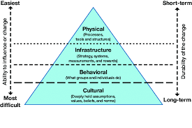
Fig 8:infrastructure organization

Logical Organization
PC Logical Organization alludes to the degree of reflection over the computerized rationale level, however underneath the working framework level. At this level, the significant parts are practical units or subsystems that compare to explicit bits of equipment worked from the lower level structure blocks. The Data interface layer portrays the sensible association of information bits communicated on a specific medium. This layer characterizes the outlining, tending to, and check-adding of Ethernet parcels. The fundamental errand of the Data connect layer is to change a crude transmission office into a line that shows up liberated from transmission mistakes in the Network layer. It achieves this errand by having the source split the information up into information outlines (regularly, two or three hundred bytes), send the edges consecutively, and process the affirmation outlines sent back by the beneficiary. Since the Physical layer only acknowledges and sends a flood of pieces with next to no respect to significance of design, it ultimately depends on the Data connect layer to make and perceive outline limits. This can be achieved by joining extraordinary piece examples to the start and end of the edge. Assuming quite possibly these piece examples could happen in the information, exceptional consideration should be taken to stay away from disarray. The Data connect layer ought to give mistake control between neighboring hubs. Another issue that emerges in the Data connect layer (and a large portion of the greater layers too) is the manner by which to keep a quick transmitter from "suffocating" a sluggish collector in information. Some traffic guideline system should be utilized to tell the transmitter how much support space the collector has right now. Much of the time, stream guideline and mistake taking care of are coordinated for comfort.
On the off chance that the line can be utilized to communicate information in the two headings, this presents another difficulty for the Data connect layer programming. The issue is that the affirmation outlines for A to B traffic vie for utilization of the line with information outlines for the B to A traffic. A smart arrangement through piggybacking has been concocted. ViewContainers likewise come convenient for communicating the coherent association of some certifiable web applications that show a various leveled structure by which the pages of the website are bunched into segments managing a homogeneous subject. Settled ViewContainers can assume the part of "site regions," recursively organized into other subareas and additionally pages. Most genuine sites display an association into regions. For instance, Figure 4.16 shows a connection point piece taken from a site whose pages incorporate a route bar with secures highlighting the different region of the site.
Consider the following block diagram represents logical organization of cloud computing.
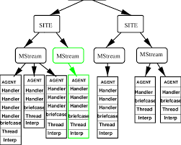
Fig 9: logical organization
Private cloud deployment mode
The confidential cloud organization model is the specific inverse of the public cloud arrangement model. It's a one-on-one climate for a solitary client (client). There is compelling reason need to impart your equipment to any other individual. The qualification among private and public cloud is by they way you handle the entirety of the equipment. It is likewise called the "inward cloud" and it alludes to the capacity to get to frameworks and administrations inside a given line or association. The cloud stage is carried out in a cloud-based secure climate that is safeguarded by strong firewalls and under the management of an association's IT division.
The confidential cloud gives the more noteworthy adaptability of command over cloud assets.
Benefits of the confidential cloud model:
• Better Control: You are the sole proprietor of the property. You gain total control over help coordination, IT tasks, approaches, and client conduct.
• Information Security and Privacy: It's reasonable for putting away corporate data to which just approved staff approach. By fragmenting assets inside a similar framework, further developed admittance and security can be accomplished.
• Upholds Legacy Systems: This approach is intended to work with inheritance frameworks that can't get to the public cloud.
• Customization: Unlike a public cloud organization, a confidential cloud permits an organization to fit its answer for meet its particular requirements.
• Confidential Cloud permits frameworks and administrations to be open inside an association. The Private Cloud is worked exclusively inside a solitary association. Notwithstanding, it could be overseen inside by the actual association or by outsider. The confidential cloud model is displayed in the graph beneath.
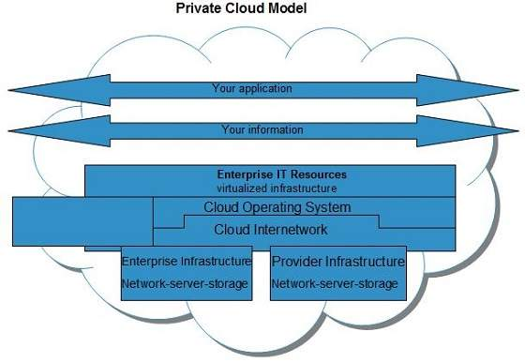

Fig 10: private cloud

Benefits
- There are many benefits of deploying cloud as private cloud model. The following diagram shows some of those benefits:

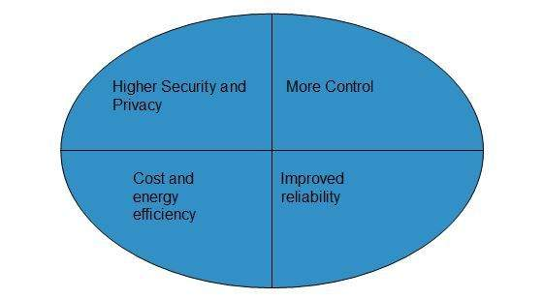
Fig 11: private cloud deployment model
High Security and Privacy
• Confidential cloud activities are not accessible to overall population and assets are shared from particular pool of assets. In this manner, it guarantees high security and protection.
• More Control
• The confidential cloud has more control on its assets and equipment than public cloud since it is gotten to just inside an association.
• Cost and Energy Efficiency
• The confidential cloud assets are not quite as practical as assets out in the open mists however they offer more effectiveness than public cloud assets.
• Weaknesses
• Here are the weaknesses of utilizing private cloud model:
• Limited Area of Operation
• The confidential cloud is just open locally and is extremely challenging to universally convey.
• Expensive
• Buying new equipment to satisfy the interest is an expensive exchange.
• Restricted Scalability
• The confidential cloud can be scaled exclusively inside limit of inner facilitated assets.
• Extra Skills
• To keep up with cloud sending, association requires talented ability.

Public cloud deployment mode
The public cloud makes it feasible for anyone to get to frameworks and administrations. The public cloud might be less secure as it is open for everybody. The public cloud is one in which cloud foundation administrations are given over the web to the general individuals or significant industry gatherings. The framework in this cloud model is possessed by the element that conveys the cloud administrations, not by the shopper. It is a sort of cloud facilitating that permits clients and clients to get to frameworks and administrations without any problem. This type of distributed computing is a great illustration of cloud facilitating, in which specialist co-ops supply administrations to different clients. In this game plan, stockpiling reinforcement and recovery administrations are given for nothing, as a membership, or on a for every utilization premise. Model: Google App Engine and so forth.
Benefits of the public cloud model:
• Insignificant Investment: Because it is a compensation for each utilization administration, there is no significant forthright expense, making it brilliant for endeavors that require quick admittance to assets.
• No arrangement cost: The whole framework is completely financed by the cloud specialist organizations, in this manner there is compelling reason need to set up any equipment.
• Framework Management isn't needed: Using the public cloud doesn't require foundation the board.
• No upkeep: The support work is finished by the specialist co-op (Not clients).
• Dynamic Scalability: To satisfy your organization's requirements, on-request assets are open.
• Public Cloud permits frameworks and administrations to be effectively open to overall population. The IT goliaths, for example, Google, Amazon and Microsoft offer cloud administrations by means of Internet. The Public Cloud Model is displayed in the outline underneath.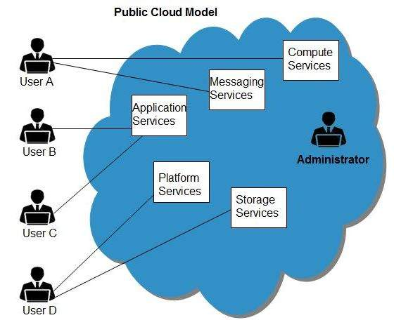
Fig 12: Public cloud

Benefits
- There are many benefits of deploying cloud as public cloud model. The following diagram shows some of those benefits:
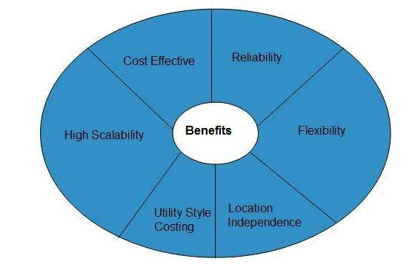
Fig 13: Public cloud deployment mode

Cost Effective
- Since public cloud shares same resources with large number of customers it turns out inexpensive.

Reliability
- The public cloud employs large number of resources from different locations. If any of the resources fails, public cloud can employ another one.

Flexibility
- The public cloud can smoothly integrate with private cloud, which gives customers a flexible approach.

Location Independence
- Public cloud services are delivered through Internet, ensuring location independence.

Utility Style Costing
- Public cloud is also based on pay-per-use model and resources are accessible whenever customer needs them.

High Scalability
- Cloud resources are made available on demand from a pool of resources, i.e., they can be scaled up or down according the requirement.

Disadvantages
- Here are some disadvantages of public cloud model:

Low Security
- In public cloud model, data is hosted off-site and resources are shared publicly, therefore does not ensure higher level of security.

Less Customizable
- It is comparatively less customizable than private cloud.

Hybrid Cloud Deployment Mode
A half and half cloud is the blend of both public and confidential cloud organization models. Associations utilize the cross breed model to mix their framework on request. Utilizing a half and half cloud, an association can scale processing assets and cutoff the immense expense of overseeing spikes popular. Also, half and half mists give organizations the adaptability to let loose neighborhood assets to store and run more delicate information and applications when required. Half breed mists likewise give a way to organizations to restrict the public cloud's admittance to their whole information pool by saving public cloud use for dealing with flood just, guaranteeing more grounded digital protection. Besides, by covering their utilization of the public cloud, an undertaking can exploit paying for only the assets they need as opposed to keeping up with extra framework that stays inactive a significant part of the time. As anyone might expect, since cross breed distributed computing started, its fame has developed hugely and conventional information reevaluating has declined. As a matter of fact, the half and half cloud market is supposed to reach $128 billion by 2025 with 98% of organizations intending to utilize the climate.
Organizations utilize crossover cloud administrations by blending nearby, on-premises assets with private cloud and outsider public cloud administrations. An association parts instrumentation between the three so jobs can move between the general population and confidential cloud stages as figuring needs change.
On a very basic level, a half breed cloud model works by dividing data among on location and off-site stages. Interconnectivity between the stages is accomplished first through information virtualisation followed by connective instruments and conventions like APIs (application programming points of interaction), VPNs (virtual confidential organizations) or potentially WANs (wide region organizations).
Yet, the most common way of dealing with a crossover cloud model is considerably more than only lifting and moving applications into the cloud. An IT office additionally needs to design assets to empower them to convey. What's more, there's the time expected to prepare clients and guarantee both effective sending and upkeep long term that add to the speculation.
As it is such an asset weighty venture, changing to crossover distributed computing ought to be painstakingly thought of. While this blended climate gives organizations more prominent adaptability and more information sending choices, it can mean IT divisions will battle to deal with the expanded intricacy.
advantages of utilizing a mixture cloud?
Changing to a mixture cloud model changes essentially everything about how an organization oversees information and responsibilities. IT divisions need to get ready to give answers in regards to how this essential change in individuals, cycle and innovation will eventually help the general business.
Most organizations utilize a half breed cloud model to:
Improve on activities
Lessen risk
Increment responsibility productivity
Widen ability to satisfy spikes in need
Diminish costs
With this multitude of advantages, a half and half cloud model builds an undertaking's general deftness and adaptability, changing an opportunity to offer new administrations from months to hours. Furthermore, on the grounds that engineers can repeat, test and convey new applications off-site, less staff are expected to deal with the interaction. Moreover, IT divisions can likewise decrease their on-premises cloud framework, along these lines saving money on significant capital ventures.
Besides, with a half and half cloud model, engineers can make and change their cloud framework necessities themselves utilizing programming. That power additionally adds to sped up and efficiencies.
How do ventures utilize crossover cloud?
For every venture that changes to mixture cloud, different sorts of clients send various activities to help the whole association.
IT chiefs can:
Robotize the provisioning and the executives of on-premises and cloud assets
Empower quick virtual machine (VM) and holder distributing
Speed up the improvement interaction to put up new items for sale to the public quicker than at any other time
Guarantee cloud advancement self-administration
Transform a VM group into a confidential cloud
Transform compartments and exposed metal into private mists
Interface with any supplier
Astutely scale foundation

Engineers can exploit cloud conditions that:
Are quick
Incorporate smoothed out advancement project work areas
Have total self-administration provisioning, devices and admittance to an extensive variety of organized instruments, formats and assets

Boss data officials (CIOs) can further develop efficiency with cross breed cloud innovations that:
Are able to do rapidly turning up new administrations
Can move IT thinking away from activities and towards applications

Line of business leaders can watch out for cost/efficiency and use stages and frameworks that help them to:
Straightforwardly accomplish their objectives without steady IT intercession
Upgrade their singular help levels
Work on the general wellbeing of the business.

Consider the following block diagram shows a hybrid cloud model.

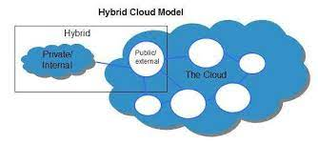
Fig 14: Hybrid Cloud Deployment Mode

Cloud Programming and Management
Distributed computing the executives is keeping up with and controlling the cloud administrations and assets be it public, private or half and half. A portion of its viewpoints incorporate burden adjusting, execution, capacity, reinforcements, limit, sending and so on. To do so a cloud overseeing work force needs full admittance to all the usefulness of assets in the cloud. Different programming items and innovations are joined to give a strong cloud the executives procedure and interaction.

As we probably are aware Private cloud foundation is worked exclusively for a solitary association, so that can be overseen by the association or by an outsider. Public cloud administrations are conveyed over an organization that is open and accessible for public use. In this model, the IT foundation is claimed by a privately owned business and individuals from the general population can buy or rent information capacity or figuring limit depending on the situation. Cross breed cloud conditions are a mix of public and confidential cloud administrations from various suppliers. Most associations store information on confidential cloud servers for protection worries, while utilizing public cloud applications at a lower price tag for less delicate data. The mix of both people in general and confidential cloud are known as Hybrid cloud servers.
Cloud is these days liked by enormous associations as their essential information stockpiling. A little margin time or a mistake can cause a lot of misfortune and bother for the associations. In order to configuration, handle and keep a distributed computing administration explicit individuals are dependable who ensure everything pan out as assumed and all emerging issues are tended to.
A cloud the board stage is a product arrangement that has a powerful and broad arrangement of APIs that permit it to pull information from each edge of the IT framework. A CMP permits an IT association to lay out an organized way to deal with security and IT administration that can be carried out across the association's whole cloud climate.
Cloud Management Tasks:
The below figure represents different cloud management tasks :
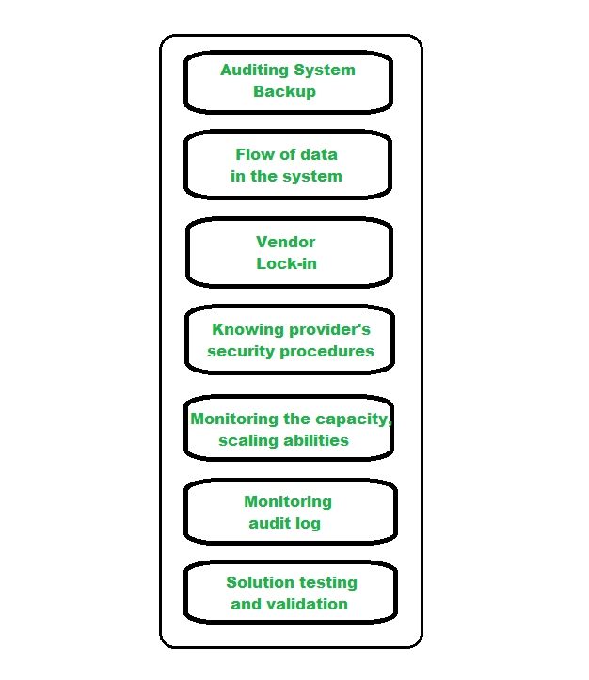
Fig 15: Cloud Programming and Management
- Auditing System Backups –
It is required to audit the backups from time to time to ensure restoration of randomly selected files of different users. This might be done by the organization or by the cloud provider.
- Flow of data in the system –
The managers are responsible for designing a data flow diagram that shows how the data is supposed to flow throughout the organization.
- Vendor Lock-In –
The managers should know how to move their data from a server to another in case the organization decides to switch providers.
- Knowing provider’s security procedures –
The managers should know the security plans of the provider, especially Multitenant use, E-commerce processing, Employee screening and Encryption policy.
- Monitoring the Capacity, Planning and Scaling abilities –
The manager should know if their current cloud provider is going to meet their organization’s demand in the future and also their scaling capabilities.
- Monitoring audit log –
In order to identify errors in the system, logs are audited by the managers on a regular basis.
- Solution Testing and Validation –
It is necessary to test the cloud services and verify the results and for error-free solutions.

Aneka SDK,Management Tools.

Manjrasoft is centered around the production of inventive programming advancements for working on the turn of events and arrangement of uses on private or public Clouds. Our item Aneka assumes the part of Application Platform as a Service for Cloud Computing. Aneka upholds different programming models including Task Programming, Thread Programming and MapReduce Programming and instruments for fast making of utilizations and their consistent arrangement on private or public Clouds to circulate applications.
Aneka innovation principally comprises of two key parts:
SDK (Software Development Kit) containing application programming points of interaction (APIs) and instruments fundamental for quick advancement of utilizations. Aneka APIs upholds three famous Cloud programming models: Task, Thread, and MapReduce; and
A Runtime Engine and Platform for overseeing sending and execution of utilizations on private or public Clouds.
One of the prominent qualities of Aneka PaaS is to help provisioning of private cloud assets going from work areas, groups to virtual datacenters utilizing VMWare, Citrix Zen server and public cloud assets, for example, Windows Azure, Amazon EC2, and GoGrid Cloud Service.
The capability of Aneka as a Platform as a Service has been effectively outfit by its clients and clients in three different areas including designing, life science, schooling, and business knowledge.

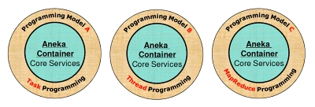
Fig 16: Aneka SDK,Management Tools.

Highlights of Aneka

Technical Value
- Support of multiple programming and application environments
- Simultaneous support of multiple run-time environments
- Rapid deployment tools and framework
- Simplicity in developing applications on Cloud
- Dynamic Scalability
- Ability to harness multiple virtual and/or physical machines for accelerating application result
- Provisioning based on QoS/SLA

Business Value
- Improved reliability
- Simplicity
- Faster time to value
- Operational Agility
- Definite application performance enhancement
- Optimizing the capital expenditure and operational expenditure

