Individualisation: Medico, Social, and Psychological Approach

Dr. Sinchan Das
Author1
Director
Humanity, Institute for Advanced Medical & Cultural research
J-40, Banerjee Para, Kamdahari, Garia, Kolkata-84
Kolkata, India
drsinchandas@gmail.com

Swastika Subba
Author 2
Research Scholar
Humanity, Institute for Advanced Medical & Cultural Research, India
J-40 Banerjee Para, Kamdahari, Garia, Kolkata-84
Kolkata, India
7novsandypota@gmail.com

Priyankesh Mishra
Author 3
Research Scholar
Humanity, Institute for Advanced Medical & Cultural Research, India
J-40 Banerjee Para, Kamdahari, Garia, Kolkata-84
Kolkata, India
impriyankesh@gmail.com

Abstract
We live in a system of varying diversity where we share different interests, thoughts, perspectives, wants and dislikes. On the other hand, everything in this system shares a symbiotic relationship with one another where a small disruptions or breakage leads to major impact on the entire diversity. However, as humans are progressing, this symbiotic relationship is slowly losing its grips while making a major disruption in the ecological balance. This disruption in our symbiotic relationship has been fading our ability to think, questions, and perceive differently. In addition, the hyper consciousness of human has been majorly distancing them from nature and more towards destruction. For instance, the individualised traditional approach carried forwards throughout the course of history like in case of Ayurveda have now accounted to alternative approach. Currently, the society is instead more depended on approaches that are more generalised, faster and so call laboratory proved. The ignorant and hyper-individualistic mentality of people in the current scenario has eradicated out capacity to think rationally, logically and seek beyond truth. We may feel that our action is negligible but we forget or say we have lost that ability to sense the fact it is enough to cause a mass eradication. The major crisis of Covid-19 for instance is just the small outcome of our ignorant and hyper-individualistic mentality while accelerating towards extinction.

Keywords
Individualisation; Generalisation; Health; Disease; Society; Homoeopathy; Psychology; Medico-social; Genetics; Individual; ID; Superego; Ego; Consciousness

Introduction
One of the unique features that serve us being a part of Homo sapiens is our diversity not just in terms of ethnicity, beliefs, religion, caste, creed or colour but also in terms of thoughts, perceptions, thinking, emotions and the diseases or disorders one suffers. We all may belong to the same species greatly with our mental and physical development. The concept of individualisation holds a deep meaning throughout our history of evolutions as well as through the course of traditional and ancient medical beliefs. For instance, the age-old Ayurveda text outlines a unique concept of “Prakriti” which is genetically determined while categorising populations based on several subgroups in terms of their phenotypic characteristics such as appearance, temperament and habits. The following concept is thought to be an effective way that plays a major role in predicting the susceptibility of an individual towards a specific disease, and the prognosis of their illnesses while being able to make the most suitable therapy. However, in the current scenario, all of these have faded away under the dumps of consistent human ignorance, manipulations, resistance, denial, displacement, projection and regression. On the other hand, the very concept of reality or actuality has just got confined within the boundaries of human vision, touch and feel where other things beyond their boundaries are either non-reachable or vague mythological concepts. This has been more significant lately among humans due to their super-sensual complex while making them fully disconnected from nature. The detachment from nature has made humans more reluctant while transforming them into complex hyper-individualistic individuals. In addition, this hyper-individualistic complex of humans has been compelling humans to be the ultimate supreme as well as super-conscious. As a result of this, the humans are becoming more and more ignorant as well as resistant to the things that threaten their concept of reality.
Individualisation
Individualisation is a condition where society as a whole increasingly adapts to the circumstances, preferences, and needs of each individual while acknowledging the individuals rights to this and encourages individuals to use it. The aim of this findings is not here to disrespect any professions or hurt anyone’s believe nor question on any life saving works of doctors. Rather, what I strongly want to convey is the need of changes in the approaches of treatment so that we are able to reach every person with the need of health care, where treatments are accessible to every group and class of people and more importantly a disease free environment. Not only in the field of healthcare but also a change in the society which will help in breaking many age-old stereotypes.

Individualisation in Medicine-Genetic approach:-
A. Personalized medicine,
This is even also termed individualised medicine, is a medical procedure that separates patients into different groups—with medical decisions, practices, interventions and/or products being tailored to the individual patient based on their predicted response or risk of disease. The process might take a longer period and might take hours and maybe a day, and in that same period of time a doctor might be able check 9-10 patient but the question arises here; what kind of healthcare facility are we providing to a person who completely and blindly relies on us for cure, quantity or quality? Although most of the variation between individuals has no effect on health, an individual's health stems from genetic variation with behaviours and influences from the environment. Modern advances in personalized medicine rely on technology that confirms a patient's fundamental biology, DNA, RNA, or protein, which ultimately leads to confirming disease. For example, personalised techniques such as genome sequencing can reveal mutations in DNA that influence diseases ranging from cystic fibrosis to cancer. Another method, called RNA sequencing, can show which RNA molecules are involved with specific diseases. Unlike DNA, levels of RNA can change in response to the environment. Therefore, sequencing RNA can provide a broader understanding of a person’s state of health. Recent studies have linked genetic differences between individuals to RNA expression, translation, and protein levels.
In order for physicians to know if a mutation is connected to a certain disease, researchers often do a study called a “genome-wide association study “ (GWAS). A GWAS study will look at one disease, and then sequence the genome of many patients with that particular disease to look for shared mutations in the genome. Mutations that are determined to be related to a disease by a GWAS study can then be used to diagnose that disease in future patients, by looking at their genome sequence to find that same mutation.
Having the genetic content of an individual will allow better guided decisions in determining the source of the disease and thus treating it or preventing its progression. This will be extremely useful for diseases like Alzheimer’s or cancers that are thought to be linked to certain mutations in our DNA.
Individualisation: Medical Approach (Homeopathy):- The concept of disease in homeopathy is disease due to total affection of mind and body. Mind and body are dynamic and complexly interlinked; each one influencing the other and acting together. Neither mind nor body falls ill individually. Now we are start learning that prolong emotional stress (too much desire, anger, greed, pride, jealousy, suspicion, etc.) can lead to upset stomach, difficulty digesting food, poor nutrient absorption, sleeplessness, weaken immune system, etc.
The emotional state closely relates to endocrine glands and nerves, which influence over the working of the physical body.
Thus, homeopathy medicine is as psychosomatic medicine and is excellent for psychosomatic diseases such as Migraine, Asthma, Peptic ulcer, Allergy, Ulcerative colitis, etc.
Individualisation: Medical Approach (Ayurveda):- Ayurveda, the traditional Indian medicinal system remains the most ancient yet living traditions with sound philosophical and experimental basis. It is a science of life with a holistic approach to health and personalized medicine. It is known to be a complete medical system that comprised physical, psychological, philosophical, ethical, and spiritual health. In Ayurveda, each cell is considered to be inherently an essential expression of pure intelligence hence called self-healing science.
In addition, to the self-healing concept, the use of herbal treatment is equally important in this Indian traditional system of medicine.
Individualisation: Social approach:-
Although physicians are just beginning to see the promise of genetic medicine coming to fruition and cannot hide their excitemnt for the technology, the patients are asking for personalized care: a holistic approach that considers an individual’s physical, mental, and spiritual well-being. This perspective considers psychological, religious, and ethical challenges that may arise as the precision of preventive medicine improves.
Understanding current areas of potential conflict between religion and medicine can be informative when anticipating the public’s concerns regarding personalized medicine. The most extreme conflict currently is between the medical community and churches that reject modern medicine, such as the Indiana-based Faith Assembly and the Christian Science Church. Personalized medicine will not be relevant to these individuals as they reject most medical assistance. The majority of the estimated 172 children who died between 1975 and 1995 because prayer was used in lieu of medical care were from such churches. Another group of people who may challenge personalized medicine are those who question evolution and, by association, genetics.
In a June 2008 Pew Forum poll, 45% of Americans rejected evolution as the best explanation of the origins of human life. Population genetics, which will form the basis for much of the scientific advances in personalized medicine, relies on certain tenets of heredity that stem from evolutionary biology. As such, certain religious groups may reject personalized medicine, while the majority of patients and physicians are likely to continue to accept the technologies while distancing themselves from the theoretical foundations. Atheists may view illness as a statistically based combination of genetic and environmental factors, while believers of certain religions may view illness as punishment or a test of faith by a higher power, as illustrated in the story of Job. Many Pentecostal and Charismatic Christians envision Satan as the author of sickness and Christ as their healer; in this framework, they view spiritual and physical healing as complementary rather than conflicting. Although the majority of religious institutions, including Roman Catholic and conservative Protestant churches, have been supportive of DNA-based research and diagnostics, this view could change if personalized medicine appears to conflict with the sanctity of human life.
Individualisation: Medico-Social Approach:
Indians have been keeping track of their DNA line, knowingly or unknowingly, through the GOTRA tracking system. In most of tribes and religion, two people from same kula or gotra are not allowed to marry as they are considered to be sharing same ancestors and some similarities in the genetic sequences. In a way if we see the reason is very scientific that’s because according to genetic science the parents who are close relatives and siblings are like to be give birth to a child who are mentally retarded, suffer from various genetic conditions, and like to show grater mutation in the genetic makeup which leads to various deformities. So as to avoid all this; from very ancient time Raj-gurus have kept the track of gotra.
This tracking of DNA line can significantly help in individualising medicines based on the GOTRA of an individual.
Individualisation: Psychological approach:-
The biggest challenges in implementing these concepts would be the most difficult task as there are many ruler areas where the basic accesses to healthcare facility is stilled believed to be taboo, people believe more on tantras, black magic, shamans for thir cure. These is due to lack of awareness, and the mentality of people under the pressure of there elders or in the name shake of age-old practices.
Implementing personalized medicine will require attention to psychological issues already encountered by genetic counsellors and physicians. Before genetic testing was possible, 60%–75% of individuals at risk for Huntington disease indicated that they would undergo testing, but when a test became available only 3%–21% opted to be tested. In cancer where positive genetic testing could encourage women or their daughters to participate in vigorous screening or pre-emptive surgery (such as mastectomy), testing is not universally accepted. Even among insured women with recently diagnosed breast cancer, a significant number (approximately 20%–30%) refuse genetic testing proper psychological counselling is very important for individualisation. Understanding the patient will make the medicines holistic, personalised and effective. In addition, making the patients connect to themselves will make the medicine much more effective as a person in peace produces minimal level of stress hormone and make the medicine work with least hindrance.
Individualisation v/s Generalisation
Every human is made up of 206 bones, over 640 muscles, 34 main veins and other similar structures that categorise the human species in a general class. However, considering the overall structure, it would be valid to focus on the actual scenario of an individual rather is it not essential to focus on other aspects of the overall human society. For instance, if we consider the multi-factorial approach of health, it could be found that an individual health is dependent on 12 determinants that not only vary from region to region rather vary from person to person making a clear differentiation with the concept of generalisation.
In contrast to the above fact, one must even understand that generalisation is the form of abstraction where common properties of specific instances have been formulated for the general population excluding other individual factors. For example, the normal range for the blood pressure measurement have been considered between 100-130/70-90mm of Hg for each and every individual; however, the impact of weather, food habit, circadian rhythm, region of birth, developmental stage, age, sex, occupation, and many more factors have been totally excluded for the people creating a chaos on the general people.

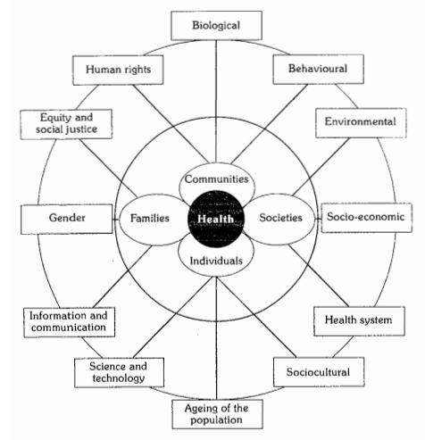
Figure 1: Determinants of Health
The textbook of Park’s Preventive and Social medicine highlighted that “factors which influence health both within the individual and externally in the society in which he or she lives.” Hence, the findings from this section and the above image clarifies that an individual health or any other factor could not be considered as a generalised possession as the totality of the individual.
In order to clarify the difference between the individualisation and generalisation, a simple study was conducted on the people from different regions of India considering their common diseases, issues, weather condition, soil condition, and many more. Hence, following report was found valid within them:
Table 1: Study conducted on people from different regions of India
Region | Weather condition | Desires of individual | Soil condition | Common diseases found
Gangtok and Namchi, Sikkim, India | Sub-tropical climatic scenario with altitudinal variation  It faces the temperate weather condition in southern lower parts to cold deserts and snowy northern Sikkim | Sour and pungent | Summit and ridge (<30%)  Side Slope of Hills  Very steeply sloping (>50%)  Escarpments (>50%)  Steeply Sloping (30-50%) | DCM  Dermal issues  DM2  Hepatobiliary complication
Darjeeling, West Bengal | Sub-tropical hilly regions with several fertile lands and arid places  It has a temperate to snowy weather condition with heavy rainfall throughout the year | Sweet, Sour and Pungent | Mixed sandy loam and loamy at the regions of Pokhrebong, Bijanbari  Clayey loam and reddish soil in Mirik and Kurseong  Sandy soils near the slopes of Tista, Naxalbari | UTI  Cholethiasis  Nephrolithiasis  Hepato-billiary complication  DCM  Varicose veins
Hasnabad, Sundarban | Swampy, loamy weather with huge rainfall during the mid annual monsoon season | Salty to pungent | Dry, fertile lands  Salty soil condition due to correlated bay of Bengal | DCM  HTN  DM2  Insomnia  Loss of appetite
South Bihar | Fertile land with Ganges and Koshi on each side of 8 districts of Bhagalpur, Purnea, Katihar, and Banka | Sweet, sour, pungent | Gangetic Alluvium soil in the Ganges region  Terai Soil have been found across the border of Nepal such as Purnea and Katihar | Dermal issues  Hernia  Orchitis  Cancer  Leukoplakia  Leucoderma  Uternine Fibroid  Eczema
Kolkata & urban regions of South 24 Paraganas | It has a tropical wet and dry climate with an annual mean temperature of 26.8 degree Celsius and connective rainy season between the months of June to August | Mixed and diverse living and taste preferences  Predominately, sweet, sour and pungent | Alluvial soil around the regions of Indo-Gangetic Plane making it the fertile region for agriculture in the Bengal Basin | Lifestyle-based diseases turning to genetic disposition  Psychosomatic origin of issues majorly found with sleeplessness, deranged circadian system
The above study of several regions that lies within distant places provides critical evidences that the determination of a generalised system excludes the above stated points clearly causing issues in understanding their visionary approach. On the other hand, one could even identify that the weather condition even changes with the change in district, soil infrastructure and hence a change in the occupational standard has been even administered. Thus, one could easily justify that considering a generalised approach for any health or other parameters could affect the health of an individual rather it could create a barrier in the social infrastructure.
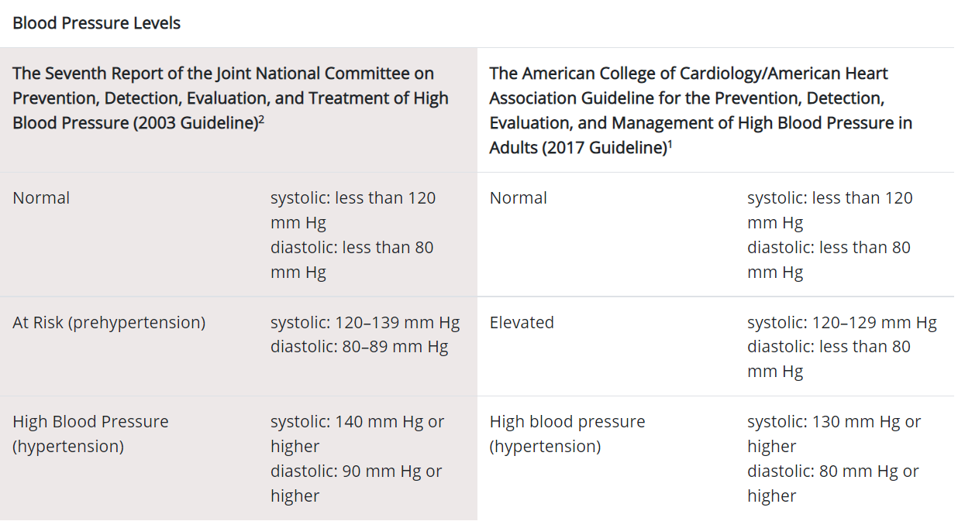
Figure 2: Blood pressure diagnosed by CDC
For instance, the above report provided by the Centre for Disease Control and Prevention clearly outlines the term adult without specifying the range of adulthood in their guidelines for the high blood pressure. Moreover, a common anatomical differentiation occurs between man and women that even differentiates its physiology that is even not considered during this generalised approach. In order to focus on this case, it is important to understand a study that was conducted by Chatterjee and Raymahasaya in 1956 that pointed out the differentiation in the average blood pressure within an apparently healthy person considering their age gap as well as sex.
Table 2: Differentiation in the average blood pressure
Age Group | Males |  | Females
 | Systolic | Diastolic | Systolic | Diastolic
20-29 | 124.0±13.2 | 77.0±9.5 | 116.5±11.6 | 73.0±9.4
30-39 | 126.5±13.9 | 79.5±10.0 | 122.0±14.0 | 76.5±10.4
40-49 | 129.5±16.0 | 81.5±10.2 | 129.0±18.3 | 81.0±11.1
50-59 | 136.5±19.0 | 83.5±11.4 | 138.0±21.4 | 84.0±12.0
60-69 | 142.5±23.5 | 84.0±11.2 | 149.0±25.7 | 85.0±13.4
70-79 | 145.5±24.0 | 81.5±14.1 | 158.5±26.0 | 84.5±14.2
80-89 | 145.0±25.0 | 80.5±12.4 | 155.5±28.0 | 82.5±15.2
From the above table, it could be understood that the differentiation in generalisation is highly prevalent where the ratio of false and fallacies have been strongly affecting the health of an individual. So, it could be said that if we consider the definition of health as the balance between physical, social, and mental determinants; then, every individual posses different physique with various BMI/BMR, weight, height, sex; mental state; and social parameter on which their life exists.
The individualisation approach witnessed in psychoanalysis
Psychoanalysis can be accounted as a generic term that can be outlined as the set of both psychological theories and a group of techniques where each of it gives its major emphasis on unconsciousness as one of the crucial factors for adaptation and behaviour in humans. The following therapeutic approach was brought to light by the Austrian neurologist and psychiatrist Sigmund Freud (1856-1939), which is currently known as “Talk” Psychotherapy. Freud further outlines that “The unconscious mind is the primary source of human behaviour like an Iceberg; the most important part of the mind is the part you cannot see. Our feelings, motives and decisions are actually powerfully influenced by our past experiences and stored in the unconscious.”
Unlike other therapies in psychology, Psychoanalysis psychology can be accounted as one of the most holistic approaches that are administrated by clinicians on a particular individual. The major success of psychotherapy depends on the individual’s conduct, understanding, adaptability and perseverance. Further, Freud and Breuer outlines that the improvement of a patient through an intervention depends on two major factors, which are as follows:
Abreaction, a cathartic process where repressed emotions are released
Insight, a process whereby the unconscious conflicts in a patient is brought into consciousness
The intervention of psychoanalysis is outlined to be individualistic as well as holistic approach to help people with neurotic condition. The major part of the therapy relies on the Freud’s concepts of Mind. Freud divides mind into three major parts, commonly to known as the Iceberg model.
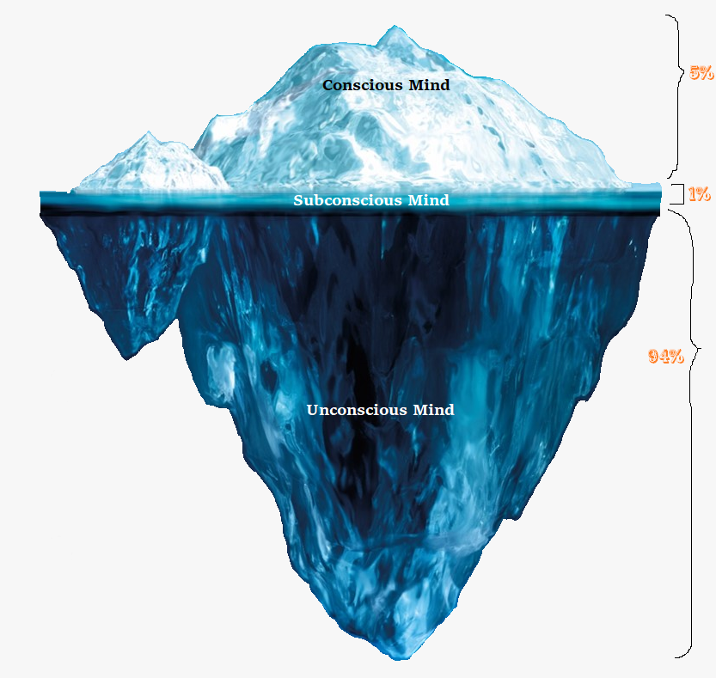
Figure 3: Iceberg phenomenon of mind by Sigmund Freud
The major parts of mind are as follows:
Conscious: Part of mind that is aware of their environment, thoughts, feelings or sensations helps an individual to be both aware and awake for being able to experience. It is also the place ego resides within small portion of mental life
Subconscious: This accounted to be an associations and impulses that are not accessible to consciousness. In other words, it can also be described as a bridge between the conscious and unconscious.
Unconscious: In context to the figure below, it can be noted that this is the part comprising of largest portion. Further, this is also the place where ID resides and its not easily reachable. However, it makes a huge contribution in giving rise to importance needs and influences of human behaviour.
*Superego resides in all the three level of consciousness
In context to the aforementioned discussion, it can be outlined that psychoanalysis is a kind of psychotherapy that seeks to facilitate eventually ensure to work though and resolve a neurotic transferase through interpretation. Considering, an interpretation can be accounted as an intervention designed by the psychoanalyst that links together both conscious (manifest) and the unconscious (latent) aspects of the communication made by the patients. Further, Freud considered dream as a major source of insight to unconscious. Freud further outlines that dream analysis, free association and the childhood interpretation conflict makes a major contibution to the patient’s neurotic symptoms.
Practice of Individualisation within the regions of Homoeopathy
CFS Hahnemann in the 17th century came up with the discovery of Homoeopathy and even coined the aspects for individualisation in health practices. In his words from Organon of Medicine 6th Edition, one could easily find the approach of individualisation that Hahnemann wanted to be practised from Aphorism 82-104.
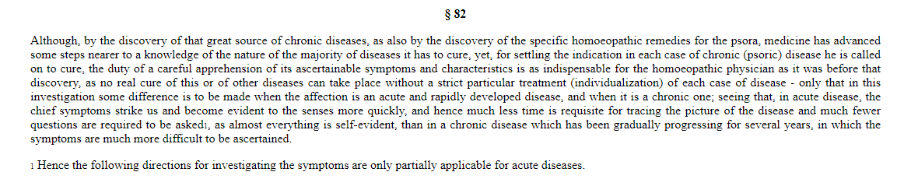
Figure 4: concept of individualisation introduced by Hahnemann in Homoeopathy
The above aphorism relates with the fundamental approach that is, it should be a duty of a practitioner to focus on careful apprehension of its ascertainable symptoms and characteristics as the indispensable factor for an individual only. He even quotes that for any individual person or a patient there is no real cure of the disease without considering its own particular treatment for each case of disease. Hence, for the investigation of any disease for any individual of any origin should be analysed by tracing the picture of disease, picture of the patient comprising all through the ends across the mind to toe.
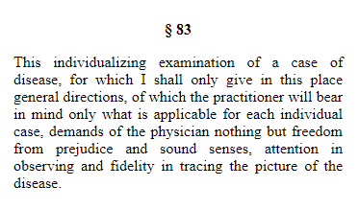
Figure 5: Aphorism 83 providing direction for individualisation to practitioner
In the above image, the quotation for the examination of mind to toe concept for each individual is specified where Hahnemann provides specific guidelines to the practitioner so that they could concentrate on individual case rather than being affected from any sort of prejudice and sound senses. Hence, the guidelines from the Aphorism 82-104 could be justified by understanding the following approach used by the homoeopathic practitioner excluding the generalised structure.
Similarly, the other visionary statement from the Organon of medicine directs to manage the issues that correlated with an individual by considering the patient. In § 3, Hahnemann clearly states about the what is to be cured in diseases that is in every individual case of disease, a physician should have knowledge of disease with its clear indication. Additionally, the physician should even perceives that what each individual curative medicine could be applied on that specific individual case and how it could adapt the disease of an individual case in order to ensure suitability and appropriate recovery. Thus, he even needs to understand the doses, way of drug administration, and the pathways based on which the medicine could work on restoring the health of each individual.
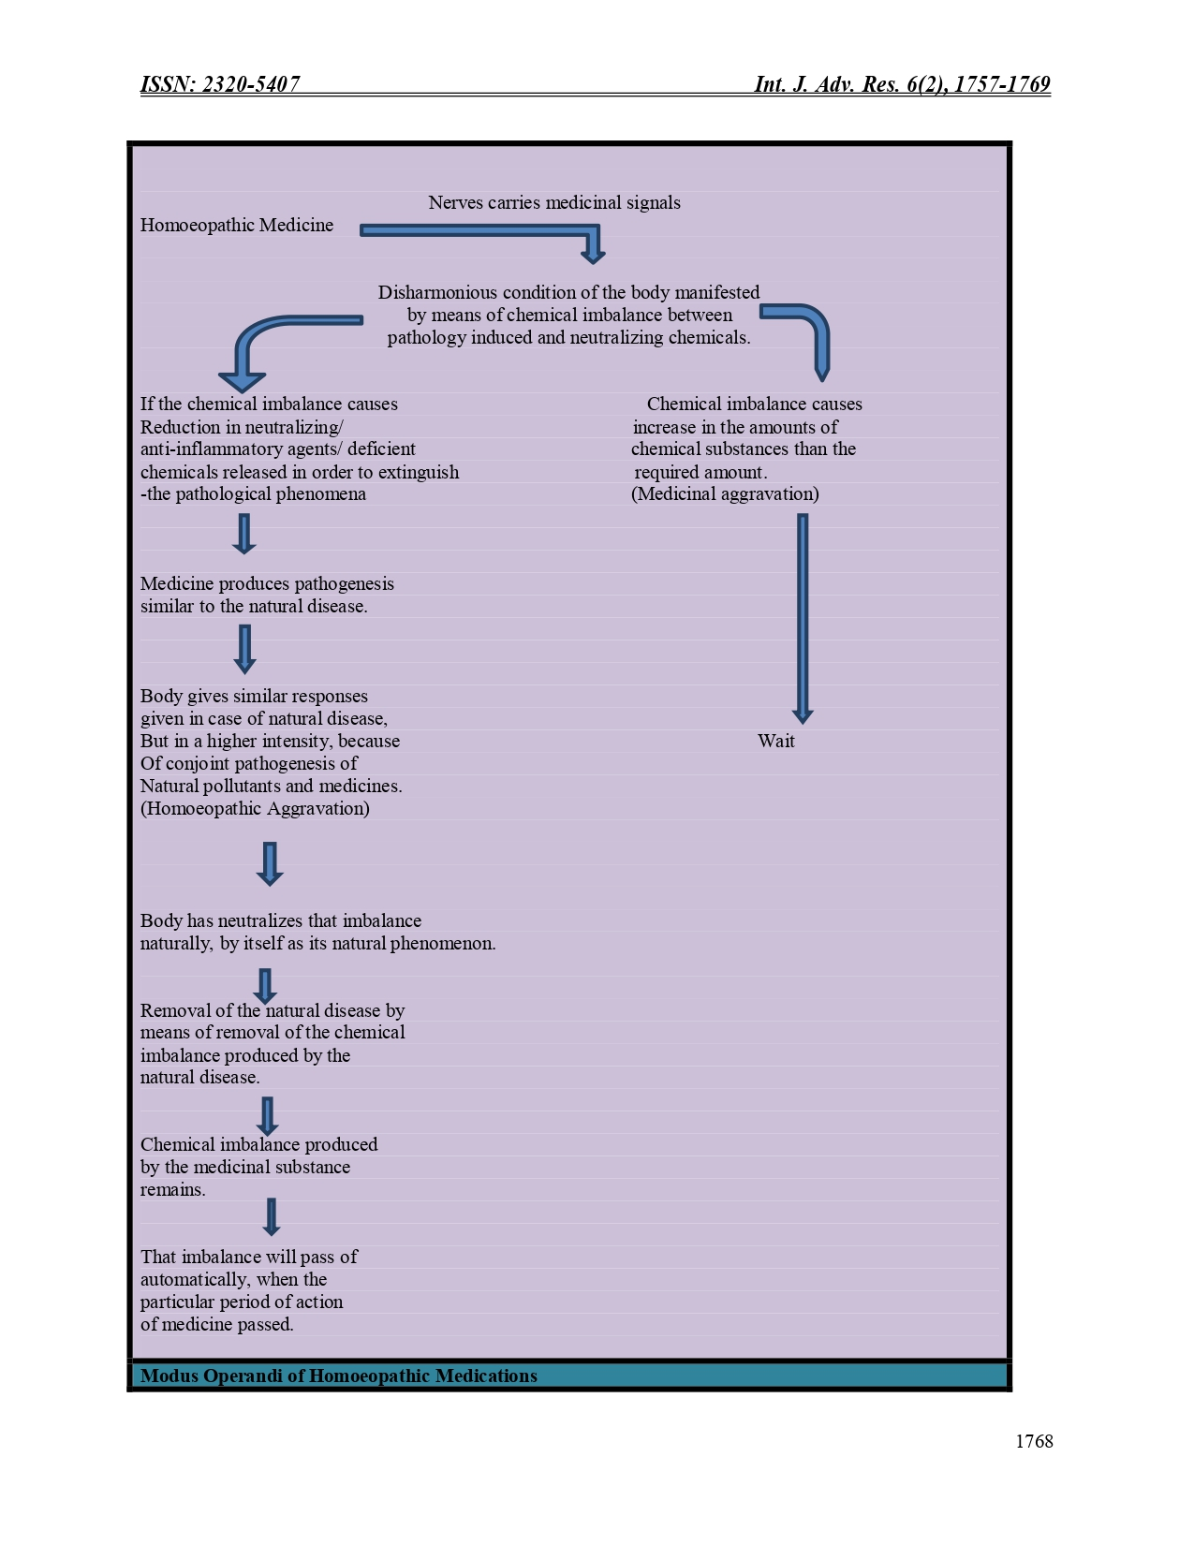
Figure 6: Modus operandi of Homoeopathic Medicine

References
https://www.researchgate.net/publication/316011507_Psychoanalysis
https://en.wikipedia.org/wiki/Psychoanalysis
https://eduardolbm.files.wordpress.com/2014/10/a-general-introduction-to-psychoanalysis-sigmund-freud.pdf
Chatterjee, C.C. and Raymahasaya, D., 1956. Human physiology. Book Concern.
https://www.ijtsrd.com/humanities-and-the-arts/sociology/26359/individualisation-a-medico-social-and-psychological-approach/swastika-subba
https://www.academia.edu/39735749/DIAGNOSIS_OF_LIFE_STYLE_DISEASES_Manuscript_info
https://en.wikipedia.org/wiki/Climate_of_Kolkata#:~:text=Kolkata%20has%20a%20Tropical%20wet,F%20to%2086%20%C2%B0F).
https://www.cdc.gov/bloodpressure/about.htm
https://www.journalijar.com/article/19999/role-of-colours-on-human-life/
https://www.journalijar.com/article/22375/mechanism-of-action-of-homoeopathic-medicines/

