Influence of Silicon on Plant Uptake of Heavy Metals and Metalloid from Soil
Plabani Roy¹, Moumita Ash¹,
¹Division of Soil Science and Agricultural Chemistry, ICAR-Indian Agricultural Research Institute, New Delhi, India, PIN-110012

¹Ph.D. Research scholar (e mail: plabaniroyiari@gmail.com), ¹Ph.D. Research scholar (e mail: moumitaiari2019@gmail.com)

Abstract
Silicon, the second most abundant element of earth’s crust, performs a variety of beneficial roles in soils and plants. It is involved in the mitigation of various biotic (insect pests and diseases) and abiotic stresses (salt, drought and heavy metals) .Si influences the heavy metal and metalloid uptake by plants through different mechanisms including (1) biological factors affecting Si bioavailability in soil, (2) by changing the soil characteristics, (3) co-precipitation with heavy metals, (4) conversion of heavy metals to less soluble forms, (5) changing the root architecture, (6) regulating antioxidant enzymes , (7) up and down-regulation of gene expression responsible for heavy metals uptake and transportation to plants .In this chapter it is discussed about the various mechanisms involved in heavy metal and metalloid uptake by Silicon. The application of industrial by products (fly ash, steel slag etc.) decreased the heavy metal uptake by transforming the soluble metals to insoluble metal silicates, phosphates and hydroxides. Si application can reduce heavy metal bioavailability in soil. Silicon nanoparticles along with Pb-resistant microbes significantly reduced the Pb concentration in plants. Si application changes mineral composition of Fe plaque in rice root which decreases both shoot As and grain As. A significant decrease in Cd and Pb toxicity of wheat along with increased grain yield can be possible by the application of organic and inorganic silicon fertilisers. Silicon nanoparticles can reduce the Cd uptake into rice grains and phloem by inhibiting the expression of low affinity cation transporter (OsLCT1). Si application mitigate Cd toxicity in cotton through reduced electrolytic leakage, malondialdehyde and hydrogen peroxide contents and improved antioxidant enzymes activity. Long-term field trials are required to evaluate the feasibility of Si application for the remediation of metal-contaminated soils.
Keywords : Silicon, heavy metals, metalloid, toxicity, remediation

Introduction-
Silicon (Si) the second most abundant element of earth’s crust, performs a variety of beneficial roles in soils and plants. It is involved in the mitigation of various biotic (insect pests and diseases) and abiotic stresses (salt, drought and heavy metals) (Ma et al., 2021). Amorphous elemental silicon was first isolated by Jöns Jacob Berzelius (1824), element name derived from Latin silex or silicis (“flint” or “hard stone”), includes to group 14 [IVa], having atomic number 14, atomic weight 28.086, density 2.33 gcm⁻³ Specific gravity 2.24 and oxidation state −4, (+2), +4. Range of Si as silicic acid in the soil varies between 0.1 - 0.6 mM. Heavy metals are generally defined as metals with relatively high densities, atomic weights, or atomic numbers. Examples of heavy metals include mercury (Hg), cadmium (Cd), chromium (Cr), thallium (Tl), and lead (Pb). Boron (B), silicon (Si), germanium (Ge), arsenic (As), antimony (Sb), and tellurium (Te) are commonly recognised as metalloids.
Different fractions of silicon in soils
According to Souri et al. (2020) the main two fractions of Si in soil are liquid and solid phase. Liquid phase includes monosilicic, polysilicic acid, complexes with organic and inorganic compounds, orano-silicon compounds etc. Amorphous and crystalline forms include to solid phase, where quartz, feldspar, mica, kaolinite, smectite includes to crystalline form and biogenic and non- biogenic include to amorphous form (Fig : 1).

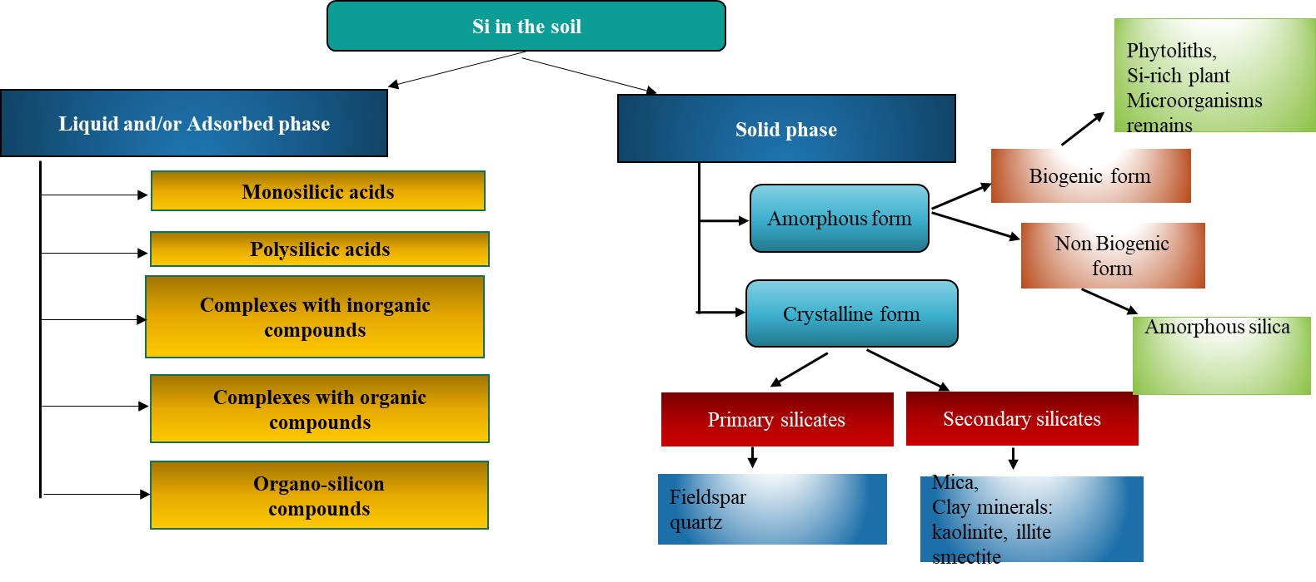
Fig 1 : Different fractions of silicon

Silica accumulator plant
Meena et al. (2021) reported there are three categories of Si accumulator high accumulator (>1.5% Si) - rice, sugarcane, wheat etc, intermediate accumulator (1.5% − 0.5% Si) - soybean, squash, cucumber, pumpkin etc and Non accumulator (< 0.5% Si) - sunflower , tomato, grapes etc (Table:1).

High accumulator  (>1.5% Si) | Intermediate accumulator  (1.5%−0.5% Si) | Non accumulator  (< 0.5% Si)
Rice | Soybean | Sunflower
Sugarcane | Pumpkins | Tomato
Wheat | Cucumber | Grapes
Lentils | Rose | Snapdragon
Spinach | Squash | Gerbera
Ferns | Chrysanthemums | Petunia
Conifers | Zinnia | Pansy
Table 1 : Silica accumulator plant

Benefits of Si
Si is not considered essential for plant growth and development, however, increasing evidence in the literature shows that this metalloid is beneficial to plants, especially under stress conditions. Indeed Si alleviates the toxic effects caused by abiotic stresses, e.g. salt stress, drought, heavy metals (Gaur et al., 2020) (Fig : 2)
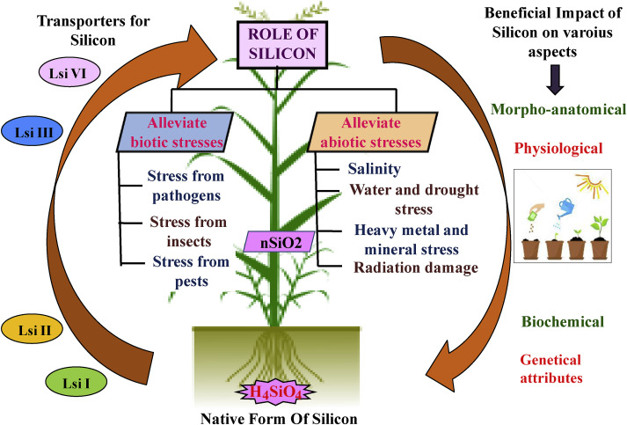
Fig 2 : Benefits of Si for plants
Plant Available Silicon (PAS)
Normally, Si is presented in various forms in the soil and in abundance especially the quartz, silicates, biogenic SiO₂ (e.g diatoms and phytoliths) and silica gel. The extractable forms of Si in the soil include amorphous, active, and water soluble Si. Water soluble forms of Si can be directly available to plants while rest of the Si firstly converted to water soluble form under favorable conditions and then easily available to plants for utilization (Ma et al., 2006). The southern dry zone (SDZ), southern transition zone (STZ), coastal zone (CZ), and central dry zone are the four main agro-climatic zones of Karnataka that Majumder et al. (2021) documented the vertical distribution of the plant accessible silicon (PAS) content in soils of (CDZ). Regardless of the crop, STZ and CZ have high DSi content (more than 40 mg kg), while SDZ and CDZ have medium DSi content (between 20 and 40 mg kg⁻¹). The lowest concentrations of DSi and AdSi were found in SDZ and CZ, respectively. In the CDZ and SDZ soil profiles of rice, the average AdSi content was 2.4 and 4 times greater than DSi, respectively. In sugarcane soil profiles, CDZ and SDZ, respectively, had AdSi contents that were 2.6 and 4 times greater than DSi levels (Table:2)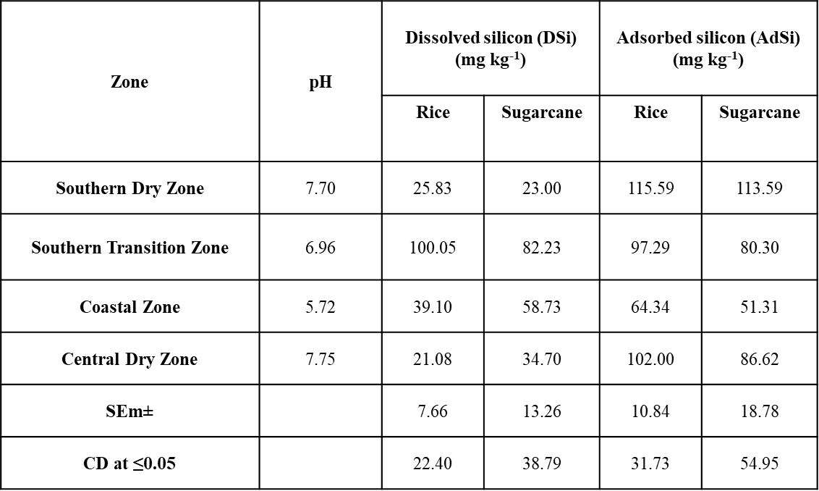
Table 2 : Relationship of properties of rice and sugarcane soils and Plant Available Silicon (PAS) in four different agro-climatic zones of Karnataka

In order to determine the impact of different diatomite grades (diatomite-1, diatomite-2, diatomite-3, diatomite-4, and diatomite-5) and levels (0, 250, 500, 750, 1000, and 1500 kg ha-1) on silicon availability in acidic and alkaline soils under field capacity, Anitha et al. (2015) conducted a pot experiment. In both soil types, diatomite-3 and diatomite-4 applied at 750 kg ha-1 each together with RDF resulted in considerably higher straw and grain yields, silicon content, and rice uptake. Comparing the application of diatomite-4 @ 1000 kg ha-1 + RDF to other grades of diatomite, higher straw silicon content was found in alkaline soil. This may be due to higher silicon dissolution at higher pH levels as well as the mechanism of silicic acid distribution in the shoots and deposition in the plant parts. Diatomite-4 @ 750 kg ha-1 + RDF treatment in acidic soil resulted in greater straw Si% content (5.9%) compared to other grade of diatomite. (Fig : 3)

Straw Si (%)

Grain Si (%)
Diatomite-2(kg ha⁻¹)
Diatomite-1(kg ha⁻¹)
Diatomite-3(kg ha⁻¹)
Diatomite-5 (kg ha⁻¹)
Diatomite-4 (kg ha⁻¹)

Fig 3 : Evaluation of different grades of diatomite on paddy straw and grain Si (%) plant in acidic and alkaline Soils at harvest
There was a greater dissolution of diatomite and release of silicon in both the soils and thereby diatomite can be used as sources of silicon. According to Khan et al. (2021) reported Si based detoxification mechanisms in plants including (1) activation of antioxidant defense system and thus reducing the oxidative damage, (2) Removal of heavy metals and metalloid from the cells, (3) Relocation of heavy metals and metalloid at subcellular level (4) Improvement in photosynthetic system (5) Repair of injured cell membranes (6) Regulation of phytochelatins.
Si influences the heavy metal and metalloid uptake by plants through different mechanisms including (1) biological factors affecting Si bioavailability in soil, (2) by changing the soil characteristics, (3) co-precipitation with heavy metals, (4) conversion of heavy metals to less soluble forms, (5) changing the root architecture, (6) regulating antioxidant enzymes , (7) up and down-regulation of gene expression responsible for heavy metals uptake and transportation to plants (Khan et al., 2021).

- Effects of silicon rich amendments on heavy metals and metalloid accumulation
- Effects of silicon rich amendments on heavy metal accumulation in rice (Oryza sativa L.)
In the treatments of Fly ash (FA20) and Steel slag (SS3), the concentrations of cadmium, zinc, copper, and lead (Pb) calculated using the DGT technique (the DGT pools) all dramatically dropped (Table:3), and the reduction was at least 84%. Fly ash, steel slag, and other industrial byproducts reduced the uptake of heavy metals by converting soluble metals to insoluble metal silicates, phosphates, and hydroxides (Gu et al., 2011)

Treatments | Cd  (µg kg⁻¹) | Zn  (mg kg⁻¹ soil) | Cu  (mg kg⁻¹soil) | Pb  (mg kg⁻¹ soil) | pH
Control | 7.3 ± 0.30a | 6.7 ± 0.73a | 6.3 ± 0.79a | 57 ± 7.8a | 3.9–4.0d
Fly ash  (20 g kg⁻¹) | 1.7 ± 0.18b | 0.56 ± 0.07c | 1.0 ± 0.07b | 4.1 ± 0.50c | 5.0–5.2c
Fly ash  (40 g kg⁻¹) | 0.06 ± 0.01c | 0.01 ± 0.01c | 0.76 ± 0.08b | 0.30 ± 0.04c | 6.3–6.5a
Steel slag  (3 g kg⁻¹) | 2.1 ± 0.30b | 1.4 ± 0.32b | 1.3 ± 0.19b | 9.8 ± 2.5b | 4.9–5.1c
Steel slag  (6 g kg⁻¹) | 0.10 ± 0.17c | 0.11 ± 0.07c | 0.72 ± 0.06b | 0.53 ± 0.15c | 6.0–6.2b
Table 3 : Effects of silicon rich amendments on heavy metal accumulation in rice (Oryza sativa L.)
Hamsa et al. (2018) assess the impact of several Si sources, such as rice hull biochar, diatomaceous earth, and calcium silicate at various quantities, in reducing the uptake of heavy metals by spinach. In RDF + Diatomaceous earth @ 500 kg Si ha-1, the uptake of Cr in spinach shoot and root is 10.10 m kg⁻¹ and 1.12 mg kg⁻¹, respectively, which is significantly less. Due to its increased solubility and the availability of other nutrients, diatomaceous earth application was found to be more effective than other treatments in lowering the Cr concentration in spinach shoots (Table:4).
Effect of different silicon sources on chromium uptake by spinach
Treatments | Cr content (mg kg⁻¹)after harvest
 | Shoot | Root
Control | 16.20 ±0.81 a | 2.45 ±0.034 a
Rice hull biochar @ 200 kg Si ha⁻¹ | 15.40 ±0.74 ab | 2.22 ±0.031 c
Rice hull biochar @ 500 kg Si ha⁻¹ | 10.70± 0.54 fg | 1.95 ± 0.027 ef
Diatomaceous earth @ 200 kg Si ha⁻¹ | 11.20 ±0.56 def | 1.88 ±0.026 g
Diatomaceous earth @ 500 kg Si ha⁻¹ | 10.10 ±0.50 g | 1.12 ±0.030 h
Calcium silicate @ 200 kg Si ha⁻¹ | 11.80 ±0.59 cde | 1.83 ±0.026 g
Calcium silicate @ 500 kg Si ha⁻¹ | 10.30 ±0.52 fg | 1.98 ±0.028 e
(n =3) ±SD. p< 0.05

Table 4 : Effect of different silicon sources on chromium uptake by spinach

Effect of combined use of lead (Pb) resistant microbes and silicon nanoparticles (Si-NPs) on coriander (Coriandrum sativum L.) under Pb stress

The combination use of silicon nanoparticles (Si-NPs) and lead (Pb) resistant microorganisms was assessed by Fatemi et al. (2020) under Pb stress. It has been proposed that Si-NPs and Pb-resistant microorganisms could be employed to increase plant growth, photosynthesis, and antioxidant capacity, hence reducing Pb stress in coriander. The plants treated with 500 mg/kg Pb had the highest concentration of shoots and roots, whereas the plants treated with the control treatment had the lowest concentration of Pb. Comparing the identical Pb treatments with and without the application of silicon, the concentrations of Pb in the shoots and roots reduced by 22% and 2%, respectively. (Fig : 4) T1: Command, T2: 500 mg/kg of lead T3: S6 + Pb500 Inoculation, T4: S19 + Pb50 Inoculation T5: Foliar Si-NPs 1.5 mM application Si-NPs + S6 + Pb in T6, and T7: Si-NPs + S19 + Pb

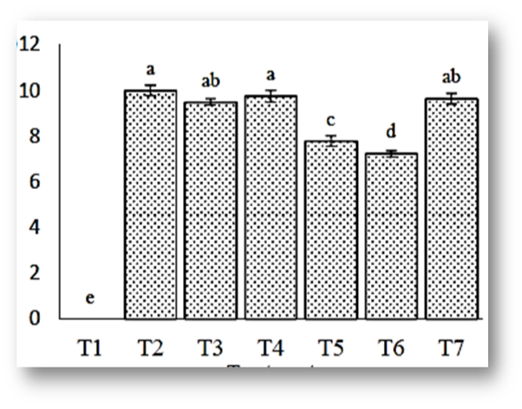
Treatment

Shoot Pb ( mg kg⁻¹ dry weight)
Root Pb ( mg kg⁻¹ dry weight)
Fig 4 : Effect of combined use of lead (Pb) resistant microbes and silicon nanoparticles (Si-NPs) on coriander (Coriandrum sativum L.) under Pb stress

- Changing the soil characteristics
To investigate the effects of silicon on soil-cadmium availability and uptake in rice cultivated in an acid soil maintained under two distinct moisture regimes, Babu et al. (2017) carried out a greenhouse experiment (field capacity or submergence). Due to lowering circumstances in the soil and the addition of Si as wollastonite, soil pH rose after flooding and reached 6.5 to 7.1 during harvest. Contrary to changes in soil pH, the amount of Cd²⁺ that was readily available in the soil changed. In soils that were kept in a waterlogged condition, it was lower (Fig : 5).
pH
Field capacity moisture regime Submergence regime
Silicon level (kg ha⁻¹)

Silicon level(kg ha⁻¹)
Field capacity moisture regime Submergence regime
Soil Cd (µg g⁻¹)
Soil Si (µg g⁻¹)

p < 0.05 by Tukey–Kramer post-hoc test.

Fig 5 : Effect of silicon amendment on soil pH and soil-cadmium availability and uptake in rice

Effect of Silica fertilization and nano-MnO₂ amendment on bacterial community composition in high arsenic paddy soils

According to Shao et al. (2015), Proteobacteria, Chloroflexi, and Acidobacteria were the three phyla that predominated in all of the paddy soil samples used in this investigation. Increases in the relative ratio of Acidobacteria and the addition of nano-MnO₂ were accompanied by a decrease in the relative abundance of Chloroflexi. According to earlier research, low soil pH was advantageous to Acidobacteria and substantially regulated the amount of Acidobacteria present. Arsenite methylation, volatilization, arsenite reduction, and efflux are just a few of the different ways that cyanobacteria, including Microcystis, Nostoc, and Synechocystis, detoxify arsenic. Under silica fertilisation or amendment with nano-MnO₂, the amount of bioavailable arsenic reduced (Fig : 6). If silica fertilisation or nano-MnO₂ amendment reduce arsenic biotoxicity (Table : 5), cyanobacteria may compete less fiercely, resulting in a reduction in the relative abundance of this microorganism in the environment.

Soil As (µg g⁻¹)
Fig 6 : Effect of Silica fertilization and nano-MnO₂ amendment on bacterial community composition in high arsenic paddy soils

Treatment | Bioavailable As  (mg kg⁻¹) | pH
Control | 0.95±0.14ª | 7.35±0.05ª
Si-L | 0.66±0.05^{b} | 7.25±0.07^{ab}
Si-H | 0.55±0.13^{bc} | 7.26±0.01^{b}
Mn-L | 0.55±0.01^{bc} | 7.33±0.04^{ab}
Mn-H | 0.36±0.02^{c} | 7.25±0.01^{b}
Means±SD (p<0.05)
Table 5 : Effect of silica fertilization and nano-MnO₂ amendment on the α-diversity of bacteria in arsenic-contaminated paddy soil

- Co-precipitation of Si with heavy metals and metalloid
Comparative efficacy of organic and inorganic silicon fertilizers on Cd/Pb accumulation in wheat (Triticum aestivum L.)
The effects of two organic silicon fertilisers (OSiFA and OSiFB) and an inorganic silicon fertiliser (InOSiF) on wheat heavy metal uptake and biochemical parameters in a Cd and Pb co-contaminated soil were assessed and compared through a soil pot experiment. By increasing Si uptake in roots and shoots using OSiFA, OSiFB, and InOSiF, the accumulation of Cd and Pb in wheat shoots, bran, and flour was reduced. In particular, the amount of Cd and Pb in the flour was reduced by 17%, 10%, and 31%, and by 74%, 53%, and 48%, respectively (Huang et al., 2019) (Table:6).

Treatments | Cd concentration |  |  |  | Pb concentration |  |  |  | Si concentration
 | Root | Shoot | Bran | Flour | Root | Shoot | Bran | Flour | Root | Shoot | Grain
 | 1 | 1 | 1 | 1 | 1 | 1 | 1 | 1 | 1 | 1 | 1
Control with common fertilizer | 1.07 | 1.44 | 2.22 | 1.46 | 1.06 | 1.67 | 3.72 | 3.84 | 0.57 | 0.84 | 0.90
Organosilicon fertilizer A | 1.05 | 1.24 | 1 | 1.22 | 1.51 | 1.21 | 2.11 | 1 | 1 | 0.97 | 0.81
Organosilicon fertilizer B | 1 | 1.34 | 1.79 | 1.31 | 1 | 1.30 | 1.50 | 1.82 | 0.90 | 1 | 0.42
Sodium silicate with common fertilizer | 1.05 | 1 | 1.38 | 1 | 1.06 | 1 | 1 | 2.02 | 0.87 | 0.92 | 1
Results of standardization of raw data of Cd and Pb contents of wheat root, shoot, bran, flour, and Si content of wheat root, shoot, grain
Table 6 : Comparative efficacy of organic and inorganic silicon fertilizers on Cd/Pb accumulation in wheat (Triticum aestivum L.)
Effects of exogenous Si on Cd translocation and toxicity in rice (Oryza sativa L.)
In a long-term experiment with rice (Oryza sativa L.), Zhang et al. (2008) showed that the addition of Si boosted shoot and root biomass by 125–171% and by 100–106% in comparison to the zero-Si treatment ( Fig : 7) In comparison to the treatment without silicon supply, silicon supply reduced the Cd concentrations in the shoot by 30–50% and the Cd distribution ratio by 25.3–46% (Table : 7).
SiO₂ concentration (%)
Cd content (mg kg⁻¹)
Shoot
Shoot
Root

Root

Fig 7 : Effects of exogenous Si on Cd translocation and toxicity in rice (Oryza sativa L.)

Cd concentration  (×10⁻⁶ mol L⁻¹) | SiO₂ concentration  (×10⁻³ mol L⁻¹) | Days after Cd treatment
 |  | 15 | 45 | 75 | 105
 |  | Cd distribution in shoots (% of total Cd in plant)
2 | 0 | 30.0ª | 11.7^{b} | 12.5ª | 9.9^{ab}
 | 2 | 23.1^{b} | 6.62^{c} | 5.65^{b} | 8.7^{ab}
 | 4 | 16.2^{c} | 6.08^{c} | 4.57^{b} | 7.4^{b}
4 | 0 | 24.2^{b} | 17.3ª | 11.6ª | 12.5ª
 | 2 | 21.9^{bc} | 11.5^{b} | 11.0ª | 10.4^{ab}
 | 4 | 18.5^{bc} | 8.1^{bc} | 10.5ª | 10.0^{ab}
Table 7 : Effect of Si on Cd distribution in shoots of rice (Oryza sativa L.)
Effect of Si on changes in Fe mineral composition of Fe plaque and shoot As in rice
Amaral et al. (2017) evaluate Si's effects on the mineral makeup of root Fe plaques and how they affect rice's uptake of As. Si content is essential for managing the concentration of shoot As. Rice shoot As accumulation and inorganic rain As content are both affected by increasing solution Si and ferrihydrite concentration, higher Si's ability to precipitate and encrust As containing ferrihydrite, and lower ferrihdrite. As a result, As becomes less mobile as Si precipitates, resulting in plaques of As carrying ferrihydrite (Fig : 8).

Inorganic grain As (µg)

Si in plaque (mg)
As in plaque (µg)

Fig 8 : Effect of Si on changes in Fe mineral composition of Fe plaque As in rice
- Conversion of heavy metals and metalloid to less soluble forms in the soil
Effect of silicate on Cd uptake into cells of wheat by phytochelatins formation
To investigate whether and how silicate (Si) effects cadmium (Cd) uptake at the cellular level in wheat, Greger et al. (2015) performed a pot experiment in wheat. Plants treated to all four treatments had their roots and shoots examined for the expression of genes related to Cd absorption, including phytochelatin (PC) content and PC gene (PCS1) expression (Fig : 9). Si promoted PC formation in the presence of Cd. Si-treated plants had higher PCS1 expression, which was much stronger in plants that had received Cd treatment. Protoplasts exposed to Cd or Cd²⁺ ⁺ Si contained PC2. Plants exposed to all treatments and controls both contained glutathione (GSH). Cell wall-bound Si hindered Cd absorption into cells, preventing Cd uptake into cells. Si may affect both the release of Cd from the inner side of the membrane and the binding of Cd to the membrane's uptake sites. Additionally, additional Si might bind to one Cd transporter, preventing the transport in the event that an other transport route is available. Treatments are : Control = 0 mM Si + 0 μM Cd, Si = 1 mM Si, Cd = 1 μM, Si+Cd = 1 mM Si + 1 μM Cd

N = 4-5 ± SE
Root
Shoots
- Phytochelatins (PC2 = black, PC3 = grey)
- Glutathione (GSH = white)
Conc. pmol 10⁻⁶ protoplasts
Fig 9 : Effect of silicate on Cd uptake into cells of wheat by phytochelatins formation
Effect of silica nanoparticles in alleviating Cd toxicity in rice cells
Cui et al. (2017) carried out an experiment and used the CELLQuest programme to monitor the rice cells that had been treated. The threshold was established by the fluorescence emission in M2 areas, which represented the dead cells. The live cells and the dead cells, respectively, were represented by the fluorescence emission in the M1 and M2 regions. The vitality of the cells after the various treatments can be clearly seen in the data. The proportion of live cells exhibited the reverse tendency, and the number of dead cells was much higher in the absence of the SiNPs than it was in the presence of them (M1 area)(Fig : 10). After 48 hours of cultivation under the control circumstances, it was found that there were significantly more dead cells (65.5%) than live cells (34.5%). However, the inclusion of 19 nm, 48 nm, and 202 nm SiNPs significantly increased the proportion of live cells to 95.4%, 78.6%, and 66.2%, respectively. The average Cd content in cells and protoplasts grew gradually with rising Cd concentrations in the medium in the absence of the SiNP treatments, and the Cd content of the protoplasts was only marginally lower than that of the cells. The diameter of SiNPs was favourably linked with the Cd concentrations of the cells and protoplasts. The amount of Cd²⁺ entering cells was reduced in a size-dependent way as a result of the large particles offering fewer Cd²⁺ binding sites than the small particles. More Cd binding sites are made available by the increased Si concentration in cell walls, which prevents Cd from entering cells (Fig : 11).

Fig 10 : Fluorescence emission in the M1 and M2 regions

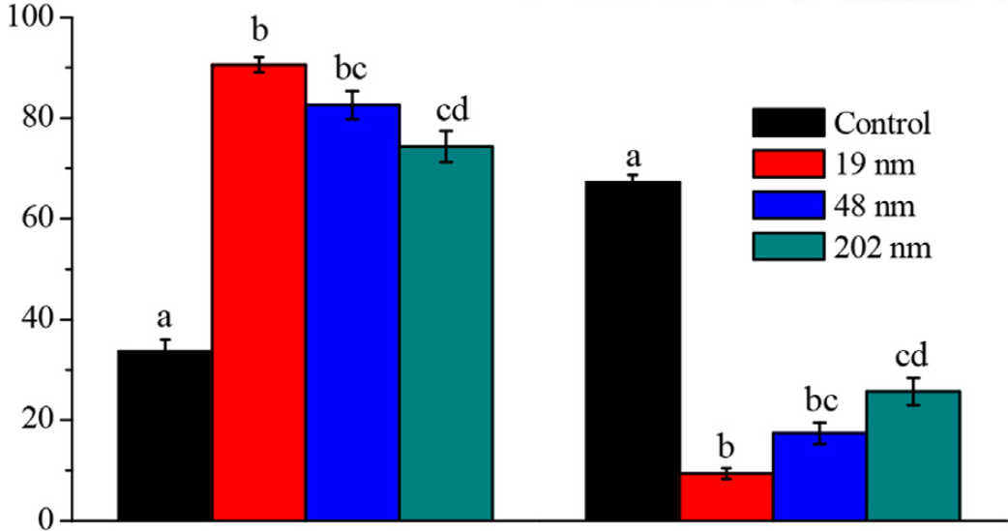
The ratio in total cells (%)
Live cells Dead cells

[Cd²⁺ ] in medium (µm)
Si contents (mg kg⁻¹ dry weight )
Cd contents (µg kg⁻¹ dry weight )

Tukey's test (P < 0.05).
Fig 11 : Effect of silica nanoparticles in alleviating Cd toxicity in rice cells

Effect of Si on Cu uptake by wheat seedlings (Triticum turgidum L.) by complex formation
The influence of Si on Cu tolerance in durum wheat (Triticum turgidum L.) grown in 0, 0.7, 7.0, and 30 M Cu without and with 1.0 mM Si (Table:8) was investigated in a hydroponic study, along with the mechanisms involved in reducing Cu toxicity. Compared to the same Cu treatment without Si, Si application considerably reduced the concentration of Cu in the shoots in the Cu 30 M + Si treatment. In the Si treatment, the concentration of malate, citrate, and aconitate ( Fig : 12) was higher in the shoots than the roots, which can bind the Cu and prevent its concentration by complex formation (Keller et al., 2014).

Treatment |  | Si | Cu
0 µM Cu, 0 mM Si  n = 3 | m | 0.77 | 0.00
 | sd | 0.12 | 0.00
7 µM Cu, 0 mM Si  n = 4 | m | 0.12 | 0.04
 | sd | 0.05 | 0.00
30 µM Cu, 0 mM Si  n = 4 | m | 0.75 | 0.04
 | sd | 0.35 | 0.02
0 µM Cu, 1 mM Si  n = 3 | m | 1.23 | 0.00
 | sd | 0.32 | 0.00
7 µM Cu, 1 mM Si  n = 4 | m | 0.63 | 0.03
 | sd | 0.30 | 0.02
30 µM Cu, 1 mM Si  n = 4 | m | 0.48 | 0.08
 | sd | 0.19 | 0.01

Table 8 : Effect of Si on Cu uptake by wheat seedlings (Triticum turgidum L.) by complex formation

Roots
Roots
Shoots
Shoots
mmol kg⁻¹ dry weight
Shoots Roots
Shoots Roots
[Cu ] in solution µM

Bars represent sd of four replicates, P ≥ 0.05
Fig 12 : Effect of silicon on Cu uptake by wheat seedlings (Triticum turgidum L.) by complex formation

- Changing the root architecture
Effect of silicon on root modification and uptake of cadmium in young maize plants
In order to assess the impact of Si on Cd uptake and cellular distribution in connection to the growth of root tissues, Vaculik et al. (2012) performed a hydroponic experiment on a maize plant. Compared to controls, the addition of Si improved the branching of seminal roots. Increased Cd treatment was favourably linked with the Cd concentration in maize roots. Compared to control plants, roots treated with Cd5 developed casparian bands and, in particular, suberin lamellae closer to the root apex. Individual endodermal cells began to suberize farther away from the root apex in Si-treated roots than in control roots. When compared to untreated rice plants, si improved the suberization and lignification of root tissues in both the exodermis and the endodermis. Exodermis is less effective than endodermis at blocking apoplasmic Cd transfer( Fig : 13).
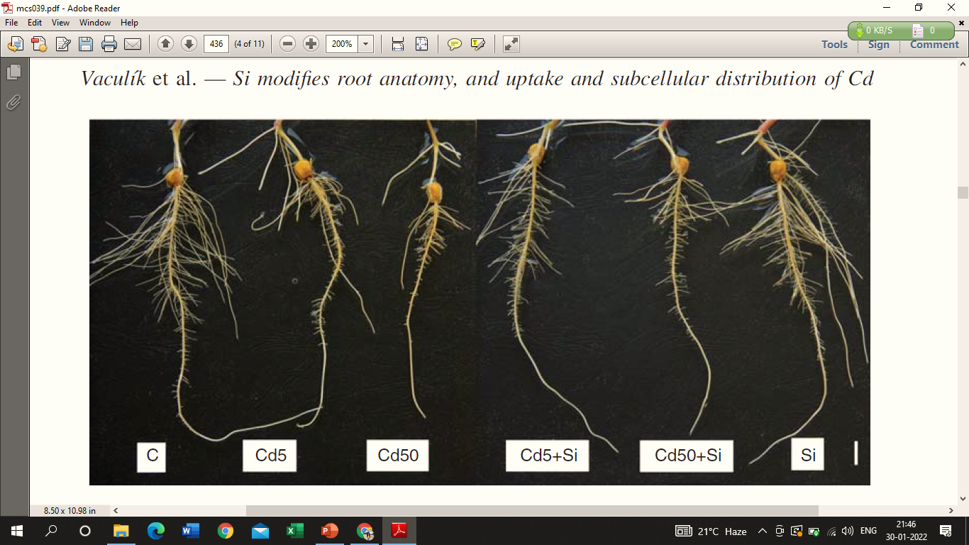Scale bar= 10 mm
C = control
- Cross-section of the root of young maize (scale bar = 50 mm).
Cd5 = 5 µM Cd
Cd5 + Si = 5 µM Cd with 5 mM Si
Cd50 = 50 µM Cd
(B) Cross-section of the basal part of young maize plants (scale bar =200 mm).
- epi = epidermis;
- ex = exodermis;
- en = endodermis
Cd50 + Si = 50 µM Cd with 5 mM Si
Si = 5 mM Si

Fig 13 : Effect of silicon on root modification and uptake of cadmium in young maize plants

Effect of Si in alleviating antimony phytotoxicity in giant reed (Arundo donax L.) by changing root architechture
Shetty et al. (2021) carried out a greenhouse experiment to test the gigantic reed's tolerance to Sb toxicity and the ability of Si to lessen its phytotoxicity. However, lignified central pith, including proto and early metaxylem vessels, and particularly deeply lignified endodermal layer, were found in SbSi treated roots relatively closer to the root apex than in Sb treated plants, despite Sb only slightly increasing root lignification compared to control plants (Fig : 14). The lower Sb concentration in the shoots of SbSi treated plants is further explained by the fact that Si-enhanced lignification of root structures likely restricts the Sb translocation to the shoot ( Fig :15).

Root length (cm)
Lignification (red color)a,b=30%, c,d=90% of root length
(L lignification, ex exodermis, en endodermis, mx meta xylem)
C = Control, Sb = Sb 20 mg L, Si = 1 mM,SbSi = Sb 20 mg L + Si 1 Mm
Means ± SE (n = 3). p < 0.05.
Fig 14 : Effect of Si in alleviating antimony phytotoxicity in giant reed (Arundo donax L.) by changing root architechture
Root
Shoot

Root
Shoot

Means ± SE ,(n = 3). p < 0.05

Fig 15 : Effect of Si in alleviating antimony phytotoxicity in giant reed (Arundo donax L.) by changing root architechture

Since roots of SbSi plants contained more Sb than Sb treated roots, the addition of Si to Sb treated plants increased root lignification, likely as a defensive reaction. Further explaining the lower Sb concentration in the shoots of SbSi treated plants is the Si-enhanced lignification of root structures, which is likely to hinder Sb translocation to the shoot.

- Regulating antioxidant enzymes
Comparative efficacy of organic and inorganic silicon fertilizers on antioxidant response in wheat (Triticum aestivum L.)
The byproducts of peroxidation under stress are hydrogen peroxide (H₂O₂)and malondialdehyde (MDA), which can seriously harm the cell membrane system. When compared to the control, both Si fertilisers considerably reduced the amount of H₂O₂ and MDA present in wheat. In comparison to CK and InOSiF, OSiFs considerably reduced their H₂O₂ levels by 36%-51% and 18%-31%, respectively, and their MDA by 27%-28% and 23%-25%, respectively. By balancing the osmotic strength of the cytoplasm and vacuoles and the osmotic intensity of the surrounding environment, Superoxide Dismutase (SOD) and Catalase(CAT) together transformed superoxide radicals and H₂O₂ into H₂O and simultaneously produced more Glutathione (GSH) to protect plant cells (Fig : 16).
µg⁻¹min⁻¹ fresh wt.
µg g⁻¹ fresh wt.
Superoxide Dismutase
Peroxidase
µg⁻¹min⁻¹ fresh wt.
Catalase
CK
OSiFA
OSiFB
InOSiF
µmol g⁻¹ fresh wt.
CK
OSiFA
OSiFB
InOSiF
µg g⁻¹ fresh wt.
Glutathione
Hydrogen Peroxide
CK
OSiFA
OSiFB
InOSiF
µmol g⁻¹ fresh wt.
Malondialdehyde

Mean (n=3) ± SD; p < 0.05
CK = Control
OSiFA =Organosilicon fertilizer A
OSiFB = Organosilicon fertilizer B
InOSiF = Sodium silicate with common fertilizer
Fig 16 : Comparative efficacy of organic and inorganic silicon fertilizers on antioxidant response in wheat (Triticum aestivum L.)

According to Farooq et al. (2013), application of Si lessens Cd toxicity in cotton by lowering the levels of malondialdehyde and hydrogen peroxide and increasing the activity of antioxidant enzymes. Even though Cd does not directly produce ROS, it causes oxidative burst by interfering with the antioxidant defence system, which encourages the MDA concentrations because of lipid peroxidation. This is one of the key processes underlying Cd-induced stress to plants ( Fig :17).

Alleviation of cadmium toxicity by Si in oxidative stress condition in cotton
Root
Malondialdehyde
(µ Mg⁻¹ fresh wt.)
Hydrogen peroxide
(µ Mg⁻¹ fresh wt.)
Leaf

Mean ±SE P≤0.05.
Fig 17 : Alleviation of cadmium toxicity by Si in oxidative stress condition in cotton

- Up and down-regulation of gene expression responsible for heavy metals and metalloid uptake, accumulation and transportation to plants
Silica nanoparticles alleviate cadmium toxicity in rice cells by genetic expression
According to Cui et al. (2017), silicon nanoparticles can lower the absorption of Cd into rice grains and phloem by 16.7% to 64.3% above control by decreasing the expression of the OsLCT1 low affinity cation transporter. SiNPs decreased the expression of the genes for Cd uptake and transport (OsLCT1 and OsNramp5), but they increased the expression of the genes for Cd transport into the vacuole (OsHMA3) and Si uptake (OsLsi1). These findings show that the presence of SiNPs boosted Si absorption capacity by at least 1.87 times and decreased Cd uptake capacity, which jointly reduced the toxicity of Cd in rice ( Fig :18).
Relative expression level
- Means ± SD (P < 0.05).
Cd²⁺ concentrations (10, 20 and 40 µm)
- mM SiNPs (19 nm, 48nm, and 202 nm)

Fig 18 : Silica nanoparticles alleviate cadmium toxicity in rice cells by genetic expression

Effect of silicon transporters on heavy metals uptake, accumulation, and transportation by rice
Three mutant cultivars of rice were grown in a field experiment on soil with a background level of total As (5.3 mg/kg) to study the involvement of the Lsi1 and Lsi2 transporters in the accumulation of As in rice. Ma et al. (2008). As concentrations in straw were lower in all three mutants than in the wild type, with the two lsi2 mutants having concentrations that were just 13–19% of the equivalent wild-type rice. In contrast, the grain As concentration in both lsi2 mutants was considerably (P 0.01) lower than that of wild-type rice, being 63% and 51% of the corresponding wild-type rice, respectively (Fig : 19).

Husk As (mg kg⁻¹)
WT1
LSi1
WT2
LSi2-1
WT3
LSi2-2
Grain As (mg kg⁻¹)
Straw As (mg kg⁻¹)

means ± SD (n = 3).
Fig 19 : Effect of silicon transporters on heavy metals uptake, accumulation, and transportation by rice

- Conclusions
- Application of fly ash and steel slag could be a potential strategy to mitigate environmental and health risks posed by multi-metal contaminated acidic soil.
- Si application changes soil pH , microbial community etc which reduce the available form of heavy metals and metalloid
- Si application enhance formation of phytochelatins, oranic and inorganic ions which can form complex with heavy metals and metalloid and reduce their availability in plants
- Most SiNPs alleviate heavy metals and metalloid toxicity by accumulated on the cell walls and bind them to prevent entering into the cell.
- Si application enhanced root lignification as a defence reaction restrict the heavy metals and metalloid translocation to the shoot
- Application of Si lowering reduce uptake and accumulation of heavy metals and metalloid by reducing the reactive oxygen species (ROS) damage through increased antioxidant enzyme activities
- Si application can reduce plant heavy metals and metalloid uptake by stimulating the Si transporter (OsLsi1); and inhibiting the heavy metal transporters.

- Future prospects
- Long-term field trials are required to evaluate the feasibility of Si application for the remediation of metal-contaminated soils
- Further studies are required to elucidate the possible concomitance of Si and Cd in phytoliths of shoots or in the endodermis of roots
- More study should focus on the Si-NPs distribution and migration of plant, and unknown influence of microbial communities in the rhizosphere soil.
- Research at the transcriptomic level is needed to investigate the exact mode of action and underlying mechanism of Si-mediated regulation of antioxidant enzymes of the plant under abiotic stress conditions.
- More research is needed to identify allelic variations in LSi1 and LSi2 that favor uptake of silicon over arsenite

References :
- Amaral, D. C., Lopes, G., Guilherme, L. R. and Seyfferth, A. L. (2017). A new approach to sampling intact Fe plaque reveals Si-induced changes in Fe mineral composition and shoot As in rice. Environmental science and technology, 51(1), 38-45.
- Anitha, M. S., & Prakash, N. B. (2015). Evaluation of Different Grades of Diatomite on pH and Plant Available Silicon in Acidic and Alkaline Soils. ecialise Sp, 49(2), 161-166.
- Babu, T. and Nagabovanalli, P. (2017). Effect of silicon amendment on soil-cadmium availability and uptake in rice grown in different moisture regimes. Journal of Plant Nutrition, 40(17), 2440-2457.
- Cui, J., Liu, T., Li, F., Yi, J., Liu, C. and Yu, H. (2017). Silica nanoparticles alleviate cadmium toxicity in rice cells: mechanisms and size effects. Environmental Pollution, 228, 363-369.
- Farooq, M., A., Ali, S., Hameed, A., Ishaque, A., Mahmood, K. and Iqbal, Z. (2013). Alleviation of cadmium toxicity by silicon is related to elevated photosynthesis, antioxidant enzymes; suppressed cadmium uptake and oxidative stress in cotton. Ecotoxicology and environmental safety, 96, 242-249.
- Fatemi, H., Pour, B. E. and Rizwan, M. (2020). Isolation and characterization of lead (Pb) resistant microbes and their combined use with silicon nanoparticles improved the growth, photosynthesis and antioxidant capacity of coriander (Coriandrum sativum L.) under Pb stress. Environmental Pollution, 266, 114-124.
- Gaur, S., Kumar, J., Kumar, D., Chauhan, D. K., Prasad, S. M. and Srivastava, P. K. (2020). Fascinating impact of silicon and silicon transporters in plants: A review. Ecotoxicology and Environmental Safety, 202, 110-118.
- Greger, M., Kabir, A. H., Landberg, T., Maity, P. J. and Lindberg, S. (2015). Silicate reduces cadmium uptake into cells of wheat. Environmental Pollution, 211, 90-97.
- Gu, H. H., Qiu, H., Tian, T., Zhan, S. S., Chaney, R. L., Wang, S. Z. and Qiu, R. L. (2011). Mitigation effects of silicon rich amendments on heavy metal accumulation in rice (Oryza sativa L.) planted on multi-metal contaminated acidic soil. Chemosphere, 83(9), 1234-1240.
- Hamsa, N., Prakash, N. B., Gowda, R. C. and Kadalli, G. G. (2018). Effect of different sources of silicon on spinach grown in chromium contaminated soil. IJCS, 6(5), 68-71.
- Huang, H., Rizwan, M., Li, M., Song, F., Zhou, S., He, X. and Tu, S. (2019). Comparative efficacy of organic and inorganic silicon fertilizers on antioxidant response, Cd/Pb accumulation and health risk assessment in wheat (Triticum aestivum L.). Environmental Pollution, 255, 113-146.
- Keller, C., Rizwan, M., Davidian, J. C., Pokrovsky, O. S., Bovet, N., Chaurand, P. and Meunier, J. D. (2014). Effect of silicon on wheat seedlings (Triticum turgidum L.) grown in hydroponics and exposed to 0 to 30 µM Cu. Planta, 241(4), 847-860.
- Khan, A., Bilal, S., Khan, A. L., Imran, M., Al-Harrasi, A., Al-Rawahi, A. and Lee, I. J. (2020). Silicon-mediated alleviation of combined salinity and cadmium stress in date palm (Phoenix dactylifera L.) by regulating physio-hormonal alteration. Ecotoxicology and environmental safety, 188, 109-115.
- Khan, I., Awan, S. A., Rizwan, M., Ali, S., Hassan, M. J., Brestic, M. and Huang, L. (2021). Effects of silicon on heavy metal uptake at the soil-plant interphase: a review. Ecotoxicology and Environmental Safety, 222, 112-119.
- Liang, Y., Sun, W., Zhu, Y. G. and Christie, P. (2007). Mechanisms of silicon-mediated alleviation of abiotic stresses in higher plants: a review. Environmental pollution, 147(2), 422-428.
- Ma, C., Ci, K., Zhu, J., Sun, Z., Liu, Z., Li, X. and Liu, Z. (2021). Impacts of exogenous mineral silicon on cadmium migration and transformation in the soil-rice system and on soil health. Science of The Total Environment, 759, 143-151.
- Ma, Q., Rossmann, T. and Guo, Z. (2008). Temperature sensitivity of silica micro-resonators. Journal of Physics D: Applied Physics, 41(24), 245-251.
- Ma, Z., Guan, Y. and Liu, H. (2006). Superparamagnetic silica nanoparticles with immobilized metal affinity ligands for protein adsorption. Journal of Magnetism and Magnetic Materials, 301(2), 469-477.
- Majumdar, S. and Prakash, N. B. (2021). Relationship of Properties of Rice and Sugarcane Soils and Plant Available Silicon in Karnataka, South India. Silicon, 1-14.
- Meena, V., Dotaniya, M. L., Saha, J. K. and Patra, A. K. (2021). Silicon potential to mitigate plant heavy metals stress for sustainable agriculture: a review. Silicon, 1-16.
- Shao, J., He, Y., Zhang, H., Chen, A., Lei, M., Chen, J. and Gu, J. D. (2015). Silica fertilization and nano-MnO₂ amendment on bacterial community composition in high arsenic paddy soils. Applied microbiology and biotechnology, 100(5), 2429-2437.
- Shetty, R., Vidya, C. S. N., Weidinger, M. and Vaculík, M. (2021). Silicon alleviates antimony phytotoxicity in giant reed (Arundo donax L.). Planta, 254(5), 1-11.
- Sommer, M., Kaczorek, D., Kuzyakov, Y. and Breuer, J. (2006). Silicon pools and fluxes in soils and landscapes—a review. Journal of Plant Nutrition and Soil Science, 169(3), 310-329.
- Souri, Z., Khanna, K., Karimi, N. and Ahmad, P. (2020). Silicon and plants: current knowledge and future prospects. Journal of Plant Growth Regulation, 40(3), 906-925.
- Vaculík, M., Landberg, T., Greger, M., Luxová, M., Stoláriková, M. and Lux, A. (2012). Silicon modifies root anatomy, and uptake and subcellular distribution of cadmium in young maize plants. Annals of Botany, 110(2), 433-443.
- Zhang, C., Wang, L., Nie, Q., Zhang, W. and Zhang, F. (2008). Long-term effects of exogenous silicon on cadmium translocation and toxicity in rice (Oryza sativa L.). Environmental and Experimental Botany, 62(3), 300-307.

