A Study On The Influence Of Different Cooling Rates During The Processing Of Glazed Alumina Porcelain On Fracture Toughness And Microhardness

Dr.AathiraKuruvilla
Department of Prosthodontics
Mar Baselios Dental College
Ernakulam, Kerala,India

Dr.Babu Cherian
Department of Prosthodontics
Mar Baselios Dental College
Ernakulam, Kerala,India

Dr.Jacob Kuruvilla,
Department of Community Dentistry
Mar Baselios Dental College
Ernakulam, Kerala,India

ABSTRACT
The lab processing techniques for porcelain can significantly affect strength of a porcelain dental restoration, and thereby, its clinical performance. In this context, a study was done to assess the effects of four different cooling rates on the fracture toughness and microhardness, after glaze firing of alumina reinforced porcelain. Vickers microhardness indentation was used to quantify fracture toughness and microhardness. And, Image J Analyzer, a software tool was used for measuring the cracks created in the porcelain on indentation. The study also attempts to assess if a change in the medium of cooling, can affect strength. The rapidly cooled groups (both in air and water), showed least amount of crack propagation, and higher fracture toughness and microhardness indentation values relative to slow and medium cooled groups.
Keywords— Cooling rates; microhardness; fracture toughness; alumina reinforced porcelain; glaze firing

INTRODUCTION
Dentistry has given much significance to meeting esthetic demands of patients. The developments in the field of ceramics have accelerated the evolution of dentistry in this regard. However, brittleness and low tensile and shear strengths render the porcelain restoration liable to fracture during mastication. Porcelain fracture has been attributed to “crack propagation”. Greater extent of crack propagation would imply a higher chance for fracture. A fracture usually initiates at a surface flaw, and propagates through other flaws in the material. Fracture toughness (Kc) quantifies the ability of a material to resist crack propagation and can be calculated by measurement of radial cracks created in the material by a loaded microindenter.
There are several parameters to assess the clinical potential of dental ceramics. The evaluation of strength may hold a clue to long term restorative success, along with other clinical and technical factors in the use of ceramics as a restorative material. This study focuses on the effect of different cooling rates following glaze firing of alumina porcelain on Vickers microhardness and fracture toughness, which are parameters related to the strength of ceramics.
A. REVIEW OF LITERATURE
Thermal tempering is a process which involves heating the glass to a critical temperature and then rapidly quenching it to room temperature via air jets or, in some cases, an oil bath [1]. This technique has been widely used with great success in the glass industry in fabricating “toughened glass” for car windscreens and glass doors. To cause fracture in tempered glass, the magnitude of an externally applied tensile stress must be great enough to first overcome the residual compressive surface stress and, in addition, to stress the surface in tension sufficiently to initiate a crack, which may then eventually propagate to fracture the plate.
Just as commercial tempering is used to strengthen glass [2], tempering of metal-ceramic restorations by removing them from the furnace at high temperatures and allowing them to bench-cool in air at ambient temperatures, has been established as common practice by dental laboratories to strengthen the veneering porcelain [3,4]. Strength is considered as an important parameter that affects the clinical performance of dental ceramic restorations. Unfortunately, with extremely brittle materials such as ceramics, high strength does not imply a satisfactory fracture resistance. Fracture is caused by a propagating crack, which often originates from flaws and extends when the applied stress exceeds a certain threshold. In very brittle materials, this threshold largely depends on the crack tip radius, flaw size, flaw distribution, and fracture toughness.
Fracture toughness is one of the most important material properties in fracture mechanics for brittle materials and is assumed to be independent of flaw size, specimen shape, and the stress concentration acting on the surface. Fracture toughness (Kc) of a brittle material is characterized by a critical level of the stress intensity factor near the crack tip at which a crack will start to propagate. For ceramics that have a primary disadvantage of brittleness and contain many flaws, fracture toughness is, therefore, more elucidating than strength.
The concept of quantifying fracture toughness in brittle materials with indenter was first developed by Palmqvist. In ceramic materials, the use of the Vickers indentation technique for the evaluation of the fracture toughness has become outstanding due to the simplicity of specimen preparation. It requires only the provision of small size of specimen surface, enabling generation of large quantity of measurements. This technique has been used to evaluate fracture toughness of dental porcelain, composite resin, as well as human enamel and dentin. [5-9]

Relationship of different cooling rates with fracture toughness and hardness values in dental ceramics
A study conducted by Haim Baharav et al concluded that rapid cooling of glazed porcelain reinforced with aluminium oxide can result in higher fracture toughness than that in medium and slow cooling.[10]
Niwut Juntavee et al studied the effect of different cooling rates on the fracture toughness of different feldspathic porcelains. They observed that fast cooled procedure resulted in greater toughness of porcelain [5]
It is however interesting to note that fast cooling protocols are not followed for veneering zirconia porcelains. Rapid cooling leads to formation of tensile zones which act as weakness zones within the veneering porcelain that increase the risk of fracture. Hence, slow cooling protocols are currently recommended for zirconia-based restorations to reduce the development of high residual tensile zones, and therefore reduce the risk of chipping fractures.[11]

II.METHODOLOGY
The method involved the evaluation of fracture toughness and Vickers microhardness of alumina reinforced porcelain (Shofu Inc., Kyoto, Japan) ceramic discs. Forty specimens, ten each from four different groups was tested with Vickers microhardness indenter.
A standardised rigid plastic mould for forming ceramic disc of 8 mm x 0.6 mm was fabricated. The ceramic disc could be ejected from the mold by piston pump mechanism. A separating medium, Picosep (Renfert, Germany) was applied onto the mould. The alumina reinforced porcelain powder is condensed and packed into the plastic mould. A ceramic disc of 8mm x 0.6mm was ejected from the mould. The ceramic disc was subjected to bisque firing in the ceramic furnace, and mildly polished. Glaze (Renfert, Germany) was applied to the ceramic disc. The ceramic disc was then subjected to glaze firing in the ceramic furnace.
Cooling of ceramic disc was done at different rates in the following protocol:
Following glaze firing, 10 ceramic discs each of the given dimensions are cooled in four different cooling protocols as described below:
- Rapidly cooled group: Specimens were subjected to rapid cooling by lowering the firing platform to its most inferior position and removing specimens from the vicinity of the furnace and allowing them to cool to room temperature.
- Medium-cooled group: Specimens were subjected to a medium rate of cooling by lowering the firing platform by 3cm for 4minutes followed by a position at 6cm for 4minutes and then removing specimens from the vicinity of the furnace.
- Slow-cooled group: Specimens were subjected to slow cooling by positioning the tray 2cm from the entrance of the furnace for 12 minutes and then switching off the furnace and allowing specimens to cool to room temperature
- Rapidly cooled in water. Specimens were subjected to rapid cooling by lowering the firing platform to its most inferior position and removing specimens from the vicinity of the furnace and allowing them to cool by quenching in water.
Each ceramic disc was tested with digital Vickers microhardness indenter Shimadzu HMV- 2TAW. A 300gf test load was applied for 14 seconds. Five indentations were made on each disc, and averages were taken to assess Vickers microhardness value, and crack length. An optical image is obtained on testing each sample with the digital microhardness indenter. Vickers microhardness values was obtained from the axis of indentation, while the crack length was assessed with ImageJ analyzer, which was downloaded from the National Institute of Health website.
The fracture toughness was calculated by the following formula:
- $Kc=1{[P/D]}^{3/2}÷π^{3/2}\tan{ω}$
Kc= fracture toughness (residual stress intensity factor),
ψ= indenter cone angle (136/2=68)
P =peak contact load and D= radius of radial crack

III.RESULTS

The SPSS 16.0 statistical package was used for all of the statistical analysis. The observed data was abstracted using mean and standard deviation. Further data analysis to estimate the level of differences between the groups were done using ANOVA analysis.
    - In this study,
- Lowest crack length was observed for rapidly cooled group.
- Highest fracture toughness value was obtained for rapidly cooled group.
- Highest VMH value was also obtained for the rapidly cooled group.
4) In the rapidly cooled group, higher VMH values, higher fracture toughness values, lower crack length values were noted in the group cooled in air relative to the group cooled in water.
5)Vickers microhardness values and fracture toughness values showed positive correlation.

Table I: Data expressed in mean and standard deviation

Descriptive | Cooling rates | N | Mean | + | Standard deviation
Vickers | Rapid cooling in air | 10 | 511.0286 | + | 16.07569
microhardness values | Medium cooling in air | 10 | 467.3738 | + | 04.42086
(Kg/mm²) | Slow cooling in air | 10 | 444.8110 | + | 12.91117
 | Rapid cooling in | 10 | 496.3406 | + | 11.30576
 | water
 | Total | 40
Crack length(µm) | Rapid cooling in air | 10 | 19.7710 | + | 2.61431
 | Medium cooling in air | 10 | 30.9427 | + | 1.06636
 | Slow cooling in air | 10 | 39.7347 | + | 3.30354
 | Rapid cooling in | 10 | 22.6844 | + | 1.42036
 | water
 | Total | 40
Fracture | Rapid cooling in air | 10 | 2.5509 + .40044
toughness((Kc) | Medium cooling in air | 10 | 1.276 + .06518
 | Slow cooling in air | 10 | 0.8820 + .12917
 | Rapid cooling in | 10 | 2.0360 + .17488
 | water
 |  | 40
 | Total

Highest mean Vickers microhardness value, highest fracture toughness value, least crack length is observed in the rapidly cooled group (both cooled in air and water), relative to medium and slow cooled groups.

Means plots
Figure I: Means plot of crack length across differently cooled groups.
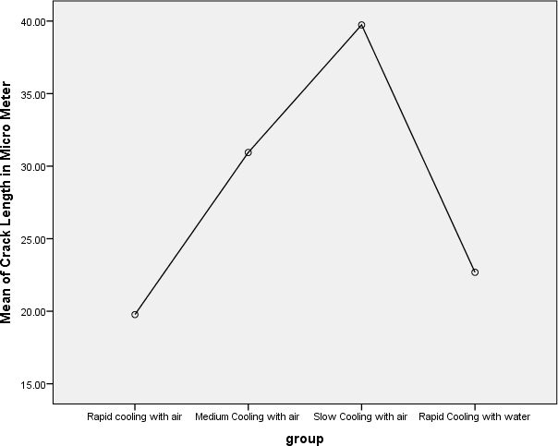
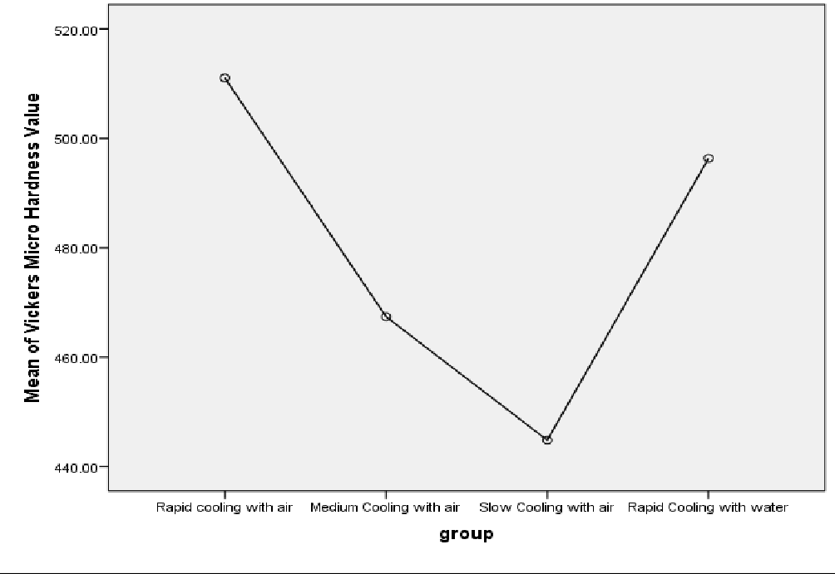
Figure II : Means plot of Vickers Microhardness values across differently cooled groups

Figure III: Means plot of fracture toughness across differently cooled groups
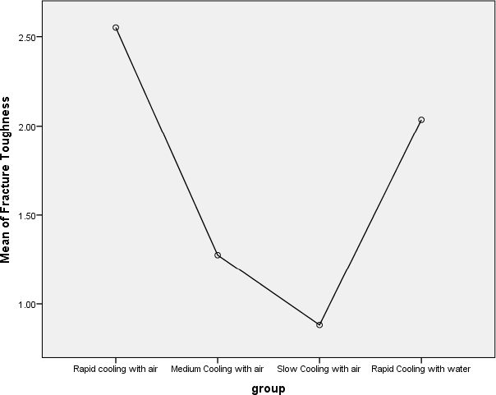

One way ANOVA analysis
Table II: ANOVA analysis

Descriptives |  | Sum of  squares | df | Mean  square | F | Significance
Vickers microhardness  (Kg/mm²) | Between groups | 26274.261 | 3 | 8758.087 | 61.193 | .000
 | Within groups | 5152.413 | 36 | 143.123
 | Total | 31426.675 | 39
Crack length(µm) | Between groups | 2420.145 | 3 | 806.715 | 154.376 | .000
 | Within groups | 188.123 | 36 | 5.226
 | Total | 2608.268 | 39
Fracture toughness((Kc)  (MN/m^{3/2}) | Between groups | 16.851 | 3 | 5.617 | 106.044 | .000
 | Within groups | 1.907 | 36 | .053
 | Total | 18.758 | 39
One way ANOVA analysis shows significant increase in Vickers microhardness values, fracture toughness values, and significant decrease in crack length values, in rapidly cooled group, relative to medium and slow cooled groups. The p value was found to be .000, for the three parameters (Vickers microhardness values, crack length and fracture toughness) observed.

Post hoc Tests-After ANOVA analysis, post hoc test, Tukey HSD test was performed for further detailed analysis by multiple comparison among the groups for each parameter assessed.
Dependent variable: Vickers microhardness.

Table III: Tukey HSD test; Vickers microhardness data

(I) group (J) group | Mean Difference (I-J) | Std. Error | Sig.
Medium Cooling | 43.65480* | 5.35019 | .000
with air
Rapid cooling with air Slow Cooling with | 66.21760* | 5.35019 | .000
air
Rapid Cooling | 14.68800* | 5.35019 | .044
with water
Rapid cooling with | -43.65480* | 5.35019 | .000
air
Medium Cooling with Slow Cooling with | 22.56280* | 5.35019 | .001
air air
Rapid Cooling | -28.96680* | 5.35019 | .000
with water
Rapid cooling with | -66.21760* | 5.35019 | .000
air
Slow Cooling with air Medium Cooling | -22.56280* | 5.35019 | .001
with air
Rapid Cooling | -51.52960* | 5.35019 | .000
with water
Rapid cooling with | -14.68800* | 5.35019 | .044
air
Rapid Cooling with Medium Cooling | 28.96680* | 5.35019 | .000
water with air
Slow Cooling with | 51.52960* | 5.35019 | .000
air

*. The mean difference is significant at the 0.05 level.
The above table illustrates that there is a significant increase in Vickers microhardness values in the rapidly cooled group relative to medium and slow cooled groups. It is noted that different modes of cooling significantly affect the Vickers microhardness value. This post hoc test shows significant difference between the groups, given that the mean difference is significant. The rapidly cooled group in air shows significantly higher VMH (p value: .044), relative to the group cooled in water.

Tukey HSD
Dependent variable: Crack length in micrometers
Table IV: Tukey HSD test; Crack length data

(I) group (J) group | Mean Difference (I- J) | Std. Error | Sig.
Medium Cooling with | -11.17173* | 1.02231 | .000
air
Rapid cooling with air Slow Cooling with air | -19.96373* | 1.02231 | .000
Rapid Cooling with | -2.91343* | 1.02231 | .035
water
Rapid cooling with air | 11.17173* | 1.02231 | .000
Medium Cooling with Slow Cooling with air | -8.79200* | 1.02231 | .000
air Rapid Cooling with | 8.25830* | 1.02231 | .000
water
Rapid cooling with air | 19.96373* | 1.02231 | .000
Medium Cooling with | 8.79200* | 1.02231 | .000
Slow Cooling with air air
Rapid Cooling with | 17.05030* | 1.02231 | .000
water
Rapid cooling with air | 2.91343* | 1.02231 | .035
Rapid Cooling with Medium Cooling with | -8.25830* | 1.02231 | .000
water air
Slow Cooling with air | -17.05030* | 1.02231 | .000

*. The mean difference is significant at the 0.05 level.

The above table illustrates significant differences in crack length across different cooling protocols, given that the mean difference is significant at the 0.05 level. The rapidly cooled group showed significantly less crack length relative to medium and slow cooled groups. The rapidly cooled group in air shows significantly less crack length relative to the group cooled in water. (p value: 0.035)

Tukey HSD
Dependent variable: Fracture toughness

Table V: Tukey HSD test; Fracture toughness data

(I) group (J) group | Mean Difference (I- J) | Std. Error | Sig.
Medium Cooling with | 1.27490* | .10292 | .000
air
Rapid cooling with air Slow Cooling with air | 1.66890* | .10292 | .000
Rapid Cooling with | .51490* | .10292 | .000
water
Rapid cooling with air | -1.27490* | .10292 | .000
Medium Cooling with Slow Cooling with air | .39400* | .10292 | .003
air Rapid Cooling with | -.76000* | .10292 | .000
water
Rapid cooling with air | -1.66890* | .10292 | .000
Medium Cooling with | -.39400* | .10292 | .003
Slow Cooling with air air
Rapid Cooling with | -1.15400* | .10292 | .000
water
Rapid cooling with air | -.51490* | .10292 | .000
Rapid Cooling with Medium Cooling with | .76000* | .10292 | .000
water air
Slow Cooling with air | 1.15400* | .10292 | .000

*. The mean difference is significant at the 0.05 level.

The above table illustrates significant increase in fracture toughness relative to slow and medium cooled groups. It is also noted that there is a significant increase in fracture toughness in the rapidly cooled group in air (p value: .000), relative to the group cooled in water.

Figure IV: Correlation between Vickers Microhardness values and fracture toughness
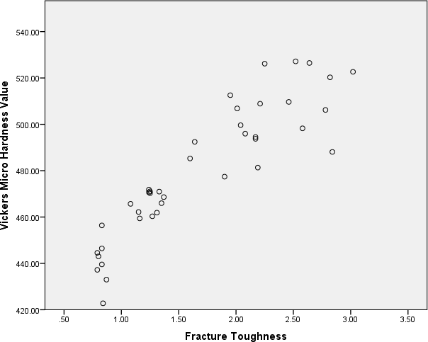

The above graph points to a positive correlation between Vickers microhardness and fracture toughness

DISCUSSION
In the present study various cooling rates resulted in different Kc values. As the rate of cooling decreased from rapid through medium to slow, crack lengths increased and Kc diminished. In an "all-porcelain" restoration, different temperatures within the porcelain and inhibition of free expansion or contraction of adjacent areas of the porcelain can result in formation of residual stress. The outer layer, cooling first, develops tensile stresses while contracting. Because the temperature at the centre of monolithic ceramic material is higher, this area is the last to contract, causing compressive residual stresses that compensate for the tensile stresses at the surface. This phenomenon is manifested where slow cooling occurs and to a lesser degree with a medium rate of cooling. However, on rapid cooling the outer surface becomes rigid and cannot adjust to changes of interior volume. The situation is then reversed with compressive stresses at the surface and tensile stresses at the centre. Rapid cooling thus creates residual compressive stresses on the outer surface of porcelain that increases resistance to fracture.

REFERENCES
- Callister, W.D. (2007), Materials science and engineering: An introduction (7th ed.; New York: John Wiley & Sons New York).
- Rawson, H. (1974), 'Physics of glass manufacturing processes', Physics Technol, 5, 91- 114.
- DeHoff, P.H., Anusavice, K.J., and Gray, A.E. (1990), 'Tempering as a means to strengthen porcelain-fused-to-metal restorations', Biomed Sci Instrum, 26, 167-174.
- Asaoka, K., Kuwayama, N., and Tesk, J.A. (1992), 'Influence of tempering method on residual stress in dental porcelain', J Dent Res, 71, 1623-1627.
- Niwut Juntavee, Wichuda Chinklang, Sirinthip Chaleekler. Effects of different cooling procedures on fracture toughness of feldsparthic dental porcelains. KDJ Vol 2 No.2 July- December, 1999
- Morena R, Lockwood P E, Fairhurst CW. Fracture toughness of commercial dental porcelains. Dent Mater 1986;2:58-62.
- Anusavice KJ, Lee RB. Effect of firing temperature and water exposure on crack propagation in unglazed porcelain. J Dent Res 1985:64 (Abstract # 1092).
- Anusavice KJ,Gray A, Shen C. Influence of initial flaw size on crack growth in air tempered porcelain. J Dent Res 1991; 70:131-6.
- Hassan R, Caputo AA , Bunshah RF. Fracture toughness of human enamel. J Dent Res 1981; 4; 820-7.
- Baharav H, Laufer BZ, Mizrachi A, Cardash HS. Effect of different cooling rates on fracture toughness and microhardness of glazed alumina reinforced porcelain. J Prosthet Dent 1996; 76:19-22.
- Al-Amleh B., Lyons K., and Swain M. (2010), 'Clinical trials in zirconia: A systematic review', J Oral Rehabil, 37, 641-652.

