BOOK – FURURISTIC TRENDS IN SOCIAL SCIENCE
CHAPTER – TIMELINE - THE MAJOR DEVELOPMENT IN HISTORY
EVOLUTION TO MODERN HISTORY
MS TASEMEENA MIRZA
DEPARTMENT OF SOCIAL SCIENCE
DEOGIRI GLOBAL ACADEMY AURANGABAD MAHARASHTRA
Introduction
Even though the origin of life on the earth is not exactly known, it is full of long and complex process but most of the scientist and philosophers were agreed that it was around 4.6 billion years ago the earth was covered by different gases.
As per some studies universe came into existence around 14 billion years ago.
According to Haden Bioscience colleagues ‘Earth was a Naked Planet and had no ocean or atmosphere in the beginning. Then slowly these gases started cooling down and the atmosphere form because of gravitational force of the earth.
According to Alfred Wegner the German Climatologist introduced the theory of continental drift according to this theory all the continents were joined together which he called as supercontinent and gave the name Pangaea. The word Pangaea derived from the Greek Words Pan means ‘all’ and Gaia means ‘Earth’. So here Pangaea means single piece of a huge landmass which was surrounded by Single Ocean named Panthalassa.
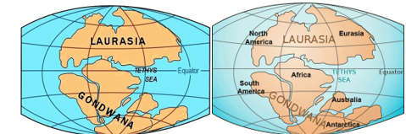He further added that due to movement of tectonic plates the super continent started breaking around 250 million years ago in several stages. First it was divided into two parts the upper part was called as Laurasia and the lower part was called as Gondwanaland and in between water body was called as Tethys sea.
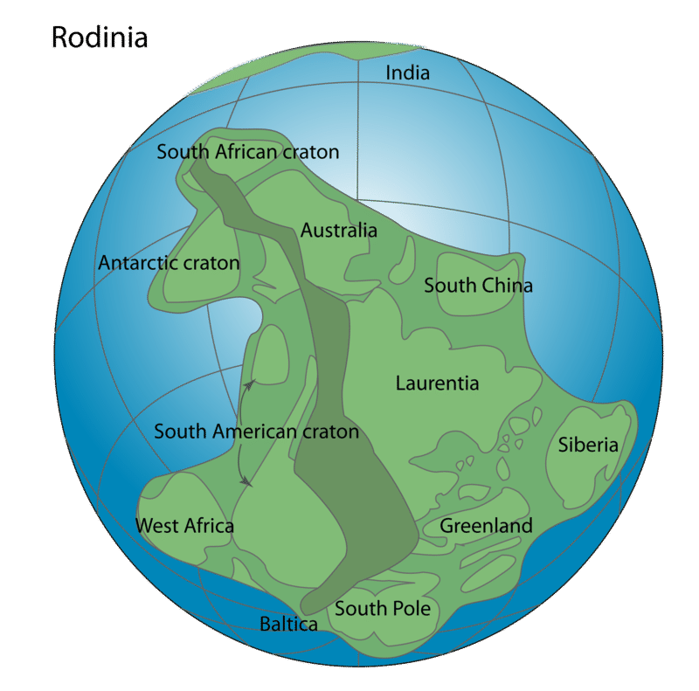The two more super continents were Rodinia (round 1 billion years ago) and Pannotia (around 650 million years ago)
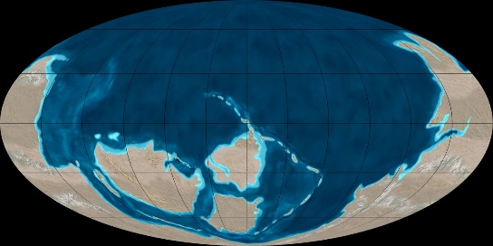

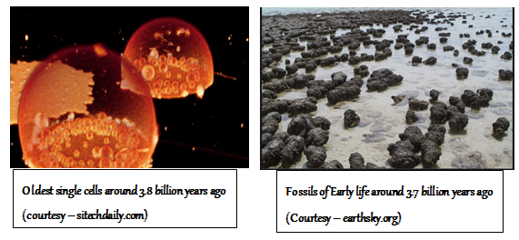Life on the Earth started around 3.7 - 3.8 billion years ago the single cellular organism appears on the surface of the earth than years after multi cellular organism occurred. The very first living organisms on the surface of the earth were ‘single cellular bacteria. These multi cellular organism further went across many changes till one of their branch developed the backbone, then amphibian Further develop into reptile than mammals and finally human beings.
The remains of the earliest human life were found in Africa. The oldest fossils of earliest human (Homo sapiens) were found in Eastern and Southern region of Africa.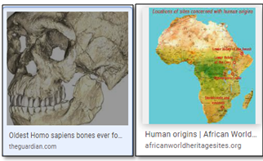Around 160000 – 90000 years ago the sub species of Homo sapiens called as Homo Sapiens Sapiens came into existence.

Timeline of Human Evolution
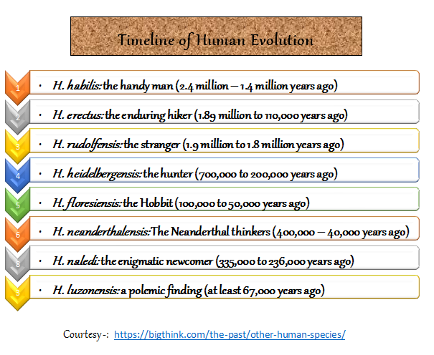

The Life on earth during this period – As we know the earliest remains of human life found in Africa in Ethiopia and Morocco so Africa is also called as the cradle of human life. Hominids were the oldest humans which exist in that region nearly 7 million years ago. The oldest stone tools were also found in Africa dated around 3 million years ago. Use of fire was known to be 1 million years ago.
Homo Habillis were just 3.5 feet to 4.5 feet tall, making complex stone tools and slaughtering animals to fulfil their appetite.
Homo Erectus were comparable taller than Homo Habillis, they had small teeth, long legs, larger skull, stand straight, they were able to cook food that increase the nutrition level in their bodies and this help in their physical and mental growth and strength they walk fast as compare to Homo Habillis.
Homo Rudolfensis Known to be existing in Kenya near Lake Rudolf, they had greater skull, small shoulder and small pelvis. Very less information is available about them in the historical records
Homo Hydelbergensis were first living in eastern Africa and Europe, they were probably migrated from cold regions, they were smaller in size, they were the first to use the spears to hunt the large animals, and they know the use of fire as to keep themselves warm, remains of many animals like elephants, horses were found from the same places. They were living in caves or wood houses. They were also the nearest ancestors of modern human.
Homo Florensiensis the remains were found in 2003 on Flores Island of Indonesia they were 3 to 4 feet tall, hunting small elephants and other small animals existing on the island. Their population limited to that island only. It was predicted that they landed their accidentally but their origin is still unknown.
Neanderthalensis - They probably survive in south east and central Asia and Parts of Europe. As they were also our close ancestors a lot of information is available about them. They were also hunting large animals, living in extreme conditions, knew the use of fire, making houses of stones or carving caves for shelter, making small stone tools, know make clothes, use of needle both stone and bones. Many graves were found the archaeological sites helped the scientist to conclude that they were much advance and civilized.
Homo Naledi – only through the recent researches in 2015 world came to know about their existence. They were living in South Africa they were only 4 to 5 feet tall. Only few skeletons and bones were found. May be they were there for temporary arrangement and died without any known reason. Nothing related to their live in known till now.
Homo Luzonensis - The name they got because they remain were found on the Luzon island of North Island. These archaeological sites were recently found in 2019 and not much information is available about them. Probably reached on that island accidentally as Homo Florensiensis
All Homo disappeared in due course of time one after another the actual reasons are not known, but may be due to change in climate, inadaptability, war lack of food or some natural disaster except homo sapiens who were the toughest survivor.
If we compare Neanderthal and Homo sapiens they were different in many ways one important is that homo sapiens survived all over the world while Neanderthal were limited to the region in Europe and Asia extinct around 40000 years ago but evidences shows that Homo sapiens and Neanderthals had intimate relation because 8% of present humans carry the same DNA of them. Homo sapiens is the scientific term for modern human.
If we divide the time duration from the beginning of life till date, we have two major divisions called as Prehistoric and the Historic age. Prehistoric age counted between 250000 years to 10000 years. Historic age further divided between Ancient age, medieval age and modern age.
Because these covers thousands of years and many developments took place all over the world during this period, here are some major and the most important developments.
The prehistory period is the time when unwritten records like stone tools artifacts monuments bones ornaments cave paintings were available as evidence to known about the life of those early human. Prehistoric period further has three stages of development. Stone Age or say Paleolithic early human were hunters and gatherers,
Mesolithic age around 12ooo BC to 10000BC years ago sudden change occurred in to the climate and few food grain or say grass containing grain naturally grown on the earth. The period when early human started growing crop or they came to know about the food grains this was the period of transition from nomadic life to settled life and
Neolithic age from 10000 BC to 5000 BC early human learnt to grow crop and started staying a one place for long time.
, Bronze Age metals as the word suggest the use of Bronze the smelting of metal and the early human started making tools and the ornaments out of bronze and Iron Age.
The metal was the blending of copper and tin. Even though copper was first metal to be found by the early human but it was not hard enough to be crafted. very less is known how the people at that time came to know the amalgamation of two.

BRONZE AGE
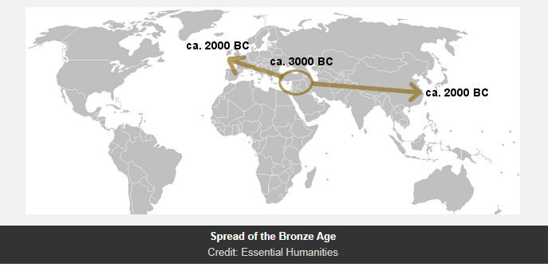

Iron Age – The Era began from 1500 BC to 500 BC making and smelting of iron tools and implements in Middle East. Turkey is the first place where early human learns to make iron and steel tools.
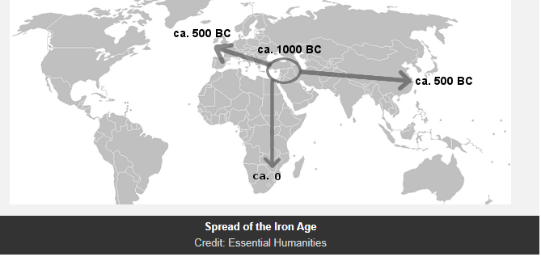
IRON AGE

The main challenges in front of those early human were the survival. No scientific development took place life was too difficult at that time. Early human were mostly hunters and gatherers they were unaware of cooking in most of parts of the world. This is the period when Neanderthals exists.
Historic Period is the time duration when mostly the written records were available like books, biographies, autobiographies, travelogues official records, degrees, books of accounts some manuscript on leaves or animal skin etc. these records are saved in most of the archives.
Historic Period divided into Ancient history, Middle History and Modern history.
Ancient History – The duration of ancient history is counted from 3000 BCE to 500 CE. It started from the Sumerian civilization and ends with the fall of Roman Empire in Europe. The main civilizations during this period were Greek civilization, Roman Civilization, Minoan Civilization, Mycenaean civilization. The duration of ancient history is varied from place to place or continent to continent.
Ancient Europe
3000 – 2000 BCE
2000 – 1000 BCE
1000 – 0 BCE
0 - 500 CE

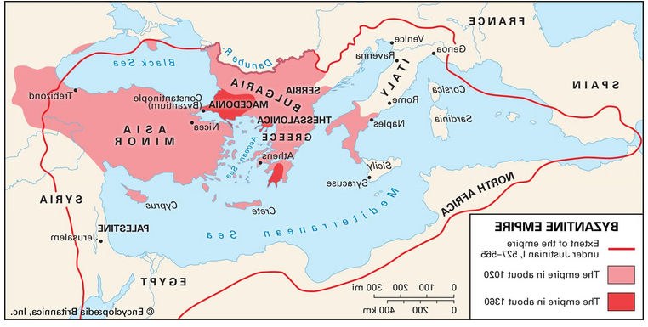The Early Medieval period 500 CE – 1000 CE In Europe it started from the fall of Roman Empire till the beginning of Renaissance between 5th to 11th centuries. The most important kingdom during this period was Anglo Saxon kingdom, emergence of France and German Kingdoms. Early medieval period in European History is also called as Dark Age because this period had very less development in science.
Major Development during this period were growth of Byzantine Empire which was counted as the first golden age of European History. Their capital was Constantinople Present day Istanbul in Turkey. They ruled between 500 CE to 1453 CE.
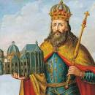The political philosophy the concept of democracy and freedom for the people started getting shape.
Another feature was the development of many languages like French, Spanish, German, Italian Portuguese.

Charlemagne from Carolingian Dynasty declared by the church as the first Holy Empire. He ruled the area of Franks he got the support of the Roman Catholic Church.
Charlemagne
High or central Medieval Period 11th to 14th century the period notice the rise of France and the Byzantine kingdoms, fall of Roman Empire, one more striking feature of this period was the development of Ottoman Empire who started extending their power in the end of 13th century and rule till world war I in the Turkey, Austria, part of middle east they were the cause of decline of Byzantine Empire.
The later medieval periods counted from the Renaissance in 14th century and continue till 17th century.
In this period the social science and humanities developed the field of history sociology psychology and the study of anthropology made its mark on human life.
This period also witnesses the first great famine between 1315 to 1317 and the Bubonic Plague between 1346 to 1353 which was also called as black Death in this disaster around 200 million people perished
The Middle Ages have nourished the social sciences and humanities (SSH), from history to psychoanalysis, both directly and through the modern sciences that resulted from their study. Indeed, from the end of the nineteenth century onwards, writings, topics, sociopolitical agendas, and methodological endeavors from medieval studies circulated outside the field. Conversely, the social sciences, especially anthropology, in the twentieth century renewed these studies.
After the renaissance till date the period is known as modern history.
Early Modern History – starts from 16th century to 19th century. The Europe was on its peak of development in all important spheres like science, political, social and the economic. Some events of this period were thirty years was, French Revolution English Revolution, American Independence, Colonization and Imperialism.
This period was also called as the period of reformation and Enlightenment. In many countries people over throw the monarchy or established the constitutional monarchy.
Many religious changes occurred during this period between 1500 to 1620.CE.
Christianity divided in to two sects Catholics and Protestants (1517 -1648 CE) The countries like France, Denmark, Sweden, and Austria grew as powerful nations. British ruled over three continents, Europe, Asia and Africa by their imperial domination.
Many developments took place in the field of education literature and philosophy.
This was the period of humanism the critical thought and the secular ideas.
Habsburg Empire emerges in the Austria in 16th century till World War I. It was further divided into many small kingdoms.
The scientific temperament and the liberalism started getting its place in the societies.
As the result of growth of education the middle class emerge on the scenario and started asking the question regarding the power of king and the basic human rights.
Even though this was not the only period when these field emerge. It started in the stone and the Bronze Age but records separate discipline and learning got impetus in this period. If we consolidate it to social science this was the period, the subject got its base.
This was the duration in which subject social science as the separate discipline started getting its roots.
Review of subjects like politics, economics Started growing as separate discipline.
Territorial expansions indulge many people in war and a lot of human loss occurred. The base of social science formed when the development in the human life started. Humanities - The human society, culture environment, language geography, political science, religion art etc.
Modern European History from 19th century till date It further divided between 19th century to 20th century and from 20th century till date. The first half of modern Europe was the period of political disturbance and geographical changes.
The period of unification of Britain, Italy and Germany. Modern era witnesses the two world wars first and second, the cold war, end of colonial power from most of the countries, independence of most of the Asian and African countries, emergence of two super powers USA AND USSR the most drastic even of Hiroshima and Nagasaki cold war between USA AND USSR and the end of cold war in 1989.
One most important feature is the development of computer and internet. Development of market and economy.
End the most recent the COVID 19.
In Asia Ancient period started from 7000 BC and ends with 3500 BC. One of the oldest known civilizations in West Asia was Mesopotamia near Euphrates and Tigris which exists in 5000 BC Chinese Civilization and Indus valley civilization.
As Aristotle said “Man is by nature a social animal; an individual who is unsocial naturally and not accidentally is either beneath our notice or more than human.”
Today’s Face of social Science
Social Science as separate discipline made its position in the late medieval period or in the beginning of the modern period though it has its roots from the ancient time Aristotle, Pluto, Garner Socrates and many more. Subject got the importance as the curiosity of the people increase to know about the human behaviour, life of previous people increased. But in the late 20th century the momentum shifts towards the technological development. In the developed countries the space was maintained but in the developing countries were people were fighting with the lack of resources, unemployment, population growth focus shifted toward job oriented disciplines. In these countries most of people were unaware of the opportunities available for such areas.
Most people do not know that to have career in mass media, journalism, preacher, law consultant and human disaster, social reformer
Social science which is slightly different focus on history, economics geography, psychology.
Career research analyst, professor, teachers even economist counsellors’ environmentalist, cartographers etc.
Now depending upon the level of qualification, graduate, post graduate, one can opt for Museum curter, carter archivist.
In history the opportunities are also available as educationalist, historian the curriculum designer, Author.

REFERENCES
https://www.worldhistory.org/index/
https://byjus.com/free-ias-prep/difference-between-history-and-prehistory/
https://naturalhistory.si.edu/education/teaching-resources/life-science/early-life-earth-animal-origins#:~:text=The%20earliest%20life%20forms%20we,is%20produced%20by%20living%20things.
https://byjus.com/free-ias-prep/difference-between-history-and-prehistory/
https://byjusexamprep.com/current-affairs/difference-between-history-and-prehistory
https://wwnorton.com/college/history/ralph/referenc/asiatime.htm
http://www.essential-humanities.net/western-history/early-modern-europe/
http://www.essential-humanities.net/western-history/greek-europe/
http://www.essential-humanities.net/western-history/early-medieval-europe/#rise-of-modern-western-languages
https://journals.openedition.org/rhsh/5007
https://www.maropeng.co.za/content/page/the-development-of-life-on-earth#:~:text=Since%20the%20first%20life%20appeared,living%20things%20on%20Earth%20today.
https://courses.lumenlearning.com/suny-hccc-worldcivilization/chapter/the-evolution-of-humans/#:~:text=Humans%20began%20to%20evolve%20about%20seven%20million%20years,and%20interbred%20with%20humans%2C%20they%20eventually%20died%20out.
https://humanorigins.si.edu/
https://www.livescience.com/38218-facts-about-pangaea.html
https://www.geolsoc.org.uk/Education-and-Careers/Ask-a-Geologist/Continents-Supercontinents-and-the-Earths-Crust/Break-up-of-Pangaea
https://scitechdaily.com/evidence-that-earths-first-cells-3-8-billion-years-ago-could-have-made-specialized-compartments/
https://earthsky.org/earth/3-7-billion-year-old-fossils-show-early-life/
https://bigthink.com/the-past/other-human-species/

