3D PRINTING: A NEW ERA FOR DRUG DELIVERY
Dr.N. Tamilselvan, Radhika Sivaraj and Aiswarya K N
Department of Pharmaceutics
Nehru College of Pharmacy, Pampady , Kerala

Ⅰ.ABSTRACT
FDA approval of Spritam has created an emerging interest in the application of 3D printing in pharmaceutical field. 3D printing is a technique of manufacturing involving the layer-by-layer deposition of materials to generate a ultimate product according to a digital model. There are countless techniques used to achieve this method of printing including the inkjet printing, selective laser sintering, stereolithography and extrusion based printing. 3D printing is extensively used in biomanufacturing, bone and tissue engineering to produce scaffolds. In the field of pharmaceutics, 3D printing was adapted in drug development, and the fabrication of drug delivery devices. The prominence of this chapter lies on the different 3D printing techniques involved in the manufacture of oral solid dosage forms. Fused deposition modeling, stereolithography, selective laser sintering and inkjet printing methods were found appropriate for the fabrication of oral solid dosage forms, though a great deal of the existing research was emphasized on fused deposition modelling owing to its accessibility and flexibility. This chapter also presents the merits and possible restrictions of 3D printing of medicines. KEYWORDS: Spritam, Zip dose printing, Piezo inkjet printers, Extrusion, Stereolithography
ⅠⅠ. INTRODUCTION
Three-dimensional (3D) printing is layer-by-layer construction of three dimensional objects from digital designs via computer software. It is the procedure of creating 3-dimensional solid object from a digital dossier ^{[1,2]}. This technique is widely used in drug development process. 3D printing, otherwise known as additive layer manufacturing or freedom fabrication manufacturing. It is using even during preclinical studies. Charles Hull an American engineer invented 3D printing technology ^{[3]}.3D printing results in high production rate due to its rapid operation, capable to accomplish high drug loading efficiency, diminution of material wastage saves the production cost.3D printing technology has got multifaceted features. It is possible to produce any dosage form predetermined release profile. For the production of active pharmaceutical ingredient 3D printed miniaturized reaction vessels are available.3D printing is useful for the synthesis of variety of molecules on a small scale. 3D printing is mainly useful for drugs with high cost and poor stability. 3D printing can produce different dosage form with multifaceted inner geometrics, numerous excipients and medications. For the purpose of manufacturing personalized medicine 3D printers can be provided in clinical pharmacy which results in economic benefits. 3D printed personalized dosages contribute to cost effective medications. Main benefits of 3D printers is that, they are uncomplicated to manage, accurate settling of materials with modifications in active ingredient and excipients can be easily achieved. Often drugs used in the treatment of rare diseases which are more costly can be acquired by 3D printing technology.
3D printing can be used in personalised medicine. Spritam is the foremost 3D printed tablet, it is an orodispersible tablet ^{[4]}. In the course of covid 19 pandemic 3D printer has adopted for the manufacture copper 3D NanoHack mask, HEPA masks, PPE kits. The intent of this book chapter is to emphasise the three dimensional printing approach been established for the invention of drug delivery system ,formulation and processing.
ⅠⅡ. HISTORY
In the mid-1980s Charles Hull examined the development of 3D printing, patented, industrialized and commercialized the leading equipment and also developed STL file format that merge with current Computer aided software ^{[5,6,7]}. The theory of 3D printing has been coined in the 1970s, but the experiments were started since 1981.The first 3D printing experiments were conducted by Dr Kodama for his rapid prototyping expertness. In 1984 French engineers developed a stereolithography and later neglected. In the mid of 1986 Charles hull showed attention in 3D printing and submitted initial patent in stereolithography. In 1988 Carl Deckard registered a patent for Selective laser sintering technology. In the meanwhile, Scott Crump submitted a patent for the fused deposition modelling(FDM) of 3D printing ^{[8]}. In 1990 there was evolution of 3D printers’ manufacturers. The first EOS “stereos” system was also developed in 1990. In 1993 solidscape a 3D printer was founded. In 1999 engineered organs has brought new approaches to medicine. In 2000s 3D printing has obtained media visibility. First commercially available SLS printer was released in 2006.In 2020s was marked by the advent of more sophisticated additive manufacturing materials (high performance materials).
Ⅳ. ADVANTAGES OF 3D PRINTING
- In contrast to conventional dosage form, high drug loading can be achieved via 3D printing.
- Production cost can be reduced as there is minimum wastage of materials.
- 3D printing can print the object very fastly.
- 3D printing is cost effective.
- 3D requires minimum space.
- 3D printing technology is environment friendly.
- Manufacturing of pilot batch is profitable and the can be completed in a single run.
- 3D printing is used to print organs such as heart, liver and kidney.
- It is suitable for the delivery of less water soluble and low therapeutic index drugs.
- Batch-to-batch variations can be reduced ^{[9]}.
- Accurate and precise dosing is possible in the case of potent drugs.

Ⅴ. DISADVANTAGES
- Limited materials are available for 3D printing technique.
- Clogging of powder printing is a hindrance.
- powder-based three dimensional printing is limited owing to powder spillage and also can cause work-related risks ^{[10]}.
- 3D printing technology reduce human labour due to automation.
- 3D Printer related specifications effects its quality and cost.
- 3D printing technology consumes high energy.
- Final structure may be modified owing to mechanical stress and ink formulation effects.

Ⅵ. 3D PRINTING TECHNIQUES
Zip dose printing
Inkjet printing system

3D PRINTING TECHNOLOGIES
Stereolithography

Extrusion based printing

Nozzle based deposition system
Powder based printing

There are various techniques of which fused deposition modelling is widely used. Basic principle of manufacturing remains the same.

- INKJET PRINTING SYSTEM

In this method ink is deposited on a substrate by any one of the 2 methods. One of the major advantages of this method is its high-resolution printing. This method offers low cost and minimum wastage. It provides a detailed information of CAD in a ‘direct write’ way.

Consists of 2 types
- Continuous inkjet printing(CIJ printing)
- Drop on demand printing(DOD printing)

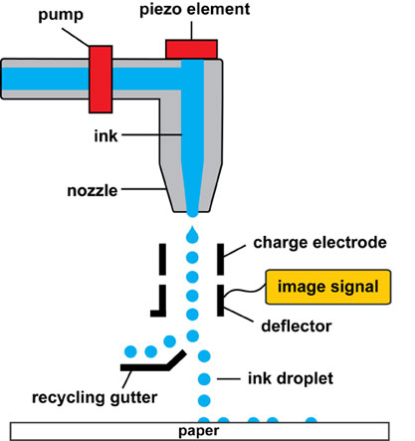
1. Inkjet printing system ^{[11]}
Continuous inkjet printing
Continuous inkjet printing initiate with a high-pressure pump device that direct liquid from a reservoir to a bank of micrometre-sized nozzles, thus generating a continuous stream of droplets at frequencies decided by the oscillations of vibrating piezoelectric crystals ^{[12]}. It is possible to carry out two-dimensional and three-dimensional printing of pharmaceutical substances. Continuous jet printing has embedded printer head which can be thermal or piezoelectric and has the control over viscosity of the liquid. In order to clarify the factors that influence print distortion continuous inkjet printing was developed.

Drop on demand printing
DOD printing has a more accurate execution. It consists of 1000 nozzles. Print heads are activated by heat and piezoelectric induction techniques.
There are 2 types of drops on demand inkjet printing technology
1.Thermal inkjet printing(TIJ)
2.Piezo inkjet printing
It remains possible to mark products with very high printing quality of up to 600 dpi. This technology is also beneficial for large scale font printing. It permits prints up to 800mm high. In thermal inkjet printing pressure is generated by heat. Steam bubbles are produced in printhead by means of heating element ^{[13,14]}. These bubbles elicit a pressure pulse allowing ink drops to escape through the nozzles and printing takes place. Contrary to the thermal inkjet printers, piezo inkjet printers do not require heat. Piezo electric printers make use of electric voltage to create pressure pulses. Piezoelectrical materials changes its shape when voltage is applied. This is known as Piezoelectrical effect.

- EXTRUSION BASED PRINTING
It involves two techniques,
- Hot melt extrusion
- Fused deposition method

Hot melt extrusion (HME):
In the case of Hot melt extrusion techniques, an analogous, solid dispersion of pharmaceutical excipients such as polymeric ingredients and plasticizers are prepared in a liquefied form and a drug substance is introduced in the polymeric composition ^{[15]}. Next, the formulation ink can be extruded directly through a dye under high compression and raised temperature, then fused and coagulated after the process of printing, thus engendering a three dimensional product of even configuration with improved quality and drug load. Main advantages of this method is that it is performed without solvent which eradicates the necessity for a laborious solvent selection phase, making it an environment responsive method of manufacture.

Fused deposition method:
This method requires higher temperature for its operation (220°C) which may destroy large amount of therapeutically active drugs and pharmaceutical excipients. In fused deposition modelling, blobs of reheated plastic are extruded through the print head. This technique makes use of thermoplastic polymers like polylactic acid, polyvinyl alcohol. Active pharmaceutical ingredients and polymer mixtures are made to pass through the nozzles and deposited on a platform in the form of filaments ^{[16]}. These filaments are then hardened. It is known as fused filament fabrications. Nozzle diameter feed rate and pressure drop determine the extent of deposition of constituents. This method provides high mechanical strength. This method is not suitable for thermolabile active pharmaceutical ingredient and thermoplastic.

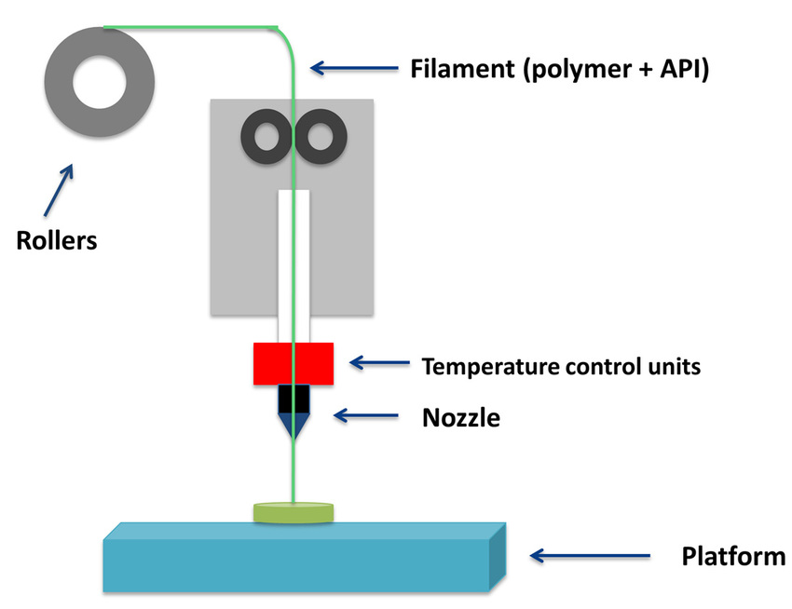
2.Fused deposition method ^{[17]}
- POWDER BASED PRINTING OR SELECTIVE LASER SINTERING
Powder bed printing technology have the ability to achieve drug loading up to 1000mg. Spritam (levetiracetam) was developed by this technology and used for the treatment of epilepsy in paediatric and geriatric patients ^{[18]}.
Powder 3D printing technique uses powder substrates for the sprayed ink and then it solidifies into a solid dosage form. This method mainly uses metals and polymers. Uses high power laser carbon-dioxide. Laser fuses powdered material by scanning cross section generated from CAD file on the surface of building platform. After scanning, the powdered bed is lowered by one layer thickness. New layer of material is applied on the top, and the process is repeated until the part is completed ^{[19,20]}.
D. NOZZLE BASED DEPOSITION SYSTEM
There are 2 categories of printings based on the type of substance employed: Fused deposition modelling(FDM), which makes use of molten components and pressure-assisted micro syringes which does not involve the usage of liquefied solids.
PRESSURE ASSISTED MICROSYRINGE TECHNOLOGY(PAM)
It is also called as semi-solid extrusion.This technique consists of a syringe extruder which deposit a viscid solid by means of air piston under pressure.Deposition is in layer-by-layer mode in the fixed geometry.

- STEREOLITHOGRAPHY(SLA)
Stereolithography is the method specified on the photopolymerization of fluid resin by ultraviolet(UV) rays. This technique has been utilized in the manufacture of tablets of paracetamol.
By means of this technique, it was possible to print tablets containing varying amount of polyethylene glycol 300. When compared to fused deposition modelling has resulted in high drug loading with rapid drug release devoid of drug degradation.
The process of printing encompasses a distinctively conceived 3D printing machine called as Stereo lithograph equipment which translates liquid plastic into solid 3D objects.
UV lasers are used to draw a pre-programmed design, normally resins are used.
The first step involves designing a 3D object by the help of CAD file, then these are sliced into horizontal layers. Hence, a digital code is generated which is given to printer after giving an input, it will move step by step down and will stay below the liquid level. Liquid will be spread over the platform, then UV rays are focused on liquid based on desired shape. It will move upward for the removal of liquid, and further taken away from the platform ^{[21]}.

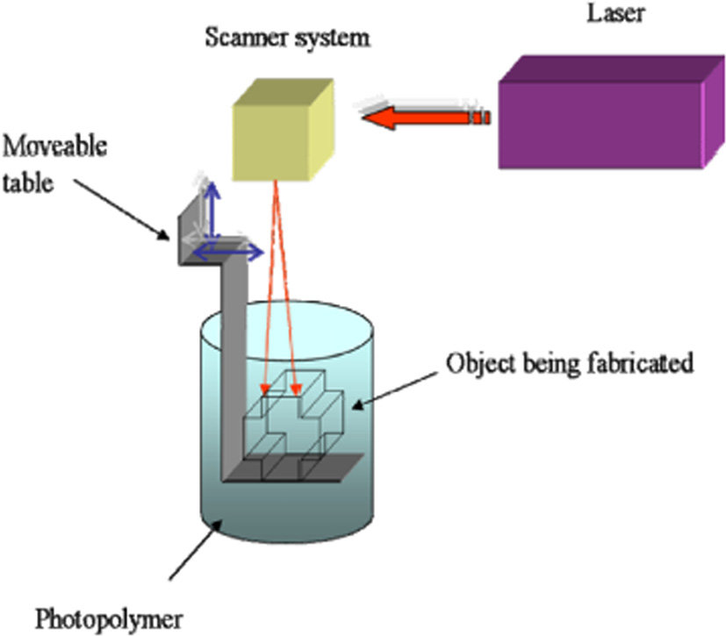

3.Stereolithography ^{[22]}
- ZIP DOSE PRINTING
Zip dose printing results in high drug loading capacity with enhanced disintegration and dissolution . In this method powdered medicine is extented onto a thin film. Liquid is poured into a powder in order to adhere the particles altogether in a thin permeable coating and then procedure is replicated.
Zip dose technology is capable for holding a high dosage load and still uphold speedy disintegration with mouthful of water. This process is also beneficial for patients with swallowing difficulty.
This technology reduces the complexity of ink formulation and resulting in the production of high dose medication.
Zip dose® is relatively easy to scale by assemblage of several inkjet heads to print solid dosage forms in aligned manner ^{[23]}.

ⅥⅠ. APPLICATION IN PHARMACEUTICAL INDUSTRY

Dosage form | API | 3D technique | Excipients | Reference
Tablet | Acetaminophen | Powder bed inkjet | MethocelTM E50, Polyvinyl pyrrolidone, ethyl cellulose, fluorescein, colloidal silicon dioxide, Eudragit RS 100 | [24]
Tablet, ER | Theophylline | Fused deposition modelling, hot melt extrusion | Eudragit RL 100, RS 100, Hydroxy propyl cellulose, tri ethyl citrate | [25]
Tablet, ER | Prednisolone | Fused deposition modelling | Polyvinyl alcohol | [26]
Polypill, SR | Captopril, Nifedipine, Glipizide | Extrusion | HPMC,Sodium starch glycolate,Polyethylene glycol 6000,sodium chloride,Tromethamine, D-mannitol,lactose, croscarmellose sodium, microcrystalline cellulose | [27]
DuoCaplet, delayed | Paracetamol, caffeine | Fused deposition modelling, hot melt extrusion | Polyvinyl alcohol | [28]
Shell-core tablets | Budesonide,  Diclofenac sodium, Theophylline | Dual fused deposition modelling(FDM) and hot melt extrusion(HME) | Core: polyvinyl pyrrolidone, triethyl citrate, talc, and Active pharmaceutical ingredient  Shell:Triethyl citrate,Talc, Eudragit L 100 | [29]
Two compartmental capsular device, pulsatile | Acetaminophen | Fused deposition modelling(FDM), hot melt extrusion(HME) | Polylactic acid, PVA, PEG 400, PEG 8000, Glycerol, Kollicoat® IR brilliant blue and Kollicoat® IR yellow | [30]

Ⅶ. CONCLUSION
3D printing has evolved as a recent horizon in drug delivery. Conventional method of manufacturing products which are out-of-date in terms of usefulness and flexibility can be improved by integration of 3D printing into manufacturing of medications.
In the forthcoming days 3D printing will be employed to engineer different advanced dosage forms. By the usage of 3D printing technology personalized medications, augmented drug discharge from their dosage form, dodging drug-drug interactions, shielding of biological molecules during manufacturing process are possible which will take the drug delivery to a new era.

Ⅷ. REFERENCE
1.Gross BC, Erkal JL, Lockwood SY, Chen C, Spence DM. Evaluation of 3D printing and its potential impact on biotechnology- the chemical sciences. Anal. Chem 2014; 86(7): 3240-53.
2. Belhabib S, Guessasma S. Compression performance of hollow structures: From topology optimisation to design 3D printing. Int. J. Mech. Sci. 2017; 133: 728-39.
3.Hull CW. Apparatus for production of three-dimensional objects by stereolithography. USA: UVP, Inc. 1986.
4.FDA SPRITAM (Levetiracetam) Tablets. Available online: https://www.accessdata.fda.gov/drugsatfdadocs/nda/2015/207958Orig1s000TOC.cfm.
5. Hull CW. Apparatus for production of three-dimensional objects by stereolithography. US4575330; 1986.
6. Hull CW. Method for production of three-dimensional objects by stereolithography. US4929402; 1990.
7. Hull CW, Spence ST, Albert DJ, et al. Method and apparatus for production of high-resolution three-dimensional objects by stereolithography. US5184307; 1993.
8.Crump SS. Apparatus and method for creating three-dimensional objects. US5121329;1992.
9.Aprecia Zipdose® technology. 12/3/2015. Available from: https://aprecia.com/zipdose-platform/zipdose technology.php.
10. Huang SH, Liu P, Mokasdar A, Hou L. Additive manufacturing and its societal impact: a literature review. International Journal of Advanced Manufacturing Technology. 2013; 67(5–8):1191–203.
11. Jain K, Jain A, Mehra NK, Jain NK. Lipoproteins tethered dendrimeric nanoconstructs for effective targeting to cancer cells. Journal of Nanoparticle Research 2013; 15:2003.
12. Ihalainen P, Maattanen A, Sandler N. Printing technologies for biomolecules and cell-based applications. Int. J. Pharm 2015; 494: 585-92.
13.Acosta-Vélez GF, Wu BM. 3Dpharming: Direct printing of personalized pharmaceutical tablets. Polym. Sci. 2016; 1:2.
14. Alomari M, Mohamed FH, Basit AW, Gaisford S. Personalised dosing: Printing a dose of one’s own medicine. Int J Pharm 2015; 494: 568-77.
15.Nayan GS, Tahsin Md, Ankita VS, Abu TM. Formulation of 3D Printed Tablet for Rapid Drug Release by Fused Deposition Modeling: Screening Polymers for Drug Release, Drug-Polymer Miscibility and Printability J Pharm Sci 2018; 107(1): 390-40.
16. Hoy MB. 3D printing: making things at the library. Med Ref Serv Q 2013; 32(1): 94-99.
17. Gross BC, Erkal JL, Lockwood SY, et al. Evaluation of 3D printing and its potential impact on biotechnology and the chemical sciences. Anal Chem 2014;86:3240–53.
18. Rowe CW, Katstra WE, Palazzolo RD, et al. Multimechanism oral dosage forms fabricated by three dimensional printing. J Control Release 2000;66:11–7.
19. Katstra WE, Palazzolo RD, Rowe CW, et al. Oral dosage forms fabricated by three dimensional printing. J Control Release 2000;66:1–9.
20. Palazzolo RD. Formulation of oral dosage forms by three dimensional printing. Massachusetts: MIT; 1998.
21. Pere CPP, Economidou SN, Lall G, Ziraud C, Boateng JS, Alexander BD, et al. 3D printed microneedles for insulin skin delivery. Int J Pharm. 2018;544:425–32.
22. Minna, Peltola A, Sanna M, Grijpma, Dirk W, Melchels, et al. A review of rapid prototyping techniques for tissue engineering purposes. Ann Med 2008;40(4):268–80.
23. Prasad L K and Smyth H 2016 3D Printing technologies for drug delivery: a review Drug Dev. Indust. Pharm. 42 1019–31.
24. Yu DG, Yang XL, Huang WD, et al. Tablets with material gradients fabricated by three-dimensional printing. J Pharm Sci 2007;96:2446–56.
25. Pietrzak K, Isreb A, Alhnan MA. A flexible-dose dispenser for immediate and extended release 3D printed tablets. European Journal of Pharmaceutics and Biopharmaceutics. 2015;96:380-387. DOI: 10.1016/j.ejpb.2015.07.027.
26. Skowyra J, Pietrzak K, Alhnan MA. Fabrication of extended release patient-tailored prednisolone tablets via fused deposition modelling (FDM) 3D printing. Eur J Pharm Sci 2015;68: 11–7.
27. Khaled SA, Burley JC, Alexander MR, et al. 3D printing of tablets containing multiple drugs with defined release profiles. Int J Pharm 2015;494:643–50.
28. Goyanes A, Wang J, Buanz A, Martínez-Pacheco R, Telford R, Gaisford S, et al. 3D printing of medicines: Engineering novel oral devices with unique design and drug release characteristics. Molecular Pharmaceutics.2015;12(11):40774084.DOI:10.1021/acs.molpharmaceut.5b00510
29. Okwuosa TC, Pereira BC, Arafat B, Cieszynska M, Isre A, Alhnan MA. Fabricating a shell-core delayed release tablet using dual FDM3D printing for patient-centred therapy. Pharmaceutical Research. 2017;34:427. DOI: 10.1007/s11095-016-2073-3
30. Maroni A, Melocchi A, Parietti F, Foppoli A, Zema L, Gazzaniga A. 3D printed multi-compartment capsular devices for two-pulse oral drug delivery. Journal of Controlled Release. 2017;268:10-18. DOI: 10.1016/j.jconrel.2017.10.008

