Polyploidy: An evolutionary plant breeding approach
A. V. Shinde | R. A. Jadhav
Assistant Professor,  Department of Genetics and Plant Breeding | Junior Research Fellow,  AICRP on Linseed & mustard,
MGM Nanasaheb Kadam College of Agriculture, | College of Agriculture, Nagpur,
Gandheli, Aurangabad. MS. India.431 001. | Dr. PDKV, Akola. MS. India. 444 001.
E-mail- akshatavshinde13@gmail.com | Email- ranijadhav74@gmail.com
A. S. Deshmukh | N. R. Thakur
Department of Agricultural Botany, | Sorghum Breeding,Accelerated Crop Improvement
College of Agriculture, Parbhani. | ICRISAT, Patancheru.
V.N.M.K.V., Parbhani. MS. India 431 402 | TS. India. 502 324.
E-mail- akshaydeshmukh1415@gmail.com | E-mail- niranjan.thakur95@gmail.com
ABSTRACT
Plants have a favourable impact on human life and supply food, medicine, and fuel. To address the issue of the need to diversify crop plants, modern breeding techniques are developed. These techniques significantly reduce the length of the breeding period and also have an impact on the breeding of some plants whose improvement is not possible using conventional techniques. The new sources of germplasms that can be exploited to create new cultivars or in breeding programmes are haploid, double haploid, and polyploid plants. Artificial polyploidy induction is one of the breeding techniques used to enhance the desirable traits of plants. Improved allelic diversity, heterozygosity, the development of sterile lines, growth and increased vigour, improvements in variety etc. All of these aspects must be taken into account in a genome-wide context to maximize marker-assisted selection and crop plant improvement. Plants that have all of their chromosomes duplicated (instead of only some of them) have more distinguishing characteristics, such as altered phytochemical properties, a higher concentration of therapeutic compounds, and unique plant shapes, colours, sizes, scents, and flowering times. In order to design an efficient process for chromosomal duplication, the genotype of the plant and the type of sample must be taken into consideration. The type, quantity and duration of mitotic inhibitors are the main considerations.
Keywords: Diversity, Germplasm, Heterozygosity and Polyploidy.
I. INTRODUCTION
When an organism has more than two basic sets of chromosomes, it is said to be polyploid (Acquaah 2007; Chen 2010; Comai 2005; Ramsey and Schemske 1998). By manipulating the number of chromosomes, crop plants can be genetically improved through a process known as polyploidy breeding. Polyploidy is a common phenomenon in nature that promotes flexibility and the creation of new species. According to Chen et al., (2007), many crop plants experienced polyploidy during their evolutionary process. Comai (2005) asserts that angiosperms produce polyploid plants significantly more frequently than other plant kinds, with an estimated one polyploid plant produced for every 100,000 plants.
The current chapter tries to shed light on the applications and effects of polyploidy in plant breeding and other commercial initiatives. Numerous studies have been carried out to better understand the nature of polyploidy. To understand polyploidy, a few basic ideas need to be clarified. The number "2n" denotes the total number of chromosomes in a somatic cell, while "x" denotes the full basic set of chromosomes. Somatic cells have twice as many chromosomes as gametes, which only have one haploid pair (Acquaah 2007; Otto and Whitton 2000). In 1947, Stebbins identified three forms of polyploidy in plants: segmented allopolyploidy, autopolyploidy and allopolyploidy. Initial genomes are all similar and arise through genome duplication within a single species. (Stebbins; 1947 Lewis; 1980 ). Allopolyploids, which have two or more separate genomes, can arise through the hybridization of two distinct species (Stebbins 1947; Grant 1975). The third form of segmental allopolyploids has more than two incompletely distinct genomes that can pair to produce both bivalents and multivalents (Stebbins 1947; Levin 2002).
The prevalence of polyploidy increased significantly at the beginning of the 20th century. Hugo De Vries' original work on mutation of Oenothera lamarckiana, which he described in his book "Theory of Mutation," is one of the earliest instances of natural polyploidy. Digby (1912) discovered that chromosome doubling could result in a fertile-type Primula kewensis from a sterile interspecific hybrid, but the author was not aware of the significance of this in the context of polyploidy. This discovery was made later, in 1990. Numerous agricultural crops, such as wheat, maize, sugarcane, coffee, cotton, and tobacco, are polyploid either as a result of intentional hybridization and selective breeding (such as some blueberry varieties) or an ancient polyploidization event (such as maize) (Ramsey and Schemske 2002). Long-lived perennials with a range of vegetative mechanisms of propagation (such Fragaria, Rubus, Artemisia and Potamogeton, etc.) and those with frequent occurrences of natural interspecific hybridizations appear to benefit greatly from polyploidy (Hilu 1993).
II. CHANGES IN CHROMOSOME NUMBER
Aneuploidy results from alterations in one or more chromosomes. The somatic chromosomal number (2n) of the species is taken into account while calculating these chromosome number variations. Nullisomic aneuploid creatures are those that are missing one pair of chromosomes (2n-2). While monosomic aneuploids (2n-1) are those that have just one chromosome. Two chromosomes from two separate chromosome pairs (2n-1-1) are absent in double monosomic individuals. A individual with aneuploidy is said to have trisomy (2n+1), which is the presence of one extra chromosome, and double trisomy (2n+1+1), which is the presence of two extra chromosomes from two distinct chromosomal pairings. A tetrasomic individual has an extra set of chromosomes (2n+2). Euploidy, on the other hand, includes a change in the complete set of the genome, which is an exact multiple of the species' basic chromosome number. It is frequently referred to as polyploidy. An autopolyploid is a polyploid with uniform genomes throughout. On the other side, allopolyploids have two or more different genomes. Euploids may have 3, 4, 5, 6, 7, 8, or more somatic chromosomes, which are composed of several genomes. Table 1. gives a summary of the heteroploidy terminology that is frequently used.
Table 1: Type of variations in chromosome number
S.N. | Term | Type of change | Symbol
1 | Aneuploid | One or few chromosomes or missing from 2n | 2n±few
2 | Nullisomic | One chromosome pair missing | 2n-2
3 | Monosomic | One chromosome missing | 2n-1
4 | Double monosomic | One chromosome from each of the two different chromosome pairs missing | 2n-1-1
5 | Trisomic | One chromosome extra | 2n+1
6 | Double trisomic | One extra chromosome from each of the two different chromosome pairs | 2n+1+1
7 | Tetrasomic | One extra chromosome pair | 2n+2
 | Euploid | Copies of a single genome more or less than two
8 | Monoploid | One copy of a single genome | x
9 | Haploid | The gametic chromosome complement of the species | n
 | Polyploid | More than two copies of one genome
 | Autopolyploid | Genomes identical with each other
10 | Autotriploid | Three copies of one genome | 3x
11 | Autotetraploid | Four copies of one genome | 4x
12 | Autopentaploid | Five copies of one genome | 5x
13 | Autohexaploid | Six copies of one genome | 6x
 | Allopolyploid | Two or more distinct genomes
14 | Allotetraploid | Two distinct genomes | 2x₁ + 2x₂
15 | Allohexaploid | Three distinct genomes | 2x₁ + 2x₂ ₊ 2x₃
16 | Allooctaploid | Four distinct genomes | 2x₁ + 2x₂ ₊ 2x₃ ₊ 2x₄
Source: Singh B.D. (2012). Plant breeding, Principles and Methods.
III. ORIGIN OF POPYPLOIDY
Polyploidy can arise for a variety of reasons. The basic processes that cause polyploidy include somatic doubling during mitosis, nonreduction in meiosis leading to the production of unreduced gametes, polyspermy (fertilisation of the egg by two male nuclei), and endoreduplication (DNA replication without cytokinesis). According to a number of scientists, somatic doubling and endoreduplication are more similar than different mechanisms. Depending on whether it occurs in the zygote or certain apical meristems, chromosome duplication can lead to polyploidy chimaeras (a type of cartilaginous fish) or full polyploids. According to Ramsey and Schemske (1998), some non-meristematic plant tissues exhibit somatic polyploidy (eg., tetraploid and octoploid cells in the cortex and pith of Vicia faba). According to Grant (1981), mitotic non-disjunction primarily contributes to somatic doubling. Somatic doubling can occur in early embryonic divisions, branches with the potential to yield flowers, and completely vegetative tissues (Grant 1981). The greatest explanation for how chromosome doubling in zygotes happened was offered by the heat shock investigations, in which immature embryos were briefly exposed to high temperatures (Lewis 1980).
There are two types of polyploidy which are mentioned as follows;
- Autopolyploidy
- Allopolyploidy

- Autopolyploidy:
Autopolyploids are polyploids that arise through the multiplication of chromosomes from a single species, and this circumstance is known as autopolyploidy. Autopolyploids can occur at low frequency spontaneously in nature and can also be produced intentionally using a range of methods, including decapitation, heat and chemical treatments, and selection from twin seedlings. When meiosis fails and the chromosomes are not split properly, autopolypoidy results. Gametes have two times as many chromosomes as normal (2n), hence unreduced 2n gametes that are produced as a result of gametic nonreduction or meiotic nuclear restoration during microsporogenesis and megasporogenesis can grow into autopolyploids. Figure 1 illustrates how two non-reduced gametes resulted in autopolyploidy. The following polyploids are examples of autoploids: triploids (3x), tetraploids (4x), pentaploids (5x), hexaploids (6x), septaploids (7x), octaploids (8x), and other polyploids. Simple polyploids or single species polyploids are other names for it. Let's explore this theory in greater depth.
- Autotriploids:
- They can be created experimentally by crossing autotetraploid and diploid species, or in some cases they can arise naturally.
- They have the three sets of chromosomes that are specific to the species.
- Triploids usually have faulty gamete production thus, makes them infertile. Only asexually reproducing plant species, such as banana, sugarcane, and apple benefits from triploids.

- Banana:Bananas are triploid and seedless cultivars. The fruits of such bananas are larger than those of diploid species
- Apples: Certain triploid apple types are propagated asexually through budding or grafting.
- Sugarbeet: Triploid sugarbeet species contain more sugar than diploids and are typically mold-resistant.
- Watermelon: Triploid watermelons are either seedless or have little, cucumber-like seeds. Tetraploid females and diploid males are crossed to create these seedless watermelons. However, a reciprocal cross does not work.

- Autotetraploids:
- They can develop naturally or can be intentionally produced by doubling the chromosomes of a diploid species with colchicine therapy.
- They have four copies of the DNA of the same species. Because pairing partners are accessible during meiosis, tetraploids are typically stable and fruitful.
- Diploid gametes (2n) are developed in such plants. Rye, grapes, alfalfa, groundnuts, potatoes, and coffee are a few well-known examples of autotetraploid plants. They are typically larger and are vigorous than diploid species.

- Rye: Germany and Sweden both grow autotetraploid rye. They have larger seeds and greater proteins than diploids.
- Grapes: Tetraploid grapes with larger fruits and fewer seeds per fruit than diploids have been developed and these are mostly used in USA and Japan.
- Alfalfa: Tetraploid cultivars of alfalfa yield more and recover faster from grazing than diploid ones do.

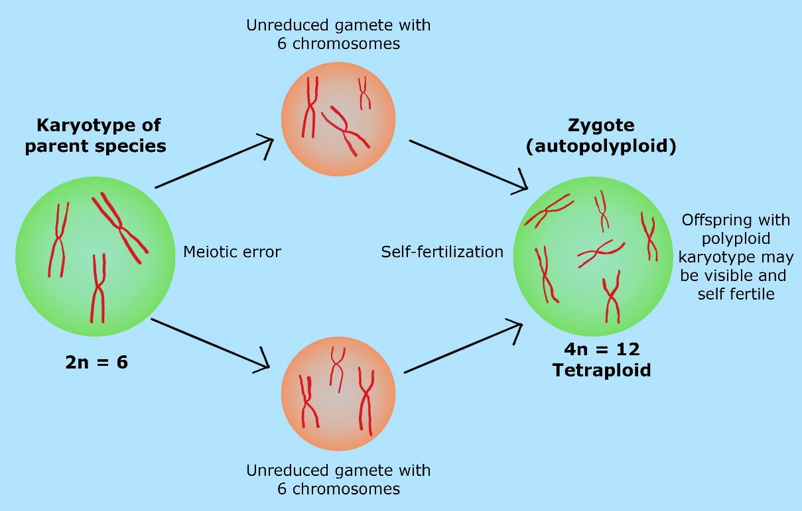
Fig 1: Illustration showing the origin of autopolyploid from unreduced gametes

- Allopolyploidy:
The word allopolyploidy is used to describe a polyploidy organism that is created when the entire chromosomal sets of two or more species are combined. A reduced "1n" gamete and a "3n" gamete, produced by the union of a reduced "1n" gamete and an unreduced "2n" gamete in the future generation, are the building blocks of a tetraploid individual. This two-step process, which is sometimes referred to as a triploid bridge, enables the development of allopolyploid. The second example shows how genotype can affect the formation of nonreduced gametes by showing how the elongate gene on chromosome 3 in maize increased the proportion of diploid eggs (Grant 1981; Lewis 1980). Quick screening methods like flow cytometry, chromosomal matching and other genomic methodologies are useful for studies on unreduced gametes in both plants and animals (Mable 2003). Ramsey and Schemske (1998) assert that the contribution of polyspermy as a method of polyploidy generation is unusual, with the exception of some orchids. Endoreduplication has been observed in the endosperm, cotyledons of developing seeds, leaves, and stems of bolting plants (Larkins et al. 2001). Fig. 2 provided a diagrammatic representation of the genesis of allopolyploidy.
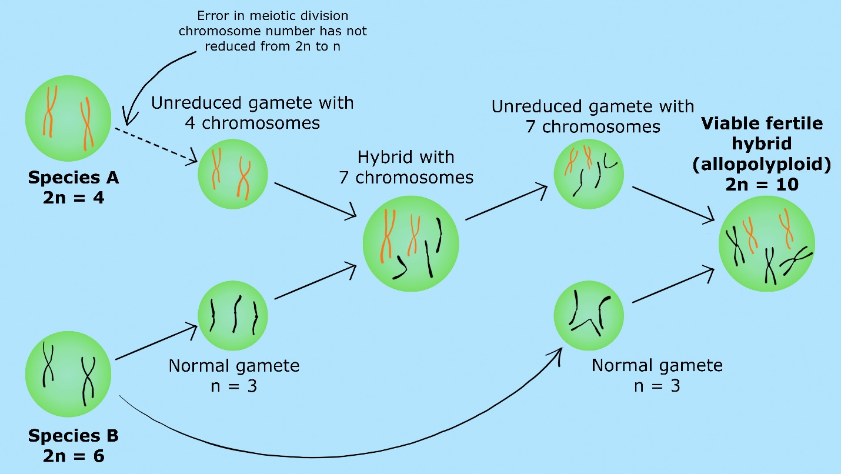
Fig. 2: Illustration showing the origin of allopolyploid from unreduced and reduced gametes

I. Natural Allopolyploids:
Let’s try to understand the concept of natural allopolyploids with the following examples,
- Wheat:
Being one of the most important cereals in the world, bread wheat's evolutionary history has so far attracted the most interest. More than 75 years have passed since the pioneering work of Kihara (1944), McFadden and Sears (1944, 1946), who identified Aegilops tauschii (syn Ae. squarrosa, Triticum tauschii) as the progenitor of the D genome of hexaploid wheat (T. aestivum) was first published, in which they described the identification of the diploid species that contributed to the three distinct genomes ( It is believed that the genome A of tetraploid and hexaploid wheat and the genome A found in diploid wheat are related. Additionally, the tetraploid emmer wheat genome B and the hexaploid wheat genome B share similarities. Chromosome pairing in crosses between wheat that are diploid, tetraploid and hexaploid serve as an example of this. Tetraploid and hexaploid wheat hybrids exhibit roughly 14II and 7I, whereas diploid and tetraploid wheat hybrids exhibit 7II and 7I. The wheat genome A is believed to have come from Triticum monococcum, the genome D from Triticum tauschii, and the genome B (2n = 14) from an undetermined source.
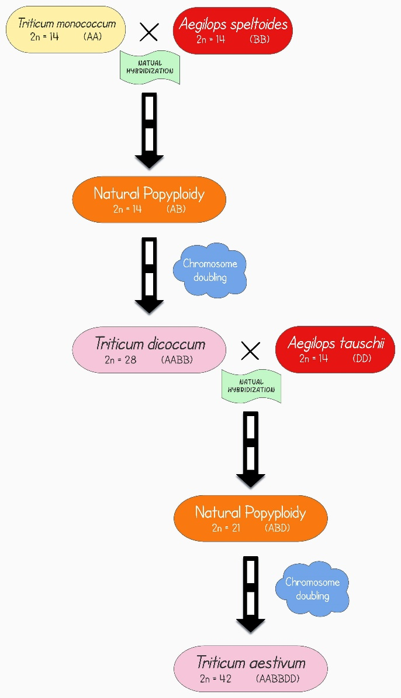
Fig 3. Evolution of allohexaploid wheat (T. aestivum) (Image is created in ‘Lucidchart’).
- Tobacco:
The genus Nicotiana contains about 76 currently recognised naturally occurring species and is divided into 13 sections (Knapp et al. 2004). The interspecific hybridization of the diploid (2n=24) Nicotiana sylvestris (female donor) and Nicotiana tomentosiformis (male donor) led to the typical allotetraploid species Nicotiana tabacum (2n=4x=48). It took about 200,000 years for this hybridization to occur (Leitch et al 2008). In contrast, Nicotiana tomentosiformis, Nicotiana otophora, or an introgressive hybrid between the two has been identified as the section Tomentosae's donor (Bland et al. 1985; Olmstead and Palmer 1991; Aoki and Ito 2000; Yukawa et al. 2006). Nicotiana sylvestris has been identified as the section Tomentosae's maternal parent and the other donor of the (Kenton et al. 1993; Riechers and Timko 1999; Lim et al. 2000; Kitamura et al. 2001; Ren and Timko 2001).
- Cotton:
All of the diploid species in the genus Gossypium have 13 haploid chromosomes and belong to one of seven distinct genome types that were developed utilising chromosomal pairing interactions from A to G. (Beasley 1942; Endrizzi et al. 1984). There are five tetraploid species in the Gossypium genus (n=2x=26). According to Kimber, disomic chromosomal pairing is present in all tetraploid animals (1961). Chromosome pairing in interspecific crosses between diploid and tetraploid cotton suggests that tetraploid cotton may have two separate genomes that resemble the A genome of G. hirsutum (n = 13) and the D genome of G. raimondii (n = 13). The A and D genome species diverged from a common ancestor about 6–11 million years ago (Wendeil 1989). The hypothesised A x D polyploidization event occurred in the New World between 1.1 and 1.9 million years ago, and the female parent was the A gene donor from the old world (Wendeil 1989; Wendeil and Albert 1992). It is thought that polyploidy-level diversification led to the emergence of the five allotetraploid species (G. hirsutum, G. barbadense, G. darwini, G. mustelinum, and G. tomentosum).
- Oat:
The allohexaploid, cultivated oat (n=21), is thought to have developed via a hybrid between the tetraploid A. barbata (n=14) and the diploid A. strigosa (n=7).
- Brassica spp.:
Nagaharu (1935) suggested a theory for the evolution and development of the six most common members of plants belonging to Brassica species. This theory is commonly known as Brassica triangle or the ‘Triangle of U’. The Brassica triangle provides an intriguing illustration of the part that allopolyploidy played in the evolution of several Brassica species. This hypothesis states that Indian mustard [Brassica juncea (n=18)] is an amphidiploid produced by an interspecific cross between Black mustard [Brassica nigra (n=8)] and Turnip/Field mustard [Brassica campestris (n=10)], whereas amphidiploid Rapeseed/Canola [Brassica napus (n=19)] was produced by an interspecific cross between Wild cabbage [Brassica campestris and Brassica oleraceae and Brassica carinata (Ethopian mustard) was developed from Brassica oleraceae (Wild cabbage) and Brassica nigra (Black mustard).
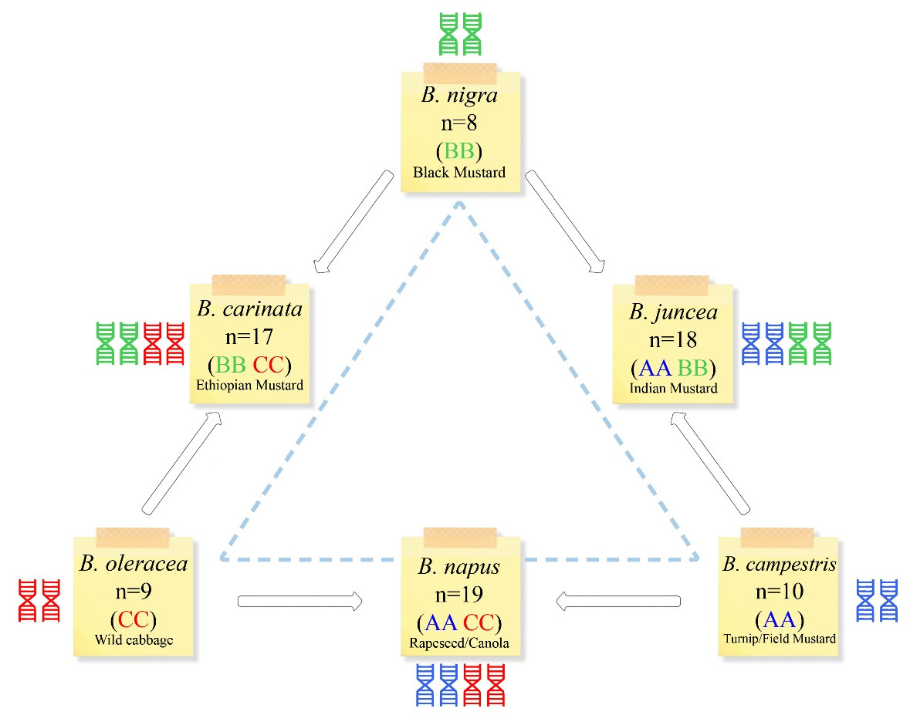
Fig4. Brassica triangle showing the relation between diploid and naturally occurring amphidiploidspecies of brassica. Three diploid species can be seen on the tips of the triangle, while amphidiploids are represented in the middle of two parents.
(Image is created in ‘Lucidchart and Vecteezy’).
II. Artificial Allopolyploids:
- Raphanobrassica:
This is a typical example of an artificially produced allopolyploid. This cross between the radish (Raphanus sativus, 2n=9) and the cabbage (Brassica oleraceae, 2n=9) was developed by Russian geneticist Karpechenko in 1928. He used radish roots and cabbage leaves to try to cross these two species successfully. Through spontaneous chromosomal doubling, he was able to create a fertile amphidiploid (4n=36), unfortunately with radish leaves and cabbage roots. Therefore, it was useless.
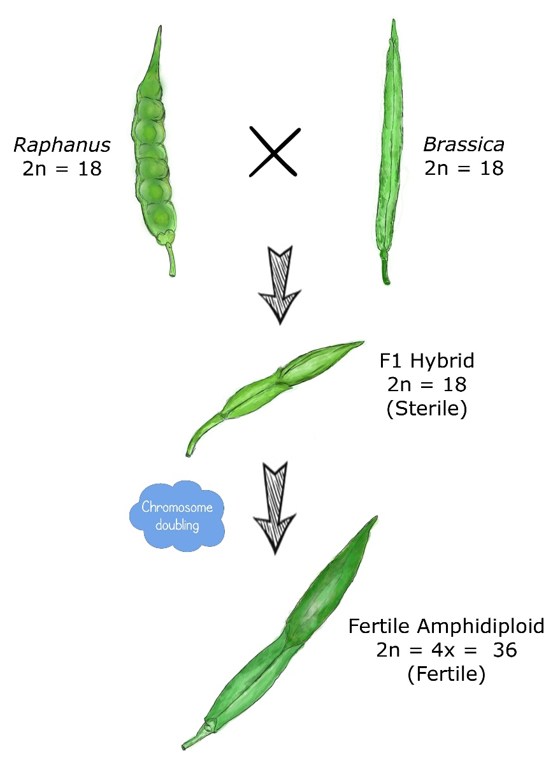
Fig 5: Evolution of Raphanabrassica (Artificial allopolyploid) from cross between Radish x cabbage (Image is created in ‘Lucidchart’).
- Triticale:
The first cereal crop produced artificially by humans was a brand-new kind of plant called triticale. Derivations vary depending on whether the genome is tetraploid (2n=4x=28) or hexaploid (2n=6x=42), as seen in Figure 5. Triticum durum (2n=28) and Secale cereale (2n=14) are combined to produce hexaploid triticale (2n=42). This crossover programme creates sterile F1 hybrids (2n=21) as a result. Chromosomes double in number following colchicine therapy, resulting in hexaploid triticale (2n=42). Similar to this, octoploid triticale (2n=56) is produced using Secale cereale (2n=14) and Triticum aestivum (2n=42). After receiving colchicine treatment, we obtained stable and fertile octoploid triticale (2n=56) from this crossing procedure, which also produced sterile F1 hybrid (2n=28). Tetraploid (2n=4x=28) and hexaploid (2n=6x=42) wheat are used to produce hexaploid triticale and octoploid triticale, respectively. Nowadays, triticale is grown extensively in countries like Canada, Mexico, Hungary, and others.
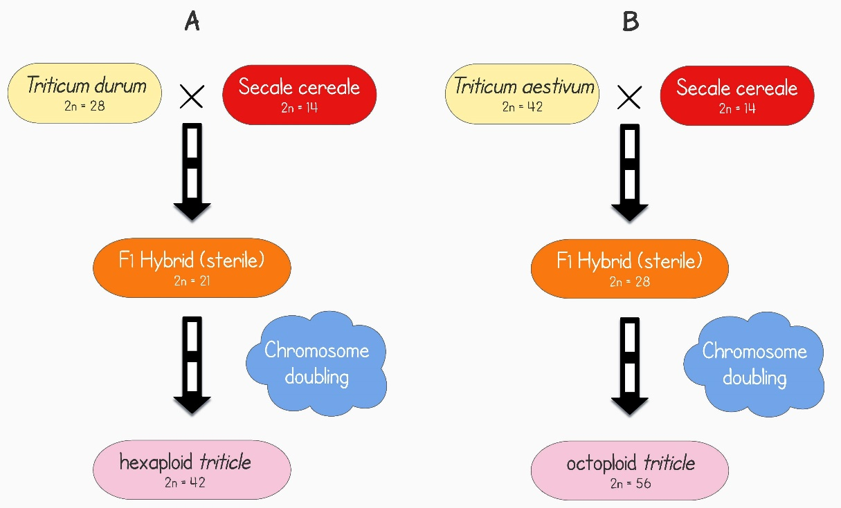
Fig. 5: Evolution of triticale. Left side (A) illustration of evolution of the hexaploid triticale and the right side (B) illustration of evolution of octoploid triticale
(Image is created in ‘Lucidchart and Vecteezy’).
- Wheat:
By combining A. tauschii with wild or domestic emmer, McFadden and Sears (1944) were able to construct hexaploid wheat. It resembled spelt, the artificial hexaploid wheat (T. aestivum sp. spelta, genomes BBAADD). They came to the conclusion that T. aestivum evolved from spelt, which was T. aestivum's predecessor, and that spelt was the parent of T. aestivum.
IV. INDUCTION TO POLYPLOIDY
Colchicine was discovered in the 1930s, and it slows the growth of spindle fibres and momentarily stops chromosomes at the anaphase stage (Blakeslee and Avery 1937). Polyploidy cells are now formed since the chromosomes have duplicated but cell division has not yet taken place. More mitotic inhibitors have been identified and used as doubling agents, including oryzalin, trifluralin, amiprophos-methyl, and N2O gas (Bouvier et al. 1994; Van Tuyl et al. 1992; Taylor et al. 1976). There are many different applications for these doubling agents. One of the easiest and most effective methods is to work with many seedlings with small, active meristems. To seedlings or the apical meristems, doubling agents can be given at various concentrations, intervals, or frequency. Shoots from older plants can still be treated, although doing so repeatedly results in less success and more cytochimeras. Smaller axillary or sub-axillary meristems can occasionally be treated with greater success. Chemical solutions can be applied to buds by dipping branch tips into a solution for a predetermined amount of time and wiping the buds with cotton, agar, or lanolin. Surfactants, wetting agents, and other carriers, such as dimethyl sulfoxide, are occasionally utilised to boost efficacy. Low frequencies can also be affected by X-rays, gamma rays, heat therapy, and cold treatment. Datura has been subjected to a cold treatment that has produced triploid branches. When maize plants or ears are exposed to intense heat (38-45 °C) during the initial zygotic division, 2-5% of the progeny are tetraploid (Randolph 1941). Heat treatment has been used to successfully produce polyploidy in several crop species, including barley, wheat, rye and a few others.
V. APPLICATIONS OF POLYPLOIDY
- Mutation breeding:
High frequency of chromosomal mutations are needed in modern breeding techniques like tilling because they provide fresh sources of variation. The multiallelic properties of polyploid loci provide many advantages for breeding. The dominant forms of any potentially dangerous alleles that may develop from forced mutation safeguard polyploids against lethal diseases typically linked with inbred diploid crops (Gaul, 1958). The emergence of polyploids during bottlenecks where forced inbreeding occurs has been greatly aided by this theory (Comai, 2005). Gene redundancy and mutation tolerance are two concepts that are utilised in mutant breeding for polyploid crop development. Polyploids are able to withstand deleterious allele modifications following mutation due to their vast genomes, which are the result of their genes being duplicated, and also have an increased mutation frequency (Gaul, 1958). The high mutation frequencies observed with polyploids may be exploited to induce mutations in diploid crops that do not generate sufficient genetic variation after a carcinogenic treatment. By first generating autotetraploids by the use of colchicine, followed by the use of fast neutrons and X-rays, this technique has been utilised to breed mutations in Achimenes spp. This study found that autotetraploids exhibited mutation frequencies that were 20–40 times higher than those of the corresponding diploid cultivars due to their large genomes (Broertjes, 1976).
- Seedless fruits:
Triploids with no seeds have been preferred, especially in fruits. Tetraploids are produced initially, and then they are crossed with diploid species to produce commercially useful triploid fruits like watermelon. To set fruit, the triploid watermelon is crossed with a suitable diploid pollen donor.
- Bridge crossing:
Another breeding strategy that makes use of polyploids' superiority in reproduction is bridge crossing. Chromosome doubling is followed by transitional crossover to produce fertile bridge hybrids when differences in ploidy between two species prevent sexual reproduction. This method has been used to grow excellent tall fescue grass (F. arundinacea) from Italian ryegrass (2n=2x=14) and tall fescue (2n=6x=42) using meadow grass (Fescue pratensis) as a bridging species (Acquaah, 2007). The same theory has been applied to fix heterozygosity in hybrids by increasing the number of chromosomes in the superior progeny of hybrids (Comai, 2005).
- Ornamental and forage breeding:
The increase in cell size that polyploidy causes in plants leads to larger plant organs, which is one of the most obvious and immediate consequences of polyploidy. The gigas effect is the name given to this phenomena (Acquaah, 2007; Levin, 1983; Stebbins, 1971). In cereal crops, chromosome doubling may result in considerably larger seeds and higher seed protein, but this benefit is offset by decreased seed set (Dhawan and Lavania, 1996). On the other hand, research on the gigas effect has been done on breeding trees, ornamentals, feed crops, and fruits (Emsweller and Ruttle, 1941; Schepper et al., 2001). Through chromosomal doubling breeding, the quality and size of the blooms on ornamental plants like snapdragons and marigolds have been improved (Emsweller and Ruttle, 1941). A significant inverse link between plant development rates and DNA concentration has been found by numerous scientists (Levin, 1983; Smith and Bennett, 1975). It has been associated with less auxin, a lower surface-to-volume ratio, and an altered nuclear surface-to-cell volume ratio (Acquaah, 2007; Levin, 1983). Due to their slower development rate than their diploid forebears, polyploids can flower later and for a longer period of time (Levin, 1983). Breeding ornamental plants may benefit greatly from this characteristic.
- Production of apomictic crops:
Apomixis is another method of using polyploids in breeding. Apomixis provides a technique for the asexual production of seeds by parthenogenesis. Although the majority of apomictic plants are polyploid, most polyploid plants are not apomictic (Otto and Whitton, 2000). Polyploidy supports sexual reproduction over asexual reproduction in plants (Dhawan and Lavania, 1996; Levin, 1983). Apomicts are the most desirable hybrids, yet little progress has been achieved in their development. However, it has been suggested that obligatory apomicts could be produced by growing plants with exceptionally high ploidy levels (Levin, 1983). One prominent example of an obligatory apomict produced at a high ploidy level is the octoploid of the grass Themedatriandra (Levin, 1983).
- Disease resistance through aneuploidy:
Aneuploidy has been utilised in plant breeding to produce plants that are resistant to disease by introducing one extra chromosome into the progeny genome. As an example, Triticum aestivum was backcrossed with Aegilops umbellulata to acquire its resistance to leaf rust. Alternative breeding methods for aneuploidy have also been researched, including chromosome replacement, deletion, and supernumerary chromosomes (Acquaah, 2007).
- Restoring fertility in wide hybrids:
It's not necessary for hybrids between distinct taxa to be infertile. One typical reason for this is chromosomal sterility, which is the failure of the chromosomes to pair correctly during meiosis. Chromosome duplication can restore the fertility of a wide hybrid. Effective use of this tactic has been demonstrated in Chitalpatashkentensis and Rhododendron (Contreras 2006; Olsen 2006). However, this tactic has been effective in restoring fertility in some cases, such as with tetraploid hybrids of Alstroemeria aurea and A. caryophyllaceae (Lu and Bridgen 1997).
- Increased allelic diversity and heterozygosity:
New characteristics have largely emerged as a result of increased allelic copy number and heterozygosity. Allelic diversity increases when two (or more) different genomes coexist in the same nucleus, a process known as allopolyploidy. Intergenomic heterozygosity has a positive effect on the growth of oil seeds in B. napus (Osborn et al. in 2003). The QTL for seed yield and other variables are likewise impacted by intergenomic heterozygosity in several populations of B. napus (Udall et al. 2006; Quijada et al. 2006). Tetraploid cotton also leads the world textile market because it can create fabric that is longer, finer and tougher than its diploid relatives. According to Jiang et al. (1998), several QTLs on the D genome showed that D genome loci have been used for fibre synthesis after polyploidy developed.
VI. LIMITATIONS OF POLYPLOIDY
- Limited applications: The single species polyploidy has few uses. It is typically helpful in crop species that reproduce asexually, such as grapes, potatoes, bananas, and sugarcane.
- Difficult to maintain: In the case of crop species that reproduce sexually, maintaining monoploids and triploids is impossible.
- Unwanted traits: In bispecific or multispecific polyploids, traits come from both parental species. In some cases, such as in the case of Raphanobrassica, these characters may be undesirable.
- Additional flaws: Numerous flaws, including low fertility, genetic instability, slow development, late maturation, etc., are present in induced polyploids.
- Opportunities:There are very few opportunities for allopolyploidy to create new species.
VII. CONCLUSION
It is currently unclear how polyploidy affects a species evolutionary path, despite the fact that it occurs frequently in nature and leaves its mark on all angiospermic genomes. Old issues like how polyploidy responds to environmental stress or whether genome doubling is helpful or harmful to evolutionary survival are being investigated with the use of contemporary genomic tools. Research on the molecular level has demonstrated that polyploidization-related genomic change takes place at a variety of regulatory levels. There are still numerous examples where the effects of polyploidy on fitness in various environmental contexts are unknown, and there is little proof that the observed transcriptional and genomic changes in natural populations actually speed up evolution or boost adaptation. Polyploids generally differ from their progenitors in terms of their morphological, ecological, physiological and cytological features, which can both aid them in filling a new niche and result in reproductive isolation. As a result, polyploidy is a crucial factor in plants' ability to adapt and speciate. Polyploidy breeding can be used to follow the origin of novel crops, interspecific gene transfer and crop evolution. Polyploidy is a fascinating topic of research since it can be used to demonstrate how agricultural plants have evolved and can be used to improve crop breeding by utilising their variety.
REFERENCES
Acquaah, G. 2007. Principles of Plant Genetics and Breeding. 2nd Edition. Willey-Blackwell.
Aoki S and Ito M.2000.Molecular phylogeny of Nicotiana (Solanaceae) based on the nucleotide sequence of the matK gene. Plant Biology. 2(3):316–324. https://doi.org/10.1055/s-2000-3710
Beasley YO. 1942. Meiotic chromosome behavior in species hybrids, haploids, and induced polyploidsof Gossypium. Genetics. 27(1): 27:25. https://doi.org/10.1093/genetics/27.1.25
Blakeslee AF and Avery AG. 1937.Method of inducing doubling of chromosomes in plants by treatment with colchicine. Journal of Heredity. 28(12): 393–411. https://doi.org/10.1093/oxfordjournals.jhered.a104294
Bland MM, Matzinger DF andLevings CS. 1985. Comparison of the mitochondrial genome of Nicotiana tabacum with its progenitor species. Theoretical and applied genetics. 69:535–541.https://doi.org/10.1007/BF00251100.
Bouvier L, Fillon F andLespinasse Y. 1994. Oryzalin as an efficient agent for chromosome doubling of haploid apple shoots in vitro. Plant Breeding. 113:343–346
Broertjes C. 1976. Mutation breeding of autotetraploid Achimenes cultivars. Euphytica. 25:297- 304.https://doi.org/10.1007/BF00041560.
Chen L., Lou Q., Zhuang Y., Chen J., Zhang X., Wolukau J.N. 2007. Cytological diploidization and rapid genome changes of the newly synthesized allotetraploids Cucumis× hytivus. Planta 225:603-614.https://doi.org/10.1007/s00425-006-0381-2.
Chen Z. 2010. Molecular mechanisms of polyploidy and hybrid vigor. Trends in plant science 15:57-71.https://doi.org/10.1016/tplants.2009.12.003.
Comai L. 2005. The advantages and disadvantages of being polyploid. Nature Reviews Genetics 6:836-846. https://doi.org/10.1038/nrg1711.
Contreras RN. 2006. Using polyploidy to restore fertility in azaleodendrons and investigating parentage of these wide hybrids. MS thesis, North Carolina State University, Raleigh
Dhawan O. and Lavania U. 1996. Enhancing the productivity of secondary metabolites via induced polyploidy: a review. Euphytica 87:81-89. https://doi.org/10.1007/BF00021879.
Digby L. 1912. The cytology of Primula kewensis and of other related Primula hybrids. Annals of Botany. 26:357–388. https://doi.org/10.1093/oxfordjournals.aob.a089395.
Emsweller S. and Ruttle M. 1941. Induced polyploidy in floriculture. American Naturalist:310-328.https://doi.org/10.2307/2457403.
Endrizzi JE, Turcotte ELand Kohel RJ. 1984. Qualitative genetics, cytology, and cytogenetics. In: Kohel RJ, Lewis CF (eds) Cotton. American Society of Agronomy, Madison, pp 81–129. https://doi.org/10.2134/agronmonogr24.c4.
Gaul H. 1958. Present aspects of induced mutations in plant breeding. Euphytica 7:275-289. https://doi.org/10.1007/BF00025269.
Grant V. 1975. Genetics of flowering plants. Columbia University Press, New York
Grant V. 1981. Plant speciation, 2nd edn. Columbia University Press, New York
Hilu KW. 1993. Polyploidy and the evolution of domesticated plants. American Journal of Botany. 80(12):1494–1499. https://doi.org/10.1002/j.1537-2197.1993.tb15395.x.
Jiang Y, Scarpa A, Zhang L, Stone S, Feliciano E and Ferro-Novick S. 1998. A high copy suppressor screen reveals genetic interactions between BET3 and a new gene. Evidence for a novel complex in ER-to-Golgi transport. Genetics 149(2):833–841. https://doi.org/10.1093/genetics/149.2.833.
Karpechenko GD. 1928. Polyploid hybrids ofRaphanus sativus L. X Brassica oleracea L. Bulletin of Applied Botany. 17: 305–408. https://doi.org/10.1007/BF01740955.
Kenton A, Parokonny AS, Gleba YY and Bennett MD. 1993. Characterization of the Nicotiana tabacum L. genome by nuclear cytogenetics. Molecular Genetics and Genemocis 240:159–169. https://doi.org/10.1007/BF00277053.
Kihara H. 1944. Discovery of the DD analyser, one of the ancestors of Triticum vulgare (in Japanese). Agriculture and Horticulture 19: 889-890.
Kimber G.1961. Basis of the diploid-like meiotic behavior of polyploid cotton. Nature 191:98–100.https://doi.org/10.1038/191098a0.
Kitamura S, Inoue M, Shikazono N. and Tanaka A. 2001. Relationships among Nicotiana species revealed by the 5S rDNA spacer sequence and fluorescence in situ hybridization. Theoretical and Applied Genetics.103:678–686. https://doi.org/10.1007/s001220100643.
Knapp S, Chase MW and Clarkson JJ. 2004. Nomenclatural changes and a new section classification in Nicotiana (Solanaceae). Taxon 53:73–82. https://doi.org/10.2307/4135490.
Larkins BA, Dilkes BP, Dante RA, Coelho CM, Woo YM and Liu Y. 2001. Investigating the hows and whys of DNA endoreduplication. Journal of Experimental Botany. 52:183–192. https://doi.org/10.1093/jexbot/52.355.183.
Leitch, I. J., Hanson, L., Lim, K. Y.,Kovarik, A., Chase, M. W.,Clarkson, J. J.,Leitch,A. R. 2008. The Ups and Downs of Genome Size Evolution in Polyploid Species of Nicotiana (Solanaceae). Annals of Botany. Volume 101, Issue 6. Pages 805–814.https://doi.org/10.1093/aob/mcm326
Levin D. 1983. Polyploidy and novelty in flowering plants. American Naturalist 122:1-25.https://www.jstor.org/stable2461003.
Levin D. 2002. The role of chromosomal change in plant evolution. Oxford University, Oxford.
Lewis W. 1980. Polyploidy in species populations. In: Lewis W (ed) Polyploidy: biological relevance. Plenum, New York, pp 103–144. https://doi.org/10.1007/978-1-4613-3069-1_6.
Lim CR, Kimata Y, Ohdate H, Kokubo T, Kikuchi N, Horigome T and Kohno K. 2000. The Saccharomyces cerevisiae RuvB-like protein, Tih2p, is required for cell cycle progression and RNA polymerase II-directed transcription. Journal of Biological Chemistry. 275(29):22409–22417. https://doi.org/10.1074/jbc.Moo1031200.
Lu C and Bridgen MP. 1997. Chromosome doubling and fertility study of Alstroemeria aurea A. caryophyllaceae. Euphytica. 94:75–81. https://doi.org/10.1023/A:1002911522748.
Lucidchart. www.lucidchart.com.
Mable BK.2003. Breaking down taxonomic barriers in polyploidy research. Trends in Plant Science. 8(12):582–590. https://doi.org/10.1016/j.tplants.2003.10.006.
McFadden ES and Sears ER. 1944. The artificial synthesis of Triticum spelta. Records of the Genetics Society of America. 13: 26-27.
McFadden ES and Sears ER. 1946. The origin of Triticum spelta and its free-threshing hexaploid relatives. Journal of Heredity. 37: 81-89. https://doi.org/10.1093/oxfordjournals.jhered.a105594.
Nagaharu, U. 1935. Genome Analysis in Brassica with Special Reference to the Experimental Formation of B. Napus and Peculiar Mode of Fertilization. Japanese Journal of Botany, 7, 389-452.
Olmstead RG and Palmer JD. 1991. Chloroplast DNA and systematics of the Solanaceae. In: Hawkes JG, Lester RN, Nee M, Estrada N (eds) Solanaceae III: taxonomy, chemistry, evolution. Royal Botanic Gardens, Kew, London, pp 161–168.
Olsen KB. 2006. Productivity impacts of offshoring and outsourcing: a review. OECD Directorate for Science, Technology and Industry (STI), Paris, pp 1–35. https://www.oecd.org/sti/working-papers.
Osborn TC, Pires JC, Birchler JA, Auger DL, Chen ZJ, Lee HS, Comai L, Madlung A, Doerge RW, Colot V and Martienssen RA. 2003. Understanding mechanisms of novel gene expression in polyploids. Trends Genet 19:141–147.
Otto S.P., Whitton J. 2000. Polyploid incidence and evolution. Annual Review of Genetics 34:401-437. https://doi.org/10.1146/annurev.genet.34.1.401.
Quijada PA, Joshua A, Udall JA, Lambert B, Osborn TC. 2006. Quantitative trait analysis of seed yield and other complex traits in hybrid spring rapeseed (Brassica napus L.): 1. Identification of genomic regions from winter germplasm. Theoretical Applied Genetics 113:549–561. https://doi.org/10.1007/s00122-006-0323-1.
Ramsey J and Schemske DW. 2002. Neopolyploidy in flowering plants. Annual Review of Ecology and systematic. 33:589–639. https://doi.org/10.1146annurev.ecolsys.33.010802.150437.
Ramsey J. and Schemske D.W. 1998. Pathways, mechanisms, and rates of polyploid formation in flowering plants. Annual Review of Ecology and Systematics 29:467-501. https://doi.org/10.1146/annurev.ecolsys.29.1.467.
Randolph L.F. 1941. An evaluation of induced polyploidy as a method of breeding crop plants. American naturalist. 75(759):347–363. https://www.jstor.org/stable/2457405.
Ren N and Timko MP. 2001. AFLP analysis of genetic polymorphism and evolutionary relationships among cultivated and wild Nicotiana species. Genome 44:559–571. PMID:11550889.
Riechers DE and Timko MP. 1999. Structure and expression of the gene family encoding putrescine N-methyltransferase in Nicotiana tabacum: new clues to the evolutionary origin of cultivated tobacco. Plant Molecular biology. 41:387–401. https://doi.org/10.1023/A:1006342018991.
Schepper S., Leus L., Mertens M., Debergh P., Bockstaele E., Loose M. 2001. Somatic polyploidy and its consequences for flower coloration and flower morphology in azalea. Plant cell reports 20:583-590. https://doi.org/10.1007/s002990100372.
Singh BD. 2012. Plant breeding principles and methods, 9th edn. Kalyani Publishers, New Delhi, pp 641–667
Stebbins GL. 1947. Types of polyploids: their classification and significance. Advances in Genetics. 1:403–429. https://doi.org.10.1016/s0065-2660(08)60490-3.
Stebbins GL.1971. Processes of organic evolution. Prentice- Hall, Englewood Cliffs.
Taylor NL, Anderson MK, Wuesenberry KH, Watson L. 1976. Doubling the chromosome number of Trifolium species using nitrous oxide. Crop Science. 16:516–518. https://doi.org/10.2135/cropsci1976.0011183X001600040019x.
Udall JA, Quijada PA, Lambert BA, Osborn TC. 2006. Quantitative trait analysis of seed yield and other complex traits in hybrid spring rapeseed (Brassica napus L.): 2. Identification of alleles from unadapted germplasm. Theoretical Applied Genetics. 113:597–609. https://doi.org/10.1007/s00122-006-0324-0.
Van Tuyl JM, Meijer B, Van Dien MP. 1992. The use of oryzalin as an alternative for colchicine in in-vitro chromosome doubling of Lilium and Nerine. Acta Horticulture. 325:625–629. https://doi.org/10.17660/ACTAHORTIC.1992.325.88.
Vecteezy.www.Vecteezy.com<ahref=https://www/vecteezy.com/free-vector/sticky-notes>Sticky Notes Vectors by Vecteezy</a>.
Wendeil F and Albert VA. 1992. Phylogenetics of the cotton genus (Gossypium): character-state weighted parsimony analysis of chloroplast-DNA restriction site data and its systematic and biogeographic implications. Systematic Botany. 17:115–143. https://doi.org//10.2307/2419069.
Wendeil F. 1989. New world cottons contain old world cytoplasm. Proceeding of the National Academy of Sciences. USA 86:4132–4136. https://doi.org/10.1073/pnas.86.11.4132.
Yukawa M, Tsudzuki T, Sugiura M. 2006. The chloroplast genome of Nicotiana sylvestris and Nicotiana tomentosiformis: complete sequencing confirms that the Nicotiana sylvestris progenitor is the maternal genome donor ofNicotiana tabacum. Molecular Genetics and Genomics. 275:367–373. https://doi.org/10.1007/s00438-005-0092-6.

