Sphere Formation of Liquid Aleovera Juice by Using Spherification Technique
Shinde Aruna^{.1}, P.V.Badadhe² ,C.D. Ingale³
Department of Chemistry, R.B.N.B. College Shrirampur-413709 (M.S.)

Abstract:
Spherification, that is the technique of molecular gastronomy which is simplest technique that are for the sphere formation of liquid juices of various vegetables with using some home remedies to cure food poisoning in it. Aloevera plant used for the health beauty, medicinal, skin care as well as increases the oxygen level in the human body. The leaf is composed three layers 1st layer (inner) layer contain clear gel that contain 99% water , glucomannans, amino acid, lipids sterols and vitamins. 2nd layer (middle) of latex which is the bitter yellow sup and contains anthraquinones and glycosides.3rd layer (upper) is thick layer of 15-20 cells called as rind which has protective called as well as synthesis carbohydrates and proteins. Aloevera contain important constituents of vitamins, enzymes, salicylic acid and amino acid. Aloevera plant is emitting oxygen at day as well as night time.
Keywords: Spherification, sphere , aloevera, molecular gastronomy
Introduction :
The molecular and physical gastronomy was coined in 1988 by Hungarian physicist Nicholas kurto and French physical chemist herve. This in 1992 it became the title for asset of workshops hrld in Erice, Italy that brought together scientists and professional cooks for discussions about the science behind traditional cooking preparation. Kurti death in 1998, the name of the Eric workshop was changed by this to International Workshop on Molecular Gastronomy N. Kurti. This remained the sole director of the subsequent workshops from 1999,and continued his research in the , field of molecular gastronomy at the Inra-Agro paris Tech International centre for Molecular gastronomy, in charge of organizing the international meetings.
The technique is called Spherification and food science trend called molecular gastronomy. Sherification is the sub type of molecular gastronomy for creating such spheres which differ based on the calcium lactate contain of the aloevera product to be spherified. The important reagent used in the spherification process like calcium lactate, Black berries essence and sodium alginate. Calcium lactate is a food additive that typically added to a wide variety of food to enhance their texture and flavor. Black berries essence 500 gm black berries add ice sugar 20% then shake well. Heat berries in steam of hot water about 2 hrs and stand at overnight in refrigerators. Then filter this mixtures and used as Black berries essence. Sodium alginate derived from brown algae or seaweed is a thickening and gelling agent that forms heat stable gels in the presence of calcium. This property allow cook to make gelled spheres in a technique known as spherification. Molecular gastronomy provides new knowledge on chemistry and physics behind culinary processes. The Chef herve was the father of molecular gastronomy as well as Chef Paul because was father of gastronomy. In the late 1990 and early 2000s, the term started to be used to describe a new style of cooking in which some chefs began to explore new possibilities in the kitchen by science, research, technological advances in equipment and various natural gums and hydrocolloids produced by the commercial food.
Materials: calcium lactate (P^{H} 5.1), Black berries essence, Sodium alginate (P^{H} 3-3.5), aloevera natural extract only (P^{H} 4.5-5.5)
1. Sodium Alginate- It has property to make gelled spheres as well as used in food industry for the production of gel like food.
2. Calcium Lactate is a commercially used to stabilize, leaven food, flavor and thicken. Calcium lactate is a calcium salt of lactic acid and it has mild taste, used reverse spherification.
3.Aloevera – It is approved by the FDA as a Flavoring, food supplements’ and herbal remedies.
4.Black berries essence- Addition of Black berries not mandatory. It is used for only colour.
5. Preservatives- Sodium benzoate is a common preservative in acid or acidified food. It kill the micro-organism, which cause spoilage.
Method :
Home Remedies beneficial for all time :
1. Aloevera increases amount of oxygen in human body as well as antibacterial, antifungal and
Antiviral property.
2. Turmeric for pain and inflammation.
3. Ginger for pain and soreness.
4. Lavender for migraine and anxiety.

Methods: (We can used ayurvedic plant extract)
50 ml water with aloevera

5 gm Calcium lactate

Stir well mix until it dissolve in the water (Mixture 1)

100 ml black berries essence

Add to this 10 gm of Sodium Alginate (Do not add excess) (Mixture2)

Add preservative and sweetening / flavouring agent

Take three bowls
1) Calcium lactated with aloevera mixture 1
2) Sodium alginate solution with black berries essence mixture 2
3) Clean water

Add small drop with the help of dropper in bowl 2nd

Then Shift spheres in 3rd bowl of clean water
Fresh sphere used for eating directly. (Oxygen rich Sphere)

Fig 1.1 Spherification of Aloevea Liquid
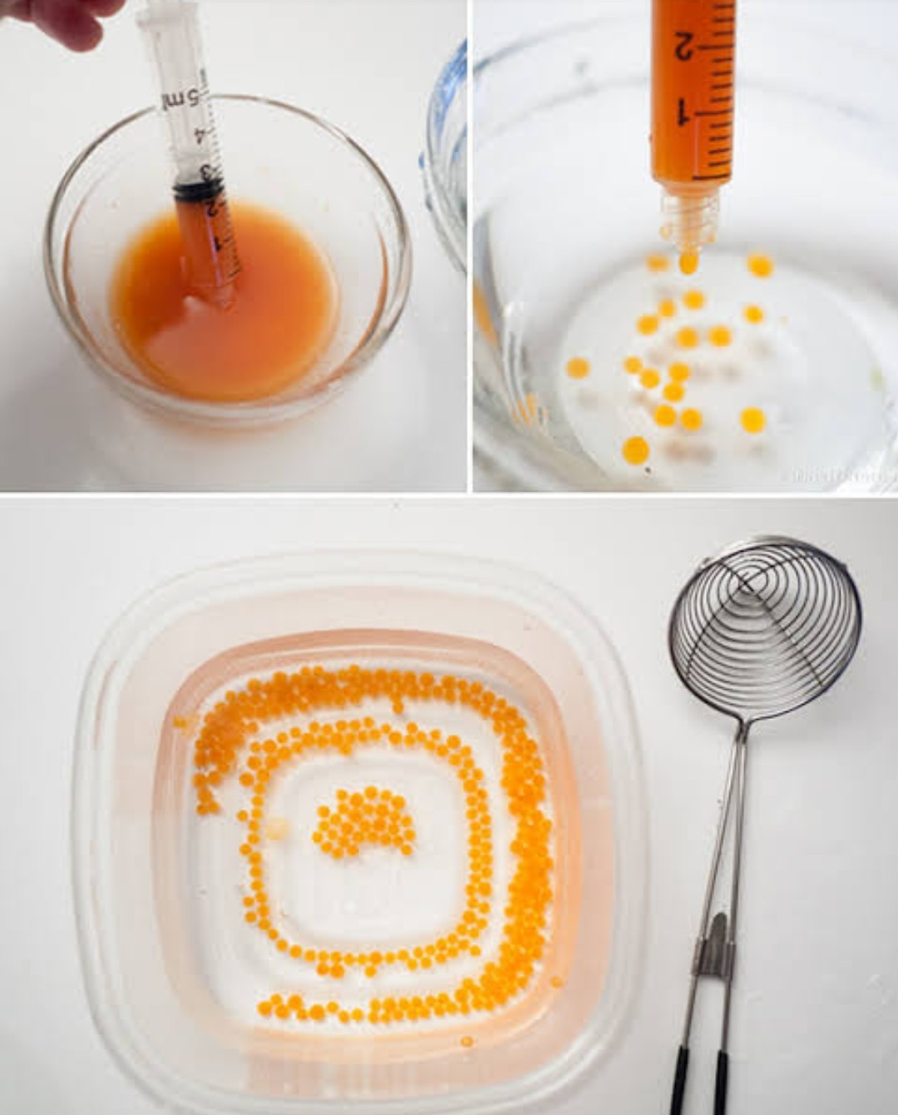
Fig 1.2 Aloevera Sphere
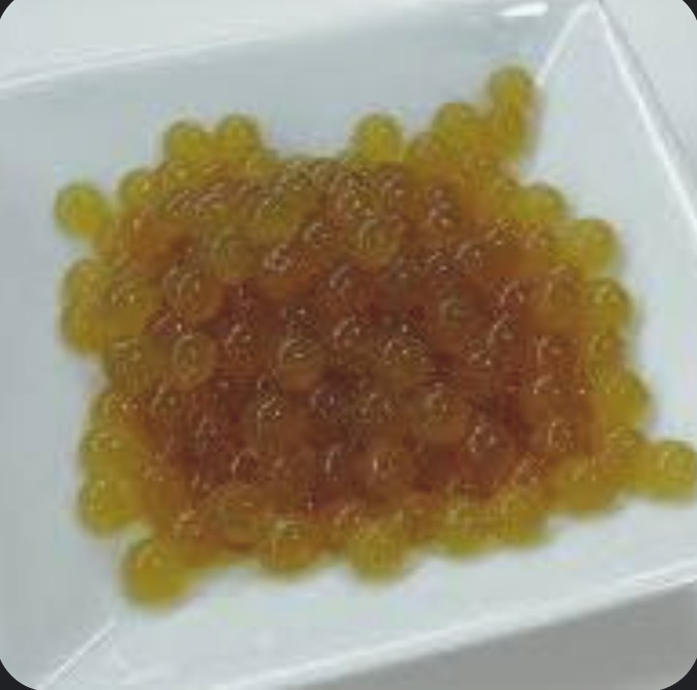

Results:
- By using this technique we can made sphere of aloevera. Aloevera liquid can also convert solid sphere they gives it different texture and oxygen rich food sphere.
- Beneficial for all human beings.
- This technique use full for the home treatment in natural way for all human being.
- We can also prepare the different ayurvedic plant extract sphere. It is more beneficial for all society. Chemical free green synthesis of sphere and specially child like that sphere like food material.

Conclusion:
1) It has introduces to a scientific aspect, an art with can create oxygen rich sphere, invent an
discover new one.
- This is modern style of cooking in kitchens and take advantage of home remedies of oxygen rich diet.
- It is beneficial of asthmatic patients and COVID 19 Patient.

References:
1. Atherton P.Aloevera revisited.Br J Phytother1998;76-83[Google Scholar]
2. Shelton M. aloevera its chemical and therapeutic properties.Int J Dermatol 1991;30:679-
83[Pub Med] [Google Scholar]
3. Atherton.P.The essential Aloevera The action and the evidence 2nd 1997.[Google Scholar]
4. Molecular Gastronomy exploring yhe Science of Flavor.
5. H.2005. Molecular gastronomy: Exploring the science of Flavor. London: Cambridge
6. Duncan BD. Multiple-range and multiple F-test. Biometrics. 1955; 11:1-42.

7. Kohn R. Ion binding on polyuronates-alginate and pectin. Pure and Applied Chemistry. 1975;
42:371-397.

8. Lee P, Rogers MA. Effect of calcium source and exposure time on basic cavier spherification
using sodium alginate. International Journal of Gastronomy and Food Science. 2012; 1(2):96-
100.

9. Mabeau S, Fleurence J. Seaweed in food products: Biochemical and nutritional aspects. Trends in Food Science and Technology. 1993; 4:103-107.

10. Mancini F, McHugh TH. Fruit-alginate interactions in novel restructured products. Nahrung.
2000; 44:152-157.

11. Mandal S, Kumar SS, Krishnamoorthy B, Basu SK. Development and evaluation of calcium
alginate beads prepared by sequential and simultaneous methods. Brazilian Journal of
Pharmaceutical Science. 2010; 46:785-793.
12. Martinsen A, Skjak Braek G, Smidsrod O. Alginate as immobilization material: I. Correlation between chemical and physical properties of alginate beads. Biotechnology and
Bioengineering. 1989; 33:79-89.

13. Menon TV, Sajeeth CI. Formulation and evaluation of sustained release sodium alginate
microbeads of carvedilol. International Journal of Pharmaceutical Technology Research.
2013; 5:746-753.

14. Park JS, Kim DK, Lee KH, Doh DS. The diffusion characteristics of colute into the
Ca-alginate gel bead. Hwahak Konghak. 1997; 35(1):41-45.

15. Sherina VM, Santhi K, Sajeeth CI. Formulation and Evaluation of Sodium alginate
microbeads as a carrier for the controlled release of Nifedipine. International Journal of
Pharmaceutical Chemical Science. 2012; 1:699-710.

16. Silva CM, Ribeiro AJ, Figueiredo IV, Goncalves AR, Veiga FX. Alginate microspheres
prepared by internal gelation: Development and effect on insulin stability. International
Journal of Pharmaceuttics. 2006; 311(1- 2):1-10.

17. Smardel P, Bogataj M, Mrhar A. The influence of selected parameters on the size and shape
of alginate beads prepared by ionotropic gelation. Science Pharmaceutics. 2008; 76:77-89.

18. Snedecor GW, Cochran WG. Statistical Methods (17th Edn.) Ames, IA.: The Lowa State
University Press, 1987, 221-222.

