FUTURISTIC TREND OF AUTOMOTIVE MANUFACTURERS AN ANALYSIS WITH HYUNDAI VS TATA MOTORS IN FY2023

Author: Dr.P.GOVINDASAMY, Associate Professor and Research Supervisor,
Vel Tech Rangarajan Dr.Sagunthala R & D Institute of Science and Technology (Deemed to be University), Chennai, Email: apgswamy1972@gmail.com

ABSTRACT

The transportation landscape has paradigm shift over the next 10 to 15 years with automotive sector trends - independent driving, connected vehicles, complete electrification, evolving electronics applications and shared mobility - amplifying their impact. The sprouting background benevolences have seamless openings for Indian auto manufacturers to lead the troublemaking modifications happening diagonally in all parts and increase the economic benefit, conferring to Mckinsey report. Indian auto players can develop backgrounds for invention, locally and in similar avenues overseas aiming to cope up with the complete products, combinations, or modules wide-reaching globally. In traditional micro mobility divisions (two Wheeler and three Wheeler), for Passenger Vehicles, such as cars and Sport Utility Vehicles, and light Computer-controlled Vehicles, Indian players can win adopting the strategy of electrification and frugal design requirements essential for emerging markets.

Key words: Automotive Manufacturers, Futuristic Trends, Economic Order, Sales Segmentation, Quality and performance.

INTRODUCTION
Reviewing the existing literature provides an initial starting point in defining the manufacturing practice adopted by the industries. Additionally, it also helps is to highlight the clarity in the initial phase of the understanding and the operational issues around the performance of the industries. Standardised work is a part of Toyota production systems is an effective way of process improvement. In the extremely modest situation and in order to achieve world class manufacturing successfully, the organization must retain both well-organized upkeep and operative engineering approaches as well as the benefits of kaizen are money, time, and distance, etc efficiency.

REVIEW OF LITERATURE

Broad trend in literature review of Indian Automobile Industry indicates that there has been a gradual improvement and contribution of the industry towards economic growth since liberalization. There have also been numerous studies that study the specific impact on ROA and ROE. For a better understanding of the subject, the Literature Review on “Impact of Liberalization on Structure and Productivity of Indian Automobile Industry” has been broadly discussed; Literature on Automobile Industry and Literature on Indian Automobile Industry

Kathuria (2001) tested two hypotheses - liberalization has improved the productivity of local firms and spill overs from technology transfer have increased all regimes irrespective of other constraints. Using production frontier approach for 487 firms belonging to three-digit manufacturing industries during 1989 - 1990 to 1996 - 1997, the study has found that the improvement after liberalisation in terms of productivity of Indian industry, especially the foreign owned firms.

Narayanan (1988a) This study undertook the occurrence of oligopoly arrangement in the corporate and found that maximum companies were appreciating huge profit boundaries, great development degrees and huge marketplace and there was slight inspiration for divergence and technological up gradation. Innovative goods and mock-ups connecting scientific up gradation were scarcely castoff. Nevertheless, considerable scientific erudition consumed in some corporates (especially Telco, Bajaj) in the process of indigenization and in their exertions to acclimate the goods to outfit the native situations.

Kathuria (1996), considered economies of scale in Indian commercial vehicle manufacturing automobile companies (1978 – 1988) and found that among the five (5) existing firms four (4) - SMPIL, MML, BTL and TELCO had economies of scale in production.

Biswajit Nag et al (2007) led a concentrate on Shifting Topographies of the Auto Industry in Asia: Comparison of manufacturing, trade and market assembly in selected countries. The review analyzes the advance strategies, modifications in ownership arrangements, trade models and job legislatures of chosen Asian nations such as China, India, Indonesia and Thailand in the auto manufacturing industry. They found that security in part area in these nations didn't function admirably overall, as it was helped just the fundamental parts area. Further, specialization in vehicle area is progressively becoming portion explicit as every one of these nations is tracking down its specialty. China concentrates to work in parts, India leads in bikes and little vehicles sector, Thailand has moved to trucks and traveller vehicles and Indonesia has in utility vehicles.

Narayan and Vashisht (2008) led a concentrate on Factors of affordability of the Indian auto industry post progression. The review covered 45 companies all over India. Which comprises of 31 were auto-parts firms and 14 were Original Equipment Manufacturers (OEMs). They reasoned that the auto-parts area has a lot higher work age potential and commodity force than the auto get together parts of the area. The part producers are currently universally serious and furthermore keeping up with sensible benefit levels in spite of a duty security of just 7.5 percent.

In August 2006, a Draft of Automotive Mission Plan (AMP) Statement arranged in conference with the business was delivered by the Ministry of Heavy Industries and Public Enterprises. This was at last delivered as a report in December 2006. This report attracts an activity intend to take the turnover of the car business in India to US$145billion by 2016, representing more than 10% of the GDP and expanding employment opportunity to 25 million individuals by 2016. An exceptional accentuation is laid on little vehicles, MUVs, bikes and auto-parts. Measures proposed incorporate setting up of a National Auto Institute, smoothing out government/instructive/research establishments to the requirements of the vehicle business, overhauling framework, taking into account changes in obligation structure and monetary motivations for R&D.

REVIVAL OF TATA MOTORS

A long time back Tata Motors was sold 3.13 lakh vehicles which were more than Hyundai India sales. Presently it sells only 1.08 lakh vehicles which have low turnover than Hyundai India. During these years the producer of Nexon has multiplied its piece of the pie from 6.85% (FY2019) to 12.14% (FY2022).

Avik Chatopadhyay, a car industry advisor, brought up two purposes behind the situation. "The first is a consistently expanding worthiness of the Tata identification because of its item styling, quality, execution and after-deals. The progress of the Nexon EV has been a significant picture sponsor. The whole experience of possessing a Tata vehicle has unfathomably worked on throughout the course of recent years."

"The second is that Tata Motors explored the semiconductor emergency better than Hyundai India. The requesting and acquisition proficiency has permitted Tata to deliver more. A Hyundai in India is bound more by what HQ in Korea orders and in this way can wind up missing out for a while," he said.

Hyundai's piece of the pie was at 8-year low at 15.7% for the financial year finished March 31, 2022. Just in Financial Year 2014, Hyundai revealed 15.1%, after which it floated around a high of 16% to 17%.

Experts following the business propose that one reason for the restricting of the volume gap could be the deficiency of manufacturing by the worldwide supply chain network limitations during the financial year, where Hyundai has been influenced significantly more than other Original Equipment Manufacturers.

About the increase sought after and deals, Shailesh Chandra, Managing Director and Chief Executive Officer, Tata Motors Passenger Vehicles and Tata Passenger Electric Mobility, said that the plan, execution and wellbeing highlights of the new models have been the foundation of its prosperity.

Debottlenecking and efficient empowering and increasing of production capacities, further developed semiconductor availability and accessibility; close working with the providers for more allotment, market-purchase and yet again designing coping with process simplification facilitated the organization. Centred activities in distinguished miniature business sectors and country regions both urban and rural, further developed network arrive at in high ethnic group regions, and improvements in sales and after-sales client experience have additionally contributed, Chandra said.

As indicated by an industry insider talking on state of secrecy, "Hyundai Group is decisively taking action for the monetary year 2022-2023 where it is more centered around on brand Kia for the Indian market and believes that it should start to lead the pack. It intends to put the Hyundai brand on the very front one year from now."

BATTLE OF THE SEGMENTS

In the midst of the current arrangement of items, in the superior hatchback portion, Hyundai's i20 has an immediate rivalry to Tata's Altroz. Since its send off in January’2020, the Altroz has gotten pace timing marketing projections extremely near i20 in Financial Year 2022.

As per Chattopadhyay, for Tata Motors to take a lead during the financial year, it would expect to keep up with the on-going energy combined with more computerized enablement during prospecting and buying. "The Tata portfolio should be utilized as a total fleet response for any corporate, from the Punch to the Safari. The Punch should be advanced more at the ground level than taking costly courses like Indian Premier League to guarantee supported numbers."

"For Hyundai India, figuring the stockpile issues out will doubtlessly assist with drawing nearer to the 50,000 imprint consistently easily. On the brand front, Kia is by all accounts taking a lead with the right commotions on the Electric Vehicles and technology spaces. The Hyundai brand is getting more 'standard' like Maruti and that may be somewhat of an annoyance as the client may not relate a higher worth with the identification any longer," Chattopadhyay noted.

In the alleged Utility Vehicle segment, Hyundai's Venue straightforwardly rivals Tata's Nexon propelled in 2017. Extraordinarily, Nexon, which used to clock around a portion of the sales of Venue around a long time back i.e 2 years, has now accomplished an accomplishment of selling equivalent as well as additional volumes than the Venue.

In the meantime, a significant piece of the sales in this segment likewise fall in the kitty of Hyundai's sister brand Kia with its Sonet classical.

Going ahead, Hyundai is supposed to send off its new model Casper for this segment. The organization has additionally declared that it will send off the cutting edge model of its superior Sport Utility Vehicle Tucson in the last option part of the schedule year 2022 and is good to go to present the facelift form of Venue to the market near future.

Hyundai likewise offers the new-gen Creta Sport Utility Vehicle which was sent off in March 2020 and stays the organization's top of the bestselling line model. It contends with any likeness of kin Kia India's Seltos as siblings. Goodbye doesn't have an immediate opponent model for Creta yet.

As per Gaurav Vangaal, Associate Director, S&P Global Mobility, "With progress in supply chains, Hyundai is supposed to quickly return to its number two position in Financial Year 2023. Its Creta and Venue models have immense appointments on the lookout and basically for the time being and Tata doesn't have an opponent item against Creta."

"Hydrogen mobility 2022, accessibility of chips is supposed to improve and new models from both Maruti Suzuki and Hyundai including facelifts will represent an interest headwind for Tata Motors," he said.

Tata sells the Punch Utility Vehicles, which has timed 52,716 units since its launched in October 2021, averaging to roughly 8,500 units every month. Furthermore, this model doesn't have direct rivalry from Hyundai up to this point.

"On all parts of client experience Tata matches Hyundai, Kia, Toyota and Honda. Assuming the Punch figures out how to keep up with momentum and watch 12,000 units consistently, then the number two position is most certainly available to all," Chattopadhyay said.
In the car Sedan segment, Hyundai offers the Verna and Elantra alongside Aura which was as of late sent off in January 2020, while Tata has only one item the Tigor model, accessible in both Compressed Natural Gas and Electric Vehicles.

As indicated by Chattopadhyay, given the Indian client's interest with anything that seems to be a Sport Utility Vehicles, both Hyundai and Tata brands are very ready, addressed and skilled. Be that as it may, Hyundai has a more complete portfolio in India than Tata as far as having a vehicle offering. In any case, both are areas of strength for similarly hatchbacks and Sport Utility Vehicles.

"Approaching a worldwide portfolio clearly helps Hyundai more in evaluating recent trends or options in contrast to current contributions," he said.

For the average size Utility Vehicle segment, Tata's Safari and Harrier rival Hyundai's Alcazar, which was sent off in June 2021.

"In the High Sport Utility Vehicles segment, we are the pioneer with 35% market share on the rear of expanding ubiquity of Harrier and Safari," Chandra of Tata Motors said.

As per Vangaal, "Tata Motors has done very well in dealing with the production network deficiency this year. Nonetheless, the organization actually has quite far to go prior to requiring up the second situation for this financial year. The two months of special case doesn't appear to be manageable as this financial year is supposed to see a rising contest for the carmaker."

Tata Motors used to offer its 6-seater Hexa model in the nation, but ended in 2020 when the Bharat Stage -VI emission standards kicked in.

"The one fragment where neither has any presence is the Multi-Purpose Vehicles, which is by all accounts developing throughout recent months. Hyundai without a doubt could check out at a contribution that reflects the Kia Carens. Tata Motors has its hands full and for the following a year spotlight will be on its current contributions and on expanding their true capacity," Chattopadhyay said.

Following THE HISTORY

Foraying into the Indian market in 1998, Hyundai turned into an easily recognized name in the country while figuring out how to snatch a market share of 10% in the initial two years of its tasks. The producer of Santro Xing has partaken in the number two situation in the Indian vehicle market for the most significant length of time now.

In Financial Year 2020, the organization got a piece of the pie of 17.5% in the country.

Back to history, Tata Motors exhibited its maximized execution just between Financial Year 2005 and Financial Year 2007 when its market share in the PVS (Passenger Vehicle Segment) drifted around 16%.

Then, at that point, this achievement was driven by an emphasis on items for the fleet segment overwhelmed by "deals of its Indica model with 144,690 units, an increment of 30% and the most noteworthy in any monetary year. The Indigo reach posted sales of 34,310 units, Sumo and Safari represented sales of 47,893 units in the monetary, a 26% increment over the last financial and the most noteworthy ever utility vehicle deals in any financial. Safari deals at 15,816 were the most elevated for any monetary year since its send off," Tata Motors had detailed.

The high market share then was driven by a totally different item arrangement of the Sumo, Indica, Indigo and Sumo Gold. The circumstance today is very surprising with the item portfolio obviously taking special care of the singular vehicle purchaser and furthermore at a more exorbitant cost point. The portfolio in 2004-2005 and the portfolio in 2022-2023 really show the advancement of the Tata brand and its process as far as styling, designing capacities and client experience, noted Chattopadhyay.

"The high piece of the pie a long time back remained on simple numbers while today it remains on brand picture and separated esteem,"

From Financial Year 2008 to Financial Year 2013, the organization's portion in the Domestic market remained somewhere in the range of 11% and 14%.

Domestic sales for Tata's two top-selling items at that point, Indigo and Indica, started to fall essentially post Financial Year 2012, when the organization's market share divided and dropped from twofold digit 11.7% in Financial Year 2013 to single digit 5.4% in Financial Year 2014.

Since Financial Year 2014, Tata Motors' segment of the overall industry has been averaging around 5%. Its most elevated was in Financial Year 2019 at 6.8% and least in Financial Year 2016 and Financial Year 2020 at 4.6%.

Following this, the carmaker started the bounce back and multiplied its market share to 8.2% in Financial Year 2021 and developed to 12.1% in Financial Year 2022, consequently denoting a 3X times development in the last two monetary years.

ELECTRIC IS THE FUTURE

For the electric vehicle (EV) Segment in the Indian Passenger Vehicle industry, Tata Motors is well ahead and has taken a lead, among every one of its partners. After its most memorable EV model sent off in mid-2020, the organization has plans to launch 10 EVs by 2025.

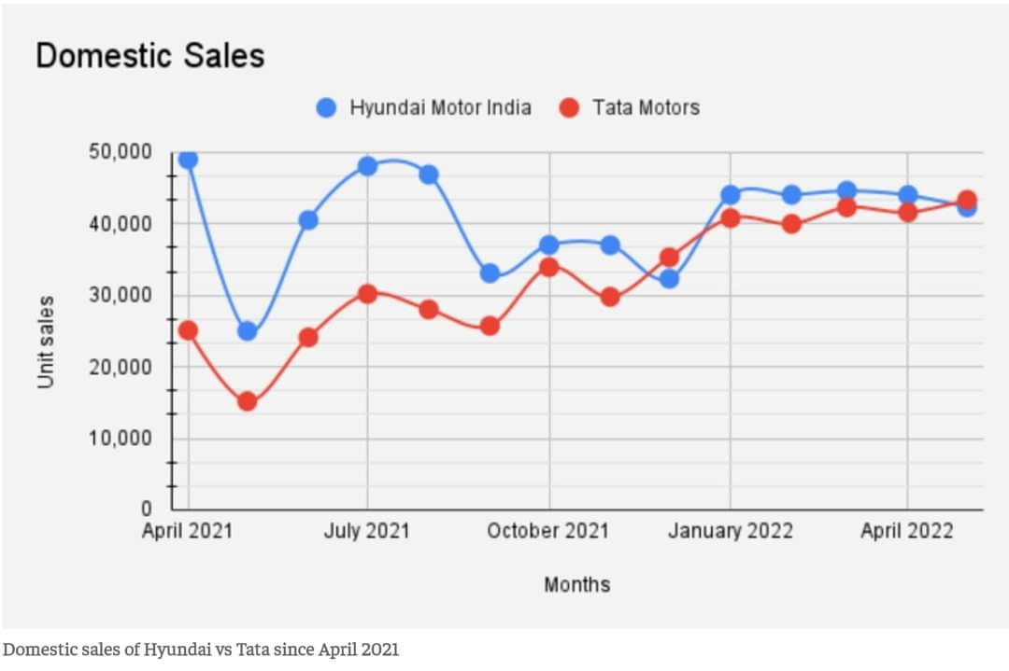

In Financial Year 2022, deals of Tata Nexon grew three-fold assisting its producer with abandoning Hyundai's Creta, to turn into the smash hit Sport Utility Vehicle in the country. This was likewise the initial occasion when a Tata Sport Utility Vehicle turned into the most elevated selling in India.

Tata Motors has as of late sent off the Nexon Max Electric Vehicle with a nearly higher reach, and displayed idea Electric Vehicle models like Curvv and Avinya.

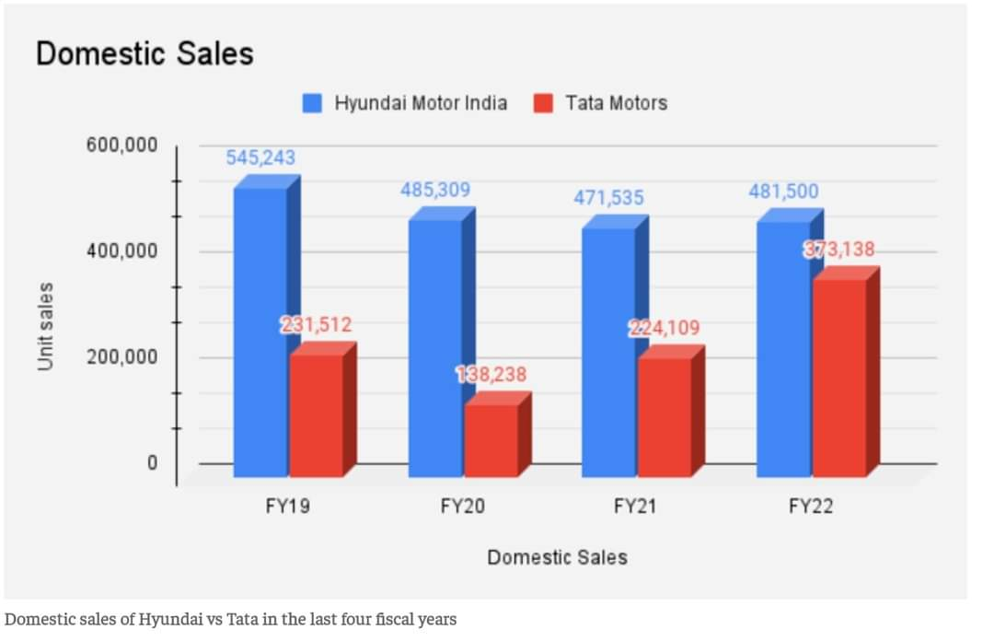

Hyundai also has solid Electric Vehicle plans, but as of now offers just a single model - its top notch Kona Utility Vehicle on the lookout. The organization has planned the launch of its Ioniq 5 Computerised Utility Vehicle this year.

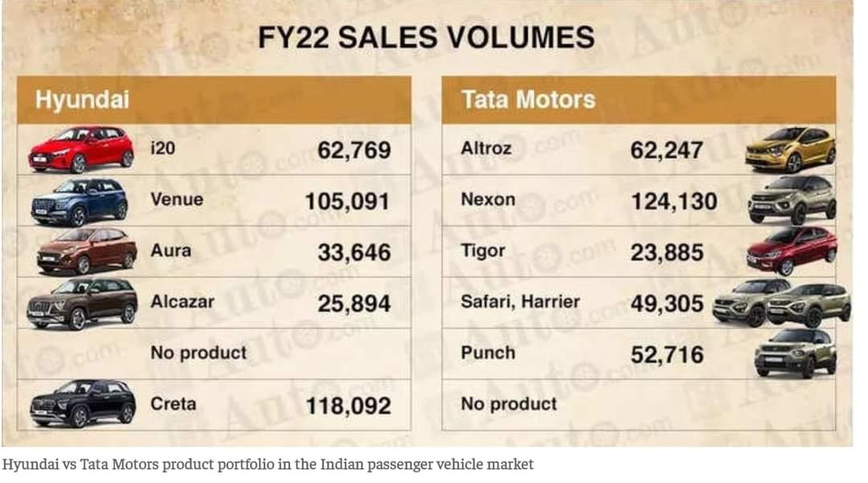

Pushing ahead this financial year, it would be fascinating to watch the new development with new item dispatches and systems to check whether the long lasting through carmaker figures out how to hold fast or the new opponent takes up the number two position by a tempest.

CONCLUSION

In the present cutthroat auto market, Hyundai Motor India has been the undisputed second carmaker in India until December 2021, when Tata Motors appropriated its very much monitored position. Tata Motors repeated the experience in May 2022, however with a slim edge. Economic Times Auto examinations how the leftover long periods of Financial Year 2023 might observer a clash of the Titans for the second space in the problematic Indian vehicle market. Shubhangi Bhatia, Economic Times Auto, New Delhi: The country's biggest carmaker Maruti Suzuki has solidified its crown place in the Indian vehicle market for a really long time. So has the second biggest - Hyundai Motor India. It has been the undisputed second for north of 10 years, until December 2021, when Tata Motors usurped its very much monitored position. Tata Motors repeated the experience in May 2022, however with a thin edge. Consequently the excess long periods of financial year 2023 might observer a clash of the Titans for the second space in the challenging Indian vehicle market. The producer of Creta started financial year 2022 with solid numbers, remaining in front of Tata Motors by around 25,000 units in April 2021. Hyundai kept on keeping up with the lead yet with a restricting distinction until November. In December, with the always developing elements of the vehicle business, Tata Motors overwhelmed the Korean carmaker's Indian auxiliary by around 3000 units, and again in May 2022 by around 1000 units.

REFERENCES
- "Amid lockdown, India switches to BS-VI emission norms". The Hindu. 2 April 2020.
- "Global carmakers Proton, Peugeot, Citroen, Kia shelve India plans due to tough financial conditions - Economic Times". Articles.economictimes.indiatimes.com. 18 March 2013. Retrieved 16 October 2013.
- "Invest in Indian Automobile Industry, Auto Sector Growth Trends". www.investindia.gov.in. Retrieved 8 April 2022.
- "Why Everyone is going below 4-Meters". Spinny Blog. 25 January 2016. Retrieved 19 June 2021.
- Automobile Industry: Unconvincing Explanations". Economic and Political Weekly. Mumbai, India: Sameeksha Trust. Vol: XX, (16): 669. 20 April 1985.
- Bhaktavatsala Rao, C. (1993). "Structural Configurations and Strategic Investments: Indian Automobile Industry". Economic and Political Weekly. Mumbai, India: Sameeksha Trust. 28 (8/9): M21.
- Biswajit Nag et al (2007) “Changing Features of the Automobile Industry in Asia’ A Paper Presented at The Pacific Economic Outlook Specialists Meeting, Osaka.
- Dr.E.Viswanathan., et.al. (2018). Price volatility of the gold commodity using technical analysis with reference to Rayalaseema Bullion Commtrade Pvt Ltd, Chennai City – An analytical Study. International Journal of Mechanical and Production Engineering and Research and Development, pp.423-440. http://www.tjprc.org/downloadcoference_files.php?fname=9e3cfc48eccf81a0d57663e129aef3cb
- Dr.P. Govindasamy; Dr.Kapila Uma Shankar; Mr.R. Ravimohan. "Modeling of dividend payout, retention, yield, capital gains and irrelevance and its impact on value of the firm". Journal of Contemporary Issues in Business and Government, 27, 2, 2021, 5166-5178. doi: 10.47750/cibg.2021.27.02.528.
- Dr.P.Govindasamy, et.al. (2019). Contemporary Contemplation on Integrated Global Financial Climate. International Journal of Recent Technology and Engineering, 8, 186-188. https://www.ijrte.org/wpcontent/uploads/papers/v8i3S2/C10341083S219.pdf
- Dr.P.R.Ramakrishnan., (2020). MARKET MOVEMENTS OF EQUITY AND CURRENCY DERIVATIVES – AN EMPIRICAL ANALYSIS. UGC Care Group-I: Alochana Chakra Journal ISSN: 2231-3990. Vol:IX, Issue: IV., April-2020, pp.3166-3171. http://www.alochanachakra.in/gallery/353-acj-april-1480.pdf
- Dr.Premraj, et.al. (2019). Economic Environment and Investment Climatic Conditions – an empirical study. International Journal of Research in Engineering IT & Social Sciences, 9, 2, pp.9-16. http://indusedu.org/pdfs/IJREISS/IJREISS_2657_93946.pdf
- https://autonoid.com/electric-vehicle-charging-must-be-accessible-for-all/
- https://www.linknovate.com/affiliation/hyundai-motor-india-ltd-7156998/all/
- Kathuria, S (1996). Competition Through The Technology And Manufacturing Strategy A Study Of Indian ,Automobile Industry, New Delhi, Oxford University Press.
- Kathuria, V( 2001). ‘Foreign Firms, Technology Transfer and Knowledge Spillovers to Indian Manufacturing firms: a Stochastic Frontier Analysis’, Applied Economics, 33, 625-642.
- Mondal, Dipak (5 July 2015). "Going Native". Business Today. Retrieved 30 June 2015.
- Mukherjee, Avinandan and Trilochan Sastry. (1996). ‘Recent Developments and Future Prospects in the Indian Automotive Industry’, IMVP Working Paper, Cambridge: Massachusetts Institute of Technology.
- Narayan and Vashisht (2008) conducted a study on “Determinants of Competitiveness of the Indian Auto Industry post liberalization’, Discussion Papers From United Nations University, Institute for New Technologies.
- Narayanan K. (1998a). ‘Technology Acquisition Deregulation and Competitiveness Study of Indian Automobile Industry’, Research Policy, 27(2).217-30.
- NCAER (2003.1) ‘Indian Automobile Industry: Optimism in the Air’, DELHI files.
- P.Govindasamy , Kapila Uma Shankar, “Covid-19 And Global Financial Markets With Special Focus To Gdp Growth Projection, Capital Mobilization And Performance Of Stock Market” Volume XI, Issue VII, 2020, PP No. 1-9
- Rais, Ahlam 2017) "India is the next manufacturing hub for automobiles".pp.123-127 "Automobile Industry in India, Indian Automobile Industry, Sector, Trends, Statistics". www.ibef.org. Retrieved 7 November 2021.
- Robinson, Vaughan (1982). "Motoring for the millions". Autocar, Vol. 156, no. 4459. IPC Business Press Ltd. p. 22. "2020 Statistics | www.oica.net". www.oica.net. Retrieved 15 April 2021.
- The rise of the automobile in free India, Mumbai (Bombay): Autocar Professional India, 2021"An opportunity missed". The Hindu. 9 June 2014. ISSN 0971-751X. Retrieved 3 July 2018

