**Chapter No :- 2**

**EARTH**

|  |
| --- |
| Subunits :  **Origin of Earth** - Gaseous Mass Theory, Nebular hypothesis, The Planetismal theory, Tidal Hypothesis. Inter stellar Dust cloud hypothesis.  **Interior of Earth**- Direct and indirect sources of interior Earth ; Structure and Composition of Interior Earth; Classification of Interior Earth by different Scholar- E.Suess, R.A. Dally, Jeferreys, Arther Holmes, B.Guttenberg and A. Mohorivisic , Vander Gracht.  **Origin of Continents And Ocean Basins And Their Theories :-** Tetrahedral Theory**,** Wegeners continental Theory , Plate Tectonic Theory, Theory of Isostacy |

Unit :- 1

**ORIGIN OF EARTH**

The Earth is an important planet of solar system. It is the only planet which has life and atmosphere. It is also called as watery planet. It is one of the inner or terrestrial planets with a diameter of 12,740 km and lies at an average distance of 149 million km from the Sun. The age of the earth (solar system) is believed to be about 4.7 billion years. It revolves around the Sun in 365.14 days. The origin of the earth is matter of great speculation and discussion. Exact process of her origin has not been known till now. As a member of solar system the process of its origin can be understood in the genesis of the solar system. Different scientists have put forward various theories to explain the origin of the earth (solar system). Hence, a brief knowledge about some facts of solar system is also essential.

**Solar System**

The solar system consists of nine planets, and together with satellites, asteroids and comets revolves around the Sun. Following are some of the important characteristics associated with solar system :

(i) All the planets revolve around the Sun in the same direction in ecliptical or almost circular orbits. Most of their satellites also revolve in the same direction;

(ii) The planets, except venus and uranus, rotate in the same direction as their revolution around the Sun;

(iii) The distance of each planet from the Sun is roughly twice that of next planet closer to the Sun;

(iv) The Sun contributes 99.9 per cent of total mass of solar system but it holds only 1 per cent angular momentum; and

(v) The planets consist of two groups, i.e. (i) terrestrial or inner planets, and (ii) outer or giant planets. Mercury, Venus, Earth and Mars are inner planets and have relatively higher density and smaller sizes while the giant planets include Jupiter, Saturn, Uranus, Naptune and Pluto which are generally of bigger sizes and low density.

**Theories or Hypotheses Regarding the Origin of the Earth**

**Gaseous Mass Theory**

Many theories regarding the origin of solar system have been given by the scientists over the centuries. The modern approach to the problem began in 1755 when the German philosopher Immanuel Kant, developed a theory to explain the origin of the earth on the basis of assumed primeval slowly rotating cloud of gases (called as Nabula) and Newton's law of gravitation and rotation. Kant's hypothesis contains following assumption:

(i) Primordial cold and motionless matter were scattered in the space; (ii) Due to gravitational force of the matters and mutual attraction, sudden motion took place among the matters;

(iii) The collision of matters caused an increase in temperature and with the passage of time, these matters became hot and gaseous rotating mass, now called as Nabula;

(iv) Increase in temperature resulted in expansion of volume and angular velocity of Nabula. Due to angular velocity, the matter from the Equator of Nabula bulged so much that rings began to separate from the gaseous mass due to centrifugal force. After the cooling of mass, rings of planets were formed; and

(v) Remaining part of gaseous Nabula was known as proto-sun. By the repetition of same process many sub-rings were separated from newly formed planets and the materials of each ring condensed to form satellites.

**Criticism**

Kant's gaseous hypothesis was the first scientific explanation of the origin of the earth. But this hypothesis was criticized on two grounds.

(i) He could not explain the source of primodial matters which formed the gaseous mass of cloud (Nabula); and

(ii) He failed to explain the angular momentum adjustment between Sun and its planets. According to the law of conservation of angular momentum, the angular momentum is directly proportional to the mass of the body. Angular momentum of the planets should be lower than the angular momentum of the Sun in the light of Kant's hypothesis. But the present solar system shows opposite arrangement of angular momentum.

**Nabular Hypothesis**

On the basis of earlier work of Kant, the French Scientist Laplace (1794) propounded Nabular hypothesis to explain the origin of the earth (SolarSystem). His hypothesis evoked great interest among the thinkers and Scientists of 19th century. The important features of this theory are given below:

1) There was a hot gaseous nabula rotating in the space.

2) The nabula contracted and shrinked gradually due to cooling effect by radiation of temperature. As the cooling and shrinkage increased, the velocity of rotation of the nabula also increased.

3) The increasing rotation of the nabula, caused bulging at the centre. When the rotation increased to a certain speed, the bulged mass at the equator was separated due to centrifugal force in the form of rings.

4) As cooling and contraction of the nabula continued, additional rings were separated. The first ring gave birth to the farthest planet and later on other planets came into being.

5) Each ring was condensed into planet which was hot and gaseous.

6) The process of cooling caused further contraction of the planets and different rings were separated to form the satellites.

7) The remaining part of nebula became the Sun.

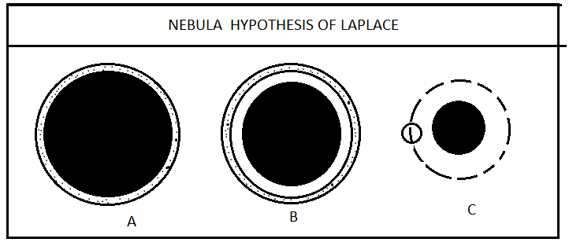

**Criticism**

The Nabular hypothesis was widely accepted during the past century owing to the confirmation of different characteristics of present solar system with the idea developed by Laplace. The merits and demerits of his hypothesis are as follows:

**Merits**

1) All the planets are composed of same elements - because they were derived from a common Nabula.

2) The planets revolve around the sun in same direction, in same plane and in nearly circular orbits.

3) The inner molten and upper solid part of the earth is confirmed by this theory. This explains that planets were formed by cooling of hot gaseous rings separated from Nabula. Thus the upper part became solid and inner remained liquid.

**Demerits**

This hypothesis suffers from a number of shortcomings and does not explain the following facts:

(i) The Sun is in slow rotation but the theory indicated that the contraction of Nabula had caused acceleration in its rotation. Thus, according to this theory, the sun should have rather more speedy rotation after about 4.5 billion years of the origin of solar system; and

(ii) The absence of any kind of equatorial bulge in the sun does not confirm the explanation that due to rotation of Nabula, equatorial bulge was formed and separated in the form of rings to form planets.

**The Planetesimal Hypothesis**

Two American scientists, Chamberlin and Moulton (1900) announced their new theory called Planetesimal hypothesis. In this hypothesis, they attempted to overcome the objections raised against nabular hypothesis. The process of formation of solar system was explained in the following manner:

(i) There was cold proto-sun and an intruding star of considerable size moving in the space;

(ii) The intruding moving star approached the proto-sun and a tidal bulge was caused on the surface of the sun due to gravitational force of the star;

(iii) The ejected mass of the sun was scattered in the form of solid particles around the sun. These particles were called planetesimals;

(iv) The big size of planetesimal was attracted and accreted to form the planets;

(v) The accretion and aggregation of planetesimals caused the phiyps heating of the planets. With the passage of time, size of planets became larger and the increasing gravitational compression of interior produced internal heat of the earth due to colescence of increasing number of planetesimals;

(vi) The gases, held in planetesimals, were given off as the growing earth became heated by internal compression. Thus the atmosphere was formed around the earth; and

(vii) The increasing content of water vapours started to condense due to cooling of the atmosphere and consequently rainfall occurred for a longer time and oceans were formed on the earth.

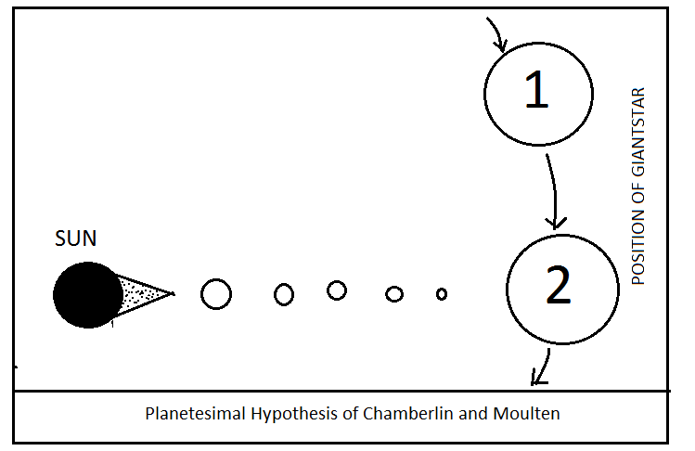

**Criticism**

The Planetesimal Hypothesis tried to explain the origin of earth in a very scientific way but it could remain non-explanatory about following issues posed by scientists.

(i) The formation of planets by accretion and aggregation of planetesimal's nuclei is not able to explain the orderly size of the planet of present solar system. The planets increase up to Jupiter as distance from the Sun decreases. Again, size of planet decreases as distance from the Sun increases;

(ii) The assumption of cold planets and satellites at the beginning is not also confirmed with the present solar system. Some of the planets are still in gaseous and hot state; and

(iii) The geological evidences indicate that the earth was in liquid state in the beginning and the present earth has been evolved through the cooling process. The arrangement of its mass into dense core surrounded by lesser dense matter is against the theory that the evolution of the earth passed through a process of cooling to heating.

**Tidal Hypothesis of Jeans and Jeffreys**

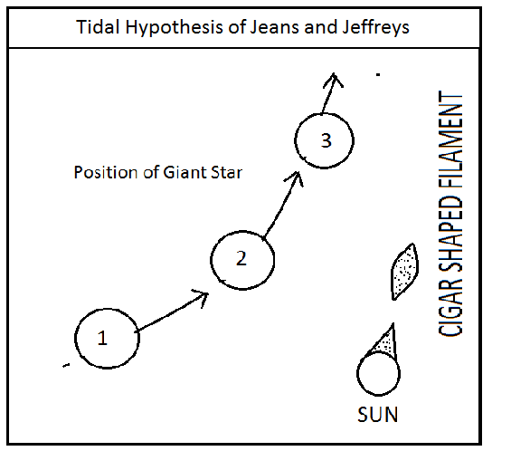

British scientists Jean and Jeffrey (1925) gave a new theory of the origin of the earth, based on the gravitational pull concept of Newton (Fig. 2.3). This hypothesis, explains the origin of the earth (solar system) in the following manner:

(i) There was a hot gaseous sun and an intruding star of larger size. They were rotating on their own orbits;

(ii) The intruding star gradually approached the Sun. Due to attractional force of the star, a tide of hot gaseous mass was formed on the surface of the Sun;

(iii) When the intruding star came close to sun, the tidal bulged portion of the Sun detached in the form of cigar like filament of hot and gaseous material and it moved away with the moving star;

(iv) When the star moved far away from the Sun, the detached filament was once again attracted by the Sun and it started to revolve around the Sun in the form of spiral nabula;

(v) The cooling of filament broke it into masses of different shapes and size which began to contract towards nuclei, which resulted in the formation of planets;

(vi) The tidal bulging again took place among the planets due to the attraction of the Sun and thus satellites were formed; and (vii) Through the gradual cooling of hot and gaseous and satellites, they have been from liquids to finally solids and the gases which remained outside became atmosphere.

**Criticism**

The Tidal hypothesis had gained wide acceptance because it explained the different aspects of present solar system. The arrangement of planets and satellites and the constituents of all the planets have been very well explained by this hypothesis. Some scientists have criticised this theory keeping inview the principles of astronomy. Demerits of this hypothesis are given below.

(i) It is said that there was a tremendous distance between the orbit of the stars and the Sun and therefore the stars could not come so close to produce tide on the Sun's surface;

(ii) Distribution of angular momentum between the planets and the sun was not explained; and

(iii) The temperature of ejected materials should have been extremely high (more than hundreds of thousands degree Celsius) because they had come out from the interior of the Sun. Under such high temperature, condensation of hot gaseous materials in the form of planets would be impossible. Instead, it should have been scattered into hot gaseous materials in the space.

**Otto Schemidst's Inter-Stellar Dust Cloud Hypothesis**

With a view to overcome the criticism of the earlier hypothesis, Otto Schemidst a Russian Scientist (1943) propounded a new theory to explain the origin of the solar system (Fig. 2.4). This latest theory is described as dust cloud theory. The important components of the hypothesis are given below:

i) Dynamic dust and gas particles (Primordial matter) were scattered in the space. These particles were having their own angular momentum:

(ii) Dust particles were attracted towards the sun and they started to revolve around the Sun. The cloud of dust particles changed into form of flat disc revolving around the Sun;

(iii) Due to rotation of disc, redistribution and rearrangement of particles took place according to their size and density. Dense and big particles adjusted in middle and smaller and lighter ones shifted outward sides of the disc

iv) The orbits of particles intersected among themselves and due to coalescence big particles became bigger in size and smaller one were extinct. The big particles became the asteroides; and

(v) Due to continuous accretion of small particles to the asteroids, their size grown up and changed into form of planets. Still some particles, were left which were not accreted in asteroids. These left particles were formed into satellites.

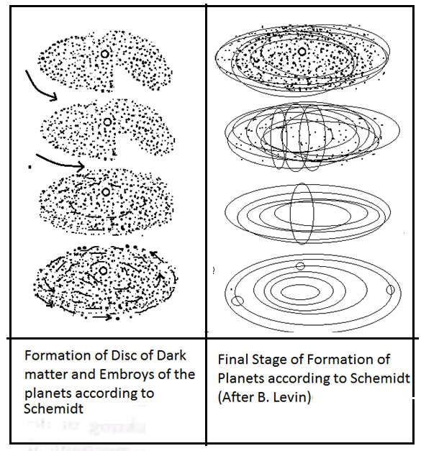

MERITS :

1) The Problem of Angular Momentum Solved: This hypothesis has solved the problem of angular momentum. Since the planets were not formed from the sun, their angular momentum was redistributed while planets cons densed. This explains the high angular momentum of the planets as compared to that of the sun.

2) Two Types of Planets: The planets of our solar system are divided into two classes. The planets closer to sun are known as Inner Planets and are composed of heavy elements such as silver and iron. These include Mercury, Venus, Earth and Mass. The Outer Planets include Jupiter, Saturn, Uranus, Neptun and Pluto. These planets are composed of lighter elements like Hydrogen, Helium, Nitrogen and simple compounds like Methane. Otto Schmidst exaplined that the rays of the sun could not go far into the dise as a result of which the side of the dise facing the sun was having a temperature of 500°C while the side away from the sun was at a very low temperature of -270°C. In between, the temperature was at freezing point (Fig. 2.10).

3) Heavy material was concentrated in high temperature area while lighter elements remained in low temperature area. Thus planets near the sun are heavy while those away from it are light. Distance between planets explained: The vast distance between the planets can be easily explained by this hypothesis because it is assumed that the planets were not formed from the sun. They were rather formed from the dust and gas particles which gathered around the sun. Otto Schmidst applied sta tistical laws to explain it.

4) Motions of the Planets : Plancts are found to be moving in circular orbits around the sun. According to Schmidst, this is due to the attainment of average motion by the particles after collision. This results in motion of the planets in the same direction and in the same plane. Although the orbital plane of the planets makes an angle of 6° with the sun's equator, yet it is the result of free movement of the particles which formed the planets. According to the great scientist See, the circular orbit of the planets is due to the existance of resisting medium around the sun after the planets were formed. The theory of Roche's limit also supports this view.

DEMERITS :

1. No satisfactory explanation of dust and cloud : Schmidst has not giver any satisfactory explanation regarding the origin and source of dust and cloud from which planets are supposed to have originated.
2. Attraction not Explained: It is also not explained why dust and gaecous masses were attracted towards the sun when the stars are located at great distances.

**Criticism**

This hypothesis seems to be a renewal of gaseous Nebula concept of Kant. The order of arrangement, and the variation of composition and density of planets of solar system are well explained in this hypothesis. Lighter and smaller planets are found on either margin (inner and outer) of solar system which shows well conformity with arrangement of consolidated particles in the flat disc around the Sun (Fig. 2.5). The problem of undue distribution of amount of angular momentum of planets and the Sun is also solved because the planets were not from the Sun. Despite of above merits, the theory is also suffering from some problems as given below

(i) This theory could not explain the source of the origin of dust clouds; and

(ii) It explains that the planets were formed by growing size of asteroids and meteorites but some scientists and astronomers believed that asteroids and meteorites were formed due to disintegration of the planets.

Unit No-2

**INTERIOR OF THE EARTH**.

Knowledge regarding the interior of the earth can be gained through the study of density, pressure and temperature conditions as well as by studying the volcanic eruptions and seismology (Science of earthquakes).

Density, pressure and temperature are called indirect sources where as volcanic eruption and seismology are called direct sources. Man has explored more about the space than the interior of the earth. The direct knowledge of man regarding the structure of the earth is limited only to the deepest mines which is about 6000 meter compared to the mass of the earth the direct knowledge of man about its interior is negligible. some petroleum wells are drilled only upto a depth of 6 to 7 Kms. so the knowledge about the earth’s interior structure to a large extent is depending on indirect evidences. These evidences are behavior of earthquake waves, temperature, pressure inside the earth, density of its different layers and evidence of the meteorites.

1. **Interior Temperature-**

The evidence of volcanic erruption & hot springs indicates that high temperature prevails in the interior of the earth. The Interior temperature is 1˚c for 32 meter depth. But this ascent rate of temperature is not uniform at every depth. Generally upto 100 km depth, this ascent rate of change of temperature is 12˚C per kilometer. In between 100 to 400 km depth, it is 2˚C per kilometer while beyond the 400 km depth it may be 1˚C/km. According to this rate & calculation, it is estimated that the actual temperature at the core of the earth would be 2500˚C. The interior temperature at various depth as below-

|  |  |
| --- | --- |
| Depth.(km) | Temperature (C˚) |
| 30 | 500˚C |
| 200 | 1400 |
| 1000 | 1700 |
| 3000 | 2300 |
| 6000 | 2500 |

The interior temperature is goes on increasing with depth due to the following factors- i)***Presence of Radio-active material***.

Much of the radio- active materials like natural Uranium, Thorium, Plutonium etc are present in the interior of the earth at different levels of depth. These all materials radiates a tremendous heat through their nuclear atomic fission process. Due to this continuous radiating heat, the temperature with its surrounding rocks may be increases .

ii**) *Geo-thermal Energy***-

It is the trapped heat inside the earth earth when the earth was begin to be cool and its only outer surface become cold & come in the solid state while its mantle and core are being so hot that much of energy flows towards the earth surface. This energy is known as geo-thermal energy because it creates in the interior of the earth from itself.

iii) ***Chemical reactions in between earthmaterials***.

In the interior of earth, much of chemical elements are present. Due to excessive heats, or incumbent pressure, some elements are /was takes place in the chemical characteristics have had been changed. at that time, much of energy is released through their chemical reaction and therefore interior temperature of the earth goes on increasing.

1. **Pressure** –

Along with rising temperature with depth, the pressure of overlying rocks are also increasing with descent due to increasing weight of superincumbent rocks. on the earth surface, at mean sea level (MSL)the atmospheric pressure is 1kg/cm2 or 1013.2mb which is known as one atmospheric pressure. But in the interior of the earth, the weight of overlying rocks goes on increasing with its depth ,therefore this interior pressure would be increased with depth.

At the base of the crust i.e. at a depth of 50 km, the pressure is 13,000 times the atmospheric pressure existing on the surface of the earth. In this way, square centimeter of the rock area at this to depth has to bear a weight of 13 tonnes. At 2900 km depths, the pressure is 13,00000 times the atmospheric pressure and it reaches 3500000 to 40,00000 times the atmospheric pressure at the core.

If the temperature of the interior core is very high, upto 2500˚c, the country rocks are not melted down at their normal melting point which is lower than this prevailing temperature. That is why, an incumbent pressure rises their melting point above that prevailing interior temperature. Hence the internal core has been found in the solid state.

1. **Density-**

Density of substance is expressed in terms of gm/cm3 It is the ratio of tatal mass in one cubic centimeter volume. The average density of the rocks on the earth surface is 2.67 gm/cm3. The outer crust of the earth is made up of continents. These continents are mainly composed of sedimentary rocks having a density of 2.7 gm/ ${cm}^{3}$. Below these sedimentary rocks, are the igneous rocks are also available at the surface of the several places & most of the old shields are made up to igneous rocks. According to Newton’s law of Gravitation the density of the inside the earth should be very high. However, the density remains at low of 3.5gm/cm3 at 2900 km depth. After this, the density suddenly increases and rises upto 9.7gm/cm3. Beyond this depth, there is a ground increase in density upto 5000km depth where it again suddenly rises and reaches a high of 11 to 12 at the core.

Density at various depth & layer as below-

|  |  |  |  |
| --- | --- | --- | --- |
| **Density Variation in Interior Earth** | | | |
| **Name of Layer** | **Sub layer** | **Extent** | **Density (gm/cm3)** |
| Lithosphere  (Crust) | Sial  ***Conrad Discontinuity***  Sima | 0 to 60  ***Transition Zone in between Sial & Sima*** | 2.75-2.90  2.90-3.30 |
| Mantle | Upper mantle Lower mantle  ***Guttenberg Discontinuity*** | 60 - 700 km  700-2900km  ***Transition Zone in between mantle & core*** | 3.3 to 4.3  4.3 to 5.5  ***Suddenly changes from 5.5 to 10.0*** |
| Core | Outer core  Inner core | 2900-5150 km  5150-6400 km | 10.0 to 12.3  12.3 to 13.6 |

D)**Earthquake waves.**

Earthquake waves originates from the focus of the earthquake. These waves are also source of knowledge about the interior of the earth as they travel inside earth through different passage. The earthquake movement originate three types of waves in the interior of the earth.

They are i) Longitudinal waves (primary waves)-power

ii)Transverse waves/Secondary waves=S.waves

iii)Long waves /Surface waves L-waves.

i) ***Longitudinal waves -***

These waves are also known as primary waves because it reaches on the earth surface initially. It is marked by the word “P” These are like of sound waves. They are also called as ***push waves*** because the direction of movement & the direction of oscillation of the particles are same in these waves. They travel at the very fast rates into the interior of the earth. Its velocity at the depth of 100 km is about 8km /sec and increases upto about 13km/sec at 2900 km depth. These waves passes through all medias i.e. solid, liquid and gaseous media. Due to this reason, these waves can reach easily on antipodal of the epicentre where first shock felts.

ii)***Transverse Waves***   
 These waves are called secondary waves because they reaches on the earth surface after primary waves. It is marked by the word “S”. These earthquake waves are like of the light waves in which the motion of particles is takes place at the right angle to the direction of its movement. The speed of these waves is always half of the primary waves. i.e their speed is in between 3.2 to 6.0 km/sec. These waves are more destructive as compared to primary waves. These waves can passes through solid medias only and therefore it cannot passes into the inner core beyond the outer core which is made of mixed liquid & solid states material.

iii)***Long waves.***

These long waves are called as surface waves because they travels along the earth’s surface between the solid, liquid and gaseous media. They do not go deep into earth & revolves around the earth. They have a very low velocity. It may be divided into two categories i.e. i) Rayleigh and ii) Love waves. It is marked by the word “L” waves. These waves are more destructive than the secondary waves.

**Seismology**- It is the scientific study & interpretation of earthquakes.

**Shadow zone of Earthquake waves.**

It is specific restricted zone, lies in between 103˚to 148˚from the normal line of epicentre, in which the primary & secondary waves are/was not reached on that earth surface. That means it is safe from any type of destruction. This is why primary waves are reflected or diverts from their original path of propagation when they enters in liquid outer core-And secondary waves are not passes through that media.

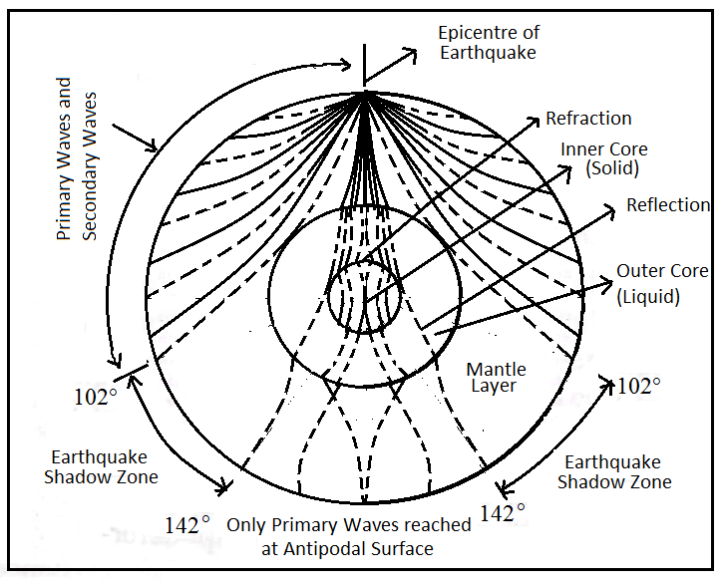

**STRUCTURE & COMPOSITION OF THE INTERIOR OF THE EARTH.**

The radius of the earth is 6371km. The earth from surface to its centre has been divided into following three layers viz i) crust /lithosphere ii) Mantle and iii) core

**CRUST/LITHOSPERE**

The outermost solid state layer of the earth is known as crust It lies below the earth surface capped by new sedimentary rocks upto 8km depth. About 29% area of the crust is covered by land surface while remaining 71% area is covered by waterbodies. These land surfaces is known as continents and water bodies is termed as ‘oceans’ The thickness of the crust is not constant, but it is variable between 16to 40km. The average depth of the crust is considered as 33km At the bottom of the mountain ranges, the depth of crust is more than 40 to 90 km. and below the oceans it is less than 10km Its average density varies between 2.75 to 2.90 gm/cm3.

Lithosphere comprising of two layer i.e. SIAL & SIMA.

1. **SIAL**-Chemically, it is formed mainly silica and Aluminum elements. Generally the upper layer of the crust is termed as SIAL. Its density is laying in between 2.65 to 2.77gm/cm3. Its thickness below the continent is upto 29km. Generally the continents are situated on the SIAL. Acidic rocks like granite and sedimentary rocks are found in that SILA at that speed of 5.6km/sec and secondary waves are 3.2 km/sec.

***Conrad Discontinuity***-

The SIAL layer is separated from SIMA layer by a transist zone which is known as conrad Discontinuity. Here the speed of primary & secondary waves are considerably increased but to the sudden change of its density.

1. **SIMA**: - The lower layer of the crust is known as SIMA. Chemically it is formed by mainly silica and magnesium. Generally the ocean floors are made up of SIMA. At the bottom of the ocean floor its thickness is 3 to5 km only and at the bottom of continental base, its thickness is 11to13km. Its density is lies in between 2.85to3.3gm/cm3.Generally gabbros typed basaltic rocks are found in that SIMA. The speed of primary waves is 6 to7.2km/sec and secondary waves is 3to4km/sec in the SIMA.

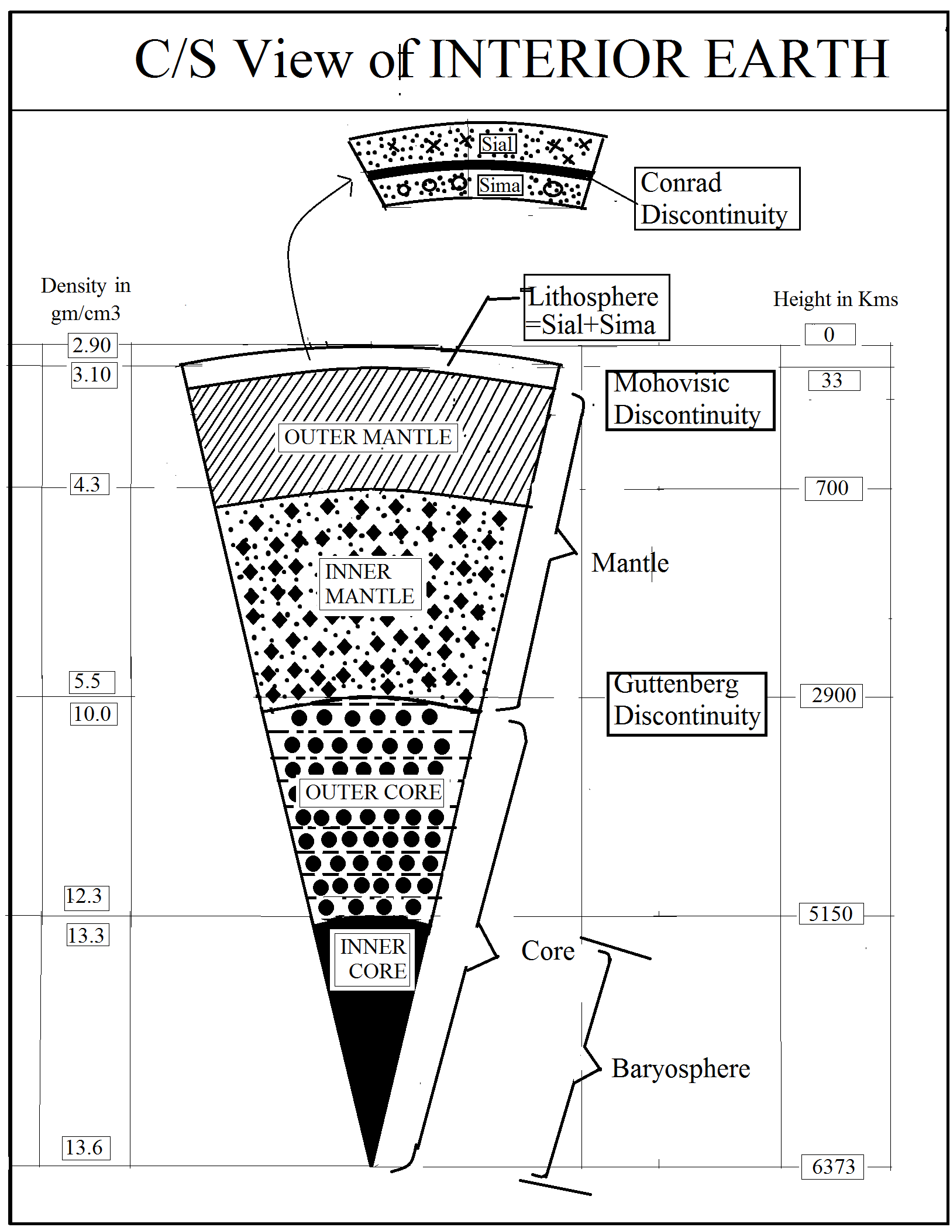

1. **MANTLE (Pyrosphere/substratum.)**

***Moho Discontinuity :***- The boundary which separates the crust from the mantle is called MOHO or Mohovisic discontinuity. It is found at the 100 km depth from earth surface. Here the speed of primary & secondary waves are suddenly changes due to changing in density.

Mantle-The layer which is lies in between uppermost crust and underlying core, is known as mantle. The thickness of the mantle is 2865km that it extends from 33kmto 2900km depth. Mantle is formed by heavier materials like silica and magnesium. Its density varies between 3.1 to 5.5gm/cm3.As a whole earth, it occupies 68% of the mass of the earth and 83% of its volume It has been divided into two layers i.e. upper mantle and lower mantle.

1. **Upper Mantle :**- In the interior of the earth, it extends from 42 Km to the 700 Km depth. Its density varies between 3.1to 4.75gm /cm3. It is composed of partly silica & aluminum and these are basic in nature. In this layer some rocks are in solid form and some in plastic nature or close to the melting point. According to the some scholars, the endogenic eruption, formation of magma, the continental drifting are closely related to this layer.
2. **Lower mantle :**- The lower mantle extends in between 700 km to2900km depth. It is the transitional zone of mixed metal and silicates. Its density varies between 4.75 to 5.5gm/cm3 It contains ultra basic rocks.
3. **CORE/BARYOSPHERE**:

***Guttenberg Discontinuity***: - It is the transitional zone in which core is separated from the mantle, is known as Guttenberg Discontinuity. Here it is called as Nife. (Nickel & Ferrous)Its density varies between 5 to13gm/cm3. As a whole earth, core occupies 32%mass of the earth and 16% of its volume. It can be divided into two sub layers i.e. outer core & inner core.

1. **Outer metallic core**-: The outer core extends between 2900km to 5150km depth. The density of the outer core is 10.0 near the Guttenberg discontinuity and 12.3 gm/cm3 near the inner core. This layer is in the liquid form. Hence the secondary waves are not passed through that zone.
2. **Inner metallic core**-: The inner metallic core extends from 5150km to the centre of the earth. It is formed of heavy metallic materials and it is in solid state. It is also known as Baryosphere. Its density varies between 12.3to13.6gm/cm3.

***Classification of Interior Earth according to different Scholar***

**A) SUESS**

Suess was a great Austrian geologist who expressed his view regarding the chemical composition of the earth. He proposed that the outermost part of the earth is made up of sedimentary rocks. It is a very thin layer whose density is very low. Below this outermost layer are three layers as below

1. SIAL- Below the sedimentary rocks, is alayer primarily made up of Silica (Si) and Aluminum(Al) and is known as SIAL (Si+ Al). its average depth varies from 50 to 3000 Km. and its density is 2.75 to 2.90. Sial is lighter than the underlying layer sima and floats over it.
2. SIMA_ Below the SIAL is another layer mainly composed of Silica and Magnesium (Ma). Therefore, it is known as SIMA (Si+Ma) . Its depth varies from 1000 to 2900 km. and its density is 2.90 to 4.75 gm/ ${cm}^{3}$.
3. NIFE – The third layer extends from 2900 km depth to the centre of the earth. It is mainly composed of Nickel (Ni) and Ferrous (Fe) and is known as NIFE (Ni+Fe). Its density varies from 11 to 12 gm/ ${cm}^{3}$.

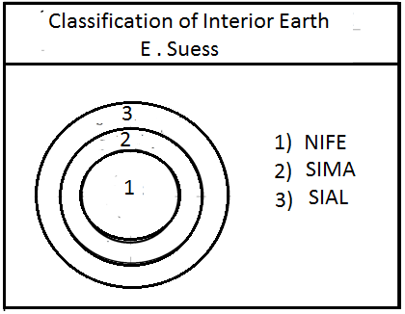

**B) R.A. DALLY**:-

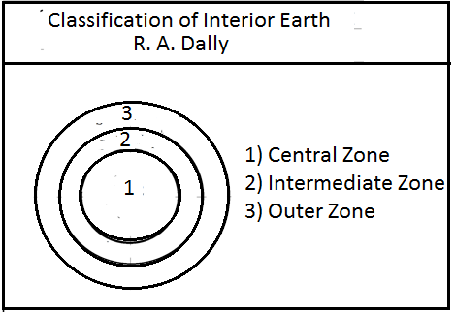

R.A. Dally divided the earth into 4 divisions as below

i) Lithosphere :- This is the outermost cover of the earth which extends upto 80 Km. This is mainly composed of sedimentary rocks.

ii) Asthenosphere :- It is a soft and found in between 80Km to 360 Km.

iii)Mesosphere :- This is comparatively rigid and found in between 360Km to 2400 Km.

iv)Centrosphere :- This is most rigid and crystalline. It extends from 2400 Km upto the centre of the earth

1. **JEFFEREYS** :-

Jeffrey’s divided the earth into four parts on the basis of of his study of the earthquake waves .

i) First or Outer Layer is composed of sedimentary rocks.

ii) The Second Layer has mainly granite.

iii)The Third Layer is made up of thickilite and diorite.

iv)The Fourth Layer is the innermost layer and is composed of dunite, peridolite etc.

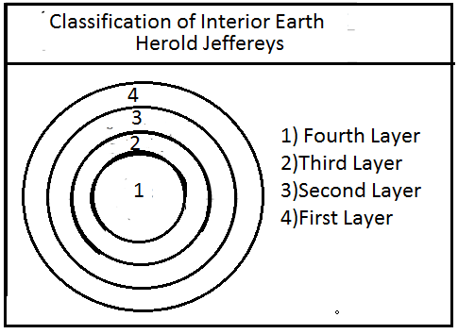

1. **ARTHUR HOLMES** :-

Arthur Holmes has divided the entire earth into two broad divisions.

i) Crust- It includes the whole of Sial and upper part of Sima

ii)Substratum:- This includes the lower part of Sima and the whole of core of the earth.

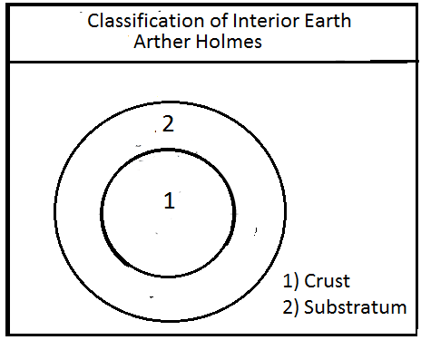

1. **B.GUTTENBERG AND A. MOHOROVISIC (1951) :-**

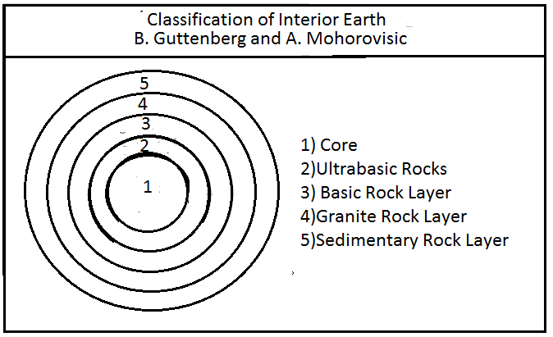

Guttenberg and Mohorovicis divided the earth into five layers described as follows :

i) Sedimentary layer :- This is the outermost layer and is made up of sedimentary rocks.

ii) Granite Rocks :- Continents are mainly composed of granite rocks. These rocks are negligibly small in oceans.

The crust is composed of sedimentary as well as granite rocks.

iii) Basic rocks :- These basic rocks are found in the crust as well as in the mantle. It was discovered by Mohorovicis and it is known as ‘Moho’ after his name.

iv) Ultra basic rocks :- The proportion of silicon rocks decreases with depth and ultrabasic rocks are found there. This layer was discovered by Guttenberg and is known as “Guttenberg layer” after his name. The thickness of the mantle is estimated to be 2900 Km.

v)Core :- This core extends for a distance of 3460 km from the centre of the earth.

The inner part of the earth upto 1400 km from its centre is known as inner core. Its estimated density is 17 gm/ ${cm}^{3}$.

**F) VANDER GRACHT** :-

Vander Gracht , more or less followed the idea of Gutenberg and divided the earth into following four parts.

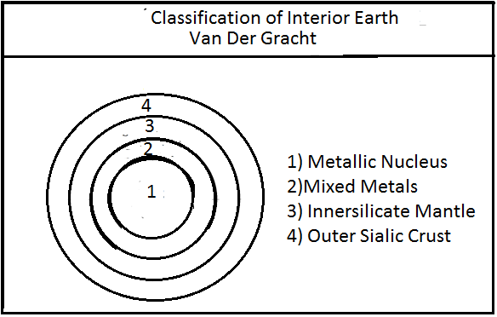

1. External Sial Layer :- Total thickness of External Sial Layer is 60 Km below the continent which is composed of mainly Silicon and Aluminum. Its density is varies 2.75 to 2.90 gm/ ${cm}^{3}$.
2. Internal Sial Layer (Its lower part is Sima):- It extends from 60 to 1200 Km and mainly composed of silicon and magnesium. Its density varies 3.1 to 4.75 gm/ ${cm}^{3}$.
3. Mixed Layer ( Pollosite) :- It extends from 1200 to 2900 Km and composed from oxygen, silicon, magnesium and heavy mixture of iron and nickel elements.
4. Nucleous :- Its extends from 2900 Km to the centre of earth. It is mainly composed of Nickel and iron. Its density varies from 7.8 to 11.0 gm/ ${cm}^{3}$

Unit No 3

**ORIGIN OF CONTINENTS AND OCEAN BASINS AND THEIR THEORIES**

After the cooling of the hot gaseous earth, the continents and the oceans came into being at first time on the earth surface. These land features are considered as first order land forms. The cause of their genesis is very much puzzled and complex. Numerous explanations and ideas have given by different scientists from time to time in the past. The present natures of earth surface, i.e. distribution of land and water and their appearance etc. have been much accounted in explaining any theory regarding the origin of continents and ocean basins.

**Features of Earth Surface**

The general outlook of present earth surface indicates the following important features:

(i) Land and water are unequally distributed on the earth surface. 28.80% (nearly 29 %) area of the earth is covered by land rather than 71.20% (nearly 71 %) by water. Generally Land bodies are known as continents and water bodies are oceans. There are 06 continents (geomorhologically view) present in the world viz North America, South America, Africa, Eurasia (Europe + Asia including Russia), Australia and Antarctica. There are four oceans present in the world viz Atlantic ocean, Indian ocean, Pacific ocean and Arctic ocean

(ii) Predomination of land in the northern hemisphere and of water in the southern hemisphere is the striking feature of the world.

(iii) Both the continents and oceans are assumed to have roughly triangular shape in their locations. Continents have their bases in the north and their apices in the south whereas the oceans show their bases in the south and apices in the north. Antarctica and Australia are having exception and they do not follow the rule of triangles. The north pole is surrounded by water, i.e. Arctic ocean. While the south pole is surrounded by land i.e. Antarctica continent. The Pacific is the largest ocean which covers about 2/3rd of ocean area of the world; and

(iv) The continents and oceans show antipodal arrangement. All the landmass, irrespective of any size, is diametrically opposite to an ocean. Patogonia and New Zealand are only two exceptions. The former is opposite to part of North China and the latter is opposite to Iberian Peninsula.

Keeping in view all these above discussed points regarding the earth, the following theories have been discussed to understand the origin of the continents and oceans on the globe.

(i) Tetrahedral theory (ii) Wegner's Continental drift theory (iii) Plate Tectonic theory

**Unit 3 A**

**Tetrahedral Theory**

In 1875 Lowthian Green propounded a theory to explain the origin of continents and oceans with the help of a geometrical design of tetrahedron. Tetrahedron is a shape which is formed by combination of four triangles. He developed his theory on the basis of following two assumptions.

(i) A sphere is that body which contains the largest volume with respect to surface area; and

(ii) A tetrahedron is that body which contains least volume with respect to surface area.

After making various experience, he assumed that if the forces from all directions are put on a spherical body, it would collapse and change into tetrahedral form. He came on conclusion after crushing a wrought iron tube through the experiment. This experience, he applied to the earth. He thought that various forces, used on the earth planet to contract it, would cause the collapse of spherical surface of the earth into tetrahedral form. As tetrahedron is the body formed by uniting four equilateral triangles in such a way that three are set on three edges of one triangle. The faces are planes and opposite to the coign on apex of the triangle. Thus after applying this idea to the earth, he tried to explain to antipodal arrangement of land and water surface.

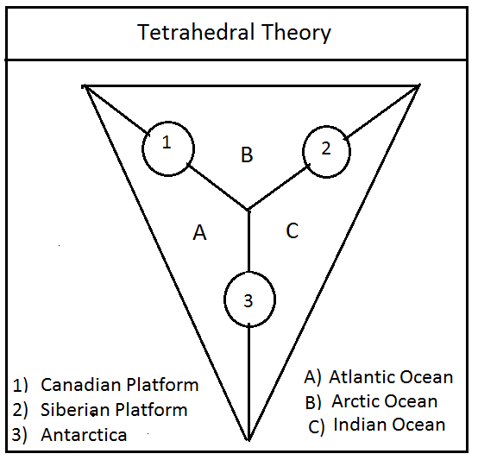

Following derivations have been made in the light of the theory, regarding the earth surface.

1. All the apices and coigns have represented to the continents (lands) and faces or planes to the oceans (Water) because if a Tetrahedron is drowned in water, the wedge or coign will be out of water and faces under the water;

2) The three important shields Laurentian, Siberian and Baltic are represented by northern edges of tetrahedron while the Antarctic coinsides with the apex in the south. The topmost face of it assumed as Arctic whereas other three faces are represented by Pacific, Atlantic and Indian Ocean.

**Merits of Theory**

The Tetrahedron theory of Lowthian Green, now-a-days, is having very few supporters but it will not be irrelevent to consider its main implication as it serves to focus attention on some important points in the earth's surface structure. The following facts support the validity of the theory.

(i) The arrangement of lands on coigns and waters on the faces of tetrahedron is well corresponding into the antipodal arrangement of land and water on the earth surface. Americas lie opposite to Indian ocean, Asia and Australia are on opposite of Atlantic Ocean, and Europe and Africa are antipodal to Pacific ocean;

(ii) Extension and position of continents and oceans in tetrahedron are in triangular shape. Continents or shields of landmass taper southwards and the oceans towards north. Such features are very much coincidence to the present geometrical shape of the continents and oceans in the world; and

(iii) The domination of land area in northern part of the tetrahedron clearly varifies the unequal hemispherical distribution of land and water on the earth surface.

**Demerits of Theory**

The tetrahedral theory is criticized on the basis of two following demerits:

(i) The speed of rotation of the earth is more enough than to counterbalance the tendency of tetrahedral earth. Thus it is believed that the assumption of change of spherical globe into tetrahedral form is of little significance; and

(ii) It is also very difficult to believe that the spherical earth with complex structure would have been contracted into tetrahedral form.

Unit 3 B

**Wegener’s Continental Drift Theory**

Introduction to the present conditions of the earth surface.

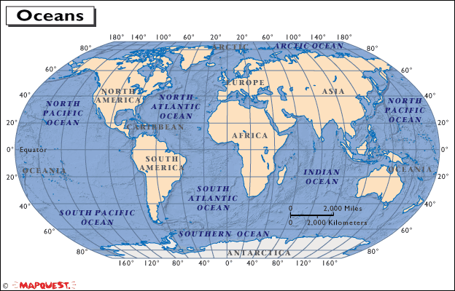

The general outlook of earthsurface indicates the following important features

**CHARACTERSTICS OF LAND & WATER DISTRIBUTION ON EARTH SURFACE**

1. Land and water are unequally distributed on the earth surface. About 28.80% (29%)area of the earth is covered by the land surface which are known as continents while remaining 70.20(71%) percent area of the earth is covered by water bodies which are known as oceans.

2. More of the land area is covered in northern hemisphere (known as Land –hemisphere) where as most of the southern hemisphere is covered with water bodies (known as Water hemisphere).

3. Almost all the continents, except Antarctica & Australia, are triangular in shape with their base in the north and their apex pointing towards the south.

4. Most of the oceans are also triangular in shape whose base is in the south and apex in the north.

5. North pole is surrounded by the Arctic ocean while south pole is surrounded by Antarctica continent.

6. The continents and oceans show antipodal arrangement. All the landmass, irrespective to any size is diamertically opposite to an ocean. Patogonia and New Zealand are only two exception. Patogonia is opposite to part of North china & New Zealand is opposite to lberian peninsula.

**WEGENER’S THEORY OF CONTINENTAL DRIFT**.

**Introduction**-

Wegener, a German scientist(Austrian), propounded his theory of continental Drift in 1912. It went almost unnoticed due World War-I (1914-1918).The second edition of the theory was issued in 1922. Its english version in 1924 attracted world wide attention.

In this theory , he tried to explain the present distribution of continents and oceans which came out as a result of drifting of continental masses into different parts, in different directions and in different periods of geological time. He was basically meterorolgist &developed this hypothesis on the basis of study of paleo-climatologist, paleo-botanist, and paleo-physists regarding the evolution of the earth.

***Aim of the theory***:-

Professor Alfred Wegener was primarily a meteorologist was interested in knowing the changes in the ancient climates. He come across many evidences which indicate that there have been climatic changes in the past. The evidence of coal deposits in Antarctica continent indicates that the landmass was hot in the past. Today it is the largest ice covered area on the earth. Similarly , there are signs of glaciations in peninsular India where there are tropical climates today. Signs of carboniferous ice age are also available in south America, Africa and Australia. All these areas have hot climate at present. These climatic changes can be explained on the basis of two possibilities.

1. The loss of sun’s control -The sun might have lost control over the climate regions and led to changes in climates.
2. Climatic zones remained stable & continents drifted.

Wegener did not find any evidence to prove that the climatic zones changed. thus he based his theory on the idea of continental Drift.

**Concepts of Theory.**

Alfred Wegener started his theory following the “Suess’ classification of interior of the earth. He believed that SIAL is the outerpart of the earth and SIMA is lower layer which underlies SIAL. He thought that continents are made up of SIAL and oceans are made up of SIMA. The density of SIMA is comparatively more than SIAL. The density of SIMA is compartively more than SIAL. so he assumed that continents (sial) are floating in SIMA.

The main components of this theory are as given below.

1. All the present continents –N. America, S. America, Africa, ,Europe, Asia & Antarctica were joined together into one super continent during Paleozoic (primary) geological period and it was surrounded by deep ocean. Wegener called this super continent or bigger landmass as ***Pangea*** and the deep ocean as ***Panthalasa.***

*** ***

1. During the carboniferous period.(200million yers ago)the ***Pangea*** was broken up into two landmasses and moved north and south directions. The northern block is called as ***Laurentia*** or ***Angara land*** while the southern landmass is called as ***Gondwana land*** .In  ***Laurentia*** landmass, North America continent, Europe continent, & Asia continents were present in Gondwana land, Australia continent, Africa continent , S. America continent, Antarctica continent & peninsular portion of India were present and joined together. Between these two blocks of landmasses, a depression was formed. After filled with surrounding water it was called as ***Tethys*** sea. At present Mediterranean sea is the relict (or remaining part) of the Tethys sea.
2. During Mesozoic times, a westward movement of continental masses took place under influence of tidal force of the oceans due to attraction of the sun and the moon on the earth. Thus North America from Angara land and south America from Gondwanaland drifted westwards and Atlantic ocean was formed between America and Europe - Africa continents.
3. During the tertiary times, peninsular India, Australia, and Madagascar were separated from the Antarctica continent and moved away to northwards equator wards). Indian ocean came into being after northward drifting of peninsular India.
4. Wegener has also presented the mechanism of mountain building in his theory. Alpine range (Alps) of mountain between Europe and Africa, Rockies Range of N America and Andres range of south America have been formed due to crumpling/folding of the edges of drifting continental masses by resistance exerted by rocks of the sea floors.
5. The drifting of landmass has been the cause of formation of a number of island arcs & festoons in Pacific ocean & Atlantic ocean. Sakhalin, Japan, Kurile and East Indies have been formed in pacific ocean from Asia continent’s westward drifting. West Indies are have been formed in Atlantic ocean due to westward drifting of America continents eastern margin.
6. Wegener believed that Africa has been the most stable landmass through out the history of the earth. According to him, “All movements are relative, and are made relative to Africa.”
7. Another important element of Wegener’s continental Drift theory is the shifting of the position of the poles and equators. Wegener has suggested that the poles have been assumed not always to be in the same places relative to the continental masses. The North pole in the *salurian* period was in lat 14˚N & Long 124˚W; in the *carboniferous* period in Lat 16˚N, Long147˚W in the *tertiary* period in Lat 51˚N, Long153˚W.The south pole and equator obviously moved into accordant positions.

**CRITICISM OF WEGENER’S THEORY.**

**Points in Favour of the theroy. OR Evidences/supports**

1. **Jig saw Fit-**

Jig-Saw-Fit is the most important element of Wegener’s Theory. The east and west coasts the of the Atlantic ocean are best examples of jig-saw-fit. If all the present landmasses are brought together they would be approximately represented as **Pangea**. For example the eastern coast of Atlantic can be refitted with the western coast. Australia can be refitted in the bay of Bengal The bulge of Brazil can be refitted in the Gulf of Guinea. The North American coastline would closely fit in the indentations of the west of Scandinavia & western Europe. In the same way the bulge of Ethiopia and Eretria on the coast of Africa may fit in the curve of coastline of western India and Pakistan (Scandinavia- A group of Norway .Sweden and Finland)

1. **Geological correlation**-

The similarity of structure , lithology. flora &Fauna & minerals along the both coast of South Atlantic ocean are important evidence of the Wegener’s continental drift theory.

1. **Young fold Mountains**-

The formation and distribution of young fold mountains is also in accordance with Wegener’s continental Drift theory. Rockies & Andes formed due to westward drift of the Americas. Similarly Himalayas, Alps and Atlas mountains were formed due to folding in the sediments of Tethys sea which was the result of coming closer of Laurentia and Gondwana land.

1. **Carboniferous Glaciations**:-

The marks of ice- -sheet spreading and glaciations in Africa, Indian peninsula, Australia, south America in present tropical region indicate that they were drifted from landmass which was under glaciations during carboniferous period-about 30 crore years ago.

1. **Evidence of Botany :-**

Wegener explained the distribution of some vegetation on the basis of his continental drift theory. For example, a glossopteris vegetation (species) is found is the carboniferous rocks of India, Australia, South Africa, South America, Falkland islands & Antarctica etc. The presence of such vegetation on that region indicates that all these lands were once united.

1. **Geodetic survey**:-

Geodetic survey has shown that the Greenland is drifting westward at a rate 6cm per year . This fact also supports the theory of Wegener.

1. **Old mountain ranges**:-

The Caledonian and Hercynian mountain told of eastern coast of North America and western coast of Europe are the some range extending across the Atlantic ocean. such continuation of mountains of same period proved that once both sides were united.

1. **Distribution of Coal**:-

Most of the present coal deposits of the world are found in Europe. Coal has been formed by the decay and decomposition of carboniferous vegetation. The present climate in these areas does not indicate such luxuriant growth of vegetation as to the converted into vast quantities of coal. Wegener explained that the carboniferous equator passed through these areas and there was tropical climate. Hence thick growth of vegetation and formation of coal.

**Points against the Theory**:-

Despite of many geological & geographical supports to the continental drift theory of wegener, a number of the continental drift theory of wegener, a number of objections against it have been raised by scientist the objections against this theory are given below-

1. ***Fault in Jig saw fit-(Misfitting in Jig saw fit)***

Wegener’s best argument is said to the jigsaw fit, but many scientists have found fault with it. Their view is that only partially true. Even the Brazilian bulge can be not completely fit in the Gulf of Guinea, the northern and eastern arms of the Brazilian bulge and those of Gulf of Guinea differ by at angle of 15˚.

1. ***Distribution of continents***:-

Wegener said that one of drift of the continents was equatorqards. It this is true, the largest concentration of the continents at the equator. But this not so.

Wegener explained in his theory that North America and South America continents were broken from each other from their former landmasses in Carboniferous period, but now American plates is unity.

1. ***Inadequacy of forces***-

The worst criticism of Wegener’s continental drift theory is regarding the forces of drift. In his theory. he assumed two types of forces which are completely responsible for the movement of continental landmass towards equatorwards and westwards directions. Wegener said that the westward drift of N. America& S. America continent took place due to the tidal forces of sun and the moon. But some scientists are doubtful about these tidal forces. They viewed that the tidal forces of the sun & the moon invoked (stated) by Wegener, have not been sufficient to cause drifting apart of continents. It required 10,000 million times more than the present gravitational force. If it was so, the rotation of the earth would have been completely ceased (stopped) for one year. But there is no any evidence available of complete ceasing (stopping) of the earth’s rotation. so this theory is not capable to explain briefly about the such invoked tidal force which was responsible for westward drifting of continental masses.

Wegener state that the equator wards movement/drift of continental blocks takes place due to the differential force between the gravitational force and buoyancy force of moving landmass. The value of these two forces are maximum at 45˚Latitudes only, but even here its value is only about 2 or 3 millionth part of gravity. Such this differential force is not sufficient /capable for equator ward movement of landmasses. so this Wegener’s continental drift theory does not like a real fact.

1. ***Objection regarding Botany***.

The scientist P.Lake has objected to the evidence of glossopteris given by Wegener. He says that this vegetation is found widely in Kashmir, Northwest Afghanistan, North .East lran, Turquin and Siberia. Wegener’s hypothesis does not justify this distribution.

1. ***Objection regarding fold***.

According to Wegener, Rockies and Andres mountains along the western coast of North and south America respectively were formed due to westward drifting of continents of America from Eurasia and Africa, by resistance exerted to rocks on the Sima/sea floors. But Wegener has assumed that the continental masses made from SIAL floats freely on the oceanic floor made from SIMA.

So this theory also presents the contradictory about the SIMA. Initially Wegener assumed that continents are floating on the SIMA freely but later on he contended the mountains have been formed by crumpling of edges of continents due to resistance caused by sima on the drifted blocks.

Unit No 3 C

**Plate tectonic theory**

Introduction :-

Plate tectonic theory is a new concept in geology to explain the tectonic movements like earthquake, volcanic activities, formation of mountains, sea arcs and festoons, seafloor spreading etc on the earth surface.

The term plate tectonics was first used by J. T. Wilson of the University of Toronto in 1965, but the theory of plate tectonics was first published by W. J. Morgan of Princeton University in 1967. This theory is based on the concept of sea floor spreading advocated by Harry Hess in 1960 and confirmed by Wine and Mathews by their interpretation of linear magnetic anomalies. It is an improvement over the Wegeners theory of continental drift and has been considered as the most sophisticated and comprehensive theory about the drift of continents and expansion of sea floors

Tectonics from the Greek words ‘tecktonics’ meaning building or construction refers to the deformation of the earth crust, as a result of internal forces, which can form various structures in the lithosphere. Tectonic process includes the upwelling magma, plate movement, subduction of crust ,plus folds, warps, fractures, earthquakes and volcanic activities.

This theory is based on the assumption that the plates are formed on the crust and partial part of the mantle. They have the thickness between 50 Km to 150 Km. They are of both oceanic and continental crust. These plates are floating in underlined hot liquid low viscous material extending from the base of lithosphere up to 700 Km depth. In 1968, the earth surface is divided into 06 major plates and 20 minor plates. The zone, in which plates are floating is known as asthenosphere.

***Major plates*** :- African plates, American plates, Antarctica plates, Australian plates, Eurasian plates and Pacific plate.

***Minor plates*** :- Arabian plates , Bismarck plates, Caribbean plates, Carolina Plates, Cocos plates, Jaun-de-fuca plates, Nazca plates / East Pacific plates, Philippines plates, Scotia plates.

Plate movements :-

All the players are not in stationary position but they move in different directions at different rates. The rate of motion varies in between 2 to 20 cm per year. There are three ways in which plates motion takes place i.e. i) convergent margin in which the plates come closer to the different directions ii) divergent margin where plates move apart while iii) transform margin in which plates move parallel to one another. The nature of plate motion is associated with a particular types of tectonic phenomena.

The plate boundaries and earth :

There are three types of plate boundaries and margins on the basis of direction of their movement with relation to each other. They are i) Convergent plate boundary ii ) Divergent plates boundary iii) Transform plate boundary. Along these boundaries, various kinds of tectonic features are formed.

Types of plates :- These are three type of plates as below

1. Continental plates :- The plates which is made from SIAL and whose density lies in between 2.75 to 2.91 gm/ ${cm}^{3}$. Then it is known as continental plates. For example African plates .
2. Oceanic plates :- The plates which is made from SIMA is known as oceanic plate. The density of such oceanic plates are varies in between 3.1 to 3.3 gm/ ${cm}^{3}$. For example, Pacific plates are the good examples of oceanic plates.
3. Continental – oceanic plates : The plates which is made from partial oceanic and remaining from continents, then it is known as continental oceanic plates. Generally continents like Australia surrounded by seas and oceans are continental -oceanic plates. Its density lies in between 3.1 to 3.3 gm / ${cm}^{3}.$

***Plate Boundaries/ Margins related Earth movement***.

**Plates convergent boundary / Destructive plate margins** :-

The plates convergent boundary is one in which two same or different plates are coming closer to each other in a common line from opposite directions. Such boundary is marked by collision of two plates moving from different directions. Along this margin plates convergent into two ways i) collision and ii) subduction processes.

In the collision process the two different continents or two different oceanic plates are closer to each other from opposite direction and collided to each other. Due to their same density of that plates the fore-edges of that plates are crumpled like folding and trusting process and the crust area is reduced.

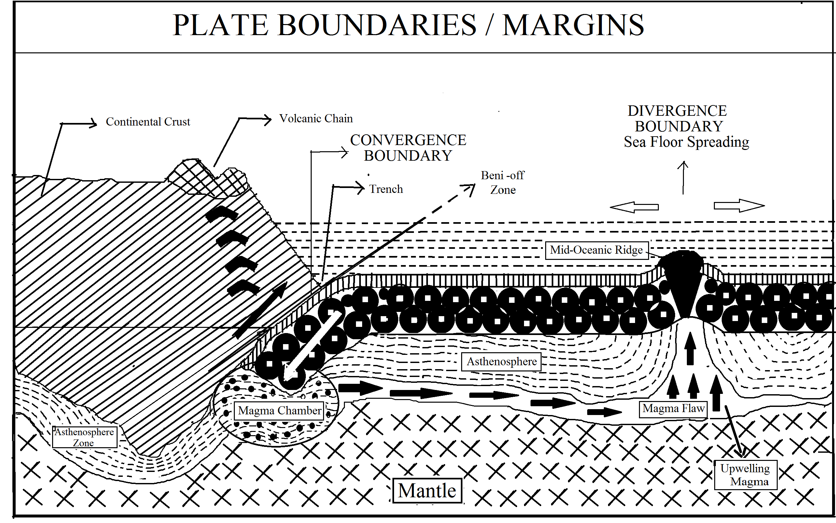

In subduction processes, one plate is oceanic and other is continental whose thickness and density are differ. Thickness of continental plates varies in between 30 to 50 km , sometimes upto 90 to 120 Kms while thickness of oceanic plates varies 3 to 5 Kms But density of oceanic plates is 3.1 to 3.3 gm / ${cm}^{3}$ while density of continental plates is varies in between 2.9 to 3.1 gm / ${cm}^{3}$. Hence in colliding processes, the lighter continental plates overrides the weighted oceanic plates that means the oceanic plates is undergoes the continental plates. These precess is known as subduction plate process. The oceanic plates are intruded in mantle by an angle of 45˚, passing through asthenosphere where the interior temperature is very high causes magma formation under the continental plates and it tries to overcome on the earth surface by finding the weakness zone or pores of rocks and it gives shaking to adjoining earth surface. That’s why the subduction zone of plate margin is well known for earthquakes and volcanoes eruption. The subduction zone, where oceanic plates intrudes in mantle and earthquake foci lie there , is known as Beni-off zone/ Beni-off plane.

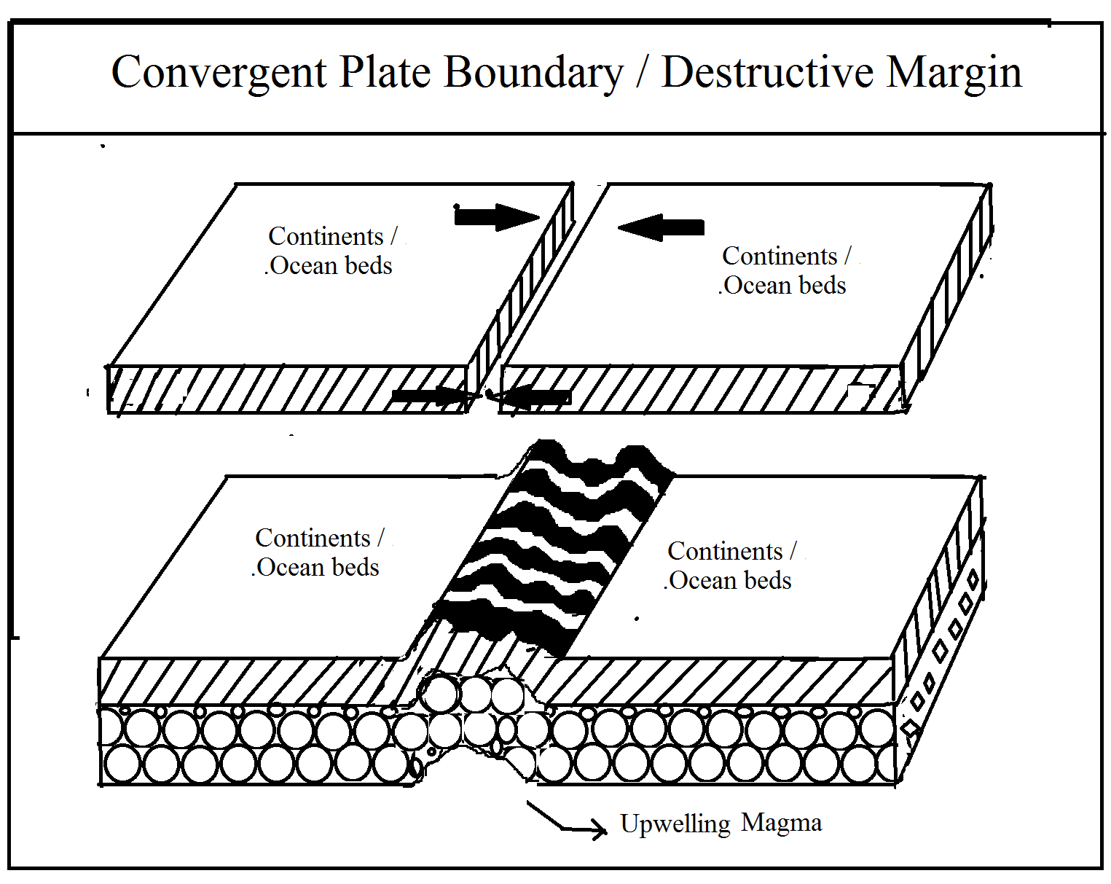

Earthquakes, sea trenches , island arcs are generally formed by subduction of plates.

The following important geographical phenomena takes place along the convergent boundary.

1. formation of folded mountain and sea trenches
2. Occurrence of volcanic activity in the ocean area near the trench e.g. Ring of fire in Pacific ocean.
3. formation of sea arcs and Islands i.e. sea arcs in Pacific ocean including Japan, Philippines, Qurile
4. Earthquake occurrence

Examples of formed earth features due to convergent boundary or margin .

1. Continental to Continental :-

Collision takes place between two different continental plates and the fore-edges are crumpled compressed which turn into folded mountains. For example, sometimes uplifted Himalaya in between China and Peninsular India, Alps range in between Africa and Europe continents have had been formed due to the convergence margin between two continents. There is more probability of earthquakes due to the formation of magma underneath of the folded mountain.

1. Ocean to Ocean convergent plate boundaries:-

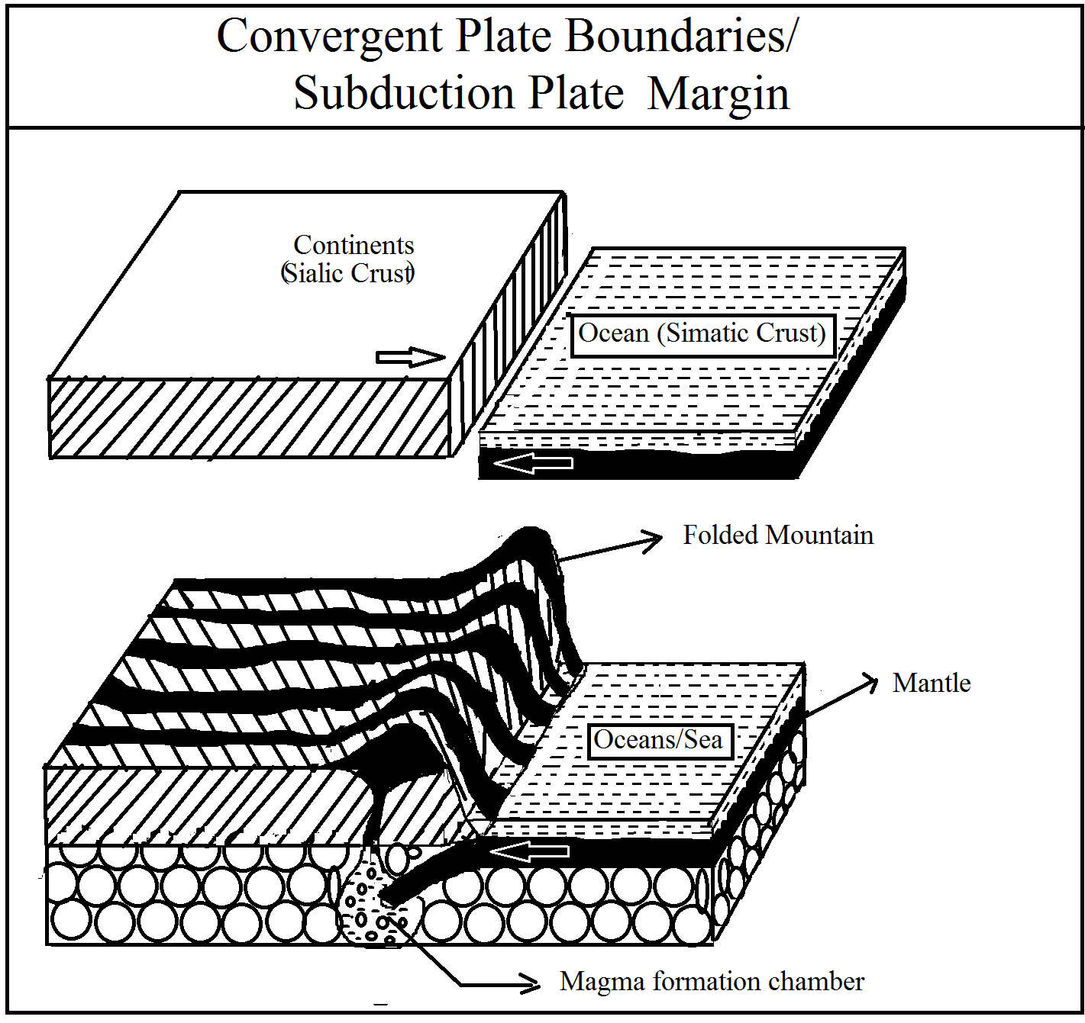

Whenever the two different oceanic plates are coming closer to each other from different directions in one line, then due to the same density of plate, they may have collided and there fore- edges are compressed, crumpled and submerged in mantle and deep trenches are formed. E.g. Aleutian and Mariana trench in Pacific Ocean formed in that way. Sometimes upwelled magma through the fracture of plates and its deposition and takes place in peripheral path. When they emerged on the ocean surface then it is known as islands. eg Islands in western Pacific Ocean like Japan, Philippines, Qurile are formed in that way.

C) Oceanic to Continental plate / convergent plate boundary :-

In the oceanic to continental , subduction process , oceanic plates subducted the continental plates and it intrudes in the mantle, and melts there and these formed magma tries to overcome on that continental plates and thus volcanic eruption takes place. On the deformed edge of continents, young fold mountains are formed due to the crumpling of the continental fore- edge colliding by oceanic plates. At the subduction point, a long narrow trench is formed which is close to the continents. Eg Nazca oceanic plates subducts the South American continental plates. Due to the subduction, Mount Amer trench, Peru Chille trench were formed at the western coast of South America and at that time and andes folded mountain was formed on frontal edge of South America continents.

**Divergent plate boundary or constructive plate margins** :-

The plate divergent boundary is one in which two plates are moving apart in opposite direction from a common line. Due to the moving away of these two plates, a rift have had been formed along this boundary or margin. The width of rift or fracture is widened as long as plate move through this passage of fracture, the molten materials are upwelling and deposited both sides of fracture. Such margin occurs usually in ocean and along the mid oceanic ridge due to the deposition of new ejected molten materials, a new oceanic floor is created. The creation of new oceanic floor is created. The creation of new oceanic floor is described as ocean floor spreading. Hence the divergent margin is also called as construction margin, as new crust is formed. The following events are associated along this margin

1. formation of rift or fracture and submarine ridge
2. upwelling of molten material from the mental
3. formation of ocean floor spreading
4. occurrence of fissure type volcanic eruption.

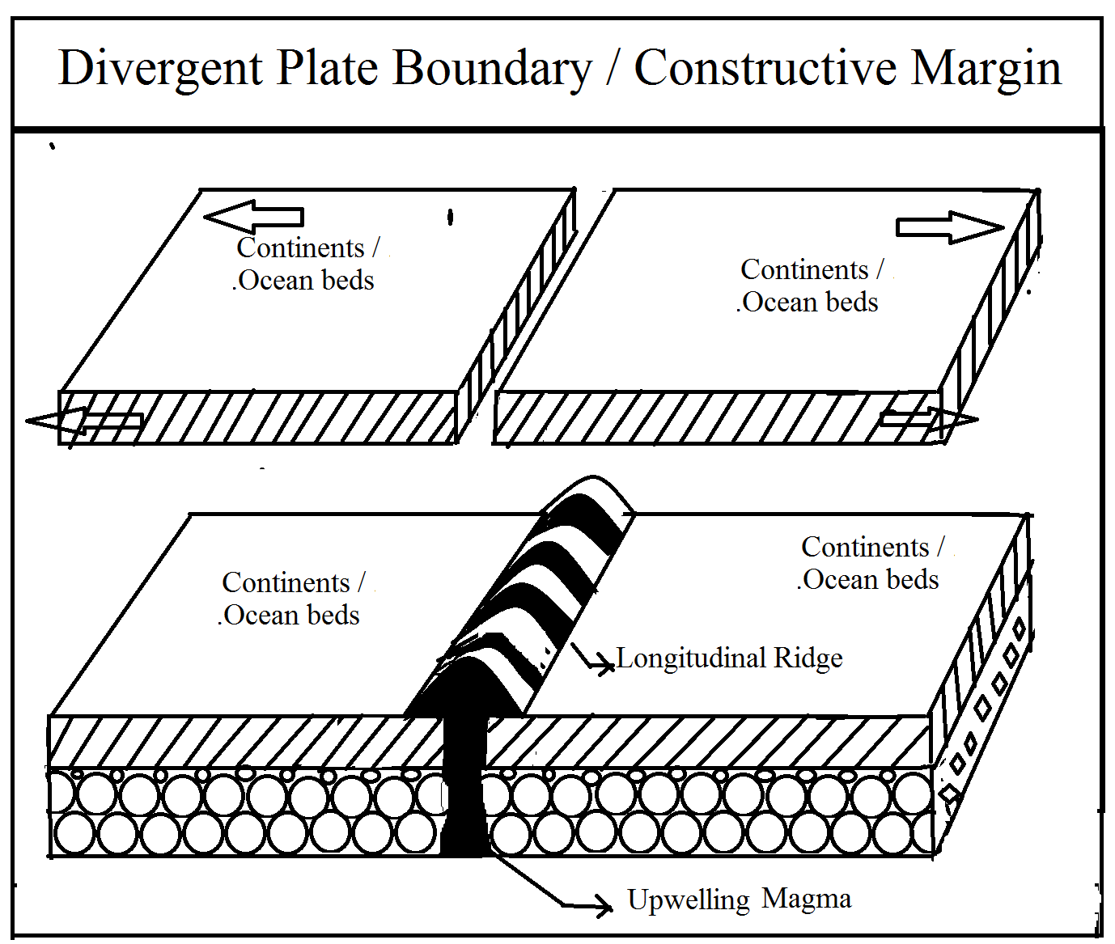

World's best example in divergent plate boundary

1. Continental to Continental divergent plate boundary :-

Whenever one continental plate moves away from other continental plates, then a rift valley is formed. Eg . the rift valleys of East Africa are believed to have formed along a zone of divergent plate boundaries and characterized by updoming, rifting and volcanism. Sometimes, in divergent plate boundaries, an island sea is formed due to the tensional forces in between adjacent continents. Eg. Red sea is formed due to the separation of Arabian Peninsula from Africa.

1. Ocean to Ocean divergent plate :-

Whenever one oceanic plate is moving away apart from the another for oceanic plate, then a rift valley is formed along the boundary / margin and the width of the rift or fracture widens with the passage of time and the movements of the plates. At that time, hot magma is slowly up welled and deposited both sides of fractures. This process of volcanism is known as fissure type of volcanoes. After depositing a long narrow ridge is formed along on fracture line. The height of that ridge is always below then the sea surface then it is known as submarine oceanic ridge. Mid-oceanic ridge is formed in Atlantic ocean due to the divergent plate boundaries in between western Atlantic Ocean crust and Eastern Atlantic oceanic crust.

**Transform plate boundary** :-

All the plates from two sides move parallel to each other and slide along common margin, such margin is called as transform margin. Along these common margin line due to the shearing process the earth crust shrieked and lengthen and transform fault is formed.

Plate in this process may join ridge to ridge , a ridge to the trench or a trench to trench . A ridge - trench transform will always change with time. A trench to trench transform may either lengthen shrink or remain constant depending on which of plates , that form the subduction system is the down going plates and transform which join to ridges axes will change in length with time.

The following events are taking place along transform plate margin.

1. Formation of transform faults :- Along the edges of parallel movements of plates, a fault is formed in which the block of rock move or displace horizontally along the fault plane at very low dip. It is called as strike slip fault. In such fault , usually scrap does not occur.
2. Earthquake:- When two plates slides along the edge of each other, a series of vibration usually a shock is felt on the earth surface in the form of earthquakes .

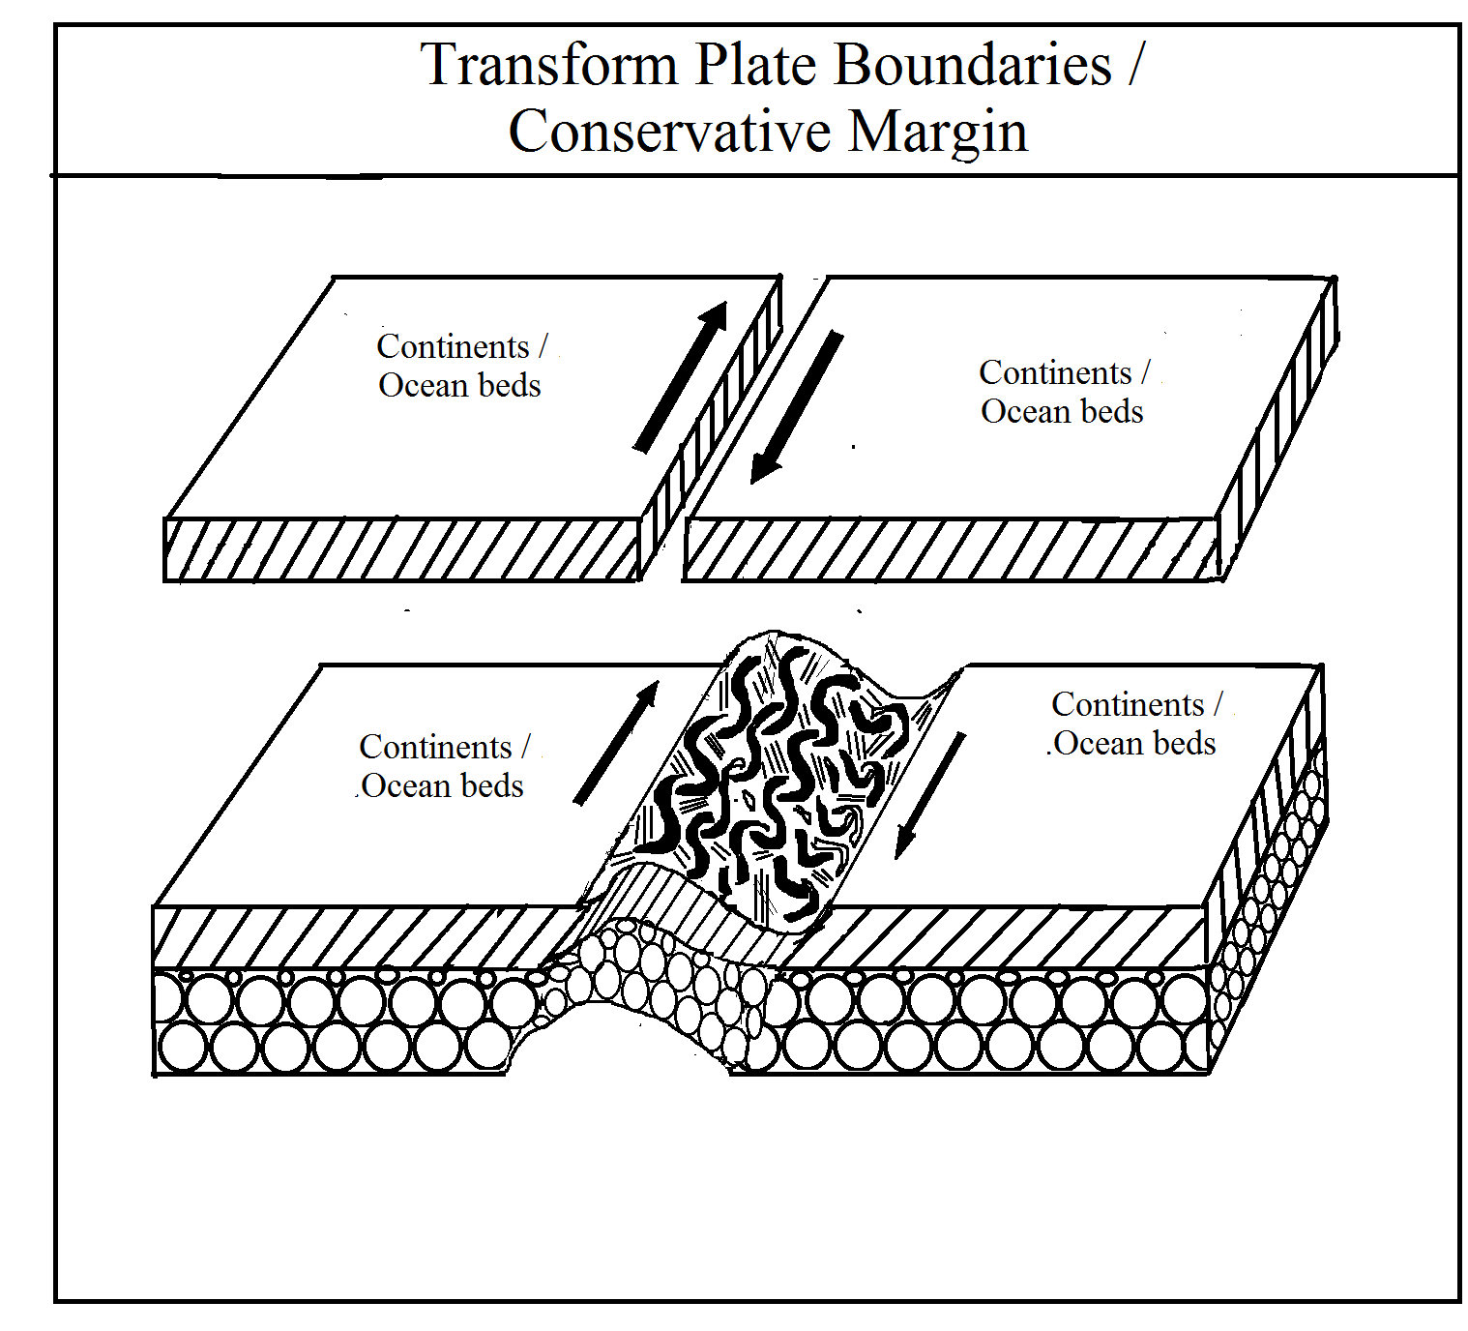

Worlds famous examples of transform plate boundary

1. Continental to continental transform plate boundary :- Whenever one continental plate slides parallel to another continental plates, a transform fault occurred on the marginal lines and ridges is formed. Thus , the crust is neither created nor destroyed.
2. Oceanic to oceanic transform plate boundary :- Here, one oceanic plates slides past to another oceanic plate and transform plates are takes place and valley features are formed.
3. Oceanic to continental transform plate boundary :- Here, one oceanic plate move parallel to one continental plates in opposite direction or in the same direction with different velocities. A transform fault takes place along marginal line and valley ridge features are formed. For example, the Eastern boundary of the Pacific plates is a long transform fault systems. California San Andreas fault is the most famous example in between the Pacific and North America continents .

Criticism :-

The geologist and geophysics agree that the plate tectonic theory has been proved beyond doubt. There are, however, a few problems to which it has not been able to provide a satisfactory solution . The main criticism of the theory as below:-

1. The length of the spreading is far greater than the subduction zones. In other words, the rate of creation of the new crust appears to be much greater than its rate of destruction.
2. Plate tectonic theory is not capable to explain why sub duction is limited to Pacific coast while spreading is found in all oceans.
3. There are evidence to show the movement of the same plate in opposite direction which is almost impossible.
4. The Benni-off zone is not present equally in all the probable places. Eg. the intermediate and deep earthquakes are absent in North America .
5. It cannot be said with confidence that all the plates behave like a unit, while some of the geologist have proposed an increase in the number of plates.
6. This theory has failed to provide a fully satisfactory explanation for mountain building. There are several mountain ranges such as Eastern Highlands of Australia, Drakenburg mountain of South Africa and Sierra Delmar of Brazil which cannot be related to plate tectonic movement .

**Global systems of Plates** :-

Returning to the global plan of plate tectonics it now post related that there are 06 major plates and 20 several smaller ones.

1. The American plate includes North American and South American continental crust and all of the ocean crust of the western Atlantic extending eastwards to mid Atlantic Ridge. This American plate has a relative westward motion as a single unit and consequently there is no important tectonic activity along the eastern margin of the American continents. The Western edge of American plate lies along the western continental margins.
2. The Pacific plate is the only one unit bearing only oceanic crust. It occupies of all the Pacific regions west to the east pacific rise. It undergoes subduction beneath the American plate along the compositional zone of the Alaska British Columbia and coastal region.
3. The Antarctica plate occupies the globe south of the mid oceanic ridge systems. The Nazca plates laying between East Pacific rise and South America, moves westwards against the west margin of South America meeting in the subduction zone of Peru Chile trench and the Andres range.
4. The African plate consists of the African continental crust and a zone of surrounding oceanic crust limited by the mid oceanic ridge.
5. A single Eurasian plate, which consists of largely of continental crust is bounded on the east and south by subduction zones of great Alpine mountain chains and island arcs. The Eurasian plate also extends into North Atlantic ocean ic crust laying east of the mid Atlantic ridge.
6. The Australian plates consists of continental crust of India and Australia as well as oceanic crust of the Indian ocean and a part of Southwest Pacific plate by a it is separated from the Pacific plate by the subduction zone passing through New Zealand. Because of its vast extent the Pacific plate can be expected to possesses, at its western portion , the oldest oceanic crust .

**Small Plates / Minor Plates** :-

1. Caribbean plate :- It was recognized as a separate minor plate bounded on the east b the Antillian island arc and subduction zone.
2. Philippines Plate :- It was recognized as a sub division of the Pacific plate, it lies between the subduction zone of Japan Philippines arc and the Bonin Mariana arc.
3. Cocos plate :- West of southern Mexico and Central America is the cocos plates , located between a speeding plate boundary and subduction zone.
4. Jaun-de-fuca- plate :- It is lying off the Pacific Northwest coast.

UNIT No 3D

**Theory of Isostasy**

There are several types of features on the surface of the earth including mountains, plateaus, plains, valleys, lakes and seas. Their shapes and extent vary greatly. But they remain more or less stable and keep occupying their respective places. There is definitely some natural force which keeps these landforms of huge size in balance. Otherwise it is difficult to keep them in their present state. Whenever, this balance is disturbed, there are great upheavals on the surface of the earth. This adjustment of the balance in between various landforms can be explained with the help of Theory of Isostasy. The world isostasy is derived from the Greek word Isostasious which means 'In equiposeis'. In other words, "Isostasy simply means a mechanical stability between the upstanding ports and low lying basins on a rotating earth".

Although the idea of isostasy had emerged way back in 1735 during the survey of Andes Mountains by Pierre Bouguer, in word 'isostasy' as a technical term was first used by Dutton in 1889. Dutton's main object was to show the balance between various features of the earth. He was of the opinion that the pressure below the mountains, plateaus, plains and sea bed is uniform at certain level. This is known as level of uniform pressure of Isostatic level or level of Compensation.

**THEORY OF ISOSTASY**

Definition - Different scholars have defined isostasy in different ways and Holmes are given below:

Definitions :-

1) "The doctrine of isostasy states that wherever equilibrium exists on surface, equal mass must underlic equal areas". - J.A. Steers

2) "Isostasy is the corresponding state of balance between extensive block of earth's crust which rise to different levels and appear at the surface mountain ranges, plateaus, plains or ocean floods". - Arthur Holmes

**Development of concept of Isostasy**

If a mountain range were simply a protuberance of continental platform and wholly supported by the strength of the foundation, then a plumb line - such as is used for levelling surveying instruments - would be deflected from the true vertical by an amount proportional to the gravitational attraction of the mass of the mountain range. The first hint that mountains are not merely masses of rock stuck on an unyielding crust was provided by the Andes expedition of 1735. Pierre Bouguer, the leader of the expedition, made observations both north and south of Chimborazo, and found to his surprise that the deflection of the plumb line towards this towering KA volcanic peak was very much less than he had estimated. He recorded his suspicion that the gravitational attraction of the Andes is much smaller than that to be expected from the mass represented by these mountains!'

Similar discrepancies were met with during the survey of the Indo. Gangatic plain, south of the Himalayas, carried out by Sir George Everest, Surveyor-General of India, over a century ago. The difference in latitude between Kalianpur and Kaliana (603 km due north) was determined astro. nomically, and also by direct triangulation on the ground. The two results differed by 5.23 seconds of arc, corresponding to a distance on the ground of 168 m. The discrepancy was ascribed to the attraction exerted by the enormous mass of the Himalayas and Tibet on the bob of the plumb-line used for leveling the astronomical instruments. The error so introduced does not arise in the triangulation method. A few years later (1855) Archdeacon Pratt made a minimum estimate of the mass of the mountains and calculated what the corresponding gravitational effects would be at the two places on the plains to the south. His estimates for the deflections of the plumb line towards the mountains were

27.853" at Kaliana, and

11.968" at Kalianpur.

The difference, 15.885", was more than three times the observed deflection, 5.23". Bouguer's suspicion that the mountains were apparently not pulling their weight was now a demonstrated fact. Even more spectacular evidence was provided by French surveyors, who found that in some of the coastal regions of south-western France the plumb-line was deflected, not towards the mountains, but away from them, towards the Bay of Biscay.

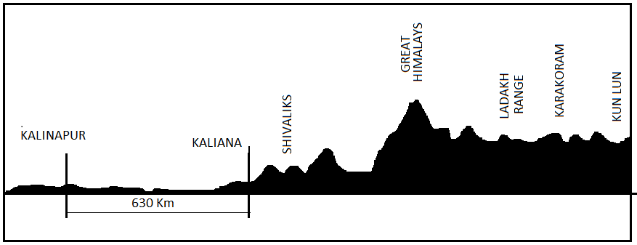

FIG :- Meridional section (about 78° E ) through Northern India and Tibet , indicating the enormous mass tending to deflect the plumb line of surveying used on the plains to the south.

Clearly the mountains seem to behave almost as if they were hollow, and this apparent gravitational anomaly has since been amply confirmed by the results of innumerable measurements of gravity on and near mountains and high plateaus. The observed results are found to be much lower than those to be expected. Only one physical explanation of these discrepancies or anomalies is available. Since the mountains are not hollow, there must be a compensating deficiency of mass in the column underlying the visible mountain ranges. In simpler languages, the density of the rocks must be relatively low down to considerable depths. The possible combinations of density distributions and depths are, of course, theoretically infinite, but unfortunately we know something about the crustal rocks and their densities in most regions, so that in practice the pro babble combinations are limited. Moreover, as we have seen, exploration of the crust by earthquake waves confirms the inference that mountain ranges have roots, largely composed of sialic rocks, going down to depths of as much as 50 or 60 km. Under plains near sea-level the thickness of the SIAL and other crustal rocks is only about 30 km, sometimes less. Beneath all the deeper parts of the oceans SIAL cannot be detected at all. The suggestion that the crust is supported by underlying denser material and that the weight of mountains is balanced by light materials extending as roots into the denser -just as icebergs are balanced in water was first made in 1855 by Sir George Airy, who was then the Astronomer Royal.

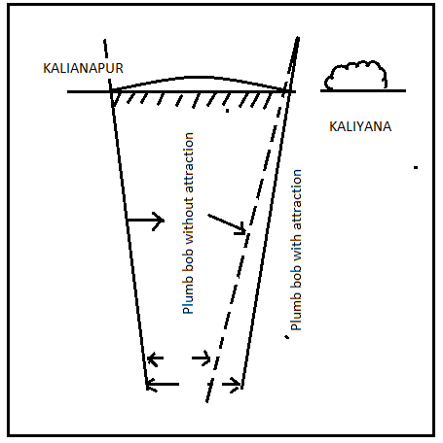

Airy and Pratt have assigned different reasons for 'below expectation gravitational pull by the Himalayas'. Some of the reasons are summarized as under:

(1) Himalayas are hollow from within.

(2) The huge mass of the raised Himalayas is counterbalance by presence of low density materials beneath them. Consequently, the weigh the entire mass is less than the expectation which results in low gravitation attraction.

(3) There are many lakes in the Himalayas which have reduced the weigh and gravitational force of the Himalayas.

(4) There is a certain level inside the earth at which there is difference in density and the weight of all landmasses (mountains, plateaus, plains, sea bed etc.) is equal. At this level it is assumed that bigger the column, lesser the density and smaller the column, greater the density.

**PRATT'S CONCEPT**

Archdeacon Pratt expressed his ideas about isostasy in 1855 after studying the gravitational pull of the Himalayas. He opined that the density of the material below the Himalayas was much less as compared to that below the Northern Plain and the Southern Plain of India. This is the main reason for lower gravitation pull of the Himalayas than that estimated by Pratt. The difference between the latitudes of Kaliana and Kalianpur as determined by Trigono- matical and Astronmical calculations was 5.236" whereas it should be 15.885" according to Pratt's calculations. Pratt arrived at this calculation on the assumption that the density of the Himalayas is 2.75. On this basis, he calculated that the density below the mountains was minimum and below the oceans it was maximum.

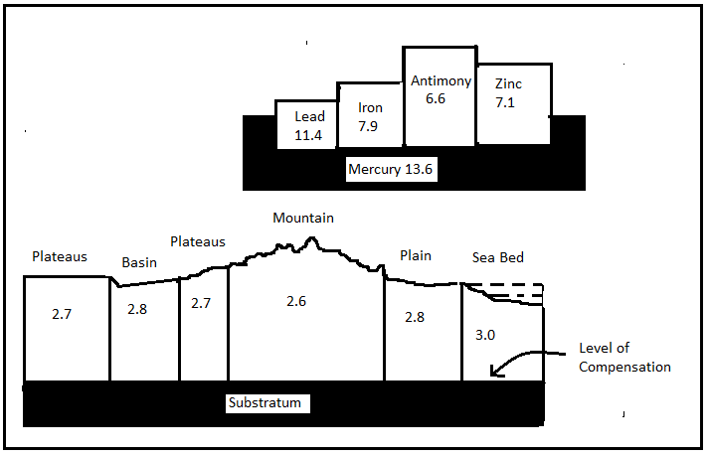

Pratt's concept is clear from Figure 5.3(a). He took four blocks of different materials having the same weight and cross section but different densities. It is obvious that they will have different lengths. He took some mercury in a pot and floated those blocks in it. All the blocks sank into the mercury by equal depth at the heights of unsunk portions were different. The blocks of lower density All rise higher than those with higher density. For example, antimony will rise out twice the height of lead because the density of antimony is 6.6 while that of lead is 11.4. In other words the heights of the block above the liquid is inversely proportional to their densities. Pratt expressed the view that similar variations in density exist below mountains, plateaus, plains and sea bed. This is clear from Figure 5.3(b). All these landforms are following on the substratum which has a density of 3.3. Mountains have minimum density of 2.6 and are rising high. On the contrary, sea bed has maximum density of 3.0 and is lying below the water. Pratt also put forward the idea of level of compensation below which there are no differences in densities although above it, the differences do exist. This is at the substratum (Fig. 5.3b). Thus Pratt's ideas are based on law of level of compensation rather than the low of floatations. Hence, according to Bowie, the most important element of Pratt's concept is "Uniform depth with varying density".

**AIRY'S CONCEPT**

Sir George Airy, the Astronomer Royal of Britain expressed his views about isostasy in 1859. He followed the 'Law of Floatation' and opined that the lighter upper crust of the earth floats on the heavier substratum. He told that Himalayan Mountains are not just a landform but has its root deep into the substratum. According to Archimedes principle, a floating body displaces liquid equal to the volume of the submerged part of the floating body. The greater the part of the body about the liquid in which it is floating, the greater the part of the body inside the liquid. For example, if ice (density = 0.9) floats over water (density 1) we find that for one part of the ice above water level, there are nine parts beneath. In the same way, if the Himalayas (density = 2.67) float in a liquid (density = 3.0), the relation between their densities is 2.67:3 or 8.89: 1. It means that for every one part of the Himalayas above liquid, ther should be nearly a parts below it. Thus we come to the conclusion that those blocks which are not much raised above the liquid are also not much submerge, below.

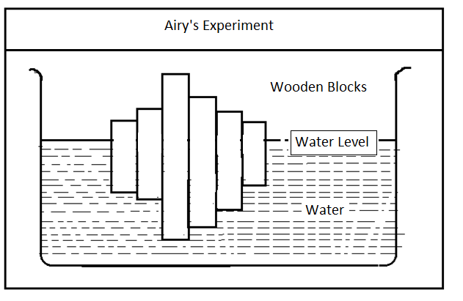

Airy explained his hypothesis by an experiment. He took a number o wooden blocks of different height and put them in a pot containing water (Fig 5.4). It was observed that the larger blocks rose higher and had deep roots in the water. On the other hand, the blocks which were not much raised above the water level were also not much submerged below it.

Airy believes that mountains, plateaus, plains and sea bed: is somewhat similar to that of wooden blocks. All the landforms have the same density of 2.67 and they float on the substratum of higher density varying from 3 to 3.3. Hence, the areas which rise high have deep roots (Fig. 5.5).

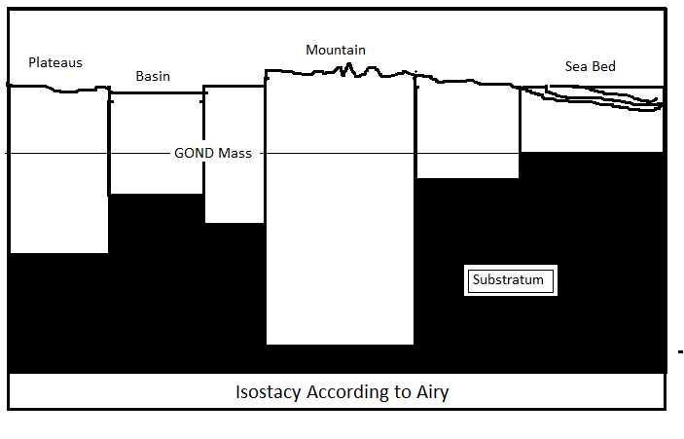

The hypothesis of Airy is considered to be more acceptable than that o Pratt. Deep mining has revealed that the density of rocks remains almost the same. Hayford and Bowie have also supposed Airy's views.

**Difference between the views of Pratt and Airy**

Though both Pratt and Airy agree that the landmasses are lighter and are floating in a denser sub-stratum, yet there is one main difference between them. Pratt believes that different landmasses such as mountains, plateaus, plains etc. have different densities and they sink to the same depth in the sub-stratum. On the contrary, Airy believes that the densitites of the blocks are the same but they sink in the denser sub-stratum to different depths. Bowie has summed up these views. According to him, “The fundamental difference between Airy's and On Pratt's views is that the former postulated a uniform density with varying thickness, and the latter a uniform depth with varying density

**HAYFORD'S AND BOWIE'S CONCEPT OF ISOSTASY**

J.F. Hayford (1909-10) and W. Bowie (1917) were directors of land survey in the United States of America. They fixed up several Geodetic centres for conducting the land survey of that country. Their main object was to know about the true shape of the earth and gain knowledge about isostasy. They also used pendulum for survey and had to face the problem of gravity.

The earth attracts everything towards its centre by a force known as its gravity. This gravity goes on increasing from the equator towards the poles due to flatterning of the earth at the poles. Similarly, gravity is found to the less in the Mountains than in the plains. These variations in the force of gravity are due to the variations in distance from the centre of the earth. Apart from these two factors, gravity is also influenced by huge landmasses. If gravity is calculated keeping in view all these factors, the result should be flawless. The difference in the gravity thus calculated and that calculated by pendulum is known as Gravity Anomaly, which helps us in knowing the state of isostasy at a place. and Bowie expressed the views similar to those of Pratt.

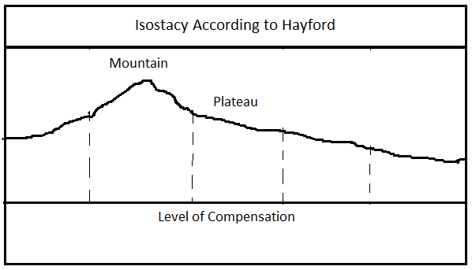

According to Hayford, there are areas of different densities in the crust of the earth. But at a certain depth, we reach a level above which there are differences density but below that level, the density remains the same. This level has been turned as "level of compensation" which is at a depth of 100 km. By its means plumb-line observations can be consistently corrected and the gravity anomalies generally reduced to about one tenth of their former value. For contiguous columns of equal cross section based upon the level of compensation the density was inversely proportional to the height. Diagram 5.6 will render this concept clear. Here we have some imaginary columns reaching down the level of compensation. The assumption is that the varying volume of matter in severa columns is compensated by their density in such a fashion that they exert equal downward pressure at the level of compensation and thus balance one another Their heights will be inversely to proportional to their densities. In other word they will adjust in such a way that 'bigger the column lesser the density, smaller . the column bigger the density'.

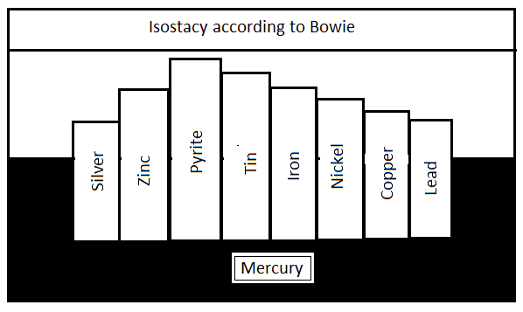

Bowie explain Hayford's concept of level of compensation by immersing light columns of Silver, Zinc, Pyrite, Tin, Iron, Nickel, Copper and Lead into Mercury. These columns were designed in such a way that their cross section and their weight was the same but their length varied according to their density. It was observed that all the columns had their base at the same level which is considered to be the level of compensation. It was also seen that lighter columns with less density stood higher as compared to the heavier columns with higher density (Fig. 5.7). Ans.

**ARTHER HOLME'S CONCEPT**

Arther Holme's concept of isostasy somewhat resembles that of Airy. Like Airy, Holmes also accepted the idea that the elevated land areas are made of lighter materials and much of their mass is submerged in the sub-stratum do for maintaining the balance. He recognized many layers inside the earth on the basis of behaviour of the earthquakes waves. Holmes expressed the view that there is a root of sial beneath the mountains which extends to a depth of 40 km or more. It is 10-12 km. deep in the coastal areas and practically absent from elevated landmasses are stable below the sea bed. He further explained that the only because they have large mass of lesser density beneath them. The low-lying areas have higher density.

Isostatic re-adjustment. According to Holmes, "In practice, perfect isostasy is of the crust the pressure exerted by the loaded column is increased, while isotasy is rarely attained, though there is generally remarkable close approach”. The geographical processes of erosion and deposition bring about changes on the surface of the earth which upset the isostatic balance. When a mountain range is gradually worn down by the agents of denudation, the load on the underlying column of the crust is reduced by the weight of the rock-waste that has been carried away. At the same time, a neighbouring column underlying a region of delta and sea floor where rock-waste is being deposited, received corresponding increase of load. Unless a compensating transfer of material occurs in depth, the two columns cannot remain in isostatic equilibrium. At the hat exerted by the unloaded column is decreased. In response to this pressure difference in the mantle, a slow migration of material is set going as shown Fig. 5.9. The loaded column sinks and unloaded column rises.

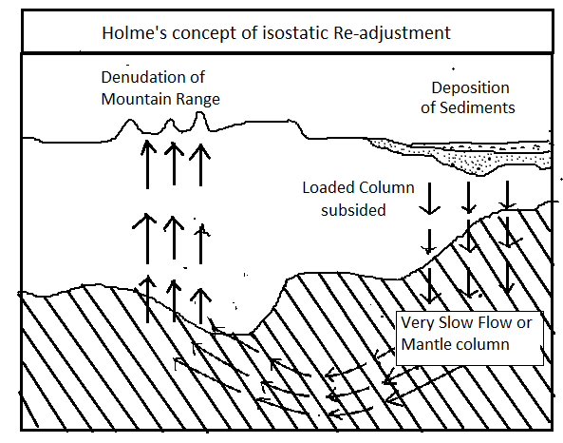

This process, whereby isostasy is restored, is called isostatic readjustment Such isostatic re-adjustments have been observed in Finland and Scandinavia around the Gulf of Bothnia. This part of the earth has already risen by 250 meter and is still said to be out isostatic balance. It is estimated that it will still rise another 200 meters or so before equilibrium is reached. Hudson Bay is also said to be out of isostatic equilibrium and is rising up.

Questions

1. Describe the Gaseous Mass theory of Origin of Earth with schematic diagram.
2. State the Nabular hypothesis about origin of earth.
3. State the Chamberlin and Moulton’s Planetismal theory of Origin of Earth.
4. State the Jeans and Jeffereys Tidal hypothesis of origin of Earth.
5. State the Otto Schemidst’s Inter-steller Dust Cloud hypothesis of Origin of earth.
6. State the direct and indirect sources of Interior earth.
7. State the structure and composition of Interior Earth with schematic diagram.
8. Describe the characteristics of water and land distribution on the globe.
9. State the concept of tetrahedral theory.
10. Describe the Wegeners continental drift theory.
11. Describe the concept of plate tectonic theory
12. Describe the Pratt’s isostasy concept with diagram.
13. Describe the Airy’s isostasy concept.
14. Describe Arther Holmes isostasy concept.

Short Notes

1. Characteristics of Solar System
2. Interior temperature
3. Interior Density
4. Interior Pressure
5. Characteristics of Earthquake waves
6. Earthquake shadow zone
7. R.A. Dally’s classification of Interior earth
8. E.Suess classification of Interior Earth
9. Arther Holmes classification of Interior Earth
10. B. Guttenburg and A.Mohorovisic classification of Interior Earth
11. Criticism on Wegener’s continental drift theory.
12. Name of major and minor plates on globe.
13. Classification of plate boundaries.
14. Convergent plate boundaries
15. Divergent plate boundaries
16. Transform plate boundaries
17. Concept of isostasy