REVIEW OF DIGITAL MARKETING

Introduction
Marketing is a dynamic, continuous changing, and restless business activity. The role of marketing itself has changed dramatically due to various crises - energy/material shortages, inflation, high unemployment, economic recessions, dying industries/companies, terrorism and war, and effects due to rapid technological changes in certain industries. Such changes, including the internet, have forced today’s marketing executives to become more market-driven in their strategic decision-making, requiring a formalized means of acquiring timely and accurate information about products, customers, the marketplace and the overall environment. Internet marketing involves marketing and selling products or services to consumers over the Internet. Internet marketing utilises the power of electronic commerce to sell and market products. Electronic commerce (E-commerce) refers to any online market on the internet. Electronic commerce supports the selling, buying, and trading of products or services over the internet. Internet marketing forms a subset of different electronic commerce. With the outburst of internet growth, internet marketing has become very popular. It is assumed that Internet marketing began at the beginning of 1990 with just text-based websites which offered the product's information. With the growth of the technology and internet, it is not only selling products and information about products, software programs, advertising space, auctions, stock trading and matchmaking. A few companies have revolutionized the way; the internet can be used for marketing& selling, such as Google.com, Amazon.com, Alibaba.com, Yahoo.com, and Youtube.com. This paper presents views on some current and future trends in internet marketing.

2. Review of Literature
There are many research papers and articles that provide a detailed insight into digital and Internet marketing. The findings from the literature are given below:-
Internet marketing has been characterised simply as ‘achieving marketing objectives through applying digital technologies’ (Chaffey et al., 2009). In the developed world, companies have felt the importance of digital marketing. In today's developed era, companies have realized the importance of digital marketing. For businesses to be successful in future, they will have to merge online with traditional methods for fulfilling the needs of customers more precisely (Zeisser, Parsons, Waitman 1996). Digital marketing refers to the use of different technologies to help marketing activities to improve customer learning by matching their needs (Chaffey, 2013). The introduction of new technologies has created new business opportunities for marketers to manage their websites and achieve their business objectives (Kiani, 1998). Expectations in terms of producing results and measuring success for advertisement money spent, digital marketing is more cost-efficient for measuring the rate on investment (ROI) on the advertisement (Pepelnjak, 2008). Online advertising is a strong marketing medium for building brands and increasing traffic for companies to achieve success (Song, 2001).
Today's, monotonous marketing and advertising techniques have given way to digital marketing. In addition, it is so powerful that it can help revive the economy and can create immense opportunities for governments to function in a more efficient manner (Munshi, 2012). Companies in Singapore have tested the success of digital marketing tools as being effective and useful for achieving results. (Teo, 2005). More importantly, growth in digital marketing has been due to the rapid advancements in technologies and changing market dynamics (Mort, Sullivan, Drennan, Judy, 2002).

For digital marketing to deliver results for businesses, digital content such as navigation, accessibility, and speed are defined as the key characteristics of marketing (Kanttila, 2004). Another tested and tried the tool for achieving success through digital marketing is the use of word-of-mouth (WOM) on social media for making the site famous(Trusov, 2009). In addition, WOM is linked with making new members and increasing traffic on the website which in return increases the visibility in terms of marketing.

Social media with an extraordinary example Facebook has opened the door for businesses to communicate with millions of people about products and services and has opened new marketing opportunities in the market. This is possible only if the managers are fully aware of using the communication strategies to engage the customers and enhance their experience (Mangold, 2009). Marketing experts must truly understand online social marketing campaigns, and programs and comprehend how to do it effectively with performance measurement indicators. As the market dynamics all over the world are changing the young audience's accessibility to social media and usage. Strategic integration approaches must be adopted in an organization’s marketing communication plan (Rohm & Hanna, 2011). With the above reviews, we can assume that GST is a tax reform which will change the country's scenario as a support for this review study.

Blogs as a tool for digital marketing have successfully created an impact for increasing sales revenue, especially for products where customers can read reviews and write comments about personal experiences they had of the products and services. For businesses, online reviews have worked well as part of their overall strategic marketing strategy (Zhang, 2013). Online service tools are more influential than traditional methods of communication (Helm, Möller, Mauroner, Conrad, 2013). As part of the study, it is proven that users experience an increase in self-esteem and enjoyment when they adapt to social media which itself is a motivating sign for businesses and marketing professionals (Arnott, 2013). Web experiences affect the mental process of consumers and enhance their buying decision online (Cetină, Cristiana, Rădulescu, 2012).
The Internet is the most powerful tool for businesses (Yannopoulos, 2011). Marketing managers who fail to utilize the importance of the internet in their business marketing strategy will be at a disadvantage because the internet is changing the pricing, branding, distribution and promotion strategy.

3. Rationale for the Study
The most interesting result of the easy access to it by consumers and the technology explosion is the disruption of the market and the marketing practice. The customer today is empowered. The power of communication and traditional marketing tools is diminishing and the customer has less trust in the corporate message and brand. Technology is changing the practice and context of marketing: marketers are increasingly forced to operate in a complex, and dynamically changing world where they do not have any kind of full control of the media and the message. Customer behaviour is also changing: the customer is losing trust and has become much more smart, critical, well-informed and proactive than ever before. New skills, knowledge and new approaches are needed by today and future marketers not only for understanding the changing and technology-enabled marketing environment but also for communicating and comprehending with the new customer. Marketing is becoming increasingly digital and continuous developments in the field of technology present marketers with new challenges and opportunities: Mobile marketing, the Internet of Things, Big Data, Analytics, 3D printing, cloud computing, Artificial Intelligence, and Consumer Neuroscience / Neuro marketing are some of the most interesting and challenging domains where the future marketer are expected to must be able to function & deliver. With the ultra-rapid development of digital technology and social media, it is an immense challenge to keep track of those developments and to use them advantageously. That is why the author felt a need to focus on this concept in this study.

4. Problem Statement and Study Objectives
Seeing that the strength of the internet & social media will not decrease in the upcoming few years, this topic will be crucial to every organization. The power of smartphones in combination with social media is a constantly expanding threat to many companies. The second big point of consideration is related to the continuing trend of children, adolescents, and teenagers using social and digital media excessively. That is why this study intends to focus on understanding the internet marketing and its technique with the following set of objectives:-

- What are the various successful techniques of internet marketing used today?
- What is a basic comparison between traditional and digital marketing?
- Which is the most preferred internet marketing approach?
- Do companies prefer internet marketing to traditional marketing?

These questions will help to predict the trends in internet marketing and make suitable suggestions to companies.

5. Methodology
The exploratory research is designed to allow an investigator to primarily look around with respect to some phenomenon, and aim to develop suggestive ideas. This study is exploratory in nature and includes both qualitative and quantitative analysis. As a purpose of this study (critical review), data has been collected on an Indian basis. The secondary data and information has been analyzed for preparing this paper extensively. The data and information have been collected from different researchers, scholars, published e-books, articles published in different journals, periodicals, working papers, conference papers, company websites for annual reports, CSR activity reports and their internal newsletters. The company-related data and information is used which is available publically on the websites of the different companies. This is the best/standard practice for research which is a critical review type.
The methodology which was used was that of critical literature review.

6. Analysis and Discussion of Study
Internet Marketing
The Internet is a global system of inter-related and inter-connected computer networks that uses the Internet protocol suite to link many billion devices worldwide. It is a network of networks that consists of millions of public, private, business, academic, and government networks. Internet works thanks to a combination of a range of technologies and it is the biggest source of information that mankind has ever had for its disposal. The Internet also laid the foundations for more information channels than people have created until the 20th century. The term Marketing has many deﬁnitions. One of the most well-known deﬁnition says that “Marketing is the social process by which individuals and groups obtain what they need and want through creating and exchanging products and value with others.” (Kotler, Keller, 2007). By connecting these two areas we can apply marketing principles within the field of the internet. This can be done primarily by internet advertising, creating web pages, and also marketing research on the internet and electronic commerce. However, internet marketing requires a little bit more diﬀerent approach in certain aspects than traditional marketing. Simply speaking internet marketing, also referred to as online marketing, e-marketing, web-marketing, or i-marketing is the marketing of products or services over the Internet..
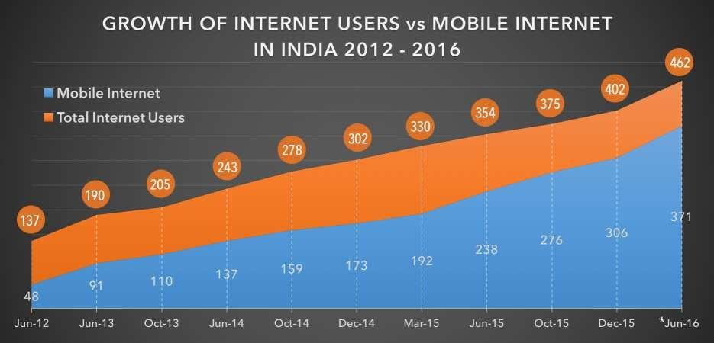
(Source: IAMAI, Feb 2016, Figures in Million Users, * Estimated Users)

