Gene Expression during Pollen Development

Rajender Kumar^{1*} Lokesh Thakur² Ankita Chauhan³ Shikha Thakur⁴
- PhD Scholar, Department of Tree Improvement and Genetic Resources
Dr. Yashwant Singh Parmar University of Horticulture& Forestry,
Nauni, 173230
- PhD Scholar, Department of Biotechnology, Dr. YSPUHF Nauni,
- PhD Scholar, Department of Silviculture and Agro - forestry
- Assistant Professor, Department of Tree Improvement and Genetic Resources
* Corresponding author – rajender.kumar0697@gmail.com

Abstract:
Male gametophyte development in higher plants is a complex process that necessitates the coordinated participation of multiple cell and tissue types, each with its own set of gene expression patterns. The male gametophytic life cycle is divided into two parts: a developmental phase that leads to the formation of mature pollen grains and a functional phase that begins with the impact of the grains on the stigma surface and ends with double fertilisation. The genes responsible for pollen development could be identified using different transcriptomic approaches like Gene Chip and SAGE. The level of expression of individual gene are different for different tissue and cell. In this chapter we have given an insight of gene expression during pollen development.
Keywords: Pollen specific gene expression, Sperm cell specific gene expression

Introduction:
Microsporogenesis is the formation of pollen grains.The anther is a four-sided (tetragonal) structure with four microsporangia, two in each lobe, located at the corners.The microsporangia continue to develop and become pollen sacs.The outline of a typical microsporangium is nearly circular.The epidermis, endothecium, middle layers, and tapetum are the four wall layers that surround it.The outer three wall layers serve as protection and aid in the dehiscence of the anther to release the pollen.Tapetum is the innermost layer of the wall. It feeds the growing pollen grains. Tapetum cells have dense cytoplasm and usually have more than one nucleus.When the anther is young, the centre of each microsporangium is occupied by a group of compactly arranged homogeneous cells known as sporogenous tissue. Microsporogenesis occurs as the anther develops, and the cells of the sporogenous tissue divide meiotically to form microspore tetrads.A microspore tetrad can be produced by any cell in the sporogenous tissue. Each one could be a pollen or microspore mother cell.Microsporogenesis is the process of producing microspores from pollen mother cells (PMCs) via meiosis. As they develop, the microspores form a tetrad, which is a cluster of four cells. The microspores separate from each other and develop into pollen grains as the anthers mature and dehydrate.
Male gametophytes are represented by pollen grains.It has a noticeable two-layered wall.The exine is a hard outer layer composed of cutin and sporopollenin, which is one of the most resistant organic materials known and is non-biodegradable.The inner wall of the pollen grain is referred to as the intine. It is made of pectin and cellulose and is thin, soft, and elastic in nature.The meiotic products' first mitotic division (unicellular pollen) gives rise to two cells, the generative cell and the vegetative cell. The generative cell undergoes a second mitotic division after being engulfed by the vegetative cell, producing two sperm cells.The pollen tube develops into female tissues after germination. The pollen tubes grow quickly (up to 35 mm per hour) and are guided into the ovules, which are seed precursors, where the two sperm are delivered to the two female reproductive cells, resulting in double fertilisation. The vegetative cell nucleus is larger than the nuclei of sperm cells.This size difference is generally attributed to a dramatic condensation of chromatin in sperm cells, leading to the belief that sperm are transcriptionally inactive.They do not, however, lack RNA; characterization of this pool of RNA may lead to the identification of factors required for gamete fusion and/or zygoteviability and development.
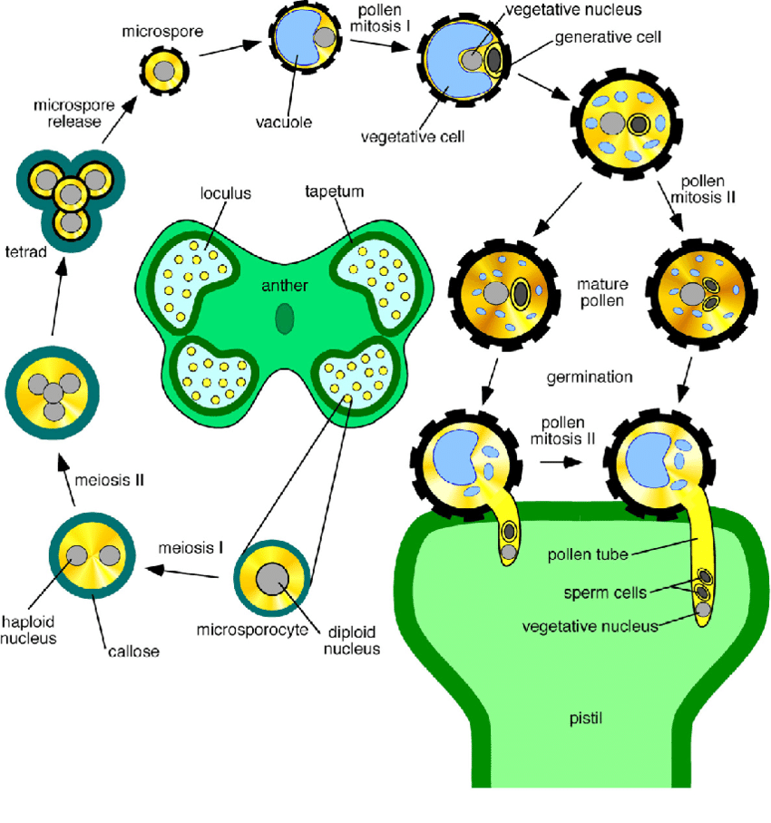
Fig. 1 Stages of pollen development
Pollen-Expressed and Pollen-Specific Genes
There are 2 types of genes required for pollen development: one for pollen grain development prior to anthesis and the other for pollen germination and tube growth.In comparison to the multifaceted vegetative tissue, a large number of genes remain active in the morphologically minimalistic male gametophyte (pollen). The majority of the genes expressed in pollen arecellular "housekeeping genes," with approximately 65% also expressed in vegetative tissues. Only 10-30% of the genes expressed specifically in pollen have been evaluated by screening pollen-specific clones in a pollen cDNA library.
Early genes and late genes are two major categories for the genes expressed in pollen. Actin is an example of an early gene that is involved in pollen formation, whereas Zm 13 and Lat 52 are examples of late genes that encode proteins related to pollen maturation and/or germination and pollen tube expansion. However, given that a number of pollen-specific genes exhibit transitional or continuous expression during pollen formation, this separation is in some ways artificial and is unable to characterise all genes expressed in pollen.

These genes may have a housekeeping role because they are necessary during the whole pollen developmental stage. The fact that the genes needed for pollen germination and tube growth are present at the time pollen is discharged from the anther is clear proof that late genes primarily serve to make the proteins needed for germination and tube growth.

Based on their sequence homology to other known proteins, the pollen-specific genes are generally divided into three classes:
- Genes that have sequence homology to wall degrading enzymes. e.g., Zm 58 in maize, G10 in tobacco, BP 19 in Brassica napus etc.

- Genes with cytoskeletal protein sequence similarity. e.g., TAC 25 in tobacco, TUA 1 in Arabidopsis, Tub 3,4,5 in maize etc.

- Genes that resemble pollen allergens in their sequence.e.g., Amb a I 1-4 in ragweed (Ambrosia), Zea m I in maize, PSI in rice, Bet v I in birch etc.

There are also several more kinds of pollen-specific genes discovered. e.g., Lat 52 in tomato, SF 3 in sunflower, Bp 10 in Brassica napus etc.

Expression Profile of Pollen
There are two methods that could be used to determine the overall gene-expression pattern of pollen: Affymetrix ATH1 8K Gene Chips and serial gene expression analysis (SAGE).The SAGE method can identify expressed RNAs from genes that are not represented on the Gene Chip, including those whose predicted forms are unknown (for comparisons of transcription profiling approaches). In addition, the two approaches provide relatively similar overall views of pollen gene expression. Contrary to popular belief, the pool of RNAs expressed in mature pollen is not just a haploid imitation of the expression in the diploid sporophyte. Pollen has the most varied expression profile when compared to expression profiles from seedlings, leaves, roots, seed pods, plants at various developmental stages, and purified pollen grains. This divergence is generally brought on by variations in gene expression levels, but it can also be attributed to variations in gene expression across entire families of genes with similar functions. One explanation for these variations is that some genes are pollen-specific while others are expressed only in sporophytic tissues.
The obvious modifications are the low levels of expression of genes involved in translation and energy processes (mainly photosynthesis) in pollen. Given that pollen does not engage in photosynthetic activity, this is not surprising. Further notable difference between pollen grains and sporophytic tissues are the greater expression level of genes with proposed functions in signalling and cell-wall metabolism. This enrichment is in accordance with the need for interactions between the pollen grain and stigmatic cells prior to germination, rapid pollen-tube growth, and the attraction of the pollen tube to the ovules, which leads to double fertilisation. Not only is the RNA pool expressed in mature pollen haploid. Finding RNA molecules that are present or expressed differentially at various phases of the pollen grain's growth is another fascinating part of examining global pollen expression. Researchers can use these data to examine not just which genes are expressed in pollen but also how those expression patterns change as pollen matures.

Pollen-specific gene expression

There have been discovered genes specific to pollen that may play a direct role in pollen biology processes including pollen-tube growth and fertilisation. The Gene Chip studies revealed that approximately 10% to 40% of the genes expressed in Arabidopsis pollen are pollen-specific, while the SAGE analysis revealed that approximately 83% of pollen-expressed gene tags are pollen-specific. Some pollen-specific genes are not only unique to pollen, but they are also among the most highly expressed genes in pollen, making them the most likely to play an important role in pollen biology. More intriguingly, the discovery of several novel pollen-specific genes with unknown functions has been revealed. Further, the Affymetrix ATH1 8K Gene Chip contains only about 8,000 genes, more pollen-expressed genes are likely to be discovered. This appears to be the case, as data from the Affymetrix ATH1 24K Gene Chip reveal 4.5 times the number of pollen-specific and 4 times the number of pollen-expressed genes as the Affymetrix ATH1 8K Gene Chip.
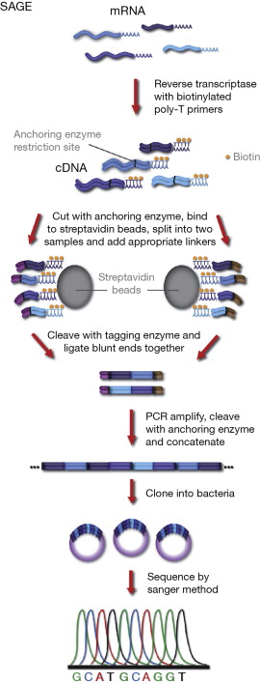
B
AA

Fig. 2. A) GeneChip B)Serial Analysis of Gene
Expression(SAGE)
Sperm-cell-specific gene expression

A cDNA library is being developed to find sperm-specific transcripts that may be involved in gamete-gamete recognition following fertilisation. Hence the sperm RNA pool is anticipated to be underrepresented in pollen-grain cDNAs because sperm cells have little cytoplasm and are considered to be transcriptionally inactive, and because the bigger vegetative cell has considerably more cytoplasm and an uncondensed nucleus that produces the 'late' pollen genes. To recognize sperm-cell-specific RNAs, a library of isolated and purified sperm cells had to be created. This library's analysis (which is still ongoing) has identified several transcripts that are present in both vegetative and sperm cells. Finding ripe pollen transcripts that don't accumulate in vegetative cells but exclusively in sperm cells. According to in situ hybridization and reverse-transcriptase-coupled PCR data, sperm-specific transcript (Zmsp041, a MtN3-like cDNA) is present only in mature pollen sperm cells, despite being expressed in unicellular and bicellular pollen. Despite having an initially wide-ranging expression pattern, the fact that it only exists in sperm cells points to a potential role in fertilisation. These and subsequent gene-expression analyses of mature pollen, particularly sperm and vegetative cells, will aid in the discovery of genes essential for pollen biology processes such pollen-stigma contact, pollen-tube guiding, and double fertilisation.

Conclusion
Pollen grains are formed in the male reproductive organs of flowering plants, the anthers. The development of pollen in flowering plants is tightly controlled by dynamic changes in gene expression. There are two types of genes required for pollen development i.e., for pollen grain development and for pollen germination and tube growth. The gene expression profiles of pollen have been characterized using Arabidopsis as model plant. To determine the overall gene-expression pattern of pollen, several transcriptomic approaches such as affymetrix ATH1 8K Gene Chips and serial gene expression analysis (SAGE)have been used. The Gene Chip studies have revealed that approximately 10% to 40% of the genes expressed in Arabidopsis pollen are pollen-specific, while the SAGE analysis revealed that approximately 83% of pollen-expressed gene tags are pollen-specific.Unknown pollen-specific transcripts that may play a role in pollen biology. This newly discovered wealth of pollen transcription data can now be used for functional research. Long-term research on pollen-expressed genes' regulatory mechanisms should also focus on how their expression fluctuates in response to various environmental factors, including as drought and cold stress.

References:

- Becker J, Boavida LC, Carneiro J, Haury M, Feijó JA: Transcriptional profiling ofArabidopsis tissues reveals the unique characteristics of the pollen transcriptome. Plant Physiol 2003, 133:713-725.
- Engel ML, Chaboud A, Dumas C, McCormick S: Sperm cells of Zea mays have a complex complement of mRNAs. Plant J 2003, 34:697-707.
- Fryer R, Randall J, Yoshida T, Hsiao L-L, Blumenstock J, Jensen KE, Dimofte T, Jensen RV, Gullans SR: Global analysis of gene expression: methods, interpretations, and pitfalls. Exp Nephrol 2002, 10:64-74.
- Honys D, Renak D, Twell D. Male gametophyte development and function. Plant Biotechnol. 2006;1:209-24.
- Honys D, Twell D: Comparative analysis of the Arabidopsis pollen transcriptome. Plant Physiol 2003, 132:640-652.
- Hulzink RJM, Weerdesteyn H, Croes AF, Gerats T, van Herpen MMA, van Helden J: In silicoidentification of putative regulatory sequence elements in the 5'-untranslated region of genes that are expressed during male gametogenesis. Plant Physiology 2003, 132:75-83.
- Lee J-Y, Lee D-H: Use of serial analysis of gene expression technology to reveal changes in gene expression in Arabidopsis pollen undergoing cold stress. Plant Physiol 2003, 132:517-529.
- Lord EM, Russell SD: The mechanisms of pollination and fertilization in plants. Annu Rev Cell Dev Biol 2002, 18:81 105.
- Mascarenhas JP: Gene activity during pollen development. Annu Rev Plant Physiol Plant Mol Biol 1990, 41:317-338.
- McCormick S: Male gametophyte development. Plant Cell 1993, 5:1265-1275.
- NASCArrays: Transcriptome analysis of Arabidopsis microgametogenesis[http://ssbdjc2.nottingham.ac.uk/narrays/experimentpage.pl?experimentid=48]
- Patino WD, Mian OY, Shizukuda Y, Hwang PM: Current and future applications of SAGE to cardiovascular medicine. Trends Cardiovasc Med 2003, 13:163-168.
- Regan SM, Moffatt BA: Cytochemical analysis of pollen development in wild-typeArabidopsis and male-sterile mutant. Plant Cell 1990, 2:877-889.
- The Arabidopsis Information Resource (TAIR) [http://www.arabidopsis.org/]
- Xu H, Weterings K, Vriezen W, Feron R, Xue Y, Derksen J, Mariani C: Isolation and characterisation of male-germ-cell transcripts in Nicotianatabacum.Sex Plant Reprod 2002, 14:339-346.

