ENDOMETRIOSIS
ABSTRACT: Endometriosis is a chronic gynaecological disorder that can lead to infertility and pelvic pain in adults and women of reproductive age. It is characterized by the presence of endometrial like-glands and stroma outside the uterine cavity. It is influenced by various risk factors like early menarche, late menopause and lifestyle. Numerous etiologic factors are linked to menstruation, genetics and hormones. With age, the diagnosis and severity of endometriosis rises up. Ultrasound, laproscopy, magnetic resonance imagings are the common diagnostic tools. Endometriosis has been classified into four stages by American Society of Reproductive Medicine based on the severity. Prevalence in women is around 2 to 50%. Endometriotic lesions can appear as red, brown, yellow, white, clear, black, pink or red vesicles and are hormonally active, responding to cyclical variations in oestrogen and progesterone.
KEYWORDS: Deep Infiltrating Endometriosis, Apoptosis, Dysmenorrhea, Menstruation, Biomarkers, Laproscopy
- DEFINITION:
Endometriosis is a disease characterized by chronic inflammation during which the growth of endometrium (tissue that lines the inside of the uterus) and lesions is seen outside the uterus. This condition is most commonly seen in pelvic areas, ovaries, the pouch of Douglas and uterosacral ligaments (ligaments that support the uterus) [1,2]. The term "endometriosis" is obtained from the Greek words endo (meaning "within"), metra (meaning "uterus"), and osis (meaning "disease"). [3]
- ETIOLOGY/ DEVELOPMENT THEORIES OF ENDOMETRIOSIS:
Multiple theories have been proposed regarding the etiology and development of endometriosis.
- Sampsons Theory/ Retrograde Menstruation - It is widely accepted theory worldwide. This theory states that retrograde menstruation causes the viable cells in the peritoneal fluid to implant, proliferate and infiltrate in peritoneal cavity. The reflux of endometrial lining from fallopian tubes in the uterus to peritoneum during menstruation is referred to as Retrograde menstruation and many women of reproductive age experience this phenomenon.[3]

- Mayer’s Theory/ Coelomic Metaplastic Theory – According to this theory, the cytokines and growth factors produced by the endometrial stroma have the ability to stimulate the coelomic cells in the visceral and abdominal peritoneum to differentiate into muller type cells. The Mayer’s theory also explains that normal undifferentiated peritoneal cells transform into endometrium like tissue. This hypothesis describes the development of endometriosis in prepubescent girls.[4]

- Halban’s Theory - According to this theory, the hematogenous or lymphatic dissemination of viable endometrial cells causes the endometrial lesions to develop. The endometrial tissue enters lymphatic and vascular systems and thereafter travels to foci like the brain, pleura or retroperitoneal regions.[3]

- Hormones – Oestrogen is the hormone responsible for endometrial proliferation and development of endometriosis. Endometriotic stromal cells aromatise circulating androgens to oestradiol and a decline in 17-hydroxysteroid enzyme activity results in very little transformation of oestradiol to less effective oestrone. Thus, it increases the bioavailability of oestrogen.[4]

On the other side, progesterone resistance in the endometrial tissue prevents progesterone from having an antagonistic effect with oestrogen, which increases the risk of developing endometriosis. The progesterone resistance may be caused due to a functional defect of the progesterone receptor already present or from decreased expression of progesterone receptor in the endometriotic lesion. [3,4]

- Oxidative Stress - Oxidative stress occurs mainly due to imbalance between the the antioxidant ability of the body and reactive oxygen species (ROS). The presence of water and electrolytes in the peritoneal fluid is the source of ROS in endometriosis. Numerous elements like the nucleic acids and proteins are susceptible to damage by ROS. When antioxidant capacity decreases in the body, reactive oxygen species (ROS) is not eliminated from the cells. This accumulation of ROS may be one of the main contributing factors to endometriosis. [5]

- Inflammation – Women with endometriosis have increased levels of inflammatory cytokines like IL-1, IL-6, IL-8, IL-10, and IL-13. Endometrial cells that have regurgitated into the peritoneum cause an inflammatory response that results in macrophage activation and monocyte proliferation. This inflammatory response prevents the removal of menstrual debris and promotes endometrial cell implantation and development in the ectopic locations. [4,6]

- Genetics – Chromosomal instability (CIN), single nucleotide polymorphisms (SNP), Microsatellite instability (MSI), gene mutations (GM), mitochondrial DNA (mtDNA) mutations and loss of heterozygosity (LOH) mutations are some of genetic variables that affect the development of Endometriosis. [5]

Women may be predisposed to ectopic endometrial cell adhesion to the peritoneal epithelium and immune clearance due to acquired as well as inherited genetic factors. Cellular damage occurs more frequently as a result of a genetic predisposition. Significant gene mutations in the endometria of endometriosis-affected women have been discovered using high resolution and throughput comparative genomic hybridization (CGH) arrays and laser capture microdissection. [4]

Numerous studies have linked genetic polymorphisms to the emergence of endometriosis as a contributing factor. Numerous loci are believed to play a role in the polygenic mode of inheritance of endometriosis and several chromosomal areas have been related to the corresponding endometriosis phenotype. [7]

- Stem Cells - Monthly regeneration of the endometrium following menstruation and the re-epithelialization of endometrium post childbirth provides evidence that a stem cell reserve exists. Due to aberrant translocation of the normal endometrial basalis during retrograde menstruation, stem cells may be involved in the development of endometriotic deposits.[4]

During menstruation, endometrium-derived stem cells located in the basalis layer can be lost and enter the peritoneal cavity through the fallopian tube and grow into endometriotic implants. It is also possible that dysfunctional endometrial stem cells show an increased capacity for implantation and ectopic tissue development or the normal stem cells find an irregular peritoneum to be a suitable implantation site.[8]

- Apoptosis Suppression - Survival of endometrial cells in the peritoneal cavity to generate ectopic depositions and to maintain the existing lesions requires modification of the endometrial cell destiny to promote antiapoptotic phenotype.

Numerous pieces of evidence point to an increase in antiapoptotic genes in ectopic endometrial cells and downregulation of genes that regulate the pathway of apoptosis. The endometrium of women diagnosed with endometriosis releases elevated levels of antiapoptotic proteins in addition to having less scavenger activity. Transcriptional activation of the genes that typically encourages inflammation and angiogenesis also play a significant role in the reduction of endometrial cells' ability to undergo apoptosis. [4]
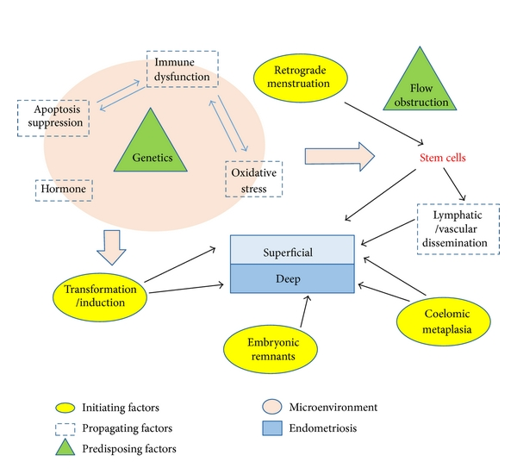Figure 1: Summary of relationship between the various etiologic factors involved in the pathogenesis of superficial versus deep endometriosis. [Adapted from Samer Sourial et al [4]]
- CLINICAL PRESENTATION:

Clinical presentation of endometriosis varies in women. The most common symptom in women with endometriosis is chronic pelvic pain which starts before menses and continues throughout the duration of menstrual flow. [9]
The second most typical symptom is infertility. Fertility rates are lower in women diagnosed with moderate and severe endometriosis, especially when the ovaries and oviducts are affected. Infertility issues affect 30 to 50 percent of endometriosis patients, particularly those under 35. [9]

Table 1: Clinical Presentation of Endometriosis [1,10]

CLINICAL PRESENTATION
Dysuria – pain while urinating
Dysmenorrhoea – periods with pain
Dyspareunia - painful intercourse
Dyschezia – pain during defecation
Inter-menstrual bleeding
Blood in stools
Diarrhoea or constipation
Infertility
Chronic fatigue
Pain in the pelvic region and sacral region of spine

- STAGES OF ENDOMETRIOSIS:

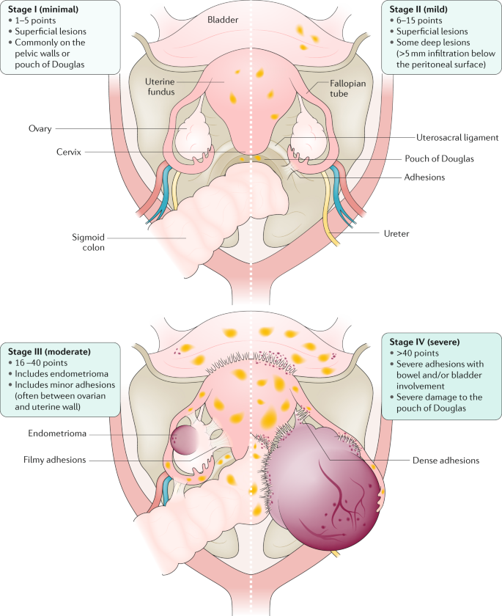Figure 2: Stages of Endometriosis [Adapted from Krina T. Zondervan et al [11]]
The updated American Fertility Society score, now otherwise called as American Society of Reproductive Medicine (ASRM) endometriosis staging system is based on a points system that takes into consideration the depth, location and extent of disease in relation to pelvic structures. [11]

Figure 3: Stages in Endometriosis according to American Society of Reproductive Medicine (ASRM) Criteria
Inadequacy of the ASRM criteria to foresee the probability of the conception following surgery, is important for patients seeking to conceive, is one of its biggest drawbacks. This resulted in the development of more recent classification schemes, like Endometriosis Fertility Index (EFI). ASRM scoring system is combined with post-surgery fertility data in the EFI. After three years, patients are given a score between 0 and 10; in patients with scores between 0 and 3 had a 10% chance of conceiving and patients those with scores between 9 and 10 had a 75% chance. [12]
- TYPES OF ENDOMETRIOSIS:

- Ovarian Endometriosis: It appears as superficial lesions with endometrial cysts in 2–10% of women of reproductive age. It is one of the most common types of endometriosis.[10]

Figure 4: Pictures depicting Ovarian Endometriosis [Adapted from I. Brosens et al [13]]

a: active and vascularised endometriotic lesion upon the ovarian surface and presence of vesicle on the parietal peritoneum.
b: endometriosis with fixed adhesions of ovary with pelvic sidewall.

- Peritoneal Endometriosis: It occurs in different forms like white raids on the peritoneum (intra-peritoneal and sub-peritoneal), peritoneal defects, brown, red and black foci, colourless vesicles and dilated blood vessels and petechiae. In 15–50% of all women with endometriosis, foci of the disease are discovered in the peritoneum.[10]
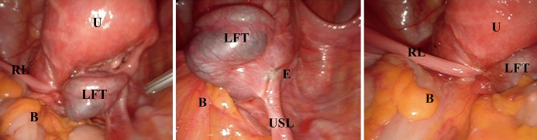
Figure 5: Pictures depicting Peritoneal Endometriosis [Adapted from Simone Ferrero et al [14]]
U – Uterus, E – Endometriosis, B – Bowel, USL – Left uterosacral ligament, RL – Right round ligament LFT – left Fallopian tube
- Deep Infiltrating Endometriosis (DIE) – It extends deep into the extra-peritoneal space of many pelvic organs. The pathophysiology of DIE is not clearly defined [10]. DIE includes endometriosis of the bladder, endometriosis of the ureter and rectovaginal endometriosis.[15]
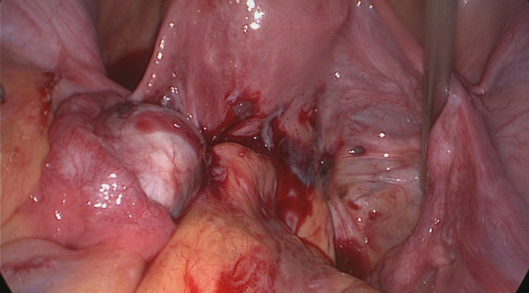
Figure 6: Picture depicting Deep Infiltrating Endometriosis [Adapted from Maurizio Nicola D’Alterio et al [15]]
- RISK FACTORS:

Table 2: List of factors that are linked to increased risk of Endometriosis [1,2,10]
FACTORS ASSOCIATED WITH INCREASED RISK
Early menarche - early first menstrual cycle before 11 years of age
Late Menopause
Menstrual cycles shorter than 27 days
Genital defects like narrow cervical canal or overgrowth of hymen
Low BMI
Alcohol and Caffeine intake
Obesity
Age 25–29
Smoking

- DIAGNOSIS/EVALUATION:

- Physical Examination: The International Deep Endometriosis Analysis group, proposes some basic steps to be followed physical examination:
- Evaluate by palpating the adnexa and uterus for presence or absence endometriomas or pelvic mass.
- Evaluation of transvaginal sonographic soft markers like ovarian mobility and tenderness.
- Examination of the Douglas pouch's condition.
- Examine the anterior and posterior compartments for DIE nodules. [16]

- Ultrasound (US): Transvaginal ultrasound is utilised to find ovarian endometriotic cysts and to more accurately look into the endometrium and uterine cavity. Pelvic masses can be visualized through transabdominal and transvaginal ultrasound. It is considered to be a first-line imaging technique due its low cost and feasibility. [1,16]

- Magnetic resonance imaging (MRI): After ultrasound (US), it is regarded as a second-line method because it offers an accurate picture of deep infiltrating endometriosis, MRI is currently regarded as the best imaging tool for mapping endometriosis. Imaging is essential for treatment planning despite the fact that final diagnosis is based on laparoscopy or surgery in addition to histological examination of the endometrium.[17]

- Laparoscopy: The only diagnostic procedure that can effectively rule out endometriosis is a laparoscopy. It is recognized as the standard investigation and is effective at detecting endometriosis [2]. Numerous studies have demonstrated that, in the majority of instances, the presence of endometriosis detected through laparoscopy may be verified histologically.[18]

- BIOMARKERS OF ENDOMETRIOSIS:

List of endometriosis diagnostic biomarkers:

- Growth factors – Hepatocyte Growth Factor (HGF), Insulin-like Growth Factor 1(IGF-1), Transforming Growth Factor Beta 1 (TGF β1).
- Stem cell markers – CD-9, Octamer-Binding Transcription Factor 4 (Oct-4), CD-34.
- Inflammatory cytokines – Interleukins (IL-1 β, IL-6, IL-8, IL-17 and IL-21), Regulated upon Activation, Normal T-cell Expressed and Secreted (RANTES), IFN-gamma (IFN‐γ), Monocyte Chemoattractant Protein-1 (MCP-1), C-reactive protein (CRP), Tumor Necrosis Factor-α (TNF-α), Macrophage Migration Inhibitory Factor (MIF).
- Steroids and hormones – Aromatase, Estrogen receptors (ERs), 17 βHSD hydroxysteroid dehydrogenase (17 βHSD).
- Cell adhesion and extracellular matrix molecules – β-catenin, Integrins, E-cadherin, ICAM-1 (CD54), Focal adhesion kinase (FAK), Osteopontin, Vimentin.
- Genomics – Homeobox A10 (HOXA10).
- Apoptosis and cell cycle control – Telomerase activity, Cyclin D1, B-cell lymphoma 2 (Bcl-2), p21 activated kinase-1 (Pak-1), Bcl-2-associated X protein (Bax), B-cell lymphoma-extra large (Bcl-xL), Myeloid cell leukemia-1 (MCL-1), Survivin. [1]

- COMPLICATIONS:

Figure 7: Picture depicting various complications of Endometriosis

- MANAGEMENT/TREATMENT:

Figure 8: Picture depicting numerous options of pharmacological treatment for endometriosis

- Non-steroidal anti-inflammatory drugs (NSAIDs): The most widely employed first-line treatments for pain caused by endometriosis is NSAIDs. It functions by inhibiting the COX enzyme, which is required for the generation of inflammatory mediators. However, research has demonstrated that tissues of ectopic endometrium contain a greater amount of COX-2 receptors. There is considerable evidence regarding the effectiveness of NSAIDs in reducing endometriosis-associated pain and its unfavourable gastrointestinal side effects [19]. NSAIDs are available over the counter and do not act by removing or decreasing deposits of ectopic endometrium [20].

- Progestins: Majority of the guidelines recommend progestins as first-line medical treatment for pain in endometriosis.

- Dienogest (DNG) is a 19-nortestosterone derivative and most commonly used dosage is 2mg per day.
- Medroxyprogesterone acetate is a derivative 17OH-progesterone. It is administered for intramuscularly or subcutaneously 150 mg every three months. It causes less bone loss than GnRH agonists.
- Levonorgestrel Intra Uterine System (LNG –IUS) is a hormonal contraceptive method that releases a derivative of 19-nortesterone. It intensifies the apoptotic activities, induces endometrial glandular atrophy and downregulates endometrial cell proliferation [21]. LNG- IUS is a T shaped device containing Levonorgestrel 52mg, which releases 20 micrograms of hormone every day for five years.[19]

- Combined oral contraceptive pills (COCPs): Progesterone by itself or in combination with oestrogen causes the endometriotic tissue to decidualize, which is believed to slow the disease's progress. The risk of venous thromboembolism is lower in combinations containing low doses of ethinyl estradiol (20 micrograms) than high doses (30 micrograms) [19]. It is widely indicated in patients with dysmenorrhea [21].

- Gonadotropin-releasing hormone (GnRH) analogs: This includes Gonadotropin releasing hormone agonists and antagonists.

- Gonadotropin releasing hormone agonists (GnRH agonists): GnRH agonists primarily cause the pituitary to release FSH and LH. Later, it results in pituitary GnRH receptor downregulation, which suppresses the hypothalamus pituitary ovarian axis and causes anovulation. As a result of the endometriotic implants being deprived of the essential oestrogen for their existence, this eventually causes regression of the implants, hypoestrogenism and amenorrhea. Leuprolide acetate, is a 3.75 mg monthly injection or 11.25 mg administered three monthly. Nafarelin and Goserelin are commonly used preparations [19]. Patients with endometriosis who continue to experience symptoms after trying first-line therapy are the only ones who are indicated with GnRH agonists.
- Gonadotropin-releasing hormone agonists (GnRH antagonist): Cetrorelix, is the most widely prescribed GnRH antagonist which provides regression of endometriotic implants and symptomatic relief. They have greater potential for treating endometriosis than GnRH agonists since they have better tolerance and less hypoestrogenemia.

- Danazol: Danazol, a derivative of 17 alpha-ethinyl–testosterone, is an androgenic agent that inhibits LH surge, disrupts estrogen production from the ovary and ovarian steroidogenesis by inhibition of ovarian enzymes. Due to its unfavourable side effects like weight gain, fluid retention, breast atrophy, acne, oily skin, hot flushes, hirsutism, its use is becoming less popular [9]. It is administered in divided doses of 400–800 mg per day for six months [19].

- Aromatase Inhibitors: The enzyme “Aromatase” is responsible for the conversion of androgens into estrogens. This induced oestrogen synthesis leads to enhanced growth of the endometrial implants and increased prostaglandin secretion that further induces the activity of aromatase. The aromatase inhibitors prevent the production of oestrogen in both the ovaries and the peripheral tissues. In postmenopausal women suffering with endometriosis, when peripheral fat is the main source of oestrogen, this mechanism is especially beneficial.

Exemestane, Letrozole and Anastrazole are third generation aromatase inhibitors are administered orally and have faster onset of action. When taken with progesterone, GnRH agonists, or combined oral contraceptives, they greatly lessen the discomfort associated with endometriosis, enhance quality of life and have proven to reduce the size of the lesion. Prolonged usage of these medications can result in ovarian follicular cysts and bone loss. Oral contraceptives and progestins can be added back in combination with GnRH agonists to lessen bone loss and prevent follicular growth.[19]

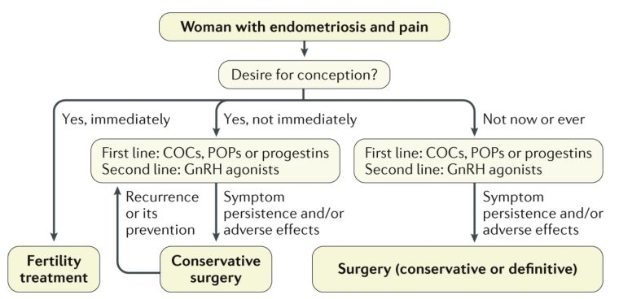
Figure 9: Algorithm for the management of endometriosis-associated pain [Adapted from Krina T Zondervan et al [11]]

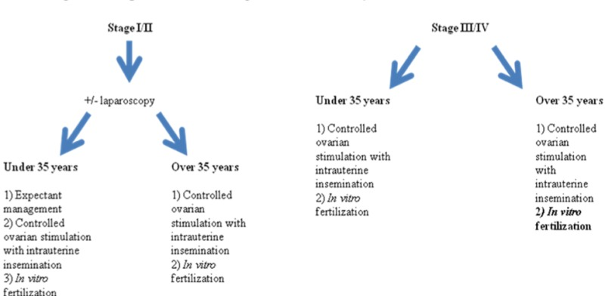
Figure 9: Algorithm for the management of endometriosis-associated infertility [Adapted from Olivia J Carpinello et al [9]]

- SURGERY OPTIONS:
Surgeries might be categorised as conservative or definitive. The Conservative therapy, sometimes known as fertility sparring, comprises the removal of endometriomas, resection of deep-infiltrating implants and ablation or excision of peritoneal implants. While hysterectomy with or without oophorectomy is the only option for definitive surgical treatment, doing so would reduce future fertility. Laparoscopy is considered as the gold standard for diagnosing as well as managing endometriosis [22].
Most guidelines advise laparoscopic surgery over laparotomy for infertility discomfort and chronic endometriosis as it is less painful, requires less time in the hospital, heals more quickly, and produces better cosmetic results [21]. Endometrial implants should only be removed or ablated laparoscopically after thorough consideration of the anatomical tissues implicated. Reduced implant recurrence rates and enhanced pain relief have been demonstrated with combined medicinal and surgical care of endometriosis implants [22].

- NEW ADVANCES IN TREATMENT:
Endometriosis is a chronic medical disorder that necessitates extensive treatment. The efficacy of current treatment approaches in controlling symptoms varies, but they are constrained with long-term consumption, increased rates of recurrence upon drug withdrawal and adverse effects of chronic hypoestrogenism. Due to these limitations, newer therapies are always being looked for. The following list of treatments have been tested in animal models with evidence in reduction lesions size and number and currently are under clinical trial testing for indication of endometriosis in humans.[19]

Figure 10: List of drugs that are currently under human trials to assess its indication in Endometriosis [19]

REFERENCES:
- Parasar P, Ozcan P, Terry KL. Endometriosis: epidemiology, diagnosis and clinical management. Current obstetrics and gynecology reports. 2017 Mar;6(1):34-41.
- Farquhar C. Endometriosis. BMJ. 2007 Feb 3;334(7587):249-53.
- Tsamantioti ES, Mahdy H. Continuing Education Activity.
- Sourial S, Tempest N, Hapangama DK. Theories on the pathogenesis of endometriosis. International journal of reproductive medicine. 2014 Oct;2014.
- Asghari S, Valizadeh A, Aghebati-Maleki L, Nouri M, Yousefi M. Endometriosis: Perspective, lights, and shadows of etiology. Biomedicine & Pharmacotherapy. 2018 Oct 1;106:163-74.
- Tao Y, Zhang Q, Huang W, Zhu H, Zhang D, Luo W. The Peritoneal Leptin, MCP‐1 and TNF‐α in the Pathogenesis of Endometriosis‐Associated Infertility. American Journal of Reproductive Immunology. 2011 Apr;65(4):403-6.
- Albertsen HM, Chettier R, Farrington P, Ward K. Genome-wide association study link novel loci to endometriosis. PloS one. 2013 Mar 5;8(3):e58257.
- Figueira PG, Abrão MS, Krikun G, Taylor H. Stem cells in endometrium and their role in the pathogenesis of endometriosis. Annals of the New York academy of sciences. 2011 Mar;1221(1):10-7.
- Carpinello OJ, Sundheimer LW, Alford CE, Taylor RN, DeCherney AH. Endometriosis.[Updated 2017 Oct. 22]. De Groot LJ, Chrousos G., Dungan K., Feingold KR, Grossman A., Hershman JM et al., eds. Endotext [Internet]. South Dartmouth (MA): MDText. com, Inc.; 2000. https://www. ncbi. nlm. nih. gov/books/NBK278996/(дата обращения—15.12. 2018). 2000.
- Smolarz B, Szyłło K, Romanowicz H. Endometriosis: epidemiology, classification, pathogenesis, treatment and genetics (review of literature). International Journal of Molecular Sciences. 2021 Sep 29;22(19):10554.
- Zondervan KT, Becker CM, Koga K, Missmer SA, Taylor RN, Vigano P. Endometriosis Nat Rev Dis Primers. 2018; 4: 9.
- Alimi Y, Iwanaga J, Loukas M, Tubbs RS. The clinical anatomy of endometriosis: a review. Cureus. 2018 Sep 25;10(9).
- Brosens I, Puttemans P, Gordts SY, Campo R, Gordts S, Benagiano G. Early stage management of ovarian endometrioma to prevent infertility. Facts, Views & Vision in ObGyn. 2013;5(4):309.
- Ferrero S, Vellone VG, Barra F. Pathophysiology of pain in patients with peritoneal endometriosis. Annals of Translational Medicine. 2019 Mar;7(Suppl 1).
- D’Alterio MN, D’Ancona G, Raslan M, Tinelli R, Daniilidis A, Angioni S. Management challenges of deep infiltrating endometriosis. International Journal of Fertility & Sterility. 2021 Apr;15(2):88.
- Rolla E. Endometriosis: advances and controversies in classification, pathogenesis, diagnosis, and treatment. F1000Research. 2019;8.
- Foti PV, Farina R, Palmucci S, Vizzini IA, Libertini N, Coronella M, Spadola S, Caltabiano R, Iraci M, Basile A, Milone P. Endometriosis: clinical features, MR imaging findings and pathologic correlation. Insights into imaging. 2018 Apr;9(2):149-72.
- Mettler L, Schollmeyer T, Lehmann-Willenbrock E, Schüppler U, Schmutzler A, Shukla D, Zavala A, Lewin A. Accuracy of laparoscopic diagnosis of endometriosis. JSLS: Journal of the Society of Laparoendoscopic Surgeons. 2003 Jan;7(1):15.
- Rafique S, Decherney AH. Medical management of endometriosis. Clinical obstetrics and gynecology. 2017 Sep;60(3):485.
- Brown J, Crawford TJ, Allen C, Hopewell S, Prentice A. Nonsteroidal anti‐inflammatory drugs for pain in women with endometriosis. Cochrane Database of Systematic Reviews. 2017(1).
- Kalaitzopoulos DR, Samartzis N, Kolovos GN, Mareti E, Samartzis EP, Eberhard M, Dinas K, Daniilidis A. Treatment of endometriosis: a review with comparison of 8 guidelines. BMC women's health. 2021 Dec;21(1):1-9.
- Zanelotti A, DeCherney AH. Surgery and endometriosis. Clinical obstetrics and gynecology. 2017 Sep;60(3):477.

