Review of Image Enhancement in Spatial vs, Frequency Domain
¹Anita Pati Mishra
²Monika Dixit Vajpayee
Abstract:
Image enhancement is a critical and difficult step in the processing of digital images.The fundamental aim of image enhancement is to uncover the hidden components in a picture. Picture enhancement improves the quality of the image for human presentation. Enhancement procedures include things like increasing contrast, eliminating noise and blur, and revealing details.Spatial domain and frequency domain picture enhancement are the two basic types.The two tactics discussed in this chapter are contrasted with ones that are comparable to them.The goal of image enhancement is to make images simpler for people to comprehend or perceive or to provide "better" input to other automated image processing techniques, like face recognition-based biometric techniques, among others.Face recognition, matching fingerprints, and early biology applications. Picture enhancement is one of the most important and difficult steps in digital image processing. The main aim of image enhancement is to reveal the hidden details in a picture.The quality of the image is improved for human presentation by picture enhancement.Increasing contrast, eliminating noise and blur, and illuminating features are a few examples of enhancement operations.Spatial domain and frequency domain are the two main types of image enhancement.This chapter contrasts these two approaches with ones that are comparable to them.The goal of image enhancement is to make images simpler for people to interpret or perceive or to provide "better" information to other automated image processing techniques, including biometric techniques that use face recognition, among others.Face recognition, fingerprint comparison, and preliminary biological terms biometric techniques that use face recognition, among others like matching fingerprints, recognising faces, and morphological applications.
Keywords: Digital Image processing, Image Enhancement, Automated Image Processing, Fingerprint Matching & Fourier Transform.
Introduction
Image processing is a technique used to perform specific operations on an image to create a better image or to extract some useful information from it.A picture is used as the input in this type of signal processing, and the output may be another image or properties or attributes that are connected to the input image.Image processing is one of the modern technologies that is growing swiftly.It also functions as a key research topic within the fields of engineering and computer science.
Improvement and coercion on Arithmetic and Logic operations:
Importing the image using image capture tools, analysing and editing the image, and producing the result—which could be an altered image or a report that incorporates image analysis—are the three steps that make up an image process.Analogue and digital technologies are the two main categories used for picture processing.
Analogue and digital technologies are the two main categories used for picture processing.
Analog image processing can be used for copies that require a lot of labour, including printouts and images. Image analysts apply a number of interpretational pillars while utilising these visual techniques. Computers can edit digital photos more easily thanks to digital image processing algorithms. Each form of knowledge should go through three general steps when employing digital technology: pre-processing, development, and show, data extraction. In this course, we'll utilise a lot of basic terms like "image," "digital image," and "digital image process."For each source of digital photos, an example will be shown, and numerous sources will be thoroughly analysed. the time it takes for a picture to appear in a laptop's screen. We will use several numerous techniques Basic terms like "image," "digital image," and "digital image process" are used throughout the course. For each source of digital photos, an example will be shown, and numerous sources will be thoroughly analysed. The journey from image processing to computer vision will be covered in this talk. We'll sum up by citing various image sensor types and image acquisition.
Division and Sampling
To be appropriate for digital processing, an image action f(x,y) needs to be digitalized both spatially and by amplitude.A frame unpleasant person, or digitizer, is often used to quantize and sample the analogue video output.Therefore, our goal is to digitise continuous knowledge in order to produce a digital image.

There are two steps to completing it:
Sampling Quantization
The division level defines the number of grey levels in the digitised image, whereas the rate controls the abstraction resolution of the digitised image. In image processing, the size of the sampled image is expressed as a digital worth. Division is the process of switching from the continuous values of an image to its digital equivalent.For humans to be able to distinguish the subtle shading characteristics in the image, there should be a sufficient number of division levels. The fundamental flaw in an image that has been measured at a low brightness level is the prevalence of spurious contours.We'll use two crucial steps of the digital picture processing in this course. Sampling and division will be adequately explained. The introduction of abstraction and grey-level resolutions.
Common interpolation algorithms may be classified into 2 categories:
Accommodative and Non-adaptive.
The division level defines the number of grey levels in the digitised image, whereas the rate controls the abstraction resolution of the digitised image.
In image processing, the size of the sampled image is expressed as a digital worth.
Division is the process of switching from the continuous values of an image to its digital equivalent For humans to be able to distinguish the subtle shading characteristics in the image, there should be a sufficient number of division levels. The fundamental flaw in an image that has been measured at a low brightness level is the prevalence of spurious contours. We'll use two crucial steps of the digital picture processing in this course. Sampling and division will be adequately explained. The introduction of abstraction and grey-level resolutions
Aliasing and image improvement
Image improvement: distinction enhancement, part I
Digital slice of any signal, whether sound, digital film land, or other signals, can produce apparent signals at frequentness that are significantly lower than those of the original. When a symbol is tried from a signal at double the optimal frequence, aliasing occurs. In order to help the product of signals at frequentness outside the original sound, signals advanced than0.5 Hz should be filtered. As a result, low- pass pollutants are used in digital audio recording outfit to remove any signals that are constantly lesser than0.5. Since a sample is a direct system, its affair will be an addition of tried sinusoids if its input is an addition of sinusoids.

Image enhancement ways are wide employed in several operations of image process
wherever the private quality of filmland is vital for mortal interpretation. Distinction is a pivotal think about any private analysis of image quality. Distinction is made by the distinction
in brilliance imaged from 2 conterminous shells. In indispensable words, distinction is that the distinction in visual parcels that produces Associate in Nursing object distinguishable from indispensable objects and thus the background..

Our sensitive system is fresh sensitive to distinction than absolute luminance; so, we will understand the earth inversely in malignancy of the respectable changes in illumination conditions. several algorithms for negotiating distinction enhancement are developed and applied to issues in image process.
In this lecture we'll quote distinction enhancement. Linear andnon-linear metamorphosis functions like image negatives, exponent metamorphoses, power- law metamorphoses, and piecewise direct metamorphoses are going to be mentioned. Bar graph system and bar graph of 4 introductory slate- position characteristics are going to be introduced. A fashion that aims to lessen the appearance of aliased slant edges isanti-aliasing. More resolution and the appearance of sandblasted edges are handed byanti-aliasing. It functions by counting for the degree to which a perfect edge overlaps neighbouring pixels. We ’ll use quotations from abstraction aliasing andanti-aliasing in this donation. In addition, we'll start talking about how to boost your image. There will be 2 main orders of image enhancement introduced. The purpose system and neighbour system will be described. Eventually, we'll offer an preface to associate in nursing distinction.
Image improvement: Distinction enhancement, part II
Still, e, If the distinction of a picture is extremely concentrated on a particularvaries.g. a picture is incredibly dark; the data could also be lost in those areas that are too and slightly targeted. The matter is to optimize the distinction of a picture so as to represent all the data within the input image.

Abstraction sphere filtering, part I

Filtering could be a fashion for modifying or enhancing a picture. Abstraction sphere operation or filtering( the reused worth for the present picture element reused worth for the present picture element depends on each itself and close pixels). thus, Filtering could be a neighbourhood operation, within which the worth of any given picture element within the affair image is set by applying some formula to the values of the picture rudiments within the neighbourhood of the corresponding input pixel. A pixel's neighbourhood is a many set of pixels, outlined by their locales relative to it picture element.

In this lecture we'll quote abstraction sphere operations. Mask or pollutants are going to be outlined. The final system of complication. Associate in nursing correlation are going to be introduced via an illustration. also, smoothing direct pollutants like box and weighted average pollutants are going to be introduced.

Abstraction sphere filtering, part II
Spatial filtering could be a variety of finite impulse response( FIR) filtering. The sludge is really a mask of weights organized in a veritably blockish pattern. The system is one in all slippery the mask on the image and playacting a multiply and accumulate operation on the pixels lined by the mask.
In this lecture we'll quote ordered applied calculation pollutants and median sludge are going to be introduced.
original and alternate ordered discriminational pollutants like grade and Laplacian are going to be introduced.
We ’ll get to grasp still Sobel driver is performing.
Basics of Spatial Pollutants

Spatial Filtering and Its kinds
Spatial Filtering fashion is employed directly on pixels of a picture. Mask is generally allowed of to be value- added in size so it's specific centre element. This mask is affected on the image specified the middle of the mask traverses all image pixels.

Classification
on the premise of linearity
There square measure 2 types
1. Linear spatial Sludge
2. Non-linear spatial Filter
General Classification

Smoothing Spatial Sludge Smoothing sludge is employed for blurring and noise reduction within the image. Blurring ispre-processing way for junking of bitsy details and Noise Reduction is fulfilled byblurring images.
Forms of Smoothing spatial Filter

1. Linear Filter( Mean Filter)
2. Order Statistics(Non-linear) filterBMGHKHIGKHYOOMPKPPTPMPPH- HJ( H(()( F)() FHJHH) H() LH)) JGL( JG( LG( J() GLJ( GLH( G( JLF() O
DYRGIRIITRYROYORIDAYOPUTUJDGLTIO( OP( UIHUHJJJJI ’( O, JKKJJ

These square measures explained as following below.
Mean Filter

Linear spacial sludge is just the typical of the pixels contained within the neighborhood of the sludge mask. the study is dicker the worth of each element in a picture by the typical of the argentine situations within the neighborhood figure by the sludge mask.
Types of Mean sludge

•( i) Comprising sludge it's employed in reduction of the detail in image. All portions square measure equal.
•( ii) Weighted averaging sludge during this, pixels square measure increased by fully different portions. Center element is increased by a better worth than average sludge.

2. Order Statistics Filter
It's supported the ordering the pixels contained within the image space encompassed by the sludge. It replaces the worth of the middle element with the worth determined by the ranking result. Edges square measure advanced saved during this filtering.

Types of Order statistics sludge
Text To Speech
y the most important value within the window.
•( iii) Median sludge every element within the image is taken into account. 1st neighbouring ingredients square measure sorted and original values of the pixel square measure replaced by the standard of the list.

stropping special Filter

It's also called by- product sludge. The end of the stropping spatial sludge is simply the volition of the smoothing spatial sludge. It’s main focus in on the junking of blurring and highlights the sides. It's supported the primary and alternate order by- product.

First order outgrowth
Must be zero in flat parts.
• Must be non zero at the onset of a argentine position step.
• Must be non zero on ramps.

First order by- product in 1- D is given by
f' = f( x 1)- f( x)
Alternate order secondary

• Must be zero in flat areas.
• Must be zero at the onset and finish of a ramp.
• Must be zero on ramps.

Alternate order by- product in 1- D is given by
f'' = f( x 1) f(x-1)- 2f( x)
The special sphere enhancing relies on pixels in a veritably bitsy vary( neighbour). this implies the remodelled intensity is set by the slate values of these points inside the neighbourhood, and thus the special sphere sweetening is also appertained to as neighbourhood operation or neighbourhood process.

A digital image are frequently viewed as a two- dimensional perform f( x, y), and thus thex-y aeroplane indicates special position word, appertained to as the special sphere. The filtering operation supported thex-y area neighbourhood is named special sphere filtering.The filtering system is to manoeuvre the sludge point- by- point within the image perform f( x, y) so the middle of the sludge coincides with the purpose( x, y). At every purpose( x, y), the sludge’s response is calculated supported the precise content of the sludge and thru a predefined relationship appertained to as illustration.still, it's also appertained to as direct special sphere filtering; else, it’s appertained to as nonlinear spacial sphere filtering, If the element within the neighbourhood is calculated as a direct operation. Figure2.3.1 shows the system of special.
The portions of the sludge in direct spatial filtering give a weighting pattern. For illustration, for Figure2.3.1, the response R to the template is
R = w(- 1,-1) f(x-1, y- 1) w(- 1, 0
f(x-1, y) w( 0, 0) f( x, y)
w( 1, 0) f( x 1, y) w( 1, 1) f( x 1, y 1)
For a sludge with a size of( 2a 1, 2b 1), the affair response can be calculated with the following function
Smoothing Pollutants
Image smoothing is a digital image processing fashion that reduces and suppresses image noises. In the spatial sphere, neighbourhood averaging can generally be used to achieve the purpose of smoothing.
Average Smoothing
First, let’s take a look at the smoothing sludge at its simplest form — average template and its perpetration.

The points within the three × three neighbourhood concentrated on the purpose( x, y) area unit altogether concerned in determinant the( x, y) purpose element within the new image “ g ”. All portions being one means they contribute constant( weight) within the system of shrewd the g( x, y) value. The last constant,1/9, is to confirm that the aggregate of the complete template corridor is one. This keeps the new image within the same argentine scale vary because the original image(e.g.,( 0, 255)). Such a “ w ” is named a median template.
How it works?
In general, the intensity values of conterminous pixels area unit analogous, and thus the noise cause argentine scale jumps at noise points. still, it's affordable to assume that occasional noises do not correction the native durability of a picture. Take the image below for case, there area unit 2 dark points within the bright space.

For the borders, we can add a padding using the “ replicate ” approach. When smoothing the image with a 3 × 3 average template, the performing image is thefollowing.OHOBOONOH Squall( FGNJF( = MHNFHHMHPJRP =P ( P
The two noises are replaced with the normal of their girding points. The process of reducing the influence of noise is called smoothing or blurring.

Smoothening and stropping Spatial Pollutants
Birth in image process. still indeed during this last case, smoothing are going to be needed so as to get a sturdy resolution. This has impelled the study and development of ways that were ready to deal with each operation.

The original approach is occasionally to contemplate it as a two- way process original smoothing and latterly stropping, or the contrary means around. still, this approach occasionally ends up in several issues. On the one hand, if we've a tendency to cosign apply a smoothing fashion, also we've a tendency to may be losing data that can not be recovered within the succeeding stropping step. On the contrary hand, if we've a tendency to cosign apply a stropping
methodology over a loud image, we're going to amplify the noise gift in it. the perfect thanks to address this strike is to contemplate a way that was ready to sharp image details and edges whereas removing noise. still, this can be not a straightforward task given the other nature of those 2 operations.

numerous ways for each stropping and smoothing are planned within the literature, still if we've a tendency to limit ourselves to ways that contemplate each of them at the same time, the progressive is not thus ferocious. during this work we're going to jointly survey
Smoothing
Image smoothing ways have the thing of defensive image quality. In indispensable words, to get relieve of noise while not losing the top options of the image. still, there square measure numerous kinds of noise. the most 3 kinds are impulsive, cumulative, and adding . Impulsive noise is occasionally characterised by some portion of image pixels that square measure corrupted, going the others unchanged. cumulative noise seems once the values of the original image are changed by adding arbitrary values that follow a precise liability distribution. Eventually, adding noise is harder to be far from filmland than cumulative noise, as a result of during this case intensities vary in confluence with signal intensity(e.g., patch noise).

There square measure completely different sources of noise and numerous of denoising ways for every nicely noise. the foremost common bone is perhaps the alleged thermal noise. This impulsive noise is because of CCD sensor malfunction within the image accession system.
Another attention- grabbing case is Gaussian noise, within which every picture element of the image are going to be modified from its original worth by some touch that follows a distribution. this type of noise is modelled as associate degree cumulative white Gaussian noise. So that, its presence are frequently dissembled by adding arbitrary values from a zero- mean distribution to the original picture element intensities in every image channel severally, wherever the quality the quality of the distribution characterizes the noise intensity.
The elimination of this kind of noise is understood as smoothing, and this may be the kind of noise elimination allowed - about during this work. There square measure numerous nonlinear ways for smoothing. within the remainder of the section, we're going to review a number of them.
Bilateral Sludge( BF)
Within nonlinear ways, a large order of them uses comprising to bear advantage of the zero- mean property of the Gaussian noise. This order includes the well- known Bilateral Sludge BF) and its variants. BF could be anon-linear methodology ready to satiny a picture whereas esteeming
sturdy edges. this could be done by process every picture element as a weighted normal of its pixel values.

Published in

VITHelper

Anshul Sachdev
Oct 2, 2019
·
3 min read
·

Spatial and Frequency Domain — Image Processing
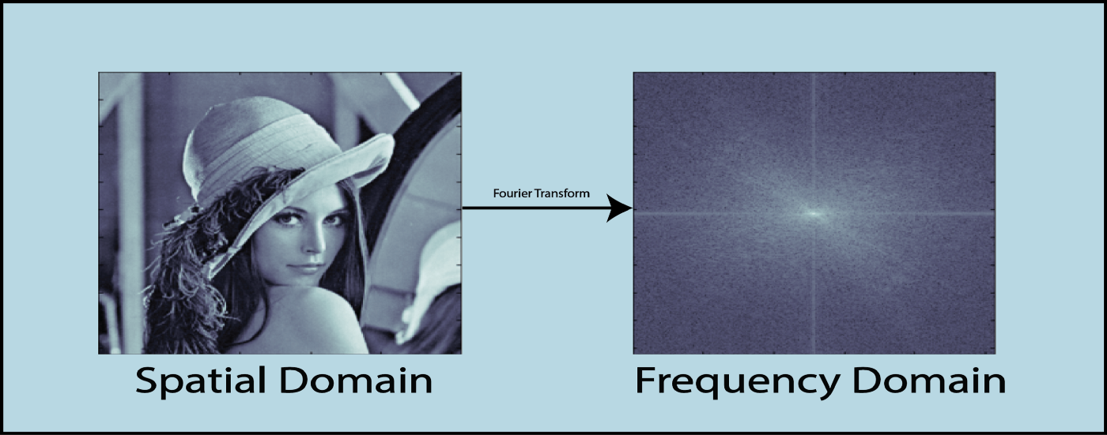

Spatial Domain-
An image can be represented in the form of a 2D matrix where each element of the matrix represents pixel intensity. This state of 2D matrices that depict the intensity distribution of an image is called Spatial Domain. It can be represented as shown below-
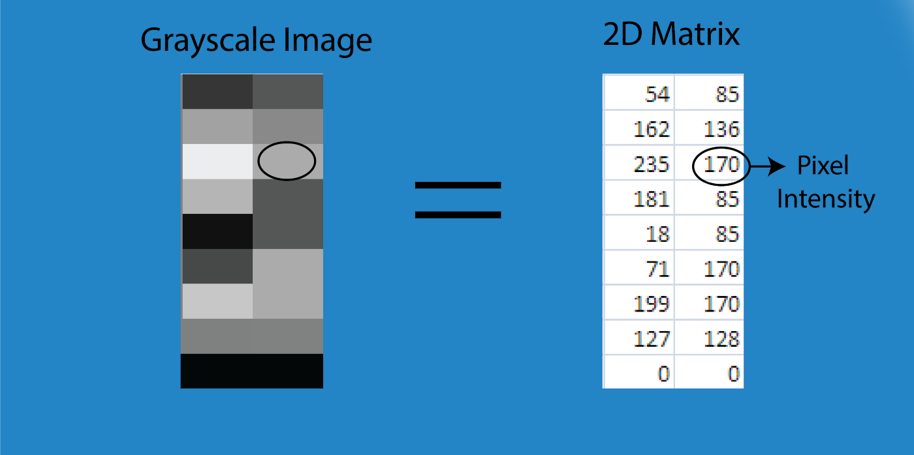
Illustration of Spatial Domain
For the RGB image, the spatial domain is represented as a 3D vector of 2D matrices. Each 2D matrix contains the intensities for a single color as shown below-
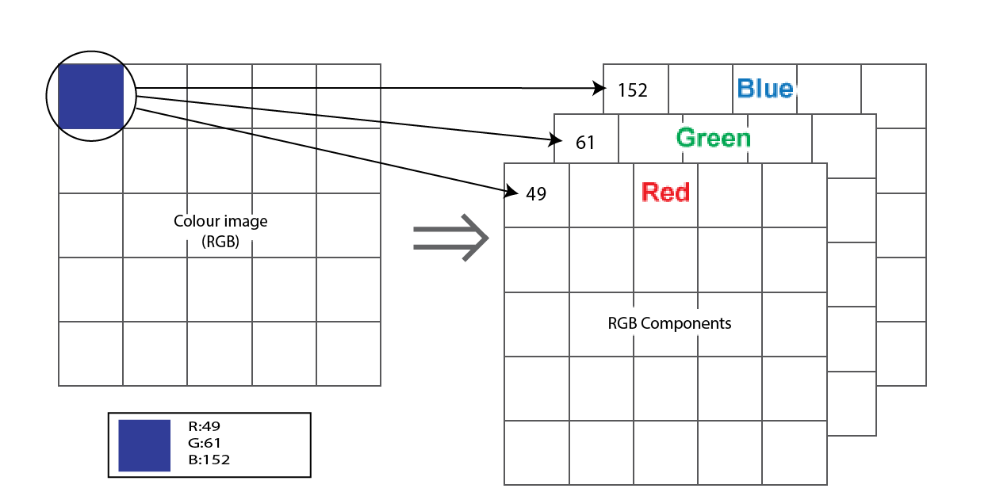
Spatial domain for color image(RGB)
Each pixel intensity is represented as I(x,y) where x,y is the co-ordinate of the pixel in the 2D matrix. Different operations are carried out in this value. For example- operation T(say, addition of 5 to all the pixel) is carried out in I(x,y) which means that each pixel value is increased by 5. This can be written as-
I’(x,y) = T[I(x,y)]
where, I’(x,y) is the new intensity after adding 5 to I(x,y).

Frequency Domain-
In frequency-domain methods are based on Fourier Transform of an image. Roughly, the term frequency in an image tells about the rate of change of pixel values.
Below diagram depicts the conversion of image from spatial domain to frequency domain using Fourier Transformation-

Some pictures mentioned belowof image enhancement techniques of frequency domain as well as spatial domain.

Image Transformation mainly follows three steps-
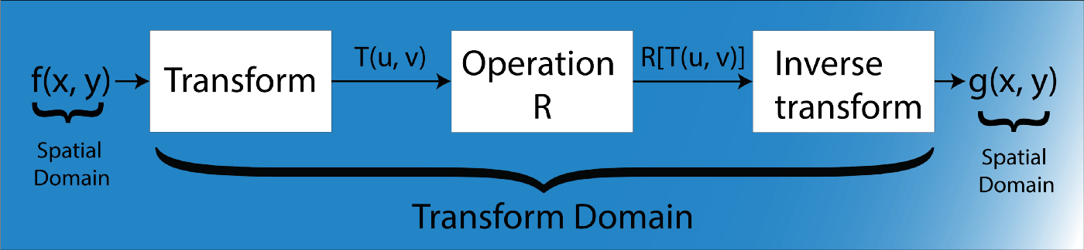
Step-1. Transform the image.
Step-2. Carry the task(s) in the transformed domain.

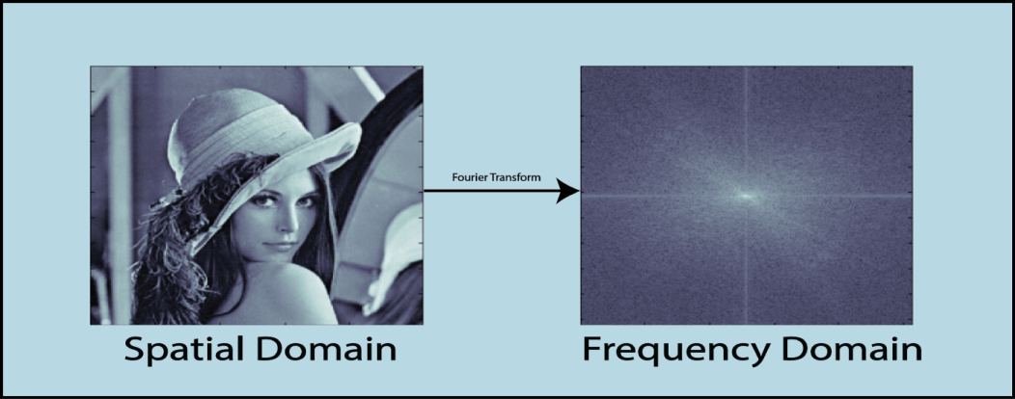
Conclusion
Linear filtering is one of the most comfortable involved in 2 dimensional image processing. Before such processing methods can be implemented on a system, the images have to be digitalized, which implies spatial sampling and luminance quantization. Spatial sampling induces periodicities in the frequency representation of the processed images, which allows limiting their pixel categorization to a precise frequency domain. The spatial convolution operator is the mathematical representation associated with linear and spatially invariant filtering. Filtering computation can be implemented in the spatial or frequency domain depending on the nature and the complexity of the applied filters. In the simplest cases, the operator is fully described by a 2x2 or a 3x3 matrix. Examples of such filters and their results on real images are presented to give an idea of the application potential of the technique. The operation are carried out on Clown and Lena images for better performance observation. Further research can be continued for lesser degradation in various images restoration and better clarity in pixel values of 2 dimensional images.

References
[1] A. Adler, D. Boublil, and M. Zibulevsky. Block-based com-pressed sensing of images via deep learning. In 2017 IEEE19th International Workshop on Multimedia Signal Process-ing (MMSP), pages 1–6, 2017.
[2] P. E. Batson, N. Dellby, and O. L. Krivanek. Sub- ̊angstromresolution using aberration corrected electron optics. Nature,pages 617–620, 2002. 1
[3] Benjamin Berkels, Peter Binev, Douglas A. Blom, Wolf-gang Dahmen, Robert C. Sharpley, and Thomas Vogt. Op-timized imaging usingnon-rigid registration. Ultrami-croscopy, 138:46 – 56, 2014. 1.
[4] E. J. Candes and T. Tao. Near-optimal signal recoveryfrom random projections: Universal encodinstrategies?IEEETransactionsonInformation Theory, 52(12):5406–5425, 2006. 1
[5] Emmanuel J. Cand`es, Justin K. Romberg, and Terence Tao.Stable signal recovery from incomplete and inaccurate measurements.Communications on Pure and Applied Mathe-matics, 59(8):1207–1223, 2006.
[6] I. Daubechies, M. Defrise, and C. De Mol. An iterativethresholding algorithm for linear inverse problems with asparsity constraint. Communications on Pure and AppliedMathematics, 57(11):1413–1457, 2004.
[7] W. Dong, G. Shi, X. Li, Y. Ma, and F. Huang. Compressivesensing via nonlocal low-rank regularization. IEEE Transac-tions on Image Processing, 23(8):3618–3632, 2014. .
[8] D. L. Donoho. Compressed sensing. IEEE Transactions onInformation Theory, 52(4):1289–1306, 2006. 1, 2
[9] Jeffrey M. Ede, Beanland, and Richard. Partial scanningtransmission electron microscopy with deep learning. Sci-entific Reports, page 8332, 2020. 2
[10] M. Haider, S. Uhlemann, E. Schwan, and et al. Electronmicroscopy image enhanced. Nature, pages 768–769, 1998

