“FOOD RECOGNITION AND CALORIE ESTIMATION.

Alakananda K Asst. Professor Dept. of CSE VTU
Mangaluru, Karnataka alakananda.cs@sahyadri.edu.in
Ayaan Imthiyaz
Dept. of CSE
VTU
Mangaluru, Karnataka ayaanimthiyaz.cs18@sahyadri.edu.in
Mohammed Hisham Jaleel Dept. of CSE
VTU
Mangaluru, Karnataka hishamjaleel.cs18@sahyadri.edu.in

Dhwanil Rokad Dept. of CSE
VTU
Mangaluru, Karnataka dhwanilr.cs18@sahyadri.edu.in
Zuhaib Mohammed Khan Dept. of CSE
VTU
Mangaluru, Karnataka
zuhaib.cs18@sahyadri.edu.in”

ABSTRACT

An unhealthy diet may contribute to obesity, which can lead to a variety of health issues including heart disease and high blood pressure. Certain malignancies can also be a result of obesity. The suggested method uses Convolution neural networks to recognize food images and calculate the calorie content based on the food's weight. This allows the user to keep track of their calorie consumption. Images belonging to 20 different classes have been used to train the model. People may benefit from the suggested system's ability to assist them maintain a healthy diet and lifestyle.

“Keywords— Feature Extraction Convolutional Neural Network Classification ,Food recognition, Calorie estimation, classification, features.

INTRODUCTION”

In order to maintain a balanced diet and avoid obesity in humans, it is now necessary to consume a variety of healthy meals on a regular basis. Diet is vital to the health of the human body. Therefore, every diet plan must take into consideration the total calorie intake required to maintain a healthy lifestyle. Most people do not record their daily caloric intake since it is inconvenient to jot it down or type it in on their phone or computer. This is why having a system in place to facilitate the process is critical. Machine learning and artificial intelligence have been in great demand during the last several years. Convolutional neural networks (CNNs) and other deep learning approaches may help handle problems like these. Users would just need to provide a picture, and the system would then make an educated guess as to what it may be. This is accomplished via the use of coevolutionary neural networks. With this technique, health-conscious individuals may keep their lifestyle and nutrition under check. Avoiding obesity, which may lead to high blood pressure and diabetes, as well as some cancers, can be achieved by adopting a balanced diet and lifestyle.
.

METHODOLOGY

- Collecting Data for model

The Indian cuisine dataset has been used to train the model. The data was downloaded from Kaggle. Images pertaining to 20 courses may be found here. Some of the lessons include Samosa, Pav Bhaji, Chapati, and tea, amongst others. Images may be gathered in a variety of methods, including by downloading them directly from the web, by utilizing Google extensions, or by using previously acquired and saved images on online platforms.

Pre-Processing

Different formats and quality levels of data were used to create the dataset's picture data. The pre-processed data was now ready to be sent into the modeling procedure. The data was scaled to fit in a single dimension. During this step, algorithms are used to enhance various aspects of the input food image in order to produce an improved output image for use in the rest of the proposed system.

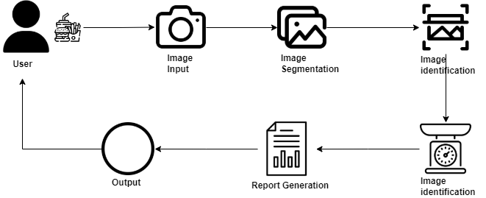
Figure 1: Proposed System
The suggested system design is shown in Figure 1 above. Preparation of data, extraction of feature sets, and model construction are all performed by the user. Classification is followed by the implementation of a calorie estimate function

Convolution Neural Networks

In order for Convolutional Neural Networks (CNNs) to be as successful as possible in computer vision tasks like image identification and classification, the layers must be tightly connected. Image, video, and visual data may all be processed using deep learning algorithms. Extracting and choosing characteristics from photos are used to classify them into different categories. Classification is the primary function, although it is also used to identify multiple-class items. CNN is made up of a series of stages or levels, as follows:

Convolution layer

To determine final dimensions, the product of each filter and each patch of images in the layer is employed. If we utilize a subtotal of roughly 12 filters for the layer, we will get an output volume of 32 x 32 x 12.

Pool layer.

A concussion's major purpose is to lower the noise level, which speeds up processing, protects memory, and limits generalization. There are two types of pooling layers: maximal pooling and the average pooling layer. If we use a maximum of 2x2 filters, including stride 2, the volume will be 16x16x12.

- Activation function

An activation function for each individual element will be utilized to merge the output of the convolution layer. Tanh, Leaky RELU, RELU: max(0, x), Sigmoid: 1 1+ex, and Tanh are all frequently used activation functions.

- Calorie Estimation

The technology then estimates the number of calories in the classified food picture. Users will be able to see how many calories they will be ingesting at any given time. The calorie count is dependent on the food's weight. The gram weight of the meal must be entered by the user. In order to compute the user's calorie intake, the csv file with calorie per gram data is used. Where can I find F*C? F – Grams of Input; C – Calories per gram. In the following table, the calorie content per gram of each food name in the dataset is provided.

“Food Name | Calories Per Gram
Burger | 2
Butter naan | 3
Chai | 1
Chapati | 2
Chole bhature | 2
Dal Makhani | 1

EXPERIMENTAL RESULT”
Testing is the process of running a program with the sole purpose of finding errors, if any, that would cause the program to fail. In order to enhance the product, you must go through this step. It plays a crucial function in QA and in ensuring that programming quality is always maintained. Errors and omissions are detected, and a comprehensive check is performed to see whether the intended outcomes and customer criteria have been satisfied.

It is the goal of the testing process to identify any requirements, outlines, or code errors that may exist in the projects. Frameworks for programming use a variety of testing methods. When it comes to maintenance, the test findings come in handy. Each class of exam should have a specific focus in this region, which is where the test's many interest points are organized. The techniques of testing, which play a critical role in the development of a product, may be used to do this in principle.

Unit testing and integration testing are two forms of testing. Unit testing was used in the testing process.

“Sl No. Test Case | Work | Duration(in Weeks)
Name of the Test | System Design | 2
Sample Input | Machine Learning Development | 3
Expected output | Dashboard Development & VNC | 3
Actual output | Integration & Porting | 2
Remark | Testing | 2
Table 1: Unit testing for feature extraction

RESULT AND DISCUSSION”

Web-based Python scripting collaboration platform was used to develop the CNN model to identify food. The model was ready for testing after ten rounds of preparation. After a short time, the model's accuracy improves and its tragedy diminishes. A few tweaks to the model resulted in an accuracy of 82%. The framework's user interface was built using Streamlit, an open-source Python application structure. Web applications for information science and artificial intelligence are unquestionably possible with it. If you are looking for a way to use the most popular Python libraries, such scikit-learn, PyTorch and Keras, you may do so with it.

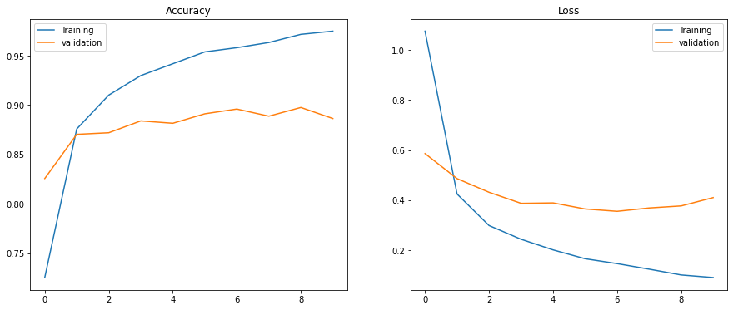
Figure 2: Accuracy Graph

V.CONCLUSION

Predicting the food class is accomplished via the use of machine learning and image processing in this study. With the aid of the food's weight, it also provides a method for calculating calories. The CNN algorithm is used to categorize food. Users may snap photos of their meals with the help of this model. Afterwards, the image is edited. As a consequence of categorizing food, the projected calorie count is shown. BMI and calorie intake are calculated using the user's height and weight in order to show whether their food consumption is healthy or not. Calorie counting is made easier with this app, which may help users stay on track with their diet. Whether you are an expert or a novice, this strategy will work for you.

Research in the future will focus on developing a full framework that includes server-side modules, including a qualified model, and an application for smart mobile devices with features such as macro and micronutrient monitoring, tailored food plans, and customized exercise programs. Users will be able to keep track of their caloric intake and live a healthy lifestyle with the help of this program. While the user enters the unknown picture data, the system will dynamically expand its dataset to help improve classification accuracy by covering as many food items as possible.

REFERENCES
- H. Hu, Z. Zhang, and Y. Song, “Image based food calories estimation using various models of machine learning,” in 2020 5th International Conference on Mechanical, Control and Computer Engineering (ICMCCE), pp. 1874–1878, 2020.H. Bahuleyan, “Music genre classification using machine learning techniques,” arXiv preprint arXiv:1804.01149, 2018.

- P. Pouladzadeh, P. Kuhad, S. V. B. Peddi, A. Yassine, and S. Shirmohammadi, “Food calorie measurement using deep learning neural network,” pp. 1–6, 05 2016.

- G. B. M.Bharathi, S.Suma, “Food recognition and calorie estimation using image processing,” Internation Journal Of Advance Research And Innovative Ideas In Education, vol. 6, no. 1, pp. 1292–1296, 2020

- F. P. W. Lo, Y. Sun, J. Qiu, and B. Lo, “Food volume estimation based on deep learning view synthesis from a single depth map,” Nutrients, vol. 10, p. 2005, 12 2018

- C. Liu, Y. Cao, Y. Luo, G. Chen, V. Vokkarane, and Y. Ma, “Deepfood: Deep learningbased food image recognition for computer-aided dietary assessment,” in Inclusive Smart Cities and Digital Health (C. K. Chang, L. Chiari, Y. Cao, H. Jin, M. Mokhtari, and H. Aloulou, eds.), (Cham), pp. 37–48, Springer International Publishing, 2016..

- V. B. Kasyap and N. Jayapandian, “Food calorie estimation using convolutional neural network,” in 2021 3rd International Conference on Signal Processing and Communication (ICPSC), pp. 666–670, 2021.

- N. O. M. Salim, S. R. Zeebaree, M. A. M. Sadeeq, A. H. Radie, H. M. Shukur, and Z. N. Rashid, “Study for food recognition system using deep learning,” Journal of Physics: Conference Series, vol. 1963, p. 012014, jul 2021.

- H. Kagaya, K. Aizawa, and M. Ogawa, “Food detection and recognition using convolutional neural network,” pp. 1085–1088, 11 2014.

- T. Ege and K. Yanai, “Image-based food calorie estimation using knowledge on food categories, ingredients and cooking directions,” pp. 367–375, 10 2017.

on Multimedia, pp. 159–168, 2008.

- T. Feng, “Deep learning for music genre classification,” private document, 2014.

