Beneficial effect of Lactic Acid Bacteria in Human
A Bala and J Victoria
PG and Research Department of Microbiology,
Sengamala Thayaar Educational Trust Women’s College,
Mannargudi, Tamilnadu, India.

Abstract
There has been reported whether consuming food kinds that have undergone fermentation can affect one's wellbeing. These beneficial effects can be achieved by combining the living microorganisms that mature food sources possess with the bioactive substances that are introduced into the food sources as an outcome of fermentation. The microorganisms linked to the ageing system frequently coexist with both the Lactic Acid bacterial assemblage, particularly in dairy fermentation sources of food (LAB). The creation of "fermentates" is a different approach to dealing with how to make some of the therapeutic benefits associated with mature food variety accessible. Most often, the word "fermentate" refers to a powdery preparation made from a ripened substance.
Introduction
Lactic Acid Bacteria (LAB) are a diverse group of bacteria that can be found in any environment that has a complex carbohydrates content, such as in plants, established food sources, and on the mucosal surfaces of humans, other apes, and marine life. LAB are crucial for the typical microbiota or microflora, the environment that typically resides in the gastrointestinal and genitourinary tracts and is made up of a huge variety of distinct bacterial species with a varying number of strains [1].
Additionally, LAB play a big role in the business these days when it comes to blending synthetic substances, medicines, or other useful goods (Figure 1). The biotechnological development of lactic acid corrosive, which just came to light and provides a solution for the natural pollution by the petrochemical industry.
Numerous tiny living things are grouped together under the umbrella name "lactic acid bacteria." The first pure culture of a lactic acid bacterium was discovered in 1873, and by the middle of the 20th century, it was realised that dairy bugs and other lactic acid-producing bacteria from various regions were similar. Orla-Jensen developed and disseminated the idea of LAB's purposeful characterisation in 1919. While significantly altered, the fundamental characteristics of grouping have remained same. The arrangement, physiology, and contemporary application of lactic acid bacteria will mostly be covered in the structure of this article. Additionally, a brief survey about the health benefits of LAB and some potential directions for future research and product development on lactic acid bacterium will be provided.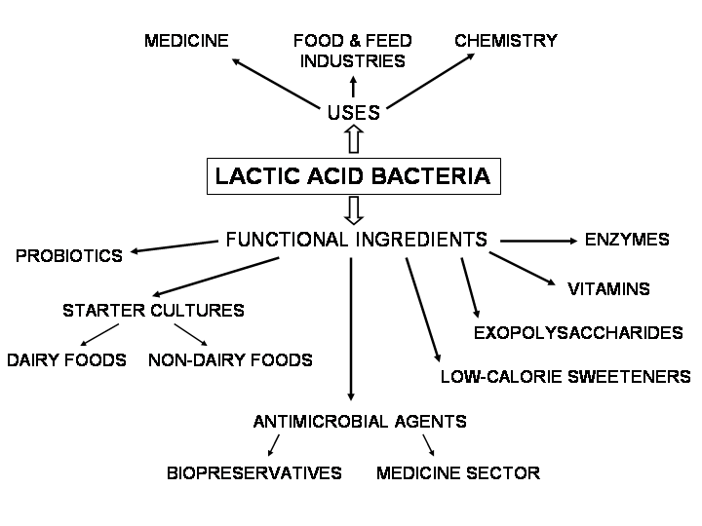

Lactic Acid Bacteria as Wellspring of Probiotics
The word "probiotics" derives from the Greek word "probios," which means "forever." Probiotics were defined as "organic organisms and substances which add to gut microbial balance" by Parker [3] in 1974. Probiotics are "a live microbial feed supplement that favourably influences the host creature by acting on its digestive microbial equilibrium," according to Fuller in 1989. Probiotic microbes were later defined by the Food and Agriculture Organization and World Health Organization as "live microorganisms that, when directed in sufficient amounts, offer a medicinal advantage on the host." Probiotics have been used for 100 years to treat a variety of mucosal surface infections (stomach, vagina), due to their ability to colonise the gastrointestinal tract and exert their beneficial effects over time without needing ongoing clinical intervention. However, their use decreased after the development of anti-microbials. But with the rising prevalence of anti-infection blockage and the need for lower healthcare expenditure, probiotics are now viewed as an optional anti-toxin’s solution. The preponderance of the identified Lactobacillus species, includes L. acidophilus, L. rhamnosus, L. reuteri, L. casei, L. plantarum, L. bulgaricus, L. delbrueckii, and L. helveticus, are regarded to be commercial probiotics. The microorganisms probiotic strains are GRAS (Generally Recognized as Safe).
Consequences for Gastrointestinal Tract
The human gastrointestinal tract is home to 500 different animal species and over 10 billion microscopic creatures. 20 genera, including LAB, predominate among them. Escherichia, Veillonella, Fusobacterium, Bifidobacterium, Lactobacillus, Peptococcus, Poststreptococcal, and Bacteroids are among them. Maintaining the digestive system's homeostasis depends on microbial balance. Live Lactic Acid Bacteria ingestion through dairy products has a significant impact on the gastrointestinal health of many people, including improving the absorption of lactose and reducing the risk of viral and drug-induced illnesses, post-use pouchitis, peevish entrail disease, fiery gut disorder, and having antineoplastic effects on human cell lines. It also helps to improve the absorption of unsaturated fats through the digestive system. LAB achieves these beneficial outcomes by reestablishing regular digestion removal of gastrointestinal bacteria, encouragement of gastrointestinal resistance to foreign antigens, stimulation of phagocytosis, stimulation of humoral resistance, and production of soothing substances.
Impacts on Lactose Intolerance and Malabsorption
Due to a deficiency inside the lactase enzyme catalyst in the brush border of the duodenums, people with lactose intolerance are unable to break down lactose into its component sugars, namely glucose and galactose. Kids typically experience it. Lactose narrow-mindedness side effects manifest 30 minutes to 2 hours after consuming lactose-containing food. Among the negative side effects are farting, squeezing, bloating, and diarrhoea. There are three different types of lactose prejudices that are clinically recognised: innate lactose prejudice, which has a hereditary origin, secondary lactose aversion brought on by the runs, flaming gastrointestinal disease, and HIV infection. Lactose is broken down into its component parts in the disease known as lactose malabsorption, however because of a lack of these components are not being ingested by the digestive system as predicted in terms of physical and cofactors. Approximately 50 million Americans are regularly afflicted by lactose narrow-mindedness. In the United States, it was strongly advised that 95–100% of American Indians, 80–90% of Blacks, Asian, Mediterranean, Jews, and 50% of Northern and Central Europeans stop eating lactose. The prevalence of optional lactose limited thinking varies depending on the underlying cause.
Job of Lactic Acid Bacteria in Treating Ulcer
In their review, Myllyluoma et al. (4) noted the beneficial effects of lactic acid bacteria on stomach ulcers. They hypothesised that these effects were caused by the terrible things that Lactic Acid Bacteria were doing to H. pylori. If LAB are combined with an ulcerative treatment, the results are an incredibly speedy recovery and increased therapeutic delicacy. It has been proven that Lactococcus rhamnosus can be used in LAB as an adjuvant therapy during the destruction of H. pylori. Alcohol-induced mucosal sores are caused by Lactococcus rhamnosus, which is also used as an aid in the treatment of ulcerative colitis. Additionally, pre-treatment with Lactococcus rhamnosus significantly increases baseline mucosal prostaglandin E2 (PGE2) levels and decreases ethanol's suppressive effects on the body fluid emitting layer. Reduces gastric mucosal transmucosal blockage and cell death.
Impacts of Lactic Acid Bacteria on Human Immune System
Insusceptibility is maintained as a barrier to protecting the body from unknown intruders or other oddities. The two main categories of vulnerability are acquired and innate invulnerabilities. The first alternative is a generalised form of resistance, and the final one is a specific form of invulnerability. Mechanical barriers, clean bodily fluid activities, and a flaming reaction are all examples of intrinsic immunity, but acquired immunity includes lymphocytes, specific types of proteins, and antibodies to protect the body. These pathways help the body function effectively. Antibodies are a crucial component of a secure architecture. Both monoclonal and polyclonal forms may exist. If administered in an inactive condition, LAB, specifically Staphylococcus aureus, can generate IgA. This method produces polyclonal antibodies that can provide resistance to many antigens.
Antifungal action of Lactic Acid Bacteria
There is evidence that LAB has antifungal properties. Infections that are contagious are difficult to treat. To identify their likely enemy of infectious movement, many LAB types have been examined. When compared to other types of LAB, Lactobacillus fermentum has been found to have some advantages, particularly when it comes to fighting Candida albicans and Candida glabrata. Because LAB contains anti-mycotic properties, it can be used as a probiotic against certain lethal parasite infections. It is typical for Candida albicans and Candida glabrata to induce contagious contamination. These problems might be better addressed by using LAB as probiotics. Organisms are adversely affected by hydrogen per oxide. Additionally effective against bacterial contaminations is hydrogen per oxide. A small number of LAB species create hydrogen peroxide. These strains exhibit both antibacterial and anti-contagious properties. Lactobacilli are the uncommon type of LAB that have the novel property of providing hydrogen per oxide, as demonstrated by Mijac et al. in their work. Numerous contaminations, such as vulvovaginal candidiasis (VVC), trichomoniasis (TV), and trichomoniasis, can be caused by these bacteria (TV).
Actually, the primary location of contamination in females is the vagina. In this area, several infectious contaminations are common. Treatment of these contaminations could be greatly simplified by using LAB as probiotics. Due to its strong antifungal abilities, Lactobacillus acidophilus and Lactobacillus casei help protect immunocompromised people from cunning Candida albicans infections. By engaging in antagonistic actions against Candida albicans, LAB demonstrates antifungal activity.
Role of Lactic Acid Bacteria in preventing colon cancer
Due to the acceptance of apoptosis by two microscopic organisms called rEPS (delivered exopolysaccharides) and cbEPS, Lactobacillus rhamnosus may have an anticancer activity (cell bound exopolysaccharides). rEPS were more effective than cbEPS at preventing illness. The various LAB subtypes may affect the uncontrolled development of colonic cells. The action of different LAB types varies, starting with the control of the growth of dangerous cells. Different LAB types were looked at. Lactobacillus helveticus, Biidobacterium, Lactobacillus acidophilus, or a strain made up of Streptococcus thermophilus and L. bulgaricus were the predominant strains with anticarcinogenic properties. The most effective of these in preventing the unchecked growth of colonic cells is Lactobacillus helveticus.
Due to its ability to increase the amount of antiproliferative protein and decrease the effects of mutagenic protein, Lactococcus lactis possesses anticolonic disease movement. This allows these life forms to be administered orally. The anticancer effects of Lactobacillus rhamnosus, another lactic corrosive bacterium (Orlando et al) [5]. Another study conducted under the direction of Golden et al. (1996) [6] shown that Lactococcus rhamnosus has antimutagenic effects and that these effects can be amplified by feeding them fat.

Job of Lactic Acid Bacteria in sensitivity
Additionally, LAB have a crucial role in both circumstances that can potentiate hypersensitive reactions as well as in reducing their occurrence. IgE, a neutralizer, is linked to quick, compassionate touchiness that frequently results in responses. It has been discovered that Lactobacillus citreum modulates serum IgE age during the formation of general neutralizers. Lactobacillus citreum can be useful in preventing the development of IgE and the course of events. It is therefore possible to prevent touchy reactions by using this microorganism. There is no doubt that Lactic Acid Bacteria are an enemy of their negatively susceptible work here. Recently, LAB has developed an interest in the immuno-guideline that is the adversary of sensitivity. Here are some supporting evidence that suggests Japanese cedar pollinosis clinical symptoms may be alleviated by Enterococcus faecalis. Investigation of the Enterococcus was investigated in eosinophil buildup. Because they play a significant role in the improvement of negatively vulnerable responses, eosinophils. Consequently, the importance of this position is greater. Enterococcus faecalis prevents eosinophil collection. It is generally accepted that Enterococcus may play a role in reducing adversely susceptible reactions.

Job Production of Inhibitory Compounds
The LAB can deliver a variety of inhibitory combinations to reduce the entry of microbes. According to Liao and Nyachoti (2017) [7], these contain AMPs like bacteriocins, natural acids, ethanol, diacetyl, carbon dioxide, and hydrogen peroxide. Gram-negative and Gram-positive microbes both produce and distribute bacteriocins, which are AMPs with ribosomal integration. Bacteriocins produced by LAB, referred to here as LAB-bacteriocins, are typically devoid of all cytotoxic properties and furnished with antagonistic capabilities as well as additional beneficial attributes. LAB-bacteriocins are emerging as a new wave of potent in vitro and in vivo anti-infection drugs. LAB-bacteriocins target specific species instead of affecting other populations in the same environment like standard anti-toxins do. 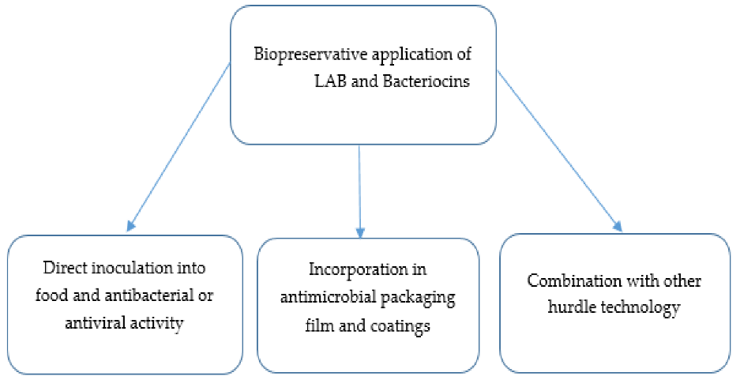
Bacteriostatic or bactericidal action is known to be used by LAB-bacteriocins to delicate living things. Their tactics have typically, although not totally, been studied. Recent information on activity approaches is researched elsewhere. Combinations of LAB-bacteriocins and anti-toxins are emerging as novel therapeutic options for organisms that supply food. The main advantages and synergistic interactions of LAB-bacteriocins with other biomolecules have been outlined in numerous papers. These include the use of ethambutol and enterocin AS-48 to treat Mycobacterium TB, nisin and citrus extract to treat Listeria monocytogenes and Staphylococcus aureus, and nisin with beta-lactams to treat Salmonella enterica. against a variety of Gram-positive and Gram-negative bacteria (Serovar Typhimurium and Garvicin KA-farnesol) (Chi and Holo, 2018) [8]. Given their enzymatic composition, these drugs' oral organisation is put to the test.

Conclusion
The use of LAB-probiotics continues to be a useful and promising alternative strategy in general. Animals treated with various LAB-probiotics have exhibited a variety of benefits. According to numerous studies, LAB-probiotics can slow the spread of bacterial diseases, promote weight gain in healthy people and animals, influence the nature of the industry's (by-)products, and even improve the water quality in hydroponic systems. By releasing inhibitory combinations or using other methods like poison avoidance, reducing the bioavailability of poisons, bolstering digestive obstruction, or vehemently boosting the immune system, LAB-probiotics can manage various bacterial infections. Their activities are applied in strain and host-explicit habits. Last but not least, combining LAB with other probiotic species, prebiotics, and other nutrients has a variety of synergistic effects.
Acknowledgement
I wish to express my profound sense of thanks to our correspondent, Dr. Jeyanandh Dhivaharan., and our chartered correspondent Dr. V. Dhivaharan., Dean, PG and Research Department of Microbiology, S.T.E.T Women’s college,Sundarakkottai, to offering to do the valuable work.

References:
- Aureli CapursoL.CastellazziA.M. ClericiM.GiovanniniM.MorelliL.PoliA.PregliascoF. SalviniF.Zuccotti 2011 Probiotics and Health: An Evidence-based Review. Pharmacol. res. 63 366376.
- Hamdan AM, Sonomoto (2011) Production of Optically Pure Lactic Acid for Bioplastics. In: Sonomoto K, Yokota A, editors. Lactic Acid Bacteria and Bifidobacteria: Current Progress in Advanced Research. Caister Academic Press, Portland, USA.
- Parker RB 1974 Probiotics, The Other Half of The Antibiotic Story. Animal nutr. health. 29 48.
- Myllyluoma E, Kajander K, Mikkola H, Kyrönpalo S, Rasmussen M, Kankuri E, Sipponen P, Vapaatalo H, Korpela R. (2007). Probiotic intervention decreases serum gastrin-17 in Helicobacter pylori infection. Digest Liver Dis, 39(6), 516–523
- Orlando A, Messa C, Linsalata M, Cavallini A, Russo F. (2009). Effects of Lactobacillus rhamnosus GG on proliferation and polyamine metabolism in HGC-27 human gastric and DLD-1 colonic cancer cell lines. Immunopharmacol. Immunotoxicol, 31(1), 108–16
- Goldin BR, Gualtieri LJ, Moore RP. (1996). The effect of Lactobacillus GG on the initiation and promotion of DMH-induced intestinal tumors in the rat. Nutr Cancer, 25(2), 197–204.
- Liao S. F., Nyachoti C. M. (2017). Using probiotics to improve swine gut health and nutrient utilization. Anim.Nutr. 3 331–343. 10.1016/j.aninu.2017.06.007 [PMC free article] [PubMed] [CrossRef] [Google Scholar]
- Chi H., Holo H. (2018). Synergistic antimicrobial activity between the broad spectrum bacteriocin garvicin KS and nisin, farnesol and polymyxin B against Gram-positive and Gram-negative bacteria. Curr.Microbiol. 75 272–277. 10.1007/s00284-017-1375-y [PMC free article] [PubMed] [CrossRef] [Google Scholar]

