Enhancement the Fresh water harvest from Hybrid PV/T Solar still Techniques
Dr.K.Valarmathi  Professor & Head  Department of Electronics and Communication Engineering,  PSR Engineering College  Sevalpatti  Sivakasi,Tamilnadu,India  Email id: valarmathi@psr.edu.in |  | R.Sasireka  Assistant Professor  Department of Biotechnology,  Mepco Schlenk Engineering College, Sivakasi,  Tamilnadu,India  Email id: sasivaran1304@gmail.com |  | T.Rengaraj  Assistant Professor  Department of Electrical and Electronics Engineering,  PSR Engineering College  Sevalpatti  Sivakasi,Tamilnadu,India  Email id: rajpriya160619@gmail.com
 | K.Ramalakshmi  Assistant Professor  Department of Electronics and Communication Engineering,  PSR Engineering College  Sevalpatti  Sivakasi,Tamilnadu,India  Email id: ramalakshmi@psr.edu.in |  | Dr.G.Karthikeyan  Associate Professor  Department of Electronics and Communication Engineering,  PSR Engineering College  Sevalpatti  Sivakasi,Tamilnadu,India  Email id: gkatthi.keyan94@gmail.com

ABSTRACT
The solar energy is one of the very popular non-conventional energy. The Solar photovoltaic (PV) power generation is depending on irradiation (light energy) and heat energy (resistance). Non-conventional energy basis is maintained on all zones of expertise, particularly the variation of solar energy for numerous resolutions. The current tentative study is approved out to advance the competence of PV/T solar still with improved evaporation and compression technique. A DC power-driven blower is static inside a solitary slope solar still which growths the commotion of evaporated vapor since the salty water confidential the solar still while the condensation is enhanced with shelter chilling method. A hybrid photovoltaic/thermal (PV/T) energetic solar still and a conservative passive solar still with solo incline were designed, fabricated and investigated at three dissimilar water pits. For the advanced making of distillate water, a heater driven by solar (PV) was combined in the planned hybrid energetic still. Solar PV module was chilled by the salt water which enhance the productivity of the solar PV as well as the distillate water making. The everyday harvest from the planned hybrid energetic (PV/T) solar still is 6 times higher than the conservative passive still. This novel system of renewable energy related power and distillate water making is extremely self-supportable in the isolated zones. From the investigational learning it is clear that, the planned hybrid energetic (PV/T) solar still provides an improved complete thermal and electrical competence, that is nearly 25% higher than the conservative passive one.

Keywords: Solar Still, Active, Passive, Efficiency, Power, incline

CHAPTER-1
I. INTRODUCTION

- Overview

The important source of energy is Sun. The world is absorbed yearly 160 units of energy from solar(sun), which is 20,000 times the necessity of manhood on the World. Around of the Solar Energy reasons vaporization of water, prominent to rains and formation of rivers etc. Roughly of it is employed in photosynthesis which is important for provisions of life on world. Human has tried from time earliest to connect this endless source of energy. But has been capable to tap only a negligibly fraction of this energy till today. Photovoltaic (PV) power producing structures transform the sun’s energy straight into electric power by help of contemporary semiconductor resources. PV structures harvest fresh, trustworthy power without overriding fossil fuels and are used in an extensive variety of applications. Nearly are called a “stand-alone or off-grid” scheme, which resources they are the individual source of energy to a home-based, water propel or any additional load. Stand-alone structures can be planned to operate with or without battery backup. Isolated water propels are frequently planned to operate without battery backup, meanwhile water propelled out of the ground during daytime periods can be Deposited in an allotment tank for use anytime. In difference, stand-alone home energy schemes frequently collection energy produced throughout the day in a battery bank for use at night. Stand-alone schemes are well economically when associated to replacements such as usefulness line extensions.
Equally, the client can draw required energy from the usefulness when power from the PV structure is inadequate to energy the construction’s loads. Under this prearrangement, the client’s regular electric convenience notice reproduces lone the net amount of power customary from the electric usefulness.
The high preliminary charges of PV connection call for a means of sizing these schemes to be capable to competition predictable loads and submissions. Sizing competitions the operator’s power requirements with the suitable solar scheme’s mechanisms.

- Solar Still
However solar PV is active one, the consequence of high value of heat performances as one of the key drawback to increase overhead. Growth in temperature of the solar PV reasons the reduction in the competence. Solar still is a expedient which practices solar heat power for making fresh water from the salty and brackish water. The brackish or salty water (salt ~10,000 ppm) can be sanitized by the use of solar still. It may be whichever energetic solar still or passive solar still.
The solar still can be categorized into numerous kinds related on several features. It is extensively categorized into two kind (i) Passive solar still and (ii) Energetic solar still.

- Passive Solar Still
The passive solar still has a accepted slow evaporation procedure does not requirement any exterior source to hotness the salty water in the sink. There are numerous kinds of passive solar stills. Around of them are sole slope passive solar still, dual slope passive solar still, triangular passive solar still and pyramid passive solar still and the single slope passive solar still is shown in Figure 1.1.

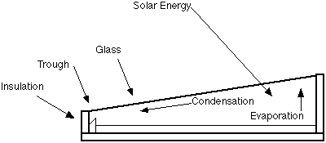
Figure 1.1 Single slope passive solar still

- Energetic Solar Still
Energetic solar still practices an outside temperature source to hotness the basin salty water to evaporate. The harvest of the energetic solar still (more than 7 L/day) is moderately high than the passive solar still (around 2 L/day). The outside source of the energetic solar still is from the solar PV then that energetic solar still is called as the hybrid Photovoltaic/Thermal (PV/T) active solar still. The single slope Energetic solar still is shown in Figure 1.2.

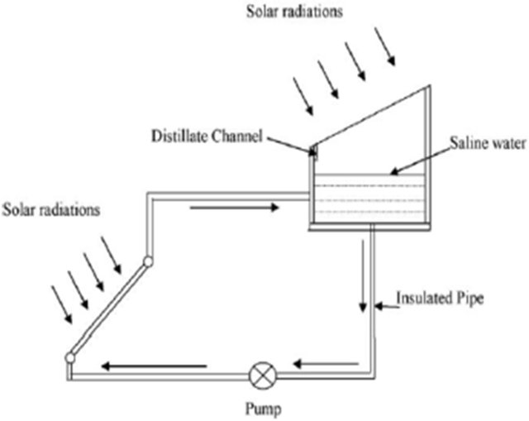
Figure 1.2 Single slope energetic solar still
The energetic solar still is commonly confidential as given below:

- High heat active solar still
- Pre-heated water active solar still
- Night-time making active solar still.

Related upon the strategy and construction, the solar stills are confidential as follows.

- Sole slope solar still
- Dual slope solar still and
- Inclined solar still.

- Sole Slope Solar Still
Single slope solar stills achieve improved than dual slope passive solar stills on the basis of yearly harvest, yearly energy, and yearly exergy and energy financial limitations. Sole slope solar still is additional confidential into conservative sole slope solar still, opposite absorber, stepped type and with condenser category.

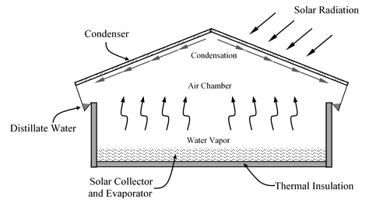
Figure 1.3 Dual slope solar still

- Dual Slope Solar Still
Sole slope solar stills have two slopes in its construction and its appearances similar two sole slope constructions associated together to respectively. Dual slope solar still gives improved appearance than a sole slope solar still for summer climatical circumstances. It is additional confidential into conservative and dual basin dual slope solar still. The conservative dual slope solar still is additional confidential into regular and non-regular dual slope solar still. As the term specifies, the dual basin dual slope solar still has two angles as well as two sinks in it. The duel slope solar still is shown in Figure 1.3.

- Inclined Solar Still
Inclined solar stills have two angles in its construction and it appearances similar two sole slope constructions associated adjacent to individually other. Dual slope solar still gives improved operation than a sole slope solar still for summer climatical circumstances.

II. LITERATURE SURVEY

Freshwater is an important substance of lifespan and the atmosphere [1]. Freshwater is also existence measured as the maximum energetic healthiness hazard problem in today's ecosphere. The freshwater quantity on the world's superficial is solitary 1%, however salt water is 97% and icebergs are 2.6%. Nevertheless, the population and contamination rise with the high-tech, industrial and transportation improvement, freshwater feeding is increasing, and freshwater bases are fast declining [2]. At current, with human feeding, manufacturing and farming feeding of water is also accumulative. The consequence of this worldwide development is producing an inequality among the source and feeding. The circumstances would be inferior since supreme of the water create on world is logically mixed and requirements appropriate action to use [3]. Likewise, here is uncommon rainfall in the recompense, stony and dry sections of the world, foremost to critical groundwater deficiency. Aimed at these reasons, procurement filtered or freshwater from brine or salt water basis, purification might be the lone resolution universally [4]. Solar still would be a key to sanitize contaminated water, where solar power is adequate. Conservative power sources to sanitize water is high cost and infrequent, but solar still is not well in cost-effective and environment responsive [2]. In remote zones where filtered water is infrequent and unobtainable, solar still may well be another resolution [5]. A solar still structure practices green power to sanitize polluted water, production it beneficial over supplementary water purification structures [6]. Solar stills practice solar power to harvest purified water and have been systematically considered and verified. Numerous investigators take experimental and acknowledged the consequence of ambient head, Air velocity, solar contribution and water deepness on the solar still functioning. Numerous identifications have talked several measures of solar stills, as well as double-basin solar still [15,16], semicircular solar still [7–10], three-way basin solar still [17], pyramid solar still [11–14], mixture solar still [18,19,24]. The purposes of this paper are to assessment dissimilar kinds of solar still has been deliberated [24].

III. METHODOLOGY OF A SOLAR STILL

The solar still is used to filtered the fresh water from the salt water. The solar still method act as two ways one is active solar still another one is passive solar still. The incline solar still tank is constructed, the higher side have 28cm and lower side have 12cm, black coating is given outside well of solar still tank which absorbed more head energy. The solar still tank-maintained three dissimilar water pits depth. The active solar still method used as waste copper and blower in of solar still tank. The waste copper is bottom of solar still tank and store the hot particles. The blower is run by regular time interval. Both waste copper and blower increase the compression and evaporation. Solar still techniques harvesting more fresh water as compared with conventional method. The Fig 1.4 is represented as design and construction of the proposed hybrid PV/T still system.
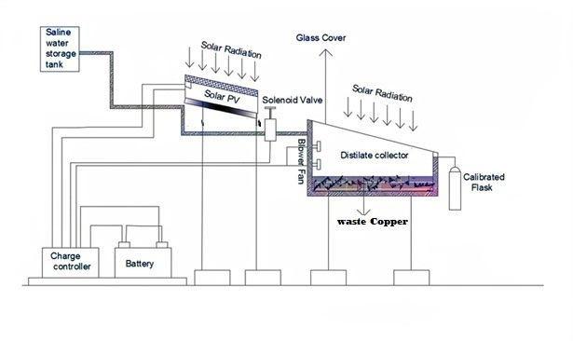
Fig 1.4 Schematic diagram of solar still

IV. PARAMETERS OF SOLAR STILL

In a hybrid PV/T method parameter analysis is very important because the efficiency of the system is mainly deepened on parameters. The any hybrid PV/T method should be considering some parameters like., solar irradiation, water heat, basin heat, glass heat, ambient heat, yield, output power with respect to time. The all the parameters mainly depend solar light and heat energy. The factor of irradiation is varied with respect to time. The analysis is taken by same interval of time period. Solar irradiation is attained maximum value time between 12.30 PM to 1.30 PM. The Hybrid method analysis is very suitable for summer period.

V. CONCLUSION

In the new method energetic solar still have more number advantages. The energetic solar still is very cost effective and payback period of investment also very low depends on conventional method. Here method uses the waste copper is used as energetic material and store the hot particles. The solar still have various construction related to energetic solar still with respect to high efficiency. The solar still analysis all heat parameters are increased gradually morning to afternoon and decreased gradually after afternoon to evening and night time it reduces to be zero. When run the blower the heat energy is transfer to waste copper to water. The temperature of the water is increased with respect to increases the evaporation. The outcome of the techniques is achieved to production of more fresh water.

REFERENCES

[1] Delyannis A, Delyannis E. Recent Solar Distillation Developments. Desalin Elsevier Sci Publ BV1983;45:3619.
[2] Sukhatme. Solar Energy: Principles of Thermal Collection and Storage. Tata McGraw-Hill Publishing Company; 2008.
[3] El-Sebaii AA, El-Bialy E. Advanced designs of solar desalination systems: A review. Renew Sustain Energy Rev 2015;49:1198–212. https://doi.org/10.1016/j.rser.2015.04.161.
[4] Tiwari GN. Solar Energy: Fundamentals, Design, Modelling and Applications. Alpha Science;2002.
[5] Yadav S, Sudhakar K. Different domestic designs of solar stills: A review. Renew Sustain EnergyRev 2015;47:718–31. https://doi.org/10.1016/j.rser.2015.03.064.
[6] Zarasvand Asadi R, Suja F, Ruslan MH, Jalil NA. The application of a solar still in domestic and industrial wastewater treatment. Sol Energy 2013;93:63–71. https://doi.org/10.1016/j.solener.2013.03.024.
[7] Arunkumar T, Jayaprakash R, Denkenberger D, Ahsan A, Okundamiya MS, kumar S, et al. An experimental study on a hemispherical solar still. Desalination 2012;286:342–8. https://doi.org/10.1016/j.desal.2011.11.047.
[8] Ismail BI. Design and performance of a transportable hemispherical solar still. Renew Energy 2009;34:145–50. https://doi.org/10.1016/j.renene.2008.03.013.
[9] Panchal NH, Prajapati V, Goswami R, Pancholi N. Performance Analysis of Hemispherical Solar Still in Climate Condition of Mehsana, Gujarat. Int J Adv Eng Res Stud 2012;I:210–3.
[10] Solanki AS, Soni UR, Patel P. Comparative Study on Hemispherical Solar Still with Black Ink Added. Int J Eng Res Gen Sci 2014;2:315–24. Hasan M.R. International Journal of Energy Technology 2 (2) (2020) 1-23
[11] Kabeel AE, Abdelgaied M, Almulla N. Performances of pyramid-shaped solar still with different glass cover angles: Experimental study. IREC 2016 - 7th Int Renew Energy Congr 2016.https://doi.org/10.1109/IREC.2016.7478869.
[12] Kalaivani S, Radhakrishnan SR. Heat Mass Transfer and Thermophysical Analysis for Pyramid Type Solar Still. Int J Sci Res 2013;2:2319–7064.
[13] Arunkumar T, Vinothkumar K, Ahsan A, Jayaprakash R, Kumar S. Experimental Study on a Compound Parabolic Concentrator Tubular Solar Still Tied with Pyramid Solar Still. In: K.Vinothkumar, editor. Adv. Desalin., Rijeka: IntechOpen; 2012, p. Ch. 9. https://doi.org/10.5772/49995.
[14] Prakash A, Jayaprakash R, Kumar S. Experimental Analysis of Pyramid Wick-Type Solar Still. Int J Sci Eng Res 2016;7:1797–804.
[15] Tiwari GN. Enhancement of daily yield in a double basin solar still. Energy Convers Manag1985;25:49–50. https://doi.org/10.1016/0196-8904(85)90068-8.
[16] Al-Karaghouli AA, Alnaser WE. Experimental comparative study of the performances of single and double basin solar-stills. Appl Energy 2004;77:317–25. https://doi.org/10.1016/S0306- 2619(03)00124-7.
[17] El-Sebaii AA. Thermal performance of a triple-basin solar still. Desalination 2005;174:23–37. https://doi.org/10.1016/j.desal.2004.08.038.
[18] Kumar S, Tiwari A. Design, fabrication and performance of a hybrid photovoltaic/thermal (PV/T) active solar still. Energy Convers Manag 2010;51:1219–29. https://doi.org/10.1016/j.enconman.2009.12.033.
[19] Pounraj P, Prince Winston D, Kabeel AE, Praveen Kumar B, Manokar AM, Sathyamurthy R, et al. Experimental investigation on Peltier based hybrid PV/T active solar still for enhancing the overall performance. Energy Convers Manag 2018;168:371–81. https://doi.org/10.1016/j.enconman.2018.05.011.
[20] David Prince Winston , Karthikeyan Ganesan , Praveen Kumar B , Devakirubakaran Samithas & Chitti Babu Baladhanautham 2020, “Experimental investigation on output power enhancement of partial shaded solar photovoltaic System”, Energy Sources, Part A: Recovery, Utilization, and Environmental Effects-Taylor & Francis, Impact factor:2.66
[21] David Prince Winston , Karthikeyan Ganesan , Praveen Kumar B , Devakirubakaran Samithas & Chitti Babu Baladhanautham 2020, “Parallel Power Extraction Technique for Maximizing the Output of Solar PV Array”, Solar Energy; Elsevier Volume 213, 1 January 2021, Pages 102-117, Impact factor:5.742
[22] G.Karthikeyan, D. Prince Winston, A.Bhuvanesh, K.Gangatharan,” Evaluation of faults in a DC Grid connected solar systems of ships” 2020”,Marine Technology Society (MTS) Journal ,Impact factor:0.619
[23] Prince Winston David1, (Member IEEE), Karthikeyan Ganesan, et al., A New Alternate Method to Reuse Rehashed Edible Oil for the Betterment of Society - Dual Benefit Approach in Photovoltaic Modules," in IEEE Access, vol. 9, pp. 128434-128441, 2021, doi: 10.1109/ACCESS.2021.3112582.
[24] Karthikeyan Ganesan, David Prince Winston, Sathyamurthy Ravishankar & Suresh Muthusamy “Investigational study on improving the yield from hybrid PV/T modified conventional solar still with enhanced evaporation and condensation technique - An experimental approach, (2022) Energy Sources, Part A: Recovery, Utilization, and Environmental Effects- Taylor & Francis 44:2, 5267-5286, DOI: 10.1080/15567036.2022.2083273.

