Next Generation Sequencing : A Paradigm shift in the elimination of Tuberculosis.

Siddhant Shetty,
Fellow, Department of Infectious Diseases
PD Hinduja Hospital and Medical Research Centre,
Mumbai, India
drsiddhantshetty@gmail.com

Priti Kambli,
PhD student, Department of Microbiology,
PD Hinduja Hospital and Medical Research Centre,
Mumbai, India
priti_kambli88@rediffmail.com

Camilla Rodrigues,
Head, Department of Microbiology,
PD Hinduja Hospital and Medical Research Centre,
Mumbai, India
dr_crodrigues@hindujahospital.com

Keywords: TB; sequencing; molecular diagnostics; drug resistance; whole genome sequencing.

I. TB : PROBLEM STATEMENT

Tuberculosis (TB) remains a significant public health problem and is still far from elimination. Globally, in 2020, approximately 10 million people were infected with tuberculosis (TB) including 1.1 million children and a total of 1.5 million people died from TB (including 214 000 people who were co-infected with HIV). Globally, TB is the 13th leading cause of death and after COVID-19 it is the second leading cause of death from an infectious disease (surpassing HIV/AIDS). India has the largest number of tuberculosis (TB) cases in the world, accounting for over 25% of the world’s cases. The COVID-19 pandemic has made matters worse due to neglect and interruption of previously well established programs for the control and elimination of treatable diseases like HIV and TB.

II. DRUG RESISTANCE AND CURRENT CHALLENGES IN THE ELIMINATION OF TB

Even though the infrastructure for detecting cases of TB and starting the patients on treatment, and their monitoring has been put in place through the RTNCP (Revised National Tuberculosis Control Program), our current challenge is of drug resistance. This problem has stemmed through rampant empiric use of TB drugs, under-dosing patients, non-compliance and interruption of treatment. Rapid urbanisation and people living in close proximity has also made the spread of these resistant strains easier in the last few decades.

WHO recommends that all tuberculosis patients should undergo routine testing for resistance to Rifampicin (RIF) and Isoniazid (INH), while resistance to fluoroquinolones (FQs) should be tested in cases which are RIF and INH resistant [4]. The mechanisms of resistance to INH and FQs are well understood, and we have commercially available molecular tools for their detection. However, the genotypic drug-susceptibility testing (DST) assays for these drugs are less sensitive than those for resistance to RIF, and additional phenotypic testing is required to detect resistance that is not picked up on genotypic DST.

Survey data shows that incidence of primary drug resistant tuberculosis (DR-TB) is particularly high in urban areas where people live in close contact, such as Mumbai, up to 20% in certain areas as per some reports. Multi-drug resistance (MDR) and Extensive drug resistance (XDR) in previously treated patients is generally attributed to sequential selection of drug resistant mutants during inadequate therapy. However for new patients, which are on the rise of late, such resistance is due to the transmission of a resistant strain. This is compounded by problems associated with currently available large scale diagnostic techniques. MDR-TB treatment differs from susceptible TB by means of longer treatment duration (6-9 months vs 18-24 months), use of daily injectables, higher cost and worse drug toxicities, many of which are irreversible. Subjecting a patient to drug toxicity without strong evidence of drug susceptibility in todays era is unjustified.

In our cohort, more than 5 months typically pass from diagnosis to MDR-TB treatment. Most MDR-TB in our cohort is resistant to either quinolones or 2nd-line injectable drugs (Pre-XDR-TB, 40%) or to both those drug classes (XDR-TB, 24%). Sole reliance on rapid molecular tests such as Xpert MTB/RIF (“GeneXpert”) and Xpert MTB/RIF Ultra (“GeneXpert Ultra”) in our setting would provide most MDR-TB patients with potentially inadequate treatment. When patients with incomplete DST receive ineffective treatment, they suffer unnecessary toxicity and may develop additional resistance. In addition to the personal impact, this prolongs community transmission. One study at our centre reported that pre-XDR and XDR-TB patients took longer to convert their sputum cultures than those with MDR-TB, indicating longer transmission in homes, offices, and communities.

TB diagnostics used currently can be broadly classified into phenotypic methods and genotypic methods. The phenotypic method consists of TB MGIT (Mycobacterial growth Inoculation tube) culture and subsequent drug susceptibility testing (DST). Genotypic methods consist of the Xpert MTB/RIF, Xpert MTB/RIF Ultra, Line Probe Assays (LPA) and Sequencing techniques.

III. CURRENT TB DIAGNOSTICS (AND THEIR LIMITATIONS) : PHENOTYPIC

For decades, culture-based drug susceptibility testing (DST) has been the World Health Organization (WHO) standard for determining drug resistance in clinical MTB isolates. Universal access to accurate DST on the culture growth is essential for effective diagnosis and treatment of MDR-TB/XDR-TB.Traditionally, DST for MTB depends on culture and DST in liquid or solid media in biosafety level 2/3 laboratories, which are not widely available. Unfortunately, phenotypic results are only obtained after a few weeks to months of incubation, typically needing 3-6 weeks for a growth, which is very crucial time for a TB patient to be started on directed treatment.

Many studies have also shown that drug resistance in M. tuberculosis is not a homogeneous entity. More specifically, different levels of phenotypic drug resistance (low-level, moderate-level and high-level) are found in MTB and these different levels of phenotypic drug resistance are associated with very different and distinct genetic mechanisms. In general, there is a good correlation between the resistance and genetic mechanism. In summary, the term “resistance” with respect to MTB is heterogeneous and not a simple homogeneous category, and composed of low-level, moderate-level and high-level drug resistance. Clinical resistance is determined on the breakpoints of therapeutic drug failure during treatment. However, the DST ignores low-level resistance mechanisms that increase the MIC without reaching or crossing the breakpoint, therefore indicating a possible evolutionary trend towards high resistance. This clearly has important biological implications. Low levels of drug resistance may not be consistent with clinical resistance. On the contrary, in the presence of a high-level resistance, the drug is of little or with no clinical benefit. The clinical implications of moderate levels of resistance are unclear, and should be explored more fully in future studies considering PK/PD (pharmacokinetic/pharmacodynamic) parameters. However, drug susceptibility testing methods need to be modified to address these issues. Most importantly, standardised protocols for quantitative DST of both first- and second-line drugs are a prerequisite for prospective studies addressing the impact of resistance heterogeneity on treatment outcomes, by the correlation of data from quantitative resistance studies with clinical outcomes. Additionally, phenotypic testing for drugs such as pyrazinamide often lack precision and reproducibility. Given the inadequate number of drugs available for the treatment of XDR-TB, it is important to utilize potential drugs for MDR-TB to treat the majority of cases. TB culture is less sensitive than molecular techniques, but is very specific since it does not detect inactive bacteria like molecular techniques do.

IV. CURRENT TB DIAGNOSTICS (AND THEIR LIMITATIONS) : GENOTYPIC

A number of genotypic tests have been recommended by the WHO for the diagnosis of MDR and XDR-TB, including cartridge-based nucleic acid amplification tests and line probe assays that can be implemented in peripheral TB laboratories. In recent years, rapid molecular testing of drug resistance in MTB, primarily by GeneXpert MTB/RIF, has contributed significantly to the detection of DR-TB. A sensitivity of 98% for swab positives and 70% for swab negatives has been reported for the test. The Xpert MTB/RIF detects TB bacillus and Rifampicin resistance but does not detect resistance to drugs other than Rifampicin, and certain mutant loci detected on the rpoB gene for Rifampicin resistance have questionable clinical significance. The Xpert MTB/RIF Ultra has better sensitivity (detects 2 loci on the TB bacillus instead of 1 on its predecessor) which comes at the cost of specificity, detecting some false positives, especially in samples from unsterile sites. The earlier concept of isolated rifampicin resistance representing MDR-TB (Multi-drug resistant TB - defined as resistance to both Isoniazid and Rifampicin) is now becoming irrelevant with the recent rise in isolated isoniazid resistance leading to treatment failures in “drug susceptible” TB.

This drawback of the GeneXpert detecting only Rifampicin resistance (thus missing out on certain Isoniazid mono-resistant strains) has been partially overcome by introducing the 1st line LPA which detects Isoniazid resistance along with Rifampicin resistance, however with limited availability.

These resistance interpretations in molecular tests are established on the basis of rapid detection of genetic mutations, however, they are an indirect measure and only consider a limited number of gene targets, leading to incomplete DST results.

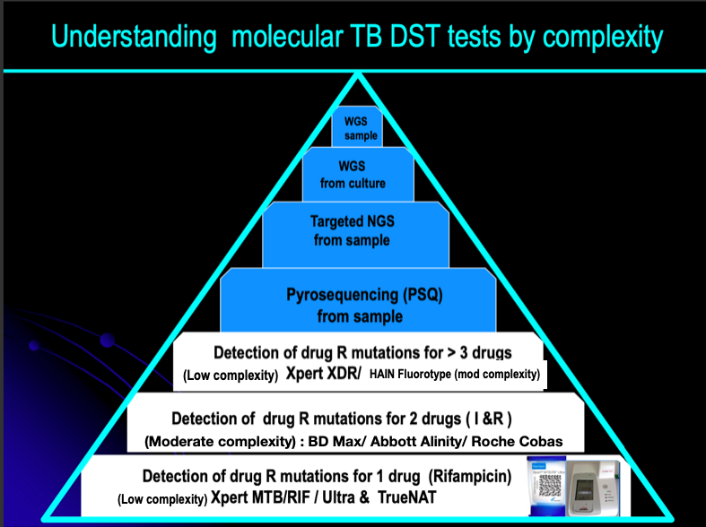
Figure 1 : Hierarchy of molecular drug sensitivity testing in Tuberculosis

V. SEQUENCING FOR THE DIAGNOSIS OF DRUG RESISTANT TB

The molecular tools currently employed in TB diagnosis target just the “hot-spot” regions of a few genes to detect resistance to a restricted number of drugs. They do not always report the exact nucleotide change upon which a prediction of phenotypic resistance is based. An all-in-one solution is required, at least at the reference lab level, to guide individual clinical decisions for the most complex resistance cases.

Sequencing is the latest molecular technique which has the ability to promptly diagnose DR-TB directly from samples. Developed in the 1970s, Sanger DNA sequencing provided the first gene and genome sequences, but its application has remained limited due to the complexity and high cost of sequencing when applied to large genomic regions. The advent of pyrosequencing dramatically increased sequencing capacity, followed by NGS methods in the mid-2000s, when costs plummeted.

Sequencing Workflows have the following steps:
- DNA Extraction
- Library Preparation
- Cluster Generation
- Sequencing
- Data Analysis

Lack of integrative vectors and low mutation rates make the M. Tuberculosis genome suitable for sequencing. The only technical challenge is the presence of repetitive and difficult-to-sequence regions with high GC content. These require sufficient genome-wide sequencing depth to be sequenced more accurately, thus impacting costs.

Pyrosequencing (PSQ) is the sequencing technology currently used in TB molecular diagnosis, currently validated for liquid samples, which can detect the TB bacillus and also resistance to 5 drugs including first line and second line drugs. Its disadvantages are that it is slightly less sensitive than the GeneXpert Ultra and is less cost effective, and hence not easily available. Currently, there is just one centre doing the test in the entire city of Mumbai. Even though the LPA and PSQ provide rapid, reliable results, they remain limited to the genes associated with XDR-TB defining drugs.

Next Generation Sequencing (NGS) techniques consist of Targeted NGS (tNGS) and Whole Genome Sequencing (WGS). Since direct testing of clinical samples by WGS results in sequencing all the genetic material, including vast amounts of human DNA and that of other commensal organisms, WGS is currently usually performed on culture isolates only [4]. In contrast, tNGS can be applied directly to clinical samples. This is in keeping with the current molecular testing in that it amplifies only the genetic targets of interest. Deep sequencing of the amplified fragments is performed, providing nucleotide-level detail as well as high-resolution detection of minor variants in mixed populations, instead of using probes to detect variants. [4].

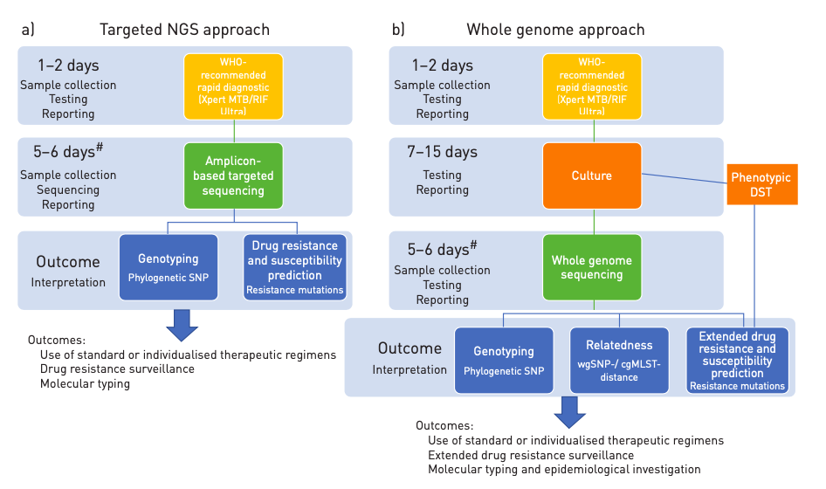
Figure 2 : targeted Next Generation Sequencing vs Whole Genome Sequencing [6]

Unlike Whole Genome Sequencing (WGS) that is currently best performed on TB isolates, Targeted, amplicon-based deep sequencing has the ability to promptly diagnose DR-TB directly from uncultured sputum samples. tNGS provides rapid sequence information for a greater number of loci than existing molecular tests, and the bioinformatics can be performed on a simple automated web based pipeline. One of the tNGS platforms is Deeplex Myc-TB (Genoscreen, Lille, France) that detects targets in 18 drug resistance associated genes in MTB, namely rpoB (Rifampicin); katG, fabG1, ahpC, inhA (Isoniazid/Ethionamide); pncA (Pyrazinamide); embB (Ethambutol); gidB, rpsL, rrs, tlyA, eis (Aminoglycosides); gyrA, gyrB (Fluoroquinolones); ethA (Ethionamide); rplC, rrl (Linezolid); rv0678 (Bedaquiline/Clofazimine). It also enables simultaneous species identification and detection of hetero-resistance. Newer platforms such as Oxford Nanopore Technologies (ONT) and Bacteriochek TB (ABL) offer 16 gene and 13 gene targets respectively. With a turnaround time of 2-3 days, tNGS solutions currently seems to be one of the most attractive, affordable and accessible methodologies for DST.

Whole Genome sequencing (WGS) provides us with complete genome information but is performed currently only on cultured isolates of Mycobacterium tuberculosis (MTB). WGS on sputum is still evolving, and needs relatively high quantity and good quality DNA to generate adequate depth. Currently, primary culture takes weeks to provide viable results, thus delaying DST informed treatment decisions. While WGS performed on uncultured sputum is still evolving, it remains less cost effective and requires complex bioinformatics infrastructure and setup, limiting its use and availability to just a few high-income countries. Whole genome sequencing (WGS) offers unprecedented resolution for genotyping, outbreak investigations and determination of known sequence variants involved in antimicrobial resistance, which deep sequencing of selected genomic regions (by targeted NGS) can further illuminate. WGS-based approaches have been proposed for surveillance of bacteria included in the World Health Organization (WHO) “priority list”. Currently, WGS has been validated on culture samples of Escherichia coli, Klebsiella pneumoniae, Staphylococcus aureus, Streptococcus pneumoniae, Pseudomonas aeruginosa, Salmonella spp., Acinetobacter spp., Neisseria gonorrhoeae and Clostridium difficile, in addition to the globally established priority group Mycobacterium spp. (including Mycobacterium tuberculosis).

VI. NGS : NEED OF THE HOUR

Molecular diagnostics such as LPA and GeneXpert that are based on rapid detection of genomic mutations associated with resistance has shown to be alternative to phenotypic DST. The reduction in time to diagnosis of MDR-TB using Xpert MTB/RIF has been seen, but such tests do not allow clinicians to select optimal drug treatment (and have not been associated with mortality reductions). If therapy were determined by Xpert MTB/RIF alone, rifampin-resistant patients in Mumbai would receive drugs to which 67-96% of patients are resistant, leaving an important role for NGS. Similarly, other current rapid tests (line probe assays and pyrosequencing) evaluate genes associated with isoniazid, quinolone, and injectable drugs, but do not fully evaluate treatment options for such patients. Ideally, such rapid tests should be screening tools to rule out resistance, with positive results triggering NGS to evaluate alternative drug options.

NGS can be potentially used for the rapid diagnosis of drug resistant tuberculosis (DR-TB) in diverse clinical reference laboratories worldwide. The NGS approach overcomes many of the significant challenges associated with conventional phenotypic testing as well as the limitations of other less comprehensive molecular tests by providing rapid, detailed sequence information for multiple gene regions or whole genomes of interest. However, these technologies have not yet received acceptance for the diagnosis of DR-TB due to cost concerns, addition into existing laboratory workflows, technical training and skills required for the application of the technology, and the need for expert guidance for managing and clinically interpreting the data derived from sequencing.

Targeted New Generation Sequencing (tNGS) can be performed using cloud-based analysis platforms and provides rapid sequence information for a much larger number of loci than the currently used molecular tests. This method is highly accurate, easy to perform and has a simplified analytic pipeline that does not require significant bioinformatics expertise when used at local labs. As our knowledge regarding the specific mutations associated with resistance to new drugs evolves, this technology can be adapted to include these new loci. The currently used rapid molecular assays like Xpert MTB/RIF and Line Probe Assays screen only a small number of genomic loci which are commonly associated with drug resistance, thus leaving many potentially clinically relevant drug resistance-associated loci unevaluated. Whole genome sequencing (WGS) will potentially screen the loci included in the rapid molecular tests used at present, as well as other known resistance-associated loci not screened by them, thus enabling the identification of new drug resistance-associated mutations that are not explained by currently available diagnostics, and all this will be done at a significantly shorter turnaround time.

A. Whole Genome Sequencing (WGS) for Mycobacteria
WGS of MTB has two main corresponding uses in clinical microbiology and public health:
- To predict the phenotype of drug-resistant strains.
- The determine genetic similarity, which can categorise transmission chains in a potential outbreak. Both of these can be of benefit to the patient.

In TB diagnostics, WGS is clearly better when compared to standard DST since the results can be interpreted much earlier (by a few weeks) and in the near future, this will only become faster and more cost effective. Until we can routinely do WGS on sputum, results will be delayed by 1-2 weeks compared to the current molecular tests. The immensely increased progress in WGS results means a more accurate and complete picture of resistance prediction than is currently possible.

B. WGS in Drug Resistance
WGS works well to differentiate between re-infection and persistent infection in isolates taken from the same patient at different times. WGS was used to demonstrate that reinfection and persistent infection in MDR-TB based on the number of Single Nucleotide Polymorphisms (SNPs), i.e. 2 SNPs within 8 months for persistent infection vs >60 SNPs within 2 years for re-infection.

C. Direct DNA from Sputum and WGS
All the above studies describing the WGS and their clinical applications utilise the DNA from the cultured isolates. However, if we can eliminate the culture step, a further 1-2 weeks could be saved. It is difficult to apply WGS directly to sputum (Fig. 3) as it depends on the load of organisms and it also contains human and non-mycobacterial DNA which are contaminants. There are 2 recent studies that have attempted to address this problem, where sputum was being tried as the direct source for WGS.

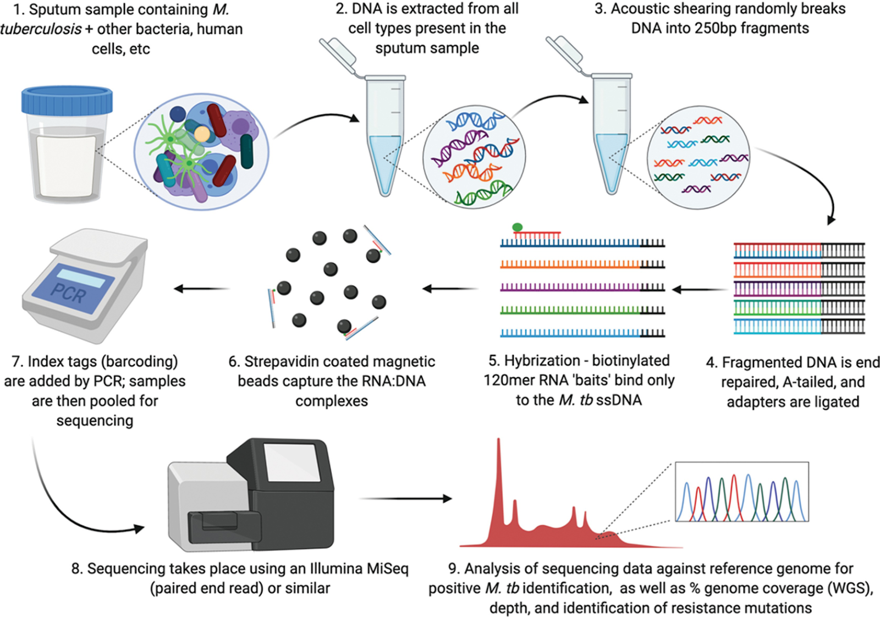
Figure 3 : Whole Genome Sequencing from sputum [7] sample
The need for culture based testing poses a challenge to NGS in its complete implementation and as an effective alternative to conventional molecular methods, especially in situations with limited resources. Hence we trying to develop protocols for WGS directly from clinical specimens to include differential lysis steps, TB enrichment and automated DNA purification. These are expensive at present with the low starting material of M. tuberculosis and contamination with other genetic material (human and oral flora) posing a great challenge to their utilisation. Targeted approaches taking advantage of the selective amplification of phylogenetic and drug-resistance related regions may represent a suitable alternative for direct sequencing.

We need to validate and certify these methods to fully implement NGS into routine workflows. We must assess and evaluate the performance, accuracy and reproducibility, quality control steps, quality thresholds (e.g. on the depth/breadth of genome coverage), use of standards and development of standard operating procedures, impact on turnaround times and clinical management, of these techniques. External proficiency testing programmes that are already implemented for molecular testing in TB will be made mandatory for the microbiology laboratories planning to introduce these technologies. Clinicians are helped by simple yet comprehensive clinical reports to arrive at best decisions while managing TB. NGS generates a huge amount of data, however our knowledge in its interpretation remains incomplete, and we are constantly learning of how best to report on this data. A report should at least give information on sequencing quality and identification of mutations to infer genotyping and drug resistance profiles, and provide details on the exact nucleotide changes and standardised prediction of resistance levels (ideally based on a literature review of minimum inhibitory concentration data). The standard for DST and epidemiological investigation in TB, and for other high-priority bacterial pathogens in the future will be replaced by WGS and tNGS. However, we need more studies to address the feasibility of WGS directly from clinical specimens, and also for standardising and automating the laboratory procedures and post-sequencing analyses, and for implementing the NGS platforms in resource limited settings, especially with high burden of disease.

VII. NEXT GENERATION SEQUENCING : REAL WORLD EXPERIENCE

In a study[2] conducted at Hinduja Hospital, Mumbai in 2019-2020, tNGS directly from sputum samples was compared to the results from Xpert MTB/RIF, LPA, PSQ, and phenotypic DST. tNGS done on uncultured sputum samples yielded results quickly and achieved very good concordance with phenotypic drug testing for isoniazid and rifampin, and second-line injectable drugs, and good concordance with phenotypic drug testing for fluoroquinolones, leading to a sensitivity of 83.5%, similar to that of LPAs. Inspite of using very little quantity of sputum, this technique successfully predicted the same drug resistance profiles for all drugs tested with overall sensitivity and specificity of 83.5% and 100%, respectively compared to phenotypic DST. Identification of MTB and prediction of drug resistance was successful in 97.5% of the smear and Xpert MTB/RIF positive samples which were tested. Also, lineage of the strains and resistance to bedaquiline, clofazimine, linezolid, and pyrazinamide were correctly predicted by tNGS done directly on sputum samples, thus establishing its supremacy over existing molecular tests and being consistent with updated MDR-TB treatment guidelines. In addition to this, tNGS was able to identify resistance mechanisms missed by other rapid molecular tests, due to its high sequencing depth. tNGS from cultured and uncultured sputum samples yielded the same results overall for all samples.

Another study [1] from India has used WGS on enhanced sputum samples and have concluded that this technique had a sensitivity and specificity of 90.9% and 95.0% respectively in predicting drug resistance, when compared to phenotypic DST using minimal sputum sample. A few studies [3,5,6] conducted in Europe have reported high efficacy of the tNGS in detecting TB and drug resistance associated genes.

In 2011, Gardy et al [8] utilised WGS to study the transmission dynamics of an outbreak from 32 MTB isolates obtained from a three year period in British Columbia, Canada and was the first study to do so. WGS was able to show two distinct lineages in contrast to contact tracing, which had suggested a single outbreak. Super-spreaders (individuals likely to spread the disease to others) could also be identified within the outbreak. Walker et al [9] showed the microevolution of strains within community outbreaks in their study following up on the findings of Gardy et al, which could not be evaluated by conventional genotyping tools. They interpreted the direction of transmission of the disease by setting an upper threshold of 5 SNPs, identifying super-spreaders and estimated the mutation rate at 0.5 SNPs/genome/year. Local or international control measures can be optimised by using NGS as shown by some other recent studies which have demonstrated the superiority of WGS in investigating community outbreaks over the conventional methods.

WGS at the frontline has the potential to minimise turn-around time, empower hospital-based microbiology, and have a positive impact on local activities like infection control initiatives. Our understanding of the complex nature of antibiotic resistance is better because of the large amount of data provided by WGS. To add to that we now have better knowledge about the possible aspects contributing to drug resistance, by identifying mutations within genes or intergenic regions that are under convergent evolution which could confer selective advantage in presence of drugs. Another recent study by Coll et al [10] applied genome-wide association study (GWAS) approach to analyse 6,465 MTB clinical isolates from more than 30 countries. They established new epistasis relationships and identified additional genes associated with resistance, along with novel mutations to drugs such as cycloserine, para-aminoslicyclic acid and ethionamide. These provide new targets for molecular diagnostics and for developing new therapies against resistant TB strains. Using specific patho-biological characteristics, WGS has a provided a system to differentiate clinical isolates into major lineages and sub-lineages, by using a nomenclature framework, thus paving the way for further investigations into lineage or sub-lineage. Strain type may play a role in disease outcome, clinical presentation, transmission, variation in vaccine efficacy and emergence of drug resistance, hence it is important to understand lineage for improving tuberculosis control efforts.

Laboratories can choose to test a given specimen or isolate from a vast variety of methods available to them, which may lead to certain discrepancies between methods. Such discrepancies may not be significant in certain scenarios, such as Streptomycin resistance in settings that use primarily Isoniazid, Rifampicin, Pyrazinamide, and Ethambutol, but they may have critical implications for treating MDR-TB in areas where the arsenal of drugs is limited in number and potency. Discordance is becoming troublesome for microbiologists and clinicians alike and will only likely to increase in frequency in the future as new technologies and techniques are adopted, yet it has been slightly neglected. Discordances between molecular and phenotypic tests are invariably going to occur. Root causes range from pre, post and analytic errors to co-existence of non-tuberculous mycobacteria, silent mutations, mutations outside the resistance-determining region, non-canonical mutations conferring increased MICs below the Critical Concentration (CC) in some phenotypic DSTs, and hetero-resistance (either due to mixed infections with two or more MTB strains or to the endogenous development of two populations following inadequate treatment) . Some of the discordances are due to borderline resistance or resistance due to the different CCs used for DST setting. Individual drug MIC values help in resolving such disagreements. The documented imperfect agreement between genotypic and phenotypic DST results also makes the choice of a tiebreaker limited and interpretation of the clinical implication of the reported discordance more challenging.

VIII. NGS : THE FUTURE??

Therefore, we describe a culture-free WGS method for identifying MTB and predicting its resistance pattern. Rapid molecular testing for drug resistance MTB is predominantly done by Xpert MTB/RIF, which has proved to be revolutionary for the diagnosis of drug resistance TB. However, despite its speed and convenience, this assay does not detect resistance to drugs other than rifampicin, which is insufficient to determine and give appropriate treatment to patients in regions with high circulating drug resistance like Mumbai. LPA too (like Xpert MTB/RIF) also provides quick and reliable results, however it remains limited to the genes associated with XDR-TB-defining drugs.

WGS technique was found to be equivalent to phenotypic DST when predicting drug resistance profiles with good overall sensitivity and specificity, inspite of using very little pus DNA. When performed on uncultured pus samples and compared to each of the existing methods, WGS was found to have good sensitivity and specificity for the XDR-TB defining drugs, when it was assessed directly from pus samples compared to phenotype. In addition, WGS directly from pus samples detected lineage and predicted linezolid and pyrazinamide resistance, being more beneficial than any of the existing molecular tests currently being used and consistent with updated MDR-TB treatment guidelines. Sequencing uncultured pus samples is time effective by reducing the turnaround time from 4 to 6 weeks for phenotypic testing to 3 days. Also, this method is highly accurate, is easy to perform and possesses a simplified analytic pipeline that seldom requires significant bioinformatics expertise at the local lab, and can easily be adapted to include new loci as our knowledge regarding specific mutations associated with resistance to new drugs evolves. Additionally, WGS can identify resistance missed by other rapid molecular tests due to its high sequencing depth. Conventional molecular tests may fail to detect heterogenous resistance. Discordance between WGS and other molecular tests are also observed which has been addressed earlier.

Injectable drugs are now being less commonly used in the treatment for DR-TB and the treatment is now slowly transitioning towards the use of linezolid and newer oral drugs like bedaquiline and delamanid, and it will only increase the relevance of tNGS and could potentially decrease the need for phenotypic drug susceptibility testing for those drugs.

The lack of a standardised, comprehensive catalogue of mutations along with their association with drug resistance is a major limitation to the development and diagnostic utility of sequencing technologies and of next-generation molecular diagnostics for comprehensive genotypic DST [4]. Continuing technical uncertainty about the number, identity and clinical interpretation of genomic resistance-determining regions has limited broad uptake and the clinical relevance of these tests, especially for new and repurposed drugs. There is a need for a high-quality, comprehensive catalogue of genetic markers of phenotypic resistance, along with their confidence grading, to distinguish clinically significant resistant strains from those not associated with clinically significant resistance or those already with sufficient data.

The World Health Organisation (WHO) is currently cataloguing the data of mutations associated with drug resistance from all over the world. It is thus creating an index which will connote the level of confidence of the mutation in causing a particular drug resistance, thereby dictating if a particular drug can be used to treat a particular patient or not. They are currently classifying the mutations in the catalogue into 5 categories.
Group 1: Associated with resistance
Group 2: Associated with resistance – interim
Group 3: Uncertain significance
Group 4: Not associated with resistance – Interim
Group 5: Not associated with resistance

Thus, when we have large scale data available in the future, a sample will be run on the system after enrichment, its mutations assessed and compared to the database available and its interpretation as to the drugs which can be used, and not, will be provided by the software with a turnaround time of 3 days, and probably lesser in the future. Hence we are heading towards a world of individualised TB treatment compared to the currently used algorithm based mass scale treatment protocols. The drawbacks will be scaling the availability and cost of this technology.

For WGS to truly replace phenotypic testing in the future, it needs to incorporate additional loci such as atpE, pepQ, and the multiple loci associated with delamanid and pretomanid resistance. In summary, WGS directly from uncultured pus samples is invaluable in diagnosis of TB and drug resistance, with the potential to replace phenotypic DST for drug resistance. WGS directly from uncultured pus samples provided results in a short time, achieved good concordance with phenotypic testing for isoniazid and rifampicin, second-line injectable drugs, and fluoroquinolones. The faster turnaround, adaptability to newly identified resistance-associated loci, and ability to detect mixed infection are important advantages compared to the conventional molecular assays.

WGS currently takes weeks to culture sufficient MTB DNA. To shorten time to results, WGS needs to move beyond this limitation. WGS evaluates all DNA in a sample, so 75% of sputum sequencing reads align to human DNA. Recent attempts to overcome this limitation have tried shotgun sequencing, lysis of human DNA, hybridized precipitation using RNA baits, amplicon sequencing and single molecule overlapping reads. Amplicon sequencing is promising due to speed, reliably, and high depth, but it can only evaluate so many targets at a time. Attempts at lysis of human DNA and enrichment of MTB DNA have also been promising, but are not yet consistent enough for DST. Studies of WGS directly from sputum have not been applied yet to large numbers of samples, to smear negative samples, in clinical cohorts with outcome data, or at sufficient depths to evaluate 2nd line drug resistance in the majority of samples tested.

IX. CONCLUDING NOTE:

For accurate diagnosis and treatment of TB, detection of MTB and testing for drug resistance is of paramount importance. Cheap test cost is a very important factor such that available treatment reaches the common people at the earliest. Therefore, it is essential to advance alternative cheaper technology for the detection of MTB to ensure that low and middle income countries (LMICs) also benefit from them.

WGS and tNGS directly from uncultured pus samples is a feasible and timely alternative to phenotypic DST, seems feasible in a high-incidence setting, and has a potential to completely replace the phenotypic DST in the future. The important advantages of sequencing technologies compared to conventional molecular assays are the faster turnaround time, adaptability to newly identified resistance-associated loci, coverage of comprehensive resistance targets and the capability to detect mixed infections. WGS directly from pus samples will be useful for moving NGS from research setting into the clinical setting. Transforming this new technology from a research setting to a clinical setting in a high TB burden country like ours is a challenge for the next few decades to come.

References :

[1] Lakshmi Soundararajan, Priti Kambli, Sushri Priyadarshini, Biswajit Let, Sakthivel Murugan, Chitra Iravatham, Jeffrey A. Tornheim, Camilla Rodrigues, Ravi Gupta, V.L. Ramprasad, Whole genome enrichment approach for rapid detection of Mycobacterium tuberculosis and drug resistance-associated mutations from direct sputum sequencing, Tuberculosis, Volume 121, 2020, 101915, ISSN 1472-9792, https://doi.org/10.1016j.tube.2020.101915.

[2] Kambli P, Ajbani K, Kazi M, Sadani M, Naik S, Shetty A, Tornheim JA, Singh H, Rodrigues C. Targeted next generation sequencing directly from sputum for comprehensive genetic information on drug resistant Mycobacterium tuberculosis. Tuberculosis (Edinb). 2021 Mar;127:102051. doi: 10.1016/j.tube.2021.102051. Epub 2021 Jan 8. PMID: 33450448.

[3] Jouet A, Gaudin C, Badalato N, Allix-Béguec C, Duthoy S, Ferré A, Diels M, Laurent Y, Contreras S, Feuerriegel S, Niemann S, André E, Kaswa MK, Tagliani E, Cabibbe A, Mathys V, Cirillo D, de Jong BC, Rigouts L, Supply P. Deep amplicon sequencing for culture-free prediction of susceptibility or resistance to 13 anti-tuberculous drugs. Eur Respir J. 2021 Mar 18;57(3):2002338. doi: 10.1183/13993003.02338-2020. PMID: 32943401; PMCID: PMC8174722.

[4] Catalogue of mutations in Mycobacterium tuberculosis complex and their association with drug resistance. Geneva: World Health Organization; 2021. Licence: CC BY-NC-SA 3.0 IGO.

[5] Feuerriegel S, Kohl TA, Utpatel C, Andres S, Maurer FP, Heyckendorf J, Jouet A, Badalato N, Foray L, Fouad Kamara R, Conteh OS, Supply P, Niemann S. Rapid genomic first- and second-line drug resistance prediction from clinical Mycobacterium tuberculosis specimens using Deeplex-MycTB. Eur Respir J. 2021 Jan 5;57(1):2001796. doi: 10.1183/13993003.01796-2020. PMID: 32764113.

[6] Whole Genome Sequencing of Mycobacterium tuberculosis
Andrea M. Cabibbe, Timothy M. Walker, Stefan Niemann, Daniela M. Cirillo
European Respiratory Journal Jan 2018, 1801163; DOI: 10.1183/13993003.01163-2018

[7] Brown, A.C. (2021). Whole-Genome Sequencing of Mycobacterium tuberculosis Directly from Sputum Samples. In: Parish, T., Kumar, A. (eds) Mycobacteria Protocols. Methods in Molecular Biology, vol 2314. Humana, New York, NY. https://doi.org/10.1007/978-1-0716-1460-0_20

[8] Gardy, J. L. et al. Whole-genome sequencing and social-network analysis of a tuberculosis outbreak. N. Engl. J. Med. 364, 730–739 (2011).

[9] Walker TM, Kohl TA, Omar SV, Hedge J, Del Ojo Elias C, Bradley P, Iqbal Z, Feuerriegel S, Niehaus KE, Wilson DJ, Clifton DA, Kapatai G, Ip CLC, Bowden R, Drobniewski FA, Allix-Béguec C, Gaudin C, Parkhill J, Diel R, Supply P, Crook DW, Smith EG, Walker AS, Ismail N, Niemann S, Peto TEA; Modernizing Medical Microbiology (MMM) Informatics Group. Whole-genome sequencing for prediction of Mycobacterium tuberculosis drug susceptibility and resistance: a retrospective cohort study. Lancet Infect Dis. 2015 Oct;15(10):1193-1202. doi: 10.1016/S1473-3099(15)00062-6. Epub 2015 Jun 23. Erratum in: Lancet Infect Dis. 2017 Nov 21;: PMID: 26116186; PMCID: PMC4579482.

[10] Coll F, Phelan J, Hill-Cawthorne GA, Nair MB, Mallard K, Ali S, Abdallah AM, Alghamdi S, Alsomali M, Ahmed AO, Portelli S, Oppong Y, Alves A, Bessa TB, Campino S, Caws M, Chatterjee A, Crampin AC, Dheda K, Furnham N, Glynn JR, Grandjean L, Minh Ha D, Hasan R, Hasan Z, Hibberd ML, Joloba M, Jones-López EC, Matsumoto T, Miranda A, Moore DJ, Mocillo N, Panaiotov S, Parkhill J, Penha C, Perdigão J, Portugal I, Rchiad Z, Robledo J, Sheen P, Shesha NT, Sirgel FA, Sola C, Oliveira Sousa E, Streicher EM, Helden PV, Viveiros M, Warren RM, McNerney R, Pain A, Clark TG. Genome-wide analysis of multi- and extensively drug-resistant Mycobacterium tuberculosis. Nat Genet. 2018 Feb;50(2):307-316. doi: 10.1038/s41588-017-0029-0. Epub 2018 Jan 22. Erratum in: Nat Genet. 2018 Apr 19;: PMID: 29358649.

