EARLY CHILDHOOD CARIES

CONTENTS:

1. INTRODUCTION
2. TERMINOLOGIES
3. EPIDEMIOLOGY
4. DEFINITION
5. CLASSIFICATIONS
6. STAGES OF EARLY CHILDHOOD CARIES
7. ETIOLOGY OF EARLY CHILDHOOD CARIES
8. RISK FACTORS
9. CLINICAL FEATURES
10. DIAGNOSIS OF EARLY CHILDHOOD CARIES
11. MANAGEMENT OF ECC
12. CONCLUSION
13. REFERENCES

**INTRODUCTION**

**-**Caries in the early stages of life is an unsolved enigma for most of us around the world.

-Despite the fact that it is largely preventable, dental caries is the most common chronic disease of childhood.

-In 1802, an American Physician, Abraham Jacobi, was the first to describe the clinical appearance of early childhood caries, which he observed in one of his own children.

-Dr. Ellis Fass, 1962 – 1st published comprehensive description of caries in infants and termed as “Nursing Bottle Caries”,

-In 1978, American Academy of Pedodontics released “Nursing Bottle Caries”, a joint statement with the American Academy of Pediatrics, to address a severe form of caries associated with bottle usage.

Initial policy recommendations were limited to feeding habits concluding that nursing bottle caries could be avoided if bottle feeding were discontinued soon after the first birthday.

Over the first two decades, however, recognizing that this distinctive clinical preparation was not consistently associated with poor feeding practices and that caries was an infectious disease, AAPD adopted the term “Early Childhood Caries (ECC)” to reflect better multifactorial etiology.

-In 1985, the term “baby bottle tooth decay” was proposed by ‘Healthy Mothers – Healthy Babies’ coalition as an alternative which would be more appropriate for patient acceptance and would focus attention on potential damage of using a nursing bottle.

**In 1994, Conference at the Centres for disease Control and Prevention “Early Childhood Caries”**

-The link between bottle habits and caries was not absolute.

-The finding that sleeping with a bottle of milk or other sweetened beverages does not always cause caries.

-Surveys from China, Thailand and Tanzania where feeding with baby bottles is rare, show high caries rate in primary maxillary incisors, a pattern that is generally assumed to be due to bottle feeding practices.

-Children who are 4-5-years old (bottle use discontinued) develop caries in the maxillary anterior teeth.

-Potential cariogenicity of the most common bottle contains a milk and milk formula – remains unclear.

**TERMINOLOGIES**

|  |  |  |
| --- | --- | --- |
| **S. No** | **Author** | **TERM** |
| 1 | Winter et al, 1966 | Nursing caries |
| 2 | Kroll et al, 1967 | Nursing bottle caries |
| 3 | Shelton et l, 1977 | Nursing bottle syndrome  Bottle prop caries  Labile caries  Comforter caries |
| 4 | Dilley et al, 1980 | Night bottle syndrome  Baby bottle caries |
| 5 | Croll, 1984 | Baby bottle mouth  Nursing mouth decay |
| 6 | Tsamtsorius et al, 1986 | Nursing bottle caries |
| 7 | Mim Kelly et al, 1987 | Baby bottle tooth decay |
| 8 | Ripa, 1988 | Milk bottle syndrome  Infancy caries  Soother caries  Circular caries |
| 9 | Moss, 1996 | Tooth cleaning neglect |
| 10 | Horowitz, 1998 | RIECDD  [Rampant Infant and Early Childhood Dental Decay] |
| 11 | Davies, 1998 | Early childhood caries |
| 12 | Li V & Caufield P.W, 1995 | MDSMD  [Maternally Derived Streptococcus Mutans Disease] |

**EPIDEMIOLOGY OF EARLY CHILDHOOD CARIES**

1. **Sergio E. Uribe, Systematic review & Meta analysis, 2021**

To estimate global prevalence of ECC using the WHO criteria.

64 reports published from 1992 – 2019 of 61 countries

Global random effects pooled prevalence 🡪 48%

|  |  |
| --- | --- |
| **CONTINENT** | **PREVALENCE** |
| AFRICA | 30 |
| AMERICAS | 48 |
| ASIA | 52 |
| EUROPE | 43 |
| OCENIA | 82 |

1. **Ganesh et al, 2019 – PREVALENCE IN INDIA –** META ANALYSIS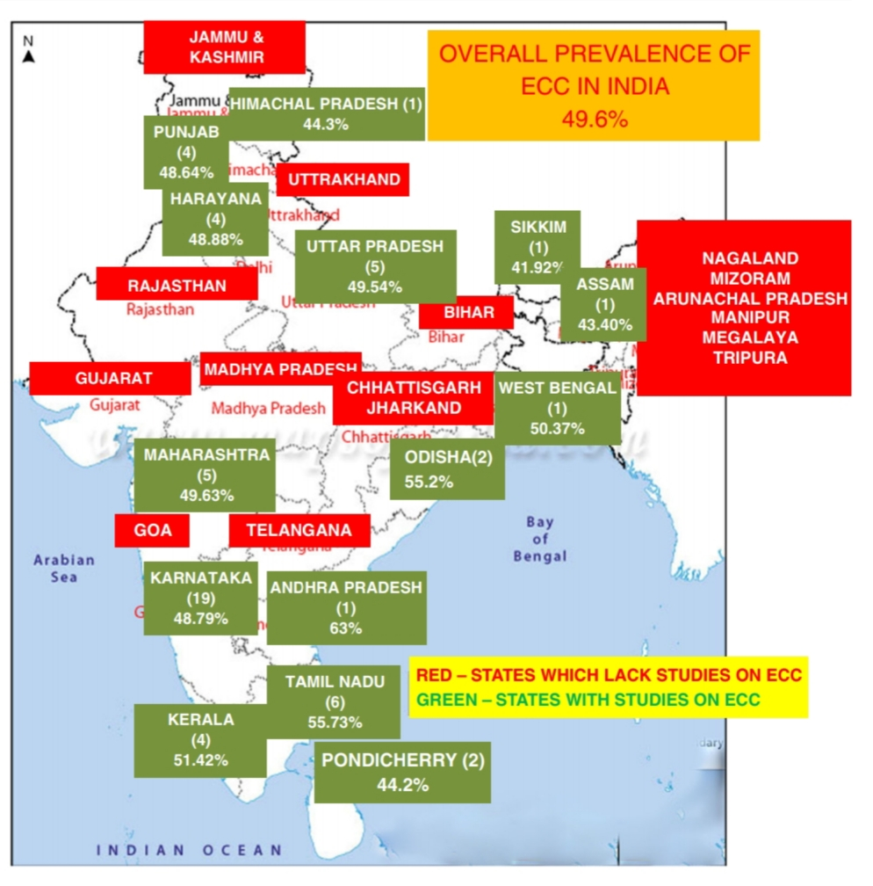

**DEFINITION OF ECC**

**Abid Ismail (1998):** Early Childhood Caries (ECC) is defined as occurrence of any sign of dental caries on the tooth surface during first 3 years of life.

**Early Childhood Caries (AAPD,2016): -**

ECC is defined as the presence of one or more decayed (non-cavitated or cavitated lesions), missing (due to caries), or filled tooth surfaces in any primary tooth in child *71 months of age or younger.*

**Bangkok Declaration Nov 2018 [reaffirmed Drury et al. (1999) definition], AAPD-2019**

"The presence of one or more decayed (non-cavitated or cavitated lesions), missing (due to caries) or filled tooth surfaces in any primary tooth in a child under the *age six*”-ECC.

**CLASSIFICATIONS AND STAGES OF ECC**

1. **Wyne A. H (1999):**

|  |  |  |  |  |
| --- | --- | --- | --- | --- |
| TYPE | SEVERITY | AGE | CAUSE | DESCRIPTION |
| TYPE 1 | Mild to moderate | 2-5 Years | Combination of cariogenic semi – solid or solid food & lack of oral hygiene | The existence of isolated carious lesion(s) involving molars and / or incisors. |
| TYPE 2 | Moderate to severe | Found soon after the first teeth erupts | Inappropriate use of feeding bottle or at will breast feeding or a combination of both, with or without poor oral hygiene. | Labio-lingual carious lesions affecting maxillary incisors, with or without molars.  It may proceed to an advanced stage, if not controlled. |
| TYPE 3 | Severe |  | A combination of cariogenic food and poor oral hygiene. | Carious lesions affecting almost all the teeth. |



TYPE 3

TYPE 2

TYPE 1

1. **Psoter et al, 2003 – Classification of dental caries in primary dentition**
2. Any maxillary incisor surfaces
3. First molar occlusal surfaces
4. Second molar pit and fissure surfaces
5. 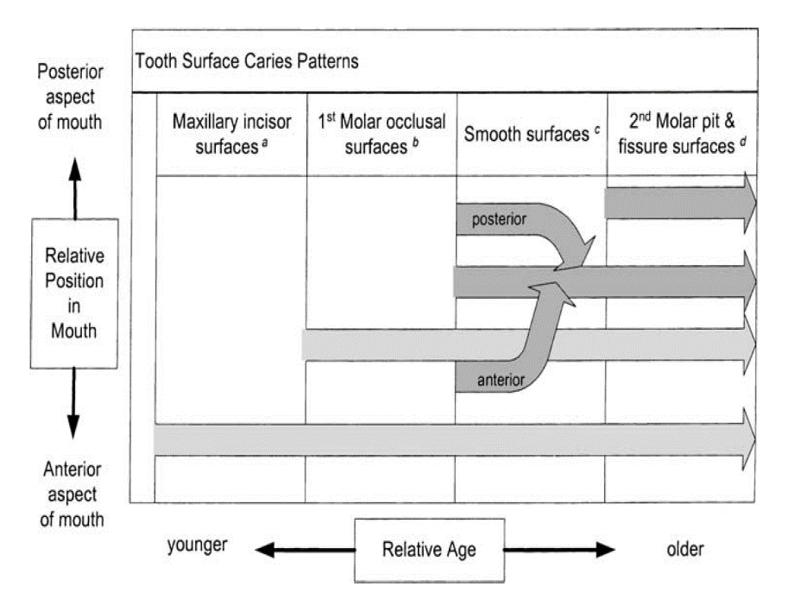Any smooth surfaces, excluding the maxillary incisor surfaces
6. **Johnson & collegues, 1994 – Classification of dental caries in primary dentition**

|  |  |  |
| --- | --- | --- |
| **Lesions associated with developmental defects** | **Smooth surface lesions** | **Rampant caries** |
| 1. Pit and fissure defects | 1. Facio-lingual lesions | Having caries in 14 out of 20 primary teeth, including atleast one primary mandibular incisor. |
| 1. Hypoplasia | 1. Approximal molar lesions |  |
|  | 1. Both |  |

1. **Veerkamp and Weerheijm, 1995**

|  |  |  |  |
| --- | --- | --- | --- |
| STAGE | CLINICAL STAGE | AGE | FEATURES |
| I | Initial reversible | 10-18 months | -Areas of chalky white demineralization  -No pain |
| II | Damaged | 18-24 months | -Dentinal lesion in maxillary anterior teeth with slight discoloration  -Pain on having cold |
| III | Deep lesion | 24-36 months | -Molars affected  -Frequent pain  -Pulpal involvement of maxillary incisors |
| IV | Traumatic stage | 36-48 months | -Pulpal involvement of molars  -Maxillary incisors become non-vital |

**Explanation of the caries pattern in ECC:**

-Nursing caries: Ripa, Pediatric Dentistry, 1998

1. Clinical appearance:
2. Four maxillary incisors affected
3. C, D, E may be affected later [Depending on how long the carious pattern remains active]
4. Four mandibular incisors remain sound.
5. The symmetrical distribution of decay between the maxillary and mandibular teeth, with the exception of the mandibular incisors.
6. Explanation of caries pattern:

The reason for the unique distribution of caries between the maxillary and mandibular incisors and the unequal severity of the lesions between the incisors and the other teeth is related to 3 factors.

1. The chronology of primary tooth eruption;
2. The duration of the deleterious habit; and
3. The muscular pattern of infant sucking.

The maxillary incisors which are among the first to erupt, will be the first to experience the cariogenic challenge and will suffer the longest caries attack.

If the habit continues, the other teeth will be subjected to the cariogenic challenge in sequence with their eruption order.

During sucking, the natural or artificial nipple rests against the palate, while the tongue is extended over the lower incisors.

Liquid from the nursing bottle or a mother’s breast will bathe all the teeth except the lower incisors which are physically protected by the tongue.

If the liquid is consumed frequently and for prolonged periods during the day or night, the liquid will pool around the teeth.

If the liquid contains a fermentable carbohydrate, it will be metabolized by oral microorganisms into organic acids that demineralize the teeth.

|  |  |  |  |
| --- | --- | --- | --- |
| **TITLE/ AUTHOR** | **JOURNAL/**  **COUNTRY** | **METHODOLOGY** | **CONCLUSION** |
| **Pattern and severity of early**  **childhood caries.**  Hallett KB, 2006 | COMMUNITY DENTISTRY & ORAL EPIDEMIOLOGY  Australia | A cross-sectional sample of 2515 children aged 4–5 years were examined in a preschool setting using decayed, missing, filled teeth/surface  (dmft/dmfs) indices | Infant bottle-feeding habits and ethnicity other than Caucasian were significant determinants for both  anterior caries pattern and severity of ECC in 4–5-year-old Australian children. |

**STAGES OF EARLY CHILDHOOD CARIES**

DCNA, 2000

1. **Normal**
2. **Very mild:** Clinical appearance shows very mild demineralization usually at gingival crest and no cavitation
3. **Mild:** Clinical appearance shows demineralization in gingival third of tooth & moderate cavitation.
4. **Moderate:** Clinical appearance shows frank cavitation on multiple tooth surface.
5. **Severe:** Clinical appearance consists of wide spread destruction of tooth & partial to complete loss of clinical crown.

**Classification of ECC and Severe Early Childhood Caries (S-ECC)**

|  |  |  |
| --- | --- | --- |
| **Age (months)** | **Early childhood caries** | **Severe early childhood caries** |
| <12 | 1 or more dmfs surfaces | 1 or more smooth dmf surfaces. |
| 12–23 | 1 or more dmfs surfaces | 1 or more smooth dmf surfaces. |
| 24–35 | 1 or more dmfs surfaces | 1 or more smooth dmf surfaces |
| 36–47 | 1 or more dmfs surfaces | 1 or more cavitated, filled, or missing (due to caries) smooth surfaces in primary maxillary anterior teeth or dmfs score >4. |
| 48–59 | 1 or more dmfs surfaces | 1 or more cavitated, filled, or missing (due to caries) smooth surfaces in primary maxillary anterior teeth or dmfs score >5. |

**ETIOLOGY OF EARLY CHILDHOOD CARIES**

Etiological patterns of Early Childhood Caries:

**Pattern A:**

Infants being fed with a nursing bottle containing a high amount of fermentable carbohydrates during sleep.

**Pattern B:**

Unrestricted nocturnal breastfeeding (At will) after eruption of primary incisors and poor oral hygiene.

**Pattern C:**

-Deficient salivary quantity/ flow.

-Deficient antibacterial properties.

-Poor salivary buffering capacity and

-High cariogenic potential

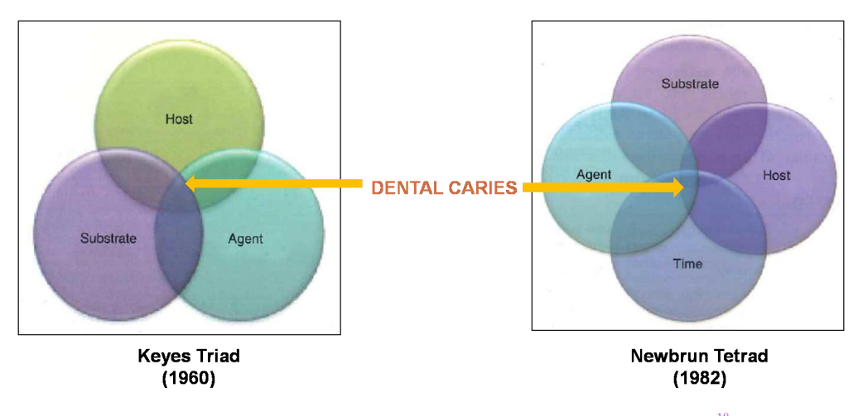

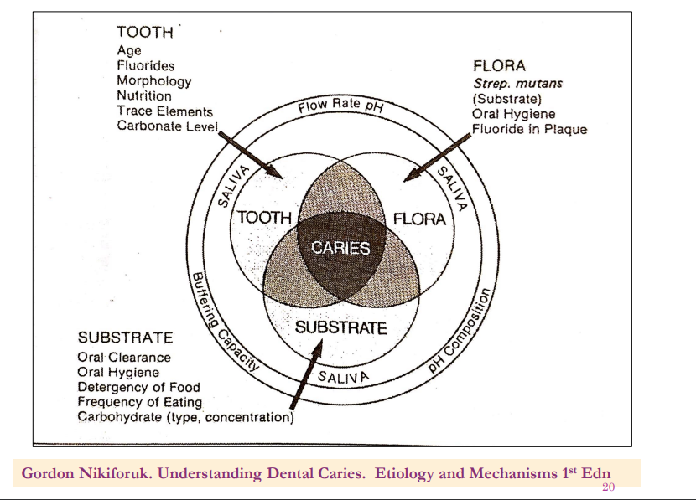

|  |
| --- |
| **Gordon Nikiforuk. Understanding Dental Caries. Etiology and Mechanisms 1st Edition** |

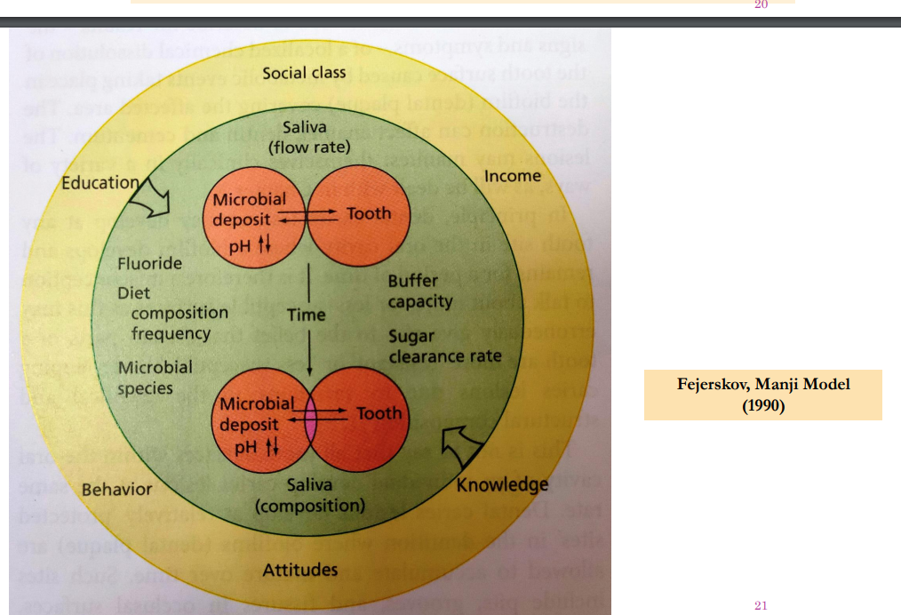

|  |
| --- |
| **Fejerskov, Manji Model (1990)** |

**MODEL OF THE SEQUENCE OF EVENTS LEADING TO HAS –ECC**

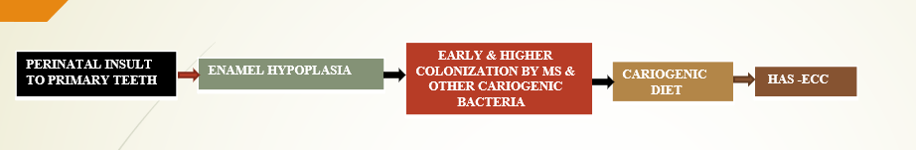

**CLASSIFICATION BASED ON EHP [CAUFIELD, 2012]:**

|  |  |
| --- | --- |
| **HAS-ECC STAGE 0** | EHP on multiple primary teeth without active caries. |
| **HAS-ECC STAGE 1** | Primary teeth with EHP and a minor to moderate degree of caries. |
| **HAS-ECC STAGE 2** | Shows primary teeth with EHP and severe caries. |

**RISK FACTORS OF ECC**

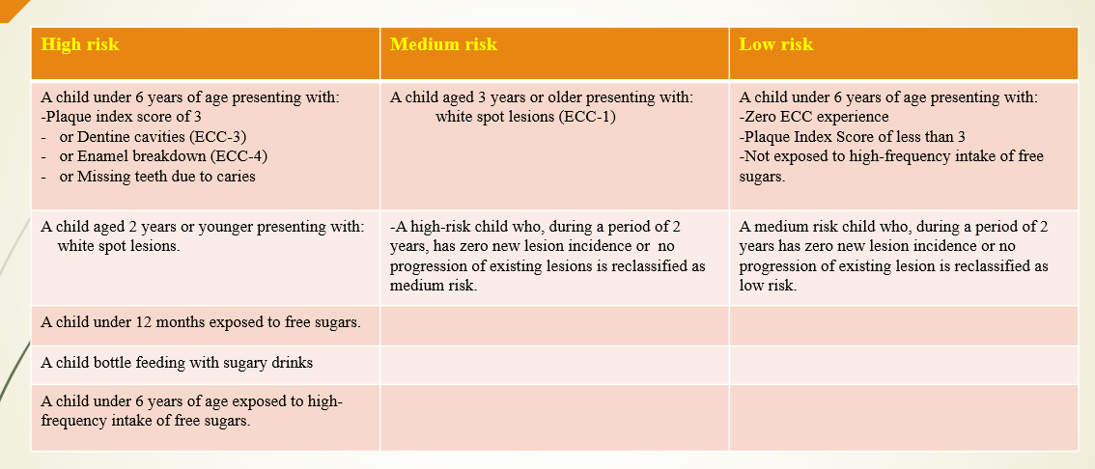

**CLINICAL FEATURES**

Fung M.H.T. et al, 2013

1. The pathogenesis frequently related to the eruptive pattern of the primary dentition, the cariogenic feeding pattern of the primary dentition, the cariogenic feeding pattern, and the oral physiology of the infant or child.
2. The caries attack usually starts on the labial surface of the upper anterior incisors.

-The initial lesion appears as a whitish area of decalcification along the gingival margin.

-These lesions soon become pigmented and spread laterally and coronally.

-Caries on molars may start simultaneously in the pit and fissure area and the gingival area of the buccal surface.

-The four upper incisors are usually the more severely affected, since they are among the first teeth to erupt and therefore have the longest exposure to cariogenic substances.

1. The mandibular incisors are more resistant to decay, which may be due to their close proximity to the secretion area of the submandibular glands as well as the cleansing action of the tongue during sucking.

The tongue extends anteriorly during sucking to form an oral seal, which prevents the nursing liquid from pooling around the mandibular incisors.

1. Difficulty to eat hard chewable food substances due to pain and sensitivity, sleep and brush.
2. Frequent episodes of cough and cold.
3. Sensitivity to thermal changes & physical stimuli.
4. Poor general health because of less intake of solids.

**DIAGNOSIS OF EARLY CHILDHOOD CARIES**

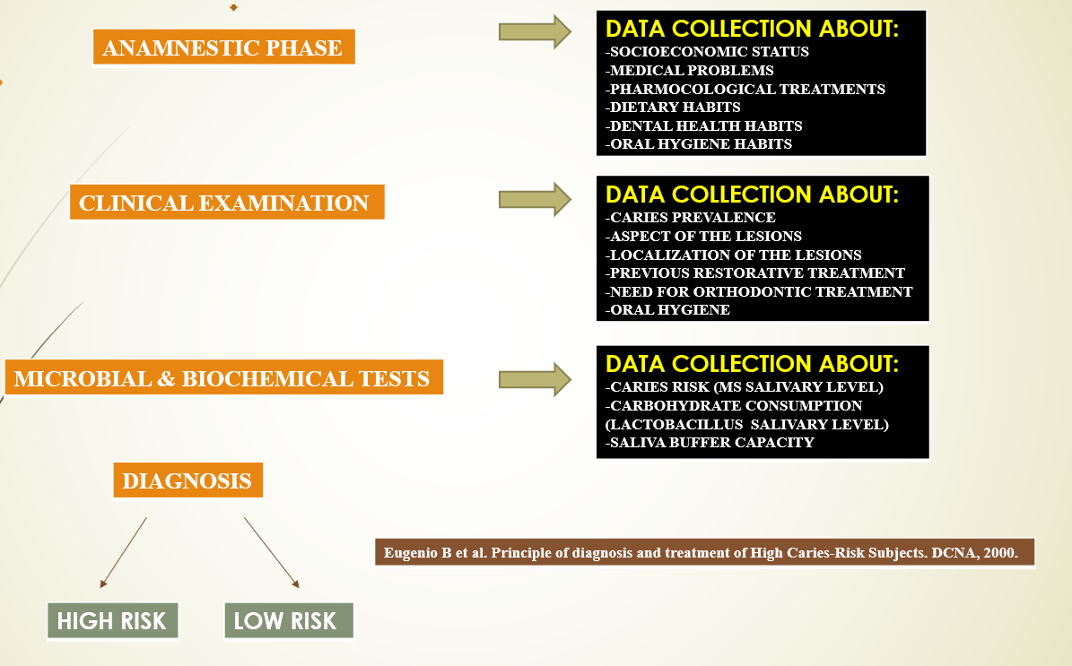

**MANAGEMENT**

**WHO Expert Consultation on Public Health Intervention against Early Childhood Caries – Bangkok, Thailand, 2016:**

1. **Primary prevention of Early childhood caries:**

Participants identified the four key public health interventions:

1. **Promoting healthy behaviour:**

-Five target groups were identified:

Pregnant women,

Mothers and primary caregivers,

Policy – makers,

The community [including the private sectors] and

Health – care professionals

-Pregnant women must be fully involved in proper oral hygiene and dietary practice.

-The recommended strategies included developing instructions and guidelines, the development of standard methodologies and the application of standard methods.

-Mothers and caregivers must adhere to the first dental visit and vaccination schedule.

An oral check up after the first tooth eruption should be integrated into the existing health programme such as vaccinations and general medical check-ups.

The continuing programme of interventions should give reassurance and should help mothers caregivers to keep appointments.

-Policy makers at local and national levels must integrate an oral health element into existing health promotion programme and policies.

-The community, including the private sector, should utilize community health workers, social media and mobile telephones to promote healthy behaviours at local and national levels.

-Health – care professionals, including bodies governing curriculum design, should develop curricula and improve the competency of health professionals to recognize the need for ECC prevention and how to implement it.

1. **Fluoride use:**

-Affordable and effective fluoride toothpaste should be available for all children.

Policy – makers and dental professionals should advocate for, and promote, legislation conductive to the affordability, accessibility and quality of fluoride toothpaste.

-Strategies should include the elimination of takes on fluoride toothpaste and destination of the toothpaste as a health product and not a cosmetic product.

-When feasible, access to national fluoridation schemes using water, salt and milk as vehicles should be promoted.

Policy – makers should reinforce fluoridation at an optimal level to prevent dental caries, using WHO recommendations.

1. **Oral hygiene practice:**

-Mothers and caregivers should be recommended to use 1000 – 1500 ppm fluoride toothpaste twice daily.

-Tooth brushing should be supervised at home, and at day care centres and pre-schoolers for children, using an appropriate amount of tooth paste according to age.

-Training in the techniques of brushing – such as how to estimate the appropriate amount of toothpaste (a smear, the size of the little fingernail, etc) and not to rinse after brushing – should be given to mothers and caregivers at vaccination visits and to teachers at daycare centres.

1. **Appropriate diet/nutrition practices**:

-Policy – makers, health professionals and kindergarten teachers should discourage bottle – feeding.

-Health professionals should follow WHO guidelines on infant and child feeding and nutrition.

-There should be no added sugars in complementary food and drinks before 2 years of age.

-Sugary beverages and juices and food high in added sugars should be avoided, white fruit, starchy staple food and cow milk as a main milk after 1 year of age should be promoted.

-Manufacturers should minimize the addition of free sugars.

🡪Policy – makers should pass laws and regulations to create a healthy environment for diet and nutrition, and should advocate the regulation of manufactured products. After the panel discussions, participants provided additional comments as follows.

-The recommendation for salt fluoridation must be considered along with the amount of salt consumption because of concern to minimize salt intake to prevent hypertension.

-Fluoride varnish should be considered as secondary prevention and may be recommended for moderate-to-high caries risk communities.

-Advice on the use of fluoride toothpaste must focus on both the concentration and the amount of toothpaste, emphasized for preschool children.

-The use of fluoride toothpaste under supervision should be emphasized for preschool children.

-Advice about bacterial transmission from mothers to children should focus on the need for good oral hygiene of mothers rather than on transmission.

-Information on complementary foods should focus on less than 5% energy from free sugars, in accordance with WHO’S recommendation.

-The strategy to advocate for the food industry to minimize sugars in complementary foods should be promoted as a national measure.

1. **Secondary prevention of early childhood caries:**

Secondary prevention includes early disease detection, making it possible to prevent worsening of the lesions and also to control the spread of the disease.

Secondary prevention is not to be implemented alone but must be on top of primary prevention.

The recommended strategies include the following;

1. **Early detection:**

**-**When the first tooth erupts or at 6 months of age, the child should be screened in postnatal health care programme and, a simple checklist for cries risk factors needs to be assessed.

**-**This screening visit should be par of the package of health care, and oral status should be included in a baby’s medical profile.

**-**Training health personnel to detect ECC is recommended.

**-**Periodontal oral check-ups should be fully integrated with general health care for mothers and children.

**-**Subsequent check-ups should be on every occasion of the child’s general health examination and vaccination visit, or at least every 3-6-months according to caries risk.

1. **Diet counselling:**

**-**Dietary advice should follow the recommendation for primary prevention, but intensively.

**-**In case breastfeeding is not possible, weaning bottle-feeding is recommended after 6 months of age.

**-**Milk and water should be the main drink without sugars added.

1. **Fluoride uses:**

**-**In homes, day care centres and kindergartens, supervised tooth brushing with a smear layer of fluoride toothpaste containing 1000 ppm fluoride should continue to be promoted.

**-**For non-cavitated lesions, the recommendation on fluoride application for primary prevention should be followed.

**-**Use of fluoride varnish with 2.26% fluoride every 3-6-months, when possible, until the lesion is arrested.

1. **Behaviour modification:**

-Parents and caregivers need to be actively involved in the dietary and oral hygiene practices of their children.

-National health policy should promote a heathy environment at home, kindergarten and in the community, and should make the hygiene armamentarium affordable to the community.

1. **Sealant:**

**-**When the tooth or the child is at risk of developing caries, and for those children who non-cavitated lesions, sealant should be placed by trained personnel with adequate equipment following the primary prevention recommendation and manufacturer’s instructions.

-The lesion should be checked regularly and re-sealed when necessary.

1. **Non-fluoride:**

**-**On the basis of current evidence and potential side-effects, non-fluoride caries-preventive agents are not recommended.

1. **Referral:**

Health and non-health personnel should be trained to deliver education and referrel.

1. **Tertiary prevention of early childhood caries:**

**-**The goal of tertiary prevention is to reduce the negative impact of established disease (cavity) by restoring function and reducing disease-related complications.

-Tertiary prevention also aims to improve the quality of life for children with ECC.

The strategies for tertiary prevention of ECC should focus on the following:

1. Control progression and restore function: with public health approaches in children under 6yers of age.
2. Detect the cavity: by primary caregivers, mothers, primary health-care workers, nurses, doctors and dental professionals.
3. Provide-training: both self-training and in-service training workshops, for health and dental professionals.
4. Use the standard tools: for screening, disease detection and referral.
5. Minimum intervention:

-Should avoid unnecessary extraction, preserve the tooth structure, and avoid negative consequences such as pain and infection which have an impact on young children’s ability by disturbing concentration and school participation.

-The daily consequences of ECC to families, communities and societies often go unnoticed.

-In extreme cases, ECC and its lack of treatment can lead to serious disability and death.

1. **Alternative procedures:**

-Include using fluoride varnish and SDF to arrest caries, using ART/ SMART/ ITR techniques, and Hall technique.

-Restorative adhesive materials with fluoride release, including glass ionomers, are the materials of choice.

-Other treatment options are available for further crown restoration and rehabilitation of primary dentition.

-Techniques and materials used for treatment should follow professional guidelines and protocols recommended by professional organizations and evidence-based documents.

1. **Establishment referral system and increase access:**

-To car by using non-dental personnel such as primary health-care workers for screening and referrals.

-Referral may include the use of a benefits package/insurance coverage and include public-private partnership approaches.

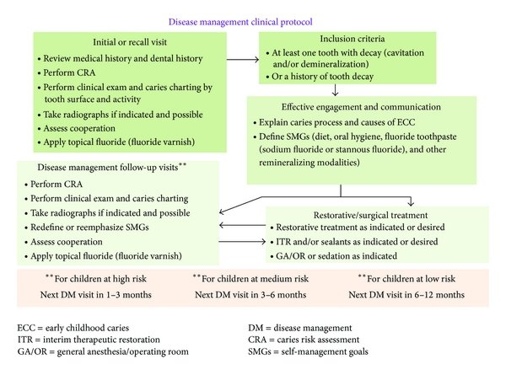

CONCLUSION

1. American Academy of Pediatric Dentistry. Policy on early childhood caries (ECC): unique challenges and treatment options. Pediatr. Dent. 30, 44–46, (2008).

2. Tinanoff, N. Introduction to the conference: Innovations in the prevention and management of early childhood caries. Pediatr. Dent. 37, 198–199 (2015).

3. Dean, J. A., Avery, D. R. & McDonald, R. E. McDonald and Avery’s Dentistry for the Child and Adolescent (10th edition). 156 (Elsevier, 2016).

4. American Dental Association. Statement on early childhood caries http:// www.ada.org/en/about-the-ada/ada-positions-policies-and-statements/ (2018).

5. Vos, M. B. et al. Added sugars and cardiovascular disease risk in children: a scientific statement from the American Heart Association. Circulation 135, e1017–e1034 (2017).

6. El Tantawi, M. et al. Prevalence and data availability of early childhood caries in 193 United Nations Countries, 2007–2017. Am. J. Public Health 108, 1066–1072 (2018).

7. Tinanoff, N. et al. Early childhood caries epidemiology, aetiology, risk assessment, societal burden, management, education, and policy: global perspective. Int. J. Paediatr. Dent. 29, 238–248 (2019).

8. Kazeminia, M. et al. Dental caries in primary and permanent teeth in children’s worldwide, 1995 to 2019: a systematic review and meta-analysis. Head. Face Med. 16, 1–21 (2020).

9. Uribe, S. E., Innes, N. & Maldupa, I. The global prevalence of early childhood caries: a systematic review with meta‐analysis using the WHO diagnostic criteria. Int. J. Paediatr. Dent. 31, 817–830 (2021).

10. Phantumvanit, P. et al. WHO global consultation on public health intervention against early childhood caries. Community Dent. Oral Epidemiol. 46, 280–287 (2018).

11. Min Quan, D. et al. Dental caries status and its associated factors among 3-to 5- year-old children in China: a national survey. Chin. J. Dent. Res. 21, 167–179 (2018).

12. Markovic, D. et al. How much country economy influences ECC Profile in Serbian children—a macro-level factor analysis. Front. Public Health 7, 285 (2019).

13. Schwendicke, F. et al. Socioeconomic inequality and caries: a systematic review and meta-analysis. J. Dent. Res. 94, 10–18 (2015).

14. Haworth, S. et al. Heritability of caries scores, trajectories, and disease subtypes. J. Dent. Res. 99, 264–270 (2020).

15. Silva, M. J. et al. Genetic and early-life environmental influences on dental caries risk: a twin study. Pediatrics 143, e20183499 (2019).

16. Zhang, S. et al. Dental caries status of Lisu preschool children in Yunnan Province, China: a cross-sectional study. BMC Oral Health 19, 1–8 (2019).

17. Cho, H., Lee, H., Paik, D. & Bae, K. Association of dental caries with socioeconomic status in relation to different water fluoridation levels. Community Dent. Oral Epidemiol. 42, 536–542 (2014).

18. Isaksson, H. et al. Parental factors in early childhood are associated with approximal caries experience in young adults—A longitudinal study. Community Dent. Oral. Epidemiol. 47, 49–57 (2019).

19. Iheozor‐Ejiofor, Z. et al. Water fluoridation for the prevention of dental caries. Cochrane Database Syst. Rev. 2015, CD010856 (2015).

20. Folayan, M. O. et al. An ecological study on the association between universal health service coverage index, health expenditures, and early childhood caries. BMC Oral Health 21, 1–7 (2021).

21. Heimisdóttir, L. H. et al. Metabolomics insights in early childhood caries. J. Dent. Res. 100, 615–622 (2021).

22. Lipton, R., Schwedt, T. & Friedman, B. GBD 2015 disease and injury incidence and prevalence collaborators. Global, regional, and national incidence, prevalence, and years lived with disability for 310 diseases and injuries, 1990-2015: a systematic analysis for the Global Burden of Disease Study 2015. Lancet 388, 1545–1602 (2016).

23. Kassebaum, N. et al. Global burden of untreated caries: a systematic review and metaregression. J. Dent. Res. 94, 650–658 (2015).

24. Teng, F. et al. Prediction of early childhood caries via spatial-temporal variations of oral microbiota. Cell Host Microbe 18, 296–306 (2015).

25. Jiang, W., Jiang, Y., Li, C. & Liang, J. Investigation of supragingival plaque microbiota in different caries status of Chinese preschool children by denaturing gradient gel electrophoresis. Microb. Ecol. 61, 342–352 (2011).

26. Chen, Y., Li, Y. & Zou, J. Intrageneric and intergeneric interactions developed by oral Streptococci: pivotal role in the pathogenesis of oral diseases. Curr. Issues Mol. Biol. 32, 377–434 (2019).

27. Kameda, M. et al. Sugar metabolism of Scardovia wiggsiae, a novel cariesassociated bacterium. Front. Microbiol. 11, 479 (2020).

28. Tian, J. et al. Acquisition of the arginine deiminase system benefits epiparasitic Saccharibacteria and their host bacteria in a mammalian niche environment. Proc Natl Acad Sci USA https://doi.org/10.1073/pnas.2114909119 (2022).

29. Yang, X. Q. et al. Genotypic distribution of Candida albicans in dental biofilm of Chinese children associated with severe early childhood caries. Arch. Oral. Biol. 57, 1048–1053 (2012).

30. Chen, J. et al. EpsR negatively regulates Streptococcus mutans exopolysaccharide synthesis. J. Dent. Res. 100, 968–976 (2021).

31. Gong, T. et al. Transcriptional profiling reveals the importance of RcrR in the regulation of multiple sugar transportation and biofilm formation in Streptococcus mutans. mSystems 6, e0078821 (2021).

32. Li, Z., Xiang, Z., Zeng, J., Li, Y. & Li, J. A GntR family transcription factor in Streptococcus mutans regulates biofilm formation and expression of multiple sugar transporter genes. Front. Microbiol. 9, 3224 (2018).

33. Pan, Y. et al. The Adc regulon mediates zinc homeostasis in Streptococcus mutans. Mol. Oral Microbiol. 36, 278–290 (2021).

34. Ma, Q. et al. Acetylation of glucosyltransferases regulates Streptococcus mutans biofilm formation and virulence. PLoS Pathog. 17, e1010134 (2021).

35. Cheng, X. et al. Regulation of oxidative response and extracellular polysaccharide synthesis by a diadenylate cyclase in Streptococcus mutans. Environ. Microbiol. 18, 904–922 (2016).

36. Zheng, T. et al. Deletion of the yqeK gene leads to the accumulation of Ap4A and reduced biofilm formation in Streptococcus mutans. Mol. Oral Microbiol. 37, 9–21 (2022).

37. Chen, J. et al. Characterization of the clustered regularly interspaced short palindromic repeats sites in Streptococcus mutans isolated from early childhood caries patients. Arch. Oral Biol. 83, 174–180 (2017).

38. Zhang, A. et al. Deletion of csn2 gene affects acid tolerance and exopolysaccharide synthesis in Streptococcus mutans. Mol. Oral Microbiol. https://doi.org/10.1111/ omi.12308 (2020).

39. Xiang, Z. et al. EzrA, a cell shape regulator contributing to biofilm formation and competitiveness in Streptococcus mutans. Mol. Oral Microbiol. 34, 194–208 (2019).

40. Dinis, M. et al. Oral microbiome: Streptococcus mutans/caries concordantdiscordant children. Front. Microbiol. 13, 782825 (2022).