ROLE AND NEED OF INTERSTITIAL FLUID PH DETECTOR DEVICE IN THE CARIES ETIOPATHOGENESIS - A REVIEW

Author 1-
Name- Amisha Nilesh Nayak
Name of the Organization- Dr. D Y Patil University, School of Dentistry.
City/Country- Navi Mumbai, India
Email Id- amisha.n12@gmail.com

Author 2-
Name- Dr. Sandhya Tamgadge
Name of the Organization- Dr. D Y Patil University, School of Dentistry.
City/Country- Navi Mumbai, India
Email Id- sandhya.tamgadge@gmail.com

ABSTRACT
One of the most prevalent diseases found in the oral cavity is dental caries. Dental caries, also commonly known as tooth decay is a bacterial process that spreads from the enamel of the tooth towards pulp leading to various periodontal problems causing pain. pH is one of the major factors influencing the formation and progression of dental caries. There is evidence which states that alteration of pH of the interstitial fluid present in the body can significantly affect the tooth mineralisation from inside to outside approach, which further accumulates various groups of bacteria causing caries. The early detection of pH interstitial fluid through a device would significantly diagnose the probability of caries progression and the necessary treatment procedure to be applied to prevent internal damage which makes the tooth weak.
Keywords- pH detector, caries, tooth decay, mechanical device.
I. INTRODUCTION
Oral hygiene has been an integral part of human life since its existence. The lack of maintenance of oral hygiene by regular brushing, flossing can lead to accumulation of food particles. On accumulation of food particles into the retentive areas of the tooth, the local pH decreases and results in dental decay. But this theory has many drawbacks. These drawbacks could be answered by an unexplored internal systemic approach which takes place before the external demineralization starts.
Thus, on subsequent decrease in systemic interstitial fluid pH which is harmful, the body tries to maintain alkalinity of the oral cavity, the calcium is withdrawn from the tooth causing demineralisation and internal porosity leading to the formation of dental caries.
II. DENTAL CARIES
In a layman’s language, dental caries is termed as tooth decay. It is a bacterial disease which is caused due to the acids generated from bacterial metabolism, which diffuses into enamel and dentin causing demineralisation of enamel. The acids are essentially a by-product of the metabolism of fermentable carbohydrates. (1)
The host causing this metabolic activity include various bacteria’s present in the oral cavity majorly of Streptococcus species. Dental caries is a result of the long-term alteration of demineralisation and remineralisation cycles which take place on ingestion of food. On exceeding the rate of demineralisation over remineralisation of a particular part of the tooth surface causes cavitation. Remineralisation is a natural repair process for the non cavitated lesions which mainly occurs due to the calcium and phosphorus ions rebuilding a surface on the existing remains of the enamel crystals promulgating arrest or reversal of caries. [1]
III. THEORIES OF DENTAL CARIES
There are various theories put forward by numerous researchers over the years. However, the most accepted theory of dental caries is the one termed by Willoughby D. Miller in 1890. The theory is known as Miller’s acidogenic theory or chemo-parasitic theory. It states that “dental decay is a chemo-parasitic process consisting of two stages- decalcification or softening of the tissues due to the acids produced by fermentation of starches and sugars in retentive areas of teeth, followed by the dissolution of the softened residue”. [2]
IV. pH AND ITS IMPORTANCE IN HUMAN HEALTH
pH is the determination of specificity of the acidity or alkalinity of a particular substance. It is logarithmic and indicates the inverse proportion of the concentration of hydrogen ions in a particular substance or solution but it has drawbacks [3]. There are two more popular theories which too have drawbacks. All have been mentioned in literature since their inception in spite of drawbacks. The normal range of pH in human serum is from 7.35-7.45. It is slightly towards an alkaline range. The body balance for normal functioning of the human body is solely dependent on the maintenance of continuous pH levels. [4,5]
The pH levels are found to be different in various areas of the human body. The consequent alteration of pH levels promotes the activity of opportunistic microbial organisms. Considering the stomach (normal pH of stomach is 1.35 to 3.5), with the alteration of pH, decreases gastric lining section of bicarbonate and decrease in acid/alkaline secretions promoting the formation of ulcers. [4,6]
V. INTERSTITIAL FLUID
Blood is the most abundant fluid present in the human body which flows through arteries, veins and capillaries. It consists of red blood cells (erythrocytes), white blood cells (leucocytes), platelets (thrombocytes) and plasma consisting of water, proteins, hormones, oxygen (O2), carbon dioxide (CO2), glucose, salts and enzymes. The arteries, veins and capillaries are the vessels which help in transportation of various nutrients and mainly oxygen to various parts of the body.
All the constituents of blood, which escape the walls of blood capillaries, are termed as interstitial fluid (also known as tissue fluid). These escaped substances surround the tissues of the body. Red blood cells & plasma proteins i.e., albumin, fibrinogen, immunoglobulins cannot escape the capillaries due to its large size and are thus, not found in interstitial fluid.
The composition of interstitial fluid is as follows (Table 1)- [7]
Table 1- Composition of Interstitial Fluid

Constituent | Quantity (mmol/L)
Total protein | 20.6 mmol/L
Albumin | 0.188 mmol/L
Total calcium | 1.551mmol/L
Calcium ion (Ca2+) | 1.183 mmol/L
Total magnesium | 0.666 mmol/L
Magnesium ion (Mg2+) | 0.506 mmol/L
Total sodium | 134.6 mmol/L
Sodium (direct ISE) | 135.7 mmol/L
Total potassium | 3.17 mmol/L
Potassium (direct ISE) | 3.97 mmol/L
Total Co2 | 23.9 mmol/L
Phosphate | 0.610 mmol/L

VI. INTERSTITIAL FLUID & pH
As the other body fluids and cellular functions are extremely sensitive to the acid- alkaline imbalance, similarly interstitial fluid also bears this sensitivity.[8,9] When the pH of the interstitial fluid is altered i.e., it becomes acidic, derangement of complex systems, impaired cellular metabolisms are observed which may lead to an array of systemic diseases including cancers. [8,11]
All the above ailments occurring due to the acidic pH of interstitial fluid is a response of maintaining normal alkaline pH of the interstitial fluid. This alkaline balance is achieved by absorbing minerals (mainly calcium) from the hard tissues of the body which are bones and teeth. With the increase in acidity, there is increase in absorption of calcium, leading to demineralisation of teeth and osteoporosis in case of bones. [8,9,12]
The interstitial fluid reaches the pulp through main excretory ducts of salivary glands, gingival crevicular fluid (GCF), interstitial fluid of pulp vessels. Further it reaches dentin through a network of dentinal tubules containing dental lymph, leading to the demineralization of inter tubular and peritubular dentin, increasing porosity of the enamel. The dental lymph is also an interstitial fluid as described by Larmas. [8,9,12] The continual demineralisation as a result of this imbalance and the continuous remineralisation of the teeth due to the fluoride and calcium ions present in the body, ultimately leads to the dissolution of the enamel crystals causing cavitation or caries. [8,9]
VII. FLUID TRANSPORT AND DENTAL HEALTH
Maintenance of the rapid rate of metabolism within the tooth through dental lymph is carried out by fluid transport systems. The fluid transport system is responsible for the nutrient uptake and subsequent waste removal from the tooth structure. Any alteration in the rate of the fluid transport through dentin, results in accumulation of lactic acid into the tooth structure. Lactic acid is a by-product of the metabolic events occurring within the tooth. This accumulation of lactic acid leads to the pH alterations as discussed earlier, causing dental caries. [13]
VIII. INTERSTITIAL FLUID MEASURING DEVICE
As discussed earlier, interstitial fluid plays a major role in pathogenesis of caries. If we can measure the pH of the interstitial fluid the same as an oximeter, the rate of caries progression can be accessed. A mechanical device installed with the features detecting interstitial fluid, if implemented, can successfully evaluate systemic pH which would help further to detect and correlate the grade of internal porosities (Figure 1)
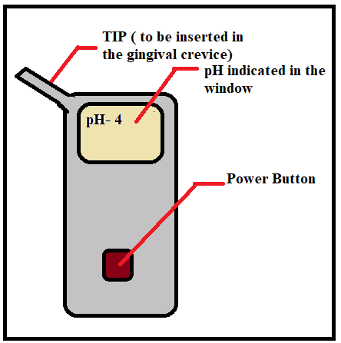
Figure 1- Interstitial Fluid Detector Device
Internal porosities are the initial events before the external caries attack which are caused by attack of acidic interstitial fluid pH. through pulpal approach. early investigation of developing carious lesions leading to quick action against the damage of the tooth foreseen. Also, a device which can detect the pH of the interstitial fluid by the use of absorbing paper with which the gingival crevicular fluid is extracted and used for pH detection. (Figure 2- a,b,c)
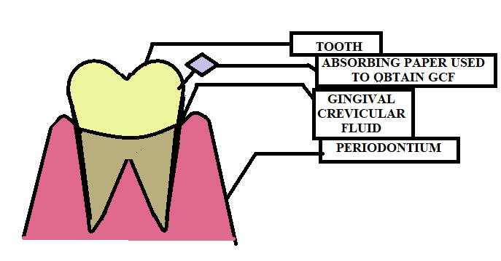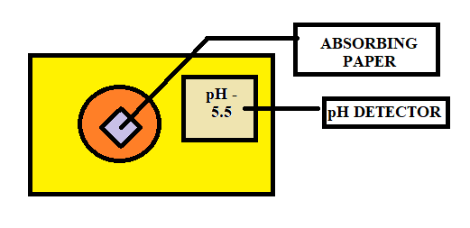
- (b) (c)
Figure- 2 - Extra-Oral Device For Interstitial Fluid Ph Detection
IX. CONCLUSION
Dental caries is one of the most widespread bacterial lesions occurring in almost every individual. With the fabrication of a mechanical device which would measure the pH of interstitial fluid present in the dentin of the tooth and within the body too, the rate of caries progression can be detected and will lead to prevention of further damage to the tooth by application of appropriate treatment procedure according to the pH. Also, the tooth susceptible to dental decay can also be detected by the altered pH levels.
X. REFERENCES
- Featherstone JDB. Dental caries: a dynamic disease process. Aust Dent J. 2008;53(3):286–91
- Shafer WG, etc. Textbook of oral pathology. 4th ed. London, England: W B Saunders; 1983.
- Wikipedia contributors. pH [Internet]. Wikipedia, The Free Encyclopedia. 2021 . Available from: https://en.wikipedia.org/w/index.php?title=PH&oldid=1042135093
- Schwalfenberg GK. The alkaline diet: is there evidence that an alkaline pH diet benefits health? J Environ Public Health. 2012;2012:727630
- A. Waugh and A. Grant, Anatomy and Physiology in Healthand Illness, Churchill Livingstone Elsevier, Philadelphia, Pa, USA, 10th edition, 2007.
- Y. S. Malov and A. N. Kulikov, “Bicarbonate deficiency and duodenal ulcer,” Terapevticheskii Arkhiv, vol. 70, no. 2, pp. 28–32, 1998
- Fogh-Andersen N, Altura BM, Altura BT, Siggaard-Andersen O. Composition of interstitial fluid. Clin Chem. 1995;41(10):1522–5
- Tamgadge S, Tamgadge A. Is systemic (interstitial fluid) acidosis an initial event in the etiopathogenesis of dental caries? A hypothesis. Dent Hypotheses. 2018;9(4):96.
- Kellum JA. Determinants of blood pH in health and disease. Crit Care 2000;4:6-14
- Reshkin SJ, Cardone RA, Harguindey S. Na+-H+ exchanger, pH regulation and cancer. Recent Pat Anticancer Drug Discov 2013;8:85-99.
- Felicetti MJ. How to balance your pH to heal your body; 2012. http:// www.mindbodygreen.com/0-6243/How-to-Balance-Your-ph-to-Heal[1]Your-Body.html. [Last accessed on March 15, 2015]; Abelow BJ, Holford TR, Insogna KL. Cross-cultural association between dietary animal protein and hip fracture: A hypothesis. Calcif Tissue Int 1992;50:14-8
- Feng X, McDonald JM. Disorders of bone remodeling. Annu Rev Pathol 2010;6:121-45
- Steinman RR, Leonora J. Relationship of fluid transport through the dentin to the incidence of dental caries. J Dent Res. 1971;50(6):1536–43.)

